Github Link: https://github.com/Dhruv200320/devsecops-project.git
Jenkins CI/CD Pipeline Execution
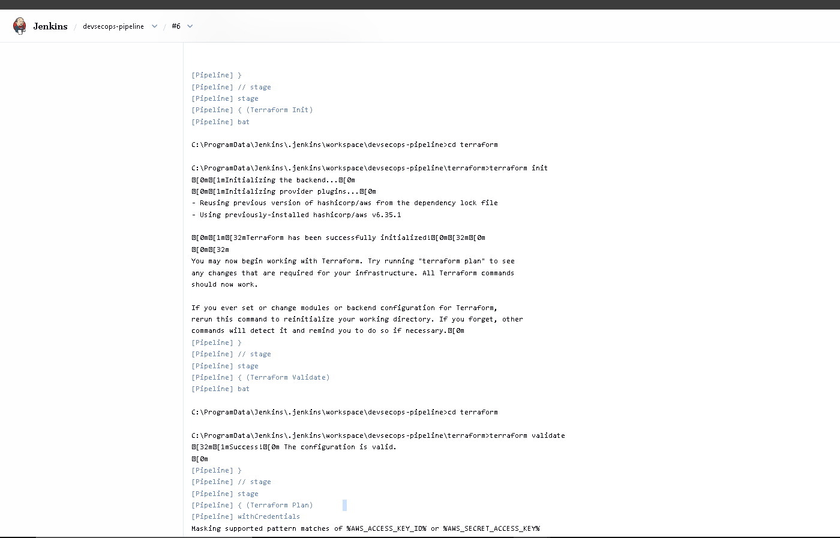
Initial Terraform Security Scan (Vulnerabilities Detected)
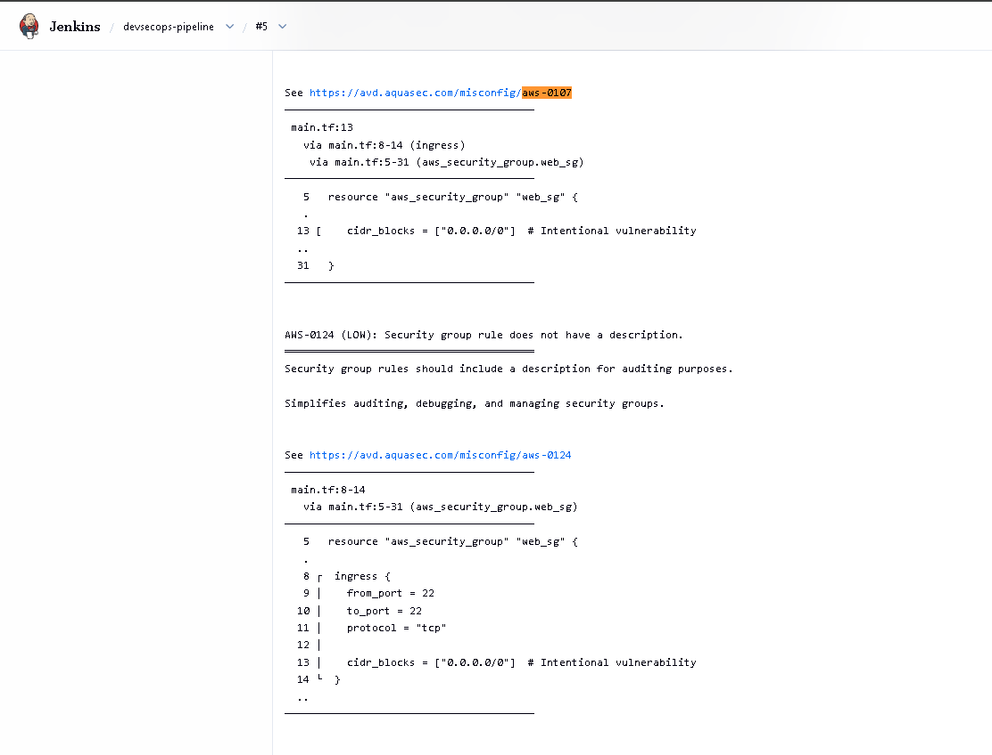
The fixed code
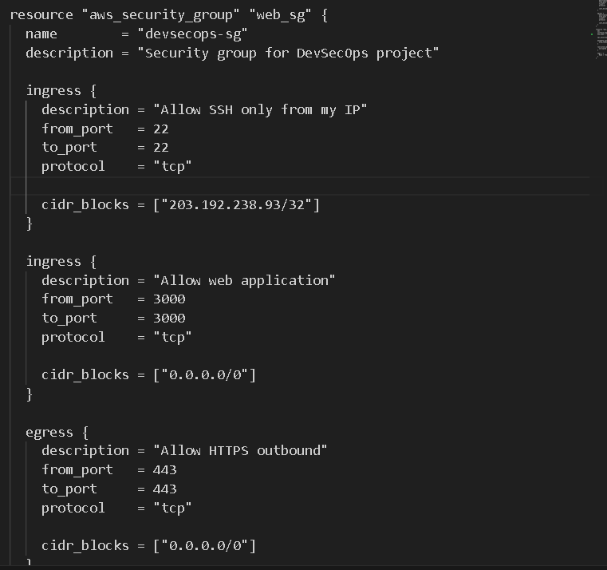
IMDSv2 enabled
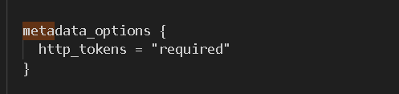
storage encryption enabled.
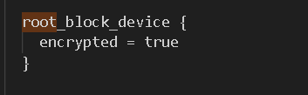

Terraform Infrastructure Plan Output
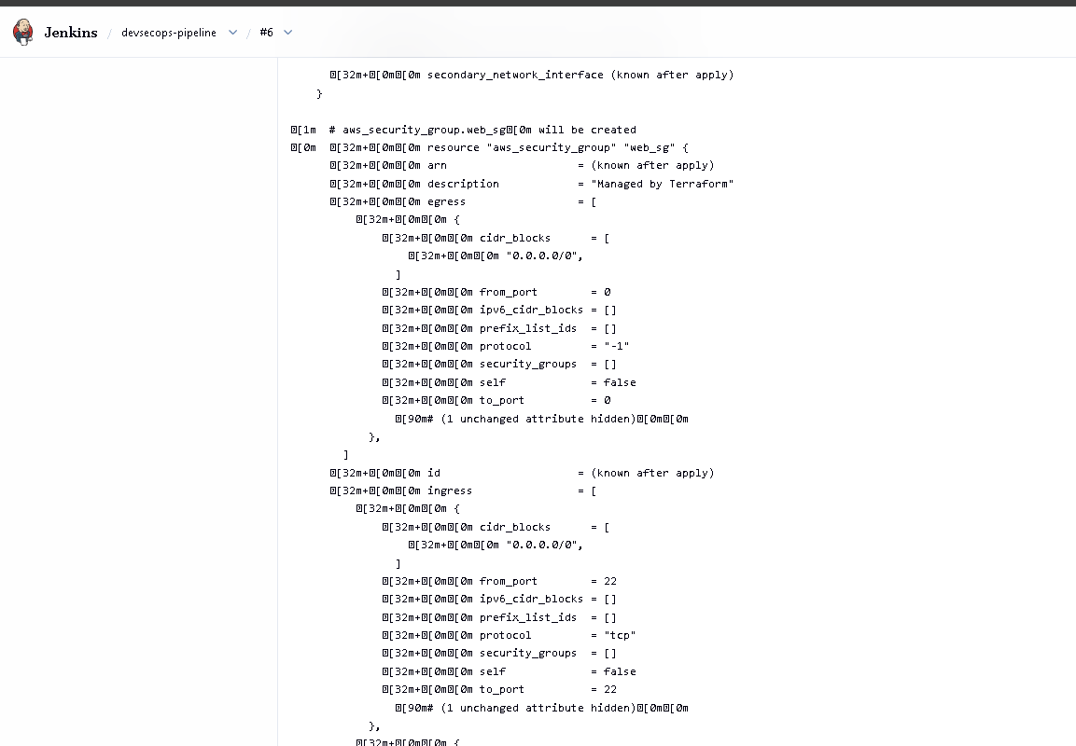
Trivy Security Scan
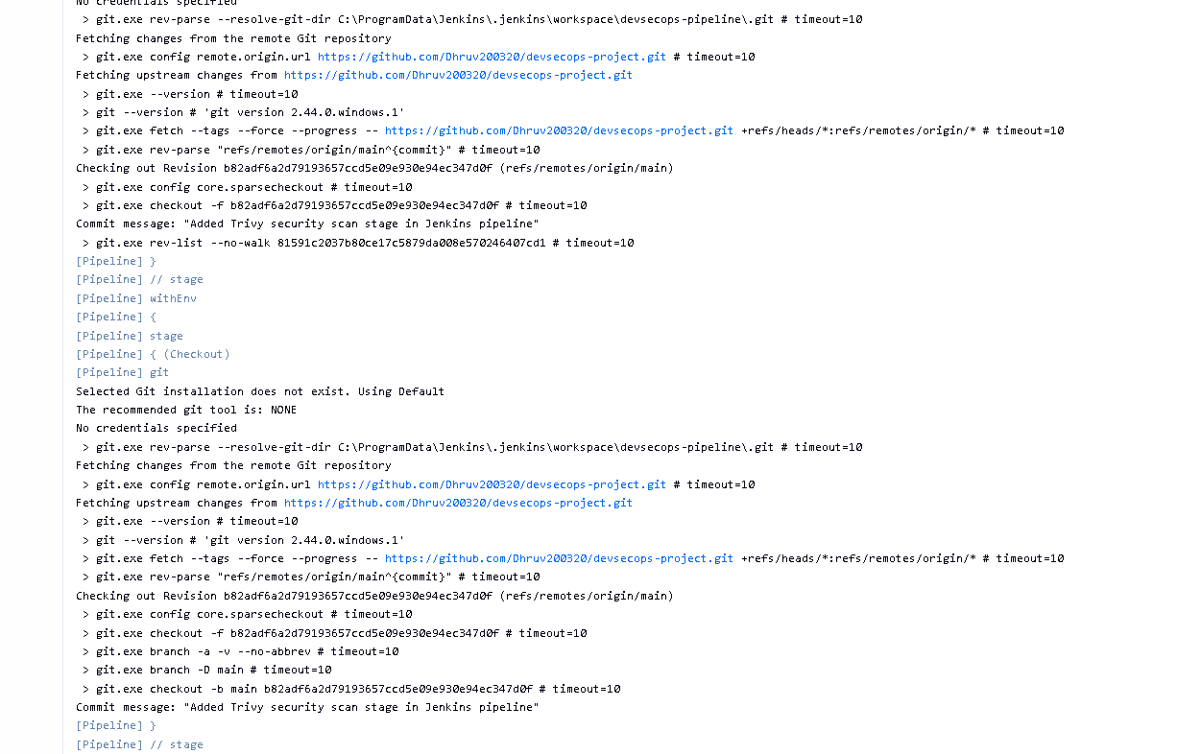
Application running on the cloud public IP
