Modelling & Simulation:
Nowadays modelling & simulation are major parts of the scientific and engineering processes, especially in industries where heavy amount of resource might get wasted due to faluty system. Same goes for Robotic industries in Agricultural.Modelling and simulation play an important role in performance analysis, and development of advanced control algorithms for robotic systems. Design, testing, and validation of robotic systems ranging from indoor mobile robots to outdoor mobile robots, articulated industrial manipulators , underwater robotic systems , and humanoid robots would be impossible without proper modelling and simulation tools. Furthermore, simulation can be used as a tool to develop virtual environments for training operators as well as an educational tool for teaching and learning basic concepts of robotic systems. Additionally, simulation provides low cost means of testing and experimentation, and makes controlling disturbances much easier compared with using real robotic systems.[a]

Along with the advancement in powerful and affordable computing technoligies in last two decades, numerous proprietary and open source robotic modelling and simulation software have been developed for robotics application. Examples of such softwares are Open Dynamics Engine (ODE), Robotic Toolbox for MATLAB, Microsoft Robotics Developer Studio (MRDS), Webots, Virtual Robot Experimentation Platform V-Rep and Gazebo. In the following table comparison of different softwares has been provided.[b]

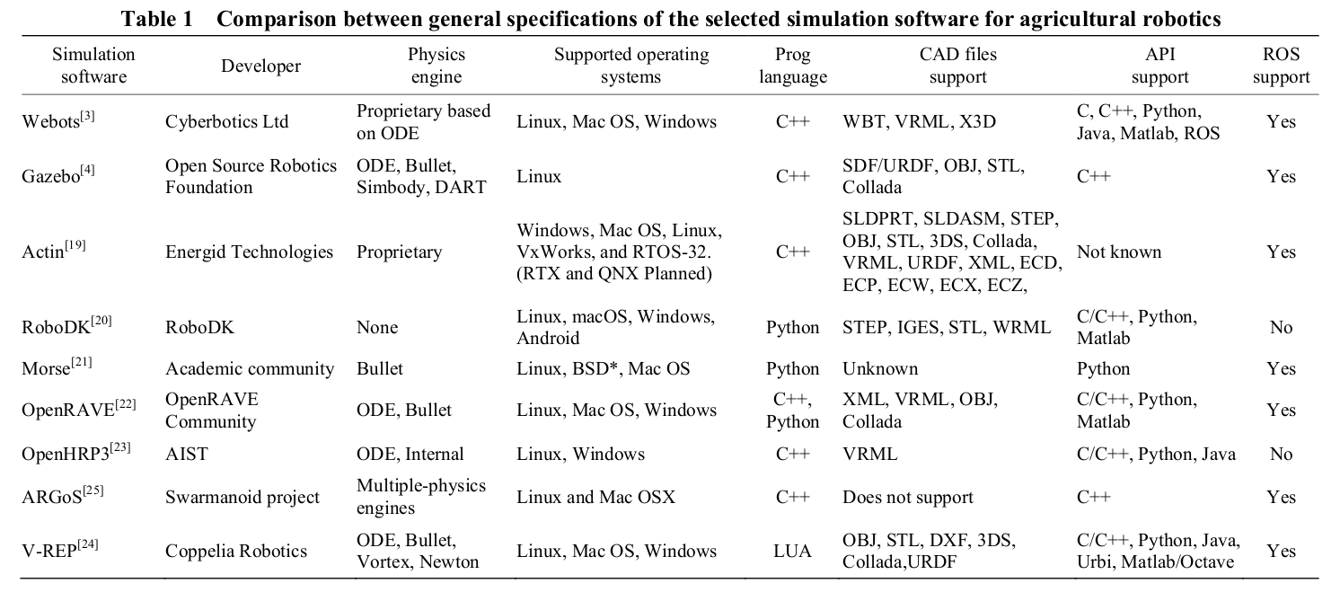
Selecting the most suitable simulation tool for a specific purpose like research, development or education can be difficult. The variety of simulation tools, features provided in above table, user-friendliness, open source support and dependency on external packages are some of the main considerations which can make it challenging to choose the most suitable robotic simulation tool.

Gazebo is a multi-robot simulation tool which has the capability of accurate and efficient simulation of a population of robots, sensors and objects in a 3 dimensional world. Gazebo generates realistic sensor feedback and has a robust physics engine to generate interactions between objects, robots and environment through URDF scripts.Furthermore, Gazebo provides high-quality gra-
phics, and suitable programmatic and graphical user interfaces. Gazebo is offered freely as a stand-alone software, but has also been packaged along with Robot Operating System (ROS) as the simulation tool. ROS was originally developed by the Stanford Artificial intelligence Laboratory in Support of the Stanford AI Robot (STAIR) project. ROS is an open source robotic middleware that
provides libraries and tools to help software developers produce robot programs. It provides hardware abstraction, device drivers, libraries, visualizers, message-passing system, package management, and more user-friendly interfaces.

Along with these ponits, Gazebo fails at several points. While it can import 3D meshes, there are no editing options, making it difficult to alter and optimize models. Moreover, Gazebo interface has a
number of issues and fails to follow established conventions. Several difficulties were noted when installing dependencies for Gazebo and for many of its third-party models. It needs high power graphics in computer. While not necessarily severe by themselves, these issues together could have a negative impact on a research project.

Many robotics research projects where Gazebo/ROS has been used widely. In this report we have taken “BoniRob” , “Rippa” and “Mario” robots for considerations. BoniRob is a public funded project, an autonomous agricultural robot that can autonomously perform repeating phenotyping tasks for individual plants. Authors have simulated robot in Gazebo and system was developed in ROS framework. It includes reliable navigation, perception system, employed sensors and
algorithms for robot[c]. MARIO - Mobile Autonomous Rover for Intelligent Operation, is a four wheels active driving/steering (4WD4S) research prototype that has been designed to be used in the agricultural environment for automation of the agricultural tasks such as data collection, monitoring and inspections. Authors have anaylised permornce and algorithms thorugh modelling and simulated environment developrd using Gazebo simulator and ROS.

[a] Modelling and simulation of a non-holonomic omnidirectional
mobile robot for offline programming and system performance
analysis

[b] Simulation software and virtual environments for acceleration of
agricultural robotics: Features highlights and performance comparison

[c] Navigation System of the Autonomous Agricultural Robot
“BoniRob”

