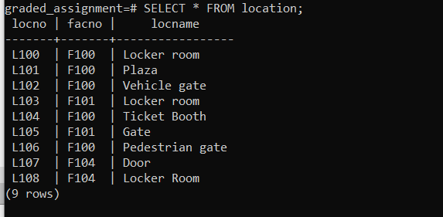

INSERT INTO location (locno, facno, locname)

VALUES ('L108', 'F104', 'Locker Room');