11/15/2022

Project

By – Real Canadian

Members:

Ajay Joshi (991651439)

Dhruvkumar Patel (991673116)

Aamir Sheth (991637060)

In this Conceptual Model we have two entities which can be classified as main entities Coach and Locations Info.

In Location Info we have relations as A location has amenities and it has a specific Name given to it corresponding to its address which is in Locations.

In Locations Name is attached with classes, Also with Work Locations but as it has the cardinality of many to many so, we create an associative entity named Coach Location.

Coach has relationship with certificate as one to many cardinality and same with reviews and refrences with one to many cardinality.

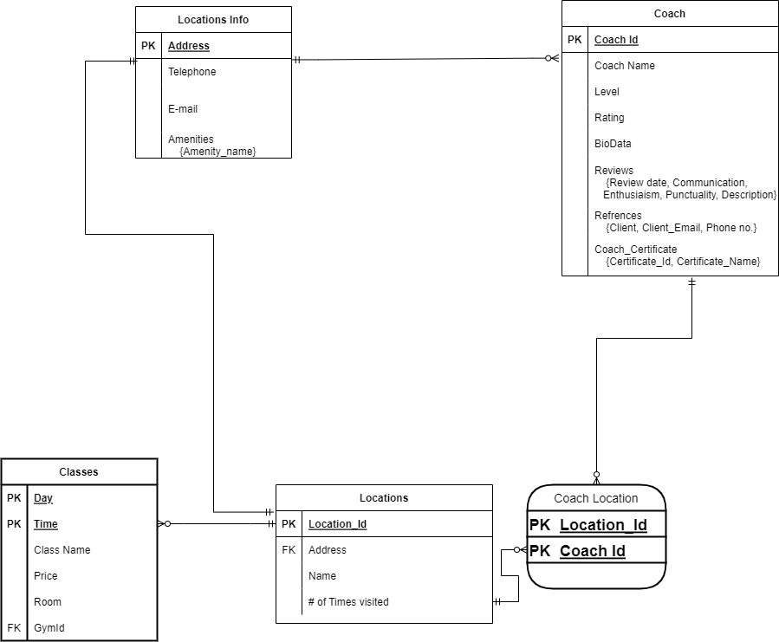

When we make the ER – Diagram we have more details as Identifier (Primary Key), Foreign Key, and other attributes.

1. Location Info has attributes such as Address as its Primary Key

Telephone and E-mail as simple attribute, and one multi-valued attribute Amenities

Locations have attributes as Primary key and foreign key Address,I

And simple attributes as Names and Times_Visited.

1. Coach entity has attributes like Coach Id as its primary key

And Coach_Name, Level, Rating and Biodata as its simple attributes.

Also, Three multi-valued Attributes named Reviews{(Review_date, Communication, Enthusiasm, Punctuality, Description)}, References {( Client, Client_Email, Phone_No)}, Coach_Certificate {(Certificate_id, Certificate_Name)}.

In Coach_Certificate Certificate_Id serves as Candidate key

And lastly, Address as foreign key (Location_Info Primary key).

Lastly, A separate entity Classes having relation with Locations with cardinality of one to many

Its attributes are Day and Time Composite Primary Key with GymId [Locations Entity (Location_Id)] as Foreign Key

And simple attributes Class Name, Price, and Room.

Next, we have the relational model of the EER diagram we have above:

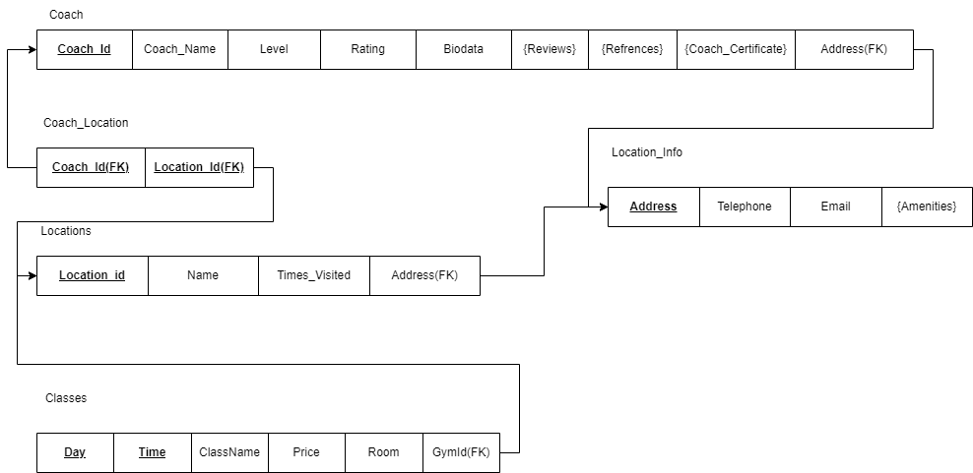

In the Relational Model we give the Subtype the same primary key as the supertype and make it a different entity.

The relations that take place are:

Coach entity is connected to Coach_Location and Location_Info.

As the cardinality between Location_Info and Coach is one to many so the foreign key is placed in Coach.

Coach_Location is an associative entity which has two Primary and Foreign key which Comes from Locations and Coach making it a composite key consisting of (**Coach_Id and Location_Id**). Location entity has its Composite Primary key consisting of **Location_Id and Address.**

**Location_Id** is also a foreign key in Classes as GymId and it has composite key as **Day and Time**.

**Address** is Primary key of Location_Info which is a foreign key to Locations entity.

**Data Structure or Normalization of relational Model**



0NF

As the relational model have Multi-Valued Attribute so it is in Oth normal form.

1NF

Therefore, we will take the multi-valued attributes as different entities. This changes its normal form to 1NF.

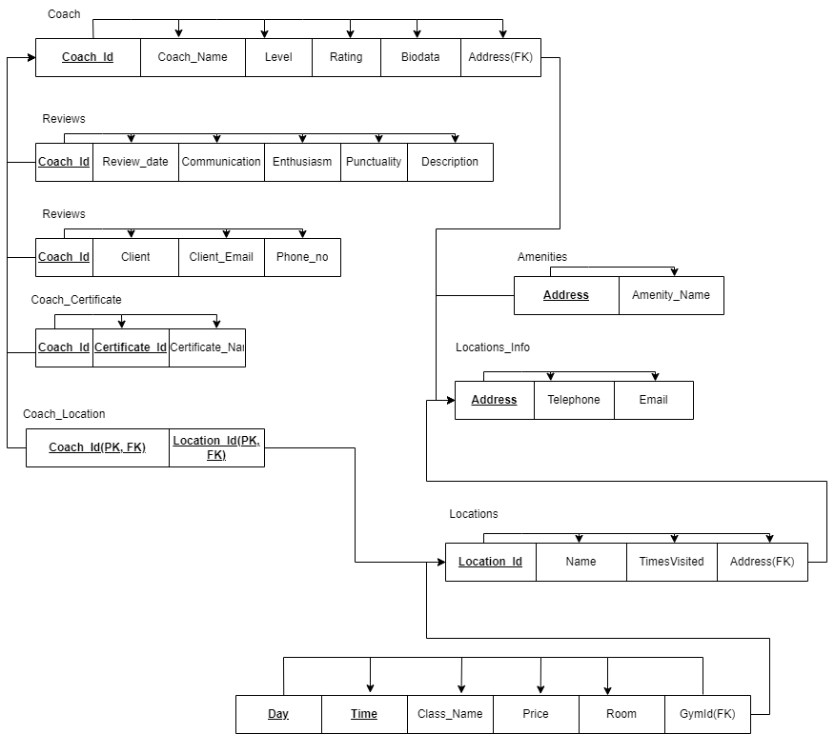

2NF

As there are no Partial Dependencies so it is in 2nd Normal Form

3NF

And finally, as there is no Transitive Dependencies, so it is in 3rd normal form as it is because it contains only Total Dependencies.