OPERATIONS ASSOCIATE
ROUND 1

Instructions
- Keep your camera on during the entirety of the test!
- Make a copy of this document and share it with the recruiter.
  - Click on 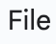 then 
  - Rename the copy to “[YOUR FULL NAME] OPERATIONS ASSOCIATE ROUND 1”
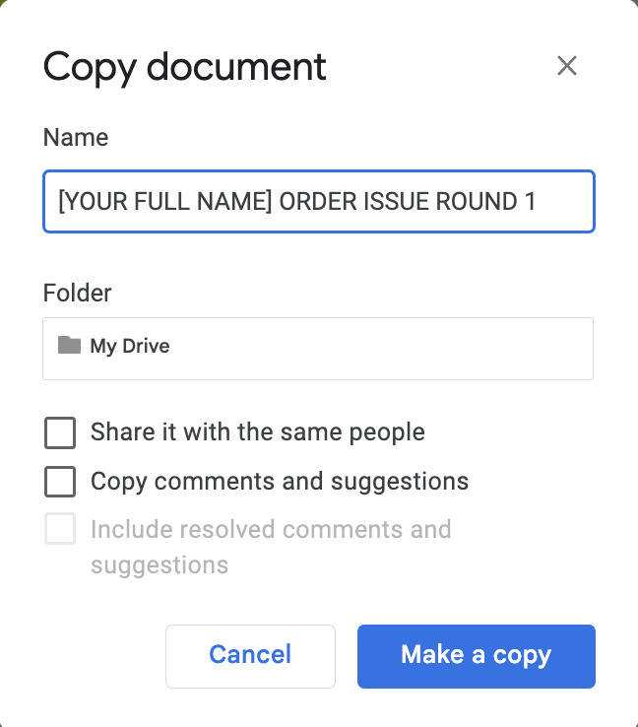
  - The new document will open automatically
  - On the new document, click 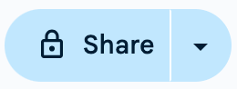
  - Click on General access -> Anyone with the link -> Done
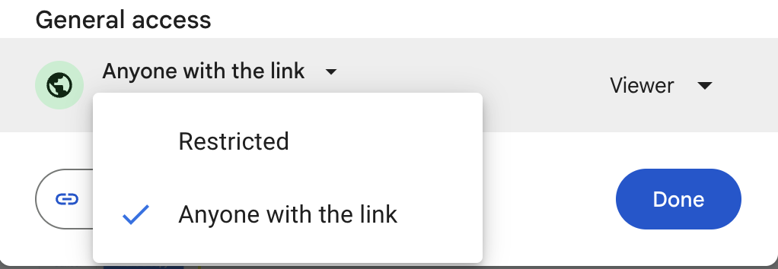
- You have 60 minutes to complete the test, make sure you answer all the questions.
- Do not use ChatGPT/AI. We're curious to get insight into your own thinking process and how you approach these tasks. (AI’s smart, but we’re smarter. We have certain AI plagiarism checks in place - so keep it original and wow us!)
- At FP, we’re not too fond of formal and corporate emails, so try and keep it casual and light while also including all the necessary details! (This DOES NOT MEAN you can ignore all sense of grammar! Make sure it reads easily and does not have any grammatical errors)
- You’ll be required to submit the test with us on the Google Form at the end of the assessment - so please make sure you submit the test there and only then drop off!

Name | :
Email ID | :
Phone Number | :

Task 1:

There was an event on Jan 10th for which the client, Katie, placed an order for 110 hoodies via our campus manager Sophia.

Here’s what they wanted:
Qty: 110
Color: Dark Grey
Design: 2 colors on the back

Here’s what they got
Qty: 105
Color: Black
Design: 2 colors on the back (exactly what they wanted)

The order was delivered to them on Jan 7th.

Katie reached out to Sophia and was extremely upset. Sophia reached out to you asking you to help her resolve this issue. What are you going to do? Please write out an email to Sophia with your resolution to this and give her direction on how she should respond to Katie.

Candidate’s Answer:

Task 2:

Rewrite the following email to present the same information in a clearer and easy to follow way.

Hey Jose!

For PO #50000, there are 6 items on the order. Items A and B have the same design on the front. Items C and E have the same design on the front. Items D and F have the same back design. Items A and C have the same back design. Items B and E have the same back design. Items D and F have different front designs compared to all other items. Also, the blanks for this order are reaching you in 4 different parts. For Item A, B and C, except for XXL size garments, everything else will be delivered on 5/7. For Item A, B and C, XXL size garments will reach you on 5/9. For Item D and E, the blank garments will reach you on 5/10. For Item F, the garment will reach you on 5/11. I’m attaching tracking for each item here. I’ll let you know if any updates and lmk if you have any questions!

Candidate’s Answer:

Task 3:

A campus manager (sales team) wrote to the logistics team saying the following:

Hi!

A client told me South by Sea offers free banners for bid day t-shirt orders. What can I offer the client to be more competitive? Thank you in advance!

Sam

Another associate responded with:

Hey Sam!

Hope you are doing great!

Can you share a proof of quote for the banner the competitor is offering for reference?

With that being said, I found a great option for the banners that you can have a look at. We can do them for $55 each. They are fully customizable and can be printed however you’d like! Also, it has a minimum order quantity of 1! The turnaround time for them is 3 weeks.

Lmk if this works and if you have any further questions :)

Best,
–
Gautam

What is wrong with this response? If you were responding to Sam’s email, how would you respond to her? Write your response.

Candidate’s answer:

Task 4:

Problem:

One of our top sororities has placed a large order for customized varsity jackets. The supplier for these jackets has just informed you that they won't be able to deliver on time, and the order is due in two weeks. This delay could jeopardize the entire order, which is critical for the event.

In a 3-4 minute video, explain how you would handle this situation and resolve the issue.

Note: Be clear, concise, and focus on practical, real-world solutions. We’re looking for your ability to adapt to unforeseen challenges and manage time-sensitive situations.

How to answer Task 4:

- Sign up on Vidyard using your Google Account.
- Click on Record Video → Camera → Start Recording
- Once you are done answering, stop the recording and wait for a few minutes until your video is processed
- Click on Share Link → Copy Link → Submit it on the Google Form below

OR

- If Vidyard does not work for you, you can use Scre.io or Loom to record your video
- Login using your Google Account → Start Recording → Download the Video once the recording is made
- Upload the downloaded file on Google Drive
- Copy link to video → Submit it on the Google Form below

Submit your test document and video resolution here: Google Form

