IOTA
Digital Product Passport Application

Technical Architecture & Project Documentation

Document Type  Architecture & Technical Report | Version  1.0.0 — May 2026
Domain  Aerospace / Blockchain / DApp | Network  IOTA EVM Testnet / IPFS

Table of Contents

Table of Contents 1
Section 1: Project Overview 1
1.1 Introduction & Vision 1
1.2 Objectives 1
1.3 Technology Stack 1
1.4 Data Model & Metadata Schema 1
1.5 Physical Asset Lifecycle Stages 1
1.6 Directory Structure & Component Roles 1
Section 2: Architecture Diagrams 1
2.1 Class Diagram — Component & Hook Structure 1
2.2 Component Diagram — System Boundaries & Interfaces 1
2.3 Deployment Diagram — Infrastructure Topology 1
2.4 Object Diagram — NFT Instance in Memory 1
2.5 Package Diagram — Codebase Dependency Graph 1
2.6 Composite Structure & Profile Diagram — Web3 Context 1
2.7 Use Case Diagram — Actor Interactions 1
2.8 Activity Diagram — Mint Equipment Workflow 1
2.9 State Machine Diagram — Asset Lifecycle 1
2.10 Sequence Diagram — Transaction Timeline 1
2.11 Communication Diagram — Message Network Topology 1
2.12 Timing Diagram — Latency Profile 1
2.13 Application Logic Flowchart — Initialization Flow 1
2.14 C4 Model — Context & Container View 1
2.15 Architecture Pattern — Fat Client / dApp Model 1
Section 3: Scope of Project 1
3.1 Current Scope — What Is Built 1
3.2 Explicit Exclusions — Out of Current Scope 1
3.3 Technical Constraints & Assumptions 1
Section 4: Future Work & Roadmap 1
4.1 Tier 1 — High Priority (Production Readiness) 1
4.1.1 Smart Contract Role-Based Access Control (RBAC) 1
4.1.2 Lifecycle State Enforcement on Smart Contract 1
4.1.3 Event Indexing & Full History Dashboard 1
4.1.4 WalletConnect & Multi-Wallet Support 1
4.2 Tier 2 — Medium Priority (Feature Completeness) 1
4.2.1 NFT.storage Migration & Decentralized Storage Strategy 1
4.2.2 QR Code & Physical-Digital Binding 1
4.2.3 Multi-Signature Governance for Critical Actions 1
4.2.4 PDF Certificate Generation & Off-Chain Attestations 1
4.3 Tier 3 — Long-Term Vision (Ecosystem Scale) 1
4.3.1 Cross-Chain Interoperability 1
4.3.2 AI-Powered Predictive Maintenance Integration 1
4.3.3 EU Digital Product Passport Regulation Compliance 1
4.3.4 Tokenization & Carbon Credit Integration 1
4.4 Suggested Output — Production System Blueprint 1
Section 5: Conclusion 1
References & Further Reading 1

Section 1: Project Overview

1.1 Introduction & Vision
The iota-dpp-app is a sophisticated, fully decentralized application (dApp) purpose-built to govern and manage Digital Product Passports (DPPs) for high-value, safety-critical manufactured components. At its core, the application functions as an immutable, on-chain ledger that chronicles the complete life history of a physical asset — from the moment superalloy raw materials are received at an investment casting foundry, all the way through active service in a jet engine, and ultimately to end-of-life decommissioning.

The primary use case demonstrated by this application is the lifecycle tracking of an Aerospace Turbine Blade. This choice is deliberate: turbine blades represent one of the most demanding engineering challenges in the world, operating under extreme thermal and mechanical loads. Their traceability, provenance, and maintenance history are not merely commercial concerns — they are direct safety imperatives governed by international aviation authorities such as the FAA (Federal Aviation Administration) and EASA (European Union Aviation Safety Agency).

🎯 Core Problem Statement
Traditional aerospace supply chains rely on fragmented, paper-based or siloed digital records that are difficult to verify, prone to forgery, and easily lost during ownership transfers. The iota-dpp-app replaces this fragile system with a cryptographically secured, decentralized truth — where every event in a component's life is permanently anchored to the blockchain and verifiable by any authorized party.

1.2 Objectives
- Immutability: Ensure that no historical record of a turbine blade can be altered or deleted once committed on-chain.
- Transparency: Allow any stakeholder (OEMs, MRO shops, regulators, auditors) to independently verify a component's full history.
- Decentralization: Eliminate single points of failure by distributing both metadata (IPFS/Filecoin) and state (IOTA EVM) across independent networks.
- Digital Twin Binding: Tie the physical component to its NFT-based digital twin, ensuring the on-chain record and the physical part are inseparably linked.
- Composability: Support hierarchical Bills of Materials (BOMs) by enabling sub-component NFTs that are on-chain children of parent equipment tokens.

1.3 Technology Stack
Technology / Tool | Role & Justification
React 19 (TypeScript) | Primary frontend framework. TypeScript enforces strict typing across all Web3 data structures (ABIs, transaction receipts, wallet addresses), preventing runtime errors in safety-critical flows.
Tailwind CSS | Utility-first CSS framework enabling rapid, dark-mode optimized UI construction without custom stylesheet overhead.
ethers.js v6 | The industry-standard JavaScript library for Ethereum-compatible blockchain interaction. Handles RPC communication, ABI encoding/decoding, transaction signing, and receipt parsing.
NFT.storage (IPFS + Filecoin) | Provides persistent, decentralized storage for JSON metadata. Metadata pinned to IPFS is content-addressed — the CID changes if the content changes, ensuring integrity.
IOTA EVM Testnet | An EVM-compatible layer on the IOTA network. Chosen for its feeless (or very low-fee) transaction model, making frequent lifecycle update transactions economically viable.
lucide-react | Lightweight SVG icon library for a consistent, accessible UI icon system.
react-hot-toast | Provides non-blocking toast notifications that elegantly communicate asynchronous transaction states (uploading, awaiting signature, mining, confirmed, error).
MetaMask (EIP-1193) | The browser extension wallet used for transaction signing. The app communicates with MetaMask via the EIP-1193 provider interface injected into window.ethereum.

1.4 Data Model & Metadata Schema
Every Digital Product Passport is represented by two inseparable layers of data: an on-chain ERC-721 NFT record stored on the IOTA EVM, and an off-chain JSON metadata object pinned to IPFS. The JSON schema is deeply structured to accommodate the full complexity of an aerospace component's lifecycle:

"name": "Turbine Blade #<tokenId>"
"description": "Investment Cast Aerospace Turbine Blade – Digital Product Passport on IOTA"
"serialNumber": "CLX-2026-<tokenId>"
"manufacturer": "Foundry ABC"
"materialBatch": "IN718-HEAT-45678"
"heatNumber": "HT-2026-089"
"currentLifecycleStage": "ManufacturingAndInspection"
"manufacturing": { "processHistory": [], "ndTReports": [], "qAReports": [] }
"supplyChain": { "ownershipHistory": [], "vendors": {} }
"customerLevel": { "warrantyInfo": {}, "lifeOfPart": {} }
"latestNotarizationHash":"0x0000...0000"

A critical design principle governs all metadata updates: every mutation creates a brand-new IPFS CID, and an on-chain transaction updates the tokenURI pointer. This means the entire history of metadata changes is preserved in the immutable audit trail of blockchain transactions — even if IPFS nodes are eventually unpinned, the hashes remain on-chain as forensic evidence.

1.5 Physical Asset Lifecycle Stages
The application is architected around seven discrete lifecycle stages, each mapping precisely to a real-world supply chain checkpoint for aerospace components:

Stage | Description & Real-World Context
1. Raw Material | Superalloy ingots (e.g., Inconel 718 — a nickel-chromium alloy capable of withstanding temperatures above 700°C) are received at the foundry. Heat numbers are logged for full material traceability.
2. Manufacturing & Inspection | The wax pattern is created, ceramic shell built, wax burned out, molten alloy poured, cooled, and the shell removed (knockout). Each step can be recorded as a distinct Process Step on-chain.
3. Quality Assurance | Dimensional inspection, X-ray fluoroscopy, fluorescent penetrant inspection (FPI), and other Non-Destructive Testing (NDT) methods are performed. Certificates are linked in the metadata.
4. Supply Chain | The blade is shipped from the foundry to the engine OEM (Original Equipment Manufacturer). Ownership transfer events are recorded on-chain, providing a verifiable custody chain.
5. In Service | The blade is installed in a turbine engine and begins accumulating flight cycles. Cycle count and environmental exposure data can be appended to the metadata.
6. Maintenance | During scheduled MRO (Maintenance, Repair, and Overhaul), the blade may undergo recoating, tip restoration, or thermal barrier repair. Each maintenance action is a permanent on-chain record.
7. End of Life | The blade is decommissioned based on life limits (flight hours or cycles), damage beyond repair limits, or regulatory mandate. On-chain decommissioning ensures the part cannot be fraudulently reintroduced into service.

1.6 Directory Structure & Component Roles
The source code is organized following a strict separation of concerns, isolating UI presentation from complex Web3 business logic:

File / Directory | Role
src/App.tsx | Root component: manages active modal states, token ID input, and bridges the UI layer to the useContract hook.
src/components/Header.tsx | Wallet connection bar: shows connected address, network badge, and disconnect button.
src/components/ConnectPrompt.tsx | Full-screen gate shown when no wallet is connected, guiding the user to connect MetaMask.
src/components/ActionCard.tsx | Reusable, color-coded card component for each DPP capability (Mint, Transfer, etc.).
src/components/Modal.tsx | Dynamic form renderer: auto-generates input fields based on the selected action configuration.
src/components/TokenIdBar.tsx | Primary identifier input — the token ID that all DPP operations act upon.
src/hooks/useWallet.ts | MetaMask lifecycle management: account connection, network verification (Chain ID 1076), and chain-switching RPC calls.
src/hooks/useContract.ts | Core Web3 logic: wraps all smart contract write functions, orchestrates IPFS uploads, and parses on-chain revert errors into human-readable messages.
src/contractABI.ts | ABI definition file that enables ethers.js to encode and decode transactions targeting the deployed Solidity contract.
src/constants.ts | Centralized config: RPC URL, Chain ID, contract address, and NFT.storage API key placeholder.

Section 2: Architecture Diagrams

This section presents a comprehensive suite of diagrams covering structural, behavioral, and high-level architectural perspectives of the IOTA DPP application. Each diagram is accompanied by a detailed explanation of its purpose, what it depicts, and how to interpret it within the context of the application.

2.1 Class Diagram — Component & Hook Structure
Purpose: The class diagram captures the static, code-level architecture of the application. It defines the primary React components and custom hooks, along with their key state variables (attributes) and callable functions (methods). More importantly, it illustrates the relationships between these entities — specifically which components are composed into the App root and which hooks the App delegates to for business logic.

📊 Class Diagram — React Components & Custom Hooks
Shows the attributes, methods, and relationships of all major application classes
classDiagram
class App {
+string tokenId
+ModalKey activeModal
+boolean loading
+openModal()
+closeModal()
+handleConfirm()
}
class Header {
+string account
+boolean connecting
+onConnect()
+onDisconnect()
}
class ActionCard {
+Icon icon
+string title
+onClick()
}
class Modal {
+string title
+Field[] fields
+onConfirm()
+onClose()
}
class useWallet {
+string account
+JsonRpcSigner signer
+connect()
+disconnect()
}
class useContract {
+mintEquipment()
+mintPart()
+updateMetadata()
+recordProcessStep()
}
App *-- Header
App *-- ActionCard
App *-- Modal
App ..> useWallet : uses
App ..> useContract : uses
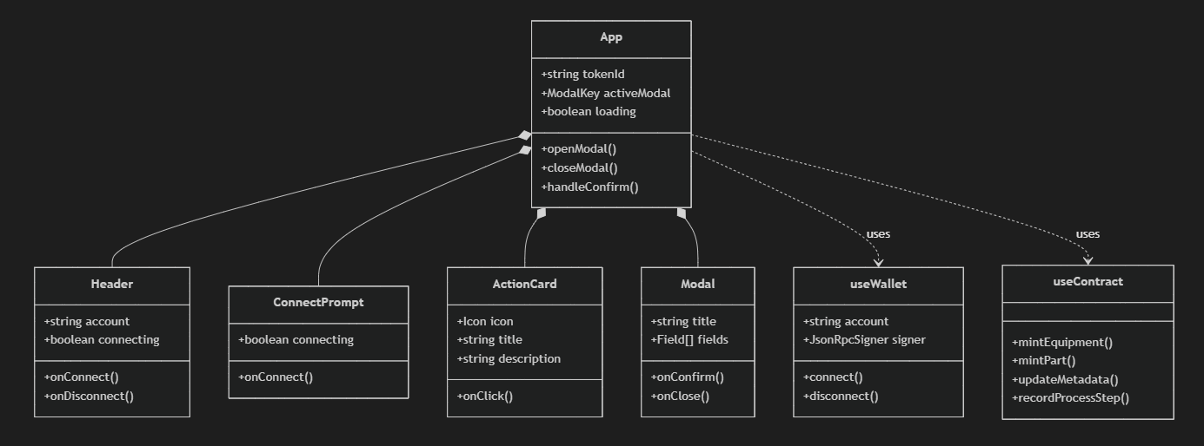
Key Relationships Explained:
- Composition (App *-- Header / ActionCard / Modal): The App component directly owns and renders these child components. When App unmounts, these children are destroyed. This models the React parent-child rendering tree.
- Dependency (App ..> useWallet / useContract): App depends on these hooks at runtime but does not "own" them in the OOP sense. The hooks manage their own internal state via React's useState and useEffect primitives.
- useWallet provides the signer to useContract: The JsonRpcSigner object obtained from MetaMask (via useWallet) is passed to useContract, allowing it to sign and broadcast transactions. This is the critical authentication handshake between the UI and the blockchain.

💡 Design Pattern Note
The architecture follows the Custom Hooks pattern popularized in React 16.8+. By separating Web3 state management into useWallet and useContract, the codebase achieves a clean separation of concerns — UI components remain stateless and testable, while all blockchain complexity is contained in hooks.

2.2 Component Diagram — System Boundaries & Interfaces
Purpose: While the class diagram focuses on code-level detail, the component diagram zooms out to show how the high-level system components interact through defined interfaces. This is critical for understanding the architectural boundaries between what runs in the user's browser (the React SPA) and what is accessed over the network (decentralized infrastructure).

📊 Component Diagram — Frontend App vs External Networks
Illustrates system boundaries between the React frontend, IPFS, and the IOTA blockchain
flowchart TB
subgraph Frontend ["Frontend Application (Browser)"]
UI["UI Components (React)"]
Hooks["Business Logic (Hooks)"]
end

subgraph External ["External Decentralized Networks"]
IPFS["NFT.storage / IPFS"]
IOTA["IOTA EVM Smart Contract"]
end

UI -->|"Calls Functions"| Hooks
Hooks -->|"Uploads JSON via HTTPS POST"| IPFS
Hooks -->|"Sends Transactions via Ethers.js"| IOTA

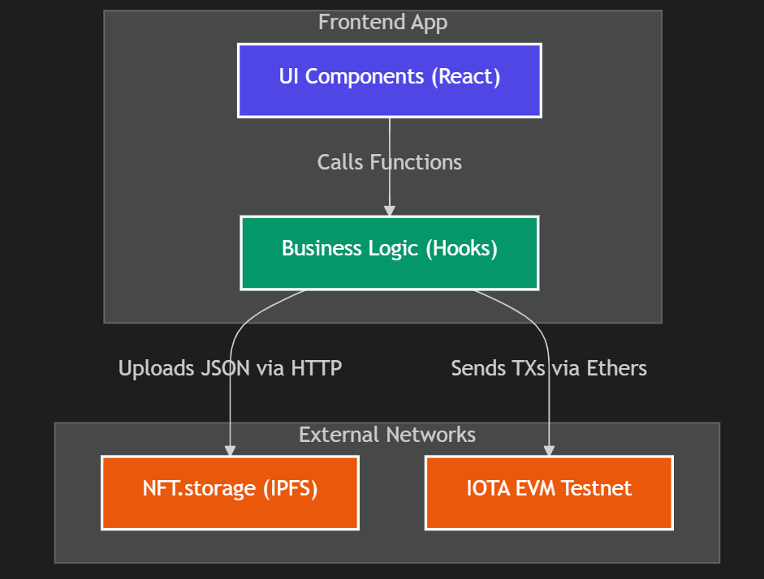
Component Interaction Analysis:
- UI Components → Hooks: The React component tree makes function calls (e.g., mintEquipment(tokenId)) to the hook layer. React's prop drilling or context passing is used to thread hook functions down to the appropriate UI elements.
- Hooks → IPFS (NFT.storage): Before any blockchain transaction is dispatched, the hook serializes the current metadata JSON object and makes a standard HTTPS POST request to the NFT.storage REST API. The response is a CID (Content Identifier) — a cryptographic hash of the data that serves as the permanent address of that metadata on the IPFS network.
- Hooks → IOTA EVM: Armed with the CID, the hook constructs an ethers.js transaction targeting the deployed Solidity smart contract. This transaction is sent to the IOTA EVM node via JSON-RPC, requesting MetaMask to sign it first.

🔗 Why Two External Networks?
Storing metadata entirely on-chain would be prohibitively expensive and technically infeasible for large JSON objects. The IPFS-on-chain-pointer pattern (sometimes called 'lazy loading' for NFTs) stores only the immutable CID on-chain (cheap, permanent) while the full metadata lives on IPFS (cheap, content-addressed). The IOTA EVM's low-fee architecture further reduces the economic barrier of frequent metadata updates.

2.3 Deployment Diagram — Infrastructure Topology
Purpose: The deployment diagram maps software artifacts to the physical or virtual infrastructure nodes they run on. For a Web3 dApp, this is especially important because the 'backend' is not a traditional server — it is a globally distributed blockchain network and a content-addressed peer-to-peer storage network.

📊 Deployment Diagram — Infrastructure Nodes & Communication Protocols
Maps all software components to their respective infrastructure environments
flowchart TD
subgraph UserEnvironment ["User Environment (Client Device)"]
Browser["Web Browser — React SPA (JavaScript Bundle)"]
MetaMask["MetaMask Browser Extension (Key Manager)"]
end

subgraph WebServer ["Hosting Layer"]
CDN["Static Web Host — Vercel / Netlify (CDN-distributed)"]
end

subgraph DecentralizedNetworks ["Decentralized Infrastructure"]
IOTA_RPC["IOTA EVM RPC Node (JSON-RPC over HTTPS)"]
IPFS_Node["IPFS / Filecoin Node (NFT.storage REST API)"]
end

Browser -->|"HTTPS: Fetches JS/CSS/HTML Assets"| CDN
Browser <-->|"EIP-1193: window.ethereum API"| MetaMask
MetaMask <-->|"JSON-RPC: eth_sendTransaction, eth_call"| IOTA_RPC
Browser -->|"HTTPS REST API: storeBlob(JSON)"| IPFS_Node
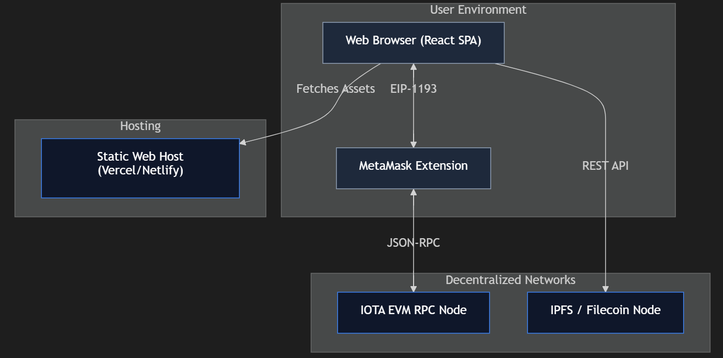
Infrastructure Node Breakdown:
- Web Browser (React SPA): The entire application runs client-side. There is no traditional application server. The JavaScript bundle (compiled TypeScript) is downloaded once from the CDN and executes entirely in the browser's V8 engine.
- MetaMask Extension: Acts as a secure hardware-separated key management layer. Private keys never leave MetaMask — the extension signs transaction payloads locally and sends only the signed transaction to the RPC node.
- Static Web Host (Vercel/Netlify): Hosts the compiled React build artifacts (HTML, CSS, JS chunks). A CDN distributes these assets globally, minimizing load time. No server-side logic is required — this dramatically reduces hosting costs and attack surface.
- IOTA EVM RPC Node: The gateway to the IOTA blockchain network. The application sends JSON-RPC method calls (eth_sendRawTransaction, eth_call, eth_getTransactionReceipt) to this node to read and write blockchain state.
- IPFS / Filecoin Node: NFT.storage provides an enterprise-grade API that pins uploaded data to both the IPFS network and Filecoin for long-term persistence. Once pinned, the content is addressable by its CID from any IPFS node globally.

2.4 Object Diagram — NFT Instance in Memory
Purpose: The object diagram depicts specific instances of classes at a particular point in time. It answers the question: 'What does a single Turbine Blade DPP actually look like in memory when it is loaded?' This is invaluable for developers who need to understand the concrete shape of runtime data before writing code that consumes it.

📊 Object Diagram — Turbine Blade Token #1 Instance
Depicts a concrete NFT instance and its resolved IPFS metadata at runtime
classDiagram
class TurbineBlade_Token1 {
<<NFT Instance — IOTA EVM>>
tokenId: 1
owner: "0xAbC...def123"
tokenURI: "ipfs://bafyreighf3..."
}

class Metadata_IPFS_bafyreigh {
<<JSON Object — IPFS>>
name: "Turbine Blade #1"
serialNumber: "CLX-2026-1"
manufacturer: "Foundry ABC"
heatNumber: "HT-2026-089"
currentLifecycleStage:"ManufacturingAndInspection"
materialBatch: "IN718-HEAT-45678"
lastUpdated: "2026-05-06T10:00:00.000Z"
}

TurbineBlade_Token1 --> Metadata_IPFS_bafyreigh : tokenURI resolves to
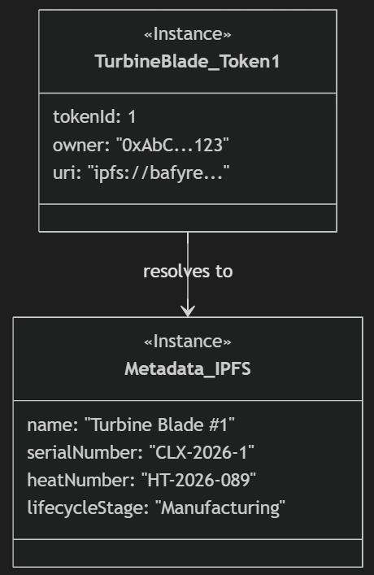
Reading the Object Diagram:
- TurbineBlade_Token1 (on-chain): This represents the ERC-721 token slot in the Solidity smart contract's storage. The tokenId is the unique on-chain identifier. The owner is an Ethereum address — the current custodian of the digital passport. The tokenURI is a pointer to the IPFS CID.
- Metadata_IPFS_bafyreigh (off-chain): This represents the actual JSON document stored on IPFS. Its CID (bafyreigh...) is deterministically derived from its content — if any single byte changes, the CID changes completely, making tampering cryptographically detectable.
- The Resolution Arrow: When a DApp or indexer calls the tokenURI() function on the contract and then fetches the returned IPFS URL, it traverses this relationship — moving from on-chain state to off-chain metadata.

2.5 Package Diagram — Codebase Dependency Graph
Purpose: The package diagram illustrates the dependency relationships between folders and modules within the codebase. It is essential for understanding which parts of the code depend on which other parts, preventing circular dependencies and helping developers understand the impact radius of any change.

📊 Package Diagram — Module Dependency Graph
Shows how source packages and modules depend on each other within /src
flowchart LR
Root["/src (Root Package)"]
Components["/src/components (UI Package)"]
Hooks["/src/hooks (Logic Package)"]
Constants["/src/constants.ts (Config Module)"]
ABI["/src/contractABI.ts (ABI Module)"]
AppTSX["/src/App.tsx (Entry Point)"]

Root --> AppTSX
Root --> Components
Root --> Hooks
Root --> Constants
Root --> ABI

AppTSX --> Components
AppTSX --> Hooks

Hooks --> Constants
Hooks --> ABI

Components -.->|"No direct dependency"| Hooks

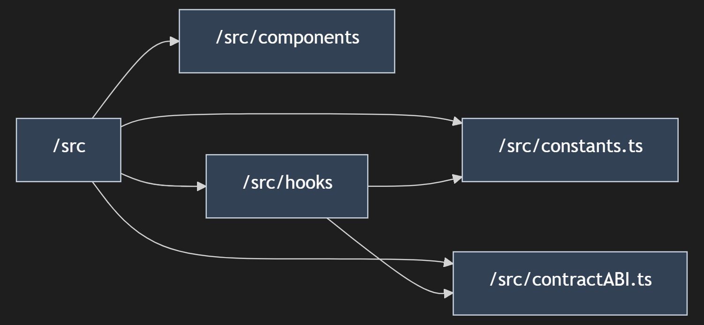
Dependency Analysis:
- App.tsx is the hub: It imports from both components/ and hooks/, acting as the integration layer that wires UI to logic.
- Hooks depend on Constants and ABI: Both useWallet.ts and useContract.ts require the network configuration (constants.ts) and the smart contract interface (contractABI.ts) to function. This makes constants.ts a foundational, low-level module.
- Components are logic-agnostic: The UI components in components/ do NOT directly import hooks. They receive data and callbacks via props from App.tsx. This deliberate design makes components independently testable and reusable.
- ABI is a leaf node: contractABI.ts has no internal imports — it is a pure data file. This is correct architectural practice, as ABIs are static contract interface definitions.

2.6 Composite Structure & Profile Diagram — Web3 Context
Purpose: The composite structure diagram reveals the internal wiring of the App.tsx component — specifically how it manages its own state, the React rendering tree, and the Web3 provider context. The stereotype annotations (using «guillemet» notation) signal domain-specific roles, customizing the standard component model for the Web3 domain.

📊 Composite Structure — App.tsx Internal Architecture
Reveals internal component wiring and the Web3 provider context stereotype
flowchart TD
subgraph AppComposite ["«ReactComponent» App.tsx"]
State["«State» TokenID & Modal"]

subgraph Web3Context ["«Web3ProviderContext» Wallet & Contract Layer"]
Wallet["«CustomHook» useWallet — Account, Signer"]
Contract["«CustomHook» useContract — Write Functions"]
end

View["«RenderTree» Header + ActionCards + Modal"]
end

Wallet -.->|"provides signer"| Contract
State -->|"drives"| View
Contract -->|"exposes actions to"| View
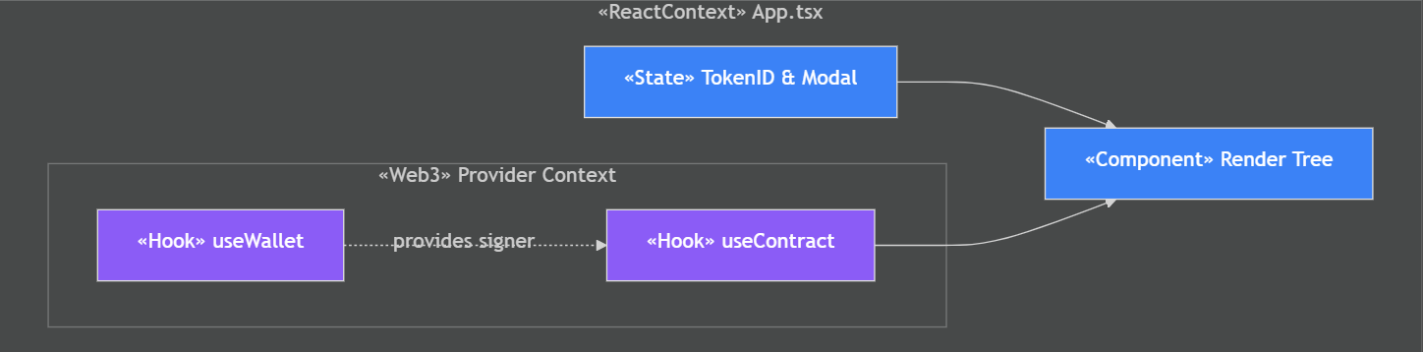
Internal Wiring Explanation:
- State drives View: The tokenId string and activeModal enum stored in App.tsx's useState dictate which modal is open and which token is being acted upon. React's reactive model ensures the View re-renders automatically when state changes.
- Wallet provides Signer to Contract: useWallet exposes the JsonRpcSigner — the authenticated MetaMask session. useContract receives this signer as a parameter to construct ethers.Contract instances that can sign transactions.
- Contract exposes actions to View: The functions returned by useContract (mintEquipment, transferOwnership, etc.) are passed as props through App.tsx down to the Modal component, which calls them on form submission.

2.7 Use Case Diagram — Actor Interactions
Purpose: The use case diagram provides a high-level functional view of the system from the perspective of its actors. It communicates — in non-technical terms — what the system enables its users to do. It is the primary artifact for stakeholder communication and requirements validation.

📊 Use Case Diagram — Foundry Worker Interactions
Depicts the primary actor (Foundry Worker) and all system capabilities they can invoke
flowchart LR
Actor(("Foundry / MRO Worker"))

subgraph DPP_System ["DPP Management System"]
UC1(["Connect Wallet"])
UC2(["Mint Equipment NFT"])
UC3(["Mint Sub-Part NFT"])
UC4(["Update Metadata / IPFS CID"])
UC5(["Record Process Step"])
UC6(["Record Maintenance Event"])
UC7(["Transfer Ownership"])
end

Actor --> UC1
Actor --> UC2
Actor --> UC3
Actor --> UC4
Actor --> UC5
Actor --> UC6
Actor --> UC7
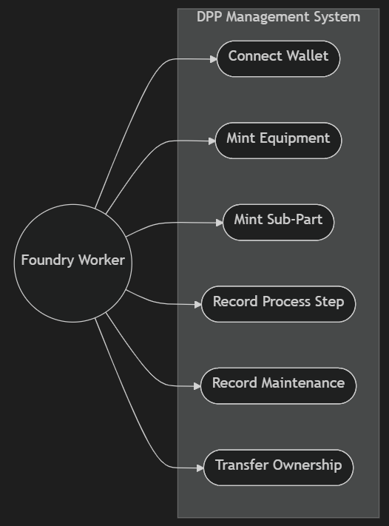
Actor & Use Case Breakdown:
- Actor — Foundry / MRO Worker: The primary human actor. This role could be a quality engineer at the casting foundry, a logistics coordinator managing shipments, or an MRO technician performing maintenance. The system does not currently differentiate between these roles — access control is governed by wallet address and on-chain ownership.
- Connect Wallet (prerequisite): All other use cases are gated behind wallet connection. The app renders a full-screen ConnectPrompt until an Ethereum-compatible wallet (MetaMask) is connected to the IOTA EVM Testnet.
- Mint Equipment NFT: Creates the root token representing the primary turbine blade assembly. This is the genesis event for the entire DPP lifecycle.
- Mint Sub-Part NFT: Creates a child token for a sub-component (e.g., a cooling channel insert) and links it on-chain to the parent equipment token. This builds the hierarchical Bill of Materials.
- Update Metadata / IPFS CID: Triggers a re-pin of modified JSON metadata to IPFS and updates the on-chain tokenURI pointer. Used whenever non-process fields (warranty, lifecycle stage, etc.) are changed.
- Record Process Step / Maintenance: Appends structured event records directly to smart contract state, creating an on-chain process log that is distinct from the IPFS metadata.
- Transfer Ownership: Executes the standard ERC-721 transferFrom function, atomically changing the on-chain owner and recording the new custodian's details.

2.8 Activity Diagram — Mint Equipment Workflow
Purpose: The activity diagram models the detailed step-by-step workflow of the most critical use case: minting a new Equipment NFT. It explicitly shows decision branches (validation failure, IPFS failure, user rejection) and async waiting states, making it invaluable for error handling design and UX flow planning.

📊 Activity Diagram — Mint Equipment Transaction Workflow
Models the sequential steps, decision branches, and async waiting states of the Mint Equipment flow
stateDiagram-v2
[*] --> ClickMint : User clicks "Mint Equipment"
ClickMint --> ValidateInput : Validate Token ID format
ValidateInput --> UploadIPFS : Input is valid
ValidateInput --> ShowError : Input invalid (empty/non-numeric)
ShowError --> [*]

UploadIPFS --> SignTransaction : IPFS CID received successfully
UploadIPFS --> ShowError : NFT.storage API error

SignTransaction --> AwaitConfirmation : User approves in MetaMask
SignTransaction --> ShowError : User rejects (MetaMask cancel)

AwaitConfirmation --> Success : Transaction mined & confirmed
AwaitConfirmation --> ShowError : Transaction reverted (contract error)
Success --> [*] : Display "Mint Successful" toast
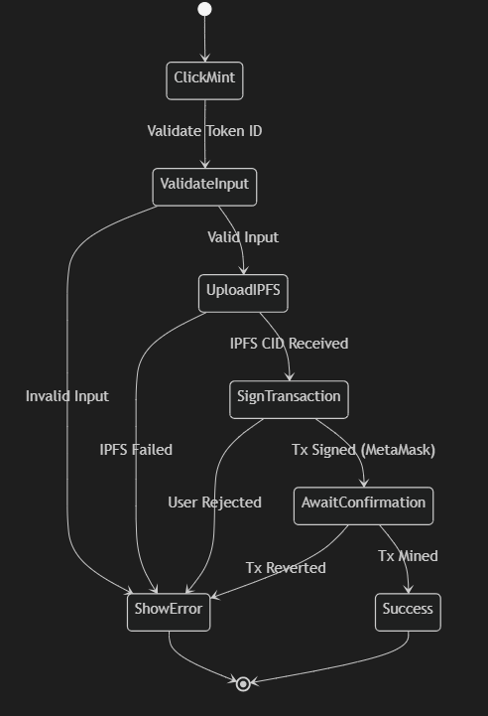

Workflow Stage Analysis:
- Stage 1 — Validate Input: Client-side validation ensures the Token ID is a non-empty numeric string before any network call is made. This prevents wasteful IPFS uploads and RPC calls for obviously invalid inputs.
- Stage 2 — Upload to IPFS: The hook serializes the base metadata JSON, generates the initial schema with default values for all lifecycle arrays, and POSTs it to NFT.storage. This stage typically takes 1-3 seconds. Toast notifications show a 'Uploading metadata...' indicator during this wait.
- Stage 3 — Request MetaMask Signature: The hook constructs the contract call (mintEquipment(tokenId, ipfsCID)) and requests a signature from MetaMask. MetaMask displays the transaction details (gas estimate, contract address, function selector) to the user for inspection.
- Stage 4 — Await Block Confirmation: Once signed, the transaction propagates through the IOTA network. The hook polls for the transaction receipt using provider.waitForTransaction(). For the IOTA EVM Testnet, block times are typically 1-5 seconds.
- Error Handling: At every stage, errors are caught and routed to the withToast error handler, which parses revert reasons from on-chain errors (e.g., 'Token ID already minted') and displays them as human-readable toast messages.

2.9 State Machine Diagram — Asset Lifecycle
Purpose: The state machine diagram models the complete set of valid states a Turbine Blade DPP can be in, and the transitions between those states. This is arguably the most domain-critical diagram in the documentation — it defines the exact lifecycle rules that should ultimately be enforced by the smart contract.

📊 State Machine Diagram — Turbine Blade Lifecycle States
Defines all valid lifecycle states and the transition triggers between them
stateDiagram-v2
[*] --> RawMaterial : mintEquipment()

RawMaterial --> ManufacturingAndInspection : recordProcessStep("Wax Pattern Creation")
ManufacturingAndInspection --> QualityAssurance : updateMetadata (NDT Cert Added)
QualityAssurance --> SupplyChain : transferOwnership() to OEM

SupplyChain --> InService : transferOwnership() to Airline
InService --> Maintenance : recordMaintenance()
Maintenance --> InService : recordMaintenance("Complete")

InService --> EndOfLife : updateMetadata("Decommissioned")
Maintenance --> EndOfLife : updateMetadata("Beyond Repair")
EndOfLife --> [*]
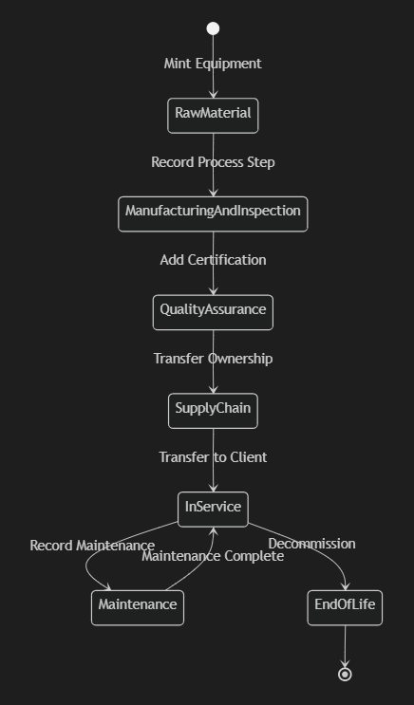
State Transition Analysis:
- RawMaterial → ManufacturingAndInspection: Triggered by the first recordProcessStep call. In a production system, this transition should be permissioned to wallet addresses associated with the casting foundry.
- ManufacturingAndInspection → QualityAssurance: Occurs when quality certification data (NDT reports, dimensional inspection certs) is added to the metadata. The lifecycle stage field in the JSON is updated to 'QualityAssurance'.
- QualityAssurance → SupplyChain: The first transferOwnership marks the hand-off from the foundry to the engine OEM. The new owner's company details are captured in the supplyChain.ownershipHistory array in the metadata.
- InService ⟷ Maintenance (cyclic): This bidirectional transition is intentional. Aircraft components cycle repeatedly between active service and maintenance throughout their operational lives. Each cycle is independently documented.
- EndOfLife (terminal): This is a one-way transition. Once a component is decommissioned, no further state transitions should be permitted. Smart contract enforcement of this rule (by checking the lifecycle stage and reverting if already EndOfLife) is a high-priority future enhancement.

2.10 Sequence Diagram — Transaction Timeline
Purpose: The sequence diagram provides the most granular view of how a blockchain transaction unfolds over time. It depicts every system participant — the user, UI, hook, IPFS, MetaMask, and smart contract — and shows the precise chronological order of all inter-system messages. This diagram is essential for debugging, latency analysis, and onboarding developers to the async transaction lifecycle.

📊 Sequence Diagram — Full Mint Equipment Transaction Flow
Chronological message sequence across all system actors from button click to on-chain confirmation
sequenceDiagram
autonumber
actor User as Foundry Worker
participant App as React UI (App.tsx)
participant Hook as useContract Hook
participant IPFS as NFT.storage API
participant MM as MetaMask Extension
participant IOTA as IOTA Smart Contract

User->>App: Clicks "Mint Equipment" on ActionCard
App->>Hook: Calls mintEquipment(tokenId)
Hook->>Hook: Generates base JSON metadata object
Hook->>IPFS: HTTPS POST: storeBlob(jsonMetadata)
Note over Hook,IPFS: ~1-3 seconds: IPFS pinning
IPFS-->>Hook: Returns CID "ipfs://bafyre..."
Hook->>MM: Requests Tx Signature: mintEquipment(id, cid)
MM-->>User: Displays transaction prompt
User->>MM: Clicks Approve
MM->>IOTA: Submits signed rawTransaction
Note over MM,IOTA: ~2-5 seconds: Block mining
IOTA-->>MM: Returns TransactionReceipt
MM-->>Hook: Forwards receipt (txHash, blockNumber)
Hook-->>App: Returns success result
App-->>User: Displays "Mint Successful!" toast
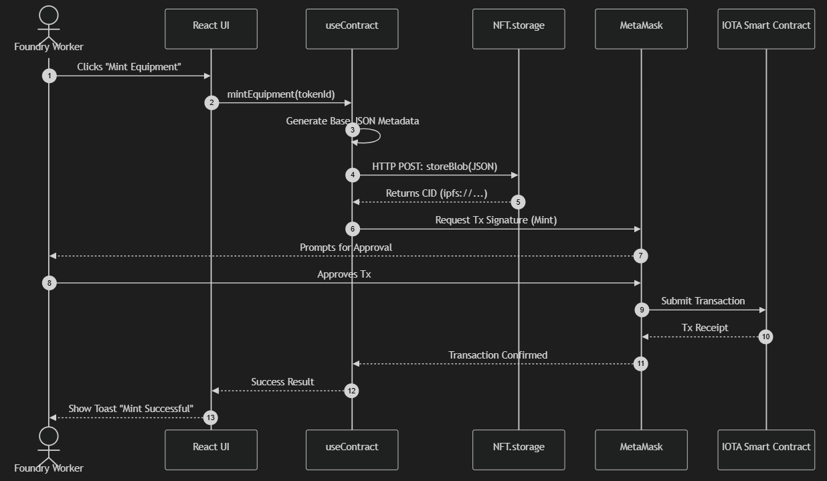
Sequence Message Analysis:
- Messages 1-3 (Synchronous Setup): These happen within a single JavaScript event loop tick — near-instantaneous. The hook generates the metadata JSON in memory with no I/O required.
- Messages 4-6 (IPFS Upload): This is the first async network boundary. The await on the NFT.storage API call suspends the hook's execution while the metadata is uploaded and pinned. Toast: 'Uploading to IPFS...'.
- Messages 7-10 (MetaMask Signature): The hook constructs the ABI-encoded transaction and requests MetaMask to sign it. This opens the MetaMask popup — the transaction is paused here until the user explicitly approves or rejects. Toast: 'Awaiting signature...'.
- Messages 11-13 (On-chain Mining): The signed transaction is broadcast to the IOTA P2P network. Nodes validate it, include it in a block, and reach consensus. The hook awaits the receipt using provider.waitForTransaction(). Toast: 'Transaction submitted, awaiting confirmation...'.
- Messages 14-15 (Completion): The receipt confirms the transaction was mined. The hook propagates success back up to the UI, which dismisses the loading toast and shows the green 'Mint Successful!' notification.

2.11 Communication Diagram — Message Network Topology
Purpose: The communication diagram complements the sequence diagram by emphasizing the network topology rather than temporal ordering. It shows which objects communicate with which, numbered to indicate sequence, but laid out to highlight the structural relationships in the communication network. This is useful for understanding the information flow architecture at a glance.

📊 Communication Diagram — Object Communication Network
Focuses on network structure of inter-object communication with sequence numbers
flowchart TD
User((("Foundry Worker
(Actor)")))
UI["React UI
(App.tsx + Components)"]
IPFS["IPFS Storage
(NFT.storage REST)"]
Wallet["Web3 Wallet
(MetaMask EIP-1193)"]
Blockchain["IOTA Network
(Smart Contract)"]

User -- "1. Input Data & Click Action" --> UI
UI -- "2. Upload JSON Metadata" --> IPFS
IPFS -- "3. Return CID (ipfs://...)" --> UI
UI -- "4. Request Tx Signature" --> Wallet
Wallet -- "5. Send Signed Transaction" --> Blockchain
Blockchain -- "6. Emit Events + Return Receipt" --> Wallet
Wallet -- "7. Forward Receipt + Hash" --> UI
UI -- "8. Show Success / Error Toast" --> User
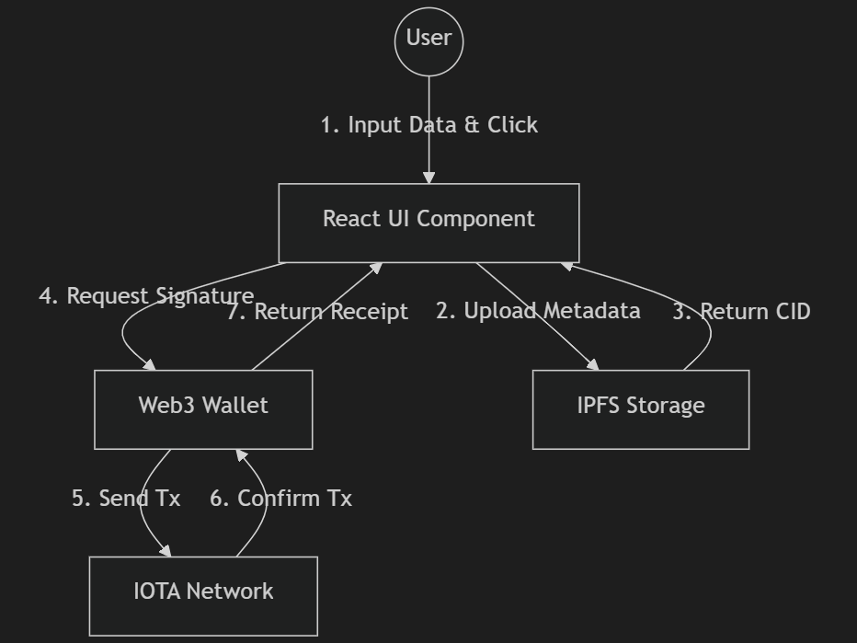
Communication Topology Insights:
- The UI is the central hub: All 8 communication messages either originate from or terminate at the React UI. There are no direct communication channels between the user and the blockchain, or between IPFS and the blockchain. The UI mediates all interactions.
- IPFS and Blockchain are parallel concerns: Steps 2-3 (IPFS upload) must complete before steps 4-7 (blockchain transaction) can begin, but the two external systems are otherwise entirely independent. Neither knows about the other.
- MetaMask is the security gateway: All blockchain communication (step 5) passes through MetaMask. The user's private key never leaves MetaMask's secure enclave — only signed transaction bytes are transmitted to the IOTA network.

2.12 Timing Diagram — Latency Profile
Purpose: The timing diagram visualizes the duration of each operation during a complete transaction lifecycle, providing a performance profile. This is critical for UX design decisions (when to show spinners, what toast message to show) and for setting realistic user expectations about blockchain interaction latency.

📊 Timing Diagram — Operation Duration Profile
Shows the relative time durations of each phase in a complete Mint Equipment transaction
flowchart LR
classDef user fill:#1e3a8a,color:#ffffff,stroke:#3b82f6
classDef network fill:#064e3b,color:#ffffff,stroke:#10b981
classDef waiting fill:#7c2d12,color:#ffffff,stroke:#ea580c

A["Form Fill
~5-15s"]:::user
B["Submit Click
<1s"]:::user
C["IPFS Upload
~1-4s"]:::network
D["MetaMask Approve
~3-30s"]:::waiting
E["Tx Broadcast
<1s"]:::network
F["Block Mining
~2-8s"]:::network
G["Receipt Parsed
<1s"]:::network

A --> B --> C --> D --> E --> F --> G

subgraph Legend
U["User Interaction"]:::user
N["Network Action"]:::network
W["Human Wait"]:::waiting
end
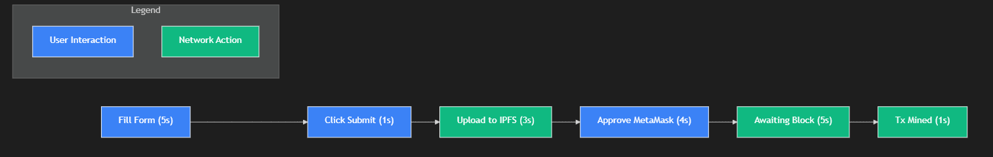
Operation | Typical Duration
Form fill (user enters data) | 5 – 15 seconds (user-dependent)
IPFS upload (NFT.storage API) | 1 – 4 seconds (network-dependent)
MetaMask approval (user decision) | 3 – 30 seconds (user-dependent)
Transaction broadcast | < 1 second
Block mining (IOTA EVM Testnet) | 2 – 8 seconds
Receipt parsing and UI update | < 1 second
Total end-to-end (typical) | 15 – 60 seconds

⚡ UX Implication
The IOTA EVM's fast block times (2-8 seconds) significantly improve UX compared to Ethereum mainnet (12-second average). However, the human approval step (MetaMask confirmation) remains the largest source of variance. Future enhancements could explore EIP-4337 account abstraction to allow gasless meta-transactions, removing the need for users to manually approve each transaction.

2.13 Application Logic Flowchart — Initialization Flow
Purpose: This flowchart captures the application's boot sequence — the decisions made every time a user loads the app. Before any DPP functionality is accessible, the app must verify that the user has a compatible wallet installed and that the wallet is connected to the correct blockchain network.

📊 Flowchart — App Initialization & Network Validation
Decision tree for app load sequence: MetaMask check → Connection check → Network check → Dashboard
flowchart TD
A(["App Load — React SPA Initializes"])
B{"window.ethereum
injected?"}
C["Show: 'Please install MetaMask' Error Toast"]
D{"Wallet account
connected?"}
E["Show: ConnectPrompt Component
(Full-screen gate)"]
F{"Chain ID ==
1076 (IOTA EVM)?"}
G["Call wallet_addEthereumChain
(Auto-switch to IOTA network)"]
H["Load Full Dashboard UI
(All ActionCards enabled)"]

A --> B
B -- "No" --> C
B -- "Yes" --> D
D -- "No" --> E
E --> D
D -- "Yes" --> F
F -- "No" --> G
G --> F
F -- "Yes" --> H
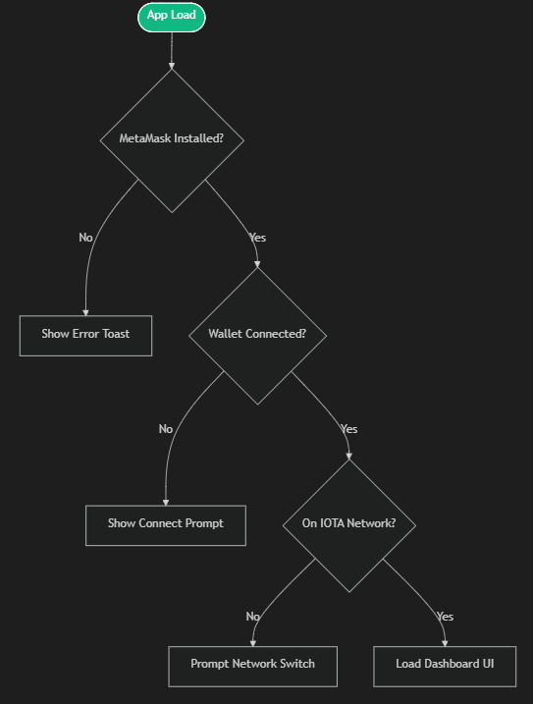
Flowchart Decision Analysis:
- MetaMask Check: The app checks for the presence of window.ethereum on page load. If absent (user has no wallet extension), a non-dismissible error is shown. No blockchain functionality is available.
- Connection Gate (ConnectPrompt): If MetaMask is present but no account is exposed (user has not connected to this site before), the ConnectPrompt renders. This is a non-blocking UX pattern — the user can still see the connect prompt and take action. The app polls for account changes via the 'accountsChanged' MetaMask event.
- Network Enforcement (Chain ID 1076): Once connected, the app verifies the active network is the IOTA EVM Testnet (Chain ID: 1076). If not, it calls wallet_addEthereumChain — a MetaMask JSON-RPC method that prompts the user to switch networks, and adds the IOTA network to MetaMask's network list if not already present.

2.14 C4 Model — Context & Container View
Purpose: The C4 model (Context, Containers, Components, Code) provides a hierarchically structured approach to architecture documentation pioneered by Simon Brown. The Context level answers 'what is the system and who uses it?' while the Container level answers 'what are the high-level technical building blocks?' Together, they provide the most accessible architecture view for both technical and business stakeholders.

📊 C4 Model — System Context & Container Diagram
Multi-level architecture view from stakeholder context down to application containers
flowchart TD
Actor(("👷 Foundry / MRO Worker
(Primary User)"))

subgraph Context ["System Context Level"]
App["iota-dpp-app
(Decentralized Application)"]
end

subgraph Containers ["Container Level — Internal Structure"]
UI["SPA Frontend
(React + TypeScript)
[Runs in Browser]"]
Hooks["Web3 Integration Layer
(useWallet + useContract)
[Custom Hooks]"]
end

subgraph External ["External Systems"]
SmartContract["IOTA Smart Contract
(Solidity ERC-721)
[IOTA EVM Testnet]"]
Storage["NFT.storage
(IPFS + Filecoin)
[Decentralized Storage]"]
MetaMaskExt["MetaMask
(EIP-1193 Provider)
[Browser Extension]"]
end

Actor -->|"Interacts via browser UI"| App
App -.->|"Contains"| UI
UI -->|"Delegates Web3 logic to"| Hooks
Hooks -->|"Signs via"| MetaMaskExt
MetaMaskExt -->|"Reads & Writes state"| SmartContract
Hooks -->|"Pins metadata to"| Storage

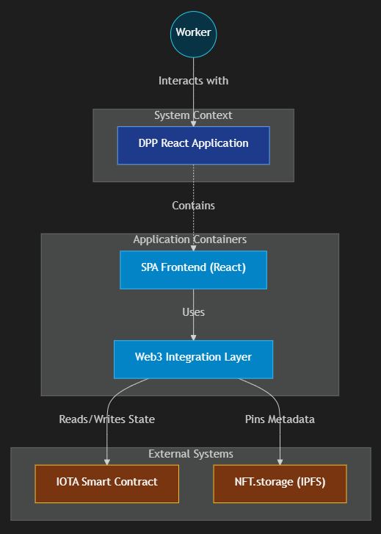
C4 Level Analysis:
- Context Level: From the outside, the iota-dpp-app appears as a single system. The only external actor is the Foundry/MRO Worker. The system is a black box at this level — the internal complexity is hidden. This view is suitable for executive briefings and regulatory submissions.
- Container Level — SPA Frontend: The React application is a single-page application container. It owns the UI rendering, state management, and user interaction handling. No traditional backend server container exists — this is a defining characteristic of the Fat Client / dApp architecture.
- Container Level — Web3 Integration Layer: The custom hooks are a logical container boundary within the SPA. They own all blockchain-related code, making them the single dependency point for the decentralized infrastructure. Replacing IPFS or the blockchain network only requires changes to this layer.
- External Systems: The Smart Contract, NFT.storage, and MetaMask are all external to the application’s codebase. They are out of the development team’s direct control — changes to their APIs or behavior can break the application, making them important risk considerations.

2.15 Architecture Pattern — Fat Client / dApp Model
Purpose: This diagram explicitly labels and illustrates the overarching architectural pattern of the application: the Fat Client dApp architecture. Understanding this pattern is essential for architects evaluating the system’s non-functional characteristics: security model, availability guarantees, and scalability profile.

📊 Architecture Pattern — Fat Client / Decentralized Backend
Contrasts the client-heavy dApp pattern with traditional client-server architecture
flowchart LR
subgraph FatClient [“CLIENT LAYER (Fat Client — Runs in Browser)”]
React[“React UI
(Presentation Logic)”]
Ethers[“Ethers.js v6
(Web3 Adapter)”]
NFTClient[“NFT.storage Client
(IPFS Adapter)”]
TypeScript[“TypeScript
(Type Safety)”]
end

subgraph DecentralizedBackend [“DECENTRALIZED BACKEND (No Traditional Server)”]
EVM[“IOTA EVM
(Smart Contract State)”]
IPFS[“IPFS Network
(Metadata Storage)”]
Filecoin[“Filecoin
(Persistence Guarantees)”]
end

React --> Ethers
React --> NFTClient
Ethers <-->|"JSON-RPC over HTTPS"| EVM
NFTClient -->|"REST API over HTTPS"| IPFS
IPFS -.->|"Pinned for persistence"| Filecoin

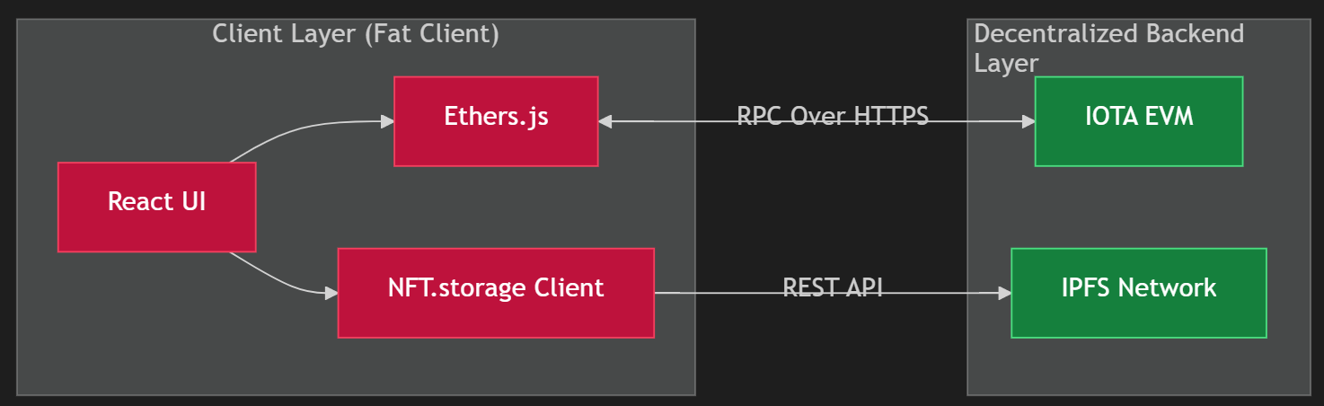
Pattern Trade-off Analysis:
Characteristic | Fat Client dApp vs Traditional Client-Server
Business Logic Location | Fat Client: All logic runs in the browser. Traditional: Logic runs on the server.
Authentication | Fat Client: Cryptographic key-based (wallet signature). Traditional: Username/password or OAuth tokens.
Data Persistence | Fat Client: Smart contract state (immutable) + IPFS (content-addressed). Traditional: Mutable database (SQL/NoSQL).
Availability | Fat Client: Depends on blockchain and IPFS uptime (high, decentralized). Traditional: Depends on server/database uptime (single point of failure).
Scalability | Fat Client: Blockchain throughput is the bottleneck (limited TPS). Traditional: Horizontal server scaling is easier.
Auditability | Fat Client: Every state change is publicly verifiable on-chain. Traditional: Audit logs are mutable and admin-controlled.
Hosting Cost | Fat Client: Static file hosting only (very cheap). Traditional: Application servers, load balancers, databases (expensive).

Section 3: Scope of Project

3.1 Current Scope — What Is Built
The current version of the iota-dpp-app delivers a fully functional proof-of-concept that demonstrates the viability of blockchain-based Digital Product Passports for aerospace components. The implemented scope covers the following capabilities:

Capability Area | What Is Currently Implemented
Wallet Integration | MetaMask connection, IOTA EVM Testnet enforcement (Chain ID 1076), account display, and network auto-switching via wallet_addEthereumChain.
NFT Minting | ERC-721 Equipment token minting with on-chain tokenURI, and Sub-Part token minting with parent-child on-chain linking for hierarchical BOMs.
Metadata Management | IPFS metadata upload via NFT.storage, CID generation, on-chain URI update, and structured JSON schema for the full DPP data model.
Lifecycle Tracking | Seven-stage lifecycle state representation in metadata, with manual stage updates via updateMetadata.
Process Recording | On-chain process step recording (manufacturing logs) and maintenance event recording as distinct smart contract state entries.
Ownership Transfer | ERC-721 transferFrom execution with company/owner metadata updates, creating a verifiable custody chain.
User Experience | Toast notification system with three-phase feedback (uploading → awaiting signature → confirming), dark-mode optimized UI, and modal-based action forms.

3.2 Explicit Exclusions — Out of Current Scope
- Role-based access control (RBAC): Any wallet can currently perform any action on any token. No foundry-only, OEM-only, or regulator-only permissions are enforced on-chain.
- Lifecycle state enforcement: The smart contract does not prevent logically invalid state transitions (e.g., moving directly from RawMaterial to EndOfLife).
- Real-time event indexing: The app does not listen for on-chain events (Transfer, ProcessStepRecorded, etc.) in real time. History is not displayed in the UI.
- NFT.storage payment management: The NFT.storage API key is a placeholder. Production usage requires account management, quota monitoring, and key rotation.
- Multi-signature governance: High-stakes actions (like decommissioning) do not require multi-party approval.
- Mobile wallet support: WalletConnect or similar mobile wallet protocols are not implemented.
- Regulatory compliance certification: The system is a proof-of-concept and has not been certified for use in production aerospace supply chains.

3.3 Technical Constraints & Assumptions
⚠️ Key Assumptions
The application assumes: (1) Users have MetaMask installed in a Chromium-based browser. (2) The IOTA EVM Testnet is reachable and has not undergone breaking protocol changes. (3) NFT.storage remains available and the provided API key has quota remaining. (4) A compatible Solidity smart contract conforming to contractABI.ts has been deployed to the testnet and its address is configured in constants.ts.

Section 4: Future Work & Roadmap

The iota-dpp-app establishes a robust architectural foundation upon which a production-grade, regulatory-compliant Digital Product Passport system can be built. The following future work items are organized by priority tier and development complexity.

4.1 Tier 1 — High Priority (Production Readiness)

4.1.1 Smart Contract Role-Based Access Control (RBAC)
Currently, any wallet can perform any action on any token. Production deployment requires granular, on-chain permissions:
- Implement OpenZeppelin AccessControl roles: FOUNDRY_ROLE, OEM_ROLE, MRO_ROLE, REGULATOR_ROLE.
- Gate mintEquipment and recordProcessStep to FOUNDRY_ROLE addresses only.
- Gate transferOwnership to the current token owner (already partially enforced by ERC-721 standard).
- Gate recordMaintenance to MRO_ROLE addresses, preventing unauthorized maintenance claims.
- Add a DECOMMISSION_ROLE for regulatory bodies to mark components as EndOfLife — requiring multi-signature approval.

🔒 Security Impact
Without RBAC, any actor with a funded wallet can fraudulently record process steps, fake maintenance events, or transfer ownership without authorization. RBAC is the single highest-priority security enhancement for production readiness.

4.1.2 Lifecycle State Enforcement on Smart Contract
The smart contract should enforce that lifecycle transitions follow the valid state machine defined in Section 2.9. Suggested implementation:
- Add a lifecycleStage uint8 enum field to the on-chain token storage (not just metadata).
- Add require() guards to transition functions: e.g., require(stage == ManufacturingAndInspection) before allowing addNDTCertificate().
- Emit a LifecycleStageChanged(tokenId, oldStage, newStage) event for indexers.
- Implement a terminal state guard: once EndOfLife is set, all modification functions revert — permanently freezing the record.

4.1.3 Event Indexing & Full History Dashboard
The current UI has no historical view — users cannot see past transactions or events for a token. Proposed solution:
- Deploy a subgraph on The Graph Protocol (or an IOTA-compatible indexer) to index all DPP-related smart contract events.
- Build a TokenHistory component that fetches and displays: all ProcessStepRecorded events, OwnershipTransferred events, MetadataUpdated events, and MaintenanceRecorded events.
- Display the full provenance timeline — from first mint to current state — in a chronological, visual timeline UI.

4.1.4 WalletConnect & Multi-Wallet Support
Current dependence on MetaMask excludes mobile users and users of other wallets. Future work:
- Integrate WalletConnect v2 (now rebranded as Reown) to support 300+ wallet apps, including mobile wallets (MetaMask Mobile, Trust Wallet, Rainbow).
- Abstract the wallet provider behind a unified interface using a library like wagmi or RainbowKit, which provides pre-built wallet connection UI and multi-chain support.
- Support hardware wallet signing (Ledger, Trezor) for high-security institutional deployments.

4.2 Tier 2 — Medium Priority (Feature Completeness)

4.2.1 NFT.storage Migration & Decentralized Storage Strategy
NFT.storage's API key model creates a centralized dependency risk. Future work should explore:
- Self-hosted IPFS node: Run a dedicated IPFS node (e.g., Kubo) pinned to the application's own metadata, removing dependence on NFT.storage API availability.
- Filecoin direct storage deals: Use the Filecoin JS SDK to make direct storage deals with miners, getting cryptographic proof of storage (PoRep, PoSt) rather than relying on NFT.storage's guarantees.
- W3UP (web3.storage): NFT.storage's successor, offering a more robust, account-based pinning API with better quota management.
- IPFS pinning service federation: Pin to multiple providers simultaneously (Pinata, Infura IPFS, NFT.storage) to maximize redundancy.

4.2.2 QR Code & Physical-Digital Binding
The fundamental challenge of any digital product passport is binding the physical object to its digital twin. Current implementation has no such binding. Proposed solutions:
- Generate a QR code embedding the tokenId and contract address at mint time, suitable for laser engraving on the physical blade.
- Explore NFC tag embedding (passive UHF RFID) into non-critical sections of the blade for contactless digital twin lookup.
- Investigate cryptographic Physical Unclonable Functions (PUFs) — microscopic, unclonable physical patterns that can be read and verified on-chain.

4.2.3 Multi-Signature Governance for Critical Actions
Actions with significant real-world consequences (decommissioning, major certification updates) should require multi-party approval:
- Integrate Gnosis Safe (now Safe{Wallet}) for multi-signature transaction execution on critical operations.
- Implement an on-chain proposal system: a Maintenance record is proposed by the MRO, then approved by the OEM before being finalized.
- Time-locks: Add a mandatory waiting period (e.g., 24 hours) before irreversible actions like EndOfLife designation execute.

4.2.4 PDF Certificate Generation & Off-Chain Attestations
Aviation stakeholders frequently require traditional paper-compatible documentation:
- Generate EASA Form 1 / FAA 8130-3 airworthiness release certificates as PDF documents from the on-chain DPP data.
- Include a QR code in the PDF linking back to the on-chain token for independent verification.
- Implement EIP-712 structured data signing to allow off-chain attestations (e.g., 'I certify this inspection was performed') that are cryptographically linked to the on-chain record without requiring a gas-costing transaction.

4.3 Tier 3 — Long-Term Vision (Ecosystem Scale)

4.3.1 Cross-Chain Interoperability
As different aviation stakeholders may operate on different blockchain networks, cross-chain interoperability becomes critical at ecosystem scale:
- Implement Axelar or LayerZero General Message Passing (GMP) to allow DPP data to be read or bridged across EVM-compatible chains.
- Explore IBC (Inter-Blockchain Communication) if IOTA integrates Cosmos SDK compatibility.
- Enable an airline operating on Ethereum mainnet to verify the provenance of a turbine blade minted on IOTA EVM without requiring an IOTA wallet.

4.3.2 AI-Powered Predictive Maintenance Integration
The richly structured lifecycle data stored in the DPP creates a unique opportunity for AI integration:
- Feed on-chain process step history, flight cycle data, and maintenance records into machine learning models for predictive maintenance scoring.
- Train models to predict Remaining Useful Life (RUL) of components based on their DPP history.
- Publish AI risk scores back to the on-chain metadata as a periodic update, creating a living, AI-augmented digital passport.
- Integrate with airline ERP systems (SAP, Oracle) via API gateways to pull flight cycle accumulation data into the DPP automatically.

4.3.3 EU Digital Product Passport Regulation Compliance
The European Union's Ecodesign for Sustainable Products Regulation (ESPR) mandates Digital Product Passports for many product categories, with aerospace components likely in scope in the coming years:
- Align the metadata schema with the EU's ESPR DPP data model once finalized by the European Commission.
- Integrate with the EU's Digital Product Passport Registry when operational.
- Add carbon footprint, recycled material content, and repairability index fields to the metadata schema to meet sustainability disclosure requirements.

4.3.4 Tokenization & Carbon Credit Integration
The detailed lifecycle data enables novel financial instrument creation:
- Tokenize carbon savings from part reuse or remanufacturing as on-chain carbon credits, linked to the DPP.
- Enable parts leasing models with smart contract-enforced usage-based payments (pay-per-flight-hour), using on-chain cycle count data.
- Integrate with secondary market platforms for certified pre-used aerospace components, where the DPP serves as the verifiable provenance document.

4.4 Suggested Output — Production System Blueprint
Based on the analysis of the current architecture and the future work roadmap, the following blueprint represents the recommended target architecture for a production-grade IOTA DPP system deployable in a real aerospace supply chain environment:

System Layer | Recommended Production Architecture
Smart Contract | Solidity 0.8.x on IOTA EVM Mainnet with OpenZeppelin AccessControl, ERC-721 Enumerable, on-chain lifecycle state machine, and Gnosis Safe multi-sig integration for critical actions.
Metadata Storage | Primary: Self-hosted IPFS cluster with 3+ nodes. Secondary: Filecoin direct deals for cold storage. Tertiary: W3UP pinning as managed backup.
Frontend | Next.js 14 (App Router) for SSR/SEO, wagmi + RainbowKit for multi-wallet support, Zustand for global state, and shadcn/ui for accessible component library.
Indexing / History | The Graph Protocol subgraph deployed on IOTA for real-time event indexing, with a React Query-based data fetching layer.
Physical Binding | Laser-engraved QR codes + NFC tags for consumer-grade parts. Cryptographic PUFs for high-security mil-spec components.
Compliance | EIP-712 structured signing for off-chain attestations. EASA Form 1 / FAA 8130-3 PDF generation. ESPR-aligned metadata schema.
Monitoring | On-chain transaction monitoring with Tenderly alerts. IPFS node health checks. API key rotation automation.
Security | Smart contract audit by a reputable firm (Trail of Bits, OpenZeppelin). Penetration testing of the frontend. Responsible disclosure policy.

Section 5: Conclusion

The IOTA Digital Product Passport application represents a technically sophisticated and domain-appropriate proof-of-concept that demonstrates the transformative potential of blockchain technology applied to aerospace supply chain traceability. By combining the IOTA EVM's low-fee transaction model with IPFS's content-addressed decentralized storage, the application achieves a level of data integrity and transparency that is fundamentally impossible with traditional centralized systems.

The architectural decisions made in the application — the Fat Client dApp model, the separation of on-chain state from off-chain metadata, the custom hooks pattern for Web3 logic isolation, and the seven-stage lifecycle state machine — are well-reasoned and scalable. They provide a solid foundation upon which the production enhancements described in Section 4 can be built incrementally.

The most critical next steps for production readiness are: (1) smart contract RBAC implementation to enforce authorization, (2) on-chain lifecycle state enforcement to prevent fraudulent transitions, and (3) the development of a full history indexing and display system to unlock the full value of the immutable on-chain audit trail.

🚀 Strategic Value Proposition
In an industry where a single counterfeit or improperly maintained turbine blade can cause catastrophic loss of life, the immutability and verifiability guarantees of a blockchain-based DPP system are not just technically interesting — they are a genuine safety imperative. The iota-dpp-app demonstrates that this vision is not only technically feasible but can be delivered with a modern, maintainable, and developer-friendly technology stack.

References & Further Reading
- IOTA EVM Documentation: https://wiki.iota.org/shimmer/
- NFT.storage API Reference: https://nft.storage/docs/
- OpenZeppelin Contracts (AccessControl, ERC-721): https://docs.openzeppelin.com/contracts/
- EIP-721: Non-Fungible Token Standard: https://eips.ethereum.org/EIPS/eip-721
- The Graph Protocol: https://thegraph.com/docs/
- EU Ecodesign for Sustainable Products Regulation (ESPR): https://ec.europa.eu/
- C4 Model for Software Architecture: https://c4model.com/
- wagmi — React Hooks for Ethereum: https://wagmi.sh/
- Safe{Wallet} Multisig Documentation: https://docs.safe.global/

