🌿 ECOSPHERE
ESG MANAGEMENT PLATFORM
Full Build Roadmap, ER Diagram & Technical Blueprint
MERN + MySQL • 4-Developer Parallel Build • 8-Hour Sprint
Environmental · Social · Governance · Gamification
Prepared as a complete execution guide — from architecture to demo.

Table of Contents

1. Executive Summary & Project Vision
Most ERP systems already capture the raw operational data an organization needs for ESG reporting — purchases, manufacturing runs, expense claims, fleet fuel usage, HR records — but that data sits disconnected from sustainability reporting. Someone in a compliance or CSR team ends up re-typing numbers into spreadsheets weeks after the fact, with no way to catch problems in real time and no way to get employees genuinely engaged in the process.
EcoSphere closes that gap. It is not three separate modules bolted together — it is one continuous pipeline:
The Core Pipeline
1. Daily ERP operations (Purchase / Manufacturing / Expense / Fleet) generate raw activity data.
2. That activity is automatically converted into Carbon Transactions using configured Emission Factors.
3. In parallel, employees participate in CSR Activities and gamified Challenges, earning XP and Points.
4. Governance activity (policy sign-off, audits, compliance issues) is tracked with clear ownership.
5. All three streams roll up into an Environmental, Social, and Governance score per department.
6. Department scores combine into one Overall ESG Score, visualized on a live dashboard and exportable as reports.
Gamification is the mechanism that makes Social and Governance participation actually happen — instead of nagging employees to submit CSR proof or acknowledge a policy, the platform rewards them with XP, badges, and redeemable rewards, and shows their standing on a leaderboard.
This document is a complete, self-contained build guide: the full data model, the business-rule engines that make the platform "smart" rather than just CRUD, the recommended MERN + MySQL architecture, a realistic plan for four developers building simultaneously inside an 8-hour window, a UI theme, and a definition of done.

2. Problem Statement — Deep Dive

2.1 Why this is hard
- ESG data has three completely different shapes: environmental data is numeric/continuous (kg CO2e), social data is behavioral/event-based (did an employee show up and participate), and governance data is compliance/state-based (is a policy acknowledged, is an issue overdue).
- The scoring model has to normalize all three into one comparable number per department, using a configurable weighting — this is a design decision, not just a formula.
- Automation toggles (auto emission calc, evidence requirement, badge auto-award) mean the same workflow must support both a manual path and an automatic path, controlled at runtime from Settings.
- Gamification has to feed back into the Social/Governance score, not exist in isolation — a Badge earned or a Challenge completed should visibly move the needle on the department's score.

2.2 Who uses it
Role | What they do in the system
Admin | Configures master data, emission factors, weighting, toggles, manages departments/categories.
Manager | Reviews & approves CSR/Challenge participation, owns compliance issues, views department dashboard.
Employee | Participates in CSR activities & challenges, submits proof, acknowledges policies, redeems rewards.
Auditor / Compliance Officer | Runs audits, raises compliance issues, tracks resolution.

3. Complete Feature Requirements
Directly from the brief, organized by module — treat each row as a screen or a distinct piece of functionality, not just a menu item.

3.1 Environmental
- Configure Emission Factors — CRUD with activity type, unit, effective date.
- Calculate Carbon Emissions — manual entry AND automatic (toggle-controlled).
- Department Carbon Tracking — emissions broken down by department and time period.
- Sustainability Goals — targets vs. actuals, attainment %.
- Environmental Dashboard — trend charts, goal progress, top emitting departments.

3.2 Social
- CSR Activities — create/schedule initiatives by category and department.
- Employee Participation — sign-up, proof submission, approval workflow.
- Diversity Metrics — aggregate workforce composition reporting.
- Training Completion — track completion of ESG-related training.

3.3 Governance
- ESG Policies — versioned policy documents by category.
- Policy Acknowledgements — per-employee sign-off tracking and reminders.
- Audits — scheduled/completed audits by department.
- Compliance Issues — severity, mandatory Owner + Due Date, overdue flagging.

3.4 Gamification
- Challenges — full lifecycle: Draft → Active → Under Review → Completed, or Archived at any point.
- XP — earned via approved CSR participation and completed challenges.
- Badges — auto-awarded when unlock-rule thresholds are met.
- Rewards — redeemable catalog, stock-limited, deducts points on redemption.
- Leaderboards — org-wide and department-level XP rankings.

3.5 Settings & Administration
- Department & Category management (hierarchical).
- ESG Configuration — scoring weights, all automation toggles.
- Notification Settings — per-channel, per-event preferences.

3.6 Reports
- Environmental Report, Social Report, Governance Report, ESG Summary Report.
- Custom Report Builder — combine filters (Department, Date Range, Module, Employee, Challenge, ESG Category) and export as PDF / Excel / CSV.

4. Data Model & Entity-Relationship Diagram
The brief specifies full fields for some models and leaves others blank (marked "-"). Below is a complete, implementable schema — the blanks have been filled in so every entity is build-ready.

4.1 Full ER Diagram
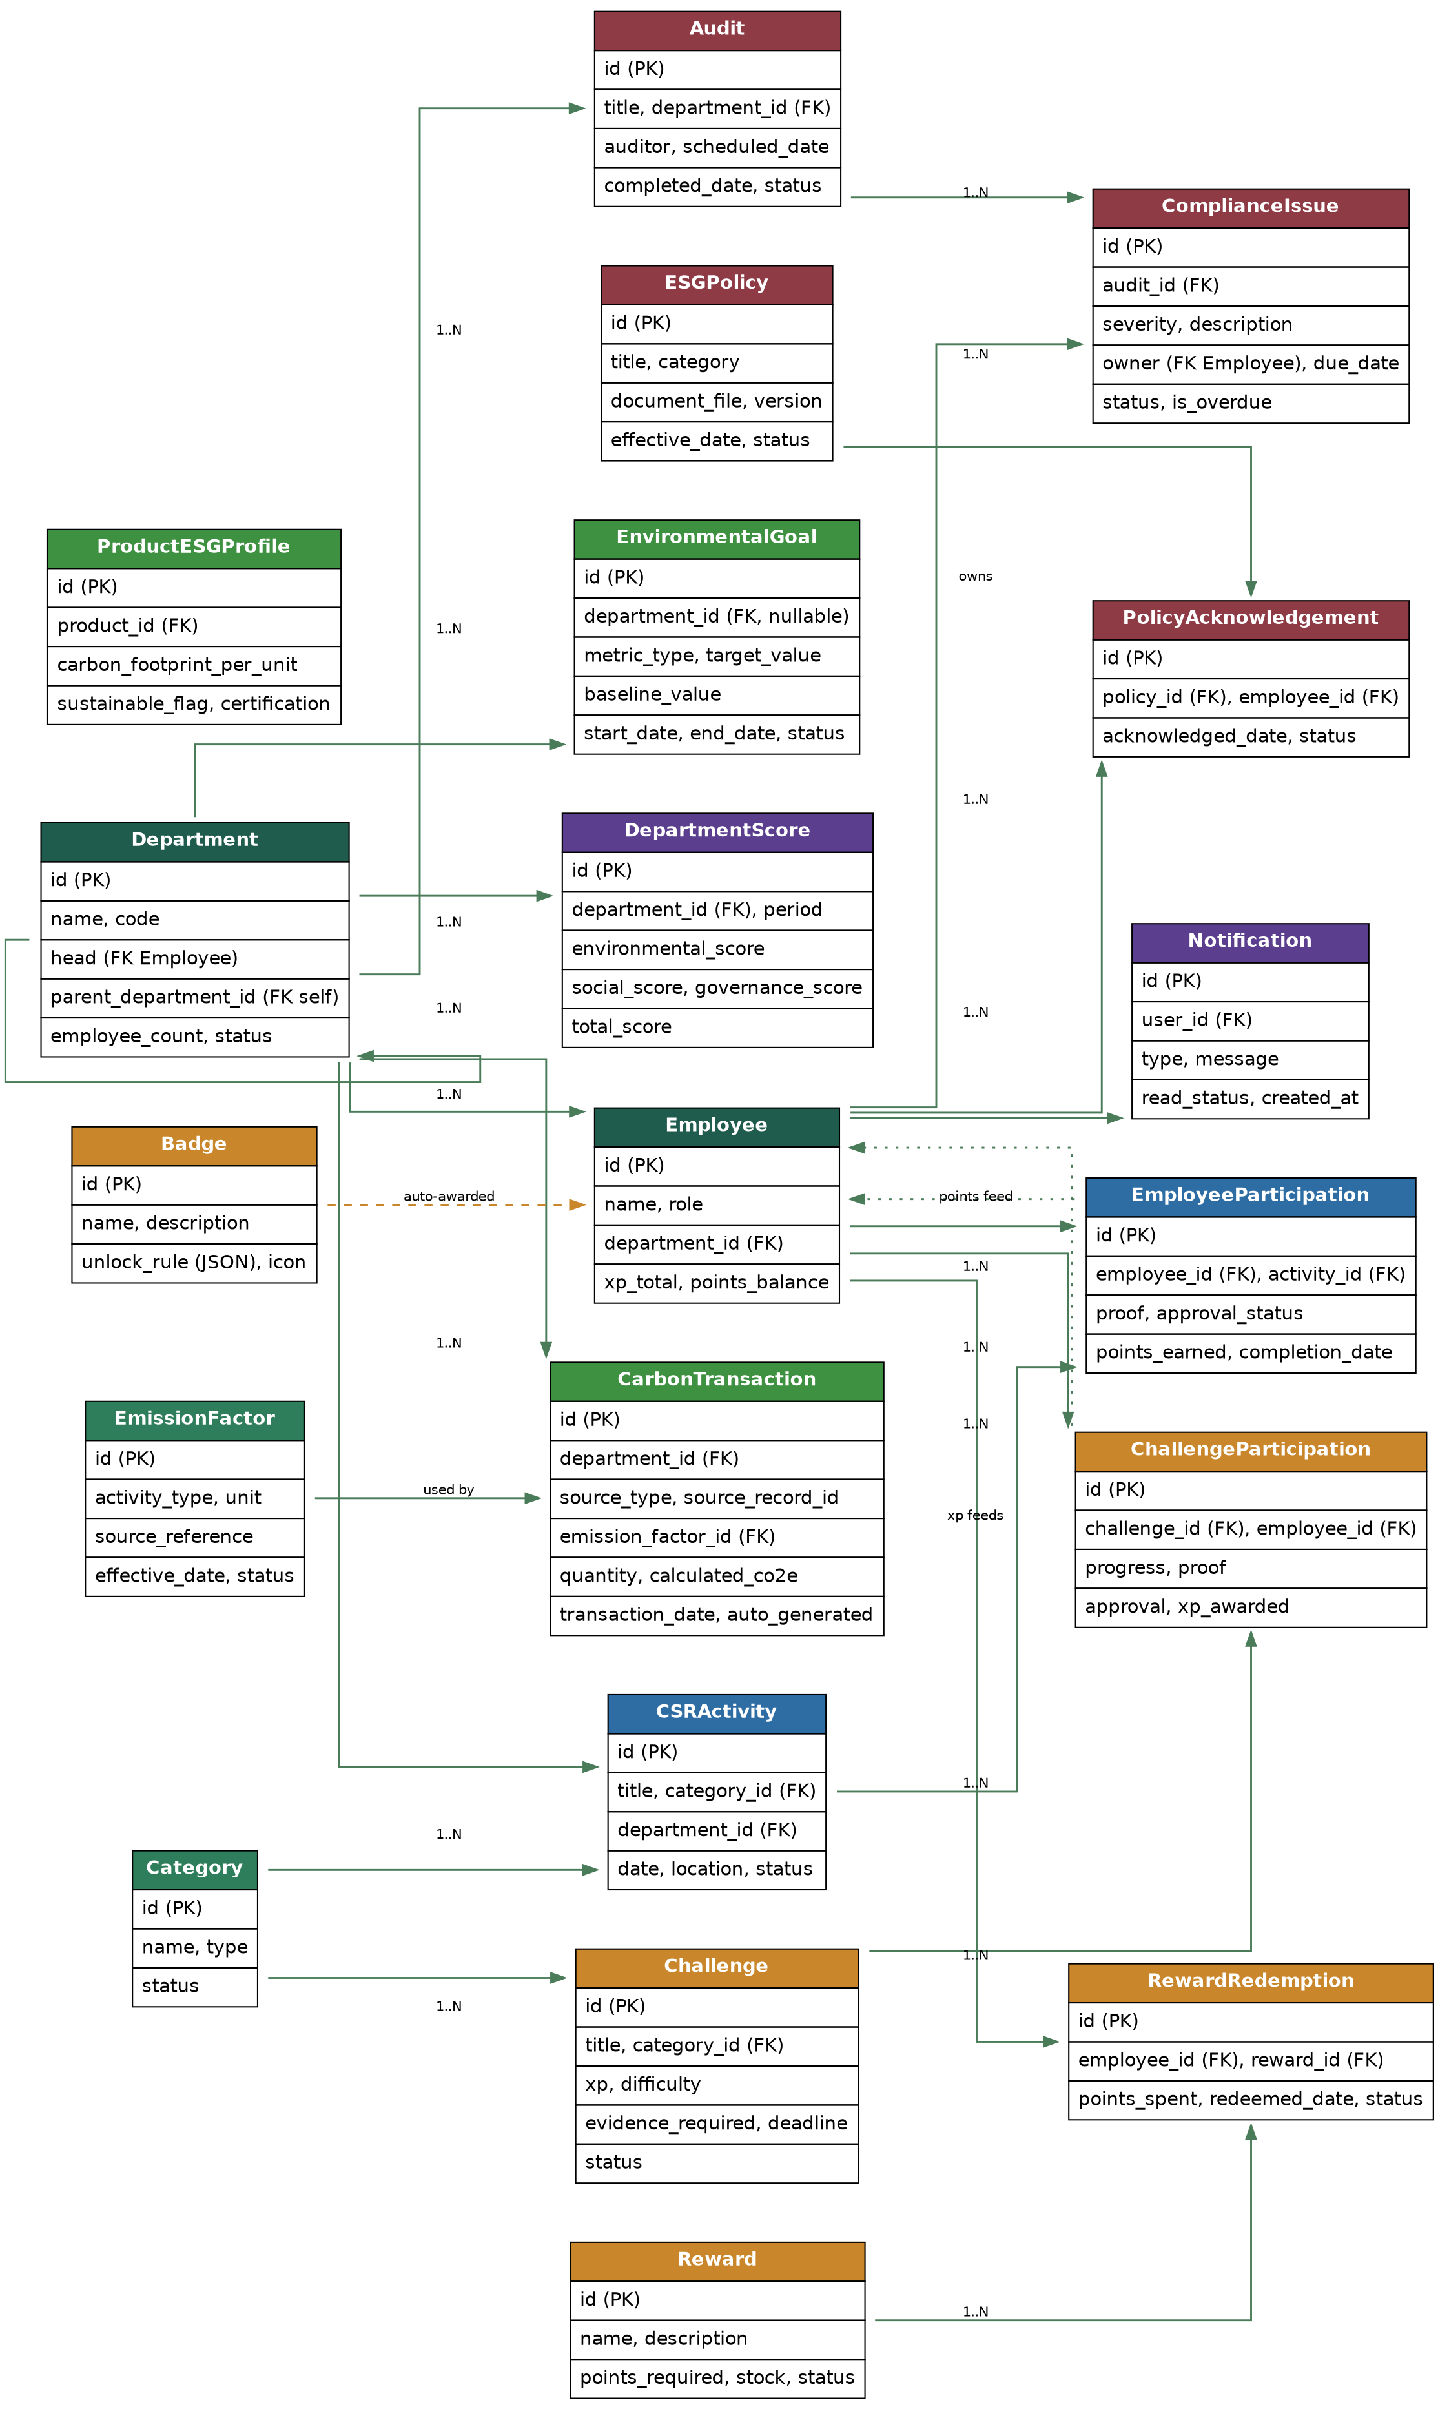
Figure 1 — Complete entity-relationship diagram for EcoSphere (Master + Transactional + supporting entities).

4.2 Master Data
Model | Key Fields
Department | id, name, code, head (FK), parent_department_id, employee_count, status
Category | id, name, type (CSR Activity / Challenge), status
EmissionFactor | id, activity_type, unit (kg CO2e/unit), source_reference, effective_date, status
ProductESGProfile | id, product_id (FK), carbon_footprint_per_unit, sustainable_flag, certification
EnvironmentalGoal | id, department_id (nullable), metric_type, target_value, baseline_value, start_date, end_date, status
ESGPolicy | id, title, description, category, document_file, version, effective_date, status
Badge | id, name, description, unlock_rule (JSON), icon
Reward | id, name, description, points_required, stock, status

4.3 Transactional Data
Model | Key Fields
CarbonTransaction | id, department_id, source_type, source_record_id, emission_factor_id, quantity, calculated_co2e, transaction_date, auto_generated
CSRActivity | id, title, category_id, description, department_id, date, location, status
EmployeeParticipation | employee_id, activity_id, proof, approval_status, points_earned, completion_date
Challenge | id, title, category_id, description, xp, difficulty, evidence_required, deadline, status
ChallengeParticipation | id, challenge_id, employee_id, progress, proof, approval, xp_awarded
PolicyAcknowledgement | id, policy_id, employee_id, acknowledged_date, status
Audit | id, title, department_id, auditor, scheduled_date, completed_date, status, findings_summary
ComplianceIssue | id, audit_id, severity, description, owner (FK), due_date, status, is_overdue (derived)
DepartmentScore | id, department_id, period, environmental_score, social_score, governance_score, total_score

4.4 Supporting Entities (implied by workflow, not stated explicitly)
Model | Key Fields
Employee | id, name, department_id (FK), role, xp_total, points_balance
RewardRedemption | id, employee_id (FK), reward_id (FK), points_spent, redeemed_date, status
Notification | id, user_id (FK), type, message, read_status, created_at

5. System Architecture
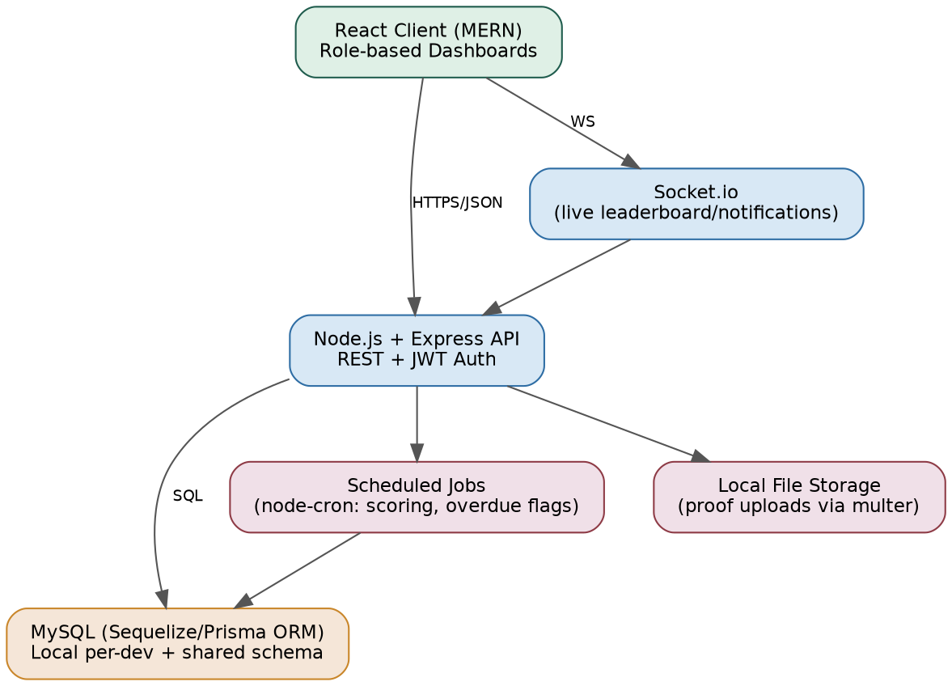
Figure 2 — Recommended architecture for a locally-run MERN + MySQL build.
Note: this is deliberately the diagram of what to build, not a mockup of screens — it shows how the pieces talk to each other so all four developers share the same mental model before writing code.
- React (client) talks to an Express REST API over HTTPS/JSON; a Socket.io channel pushes live leaderboard and notification updates.
- Express API is organized by module (environmental, social, governance, gamification, reports, admin) — this is exactly how the 4-developer split in Section 8 is drawn.
- Sequelize or Prisma ORM sits between the API and MySQL, so schema changes are version-controlled migrations, not manual SQL run by hand.
- Scheduled jobs (node-cron) recompute overdue compliance flags and can recompute ESG scores on an interval, or scores can be computed on-demand to save build time.
- Proof files (CSR/Challenge evidence) are stored on local disk via multer for the demo; note in Section 9 this is the one thing that needs a shared folder or object store if devs work on separate machines.

6. Tech Stack Recommendation (MERN + MySQL)
You specified MERN with SQL instead of Mongo — that's really "MEN + SQL": Express and Node stay, React stays, and MySQL replaces MongoDB as the data layer. Here's the concrete stack:
Layer | Recommendation | Why
Frontend | React (Vite) + Tailwind CSS + Redux Toolkit (or React Query) | Vite gives instant hot-reload for a fast build; Tailwind speeds up styling to hit the "good UI" bar quickly; React Query simplifies API state/loading/error handling.
Backend | Node.js + Express | As requested — minimal boilerplate, huge ecosystem, easy to split into 4 independent route modules for parallel work.
Database | MySQL 8 | See detailed comparison below — matches your local-PC requirement.
ORM | Prisma (or Sequelize) | Prisma gives you a single schema.prisma file as the source of truth + auto-migrations — very fast to keep 4 devs' local databases in sync.
Auth | JWT + bcrypt, role middleware (Admin/Manager/Employee) | Simple, stateless, no session store needed — one less moving part in a time-boxed build.
Realtime | Socket.io | Live leaderboard & notification badges without polling.
File uploads | Multer (local disk) → shared network folder or S3-compatible bucket if time allows | Proof-of-activity files need to be visible across the team's approval workflow.
Charts | Recharts or Chart.js | Fast to wire up for the Environmental/Social/Governance dashboards.
PDF/Excel export | Puppeteer (PDF) + ExcelJS (Excel) + json2csv (CSV) | Covers all three export formats the Custom Report Builder needs.
Dev environment | Docker Compose (one MySQL container defined once, used by all 4 devs) | Removes "works on my machine" schema drift — see Section 9.

6.1 MySQL vs. MongoDB for your specific constraint
You called out the real issue correctly: MongoDB Atlas (the common "local" setup) is still a cloud cluster underneath — even a "local" connection string in a tutorial is frequently just pointing at Atlas, and it's built around cluster/replica-set thinking even for local dev. MySQL is a single local process (or a single local Docker container) with a real, private, on-disk database file per machine — no cluster, no forced network dependency, no account tied to a cloud vendor. Given ESG data is fundamentally relational (Departments → Employees → Transactions → Scores, all with strict foreign keys and referential integrity that matters for audits/compliance), MySQL is also the structurally correct choice, not just the more "local" one.
Concern | MySQL (recommended) | MongoDB
Runs fully offline, no cloud account | Yes — install locally or via Docker, zero network dependency | Local mongod is possible, but most default setups (and every Atlas tutorial) assume a cloud cluster
Data integrity for financial/compliance-like records | Strong — foreign keys, transactions, ACID by default | Possible but requires manual discipline; not the default mental model
Fits a fixed, well-defined schema (Departments, Scores, Compliance Issues) | Natural fit — this data is inherently tabular/relational | Works, but you'd be fighting the document model for join-heavy ESG scoring
4 devs keeping schemas in sync | Easy — one migrations folder in git, `prisma migrate dev` on each machine | Similar tooling exists, but the natural MERN default nudges people toward Atlas anyway

Verdict
Go with MySQL 8, run through Docker Compose, one docker-compose.yml checked into the repo.
Every developer runs `docker compose up` and gets an identical, fully local database — no shared cluster, no internet dependency, no Atlas account.
For the final demo, merge into one running instance (see Section 9.4) so the whole team demos against the same live data.

7. Business Rule Engines (the part that makes this "smart")
These six rules are what separates EcoSphere from a plain CRUD app. Build each as an isolated, testable service function — not scattered inline logic — so any developer can call it from any route.

7.1. Auto Emission Calculation (Settings toggle)
Trigger: A new Purchase / Manufacturing / Expense / Fleet record is saved.
- If the toggle is ON: look up the matching EmissionFactor by activity type, compute calculated_co2e = quantity × factor, insert a CarbonTransaction with auto_generated = true.
- If OFF: allow manual CarbonTransaction entry through a form instead.

7.2. ESG Scoring Roll-up
Trigger: On-demand "Recalculate" action, or a nightly scheduled job.
- Environmental Score = function of emissions vs. goal attainment %.
- Social Score = function of CSR participation rate + diversity metrics + training completion.
- Governance Score = function of policy acknowledgement rate + audit pass rate + open/overdue compliance issues.
- Department Total Score = weighted average, default 40% Environmental / 30% Social / 30% Governance, configurable in Settings.
- Overall ESG Score = aggregate of all Department Total Scores.

7.3. Badge Auto-Award (Settings toggle)
Trigger: Any XP change or challenge completion event.
- Evaluate every Badge.unlock_rule (JSON: metric + threshold) against the employee's current stats.
- If satisfied and not already awarded, award the badge immediately and fire a notification — no manual admin step.

7.4. Reward Redemption
Trigger: Employee clicks "Redeem" on a catalog reward.
- Validate employee.points_balance >= reward.points_required AND reward.stock > 0.
- On success: deduct points, decrement stock, create a RewardRedemption record, fire a notification.

7.5. Evidence Requirement (Settings toggle)
Trigger: A Manager attempts to approve CSR or Challenge participation.
- If ON: block the status transition to Approved unless a non-null proof file is attached.

7.6. Compliance Issue Ownership & Overdue Flagging
Trigger: Compliance Issue creation, and a scheduled/on-load check.
- Owner and Due Date are mandatory fields — enforce at the API layer, not just the UI.
- Any issue where due_date < today AND status = Open is flagged as overdue and triggers a notification.

7.7 Notification System
A single notify(user, type, message) function called from all four trigger points below, respecting each user's Settings → Notification Settings preferences (in-app and/or email, per event type):
- New compliance issue raised
- CSR / Challenge approval decisions
- Policy acknowledgement reminders
- Badge unlocks

8. Full Entry-to-Exit User Journey
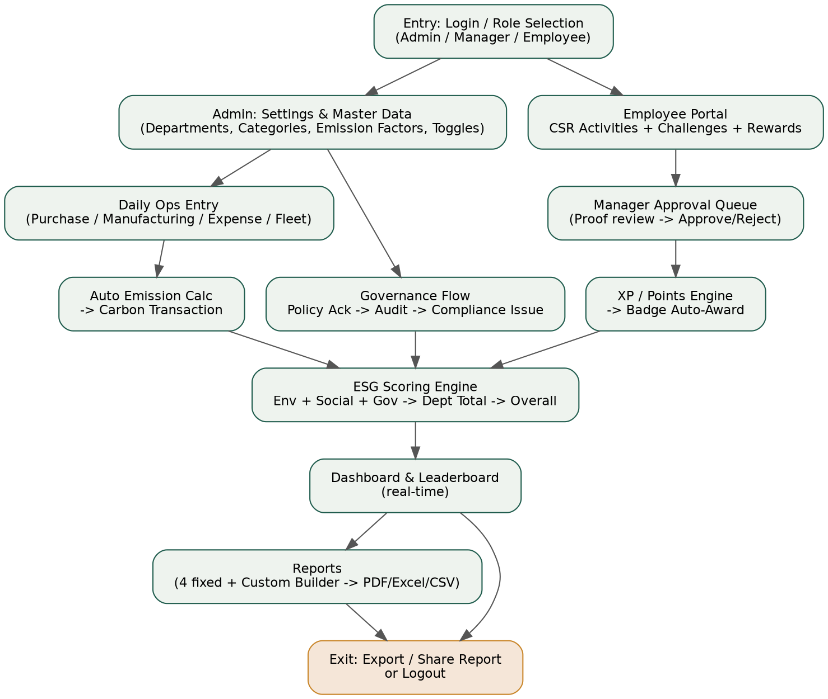
Figure 3 — Complete journey through the platform, from login to exporting a report.
- Entry — user logs in and lands on a role-specific view (Admin / Manager / Employee).
- Admin configures master data once: Departments, Categories, Emission Factors, Goals, Policies, Challenges, and all Section-7 toggles.
- Daily operational records (Purchase / Manufacturing / Expense / Fleet) are entered or simulated.
- Auto Emission Calculation converts those records into Carbon Transactions.
- Employees engage in parallel: join CSR Activities and Challenges, submit proof.
- Managers review the approval queue — approvals feed the XP Engine, which checks Badge unlock rules.
- Governance activity runs alongside: Policy Acknowledgements, Audits, and any resulting Compliance Issues (with mandatory Owner + Due Date).
- The Scoring Engine combines all three streams into Environmental / Social / Governance scores, then a weighted Department Total and Overall ESG Score.
- The Dashboard shows real-time scores, trends, department rankings, and the XP leaderboard.
- Exit — user generates/exports a report (fixed or Custom Report Builder, in PDF/Excel/CSV) or simply logs out; Notifications have been firing throughout in the background.

9. Four Developers, One Codebase, 8 Hours — Full Roadmap

9.1 Split by vertical module, not by frontend/backend
Splitting by "one person does all frontend, one does all backend" creates a bottleneck (everyone waits on the API). Instead, split by module — each developer owns a full vertical slice (DB tables → API routes → React screens) for their area. This lets all 4 people work with almost zero blocking.
Developer | Owns | Entities | Key screens
Dev A — Environmental & Core Setup | Emission Factors, Carbon Transactions, Goals, Auto-Calc rule, base project scaffold (auth, DB connection, shared UI shell) | EmissionFactor, CarbonTransaction, EnvironmentalGoal, ProductESGProfile | Emission Factor config, Carbon entry, Environmental Dashboard
Dev B — Social & Gamification | CSR Activities, Participation, Challenges, XP/Badge/Reward engine, Leaderboard | CSRActivity, EmployeeParticipation, Challenge, ChallengeParticipation, Badge, Reward, RewardRedemption | CSR CRUD, Challenge CRUD, Approval queue, Leaderboard, Reward catalog
Dev C — Governance & Notifications | Policies, Acknowledgements, Audits, Compliance Issues, Notification system | ESGPolicy, PolicyAcknowledgement, Audit, ComplianceIssue, Notification | Policy CRUD, Acknowledgement tracking, Audit/Compliance Kanban
Dev D — Scoring, Dashboard & Reports | ESG Scoring Engine, Org Dashboard, 4 fixed reports + Custom Report Builder, Settings screen | DepartmentScore + read access to all above | Org Dashboard, Settings (all toggles + weighting), Reports module

9.2 Why this split works
- Each module maps 1:1 to a brief section (Environmental / Social / Governance / Gamification+Reports), so nobody needs to touch someone else's tables in the first 6 hours.
- Dev A also owns the shared scaffold (project setup, auth, base layout, DB connection config) since that has to exist before anyone else can build — do this in the first 30 minutes, together, then split.
- Only two integration points require cross-talk: (1) XP/Points earned in Dev B's module must update Employee.xp_total, which Dev D's Scoring Engine reads; (2) Notifications (Dev C) are called from Dev A/B's approval and creation logic. Stub these as simple function calls agreed on up front (e.g. `notify()`, `awardXP()`), so each dev can build against a shared interface without waiting on the other's implementation.

9.3 Git & environment workflow for 4 people on one repo
- One shared GitHub repo, `main` branch protected. Each dev works on `feature/environmental`, `feature/social`, `feature/governance`, `feature/scoring-reports`.
- Agree on the Prisma/Sequelize schema file structure in the first 15 minutes (Dev A drafts it from Section 4, everyone reviews in 5 minutes) — this is the single most important shared artifact, since migrations touch everyone.
- Merge to `main` at 3 fixed checkpoints (roughly hour 3, hour 5.5, hour 7) rather than continuously, to avoid mid-build merge conflicts eating your limited time.
- Use a shared `.env.example` and Docker Compose file (see 9.4) so "connect to the database" is identical for all four laptops.

9.4 Running MySQL locally across 4 laptops
Recommended local-DB workflow
1. Check a single docker-compose.yml (MySQL 8 service + fixed port + volume) into the repo — every developer runs `docker compose up -d` and gets an identical, isolated local database on their own machine.
2. Schema lives as Prisma/Sequelize migration files in git — nobody hand-edits tables; everyone runs `prisma migrate dev` to apply the same schema locally.
3. A shared `seed.js` script populates the same demo data (departments, employees, emission factors) on every machine, so screenshots/demos look consistent even though databases are physically separate.
4. For the final live demo: pick one laptop as the "demo host," have the other three either present their module against that machine's DB (over the local Wi-Fi/hotspot, MySQL configured to accept LAN connections) or simply do a final `git pull` + fresh `docker compose up` + `seed` on the host machine 15 minutes before demo time.

9.5 Hour-by-hour master timeline
Time | All 4 Devs Together | Dev A | Dev B | Dev C | Dev D
0:00–0:30 | Kickoff: agree schema (Sec. 4), repo, Docker Compose, branch names, shared function signatures (notify(), awardXP()) | - | - | - | -
0:30–2:00 | - | Auth + base layout + DB connection + Emission Factor CRUD | CSR Activity + Category CRUD | ESG Policy CRUD | Settings screen skeleton + toggle fields
2:00–3:00 | - | Carbon Transaction entry + Auto-Calc rule | Employee Participation + approval flow | Policy Acknowledgement + Audit CRUD | Department CRUD + Environmental Goal CRUD
3:00–3:15 | Checkpoint 1: merge to main, resolve schema drift | - | - | - | -
3:15–4:30 | - | Environmental Dashboard (charts) | Challenge CRUD + full lifecycle + Challenge Participation | Compliance Issue CRUD + overdue flag logic | Scoring Engine v1 (Env/Social/Gov formulas)
4:30–5:30 | - | Product ESG Profile + polish | XP engine + Badge auto-award + Reward + redemption | Notification system (all 4 trigger points) | Department Total + Overall ESG Score roll-up
5:30–5:45 | Checkpoint 2: merge to main, smoke-test cross-module calls | - | - | - | -
5:45–6:45 | - | Support/bugfix + seed data | Leaderboard + Evidence Requirement toggle | Notification Settings UI | Org Dashboard (scores, trends, rankings)
6:45–7:30 | - | Support/bugfix | Support/bugfix | Support/bugfix | 4 fixed reports + Custom Report Builder + export
7:30–7:45 | Checkpoint 3 (final): merge, deploy/run on demo host, seed fresh data | - | - | - | -
7:45–8:00 | Full end-to-end run-through + demo script rehearsal (all 4 present) | - | - | - | -

10. Bonus Features (Section 9 of the brief)
Build these only after the checklist in Section 11 is fully green — they're explicitly optional in the brief, so treat them as stretch goals for the last hour, not core scope.
- Department ESG rankings — sort/rank departments by Total Score on the Org Dashboard (cheap to add once scoring exists).
- Smart dashboard visualizations — trend lines, heatmaps of emissions by department, XP-over-time charts.
- Mobile-responsive interface — Tailwind's responsive utilities make this close to free if used consistently from the start, rather than retrofitted at the end.

11. UI Theme & Design System Suggestions
An ESG product should visually read as "credible sustainability tool," not "generic admin panel." Two ready-to-use directions:

Option A — "Canopy" (recommended, used throughout this document)
Role | Color | Hex
Primary / brand | Deep forest green | #1F5C4D
Secondary accent | Warm gold (rewards/gamification) | #C9862A
Info / links | Slate blue (Social module) | #2E6DA4
Alert / governance | Muted maroon (compliance/overdue) | #8E3B46
Background | Warm off-white | #F7F5F0
Text | Near-black ink | #2B2B2B

- Typography: Inter or Calibri for UI text; a slightly rounded display font (e.g. Poppins SemiBold) for dashboard numbers/scores.
- Module color-coding carries through the whole app: Environmental = green, Social = blue, Governance = maroon, Gamification = gold — used consistently keeps 4 developers' screens visually coherent even though built independently.
- Component style: soft rounded corners (8px), subtle shadows, generous whitespace — avoid harsh corporate blue/gray "enterprise software" look.

Option B — "Slate Sustainability" (cooler, more "fintech-dashboard" feel)
Role | Color | Hex
Primary | Teal | #0F766E
Secondary accent | Amber | #D97706
Background | Cool light gray | #F1F5F9
Card surfaces | White with soft shadow | #FFFFFF
Text | Slate 800 | #1E293B

Either theme works — pick Option A if you want to visually differentiate from typical SaaS dashboards, Option B if you want a more "enterprise fintech" polish. Apply the chosen palette as Tailwind theme tokens on hour 0 so all 4 developers inherit it automatically.

12. Deliverables Checklist — Definition of Done
- All Master + Transactional entities implemented with correct relationships (Sec. 4)
- Auto Emission Calculation toggle working end-to-end
- Full Challenge lifecycle: Draft → Active → Under Review → Completed / Archived
- Badge Auto-Award triggered by real XP/completion events, not manual
- Reward Redemption correctly deducts points and respects stock
- Evidence Requirement toggle enforced on approval transitions
- Compliance Issues require Owner + Due Date; overdue ones are flagged
- Notification system covers all 4 required trigger types
- ESG scoring rolls up Department → Organization with configurable weighting
- 4 fixed reports + Custom Report Builder with all 6 filters, exportable to PDF/Excel/CSV
- Dashboard shows org score, trends, department ranking, and leaderboard
- Settings screen exposes every toggle/configuration from Section 7
- End-to-end smoke test passes: ops entry → auto carbon txn → dashboard updates → CSR approval → XP/badge fires → score changes → report generates

