Date:

**EXPERIMENT: 1**

**AIM:** Introduction to computer Hardware, Types of Memory, Types of Motherboard, Types of Processors.

**QUIZ RESULT:**

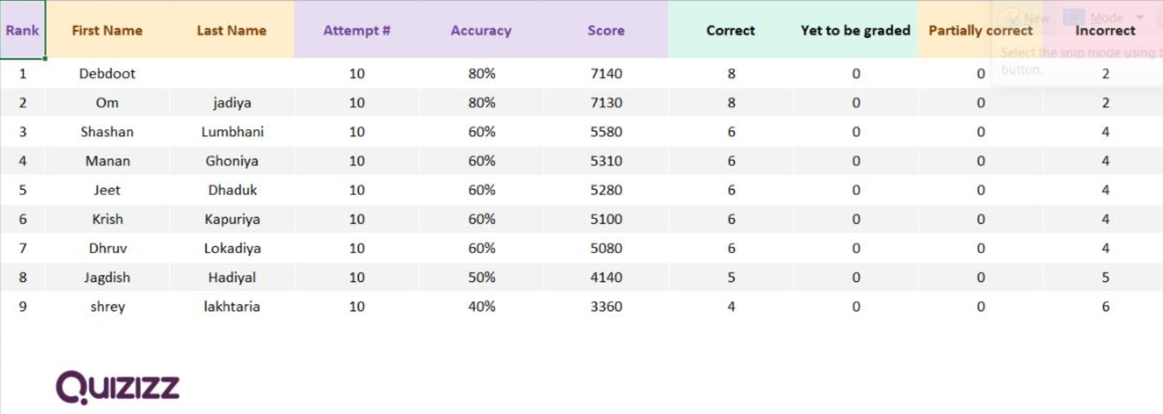

**OBSERVATIONS:**

Components:

1.Proceser

|  |  |
| --- | --- |
| Intel Computer Processor at Rs 1,100 / pcs in Delhi | PRASHAD COMPUTERS |  |

2.Memory

|  |  |
| --- | --- |
| Ram memory 1080P, 2K, 4K, 5K HD wallpapers free download | Wallpaper Flare |  |

3.Storage

|  |  |
| --- | --- |
| SSD vs HDD: What's the difference, and which should you buy? | ZDNET |  |

INPUT DEVISE:

1.Mouse

|  |  |
| --- | --- |
| Logitech M190 Wireless Mouse - Full Size Curve Design |  |

2.Keyboard

|  |  |
| --- | --- |
| Amazon.in: Buy Razer Huntsman Mini 60% Gaming Keyboard: Fastest Keyboard  Switches Ever - Clicky Optical Switches - Chroma RGB Lighting - PBT Keycaps  - Onboard Memory - Classic Black Online at Low |  |

**CONCLUSION:**