Date:

**EXPERIMENT: 3**

**AIM:** Installation of Linux and windows using VMWare/Virtual Box.

**DRIVE LINK OF VIDEO:**

Window’s setup:

[**https://drive.google.com/file/d/1QmxD9OqN8FjkwJ2k3QcEWgcOxN8avFY/view?usp=drive_link**](https://drive.google.com/file/d/1QmxD9OqN8FjkwJ2k3QcEWgcOxN8avFY/view?usp=drive_link)

Ubuntu setup:

[**https://drive.google.com/file/d/13zs2Go6eDh85Azemzl4S5U8B3F_uNFW/view?usp=drivesdk**](https://drive.google.com/file/d/13zs2Go6eDh85Azemzl4S5U8B3F_uNFW/view?usp=drivesdk)

**to be continue…**

[**https://drive.google.com/file/d/197M7tbk9bJMvbB44bt_ITwaqRcQYOkC_/view?usp=drivesdk**](https://drive.google.com/file/d/197M7tbk9bJMvbB44bt_ITwaqRcQYOkC_/view?usp=drivesdk)

**SCREENSHOTS OF IMPLENTATION:**

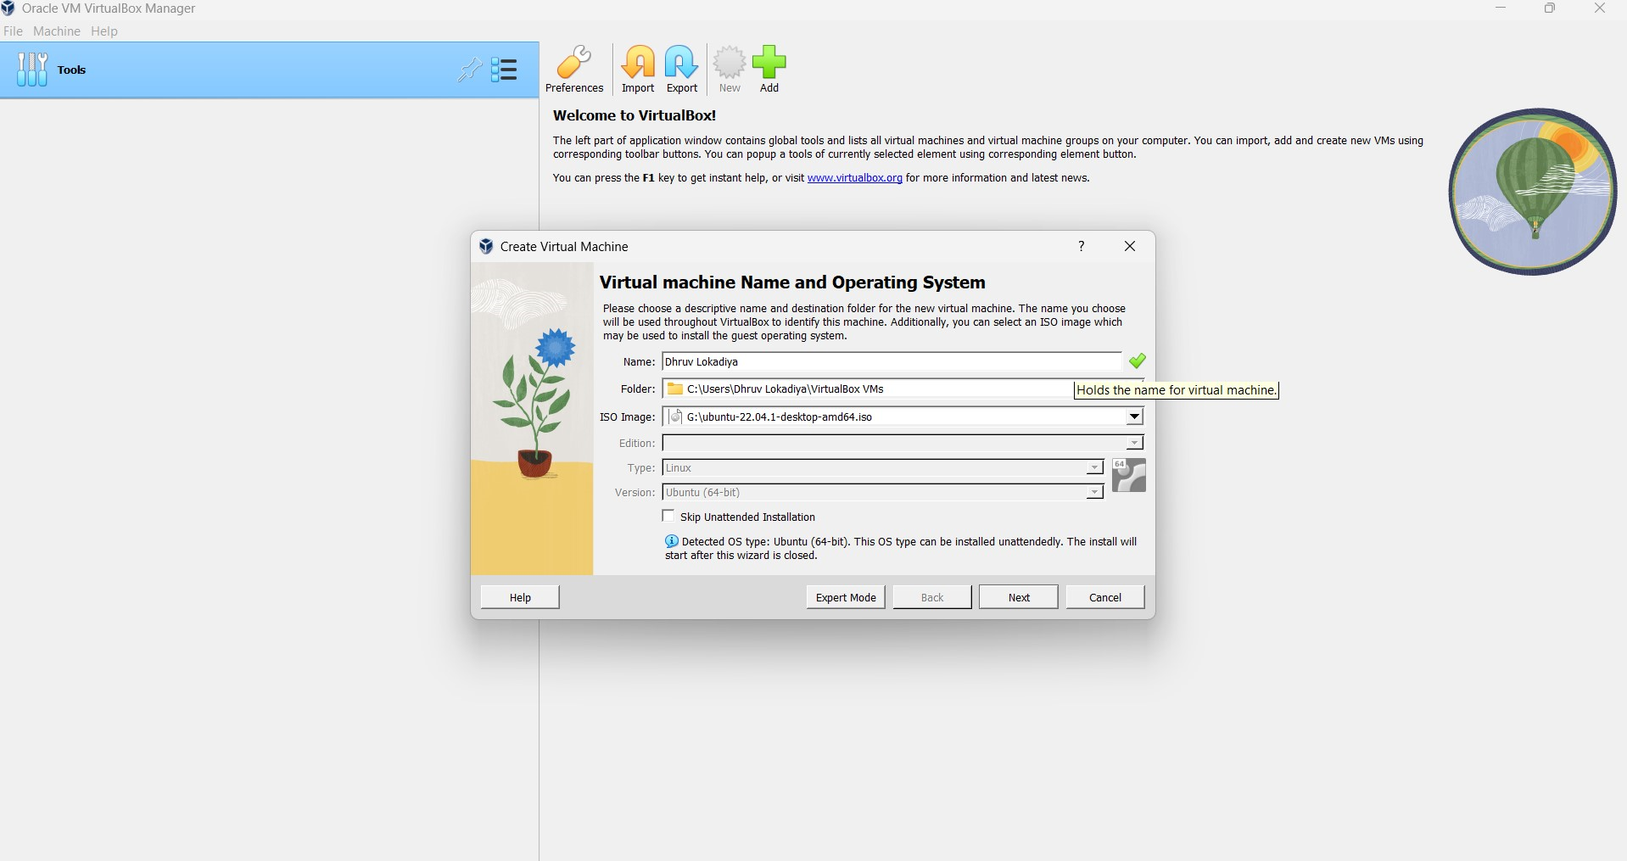

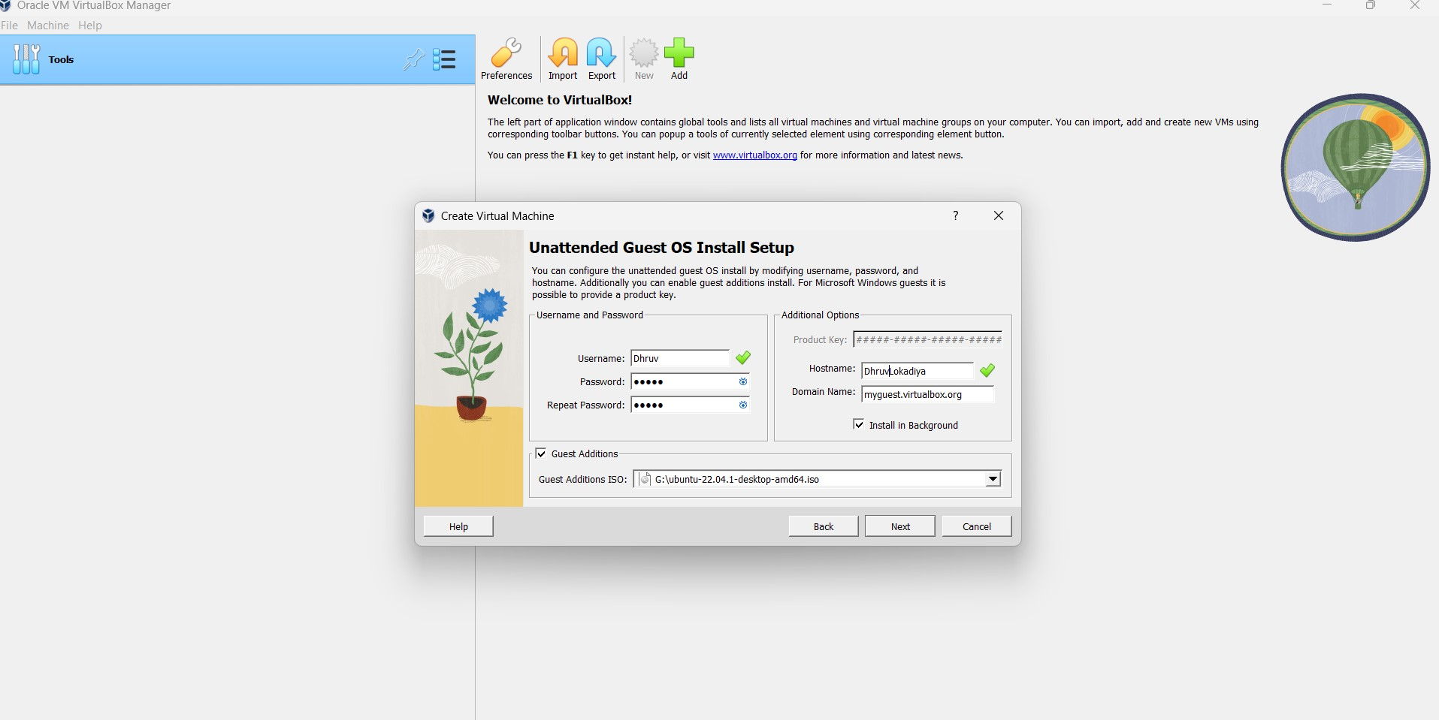

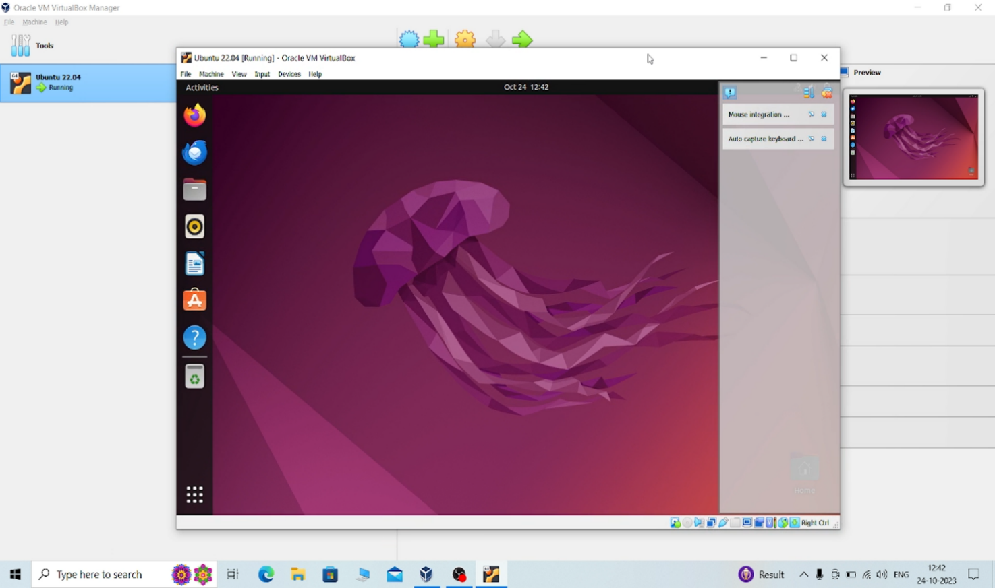

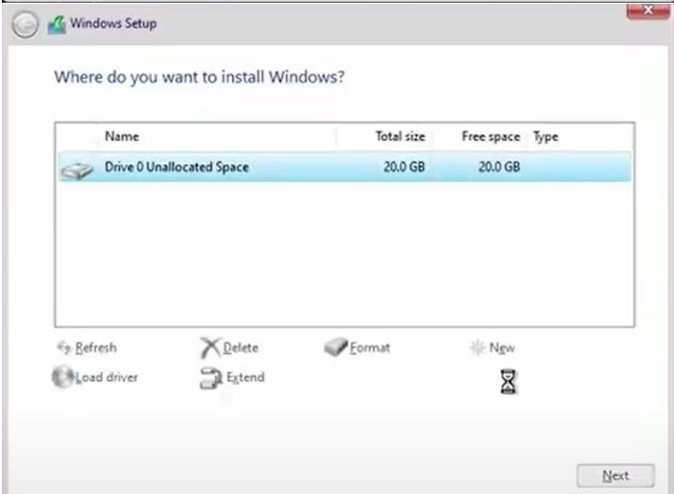

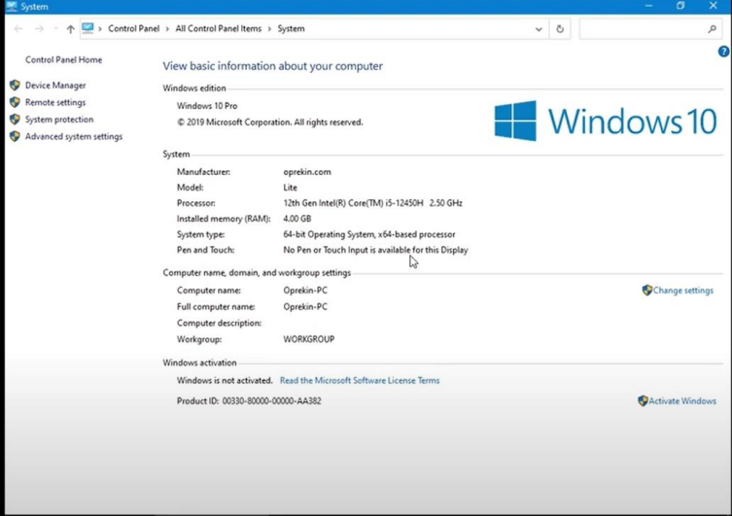

**OBSERVATIONS:**

**CONCLUSION:**