Date:

**EXPERIMENT: 7**

**AIM: Playing with Computer Network.**

**DCN Components (ICT)**

|  |  |  |
| --- | --- | --- |
| Sr. No. | Components Name & Picture | Description of Component |
| 1 | Ethernet Cables |  |
| 2 | Clamping Tool |  |
| 3 | Console Cable |  |
| 4 | Cable Tester    Figure 1scl nxc xz xz xz |  |
| 5 | Manageable Switch |  |
| 6 | Normal Switch |  |
| 7 | Router |  |
| 8 | Chromecast |  |
| 9 | Passive Extender |  |
| 10 | Active Extender |  |
| 11 | Converter |  |
| 12 | Normal ethernet extender |  |
| 13 | Passive Splitter |  |
| 14 | USB to Ethernet Cable |  |
| 15 | POE Splitter |  |
| 16 | NIC Card for optical fiber |  |
| 17 | NIC Card for wireless |  |
| 18 | NIC Card for wireline |  |
| 19 | Faceplate Punch Tool |  |
| 20 | Rack |  |

**Assign IP Address to each Network:**

1. **BUS Topology**

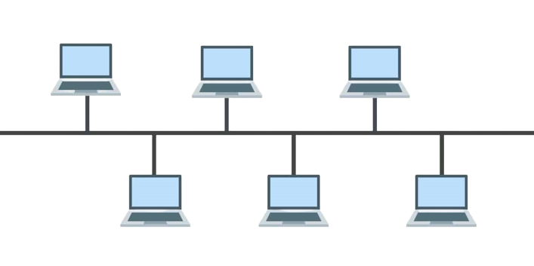

1. **Star Topology**

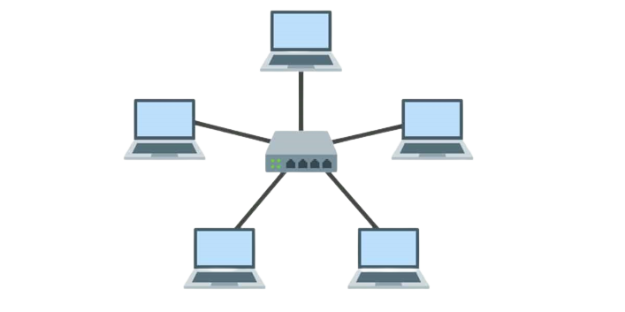**3. Ring Topology**

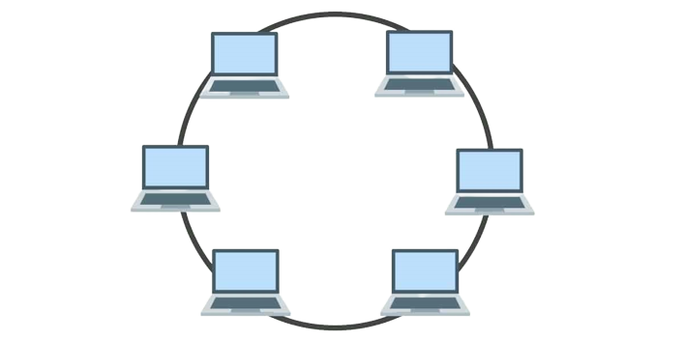

1. **Mesh Topology**

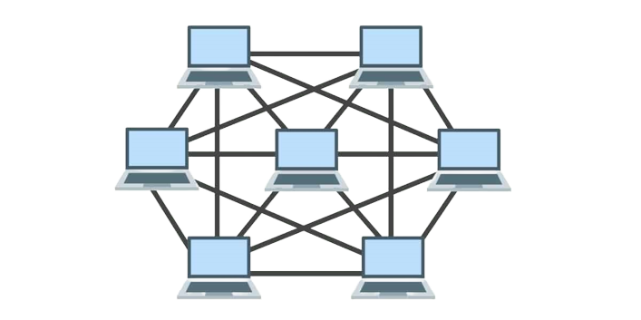

1. **Tree Topology**

