Date:

**EXPERIMENT: 9**

**AIM:** Introduction to Arduino/ESP32 & implement sample programs of i. Blink LED, ii. LED with timer and iii. LED control from Switch.

**OBJECTIVES:**

1. To study datasheet and Pin diagram of ESP32
2. Implement Blink LED program.
3. Implement program to control LED intensity with timer.
4. Implement program to control LED from switch

**COMPONENTS:**

1. **A close-up of a microchip

   Description automatically generatedESP32:**

ESP32 is a series of low-cost, low-power microcontrollers with integrated Wi-Fi and Bluetooth connectivity. [It is suitable for a wide range of IoT applications and can be programmed using various languages and frameworks](https://www.espressif.com/en/products/socs/esp32).

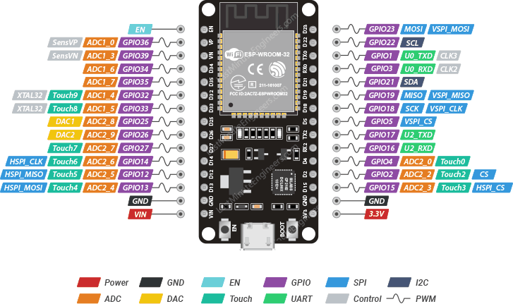

1. **USB Cable:**

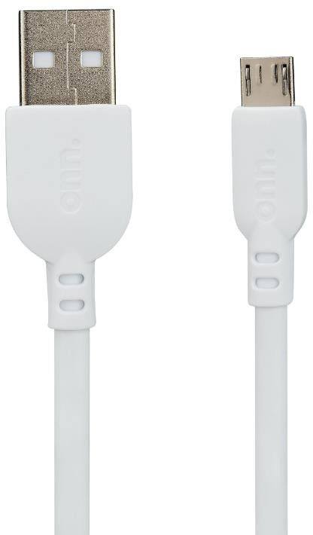

USB cables are cables that can be used to connect, charge, and transfer data between various devices, such as computers, smartphones, cameras, and more.

1. **LED:**

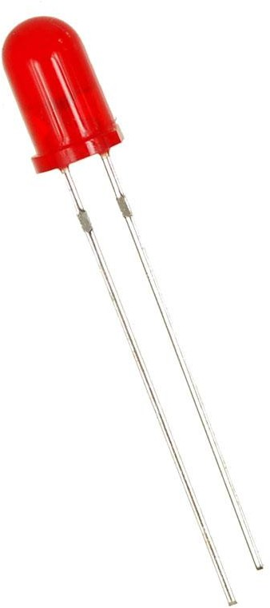

LED stands for light-emitting diode, which is a semiconductor device that emits light when an electric current flows through it.

1. **Button:**

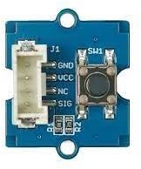

Grove button is a type of button that can be used with the Grove system, which is a modular and easy-to-use platform for connecting sensors, actuators, and displays.

1. **jumper wire:**

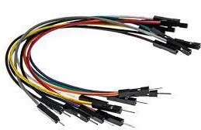

Jumper wires are wires that have connectors or pins at each end, which can be used to connect two points in a circuit without soldering.

**CONNECTION DIAGRAM:**

1. 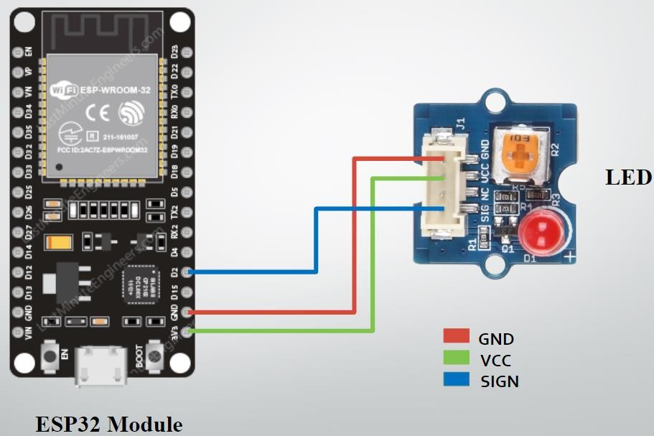**9.1 and 9.2**
2. **A diagram of a circuit board

   Description automatically generated9.3:**

**CODES:**



**9.1:**

**const int ledpin=2;**

**void setup()**

**{**

**pinMode(ledpin,OUTPUT);**

**}**

**void loop()**

**{**

**digitalWrite(ledpin,HIGH);**

**delay(1000) digitalWrite(ledpin,LOW);**

**delay(1000);**

**}**

**9.2:**

**int led = 23;**

**int brightness = 0;**

**int fadeAmount = 5;**

**void setup()**

**{**

**pinMode(led,OUTPUT);**

**}**

**void loop()**

**{**

**analogWrite(led,brightness);**

**brightness=brightness + fadeAmount;**

**if (brightness <=0 || brightness >= 255)**

**{**

**fadeAmount = -fadeAmount;**

**}**

**delay(30);**

**}**

**9.3:**

**const int buttonPin = 22;**

**const int ledPin = 23;**

**const int suppl = 19;**

**const int groun = 21;**

**int buttonState = 0;**

**void setup()**

**{**

**pinMode(ledPin, OUTPUT);**

**pinMode(buttonPin, INPUT); pinMode(suppl, OUTPUT);**

**pinMode(groun, OUTPUT);**

**digitalWrite(suppl, HIGH);**

**digitalWrite(groun, LOW);**

**}**

**void loop()**

**{**

**buttonState = digitalRead(buttonPin);**

**if (buttonState == HIGH)**

**{**

**digitalWrite(ledPin, HIGH);**

**}**

**else**

**{**

**digitalWrite(ledPin, LOW);**

**}**

**}**

**OUTPUTS:**

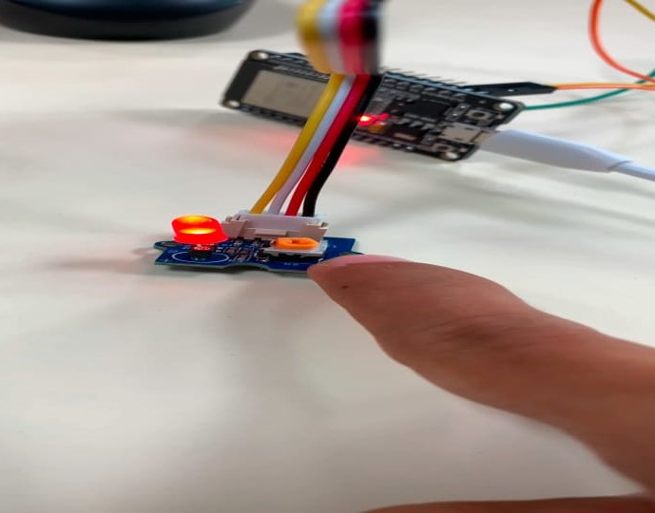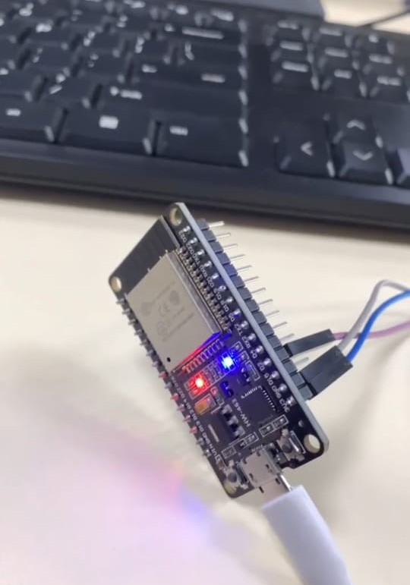**9.1: 9.2:**

**9.3:**

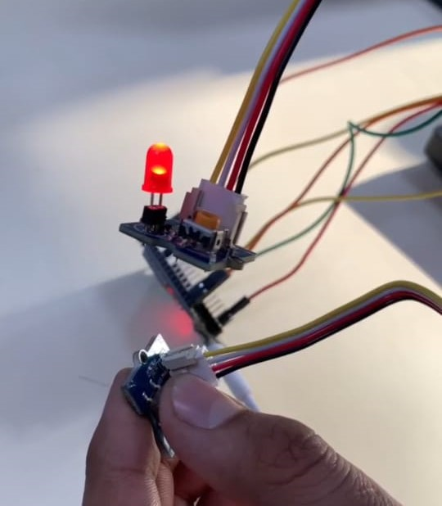

**OBSERVATIONS:**

**CONCLUSION:**

**DRIVE LINK OF VIDEO:**

**9.1:** [**https://drive.google.com/file/d/1bHL3bfXyaidL2OhV-fBAS9NkO7wah1p-/view?usp=drivesdk**](https://drive.google.com/file/d/1bHL3bfXyaidL2OhV-fBAS9NkO7wah1p-/view?usp=drivesdk)

**9.2:** <https://drive.google.com/file/d/1TanKtVY7TQ2s4jOED6_SgpJugeTpdEca/view?usp=drivesdk>

**9.3:**[**https://drive.google.com/file/d/1csVqUcZhEGe4QWQBSREbga7n5atPJFqZ/view?usp=drivesdk**](https://drive.google.com/file/d/1csVqUcZhEGe4QWQBSREbga7n5atPJFqZ/view?usp=drivesdk)

**SUBMITTED BY:**

1. 23CS041 – Dhruv Lokadiya
2. 23CS036 – Ved Kheni