Date:

**EXPERIMENT: 11**

**AIM:** Design following mobile applications using MIT app inventor: i. Talk to me app ii. Ball bounce app iii. Digital Doodle app and iv. Bluetooth client app

**OBJECTIVES:**

1. Design and Simulate Talk to me app
2. Design and Simulate Ball Bounce app
3. Design and Simulate Digital Doodle app
4. Design and Simulate Bluetooth client app

**UI DESIGN:**

**11.1 :**

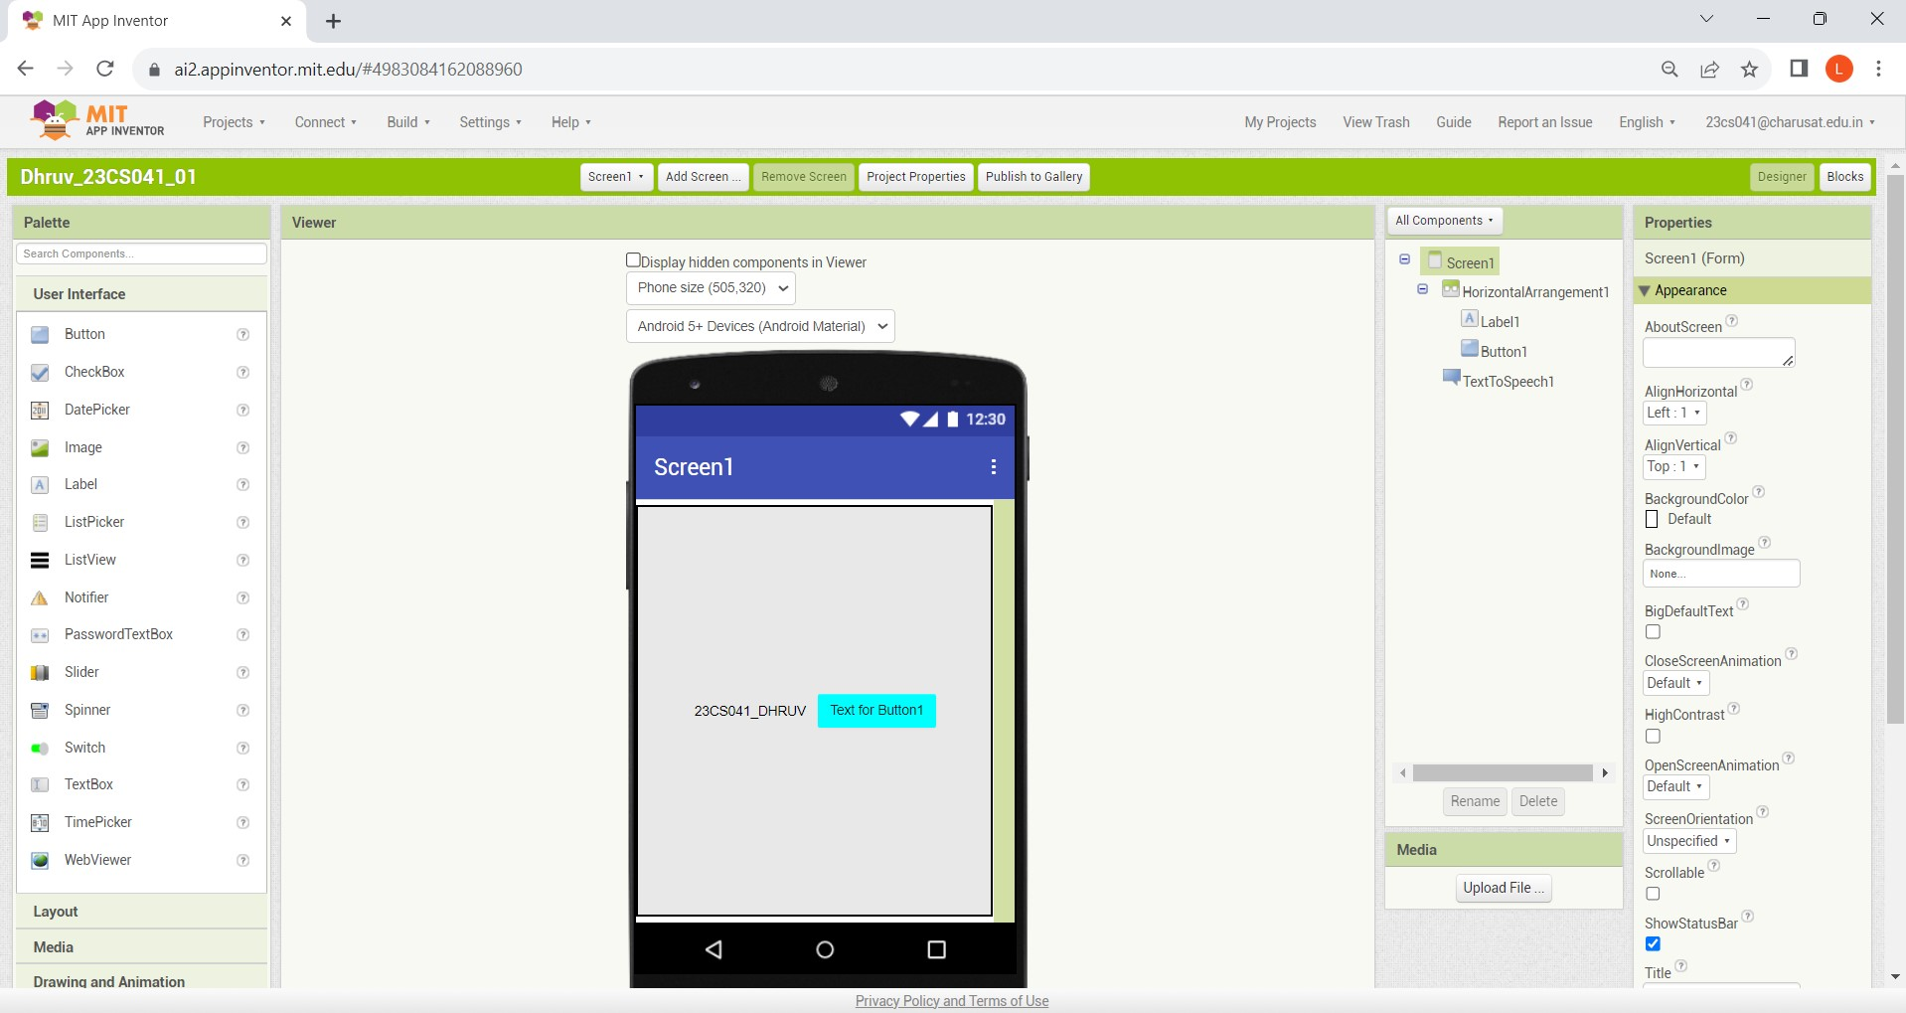

**11.2 :**

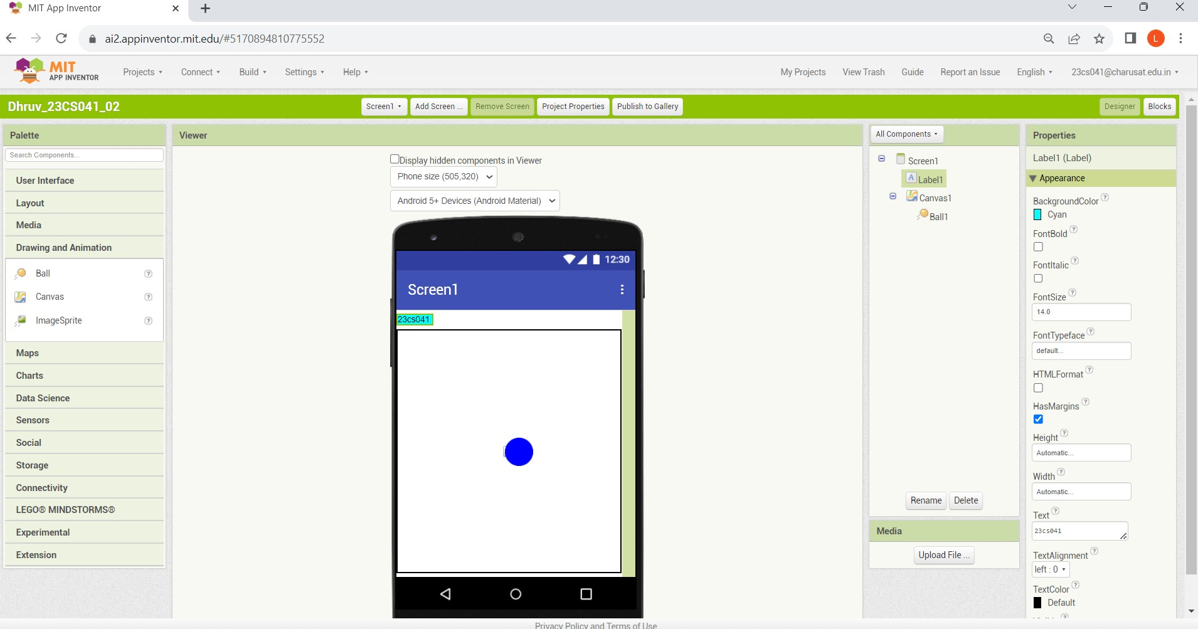

**11.3:**

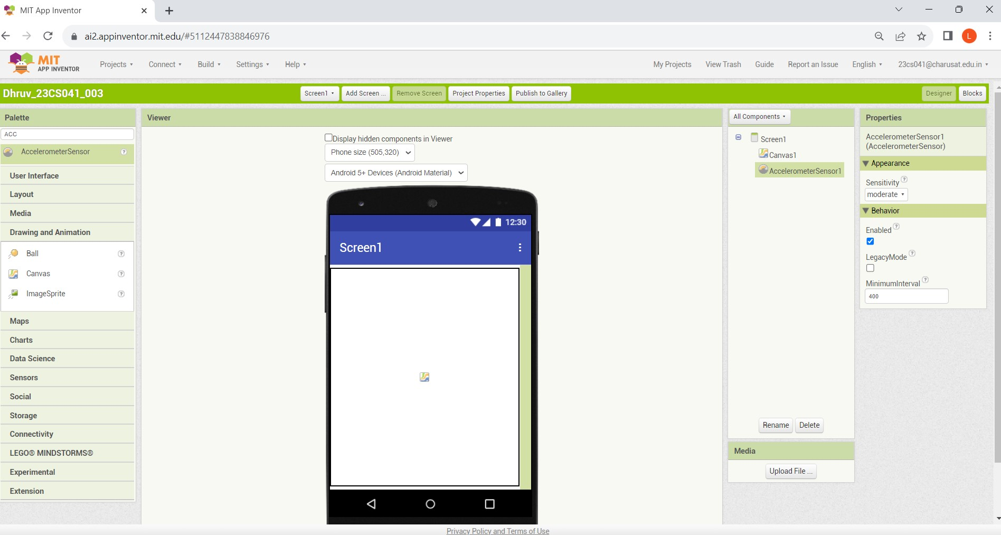

**11.4:**

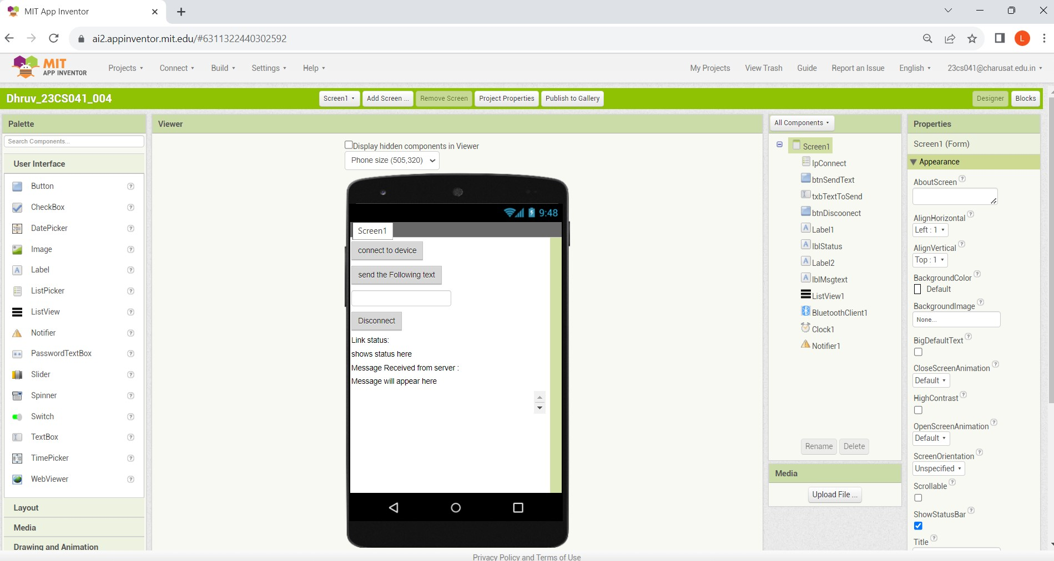

**CODE:**

**11.1 :**

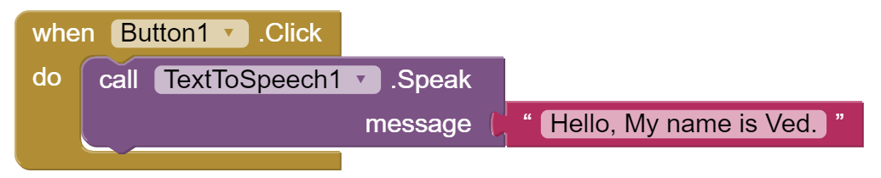

11.2:

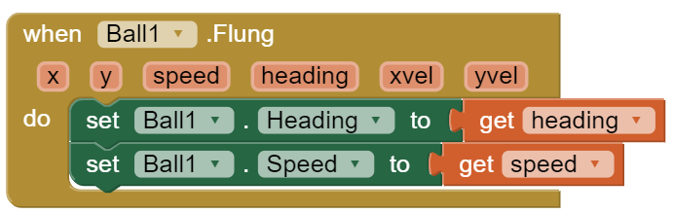

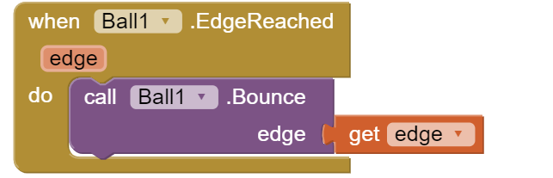

11.3:

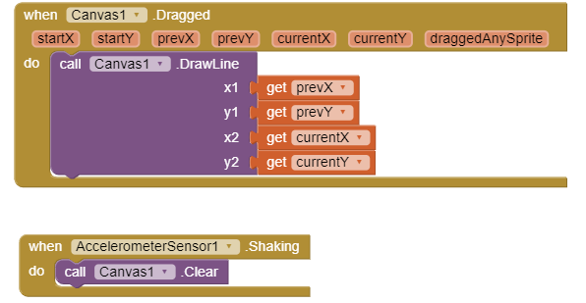

11.4:

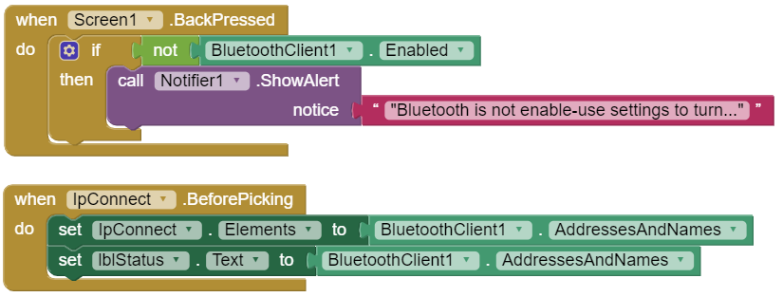

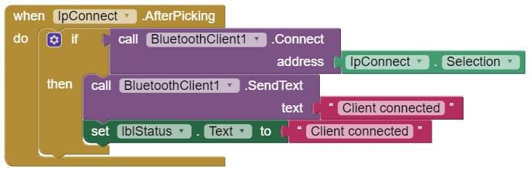

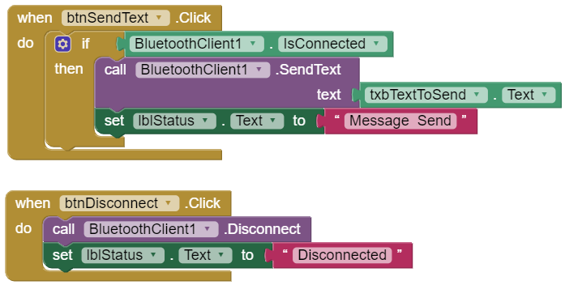

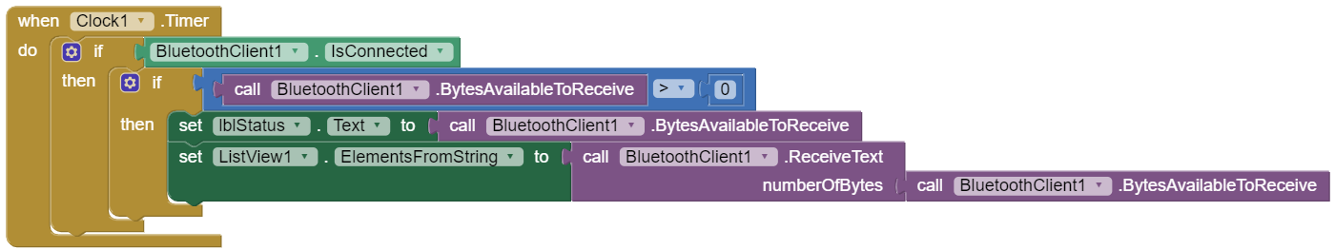

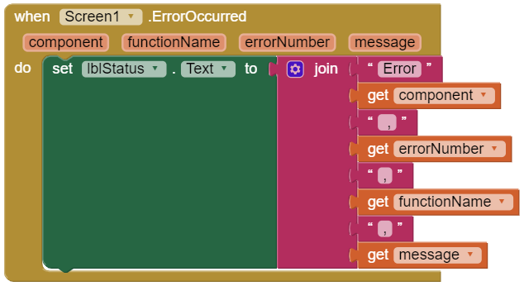

**OBSERVATIONS:**

**____________________________________________________________________________________________________________________________________________________________________________________________________________________________________________________________________________________________________________________________________________________________________________________________________________________________________________________________________________________________________________________________________________________________________________________________________________________________________________________________________________________________________________________________________________________________________________________________________________________________________________________________________________________________________________________________________**

**CONCLUSION:**

**____________________________________________________________________________________________________________________________________________________________________________________________________________________________________________________________________________________________________________________________________________________________________________________________________________________________________________________________________________________________________________________________________________________________________________________________________________________________________________________________________________________________________________________________________________________________________________________________________________________________________________________________________________________________________________________________________**

**DRIVE LINK OF VIDEO:**

**11.1 –** [**https://drive.google.com/file/d/1YBv65cl-v-jIGRZ5mgWlVhSqNyAzNs4j/view?usp=drivesdk**](https://drive.google.com/file/d/1YBv65cl-v-jIGRZ5mgWlVhSqNyAzNs4j/view?usp=drivesdk)

**11.2 –** [**https://drive.google.com/file/d/1YPMJvkY73n-DEJ_QjneL_JZgX997bf3i/view?usp=drivesdk**](https://drive.google.com/file/d/1YPMJvkY73n-DEJ_QjneL_JZgX997bf3i/view?usp=drivesdk)

**11.3 -**[**https://drive.google.com/file/d/1YIP1cjoGLCL76lE3j_jTpUh_6Op5A1vG/view?usp=drivesdk**](https://drive.google.com/file/d/1YIP1cjoGLCL76lE3j_jTpUh_6Op5A1vG/view?usp=drivesdk)

**11.4 –** [**https://drive.google.com/file/d/1YPHiGImDRnIrdN4_MaOsBicFAIuvC7lF/view?usp=drivesdk**](https://drive.google.com/file/d/1YPHiGImDRnIrdN4_MaOsBicFAIuvC7lF/view?usp=drivesdk)

**SUBMITTED BY:**

1. 23CS041- DHRUV LOKADIYA