Date:

**EXPERIMENT: 12**

**AIM:** Learn to utilize Bluetooth Module on ESP32 and implement codes to : i. scan Bluetooth devices in range ii. connect Bluetooth device and transfer data from and to ESP32 with APP iii. control LED on ESP32 through Bluetooth app.

**OBJECTIVES:**

1. Implement code to scan Bluetooth devices in range
2. Implement code to connect Bluetooth device and transfer data from and to ESP32 with app
3. Implement code to control LED on ESP32 through Bluetooth app

**COMPONENTS:**

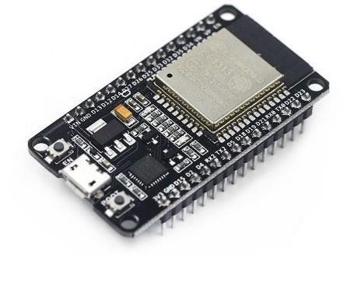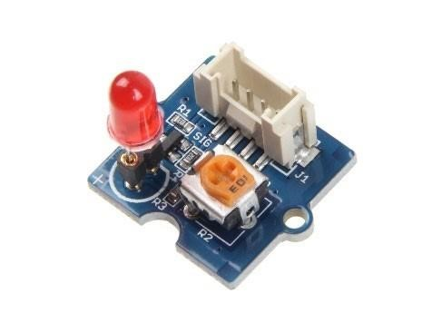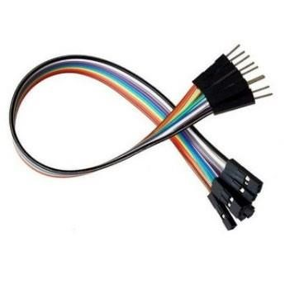

**CONNECTION DIAGRAM:**

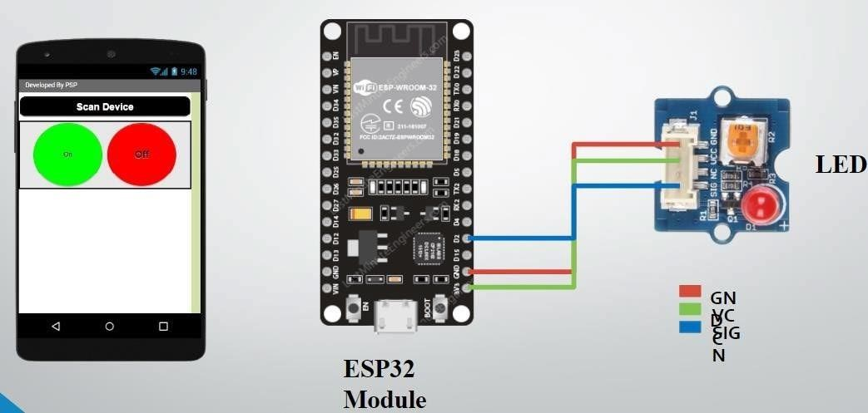

**CODES:**

**12.1:**

#include <BluetoothSerial.h>

#if !defined(CONFIG_BT_ENABLED) ||

!defined(CONFIG_BLUEDROID_ENABLED)

#error Bluetooth is not enabled! Please run make menuconfig to and enable it

#endif

#if !defined(CONFIG_BT_SPP_ENABLED)

#error Serial Bluetooth not available or not enabled. It is only available for the ESP32 chip.

#endif

BluetoothSerial SerialBT;

#define BT_DISCOVER_TIME 10000

static bool btScanAsync = true; static bool btScanSync = true; void btAdvertisedDeviceFound(BTAdvertisedDevice* pDevice) {

Serial.printf("Found a device asynchronously: %s\n", pDevice->toString().c_str()); void setup() {

Serial.begin(115200);

SerialBT.begin("ESP32TEST23AIML051|058|069|071|073"); //Bluetooth device name

Serial.println("The device started, now you can pair it with bluetooth!"); if (btScanAsync) {

Serial.print("Starting discoverAsync...");

if (SerialBT.discoverAsync(btAdvertisedDeviceFound)) {

Serial.println("Findings will be reported in \"btAdvertisedDeviceFound\""); delay(10000);

Serial.print("Stopping discoverAsync... ");

SerialBT.discoverAsyncStop();

Serial.println("stopped");

} else {

Serial.println("Error on discoverAsync f.e. not workin after a \"connect\"");

}

}

if (btScanSync) {

Serial.println("Starting discover...");

BTScanResults *pResults = SerialBT.discover(BT_DISCOVER_TIME); if

(pResults) pResults->dump(&Serial);

else

Serial.println("Error on BT Scan, no result!");

} } void loop() { delay(100);}

}

**12.2:**

#include <BluetoothSerial.h>

#if !defined(CONFIG_BT_ENABLED) ||

!defined(CONFIG_BLUEDROID_ENABLED)

#error Bluetooth is not enabled! Please run make menuconfig to and enable it

#endif

#if !defined(CONFIG_BT_SPP_ENABLED)

#error Serial Bluetooth not available or not enabled. It is only available for the ESP32 chip.

#endif

BluetoothSerial SerialBT;

#define BT_DISCOVER_TIME 10000 byte BTData; void setup() { Serial.begin(115200);

SerialBT.begin("ESP32test23aiml051|058|069|071|73"); //Bluetooth device name

Serial.println("The device started, now you can pair it with bluetooth!");

} void loop() { if (Serial.available()) { SerialBT.write(Serial.read());

} if (SerialBT.available()) { BTData=SerialBT.read();

Serial.write(BTData);

}

delay(20);

}

**12.3:**

#include "BluetoothSerial.h"

#if !defined(CONFIG_BT_ENABLED) ||

!defined(CONFIG_BLUEDROID_ENABLED)

#error Bluetooth is not enabled! Please run make menuconfig to and enable it

#endif

#if !defined(CONFIG_BT_SPP_ENABLED)

#error Serial Bluetooth not available or not enabled. It is only available for the ESP32 chip.

#endif

BluetoothSerial SerialBT; const int led=2; byte BTData; void setup() { pinMode(led,OUTPUT);

Serial.begin(115200);,

SerialBT.begin("23AIML051|058|069|071|073"); //Bluetooth device name

Serial.println("The device started, now you can pair it with bluetooth!");

} void loop() { if (Serial.available()) {

SerialBT.write(Serial.read());

}

if (SerialBT.available()) { BTData=SerialBT.read();

Serial.write(BTData);

}

if(BTData== '1')

{

digitalWrite(led,HIGH);

}

else if(BTData== '0')

{

digitalWrite(led,LOW);

}

delay(20);

}

**OUTPUTS:**

**12.1:**

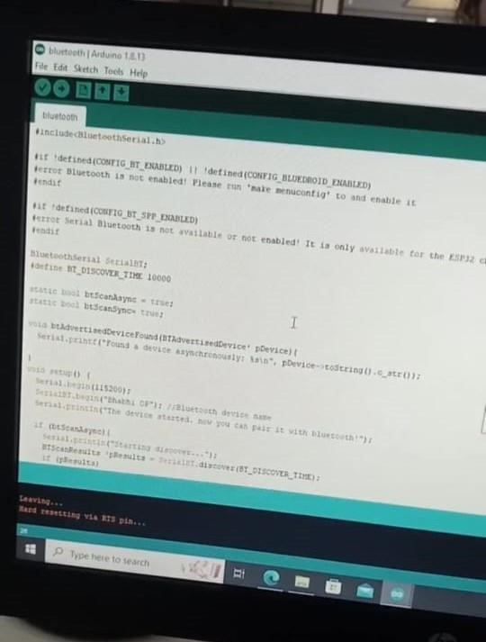

**12.2:**

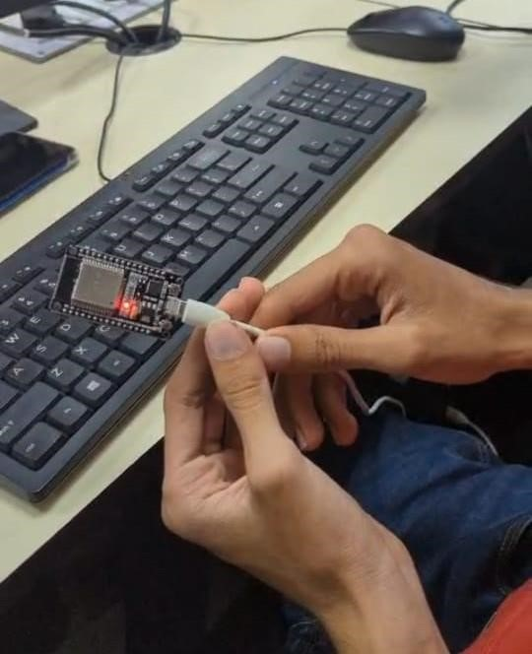

**12.3:**

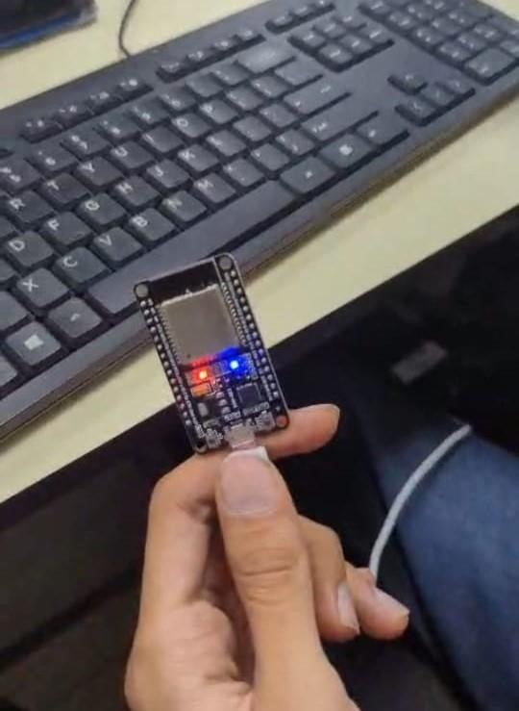

**OBSERVATIONS:**

**CONCLUSION:**

**DRIVE LINK OF VIDEO:**

**12.1:** <https://drive.google.com/file/d/1CqZMhX3i0KSdNK0-XBroaD8DEdld56S_/view?usp=drivesdk>

**12.2:**[**https://drive.google.com/file/d/1nSBTYdVDDeU7wGpc26b6yJXdw2GzKWLz/view?usp=drivesdk**](https://drive.google.com/file/d/1nSBTYdVDDeU7wGpc26b6yJXdw2GzKWLz/view?usp=drivesdk)

**12.3:**[**https://drive.google.com/file/d/1z6QjI7XlrP2eRh8vIl4loDb570SOWbEm/view?usp=drivesdk**](https://drive.google.com/file/d/1z6QjI7XlrP2eRh8vIl4loDb570SOWbEm/view?usp=drivesdk)

**SUBMITTED BY:**

1. 23CS041-DHRUV LOKADIYA
2. 23CS045-MITUL MISTRY
3. 23CS046-KATHAN MODH