Date: 21 October 2023

**EXPERIMENT: 6**

**AIM:** Workshop on Github

**SCREENSHOTS OF GITHUB ACCOUNT:**

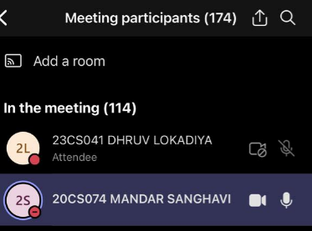

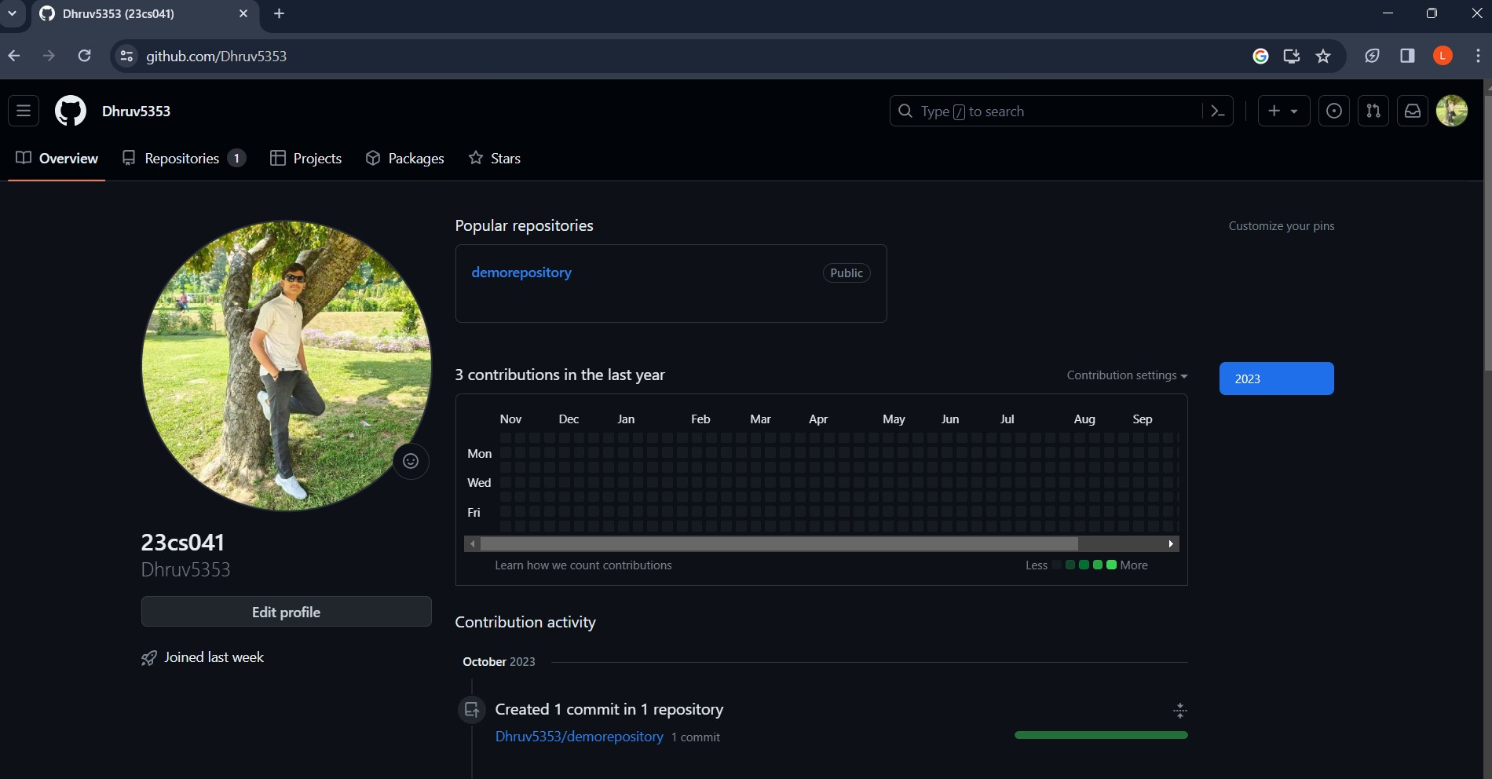

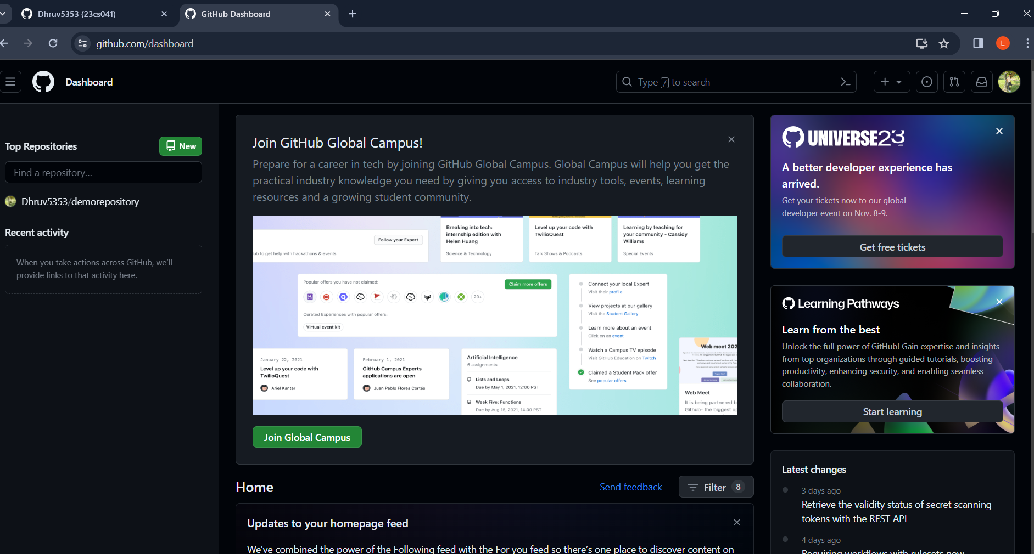

**QUIZ RESULT:**

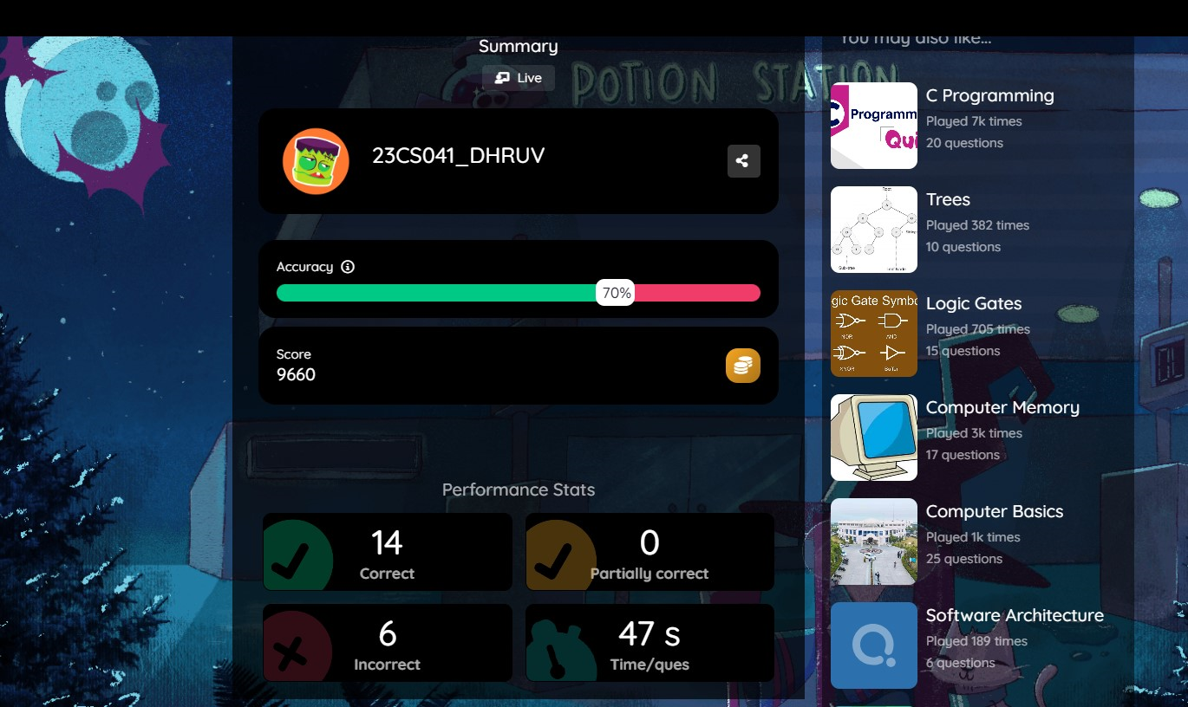

**LINK OF YOUR GITHUB PROFILE:**

<https://github.com/Dhruv5353>