Date:

# EXPERIMENT NO. 1

#### AIM: Implement a circuit in logisim to display given decimal number in binary on to seven segment display.

**TASK: i. display 0 to 9 on a seven segment display with binary number as input**

**ii. display 0 to 99 using two seven segment displays with binary number as input**

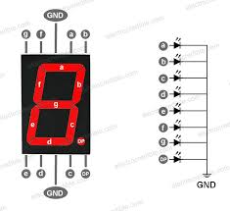

**TABLES OF CALCULATIONS:**

|  |  |  |  |  |  |  |  |  |  |  |  |
| --- | --- | --- | --- | --- | --- | --- | --- | --- | --- | --- | --- |
| **b3** | **b2** | **b1** | **b0** | **a** | **b** | **c** | **d** | **e** | **f** | **g** | **dp** |
|  |  |  |  |  |  |  |  |  |  |  |  |
|  |  |  |  |  |  |  |  |  |  |  |  |
|  |  |  |  |  |  |  |  |  |  |  |  |
|  |  |  |  |  |  |  |  |  |  |  |  |
|  |  |  |  |  |  |  |  |  |  |  |  |
|  |  |  |  |  |  |  |  |  |  |  |  |
|  |  |  |  |  |  |  |  |  |  |  |  |
|  |  |  |  |  |  |  |  |  |  |  |  |
|  |  |  |  |  |  |  |  |  |  |  |  |
|  |  |  |  |  |  |  |  |  |  |  |  |

**CIRCUITS:**

1. **0 to 9 :**

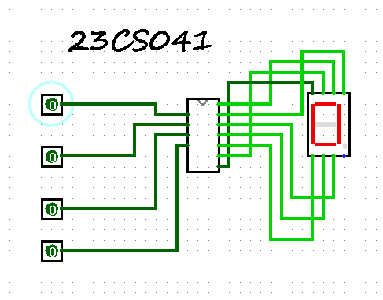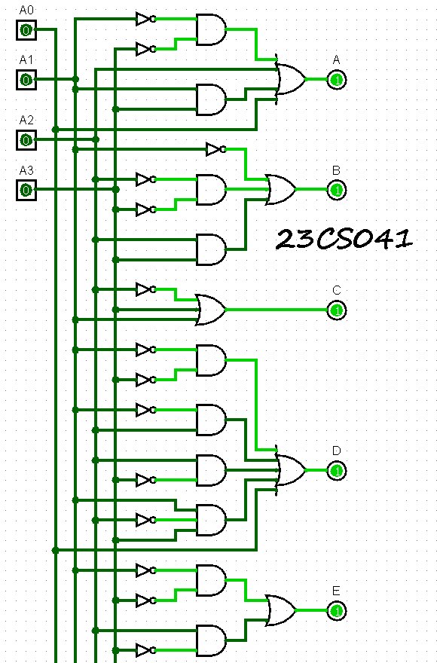

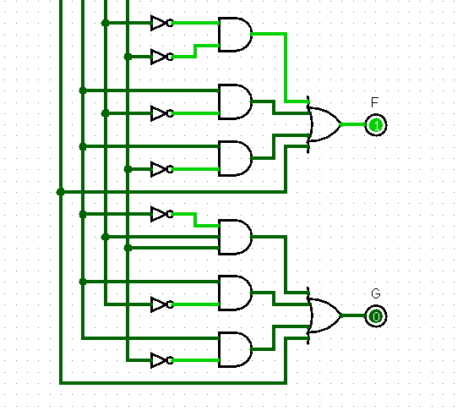

1. **0 to 99 :**

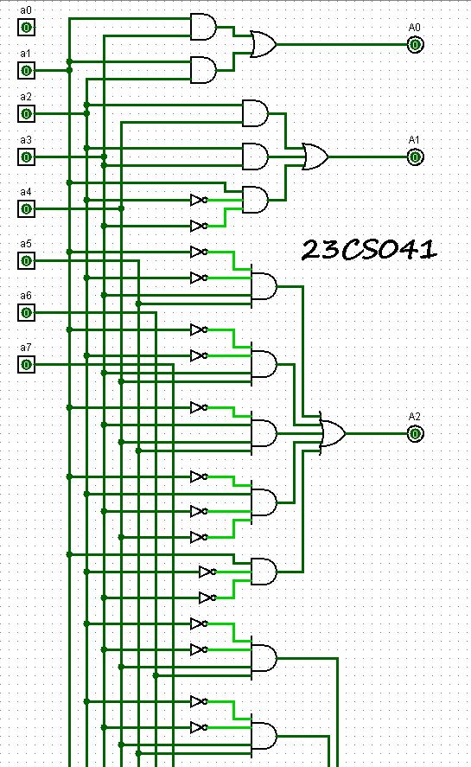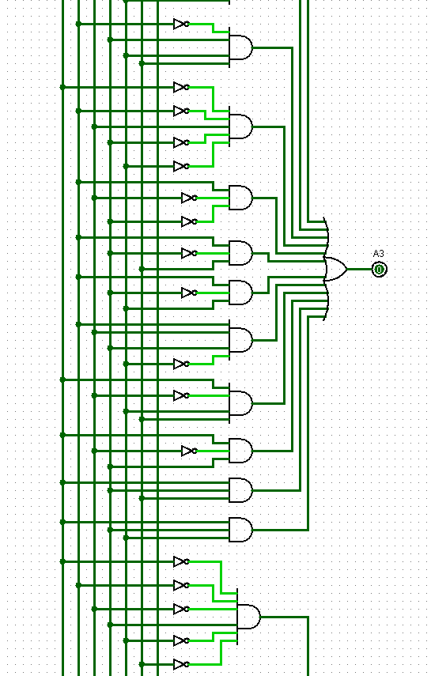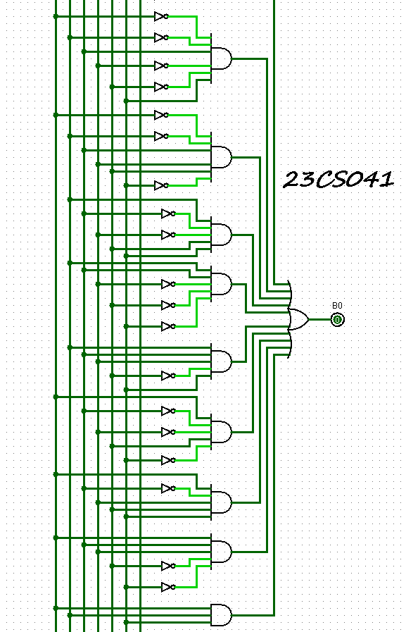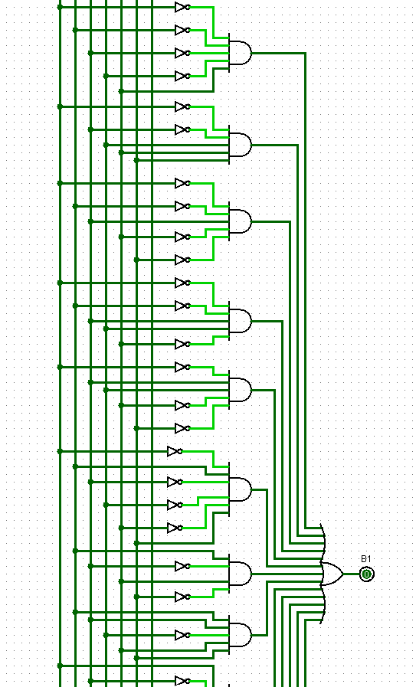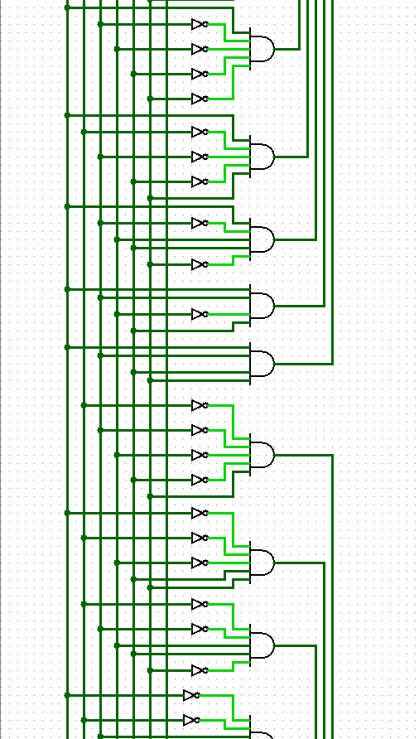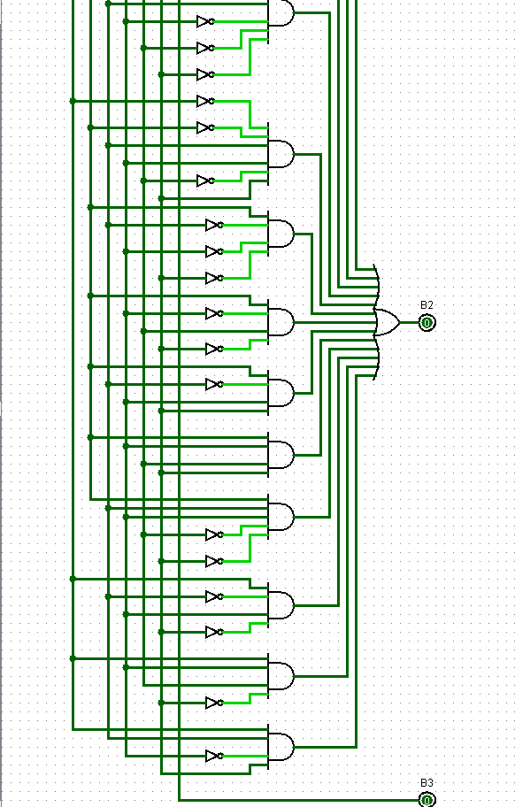

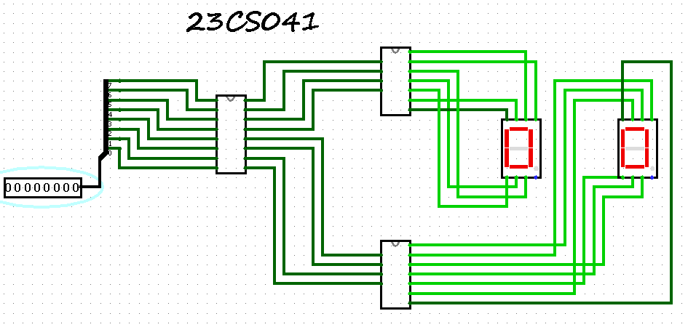

**OUTPUTS:**

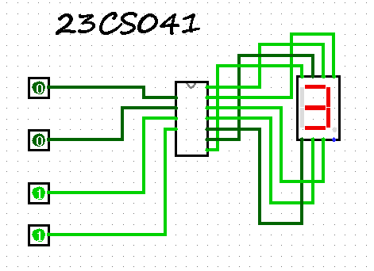

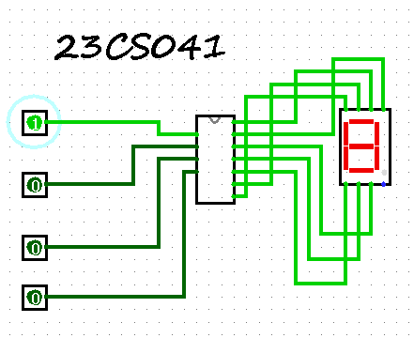

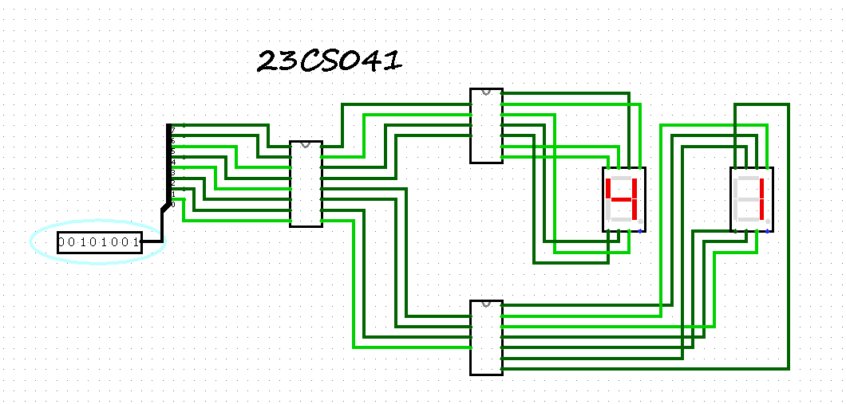

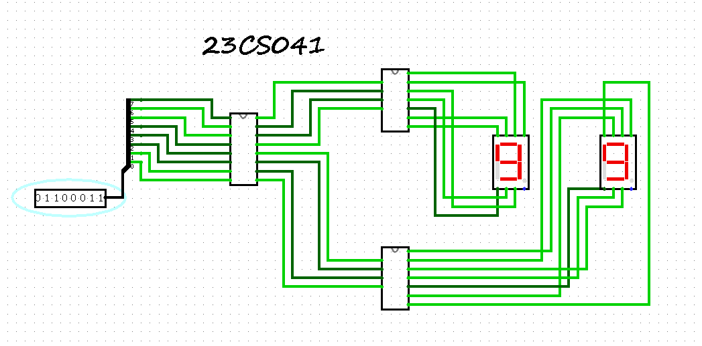

**CONCLUSION:**

|  |
| --- |
|  |
|  |
|  |
|  |
|  |
|  |
|  |
|  |