Date:

# EXPERIMENT NO. 3

#### AIM: Implement a 4-bit common bus system to interface four 4-bit registers with a common bus using i. Multiplexer and ii. Decoder and tristate buffers.

**CIRCUITS:**

1. **Multiplexer**

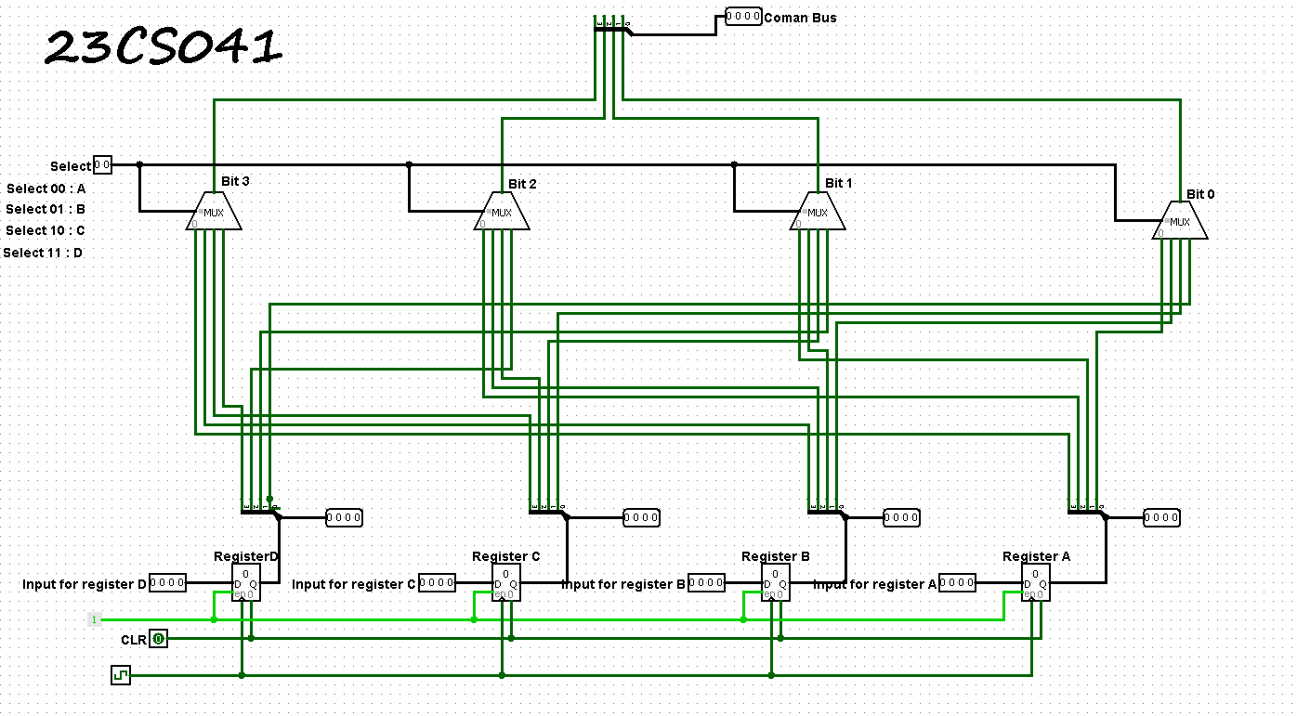

1. **Decoder & tristate buffers**

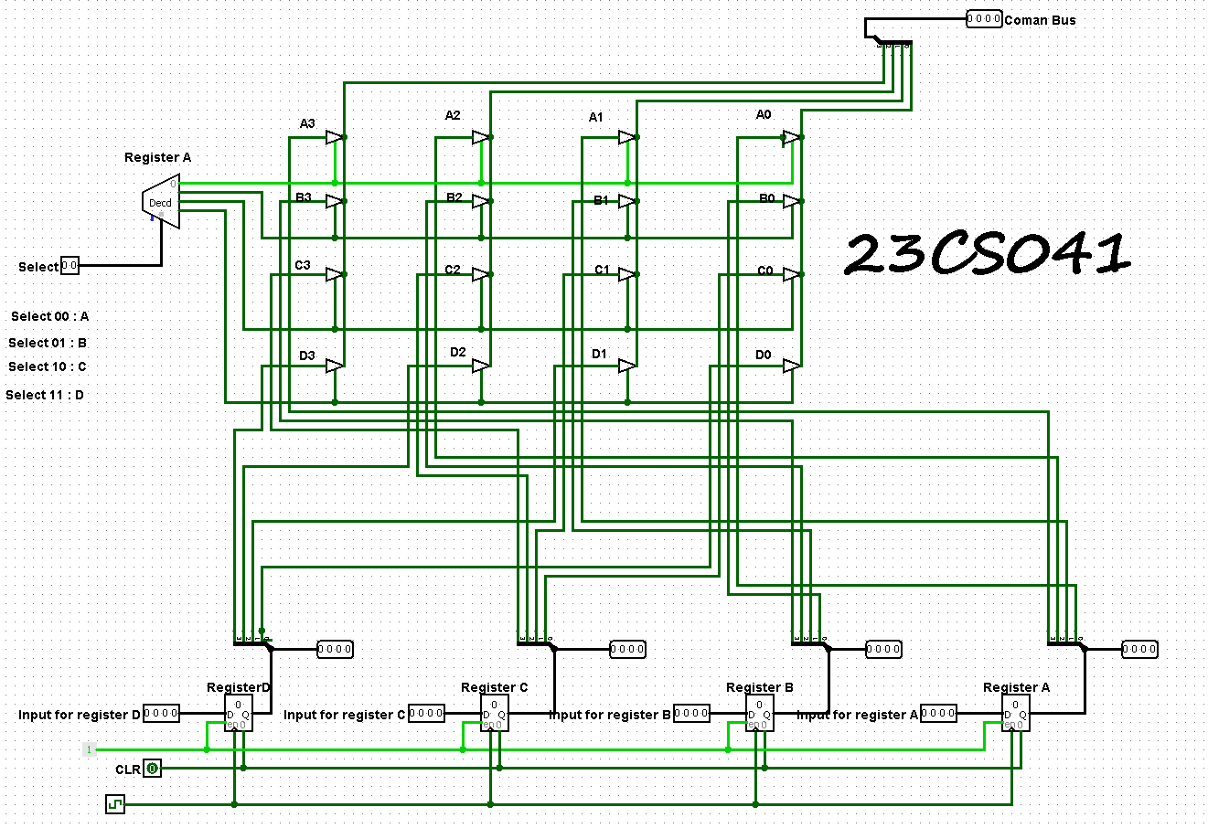

**OUTPUTS:**

**1)**

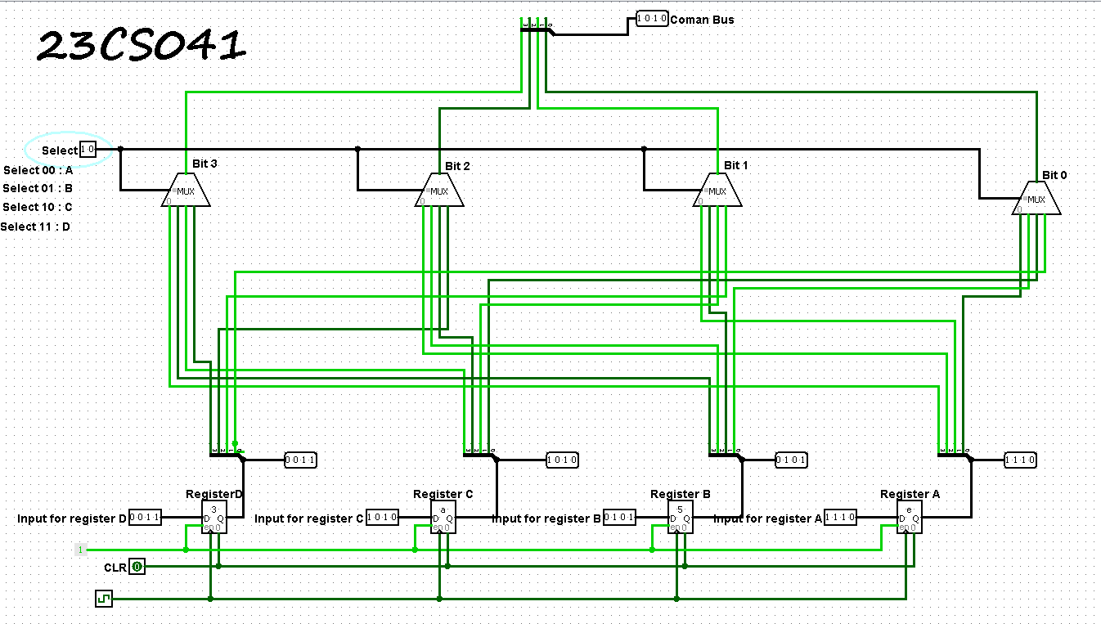

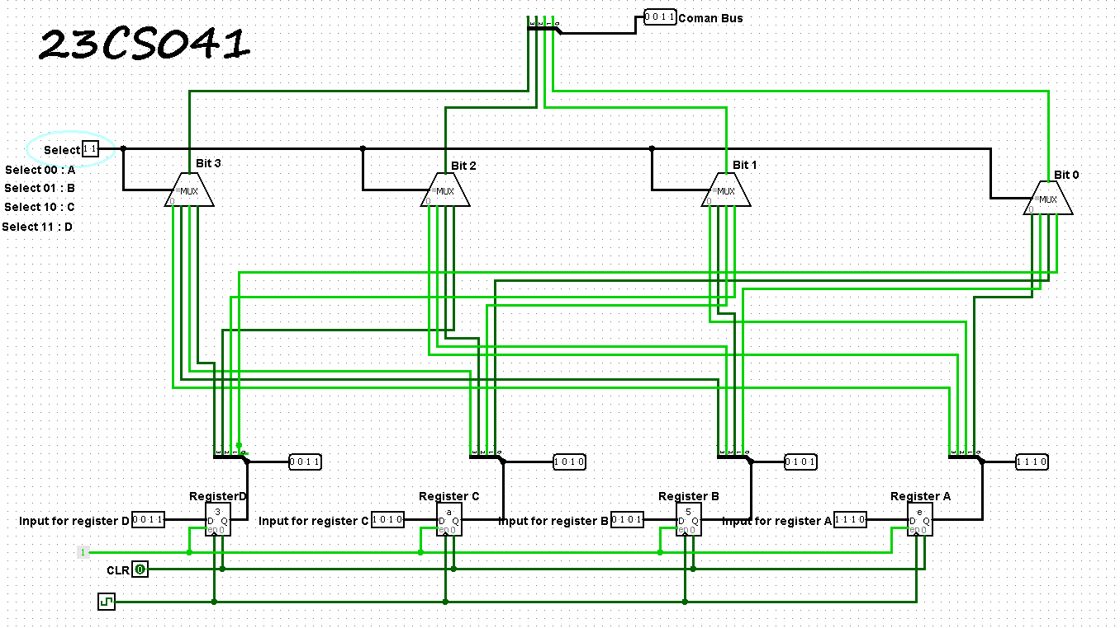

**2)**

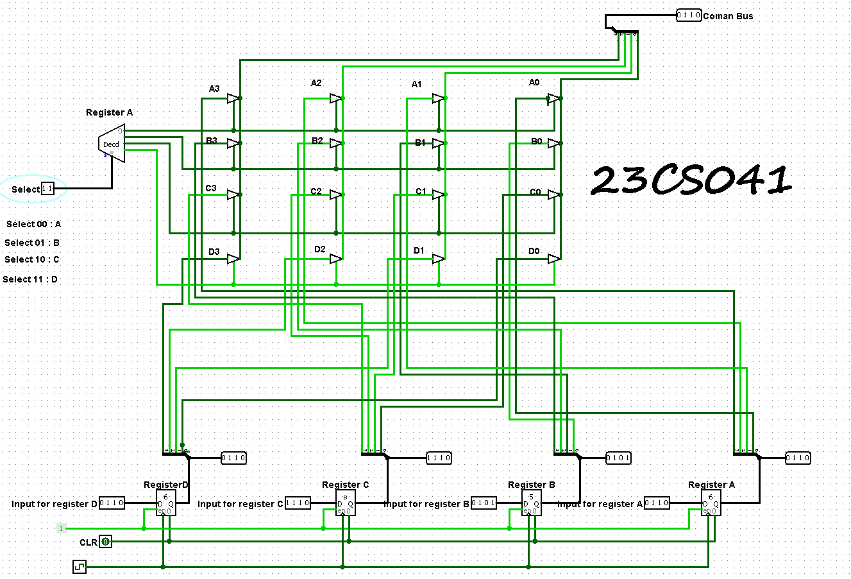

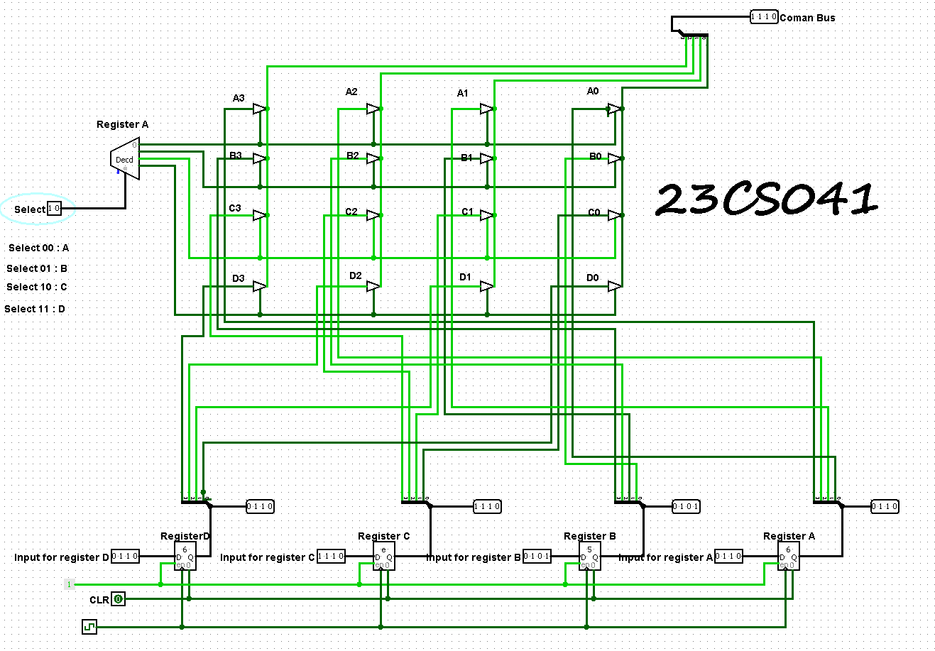

**CONCLUSION:**

**______________________________________________________________________**

**______________________________________________________________________**

**______________________________________________________________________**

**______________________________________________________________________**

**______________________________________________________________________**

**______________________________________________________________________**

**POST SESSION EXCERCISES:**

1. Find a number M=(MOD(Last Three Digits of your enrolment number, 5)+3) and find a number N=(MOD(Last Three Digits of your enrolment number, 3)+3). Implement a M-bit common bus system to interface N M-bit registers with a common bus using i. Multiplexer and ii. Decoder and tristate buffers.

🡪 Last Three Digits of my enrolment number is 041.

M = 41%5 + 3

= 1 + 3

M = 4

N = 41%3 + 3

N = 2 + 3

N = 5

Number of Multiplexers: 4

Number of registers, N = 5

Since N = 5, we need a 3-to-8 decoder .

Number of Decoders = 1

we need N x M (5 x 4) tristate buffers.

A Number of Tristate Buffers = N × M = 5x4 = 20.

**CIRCUITS:**

1. **Multiplexer**

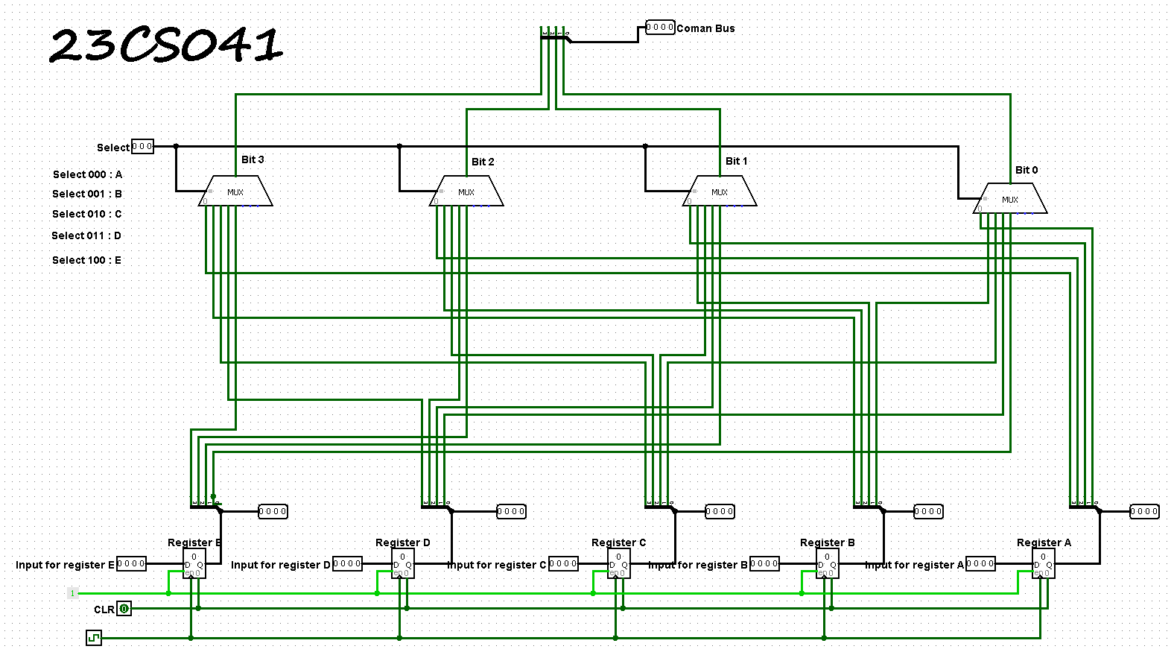

1. **Decoder & tristate buffers**

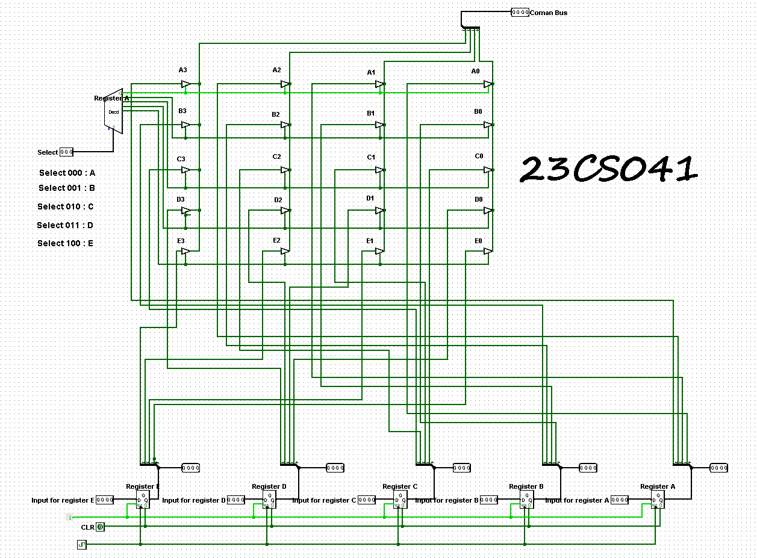

**OUTPUTS:**

**1)**

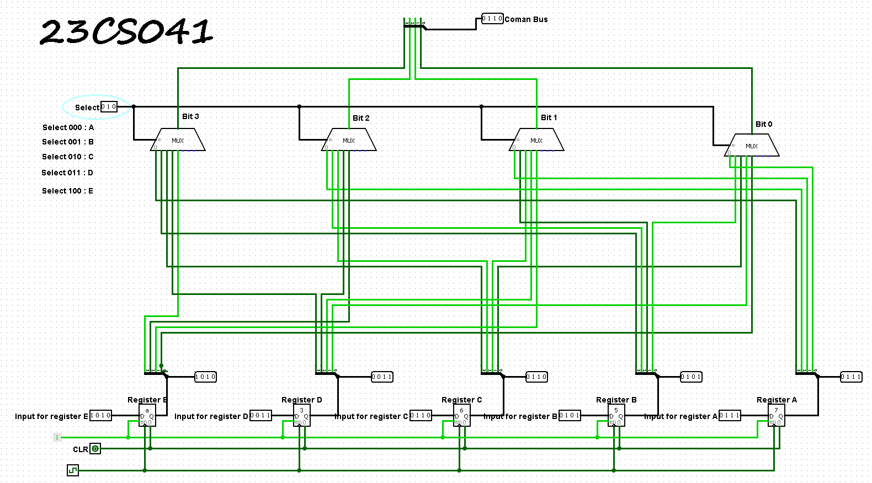

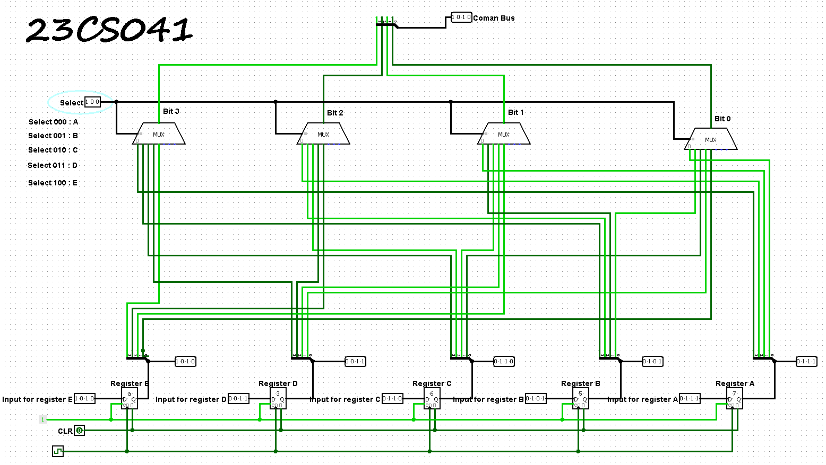

**2)**

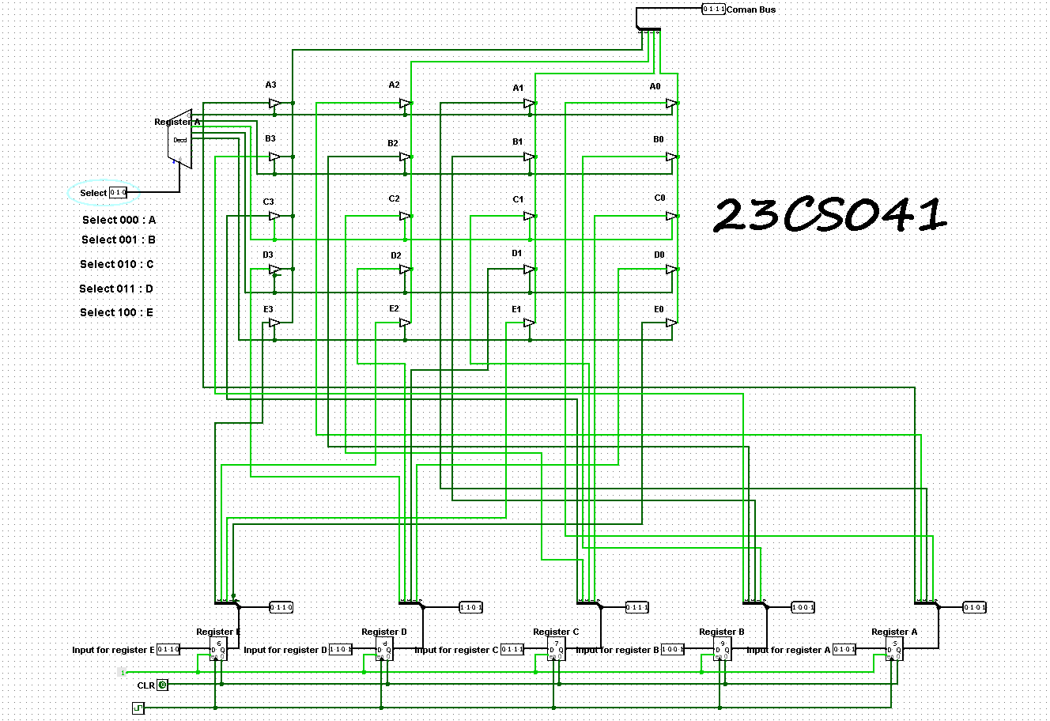

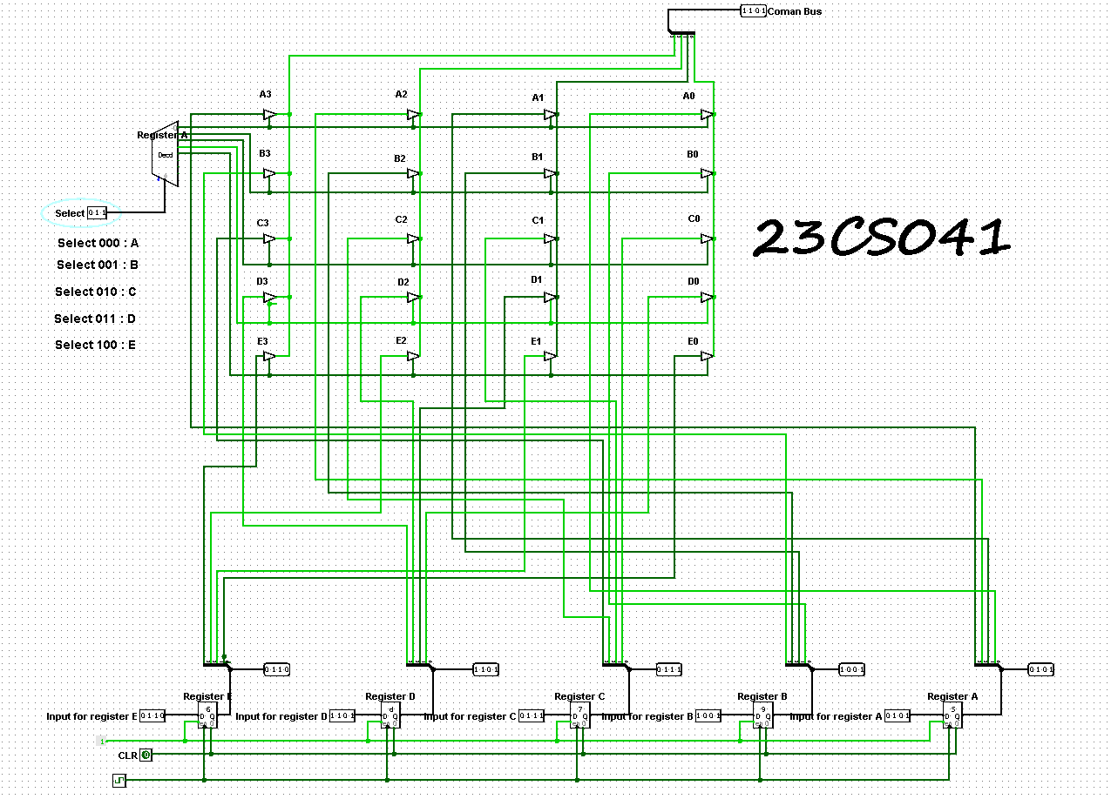

**23CS041—DHRUV LOKADIYA**