Date:

# EXPERIMENT NO. 4

#### AIM: Implement arithmetic and logic unit circuits in Logisim.

#### OBJECTIVES:

#### Implement 1-bit, 2-bit, 4-bit and 8-bit arithmetic unit circuits

#### Implement 1-bit, 2-bit, 4-bit and 8-bit logical unit circuits for four logical functions

#### Implement 1-bit and 2-bit logical unit circuits for sixteen logical functions

#### Implement 2-bit, 4-bit and 8-bit bidirectional shifter

#### Implement 1-bit, 2-bit, 4-bit and 8-bit ALU

**CIRCUITS:**

1. **1) 1-bit arithmetic**

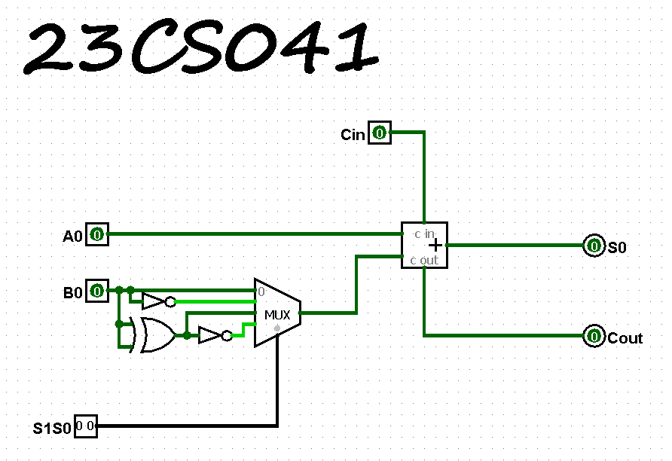

**2) 2-bit arithmetic**

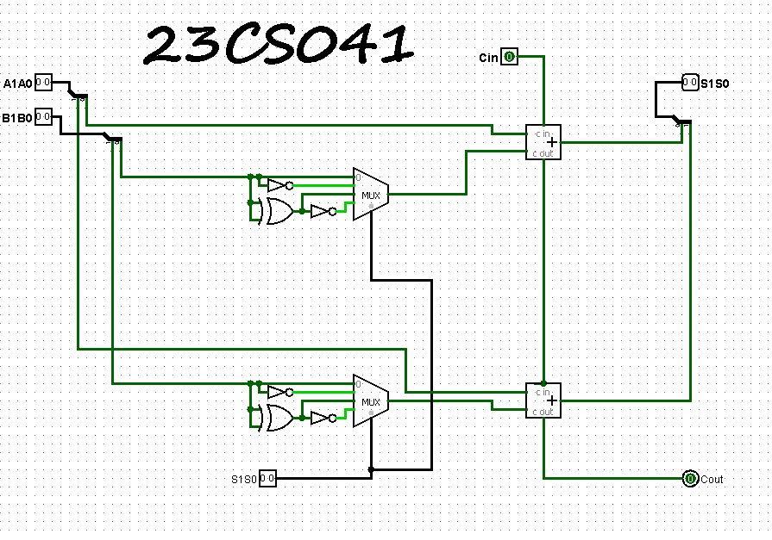

**3) 4-bit arithmetic**

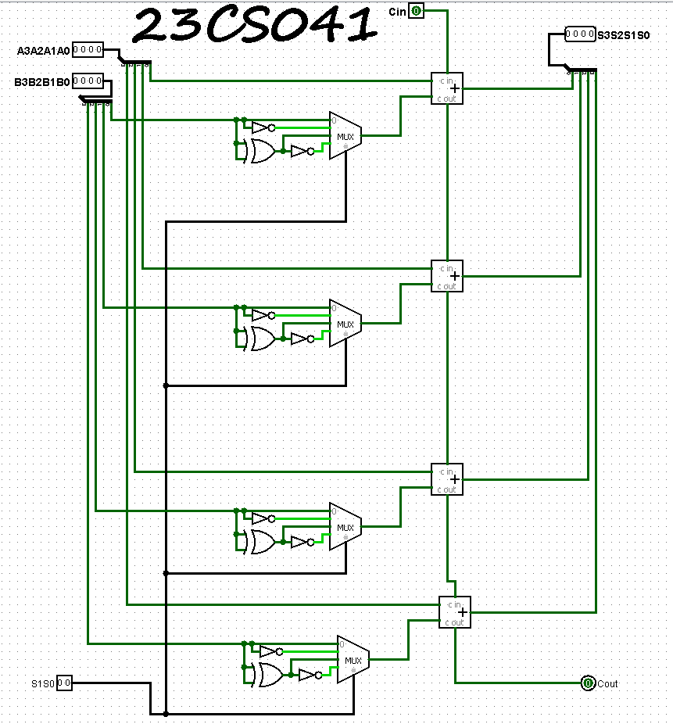

**4) 8-bit arithmetic**

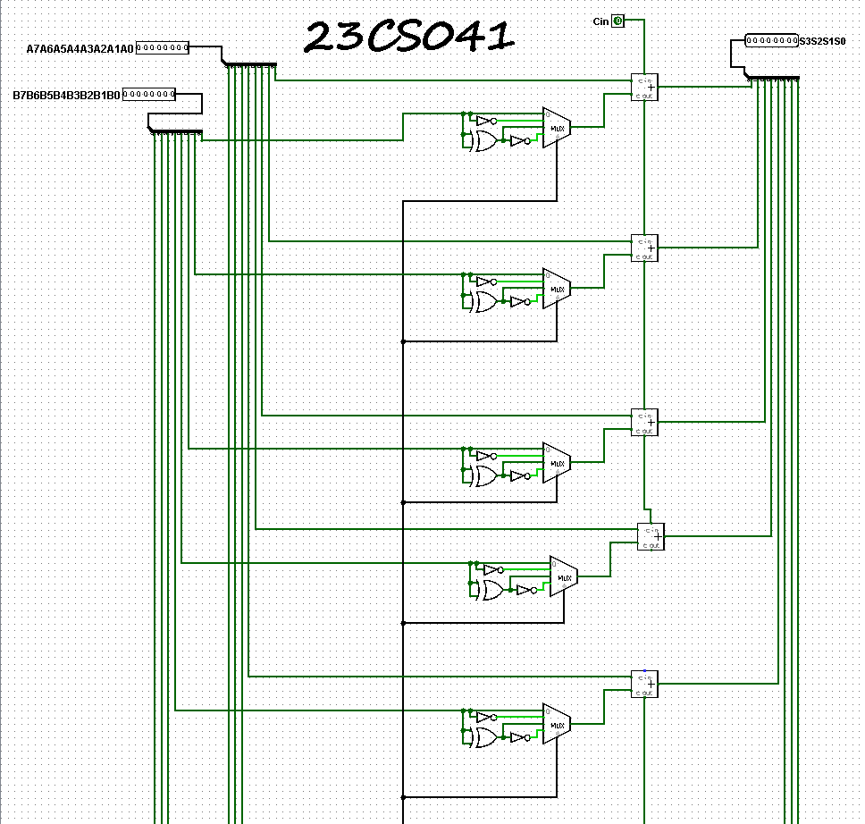

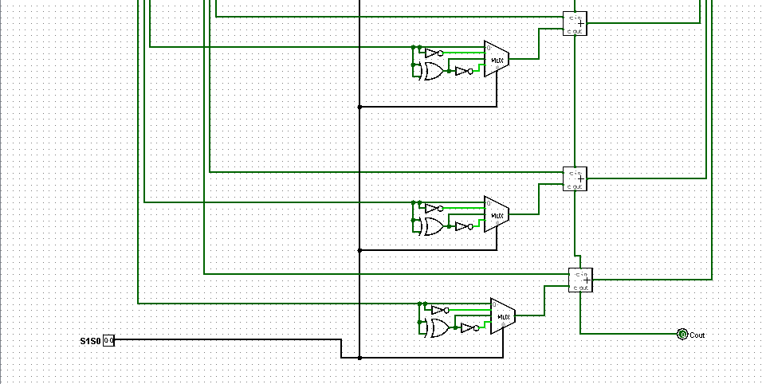

1. **1) 1-bit logical**

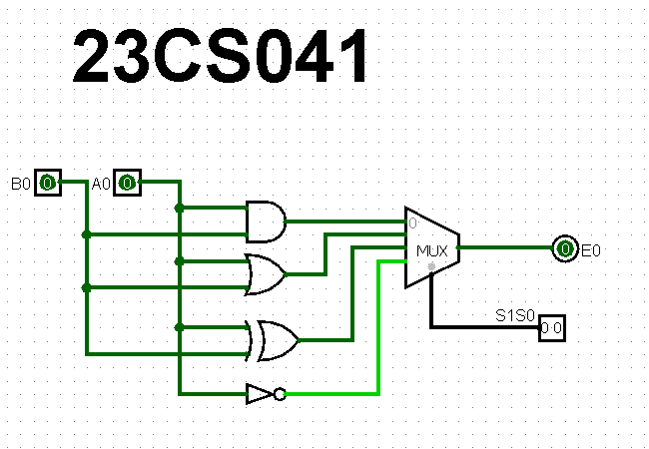

**2) 2-bit logical**

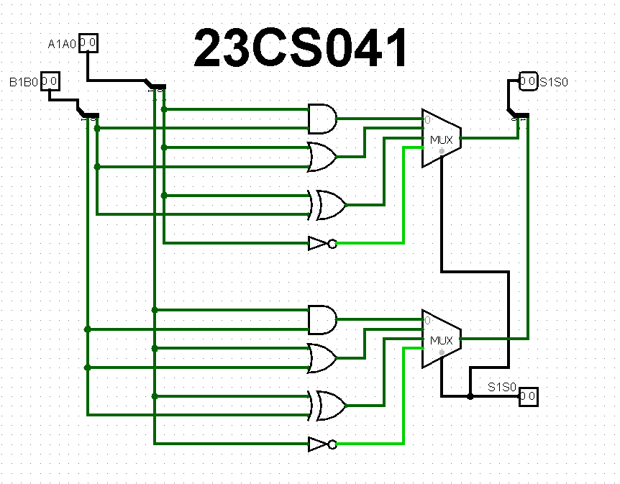

**3) 4-bit logical**

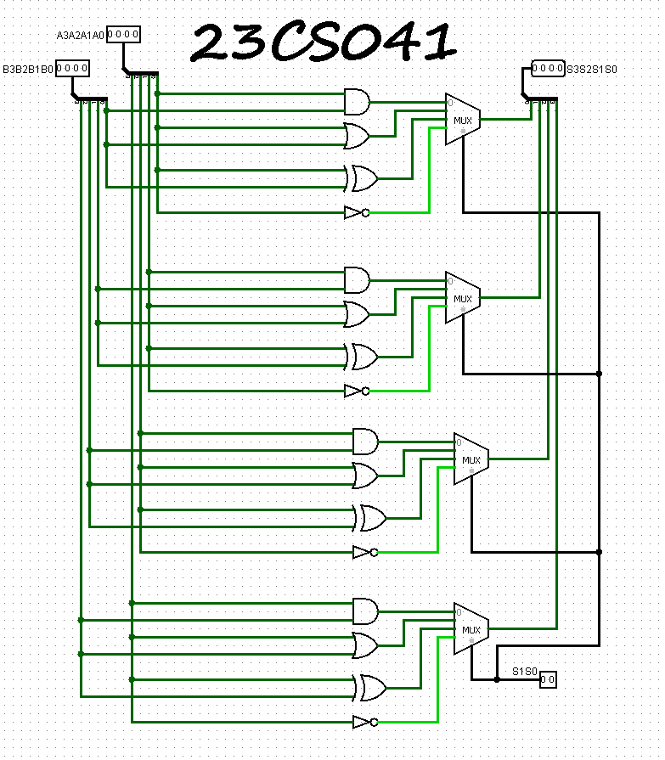

**4) 8-bit logical**

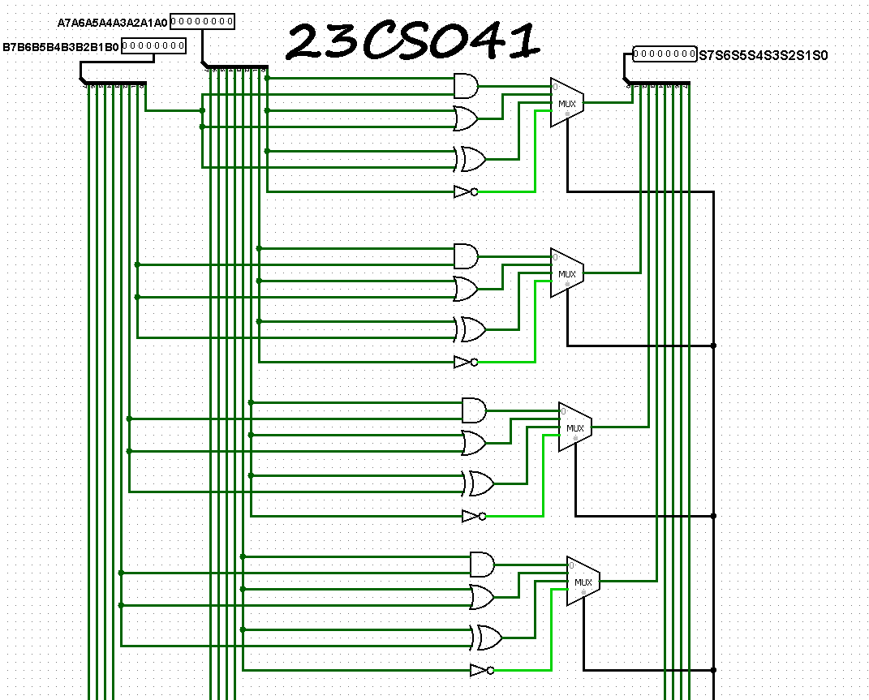

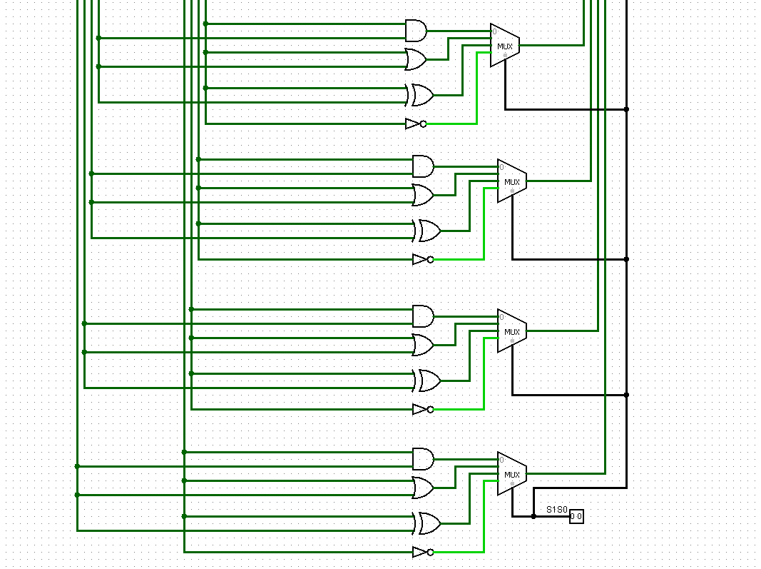

1. **1)** **1-bit** **logical circuits for sixteen logical functions**

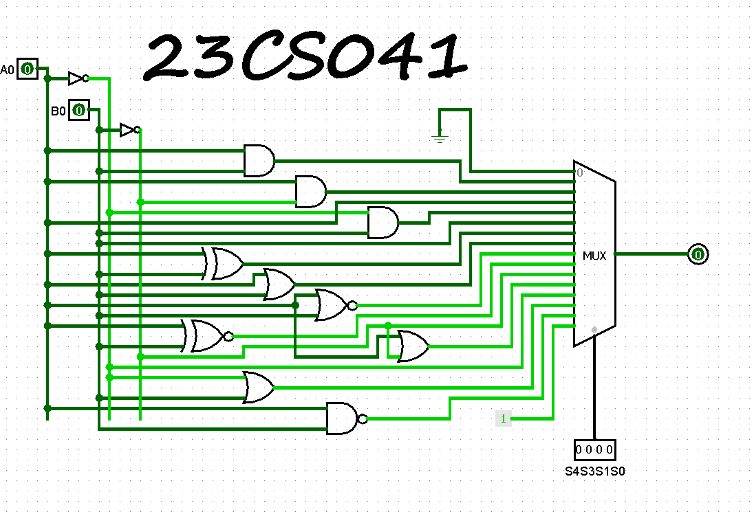

**2)** **2-bit** **logical circuits for sixteen logical functions**

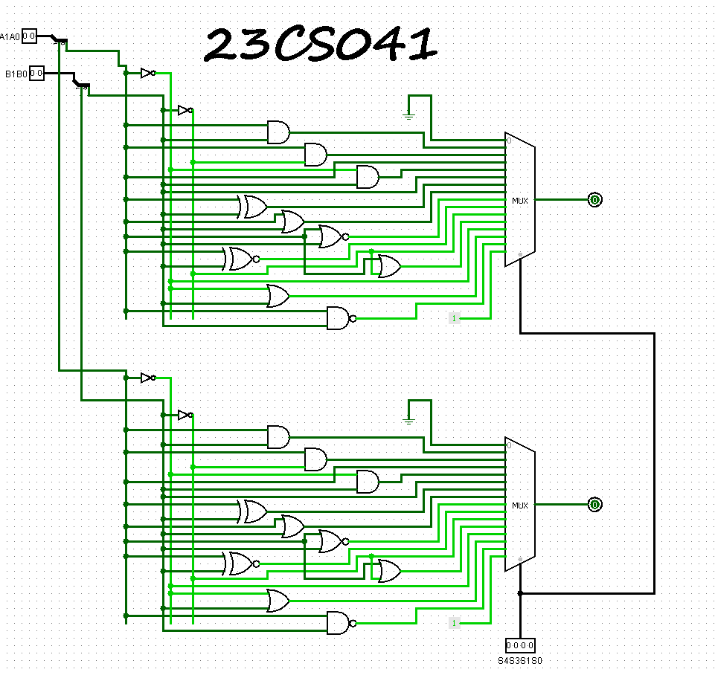

1. **1) 2-bit bidirectional shifter**

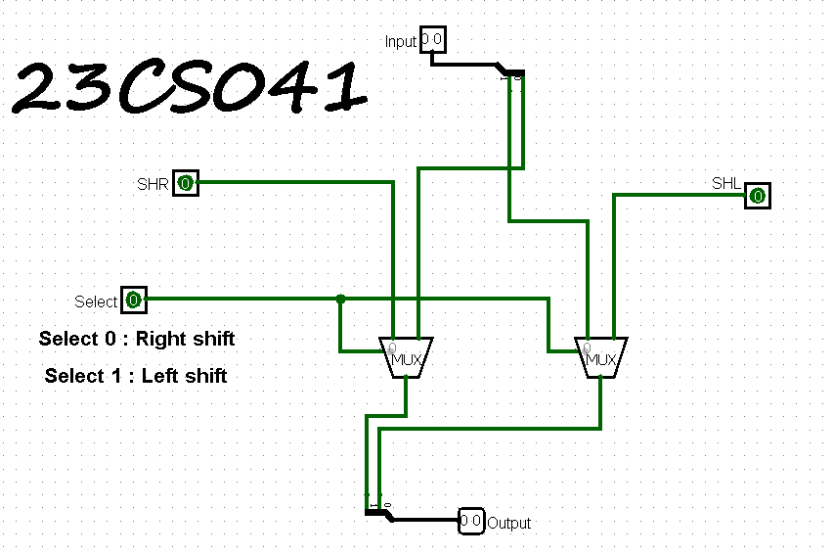

**2) 4-bit bidirectional shifter**

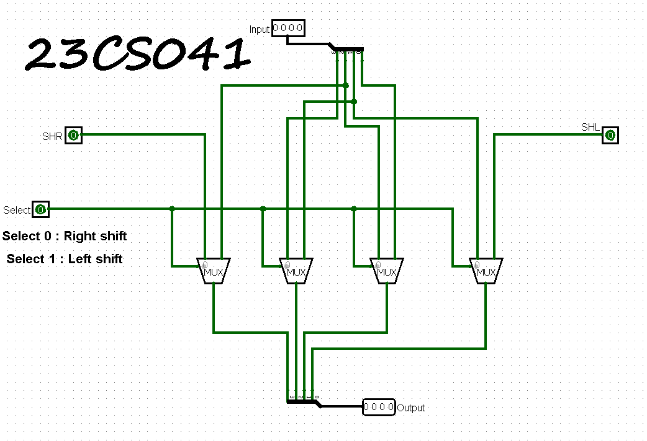

**3) 8-bit bidirectional shifter**

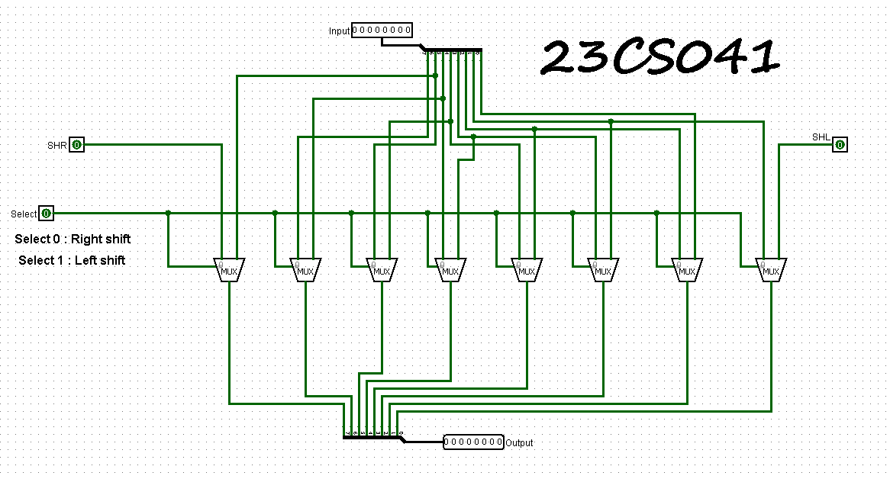

1. **1) 1-bit ALU**

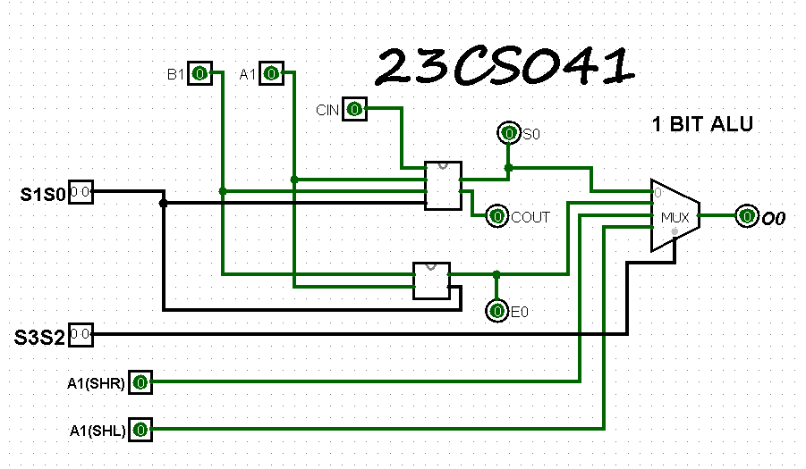

**2) 2-bit ALU**

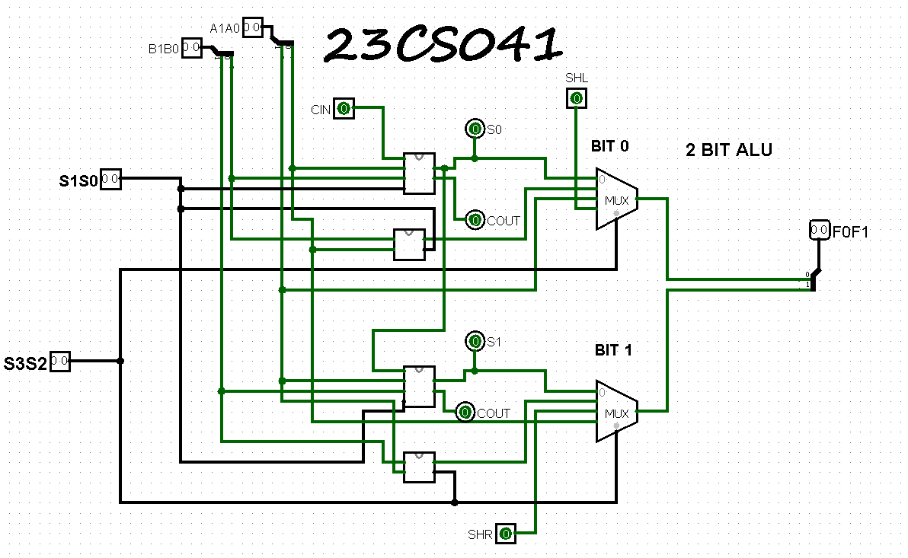

**3) 4-bit ALU**

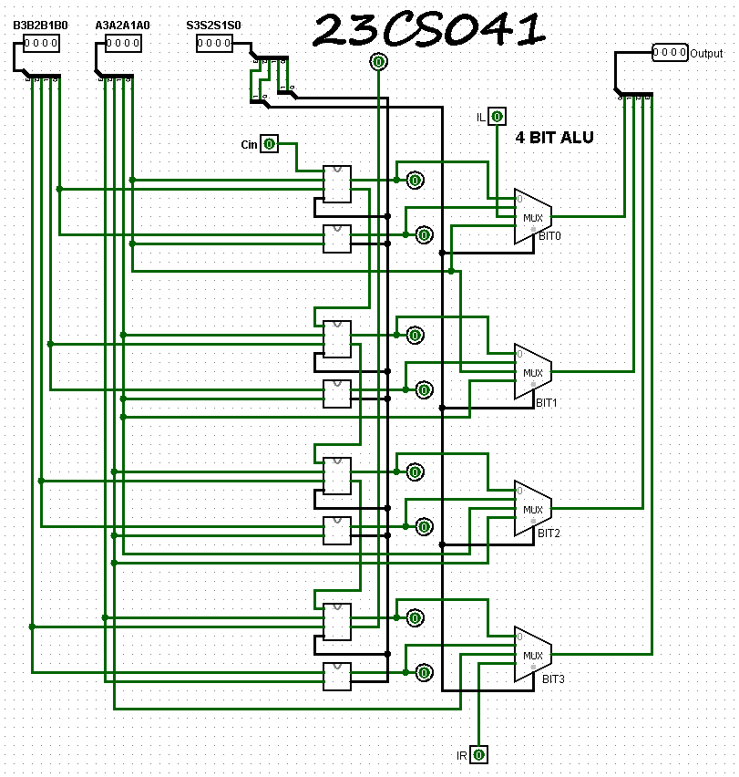

**4) 8-bit ALU**

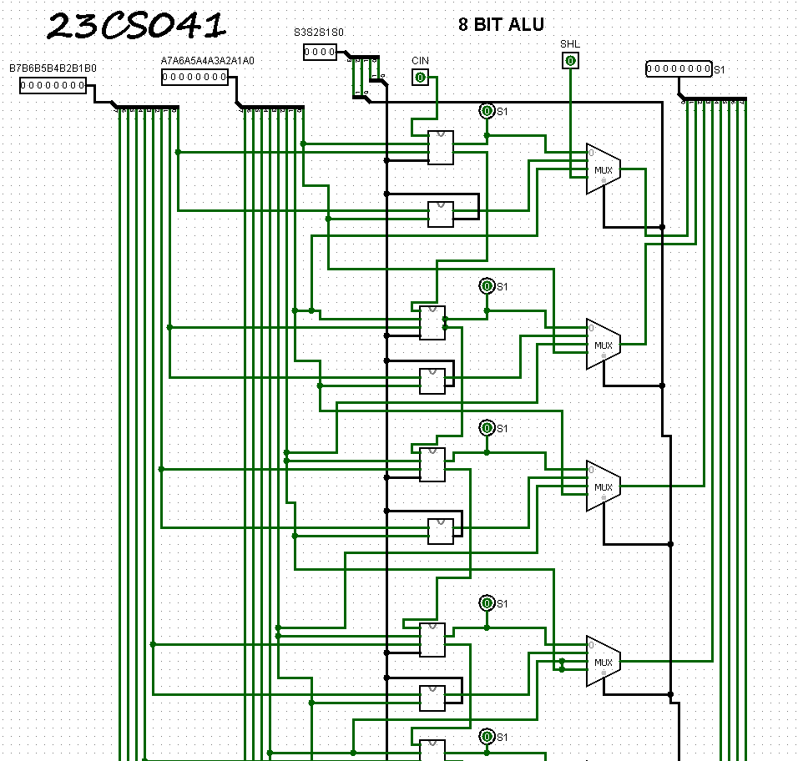

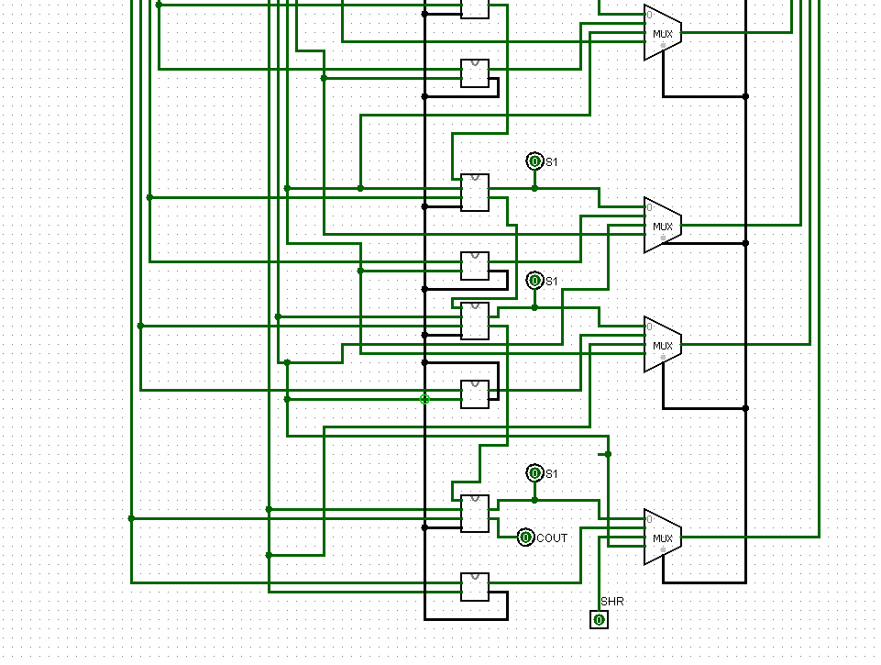

**OUTPUTS:**

1. **1) 1 bit arithmetic**

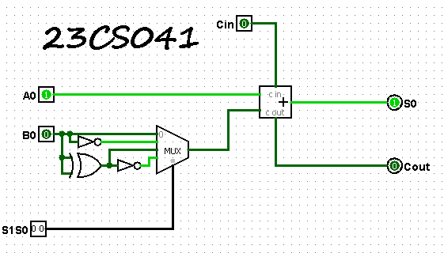

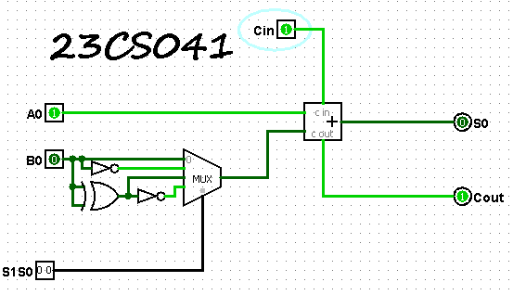

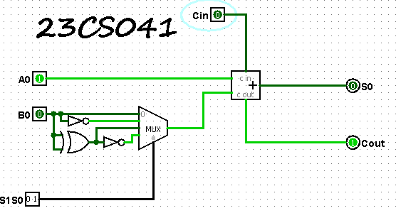

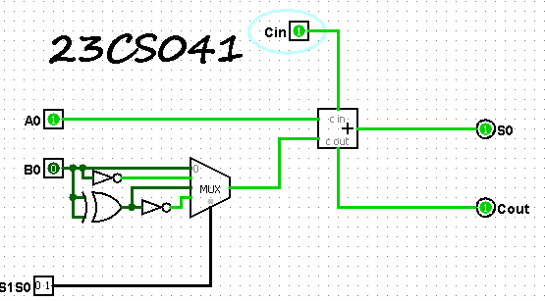

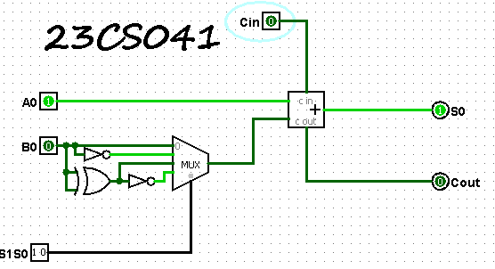

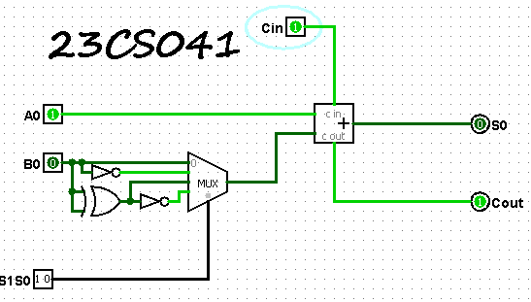

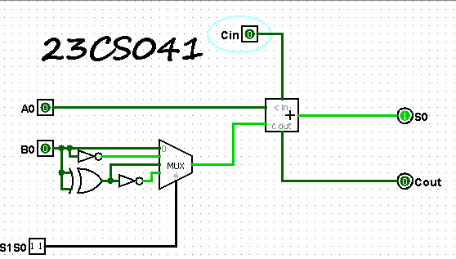

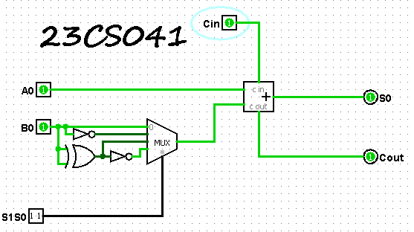

**2) 4 bit arithmetic**

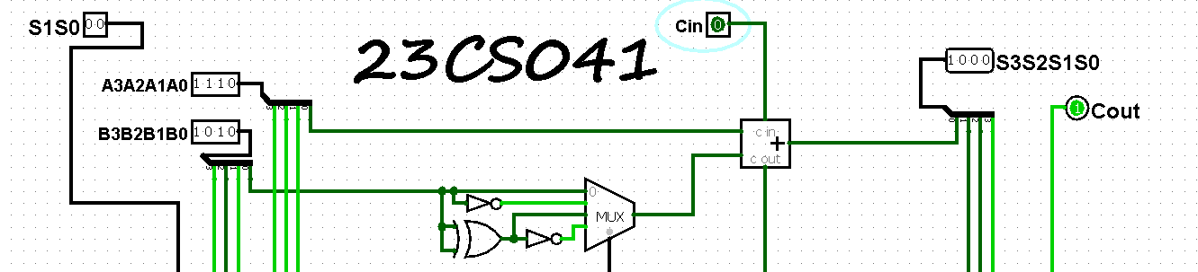

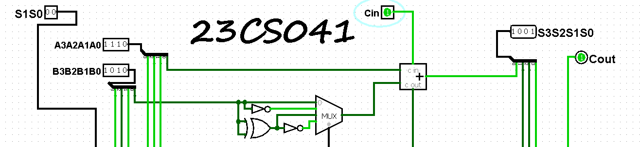

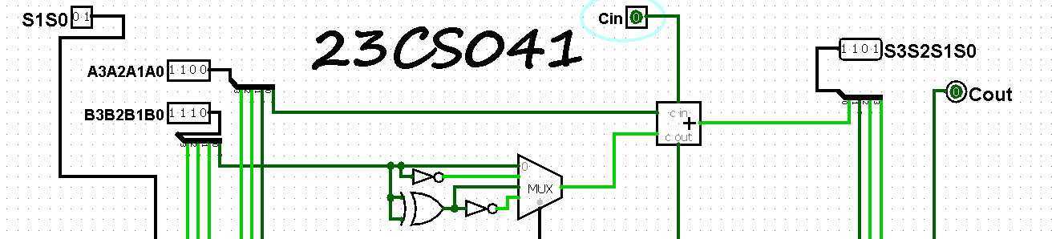

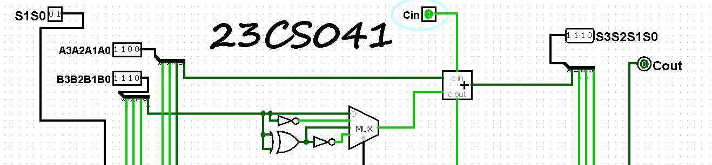

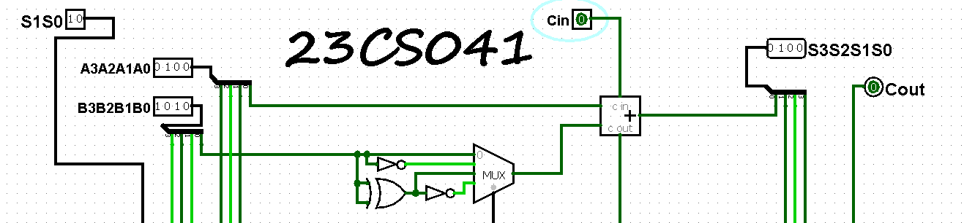

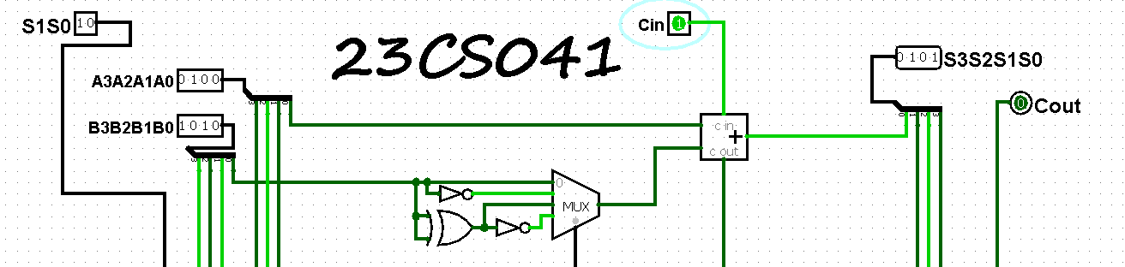

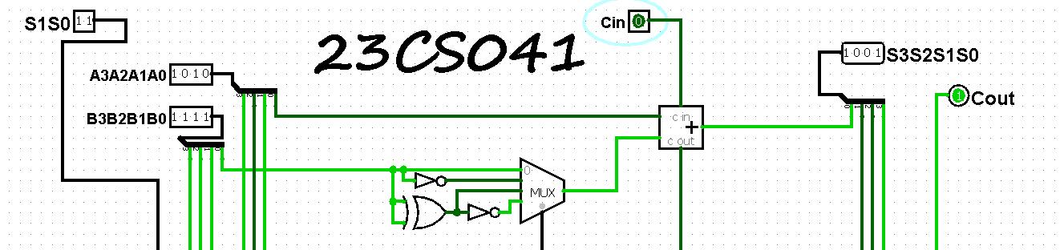

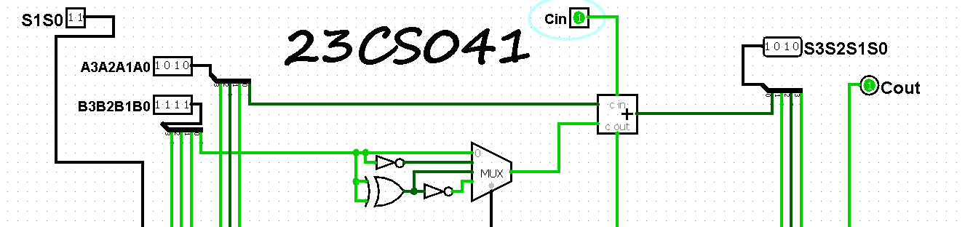

1. **1) 2 bit logical**

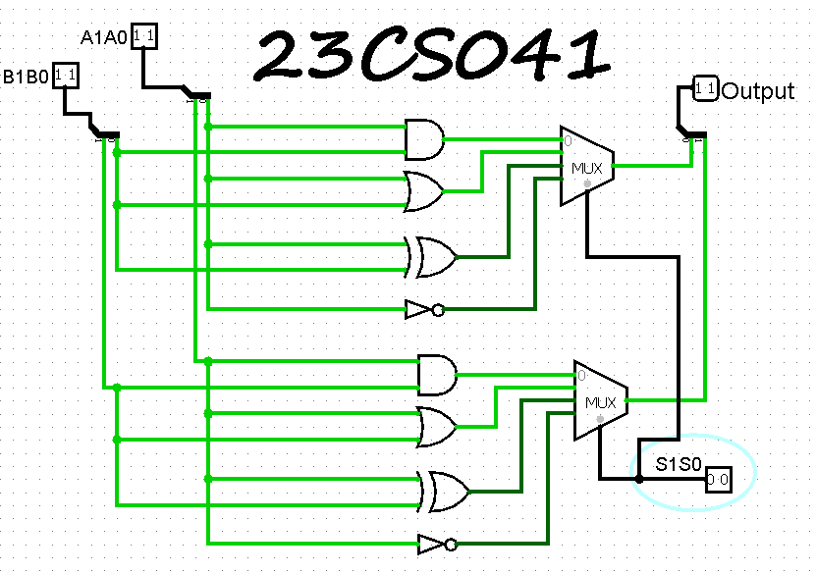

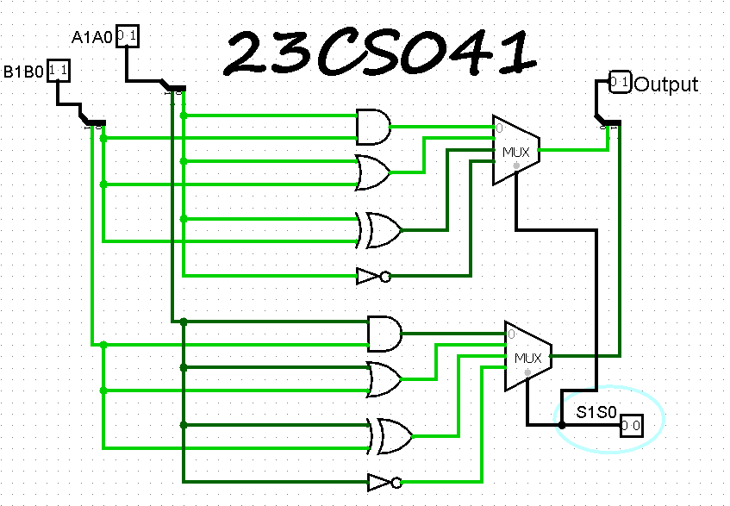

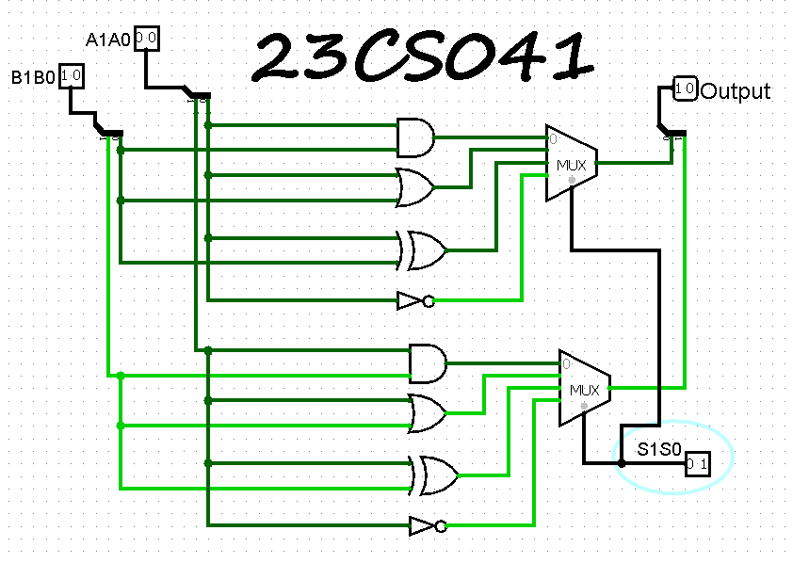

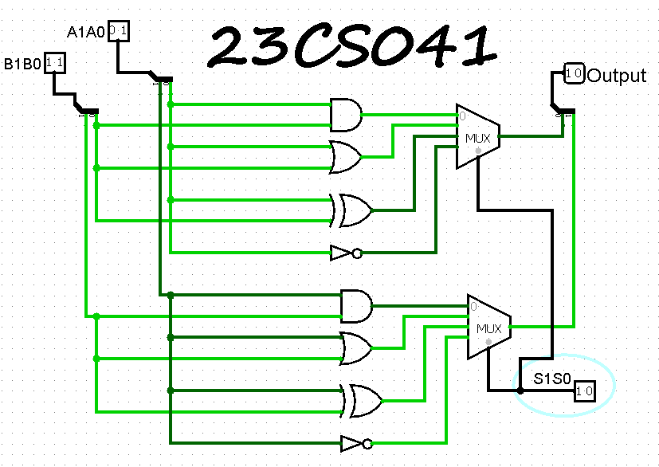

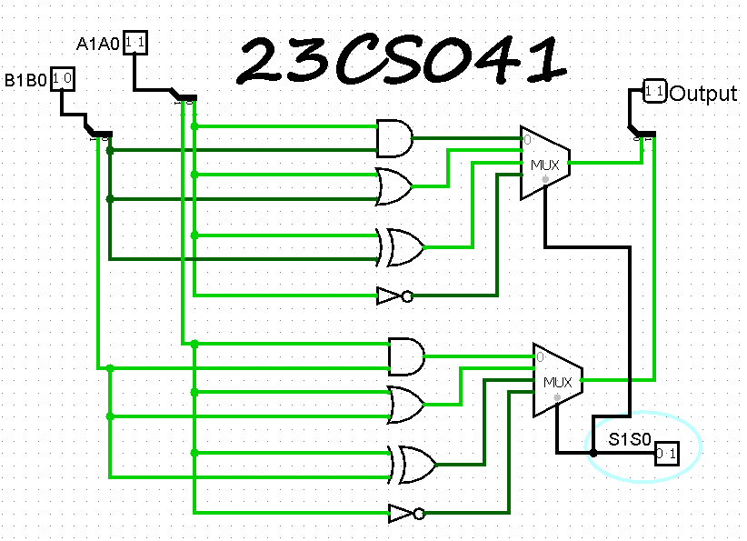

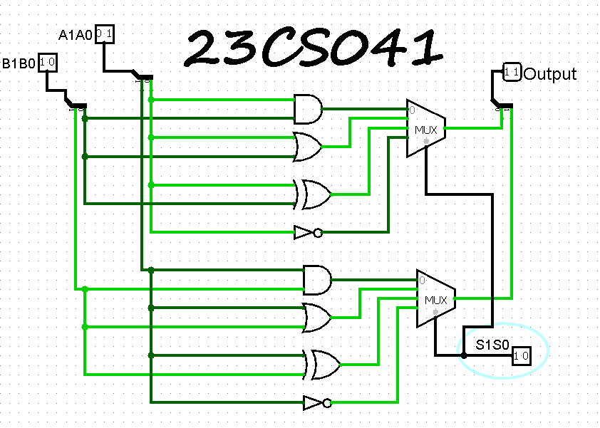

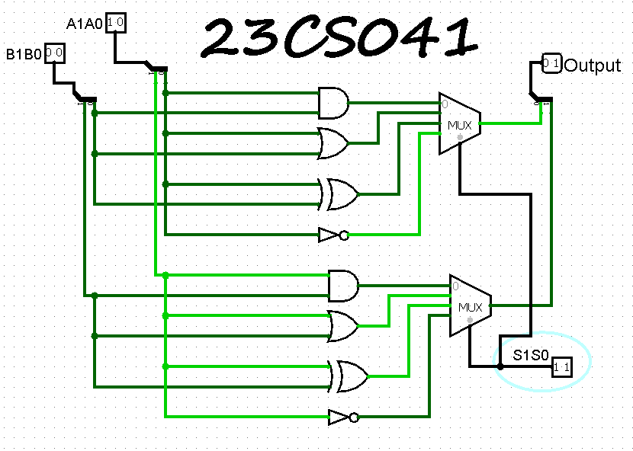

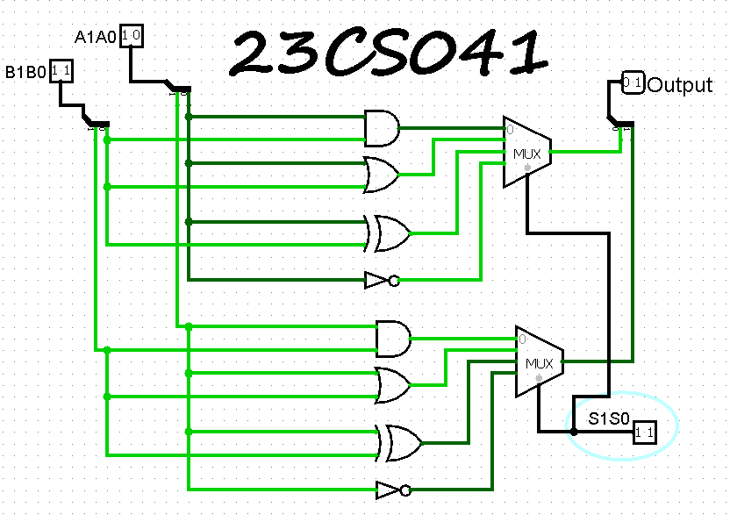

**2) 8 bit logical**

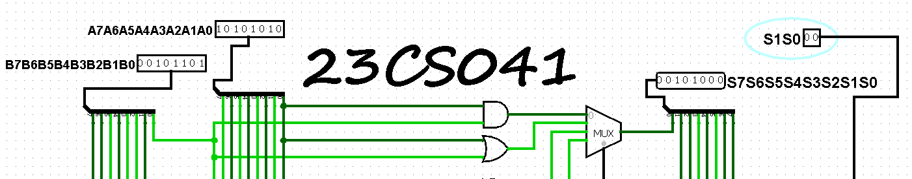

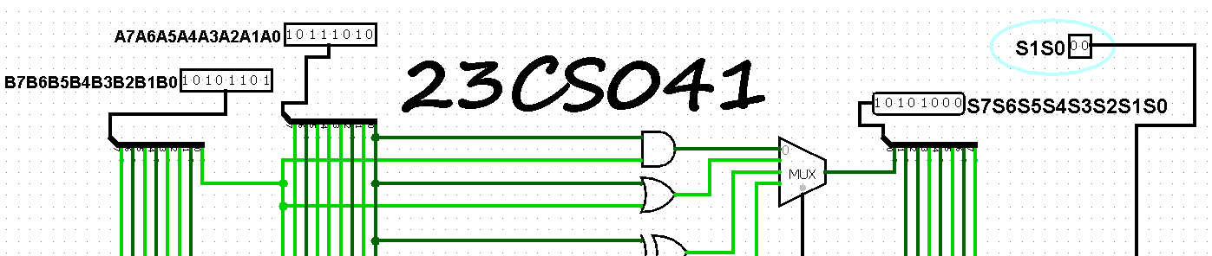

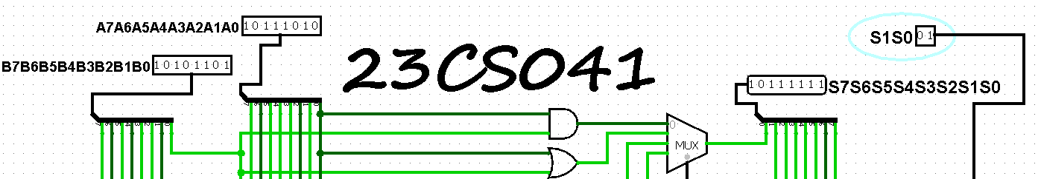

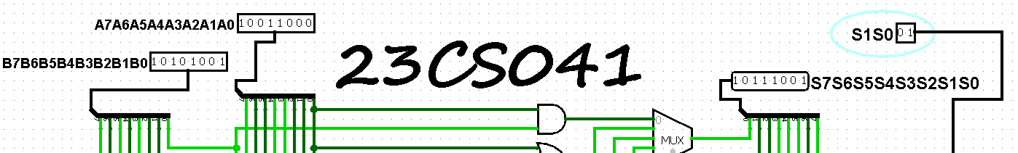

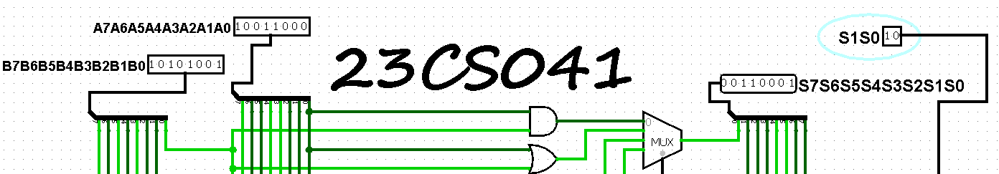

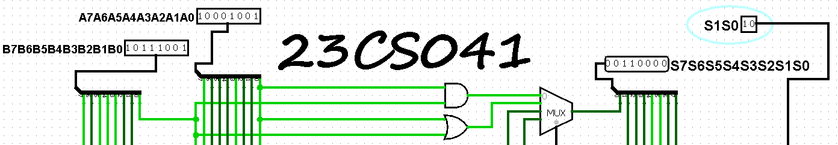

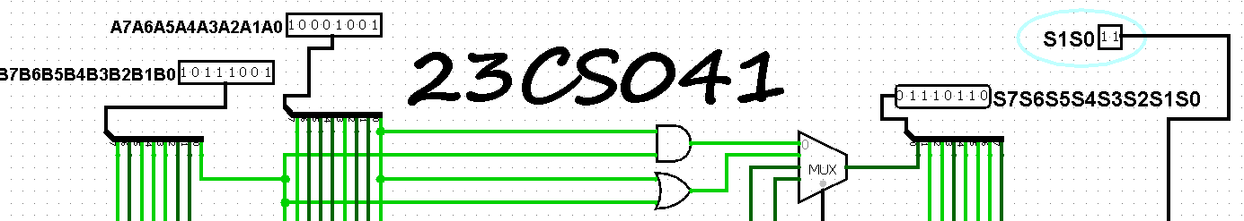

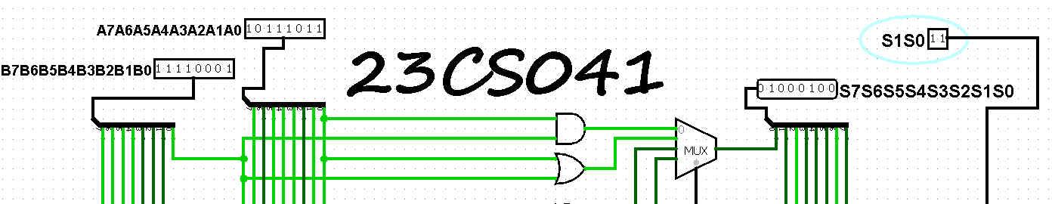

1. **1)** **1-bit**  **16 logical functions**

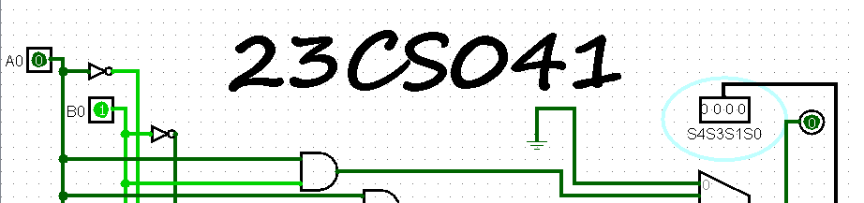

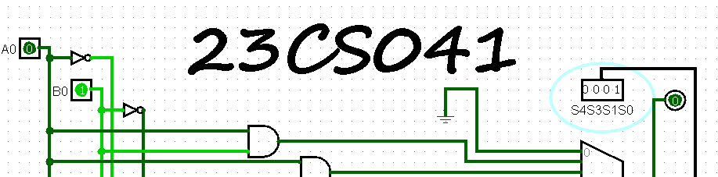

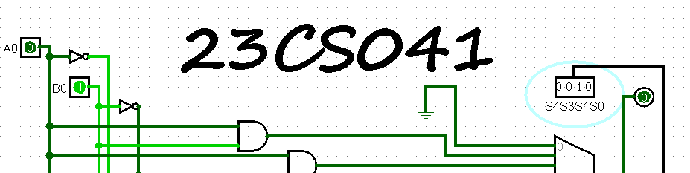

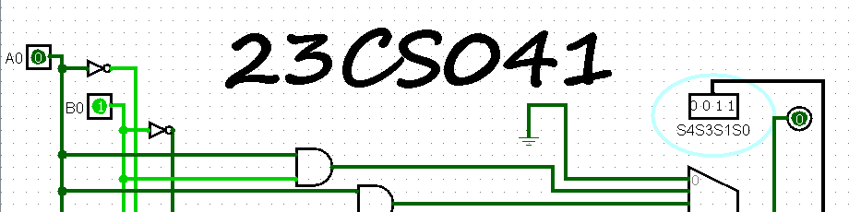

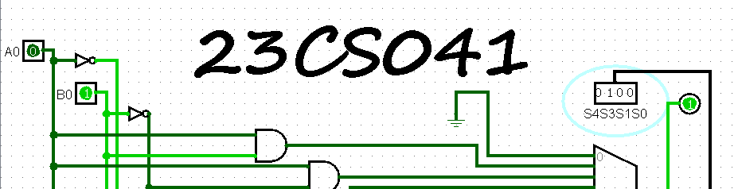

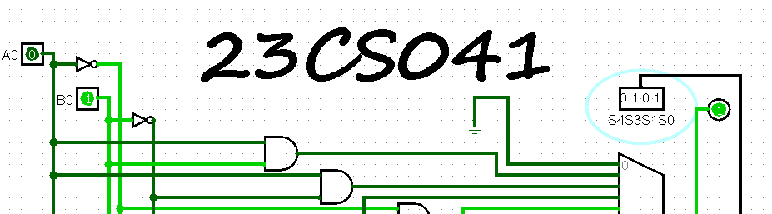

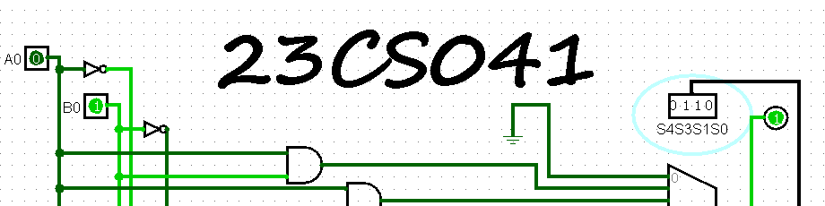

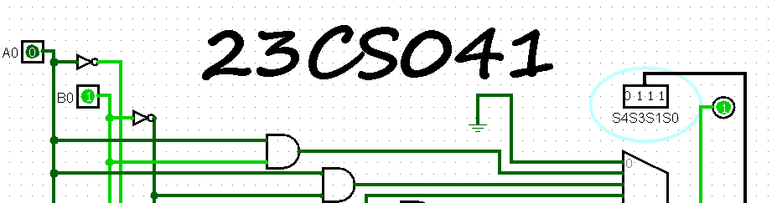

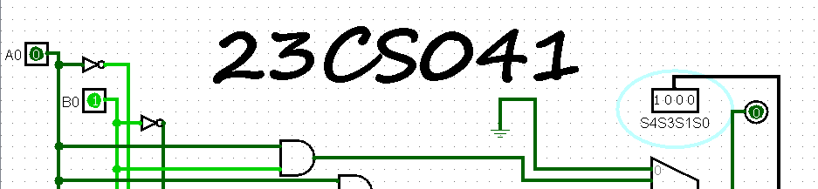

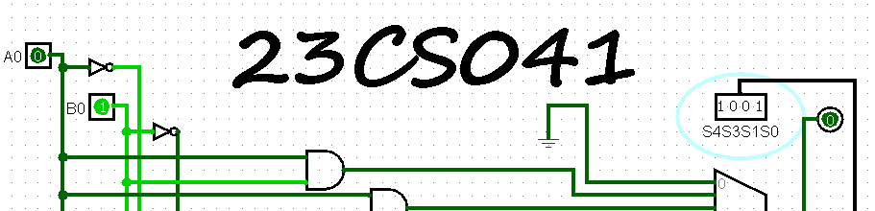

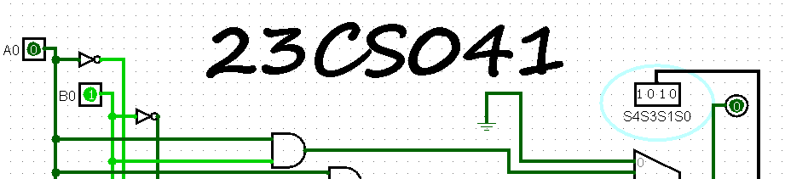

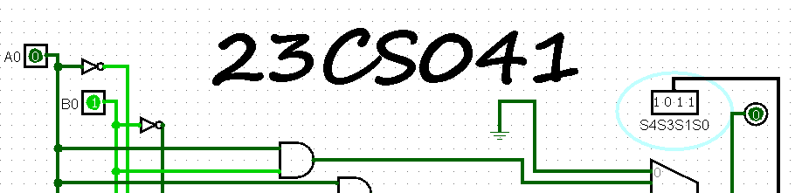

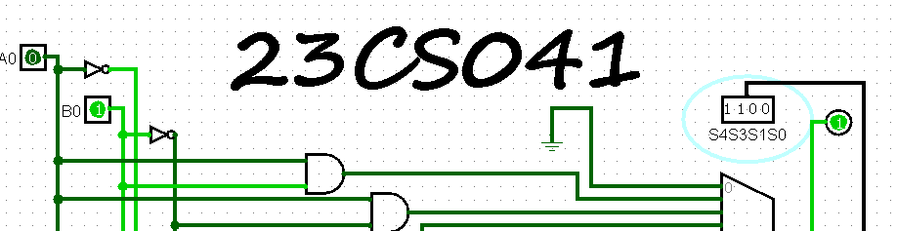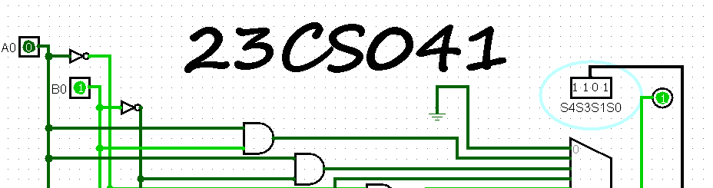

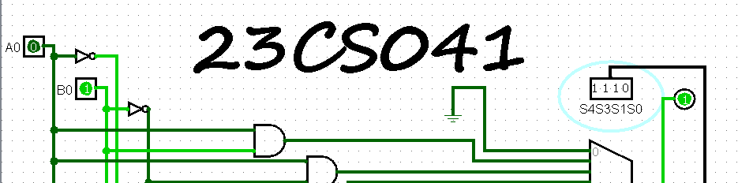

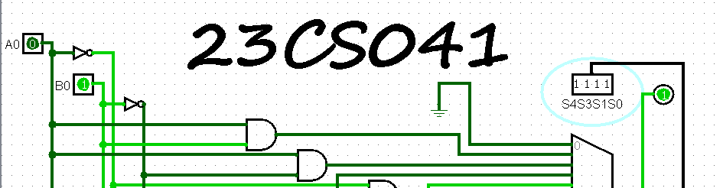

1. **1)** **2-bit bidirectional shifter**

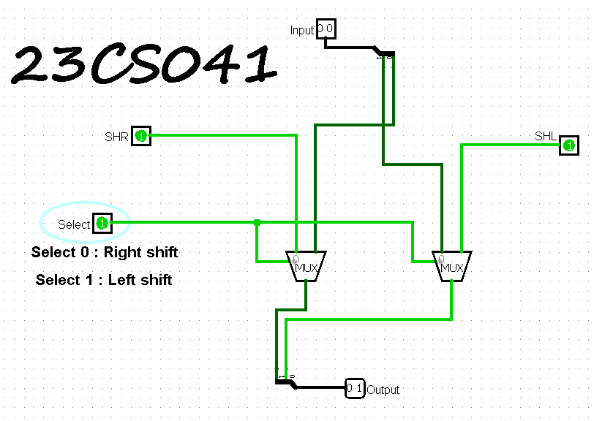

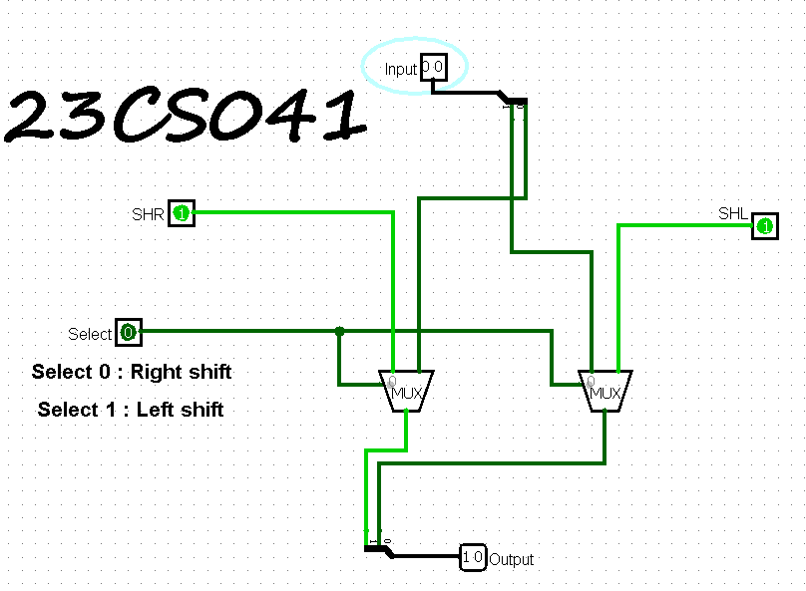

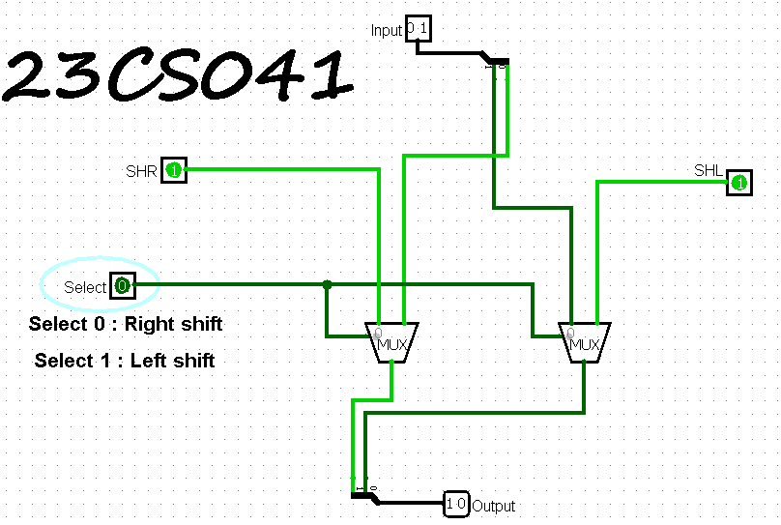

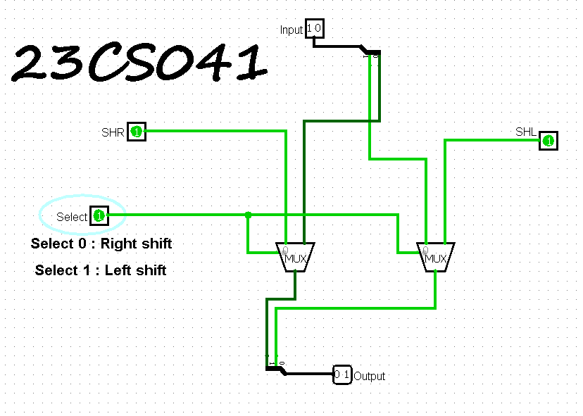

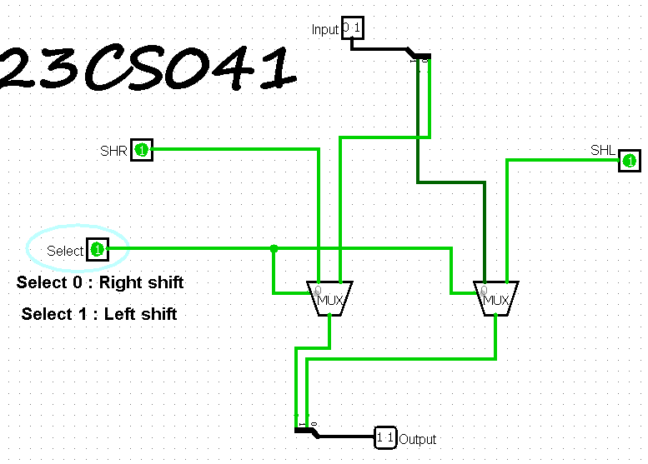

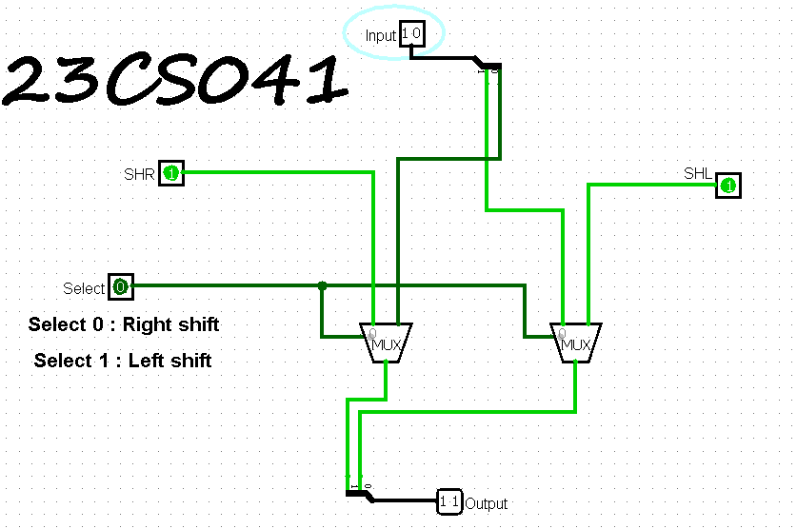

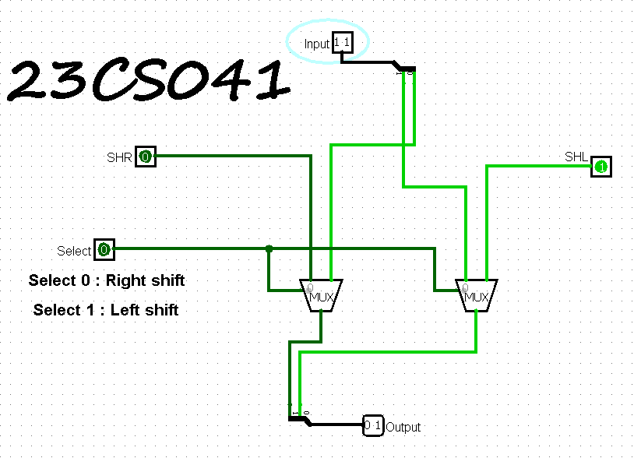

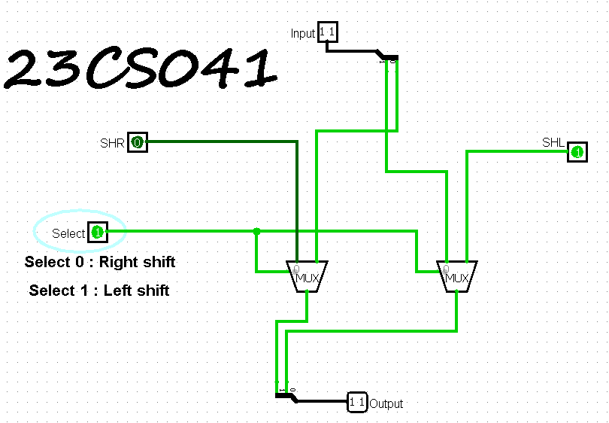

**2)**  **4-bit bidirectional shifter**

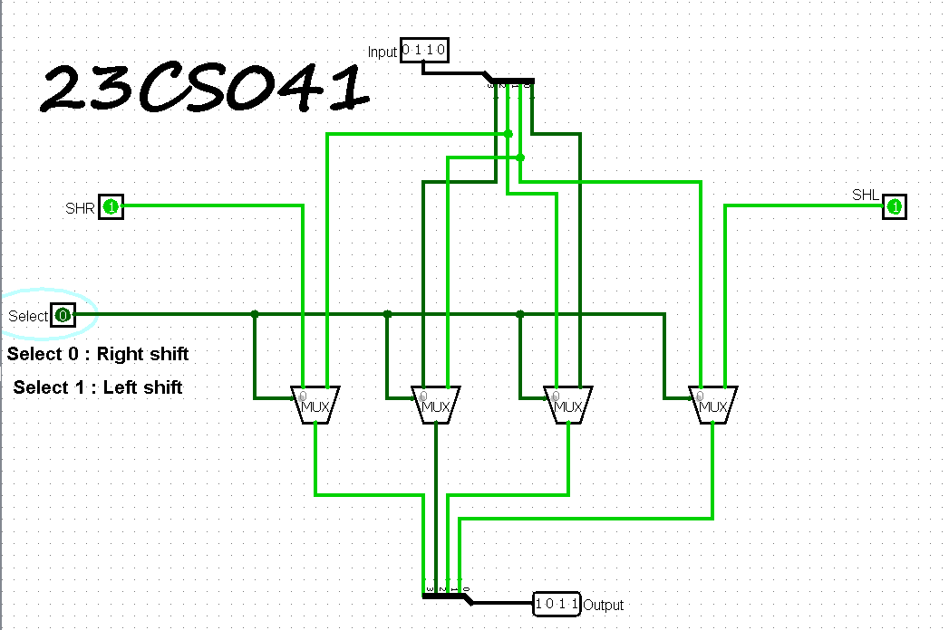

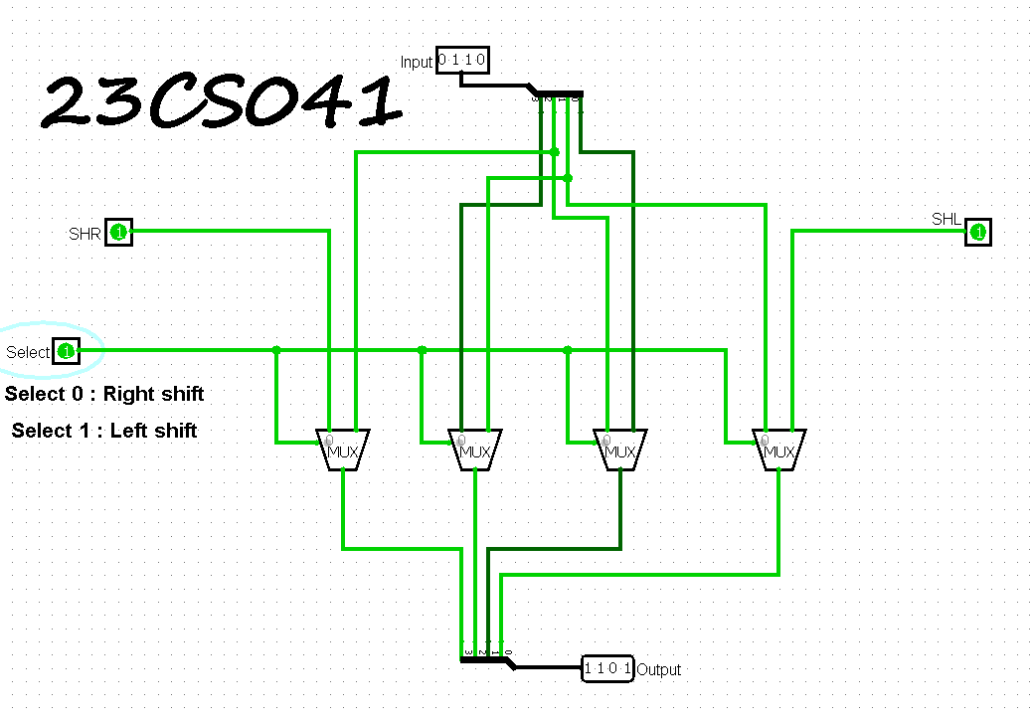

**3)**  **8-bit bidirectional shifter**

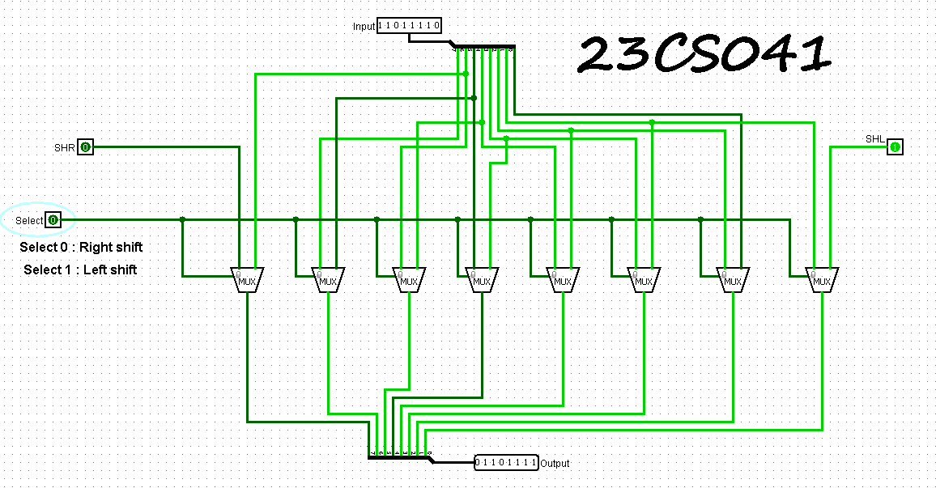

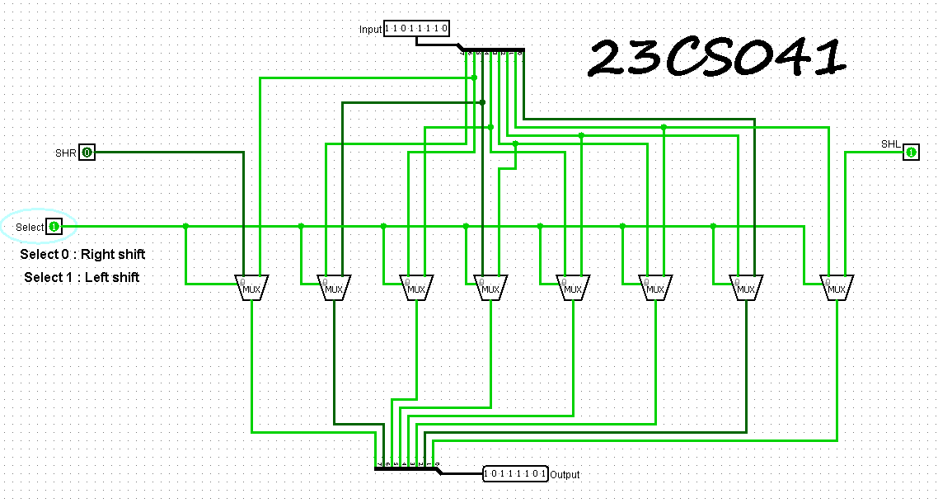

1. **1) 1-bit ALU**

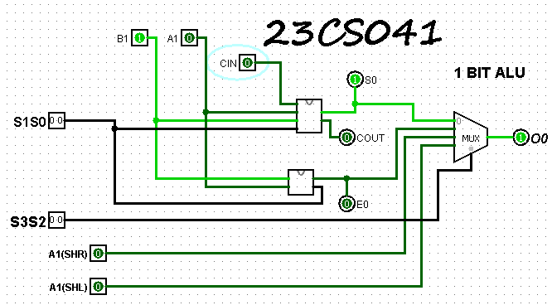

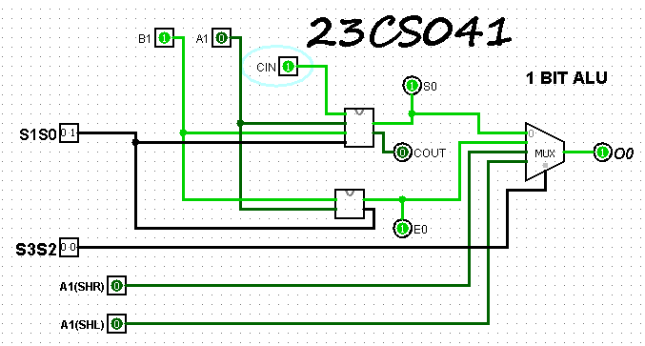

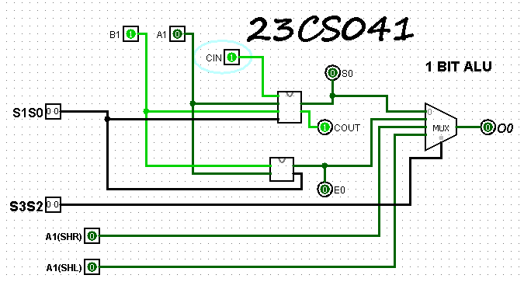

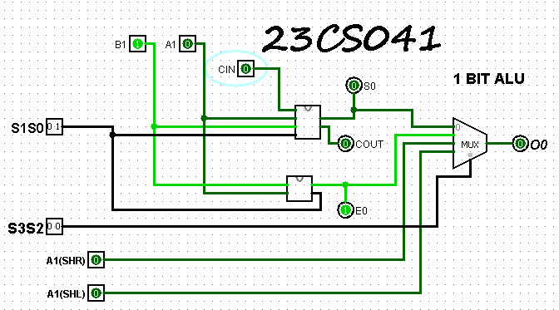

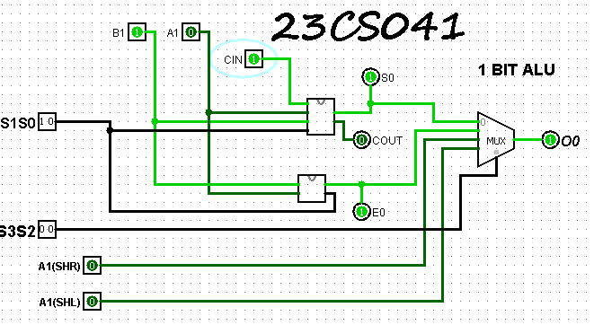

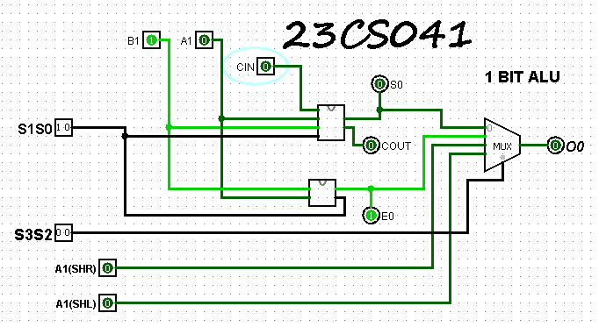

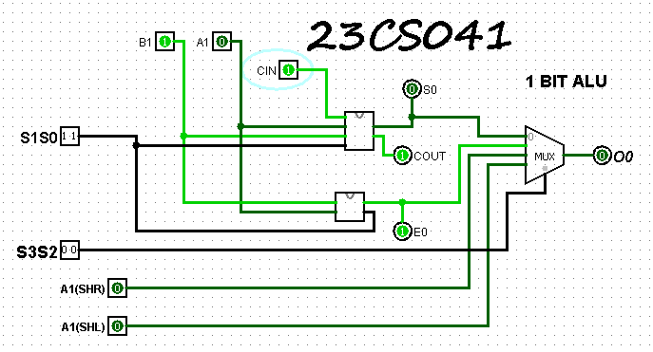

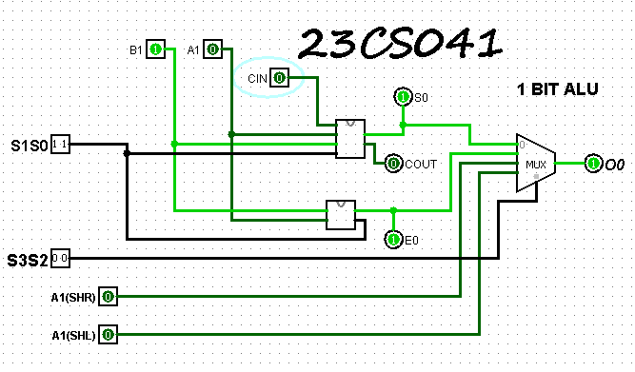

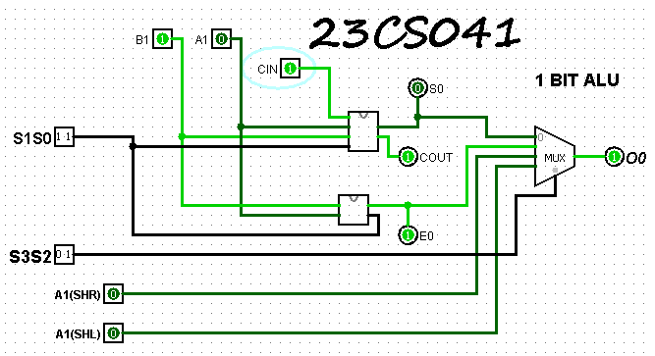

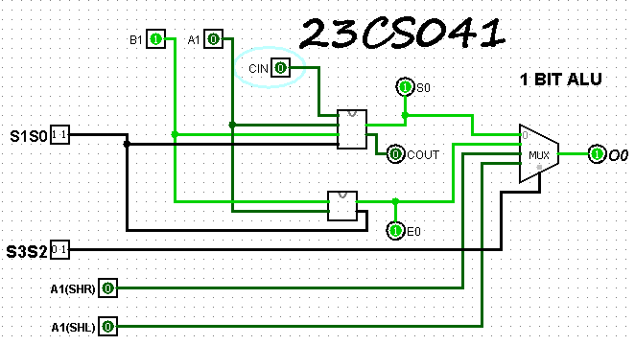

**2) 4-bit ALU**

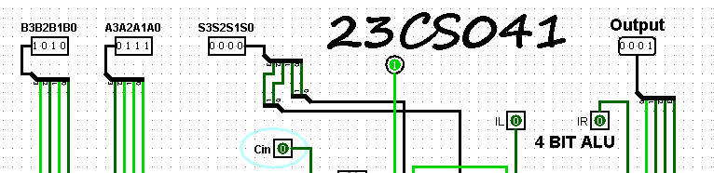

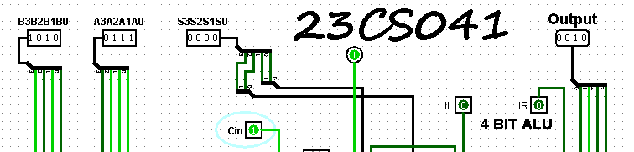

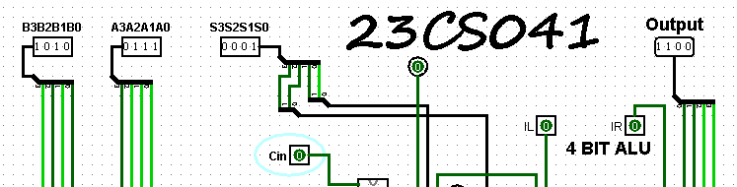

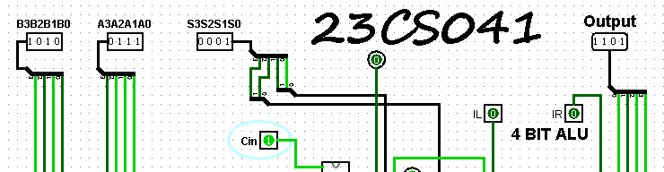

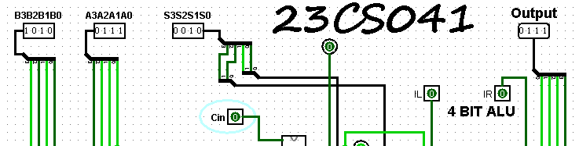

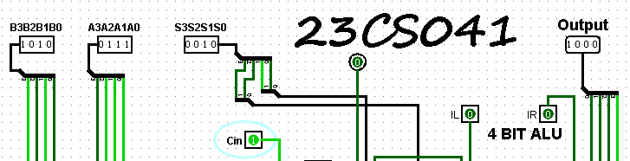

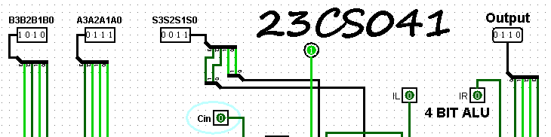

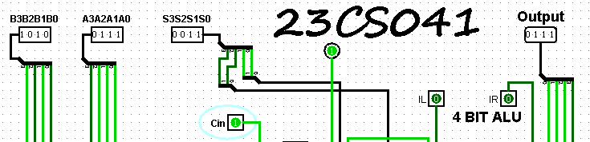

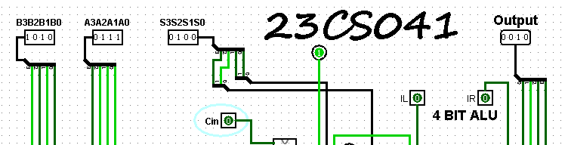

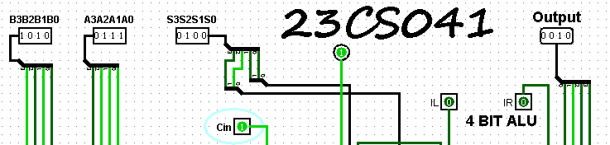

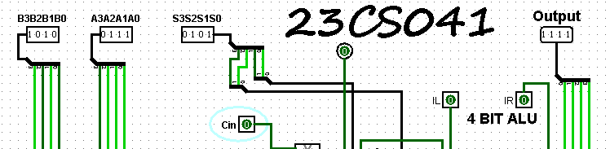

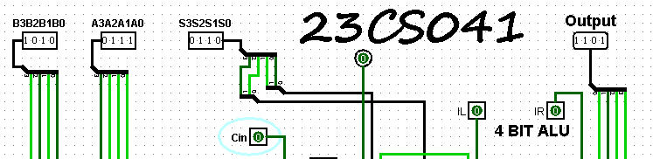

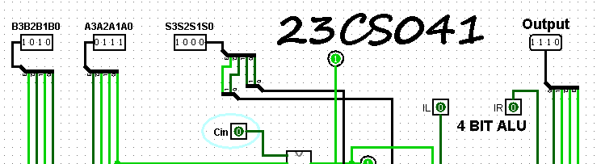

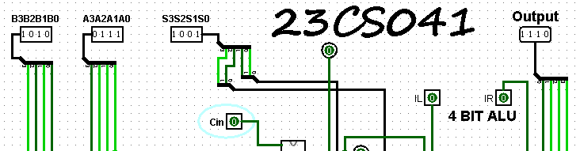

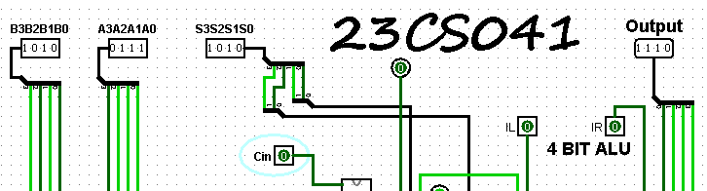

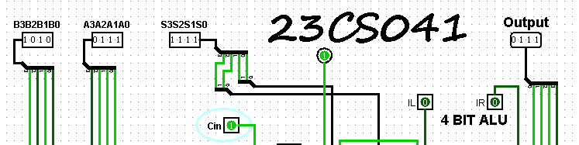

**CONCLUSION:**