**LAB – 9**

**Name :** Shubham Pareshbhai Shingala

**Roll no. :** CE146

**College ID:** 19CEUOS159

**Aim:** Write a program to implement Elliptical Curve Cryptography.

* Key Generation
* Encryption
* Decryption
* Program : Elliptical Curve Cryptography
* **Source Code:**

#include <bits/stdc++.h>

#define ll long long

#define v vector<ll>

#define loop(var, s, n) for (ll var = s; var < n; var++)

#define rloop(var, s, n) for (ll var = s; var >= n; var--)

#define pb push_back

using namespace std;

ll a, b, p, n;

class Point

{

public:

    ll x, y;

    Point(ll X, ll Y)

    {

        x = X;

        y = Y;

    }

    void print()

    {

        cout << "(" << x << ',' << y << ")\n";

    }

};

ll squareMultiply(ll base, ll exp, ll mod) // base^exp(% mod)

{

    ll z = 1;

    while (exp > 0)

    {

        if (exp % 2 == 1)

            z = (z * base) % mod;

        exp = exp / 2;

        base = (base * base) % mod;

    }

    return z;

}

bool isPrime(ll n)

{

    // Corner cases

    if (n <= 1)

        return false;

    if (n <= 3)

        return true;

    // This is checked so that we can skip

    // middle five numbers in below loop

    if (n % 2 == 0 || n % 3 == 0)

        return false;

    for (int i = 5; i * i <= n; i += 6)

        if (n % i == 0 || n % (i + 2) == 0)

            return false;

    return true;

}

ll mod(ll a, ll b)

{

    ll mode = a % b;

    if (mode < 0)

        mode += b;

    return mode;

}

ll multiplicativeInverse(ll a, ll b)

{

    ll q, r, t, t1 = 0, t2 = 1, r1 = b, r2 = a;

    while (r2 > 0)

    {

        q = r1 / r2;

        r = r1 - q * r2;

        r1 = r2;

        r2 = r;

        t = t1 - q * t2;

        t1 = t2;

        t2 = t;

    }

    if (r1 == 1)

    {

        if (t1 < 0)

            t1 += b;

        return t1;

    }

    else

        return -1;

}

ll randomNumberInRange(ll n, ll m) // m not included and n included

{

    srand(time(0));

    ll random = n + rand() % (m - n - 1);

    return random;

}

Point operator+(Point p1, Point p2)

{

    Point p3(0, 0);

    int x1 = p1.x, x2 = p2.x, y1 = p1.y, y2 = p2.y;

    int lamda;

    if (x1 != x2 && y1 != y2)

    {

        int dx = x2 - x1, dy = y2 - y1;

        if (dx < 0)

        {

            dy = (-1) * dy;

            dx = (-1) * dx;

        }

        lamda = mod(dy * multiplicativeInverse(dx, p), p); //((y2-y1)/(x2-x1))mode p

    }

    else if (x1 == x2 && y1 == y2)

    {

        lamda = mod((3 * x1 * x1 + a) * multiplicativeInverse(2 * y1, p), p);

    }

    p3.x = mod((lamda * lamda - x1 - x2), p); // x3=(lamda^2 - x1 - x2)mode p

    p3.y = mod(lamda * (x1 - p3.x) - y1, p);  // y3=(lamda(x1-x3) - y1)mode p

    return p3;

}

Point operator*(Point p1, int n)

{

    Point ans(p1.x, p1.y);

    n--;

    while (n--)

        ans = ans + p1;

    return ans;

}

bool isPointOnCurve(Point p, vector<Point> points)

{

    loop(i, 0, points.size())

    {

        if (p.x == points[i].x && p.y == points[i].y)

            return true;

    }

    return false;

}

vector<Point> pointGeneration()

{

    vector<Point> points;

    loop(x, 0, p)

    {

        ll y_square = mod((x * x * x) + (a * x) + b, p);

        ll r = squareMultiply(y_square, (p - 1) / 2, p);

        if (r == 1)

        {

            ll y = sqrt(y_square);

            while (y * y != y_square)

            {

                y_square += p;

                y = sqrt(y_square);

            }

            ll y1 = mod(-y, p);

            points.pb(Point(x, y));

            points.pb(Point(x, y1));

        }

        else if (r == 0)

            points.pb(Point(x, 0));

    }

    return points;

}

vector<Point> keyGeneration(int &d)

{

    vector<Point> points = pointGeneration(), e;

    n = points.size();

    int index = randomNumberInRange(0, n);

    Point e1 = points[index];

    // Point e1(1,26);

    d = randomNumberInRange(1, 5);

    // d = 4;

    Point e2 = e1 * d;

    while (!isPointOnCurve(e2, points))

    {

        index = randomNumberInRange(0, n);

        e1 = points[index];

        e2 = e1 * d;

    }

    e.pb(e1);

    e.pb(e2);

    return e;

}

vector<Point> encrypt(Point e1, Point e2, Point m)

{

    vector<Point> c;

    int r = randomNumberInRange(1, 5);

    // int r = 1;

    cout << "r = " << r << endl;

    Point c1 = e1 * r;

    Point c2 = m + e2 * r;

    c.pb(c1);

    c.pb(c2);

    return c;

}

Point decrypt(Point c1, Point c2, int d)

{

    Point t = c1 * d;

    return (c2 + Point(t.x, (-1) * t.y)); // c2 + inverse of t

}

int main()

{

    cout << "Enter a and b :";

    cin >> a >> b;

    while (1)

    {

        cout << "Enter prime number: ";

        cin >> p;

        if (!isPrime(p))

            cout << p << " is not a prime number so , ";

        else

            break;

    }

    int d;

    vector<Point> e = keyGeneration(d);

    Point e1 = e[0], e2 = e[1];

    cout << "e1 = ";

    e1.print();

    cout << "e2 = ";

    e2.print();

    cout << "d = " << d;

    int x, y;

    cout << "\nEnter the message : ";

    cin>>x>>y;

    Point m(x, y);

    cout << "Message = ";

    m.print();

    vector<Point> c = encrypt(e1, e2, m);

    Point c1 = c[0], c2 = c[1];

    cout << "c1 = ";

    c1.print();

    cout << "c2 = ";

    c2.print();

    Point msg = decrypt(c1, c2, d);

    cout << "Decrypt Message = ";

    msg.print();

}

* **Test Case – 1: Test Case – 2:**

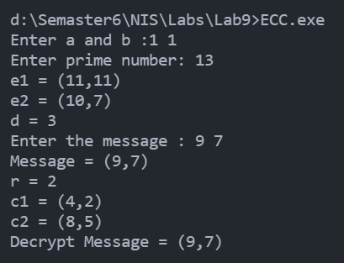 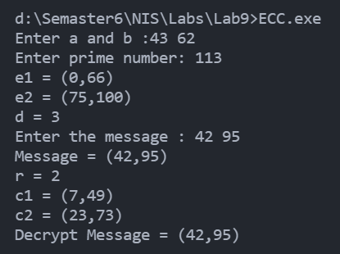

* **Test Case – 3:**

