AGENTIC AI
SMART WORKSPACE
Living Concept, Product, Research & Prototype Report
A thin, paper-like interactive mat where a human and an AI agent share the same visual workspace.
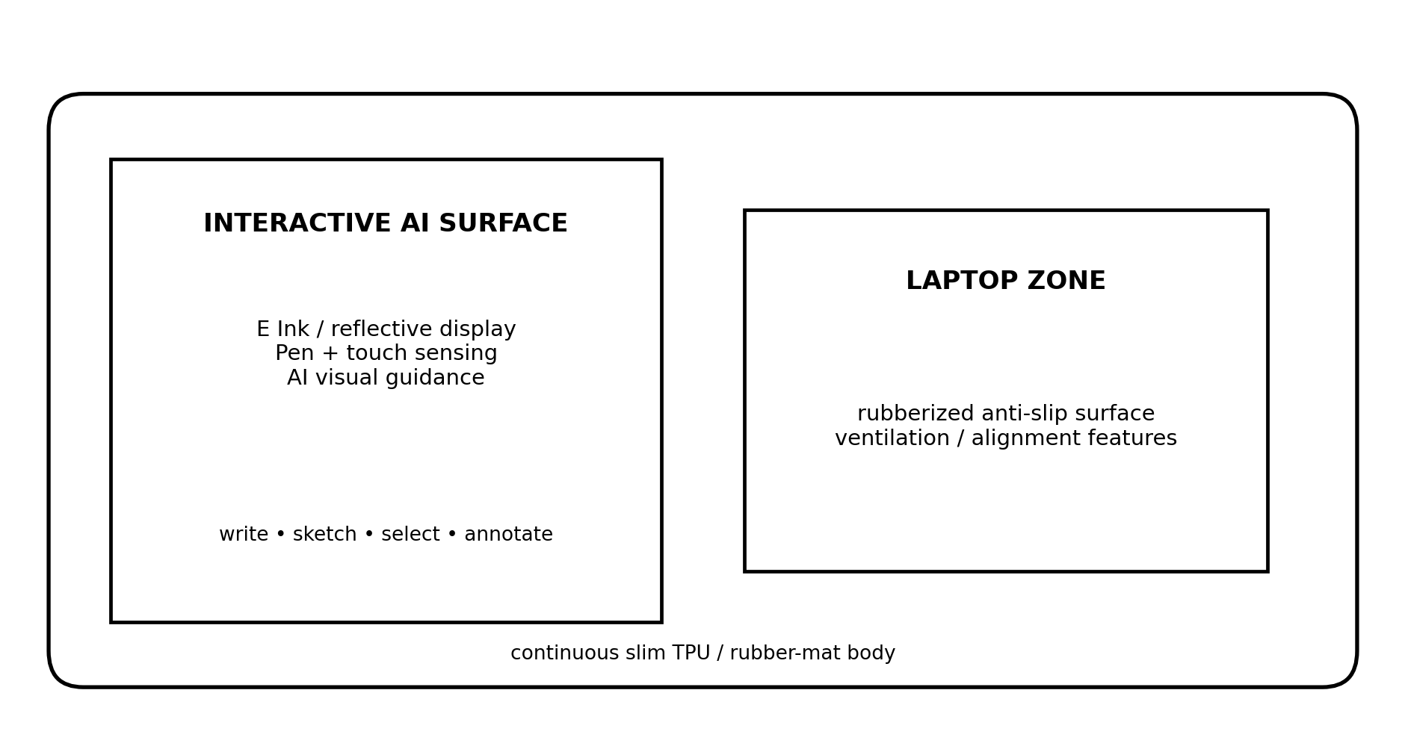
Concept Design A — Smart workspace mat with an interactive AI surface beside a laptop zone.
Purpose: personal working document. Not intended as a submission, patent filing, or final product specification. Update this document as the concept changes.

1. Concept Snapshot
Core idea: build an AI-native physical workspace that understands the process of human work—not just the finished notes—and can respond through spatial visual guidance, voice, and permitted actions.
The proposed product resembles a slim rubber desk/laptop mat. One side is a paper-like pen-and-touch display; the other side supports the laptop. The AI continuously interprets pen strokes, handwritten content, diagrams, touch gestures, pauses, corrections, selections, and voice. It maintains a workspace state and decides when to remain silent, when to offer a subtle hint, and when to actively manipulate the digital workspace.
Element | Working direction
Physical form | Slim rubber/TPU mat; interactive surface + laptop zone
Display | 13.3-inch-class reflective / E Ink-style surface for final concept
Pen | EMR-class battery-free stylus initially; custom AI pen later
Touch | Capacitive finger touch for selection/navigation
AI | Multimodal perception + persistent workspace model + reasoning agent
Assistance | Visual guidance inside the pad + context-aware voice assistant
Agency | AI can annotate, move, draw, clean up, and later invoke laptop tools with explicit permissions
Primary differentiation | AI follows the evolving workflow rather than waiting for a manually written prompt

The one-sentence product definition
A shared visual workspace where a human and an AI agent can see, reason about, and manipulate the same evolving context without forcing the user to leave the work to prompt a chatbot.

2. Problem and Product Thesis
Today, the typical AI-assistance workflow breaks concentration: a person stops working, opens a chatbot, explains the context, uploads or describes the relevant content, reads the answer, and then returns to the task. The smart workspace aims to remove that context-switching loop.
Conventional AI workflow | Proposed workspace
Work → get stuck → stop → open AI → explain context → receive answer → return | Work → AI already has spatial/task context → small hint or action → continue
AI sees only what the user explicitly sends | AI maintains an evolving model of the workspace
Prompt is mostly text | Input can include pen position, handwriting, diagram structure, voice, selection and history
Response is usually separate from the task surface | Response can appear directly beside the relevant work

3. Physical Product Direction
The mat should feel like a premium rubber desk mat, not like a tablet glued to a board. The display section may require local rigidity, but the surrounding structure should visually and tactilely read as one continuous product.
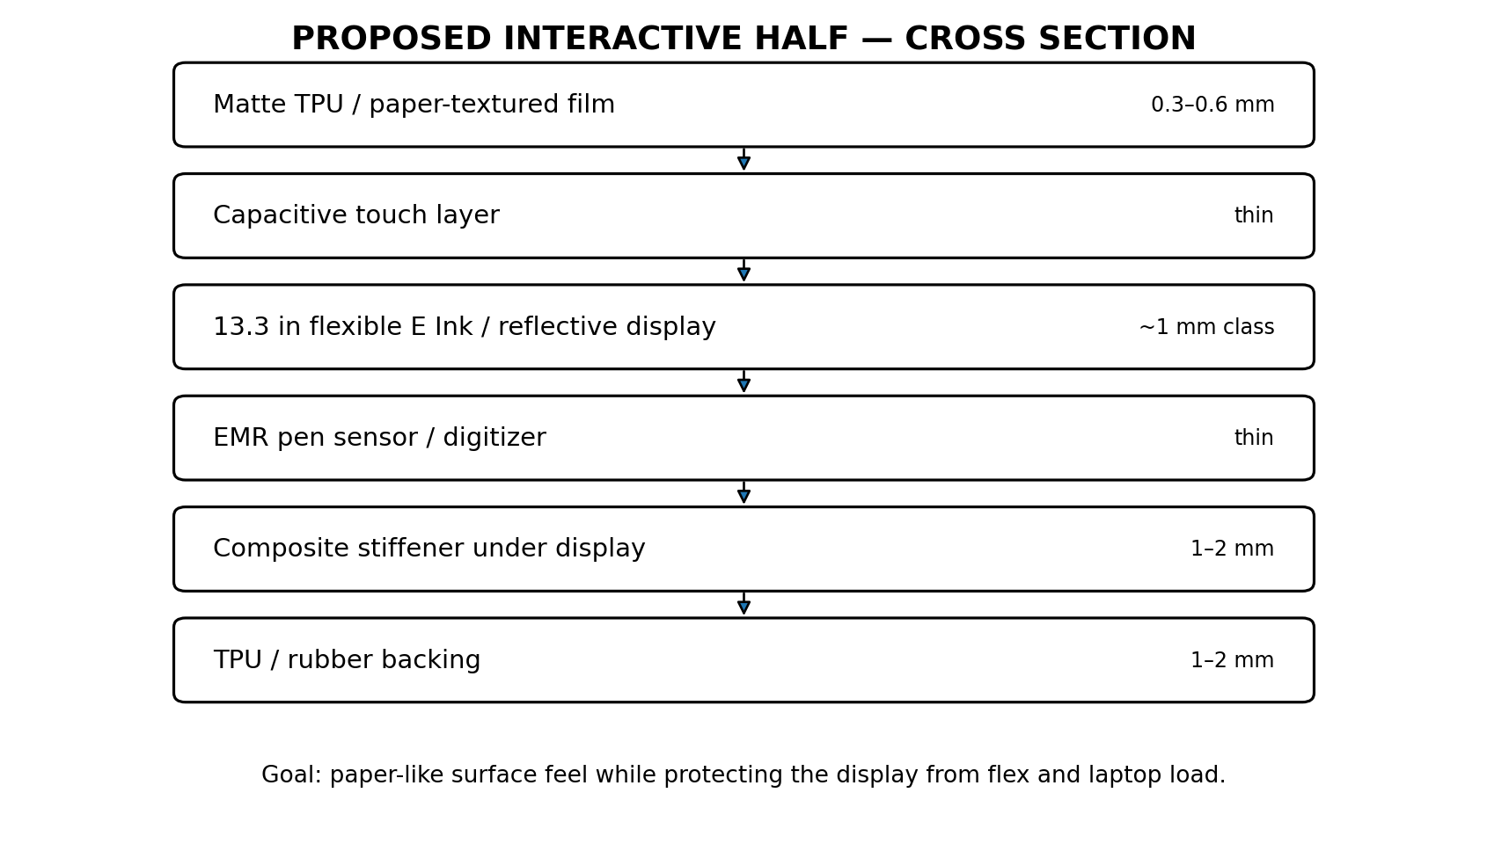
Concept Design B — Proposed interactive-half layer stack. Thickness values are targets, not final engineering specifications.

Design principles
- Paper-like and non-glare rather than glossy and screen-like.
- Slim enough to remain on a desk permanently and portable enough to move with a laptop.
- Laptop weight must never be carried through the display stack.
- The interactive side should be locally stiffened; the mat body can remain softer around it.
- Replaceable or serviceable top film is preferable to permanently exposing the display surface.
- Single-cable laptop connection is the preferred V1/V2 architecture; fully standalone compute can come much later.

Display technology decision
The current preferred final direction is flexible E Ink / reflective digital paper because it matches the desired thin, paper-like, low-glare product. E Ink’s current 13.3-inch reference digital-paper device demonstrates a 5.7 mm package with flexible e-paper, capacitive touch, Wacom EMR pen input, and 4,096 pressure levels. This validates the feasibility of the component combination, although it does not solve the custom mat integration or low-latency AI overlay problem by itself. [1]
However, the product should not become technologically locked to E Ink. If refresh latency or ghosting prevents fluid AI annotations, alternatives such as paper-like LCD / reflective LCD / matte OLED should remain open. The product requirement is “paper-like interactive surface,” not “must use E Ink.”

4. Pen and Touch Interaction
The pen is more than a writing tool. It can become the primary spatial control for the AI. A battery-free EMR-class stylus is attractive for reliability and pressure/hover sensing. A custom pen should be postponed until the software tells us which extra inputs are actually valuable.
Interaction | Possible meaning
Write / draw | Normal user content
Circle region | Select spatial context for AI
Hold side button | Push-to-talk / “analyze what I am pointing at”
Double press | Request a hint
Press + drag | Move AI/user object or indicate “put this here”
Underline | Mark important / remember
Erase / rewrite repeatedly | Possible uncertainty signal, not automatically “stuck”
Hover | Possible focus signal when supported

Raw event model
Capture raw interaction events locally before converting them into semantic events. A raw pen record might contain x/y coordinates, pressure, tilt, timestamp, pen-up/down, button state and stroke ID. The AI should not receive every coordinate directly; a preprocessing layer should compress thousands of points into meaningful events such as “wrote equation,” “circled object,” “erased same term twice,” or “paused after incomplete step.”

5. AI and Software Architecture
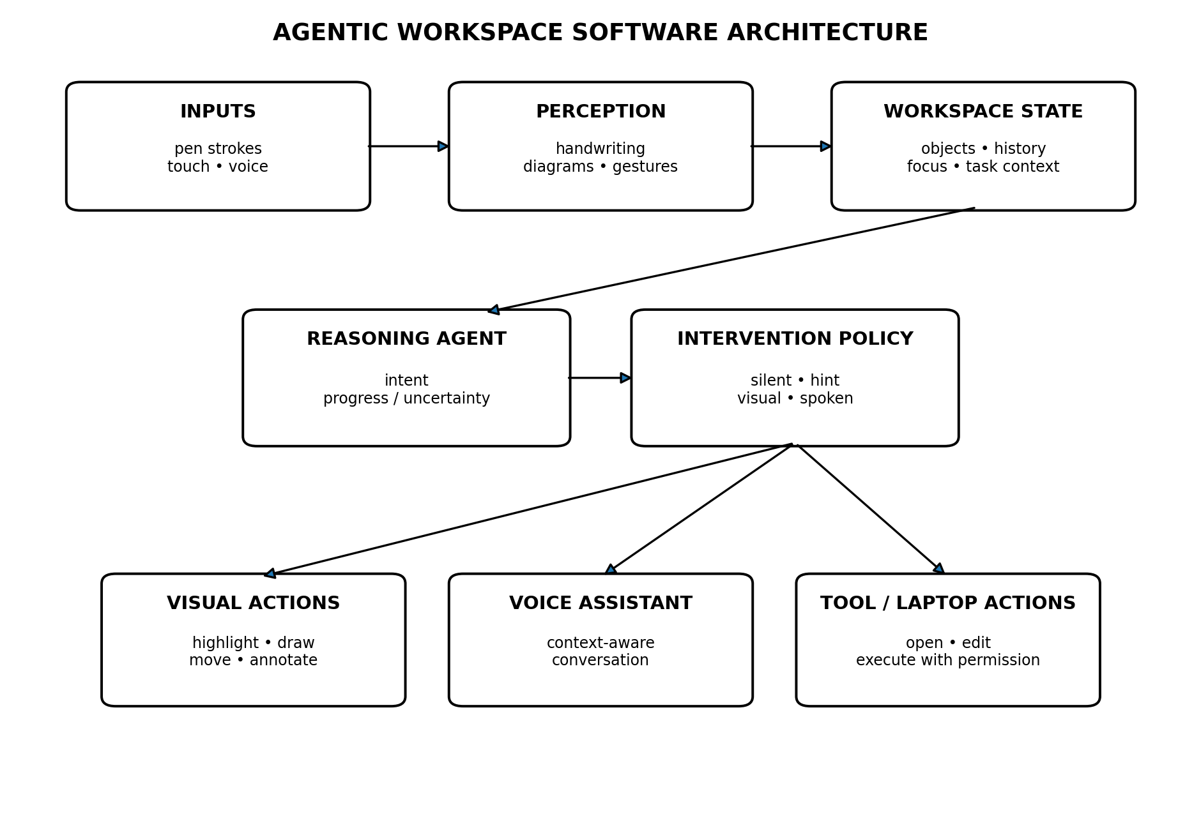
Concept Design C — Modular software architecture. The key architectural choice is separating perception, workspace state, reasoning, intervention policy and actions.

5.1 Perception layer
- Pen/touch event processing
- Handwriting and mathematical notation understanding
- Diagram / shape / connector recognition
- Spatial selection and gesture recognition
- Speech recognition
- Optional screen/laptop context when explicitly connected

5.2 Workspace state
The workspace should not be treated as a flat screenshot. It needs an object/state representation: handwritten objects, diagram nodes, relationships, selected region, active task, recent edits, user-generated content, AI-generated temporary content, and accepted AI content.

5.3 Reasoning agent
The reasoning agent asks: What is the user trying to do? What step are they on? What changed? Is there evidence of difficulty? What information would be useful? What is the least disruptive intervention?

5.4 Intervention policy
This is potentially the most important and defensible part of the system. Pausing does not equal being stuck. The policy should combine pause duration, repeated erasing, repeated attempts, semantic correctness, current task, explicit requests, prior user behavior and confidence. It should be allowed to choose “do nothing.”
Mode | Behavior
Silent | Observe and respond only when explicitly asked.
Assistive | Offer small visual suggestions; speech only when requested.
Proactive | Intervene when confidence and expected usefulness are high.
Tutor | Use progressive hints and preserve productive struggle.

6. Human–AI Interaction Model
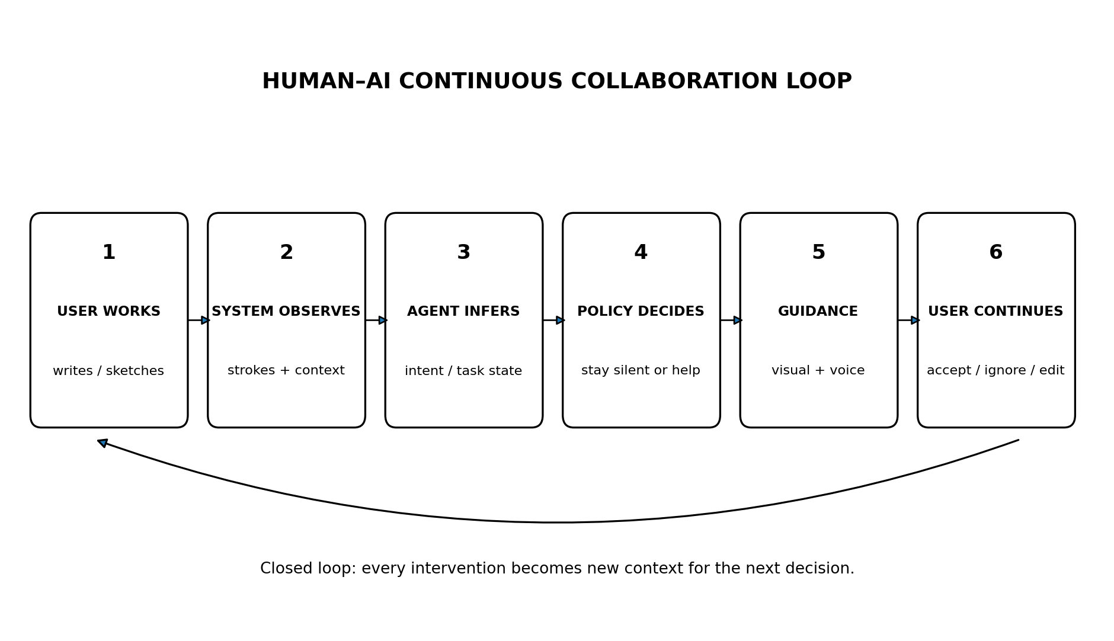
Concept Design D — Closed-loop collaboration instead of request/response chatbot interaction.

Layered canvas behavior
Canvas layer | Rule
User content | Permanent unless user edits it
AI temporary content | Hints, arrows, highlights and proposals; disappears or remains uncommitted
AI accepted content | Becomes part of the document only after user acceptance
System attention layer | Selection, hover, confidence or focus cues; never saved as content

Example interaction
A user sketches a neural-network pipeline and circles the detection block while holding the pen button: “What am I missing if I need memory across frames?” The system grounds “this” to the selected region, recognizes the pipeline, draws a temporary tracker and scene-state block directly on the canvas, and explains the recommendation by voice. The user can accept, dismiss or ask the agent to implement a cleaner version.

7. Voice Assistant and Action Model
The voice assistant should not be a standalone voice chatbot. Speech must be grounded in workspace context. This allows natural commands such as “move this here,” “why is this wrong?”, “clean this diagram,” or “show me without solving it.” The system can resolve “this” from the current selection/pen location and “here” from a destination gesture.

Permission model
Permission | Allowed capability
Observe | Read workspace state only
Suggest | Create temporary visual/voice guidance
Collaborate | Edit the current workspace after user grants permission
Act | Invoke connected laptop/tools; always explicit and auditable
The system should make autonomy visible. A powerful “Jarvis” experience without obvious boundaries will feel intrusive rather than intelligent.

8. Current Market Position
Existing devices validate demand for large paper-like pen surfaces but also show that the product cannot compete on hardware alone. BOOX Note Max already provides a 13.3-inch 300 ppi ePaper display, stylus and capacitive touch in a 4.6 mm device. [2] The opportunity is therefore not “make a thinner digital notebook”; it is to create a substantially different interaction model.
Existing category | What it proves | Gap this concept targets
E Ink notebooks | Users value paper-like digital writing | Most assistance is document-centric, not workflow-centric
AI note features | Users accept AI search/summarization | AI usually acts after content is created
Chatbots / copilots | People value contextual assistance | Context still often has to be manually supplied
Pen displays / tablets | High-quality spatial input is mature | Not designed around persistent agentic workspace state

Market thesis
The product should be positioned as an “AI-native physical workspace,” not as an E Ink tablet, smart desk mat or AI notebook. A strong first market is likely technical students, researchers, engineers, designers and other users who naturally reason with equations, diagrams, architectures and annotations.

9. Research Landscape and Opportunity
Recent work is converging on shared ink canvases and proactive visual agents. Thinkink (University of Waterloo, July 2026) explores ink-native interaction where the human and LLM write and draw in the same 2D canvas, including a semantic-tree representation for ink interpretation. [3] DrawDash (2025) explores proactive multimodal whiteboard assistance that listens to spoken explanation and suggests diagram refinements. [4] These projects make the direction credible while leaving substantial room around continuous task-state modeling, intervention timing, pen-behavior signals, permissions and a dedicated physical work-surface form factor.

Potential research questions
1. Can temporal pen/touch interaction features improve uncertainty or “stuck” detection beyond visual content alone?
2. When should an AI agent intervene during free-form visual problem solving without disrupting cognitive flow?
3. Does spatially embedded guidance reduce context switching compared with chatbot-based assistance?
4. How should an agent balance proactive assistance with productive struggle?
5. Can a persistent structured workspace representation reduce the need to repeatedly send full-screen images to a VLM?
6. How do users calibrate trust when an AI can directly manipulate a shared visual workspace?

10. What Could Become Defensible
The hardware can be copied. The potentially defensible assets are the interaction engine, the intervention policy, and—if collected ethically with consent—the dataset describing how real work evolves over time.
- Stroke-to-semantic-event processing tuned for reasoning tasks.
- Workspace graph / state representation for mixed handwriting, diagrams and voice.
- Models of productive pause vs. actual difficulty.
- Personalized intervention policy that learns when a particular user wants help.
- Accepted/rejected AI action data that trains better collaboration behavior.
- Privacy-preserving local processing that avoids uploading raw notebooks continuously.

11. Privacy, Safety and Trust Requirements
- Raw pen and touch streams should be processed locally whenever practical.
- The user must be able to pause AI observation instantly.
- Private regions/pages should be excluded from cloud processing.
- AI-generated edits should be visually distinguishable until accepted.
- Tool/laptop actions require clear permission and an undo/audit trail.
- Cloud retention should be minimal and explicitly controllable.
- The product should never market “continuous watching” as the benefit; it should market continuity of assistance with user control.

12. Recommended Development Roadmap
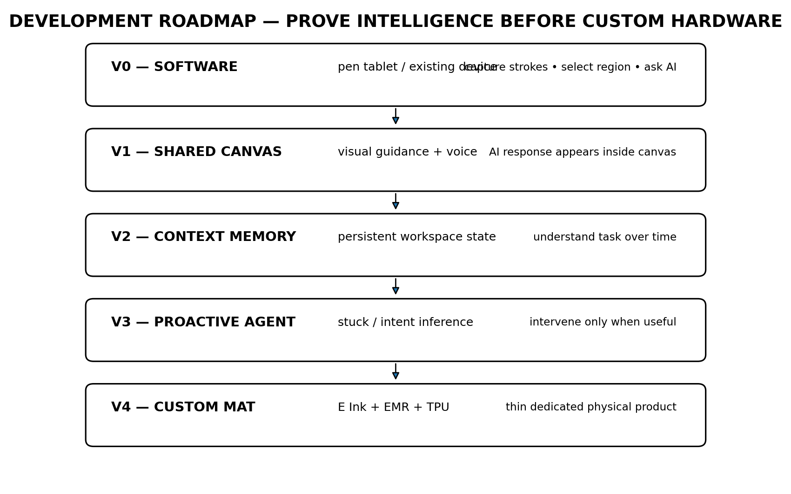
Concept Design E — Recommended sequence. Do not spend heavily on custom E Ink integration before proving the agent experience.

V0 — software proof
- Use an existing pen-enabled device or drawing display.
- Capture strokes and maintain a canvas history.
- Allow user to circle/select a region and ask a voice question.
- Return an AI response beside the selected content.

V1 — shared AI canvas
- Temporary AI overlay layer.
- Voice + visual response together.
- Accept/reject generated annotations.
- Basic semantic object representation.

V2 — persistent task state
- History-aware reasoning.
- Recognize repeated corrections / return to earlier regions.
- Track task goal and active subproblem.
- Measure context-switching reduction in user studies.

V3 — proactive assistance
- Develop intervention policy.
- Separate thinking/reading/planning from being stuck.
- Progressive hint levels.
- Personalization and explicit assistance modes.

V4 — dedicated slim mat
- 13.3-inch-class reflective display stack.
- Pen + capacitive touch integration.
- TPU/rubber enclosure and structural reinforcement.
- Single-cable interface first; embedded compute later if justified.

13. Minimum Viable Demo
The first demo does not need a custom mat. It only needs to prove that shared spatial context changes the quality of AI assistance.
1. User writes or draws on a pen-enabled canvas.
2. Software captures strokes and renders a live workspace image/state.
3. User circles a region.
4. User holds a button or says “explain this.”
5. VLM/LLM receives the selected spatial context plus recent history.
6. A temporary hint appears beside the selected work.
7. The same response is spoken aloud.
8. User can ask “show me” and receive a visual annotation.
9. User accepts or dismisses the annotation.
10. System stores that action as context for the next interaction.

Success criterion
A strong signal is not merely “the AI answered correctly.” A stronger signal is: after using the system, users find ordinary chatbot prompting noticeably disruptive because they have become accustomed to the AI already understanding the workspace.

14. Hardware Buying Strategy
Buy only what is required for the current experiment. The first purchase should be a pen-enabled development surface, not raw E Ink panels, custom digitizers, a Jetson, or a custom stylus PCB. The laptop can initially provide the AI compute, microphone, speaker and connectivity.
Stage | Buy | Avoid
V0 | Pen-enabled tablet/display; optional mic | Bare E Ink panel, custom pen, embedded compute
V1/V2 | Better pen device if needed; mechanical mockup materials | Expensive tooling / molding
V3 | Sensors only if experiments prove they add signal | Adding sensors “because they might help”
V4 | OEM display + digitizer + touch stack; custom enclosure | Consumer product tooling before design freeze

15. Major Risks and How to Test Them Early
Risk | Why it matters | Early test
AI interrupts too often | Product becomes annoying | Measure false-positive interventions and dismissal rate
E Ink latency | Visual guidance feels slow/ghosted | Prototype interaction on existing E Ink device before custom panel
Recognition errors | Wrong spatial context destroys trust | Require selection grounding and confidence thresholds
Privacy concerns | Continuous context can feel invasive | Local preprocessing + obvious AI-off controls
Hardware price | Accessory becomes harder to justify | Prove software value before BOM optimization
Big-platform copying | Hardware/features are copyable | Focus on interaction policy, data and workflow integrations
Too many use cases | MVP becomes unbuildable | Start with one technical workflow and one assistance pattern

16. First User Study / Product Validation
Before committing to hardware, compare three conditions on the same task: normal pen workspace, pen workspace + standard chatbot, and pen workspace + spatial context-aware agent.
Metric | Reason
Task completion time | Productivity
Prompting time / number of context explanations | Context-switching cost
Error rate | Task quality
Accepted vs rejected hints | Intervention usefulness
Unnecessary interventions | Agent precision
NASA-TLX or similar workload measure | Cognitive load
User preference / willingness to pay | Commercial signal

17. Current Decisions vs. Open Questions
Current working decision | Still open
AI guidance appears inside the interactive surface | Exact display technology after latency tests
Laptop sits on separate non-display zone | Exact overall mat dimensions
Rubber/TPU visual identity | Material stack and manufacturability
Pen + finger touch | Whether custom pen sensors are actually needed
AI compute on laptop for early versions | When/if embedded compute becomes worthwhile
Layered user/AI canvas | Best visual language for temporary AI content
Agent must be able to remain silent | Best intervention model and thresholding
Explicit permissions for actions | How far laptop/app control should go in first product

18. Where to Resume Next Time
If returning to this project after a break, resume in this order:
1. Choose the V0 pen-enabled development device.
2. Build a full-screen canvas in Python or a web/desktop framework with low-latency pen event capture.
3. Store strokes as structured events and render them separately from AI overlays.
4. Implement “circle + ask” before any proactive AI behavior.
5. Connect a multimodal model to the selected region plus recent workspace history.
6. Add text-to-speech and visual response inside the canvas.
7. Run small personal tests and record what information the agent actually needs.
8. Only then design stuck detection and proactive intervention.
9. Build a foam/neoprene physical mockup to test dimensions before buying custom display hardware.

19. Selected Sources / References
[1] E Ink, “Black & White Digital Paper Device,” 13.3-inch flexible e-paper reference device: capacitive touch, Wacom EMR, 4096 pressure levels, 5.7 mm thickness. https://www.eink.com/product/detail/digital-paper-device
[2] BOOX, “Note Max,” 13.3-inch 300 ppi ePaper tablet with stylus + capacitive touch; 4.6 mm thickness. https://shop.boox.com/products/notemax
[3] M. H. Payandeh, D. Vogel, J. Zhao, “Thinkink: 2D Spatial Ink-native Interaction with LLMs,” arXiv:2607.21468, 23 July 2026. https://arxiv.org/abs/2607.21468
[4] S. Ellawala, S. Gamage, D. Dissanayake, “Proactive Agentic Whiteboards: Enhancing Diagrammatic Learning,” arXiv:2512.01234, 1 December 2025. https://arxiv.org/abs/2512.01234
[5] E Ink, 13.3-inch color digital-paper reference device showing Kaleido 3 + capacitive touch + EMR integration. https://www.eink.com/product/detail/color-digital-paper
[6] Guo et al., “Magical Touch: Transforming Raw Capacitive Streams into Expressive Hand-Touchscreen Interaction,” arXiv:2605.12902 (2026), relevant to richer raw touch sensing. https://arxiv.org/abs/2605.12902

20. Living Document Notes
This report intentionally mixes product, engineering and research thinking. It should be updated when assumptions change. Recommended future version notes: V0.2 after selecting the development tablet; V0.3 after the first working shared-canvas prototype; V0.4 after user testing; V1.0 only after the physical mat architecture is justified by software results.
End of working concept report — Version 0.1

