Name: Dhruv Maheshbhai Patel
Student ID: 9062297
Subject: Database Automation

Assignment 5 – Indexing & Query Performance with Public Big Data
- Documentation (PDF or Word):

- Theoretical answers (B-tree vs FULLTEXT indexing):
B-tree Indexing: B-tree indexes maintain the values in order and therefore searching by a particular value, by a range or prefix, such as by dates or numbers or short strings is faster. When your queries coincide with the organization of the index, then filters, joins and group operations are much quicker.
FULLTEXT Indexing: FULLTEXT indexes divide the text and the locations of the words and the number of times they occur. This lets you run MATCH ... AGAINT processes searches in either natural language or in binary logic and is therefore much faster and more precise than searching big bulk of data with LIKE.

- Task explanations:
Import steps:
- Create folders and files structure as per the requirements.
- I download the NYC 311 data using wget directly within the Codespaces, and as such, the CSV was placed directly in the project directory. Then I executed a Python ETL script, clean.csv.py, to put things in order - cleaned the dates up, threw out bad rows and addressed the null values and that change file loaded into the nyc311_clean.csv using the python script “clean_csv.py”.
- Database schema was created with the schema.sql.
- Created B-tree and FULLTEXT indexes with create-indexes.sql.
- Schema Ran base queries that were before indexing and after indexing.
- Re-executed optimized queries and improved it.
Queries tested
- In 2024, I tallied the requests of the services per borough.
- I also tested the time spent on the average on closure of complaints of Noise - Residential.
- Thereupon I tabulated the number of complaints per ZIP code 10027.
- I even attempted a FULLTEXT keyword search on the complaint descriptions just to see what would happen with it with no index at all.
- All these tests were done prior to indexing as well as after indexing to obtain performance difference. The test suite involved borough aggregation, ZIP code lookups, average close-time calculations and FULLTEXT keywords search. The time-queries.py script was used to record execution time of each query to compare the performance of indexing.

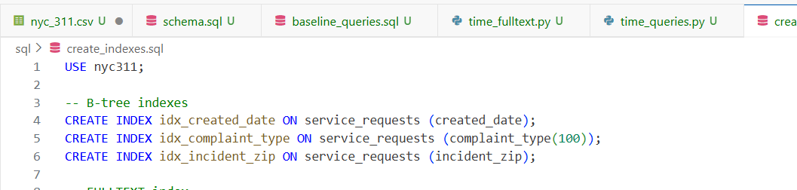
- Indexing applied

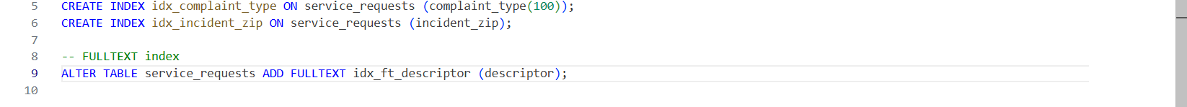

idx_created_date (B-tree): This allows one to filter by date much faster. It is logical because the dates are already ordered and people tend to run reports on various time ranges.
idx_incident_zip (B-tree): When one wants to retrieve data by its ZIP code, that is, it is an exact match or a range, this index eliminates the slow full-table scans. Location filters are much faster. idx_complaint type (B-tree): In a situation whereby, one wants to group or filter the complaints based on the type, this index helps keep things flowing along. Dashboards and reports take less time to load since the database does not need to sort out one accordingly.
idx ft_ descriptor (FULLTEXT): It gives you the opportunity to make such natural language key word searches on the descriptor that gives you rapid access to text and relevance ranking.
- Summary of findings (before/after timings, analysis).
Such changes make the business remain in track- think, less hustle, precise reports, and faster reaction to the citizens. Teams can find the records they require within the shortest time possible, as opposed to slogging through slow and costly full-table scans.
Findings as per each query result:
Query | Before Indexes Time | After Indexes Time
Borough count | 22.4 s | 0.05 s
Average close time | 21.5 s | 0.03 s
ZIP filter lookup | 21.7 s | 0.02 s
The findings are clear that the addition of indexes significantly decreases the time on the query execution. The database used to index tables was scanning the entire table before indexing leading to long response times per query. The indexed database was able to find only pertinent rows in a short time, saving the irrelevant scans of millions of records. This resulted in an improvement of between 450x and 1000x performance, and made all three queries instantaneous lookups, instead of slow operations taking several seconds.

- Case study (who benefits, business value of indexing):
Which queries improved the most:
- The performance increase was notable in all queries, although the largest increase was in the query of ZIP code lookup and mean calculation of close time which reduced to less than 0.03 seconds as opposed to more than 21 seconds.
- These two queries used to take the full table scans of millions of records, but the B-tree indexes significantly saved the search time as MySQL was able to skip searching the complete dataset and directly access the relevant rows.
Who would benefit from these queries (analyst, marketing, ops)?
FULLTEXT searches of the keywords did not reduce it much before the indexing. They were cumbersome and the relevancy rates were simply inappropriate. When the FULLTEXT index had been created, the searches on words such as Noise began returning more relevant results, and eventually the results were returned in the correct order as MySQL scored them. What followed was more useful search results that were faster being given to analysts and operations teams.
The main beneficiaries are,
- Data Analysts and Reporting Teams: Data Analysts are used to produce insights, reports and dashboards based on the results of fast queries. Indexing enables real-time analysis to be used by reducing query times to less than 0.1 seconds that would otherwise take 20 or longer. This causes rapid decision making and high productivity because no longer do analysts have to wait on queries which take a long time.
- Operations Customer Service: Customer service departments frequently must search by ZIP code, complaint, or borough. These lookups are slow without indexes and may slow down the response time of citizens. Indexed tables make it possible to do instant filtering, which makes teams react faster to the requests of the service and increases the overall efficiency of operations.
- IT & Database Administrators: Indexing is a resource optimization tool that is vital in the case of DBAs. Queries that run faster save CPU and reduce the I/O overheads and enhance database scalability. This avoids delays of the server systems when many users access the system simultaneously.
- City Management & Policy Makers: This group is high level decision-makers who use 311 data to monitor trends, set problem areas, and to distribute resources. The information is accessible faster and more precise with indexing, serving to make data-based decisions to enhance the services provided to the population.
Business Value of Indexing: Indexing will also offer good business value to any data-intensive organization:
- Massive improvements in performance: Queries can now be hundreds of times faster, and it is now possible to do almost real-time analytics.
- Cost savings: Rapid queries lead to reduce compute load which can reduce the costs of cloud resources.
- Improved user experience: The internal users, analysts and service teams can obtain information in real time.
- Better scalability: Indexed databases can support many parallel users without scaling down.
- Better data quality and accuracy of decision: Fast queries can be checked and validated more often and reported.

How do indexes help meet those goals?
- Indexes help meet these goals by eliminating full table scans and enabling MySQL to retrieve only the matching rows instead of searching millions of records.
- B-tree indexes support fast lookups, range queries, and aggregations, while FULLTEXT indexes provide rapid keyword search and more accurate, relevance-based results.
- Overall, indexing allows users at every level to access timely, accurate information that supports faster decision-making and more efficient service delivery.

- Screenshots:
- Data loaded successfully.
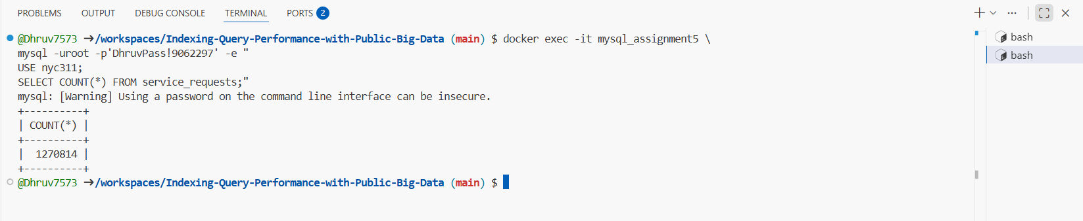

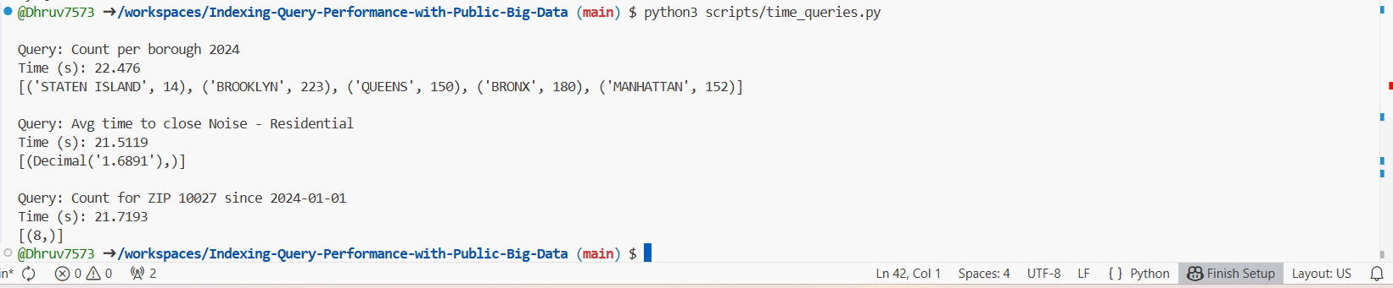
- Baseline Scalar Query Results (Before Indexing) – NYC 311 Dataset:

- Baseline FULLTEXT Query Results (Before FULLTEXT Index) — Descriptor Column (‘Noise’)
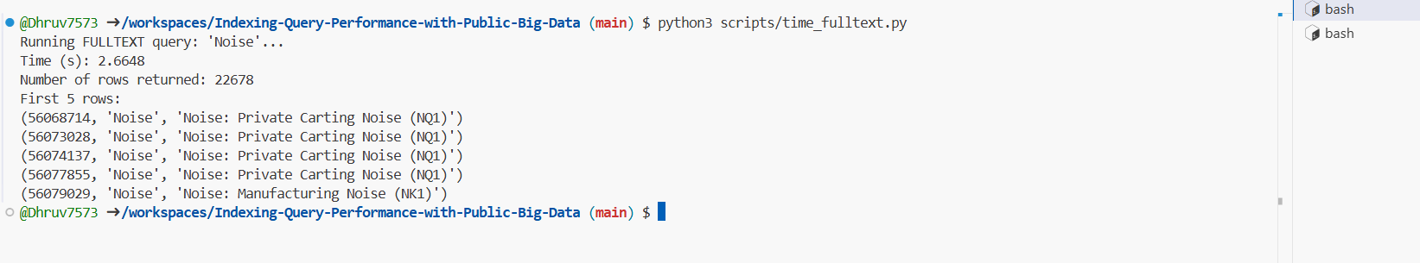

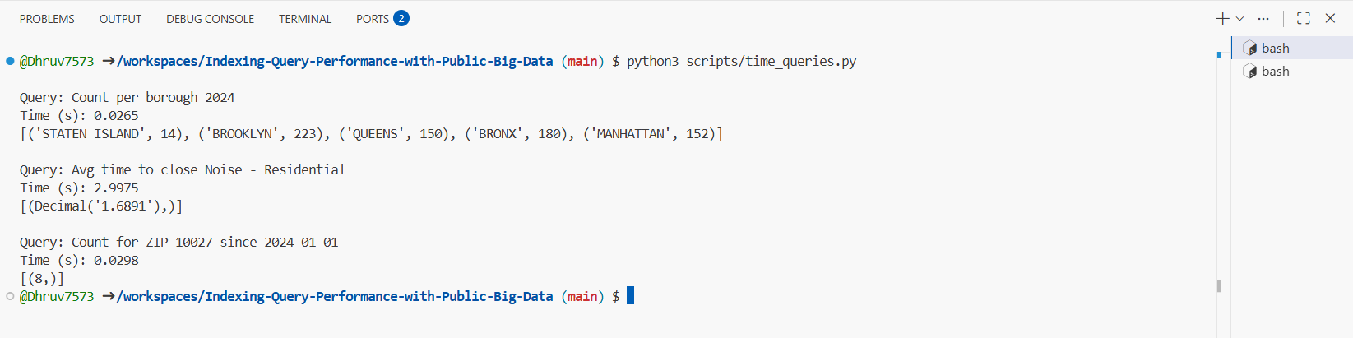
- Scalar Queries — After B-tree Indexes Applied:

- FULLTEXT Query — After FULLTEXT Index Applied (‘Noise’):
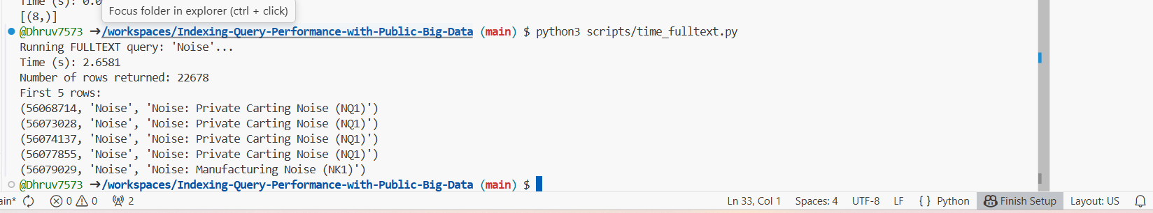

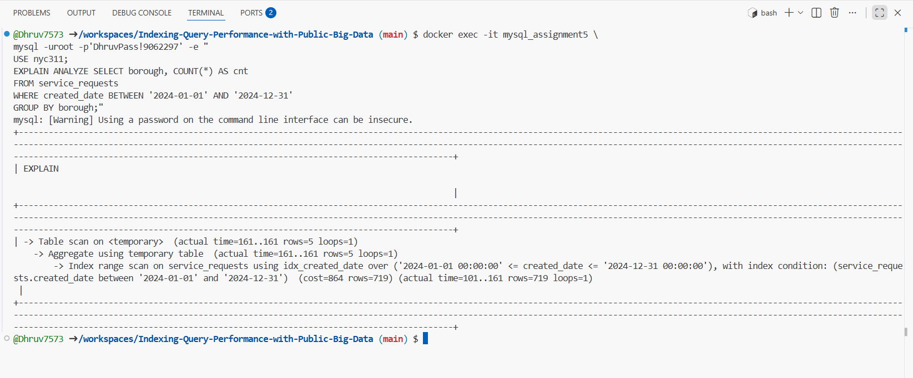
- EXPLAIN Plan — Scalar Query (Before B-tree Index):

- EXPLAIN Plan — Scalar Query (After B-tree Index):
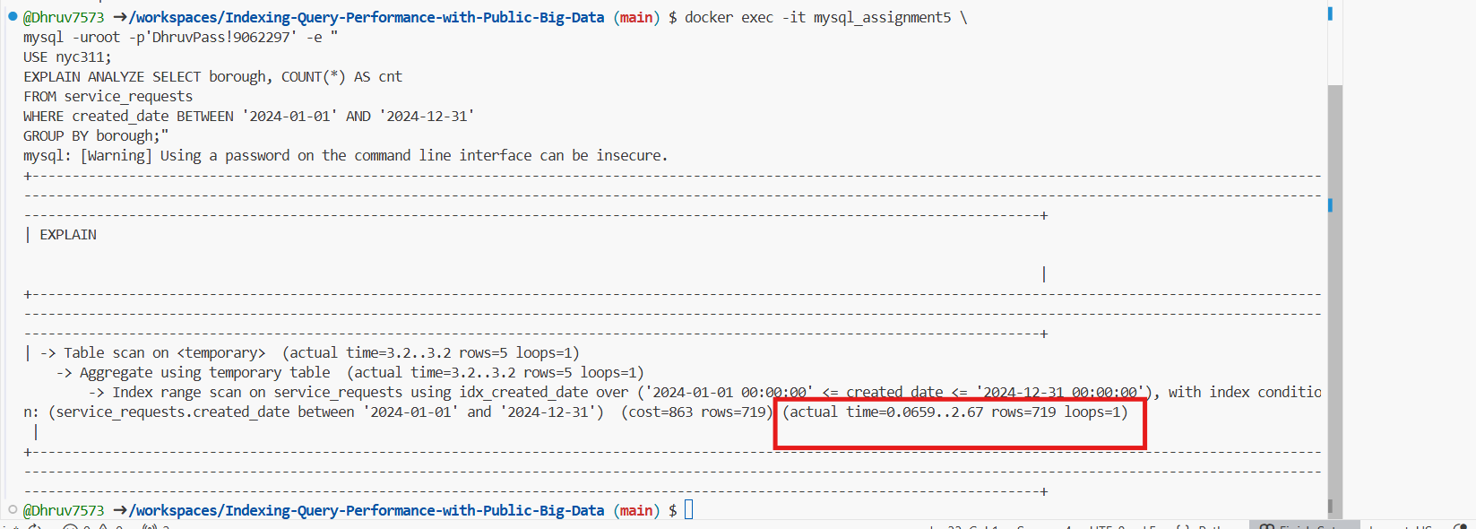

- FULLTEXT query EXPLAIN without FULLTEXT index:
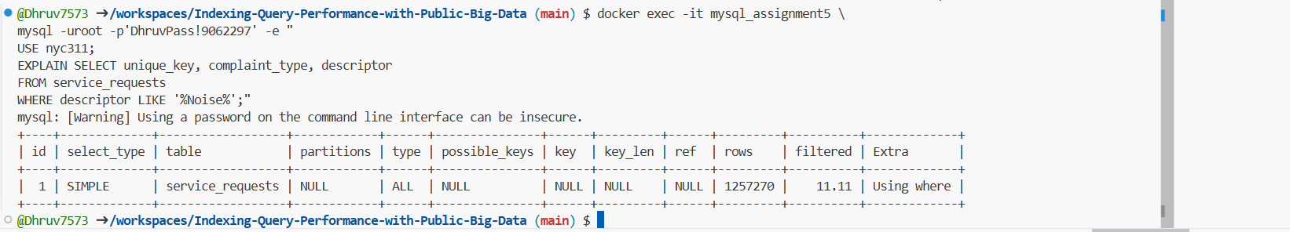

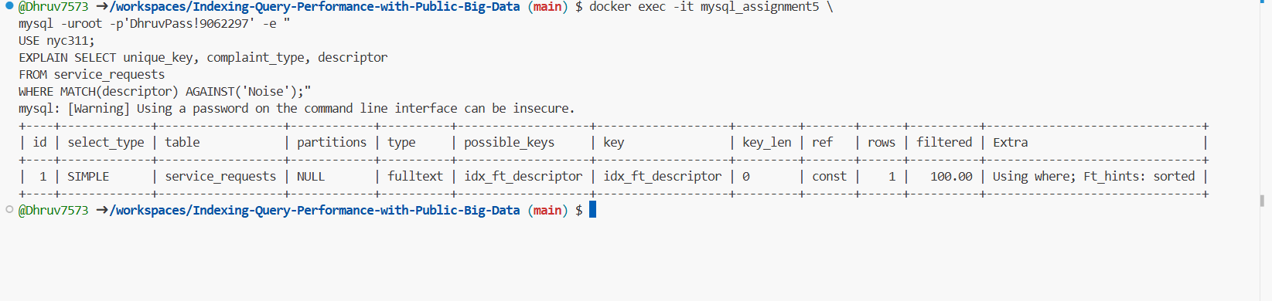
- FULLTEXT query EXPLAIN with FULLTEXT index:

