**BCSE103E -**

**Computer Programming: Java**

Digital Assignment – 1

**Name:** Dhruv Rajeshkumar Shah

**Registration No –** 21BCE0611

1. Write a java program to check the Minimum and Maximum range of all the 8 primitive data types?

**CODE**

// JAVA DA - 1

// by Dhruv Rajeshkumar Shah

// 21BCE0611

class DataSizeRange {

    public static void main(String[] args) {

        // Byte

        System.out.println("Long Min: " + Long.MIN_VALUE +

                "\nMax: " + Long.MAX_VALUE +

                "\nBytes: " + Long.BYTES);

        System.out.println();

        // Short

        System.out.println("Short \nMin: " + Short.MIN_VALUE +

                "\nMax: " + Short.MAX_VALUE +

                "\nBytes: " + Short.BYTES);

        System.out.println();

        // Integer

        System.out.println("Int \nMin: " + Integer.MIN_VALUE +

                "\nMax: " + Integer.MAX_VALUE +

                "\nBytes: " + Integer.BYTES);

        System.out.println();

        // Long

        System.out.println("Long \nMin: " + Long.MIN_VALUE +

                "\nMax: " + Long.MAX_VALUE +

                "\nBytes: " + Long.BYTES);

        System.out.println();

        // Float

        System.out.println("Float \nMin: " + Float.MIN_VALUE +

                "\nMax: " + Float.MAX_VALUE +

                "\nBytes: " + Float.BYTES);

        System.out.println();

        // Double

        System.out.println("Double \nMin: " + Double.MIN_VALUE +

                "\nMax: " + Double.MAX_VALUE +

                "\nBytes: " + Double.BYTES);

        System.out.println();

        // Character

        System.out.println("Character \nMin: " + Character.MIN_VALUE +

                "\nMax: " + Character.MAX_VALUE +

                "\nBytes: " + Character.BYTES);

        System.out.println();

        // Boolean

        System.out.println("Boolean \nMin: " + Boolean.TRUE +

                "\nMax: " + Boolean.FALSE);

    }

}

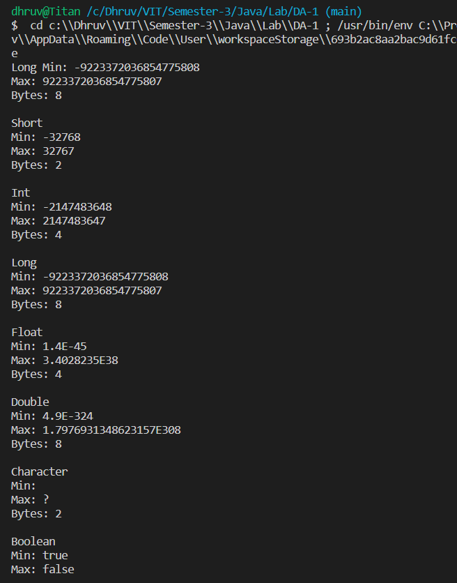**OUTPUT**

1. Java variable declaration

**CODE**

// JAVA DA - 1

// by Dhruv Rajeshkumar Shah

// 21BCE0611

public class Variable {

    public static void main(String[] args) {

        long hoursWorked = 40;

        double payRate = 25.0, taxRate = 0.10, taxPayable;

        System.out.println("Hours Worked: " + hoursWorked);

        System.out.println("Payment Amount: " + (hoursWorked * payRate));

        taxPayable = hoursWorked * payRate * taxRate;

        System.out.println("Tax Payable: " + taxPayable);

    }

}

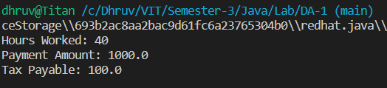 **OUTPUT**

1. Default values of variables

**CODE**

// JAVA DA - 1

// by Dhruv Rajeshkumar Shah

// 21BCE0611

public class DefaultValues {

    // Declaring primitive data types

    byte byte1;

    short short1;

    int int1;

    long long1;

    float float1;

    double double1;

    char char1;

    boolean boolean1;

    // Declaring reference data types

    String string1;

    DefaultValues defaultValues1;

    // Method for printing default values

    public void getDefaultValues() {

        System.out.println("Default value of byte: " + byte1);

        System.out.println("Default value of short: " + short1);

        System.out.println("Default value of int: " + int1);

        System.out.println("Default value of long: " + long1);

        System.out.println("Default value of float: " + float1);

        System.out.println("Default value of double: " + double1);

        System.out.println("Default value of char: " + char1);

        System.out.println("Default value of boolean: " + boolean1);

        System.out.println("Default value of String: " + string1);

        System.out.println("Default value of DefaultValues: " + defaultValues1);

    }

    public static void main(String[] args) {

        DefaultValues object = new DefaultValues();

        object.getDefaultValues();

    }

}

**OUTPUT**

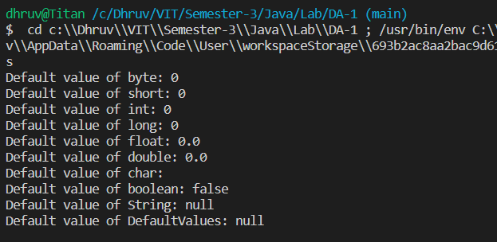

1. Local Variables

**CODE**

// JAVA DA - 1

// by Dhruv Rajeshkumar Shah

// 21BCE0611

public class LocalVariable {

    public class EmployeeSalary {

        public void getSalary() {

            // Declaring local variable

            double salary;

            // Declaring and initializing local variables

            int workingDays = 25, salaryPerDay = 1000;

            // Initializing local variable

            salary = workingDays * salaryPerDay;

            // Printing local variable

            System.out.println("Salary of the employee: " + salary);

        }

    }

    public static void main(String[] args) {

        LocalVariable object = new LocalVariable();

        EmployeeSalary employeeSalary = object.new EmployeeSalary();

    // Viewing local variable salary by calling the method it was declared in

        employeeSalary.getSalary();

    }

}

**OUTPUT**

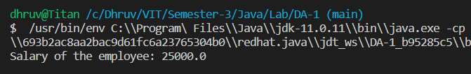

1. Instance variable

**CODE**

// JAVA DA - 1

// by Dhruv Rajeshkumar Shah

// 21BCE0611

public class InstanceVariable {

    public class AreaOfShapes {

        // Declaring instance variables

        double breadth;

        double length;

        double areaOfRectangle;

        double areaOfSquare;

    }

    public static void main(String[] args) {

        InstanceVariable object = new InstanceVariable();

        // Creating new object of AreaOfShapes class

        AreaOfShapes rectangle1 = object.new AreaOfShapes();

        // Initializing instance variables

        rectangle1.breadth = 10;

        rectangle1.length = 20;

        rectangle1.areaOfRectangle = rectangle1.breadth * rectangle1.length;

        // Displaying instance variables

        System.out.println("Length of rectangle: " + rectangle1.length);

        System.out.println("Breadth of rectangle: " + rectangle1.breadth);

        System.out.println("Area of rectangle: " + rectangle1.areaOfRectangle);

        System.out.println();

        // Creating second object of AreaOfShapes class

        AreaOfShapes square1 = object.new AreaOfShapes();

        // Initializing instance variables

        square1.breadth = 10;

        square1.length = 10;

        square1.areaOfSquare = square1.breadth * square1.length;

        // Displaying instance variables

        System.out.println("Length of square: " + square1.length);

        System.out.println("Breadth of square: " + square1.breadth);

        System.out.println("Area of square: " + square1.areaOfSquare);

    }

}

**OUTPUT**

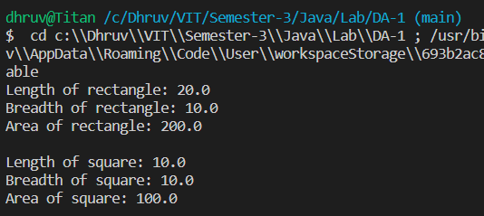

1. Static variable

**CODE**

// JAVA DA - 1

// by Dhruv Rajeshkumar Shah

// 21BCE0611

public class StaticVariable {

    // Declaring static variables

    public static int marks;

    // Declaring and initializing static variables

    public static String name = "Dhruv";

    public static void main(String[] args) {

        // Accessing static variables without creating object

        StaticVariable.marks = 99;

        System.out.println("Name: " + StaticVariable.name);

        System.out.println("Marks: " + StaticVariable.marks);

        // Creating 3 objects

        StaticVariable obj1 = new StaticVariable();

        StaticVariable obj2 = new StaticVariable();

        StaticVariable obj3 = new StaticVariable();

        // Accessing static variables using objects

        System.out.println("Name of object 1: " + obj1.name);

        System.out.println("Name of object 2: " + obj2.name);

        System.out.println("Name of object 3: " + obj3.name);

        // Accessing static variables directly

        System.out.println("Marks: " + marks);

        // Changing value of static variable using object

        obj1.name = "Dhruv Rajeshkumar Shah";

        // Accessing static variables again

        System.out.println("Name of object 1: " + obj1.name);

        System.out.println("Name of object 2: " + obj2.name);

        System.out.println("Name of object 3: " + obj3.name);

    }

}

**CODE**

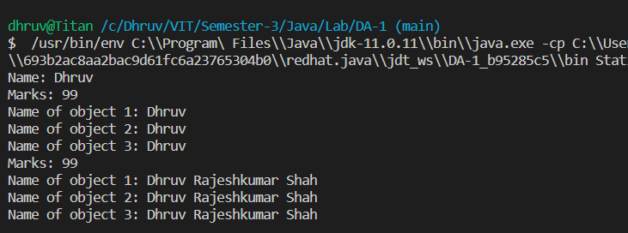

1. Program to find the Data type detail how the value is stored in machine

**CODE**

// JAVA DA - 1

// by Dhruv Rajeshkumar Shah

// 21BCE0611

public class DataTypeDetails {

    public static void main(String[] args) {

        int x = -5;// 5

        System.out.println(Integer.toBinaryString(x));

    }

}

**OUTPUT**

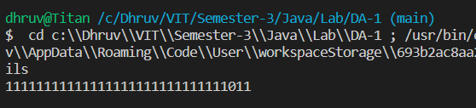

1. Program to print Unicode

**CODE**

// JAVA DA - 1

// by Dhruv Rajeshkumar Shah

// 21BCE0611

public class Unicode {

    public static void main(String[] args) {

        for (char c = 0x0370; c <= 0x03FF; c++)

            System.out.println(c + " ");

    }

}

**OUTPUT**

1. Write a program to display Devanagari alphabets

**CODE**

// JAVA DA - 1

// by Dhruv Rajeshkumar Shah

// 21BCE0611

public class Devnagri {

    public static void main(String[] args) {

        for (char c = 0x0905; c <= 0x0935; c++)

            System.out.print(c + " ");

    }

}

 **OUTPUT**

1. Program Showing all the integer literals

**CODE**

// JAVA DA - 1

// by Dhruv Rajeshkumar Shah

// 21BCE0611

public class LiteralIntegers {

    public static void main(String[] arg) {

        int decimalInt = 1234;

        int octalInt = 077;

        int hexaInt = 0x1ff2;

        int binInt = 0b1010101;

        System.out.println("This is a Decimal Literal: " + decimalInt);

        System.out.println("This is an Octal Literal: " + octalInt);

        System.out.println("This is a Hexa Decimal Literal: " + hexaInt);

        System.out.println("This is a Binary Literal: " + binInt);

    }

}

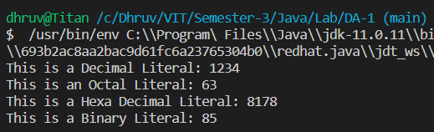**OUTPUT**

1. Floating literals

**CODE**

// JAVA DA - 1

// by Dhruv Rajeshkumar Shah

// 21BCE0611

public class LiteralFloat {

    public static void main(String[] arg) {

        float valFloat = 1.7732f;

        double doubleFloat = 1.7732d;

        float expFloat = 123E4f;

        System.out.println("This is a Floating Point Literal: " + valFloat);

        System.out.println("This is a Decimal Literal: " + doubleFloat);

        System.out.println("This is an Exponential Literal: " + expFloat);

    }

}

**OUTPUT**

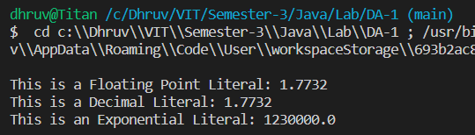

1. Boolean literals

**CODE**

// JAVA DA - 1

// by Dhruv Rajeshkumar Shah

// 21BCE0611

public class LiteralBoolean {

    public static void main(String[] arg) {

        boolean bool1 = true;

        boolean bool2 = false;

        System.out.println("This is a boolean true literal: " + bool1);

        System.out.println("This is a boolean false literal: " + bool2);

    }

}

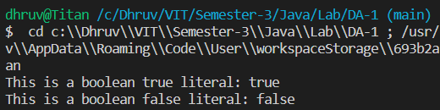**OUTPUT**

1. Character literals

**CODE**

// JAVA DA - 1

// by Dhruv Rajeshkumar Shah

// 21BCE0611

public class CharacterLiteral {

    public static void main(String[] args) {

        char character = 'd';

        char unicodeCharacter = '\u0064';

        System.out.println("This is Character literal: " + character);

        System.out.println("This is unicode character literal: " + unicodeCharacter);

    }

}

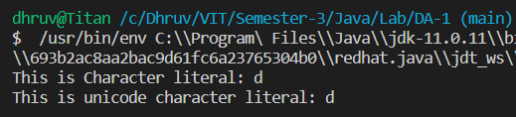**OUTPUT**

1. String literals

**CODE**

// JAVA DA - 1

// by Dhruv Rajeshkumar Shah

// 21BCE0611

public class LiteralString {

    public static void main(String[] arg) {

        String str1 = "Dhruv";

        String str2 = "Shah";

        System.out.println("This is a String literal: " + str1);

        System.out.println("This is a String literal: " + str2);

    }

}

**OUTPUT**

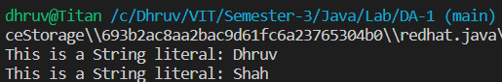

1. Increment

**CODE**

// JAVA DA - 1

// by Dhruv Rajeshkumar Shah

// 21BCE0611

public class Increment {

    public static void main(String[] args) {

        int x = 5, y, z;

        // Post increment

        y = x++;

        System.out.println("Post increment: " + x + " " + y);

        // Pre increment

        z = ++x;

        System.out.println("Pre increment: " + x + " " + z);

        // Float increment

        float f = 5.5f;

        f++;

        System.out.println("Float increment: " + f);

        // Charater increment

        char c = 'a';

        c++;

        System.out.println("Character increment: " + c);

        // Byte increment

        byte b = 5;

        b++;

        System.out.println("Byte increment: " + b);

    }

}

**OUTPUT**

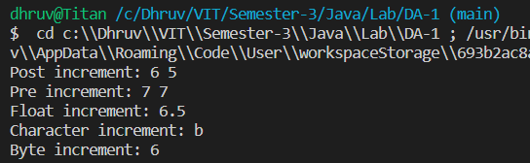

1. Bitwise operations

**CODE**

// JAVA DA - 1

// by Dhruv Rajeshkumar Shah

// 21BCE0611

public class BitwiseOperations {

    public static void main(String[] args) {

        int x = 0b1010;

        int y = 0b0110;

        // Bitwise AND

        System.out.println("Bitwise AND: " + (x & y));

        // Bitwise OR

        System.out.println("Bitwise OR: " + (x | y));

        // Bitwise XOR

        System.out.println("Bitwise XOR: " + (x ^ y));

        // Bitwise NOT

        System.out.println("Bitwise NOT: " + (~x));

        // Left shift

        System.out.println("Left shift: " + (x << 1));

        // Right shift

        System.out.println("Right shift: " + (x >> 1));

    }

}

**OUTPUT**

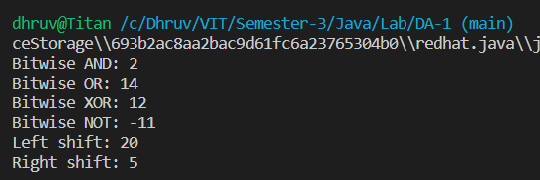

15. Scanner

CODE

// JAVA DA - 1

// by Dhruv Rajeshkumar Shah

// 21BCE0611

import java.util.Scanner;

public class Keyboard {

    public static void main(String args[]) {

        Scanner sc = new Scanner(System.in);

        // Scanning different types of input

        // String

        System.out.println("Enter a string");

        String str = sc.nextLine();

        System.out.println("String: " + str + "\n");

        // Character

        System.out.println("Enter a character");

        char ch = sc.next().charAt(0);

        System.out.println("Character: " + ch + "\n");

        // Integer

        System.out.println("Enter an integer");

        int num = sc.nextInt();

        System.out.println("Integer: " + num + "\n");

        // Float

        System.out.println("Enter a float");

        float f = sc.nextFloat();

        System.out.println("Float: " + f + "\n");

        // Boolean

        System.out.println("Enter a boolean");

        boolean b = sc.nextBoolean();

        System.out.println("Boolean: " + b + "\n");

        // Byte

        System.out.println("Enter a byte");

        byte by = sc.nextByte();

        System.out.println("Byte: " + by + "\n");

        // Binary

        System.out.println("Enter a number in binary");

        int bin = sc.nextInt(2);

        System.out.println("Binary: " + bin + "\n");

    }

}

OUTPUT

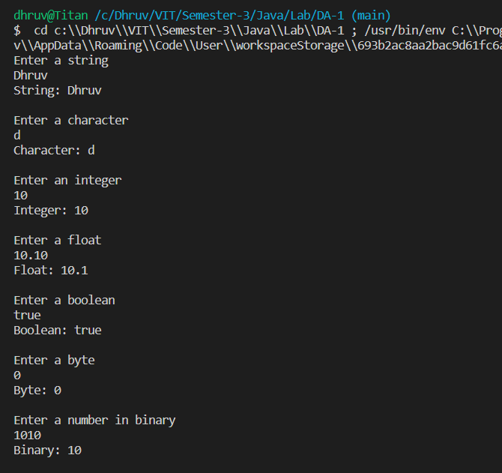

1. Area of triangle

CODE

// JAVA DA - 1

// by Dhruv Rajeshkumar Shah

// 21BCE0611

import java.util.Scanner;

public class Triangle {

    public static void main(String[] args) {

        Scanner sc = new Scanner(System.in);

        int a, b, c;

        double s, area;

        System.out.println("Enter 3 Sides of a Triangle");

        a = sc.nextInt();

        b = sc.nextInt();

        c = sc.nextInt();

        s = (a + b + c) / 2f;

        area = Math.sqrt(s * (s - a) * (s - b) * (s - c));

        System.out.println("Area of Triangle is : " + area);

    }

}

OUTPUT

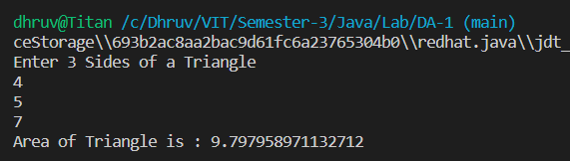

1. Quadratic equation

CODE

// JAVA DA - 1

// by Dhruv Rajeshkumar Shah

// 21BCE0611

import java.util.Scanner;

public class QuadraticEquation {

    public static void main(String[] args) {

        Scanner sc = new Scanner(System.in);

        double a, b, c, d, r1, r2;

        System.out.println("Enter the value of a, b and c");

        a = sc.nextDouble();

        b = sc.nextDouble();

        c = sc.nextDouble();

        d = (b * b) - (4 * a * c);

        if (d > 0) {

            r1 = (-b + Math.sqrt(d)) / (2 * a);

            r2 = (-b - Math.sqrt(d)) / (2 * a);

            System.out.println("Roots are real and distinct");

            System.out.println("Root 1: " + r1);

            System.out.println("Root 2: " + r2);

        } else if (d == 0) {

            r1 = r2 = -b / (2 * a);

            System.out.println("Roots are real and equal");

            System.out.println("Root 1: " + r1);

            System.out.println("Root 2: " + r2);

        } else {

            System.out.println("Roo1ts are imaginary");

        }

    }

}

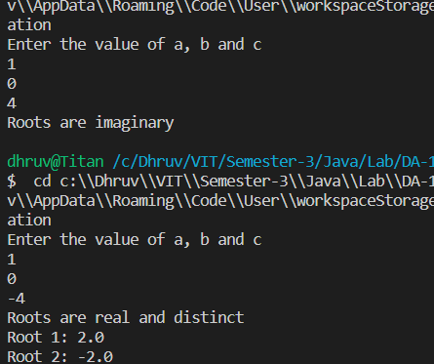OUTPUT

1. Cuboid

CODE

// JAVA DA - 1

// by Dhruv Rajeshkumar Shah

// 21BCE0611

import java.util.Scanner;

public class Cuboid {

    public static void main(String[] args) {

        Scanner sc = new Scanner(System.in);

        int length, breadth, height;

        int totalArea, volume;

        System.out.println("Enter length, breadth and height");

        length = sc.nextInt();

        breadth = sc.nextInt();

        height = sc.nextInt();

        totalArea = 2 * (length * breadth + length * height + breadth * height);

        volume = length * breadth * height;

        System.out.println("Total Area: " + totalArea);

        System.out.println("Volume :" + volume);

    }

}

OUTPUT

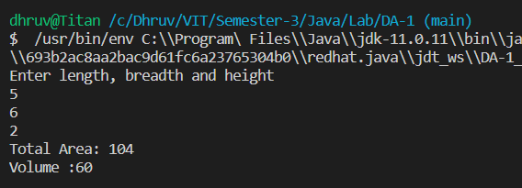

1. Operators (Arithmatic, relational, logical, bitwise, assignment)

**CODE**

// JAVA DA - 1

// by Dhruv Rajeshkumar Shah

// 21BCE0611

import java.util.Scanner;

public class Operators {

    public static void main(String[] args) {

        Scanner sc = new Scanner(System.in);

        int a, b, c;

        System.out.println("Enter 2 numbers");

        a = sc.nextInt();

        b = sc.nextInt();

        // Arithmatic operators

        c = a + b;

        System.out.println("Sum: " + c);

        c = a - b;

        System.out.println("Difference: " + c);

        c = a * b;

        System.out.println("Product: " + c);

        c = a / b;

        System.out.println("Quotient: " + c);

        c = a % b;

        System.out.println("Remainder: " + c);

        // Relational operators

        System.out.println("a > b: " + (a > b));

        System.out.println("a < b: " + (a < b));

        System.out.println("a >= b: " + (a >= b));

        System.out.println("a <= b: " + (a <= b));

        System.out.println("a == b: " + (a == b));

        System.out.println("a != b: " + (a != b));

        // Logical operators

        System.out.println("a > 0 && b > 0: " + (a > 0 && b > 0));

        System.out.println("a > 0 || b > 0: " + (a > 0 || b > 0));

        System.out.println("!(a > 0): " + !(a > 0));

        // Bitwise operators

        System.out.println("a & b: " + (a & b));

        System.out.println("a | b: " + (a | b));

        System.out.println("a ^ b: " + (a ^ b));

        System.out.println("~a: " + (~a));

        System.out.println("a << 1: " + (a << 1));

        System.out.println("a >> 1: " + (a >> 1));

        System.out.println("a >>> 1: " + (a >>> 1));

        // Assignment operators

        c = a;

        System.out.println("c = a: " + c);

        c += a;

        System.out.println("c += a: " + c);

        c -= a;

        System.out.println("c -= a: " + c);

        c *= a;

        System.out.println("c *= a: " + c);

        c /= a;

        System.out.println("c /= a: " + c);

        c %= a;

        System.out.println("c %= a: " + c);

        c &= a;

        System.out.println("c &= a: " + c);

        c ^= a;

        System.out.println("c ^= a: " + c);

        c |= a;

        System.out.println("c |= a: " + c);

    }

}

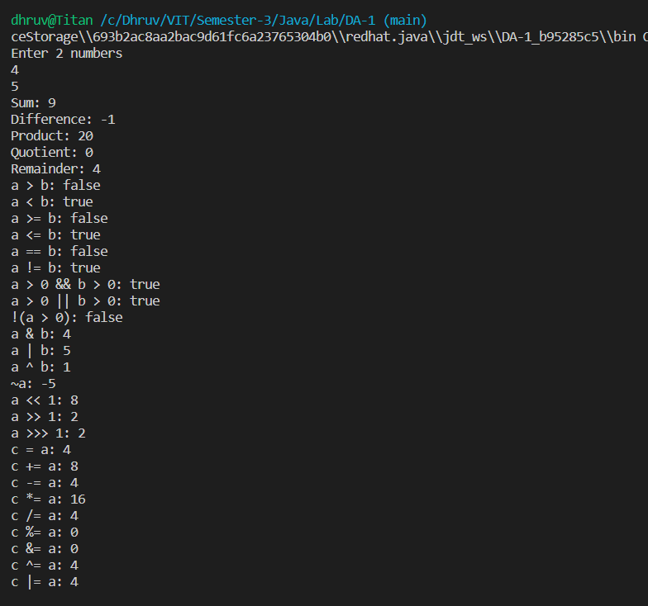**OUTPUT**

1. Swapping using bitwise operations

**CODE**

// JAVA DA - 1

// by Dhruv Rajeshkumar Shah

// 21BCE0611

public class Swapping {

    public static void main(String[] args) {

        int a = 10, b = 20;

        System.out.println("Before Swapping: a = " + a + " b = " + b);

        a = a ^ b;

        b = a ^ b;

        a = a ^ b;

        System.out.println("After Swapping: a = " + a + " b = " + b);

    }

}

**OUTPUT**

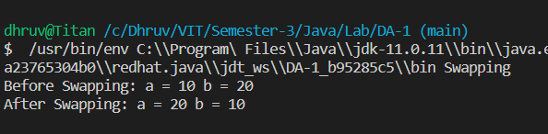

1. Store 2 numbers in a single byte

**CODE**

// JAVA DA - 1

// by Dhruv Rajeshkumar Shah

// 21BCE0611

public class TwoNumbersOneByte {

    public static void main(String[] args) {

        byte a = 9;

        byte b = 12;

        byte c;

        c = (byte) (a << 4);

        c = (byte) (c | b);

        System.out.println((c & 0b11110000) >> 4);

        System.out.println(c & 0b00001111);

    }

}

**OUTPUT**

