**BCSE103E -**

**Computer Programming: Java**

Digital Assignment – 4

**Name:** Dhruv Rajeshkumar Shah

**Registration No –** 21BCE0611

1. Inheritance ( Circle and cylinder)

**CODE**

// JAVA DA - 4

// by Dhruv Rajeshkumar Shah

// 21BCE0611

// Circle class

class Circle {

    public double radius;

    // Constructor

    public Circle(double radius) {

        this.radius = radius;

    }

    public double area() {

        return Math.PI * radius * radius;

    }

    public double perimeter() {

        return 2 * Math.PI * radius;

    }

    public double circumference() {

        return perimeter();

    }

}

// Cylinder class extended from circle

class Cylinder extends Circle {

    public double height;

    // Constructor

    public Cylinder(double radius, double height) {

        super(radius);

        this.height = height;

    }

    public double volume() {

        return area() * height;

    }

}

public class Inheritance1 {

    public static void main(String[] args) {

        Cylinder cylinder = new Cylinder(7, 10);

        System.out.println("Cylinder area: " + cylinder.area()); // Inheriting area() from Circle

        System.out.println("Cylinder volume: " + cylinder.volume());

    }

}

**OUTPUT**

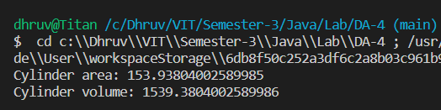

1. Inheritance (Savings and loan account)

**CODE**

// JAVA DA - 4

// by Dhruv Rajeshkumar Shah

// 21BCE0611

// Account class

class Account {

    private int accNo;

    private String name;

    private double balance;

    private long phoneNo;

    private String DOB;

    private String address;

    // Constructor

    public Account(int accNo, String name, double balance, long phoneNo, String DOB, String address) {

        this.accNo = accNo;

        this.name = name;

        this.balance = balance;

        this.phoneNo = phoneNo;

        this.DOB = DOB;

        this.address = address;

    }

    // Getters

    public int getAccNo() {

        return accNo;

    }

    public String getName() {

        return name;

    }

    public double getBalance() {

        return balance;

    }

    public long getPhoneNo() {

        return phoneNo;

    }

    public String getDOB() {

        return DOB;

    }

    public String getAddress() {

        return address;

    }

    // Setters

    public void setAccNo(int accNo) {

        this.accNo = accNo;

    }

    public void setName(String name) {

        this.name = name;

    }

    public void setBalance(double balance) {

        this.balance = balance;

    }

    public void setPhoneNo(long phoneNo) {

        this.phoneNo = phoneNo;

    }

    public void setDOB(String DOB) {

        this.DOB = DOB;

    }

}

// Savings Account class extended from Account

class SavingsAccount extends Account {

    // Constructor

    public SavingsAccount(int accNo, String name, double balance, long phoneNo, String DOB, String address) {

        super(accNo, name, balance, phoneNo, DOB, address);

    }

    // Method to deposit money

    public void deposit(double amount) {

        setBalance(getBalance() + amount);

    }

    // Method to withdraw money

    public void withdraw(double amount) {

        setBalance(getBalance() - amount);

    }

    // Fixed deposit method

    public void fixedDeposit(double amount, int years) {

        setBalance(getBalance() + amount * years);

    }

    // Liquidate fixed deposit method

    public void liquidateFixedDeposit(double amount, int years) {

        setBalance(getBalance() - amount * years);

    }

}

// Loan Account class extended from Account

class LoanAccount extends Account {

    private int interestRate;

    // Constructor

    public LoanAccount(int accNo, String name, double balance, long phoneNo, String DOB, String address,

            int interestRate) {

        super(accNo, name, balance, phoneNo, DOB, address);

        this.interestRate = interestRate;

    }

    // Calculate interest method

    public void calculateInterest() {

        setBalance(getBalance() + getBalance() * interestRate / 100);

    }

    // Method to pay EMI

    public void payEMI(double amount) {

        setBalance(getBalance() - amount);

    }

    // Method to top up loan

    public void topUpLoan(double amount) {

        setBalance(getBalance() + amount);

    }

    // Method to repay loan

    public void repayLoan(double amount) {

        setBalance(getBalance() - amount);

    }

}

public class Inheritance2 {

    public static void main(String[] args) {

        // Savings account

        System.out.println("Savings Account");

        SavingsAccount savingsAccount = new SavingsAccount(123456789, "Dhruv Shah", 10000, 1234567890, "01/01/2001",

                "Mumbai");

        savingsAccount.deposit(1000);

        System.out.println("Balance after deposit: " + savingsAccount.getBalance());

        savingsAccount.withdraw(500);

        System.out.println("Balance after withdrawal: " + savingsAccount.getBalance());

        savingsAccount.fixedDeposit(10000, 5);

        System.out.println("Balance after fixed deposit: " + savingsAccount.getBalance());

        savingsAccount.liquidateFixedDeposit(10000, 5);

        System.out.println("Balance after liquidating fixed deposit: " + savingsAccount.getBalance());

        System.out.println("Savings Account Balance: " + savingsAccount.getBalance());

        System.out.println();

        // Loan account

        System.out.println("Loan Account");

        LoanAccount loanAccount = new LoanAccount(987654321, "Dhruv Shah", 10000, 1234567890, "01/01/2001", "Mumbai",

                10);

        loanAccount.calculateInterest();

        System.out.println("Balance after interest calculation: " + loanAccount.getBalance());

        loanAccount.payEMI(1000);

        System.out.println("Balance after paying EMI: " + loanAccount.getBalance());

        loanAccount.topUpLoan(10000);

        System.out.println("Balance after topping up loan: " + loanAccount.getBalance());

        loanAccount.repayLoan(10000);

        System.out.println("Loan Account Balance: " + loanAccount.getBalance());

    }

}

**OUTPUT**

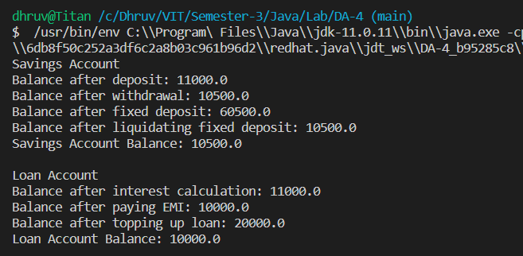

1. Constructors in Inheritance (Default and parameterized)

**CODE**

// JAVA DA - 4

// by Dhruv Rajeshkumar Shah

// 21BCE0611

// Parent class

class Parent {

    // Default constructor

    public Parent() {

        System.out.println("Parent constructor");

    }

    // Parameterized constructor

    public Parent(int x) {

        System.out.println("Parent constructor with value " + x);

    }

}

// Child class

class Child extends Parent {

    // Default constructor

    public Child() {

        System.out.println("Child constructor");

    }

    // Parameterized constructor

    public Child(int y) {

        System.out.println("Child constructor with value " + y);

    }

    public Child(int x, int y) {

        super(x);

        System.out.println("Child constructor with value " + x + " and " + y);

    }

}

// Grandchild class

class Grandchild extends Child {

    // Default constructor

    public Grandchild() {

        System.out.println("Grandchild constructor");

    }

}

public class ConstructorsInheritance {

    public static void main(String[] args) {

        // Default constructors

        Grandchild grandchild = new Grandchild();

        System.out.println();

        // Parameterized constructors

        Child child = new Child(5);

        System.out.println();

        Child child2 = new Child(5, 10);

        System.out.println();

    }

}

**OUTPUT**

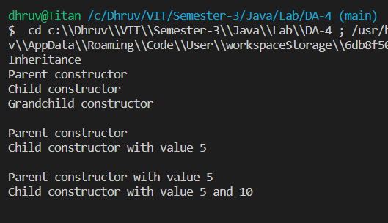

1. Super constructor

**CODE**

// JAVA DA - 4

// by Dhruv Rajeshkumar Shah

// 21BCE0611

// Rectangle class

class Rectangle {

    public double length;

    public double breadth;

    // Constructor

    public Rectangle(double length, double breadth) {

        this.length = length;

        this.breadth = breadth;

    }

    public double area() {

        return length * breadth;

    }

    public double perimeter() {

        return 2 * (length + breadth);

    }

}

// Cuboid class extended from rectangle

class Cuboid extends Rectangle {

    public double height;

    // Constructor

    public Cuboid(double length, double breadth, double height) {

        super(length, breadth); // Super keyword is used to call the constructor of the parent class

        this.height = height;

    }

    public double volume() {

        return area() * height;

    }

}

public class ConstructorsInheritance2 {

    public static void main(String[] args) {

        Cuboid cuboid = new Cuboid(7, 10, 5);

        System.out.println("Cuboid area: " + cuboid.area()); // Inheriting area() from Rectangle

        System.out.println("Cuboid volume: " + cuboid.volume());

    }

}

**OUTPUT**

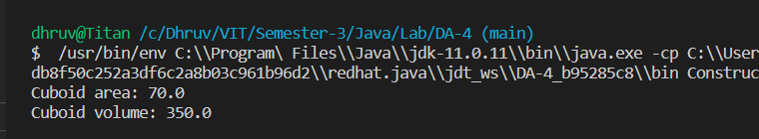

1. Overriding and Dynamic Dispatch

**CODE**

// JAVA DA - 4

// by Dhruv Rajeshkumar Shah

// 21BCE0611

// Parent class

class ParentOverriding {

    public void print() {

        System.out.println("Parent class");

    }

}

// Child class

class ChildOverriding extends ParentOverriding {

    // Overriding the print() method

    public void print() {

        System.out.println("Child class");

    }

}

public class Overriding {

    public static void main(String[] args) {

        ParentOverriding parent = new ParentOverriding();

        parent.print(); // Parent class

        ChildOverriding child = new ChildOverriding();

        child.print(); // Child class

        ParentOverriding parentChild = new ChildOverriding();

        parentChild.print(); // Dispatching to the child class

    }

}

**OUTPUT**

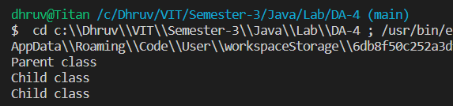

1. Abstract classes (Shape)

**CODE**

// JAVA DA - 4

// by Dhruv Rajeshkumar Shah

// 21BCE0611

// Abstract class shape

abstract class Shape {

    public abstract double area();

    public abstract double perimeter();

}

// Rectangle class extended from shape

class Rectangle extends Shape {

    public double length;

    public double breadth;

    // Constructor

    public Rectangle(double length, double breadth) {

        this.length = length;

        this.breadth = breadth;

    }

    public double area() {

        return length * breadth;

    }

    public double perimeter() {

        return 2 * (length + breadth);

    }

}

// Circle class extended from shape

class Circle extends Shape {

    public double radius;

    // Constructor

    public Circle(double radius) {

        this.radius = radius;

    }

    public double area() {

        return Math.PI * radius * radius;

    }

    public double perimeter() {

        return 2 * Math.PI * radius;

    }

}

public class AbstractClass {

    public static void main(String[] args) {

        Rectangle rectangle = new Rectangle(7, 10);

        System.out.println("Rectangle area: " + rectangle.area());

        System.out.println("Rectangle perimeter: " + rectangle.perimeter());

        Circle circle = new Circle(7);

        System.out.println("Circle area: " + circle.area());

        System.out.println("Circle perimeter: " + circle.perimeter());

    }

}

**OUTPUT**

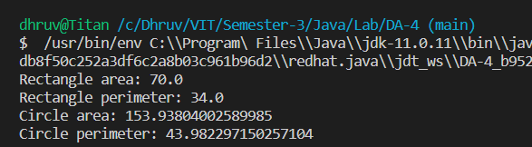

1. Interfaces (Phone)

**CODE**

// JAVA DA - 4

// by Dhruv Rajeshkumar Shah

// 21BCE0611

// Parent class

class Phone {

    public void call() {

        System.out.println("Phone call");

    }

    public void sms() {

        System.out.println("Sending SMS")

    }

}

// Interface

interface Camera {

    void click();

    void record();

}

interface MusicPlayer {

    void play();

    void stop();

    void pause();

}

// Child class

class SmartPhone extends Phone implements Camera, MusicPlayer {

    public void call() {

        System.out.println("Smart phone call");

    }

    public void sms() {

        System.out.println("Smart phone sending SMS");

    }

    public void click() {

        System.out.println("Smart phone clicking photo");

    }

    public void record() {

        System.out.println("Smart phone recording video");

    }

    public void play() {

        System.out.println("Smart phone playing music");

    }

    public void stop() {

        System.out.println("Smart phone stopping music");

    }

    public void pause() {

        System.out.println("Smart phone pausing music");

    }

}

public class Interfaces {

    public static void main(String[] args) {

        SmartPhone smartPhone = new SmartPhone();

        smartPhone.call(); // Smart phone call

        smartPhone.sms(); // Smart phone sending SMS

        smartPhone.click(); // Smart phone clicking photo

        smartPhone.record(); // Smart phone recording video

        smartPhone.play(); // Smart phone playing music

        smartPhone.stop(); // Smart phone stopping music

        smartPhone.pause(); // Smart phone pausing music

    }

}

**OUTPUT**

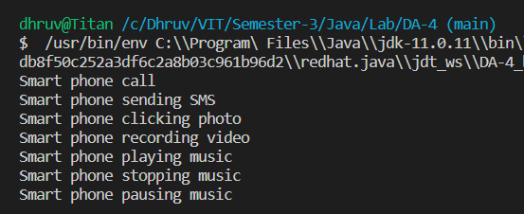

1. Interfaces and static methods and members

**CODE**

// JAVA DA - 4

// by Dhruv Rajeshkumar Shah

// 21BCE0611

// Interface

interface Test {

    final static int X = 10;

    public abstract void meth1();

    public abstract void meth2();

    public static void meth3() {

        System.out.println("Static method of test");

    }

}

interface Test2 extends Test {

    void meth4();

}

class My implements Test2 {

    public void meth1() {

        System.out.println("Meth1");

    }

    public void meth2() {

        System.out.println("Meth2");

    }

    public void meth4() {

        System.out.println("Meth4");

    }

}

public class Interfaces2 {

    public static void main(String[] args) {

        My obj = new My();

        obj.meth1();

        obj.meth2();

        obj.meth4();

        Test.meth3();

        System.out.println(Test.X);

    }

}

**OUTPUT**

