WEB TECHNOLOGY PROJECT REPORT

AutoRent – Smart Automobile
Rental System
V Semester BTech | FLEXICORE-3131 | BTech CCE
School of Computer Engineering
Manipal Institute of Technology, Manipal
SUBMITTED BY
Dhruv Sharma | 240953624
Harishraj E | 240911690
Under the guidance of
Ms. Swathi B.P.
November 2026

Team Details and Work Split
Sl. | Name | Reg. No. | Modules / Pages designed
1 | Dhruv Sharma | 240953624 | 1. User registration and authentication  2. Vehicle listing, search, and filtering
2 | Harishraj E | 240911690 | 1. Vehicle availability checking and booking creation  2. Automatic rental price calculation  3. My Bookings workflow and demo payment

1. Project Overview
AutoRent is a web application for discovering vehicles and managing self-drive rental reservations. Customers can create accounts, browse and filter vehicle listings, check date availability, create pending bookings, review their bookings, cancel eligible pending reservations, and try a simulated payment flow. React and Vite provide the user interface; Supabase supplies authentication and PostgreSQL data services, while an Express API handles the server-side demo payment operation. [1–4]

1.1 Purpose of the Website
AutoRent provides a single interface for customers to explore a small vehicle rental fleet and reserve a vehicle for a selected date range. It gives customers a way to compare categories, brands, descriptions, and daily rental prices before booking. The database checks availability and prevents overlapping active reservations. A customer can then review or cancel a pending booking and see a simulated checkout receipt. The project demonstrates a full-stack workflow without processing real payments.

1.2 Objectives
• Provide customer registration, login, email-confirmation messaging, and logout.
• Display available vehicles with image, category, daily price, and description.
• Support searching by vehicle name or brand and filtering by category.
• Check a selected date range before booking; treat the return date as exclusive.
• Calculate the booking total in the database using daily pricing.
• Allow customers to view and manage only their own bookings, including cancellation of their own pending bookings.
• Demonstrate a server-verified simulated payment flow with a receipt and payment history.

1.3 Target Users
The primary users are customers who want to browse and reserve a self-drive vehicle. Administrators are represented in the database authorization model for management tasks, although this report focuses on the customer workflow. The interface includes responsive layouts, labelled form fields, status messages, accessible names for controls, descriptive vehicle-image alternative text, and dialog semantics. These are implementation considerations visible in the source; no formal WCAG conformance audit is claimed. [6]

1.4 Site Map
Page / view | Navigation and purpose | Student contribution
Home | Featured inventory, categories, and links into browsing. | Shared project; vehicle listing by Student 1
Register / Login | Customer account creation and sign-in. | Student 1
Browse Vehicles | Search, category filters, vehicle cards, details dialog. | Student 1
Booking dialog | Date selection, availability check, daily-price estimate, pending booking. | Student 2
My Bookings | Customer booking list, details, eligible pending-booking cancellation, and payment history. | Student 2
Demo checkout | Method selection and simulated receipt. | Student 2

Flow: Home → Browse Vehicles → Vehicle Details → Booking dialog → My Bookings → Demo checkout. Login/Register is available from navigation; booking and My Bookings require a signed-in customer.

1.5 Tools and Technologies
Item | Implementation
HTML version | HTML5 document structure in the Vite React app.
CSS framework and version | CSS3 in styles.css; no Tailwind dependency is present in the frontend package.json.
JavaScript | ES modules with React components and browser APIs.
Frontend framework / build tool | React 19 and Vite 6.
Backend | Node.js and Express 4.
Data source | Supabase PostgreSQL via Supabase JavaScript client and backend REST requests.
Authentication | Supabase Auth.
IDE / environment | Visual Studio Code with Codex assistance, as specified by the team.
Version control | Git and GitHub, as specified by the team.
Accessibility considerations | Semantic headings, labelled controls, ARIA status/error messaging, dialog labels, and alt text are present in source. No formal accessibility audit is documented.
Testing tools | Node.js built-in test runner for backend payment API tests; no Lighthouse or WAVE results are claimed.

The frontend uses Supabase Auth and the Supabase client for browser-side reads and customer-scoped database operations. For demo payments, the frontend sends JSON over HTTP to the Express REST endpoint and includes the signed-in user’s access token. The backend verifies that token with Supabase Auth, checks profile role and booking ownership, reads the booking total from PostgreSQL, and writes the demo payment using its server-only key. [3–5]

1.5 Common Design Followed by the Team
The app shares an AutoRent wordmark, top navigation, responsive page containers, vehicle-card styling, and consistent form, button, dialog, loading, empty, success, and error states. The stylesheet uses a light neutral background, dark green text, and lime-green accents. The source declares DM Sans as the primary font. Navigation and components use semantic elements and accessible labels where applicable. [5–6]

2. Student 1: Dhruv Sharma (Reg. No: 240953624)
Modules / Pages: Registration and login/authentication; vehicle listing, search, and category filtering.

2.1 Module Description

Module 1: Registration and Login
The authentication page switches between registration and login forms. Registration accepts full name, email, optional phone, password, and password confirmation. Client-side checks validate required fields, email shape, phone length when provided, an eight-character minimum password for registration, and matching passwords. Supabase Auth handles sign-up and sign-in. Registration includes full name and phone metadata; the database trigger creates a customer profile, and the interface instructs users to check email when confirmation is required.

Module 2: Vehicle Listing, Search, and Filters
The browse page displays available vehicle cards and a details dialog. Customers can search by vehicle name or brand and select All, Cars, Bikes, Scooters, SUVs, or Vans. The Vans filter maps to the database category `van`. Cards show vehicle imagery, brand, model/category, daily INR price, and availability information. The page has loading, error, and empty states.

2.2 Module Design

Registration and Login Flow
The browser calls Supabase Auth through the configured Supabase client. Sign-up sends the email and password with full name and optional phone in user metadata; sign-in uses the email/password Auth operation. Auth state is observed by the app and profile data is loaded from `public.users`. The database trigger creates a customer profile, so the frontend does not manually insert one. Form validation happens in React; Supabase validates credentials and account state. Auth responses are handled as success, confirmation guidance, or readable errors. [4]

Vehicle Browsing Flow
The homepage loads vehicle rows from `public.vehicles` using the Supabase client. Browse search and category filtering are performed in the React page against the loaded vehicle collection. This listing path is a direct Supabase data API request rather than an Express route; database grants and RLS govern which rows are visible. The app displays loading, failure, and no-results feedback. The frontend code does not implement a separate search endpoint.

2.3 Development of the Module
The main implementation is in AuthPage.jsx, AuthNavigation.jsx, App.jsx, BrowseVehicles.jsx, and supabaseClient.js. These selected snippets show the actual Auth calls and category/search logic:
await supabase.auth.signUp({
email: form.email.trim(),
password: form.password,
options: { data: { full_name: form.fullName.trim(), phone: form.phone.trim() || null } },
});
await supabase.auth.signInWithPassword({
email: form.email.trim(),
password: form.password,
});
const term = search.trim().toLowerCase();
return vehicles.filter((vehicle) => {
const matchesCategory = activeCategory === 'all' ||
vehicle.category?.toLowerCase() === activeCategory;
const matchesSearch = !term ||
vehicle.name?.toLowerCase().includes(term) ||
vehicle.brand?.toLowerCase().includes(term);
return matchesCategory && matchesSearch;
});

2.4 Results
The supplied screenshots show the registration and login forms, a vehicle listing with sample inventory, and the category filter controls. The search/filter image shows the browsing controls; the report does not infer query results beyond what the screenshot displays.
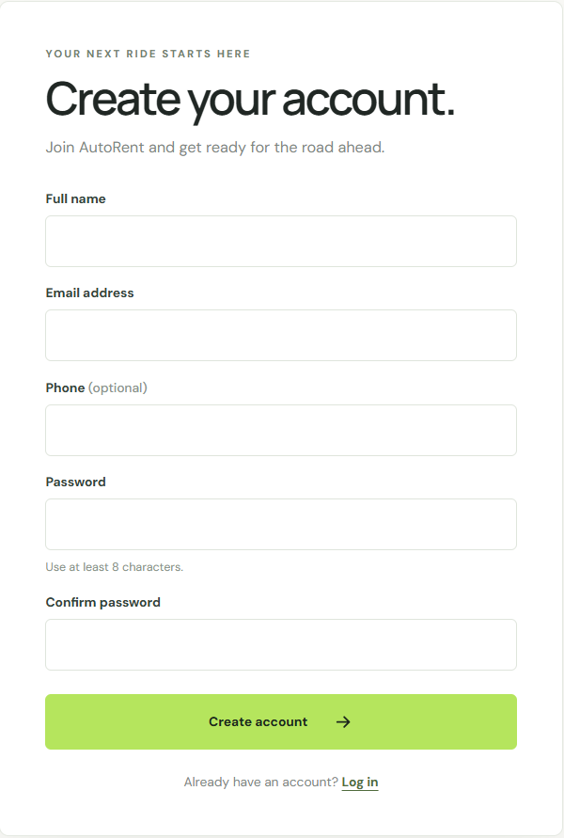
Figure 1. Customer registration form with required and optional fields.
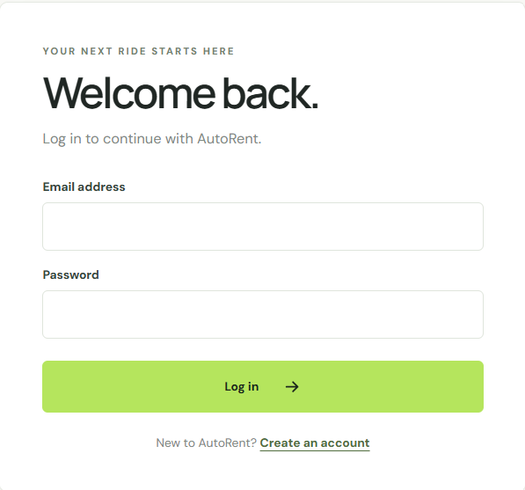
Figure 2. Customer login form.
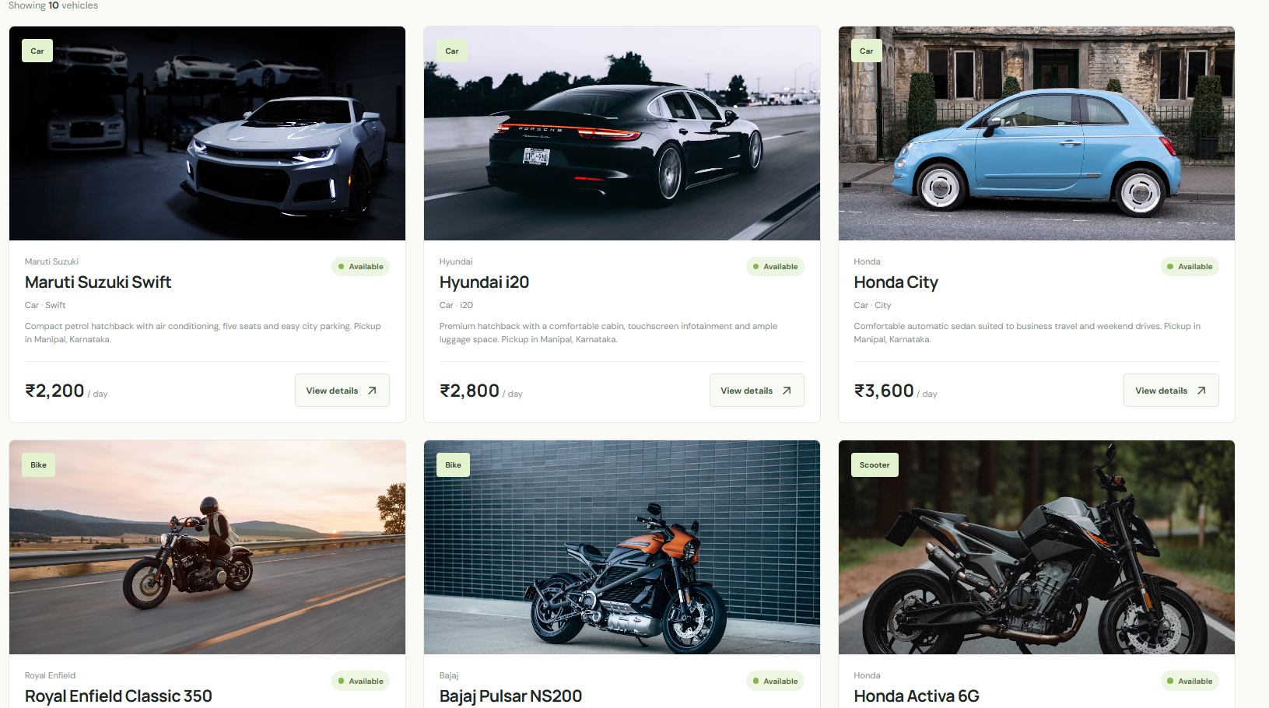
Figure 3. Vehicle listing cards with category, availability, descriptions, and daily prices.
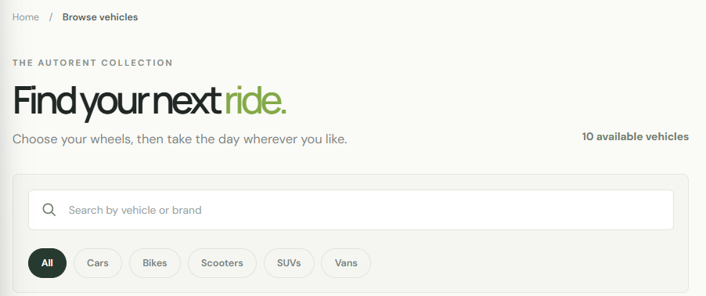
Figure 4. Vehicle search field and category filter controls.

3. Student 2: Harishraj E (Reg. No: 240911690)
Modules / Pages: Vehicle availability checking, booking creation, automatic rental price calculation, My Bookings workflow, and demo payment.

3.1 Module Description

Module 1: Availability, Booking, and Price Calculation
The vehicle details dialog displays the Manipal, Karnataka pickup location, daily price, pickup date and return date selectors. It calculates a visible estimate from the selected date difference, then calls the database availability function before inserting a pending booking. The return date is exclusive. The browser deliberately omits `total_price`; a PostgreSQL trigger calculates the authoritative amount from the vehicle’s daily rate. An exclusion constraint prevents overlapping pending or confirmed bookings for the same vehicle.

Module 2: My Bookings and Demo Payment
My Bookings completes the customer booking workflow by showing a customer’s own reservations, details, dates, database-calculated total, status, and payment history. It supports cancellation only for that customer’s pending bookings under the existing database rules. Student 2’s assigned feature work covers availability checking, booking creation, automatic rental price calculation, and demo payment; My Bookings presents and manages the resulting bookings.

3.2 Module Design

Availability and Booking Flow
React submits the vehicle ID and date range to the Supabase RPC `check_vehicle_availability`. When available, the frontend inserts `user_id`, `vehicle_id`, `pickup_date`, and `return_date` into `public.bookings` using the authenticated Supabase session. The database trigger calculates `total_price`. The database uses a half-open date range [pickup, return), which allows adjacent bookings, while its GiST exclusion constraint remains authoritative under concurrent requests. The client maps conflict and permission errors to user-facing messages.

Demo Payment Flow
The frontend sends a JSON POST request to `POST /api/payments/demo` with `bookingId` and `paymentMethod`, plus the user’s Supabase bearer access token. Express verifies the token using Supabase Auth, confirms the profile is a customer, retrieves the booking only when its `user_id` matches the authenticated user, requires a pending status, and obtains `total_price` from the database. The backend creates a pending payment with a generated demo transaction ID, then records a simulated successful or failed result. Duplicate successful records are guarded by a partial unique index. No payment gateway or card credentials are involved. [3–4]

3.3 Development of the Module
Booking behavior is implemented in BrowseVehicles.jsx; the database trigger, policies, availability function, and exclusion constraint are defined in the ordered Supabase migrations. MyBookings.jsx handles customer-scoped listing, cancellation, and the JSON request. Express payment logic is in paymentApi.js and paymentLogic.js.
const { data: available, error: availabilityError } =
await supabase.rpc('check_vehicle_availability', {
p_vehicle_id: vehicle.id,
p_pickup_date: pickupDate,
p_return_date: returnDate,
});
if (availabilityError) throw availabilityError;
const { data, error } = await supabase.from('bookings').insert({
user_id: user.id, vehicle_id: vehicle.id,
pickup_date: pickupDate, return_date: returnDate,
}).select('id,total_price,booking_status').single();
const response = await fetch(`${apiBase}/api/payments/demo`, {
method: 'POST',
headers: { 'content-type': 'application/json',
authorization: `Bearer ${session.access_token}` },
body: JSON.stringify({ bookingId: booking.id, paymentMethod }),
});
const booking = firstRow(await restRequest(`bookings?${bookingParams}`));
if (!booking) return response.status(404).json({ error: 'Booking not found for this account.' });
if (booking.booking_status !== 'pending') return response.status(409).json({ error: 'Only pending bookings can be paid in this demo.' });

3.4 Results
The supplied booking screenshots show the date selection and the displayed estimate for five rental days at ₹2,200 per day (₹11,000), followed by a demo receipt marked Successful, and the booking with payment history in My Bookings. These images document the supplied UI state; they are not presented as independent evidence of a new live database test during report preparation.
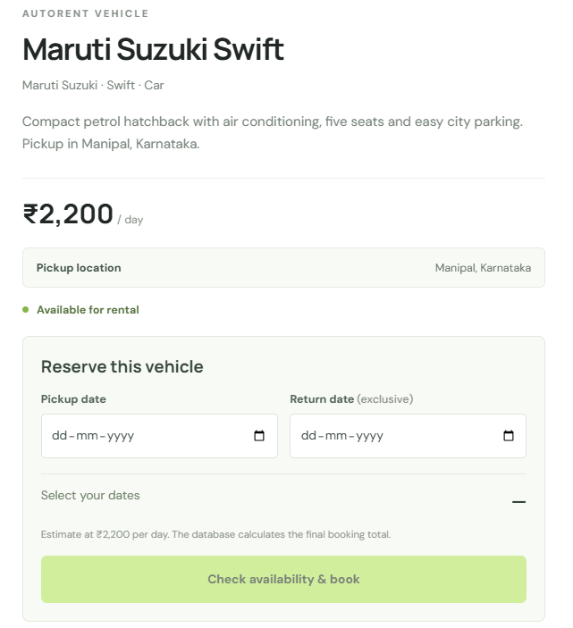
Figure 5. Vehicle details with pickup location, date selectors, and availability state.
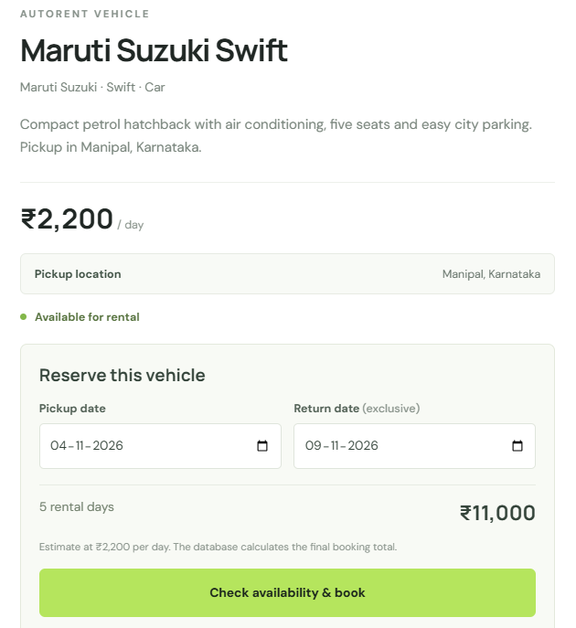
Figure 6. Selected dates and five-day rental estimate; the database computes the final booking total.
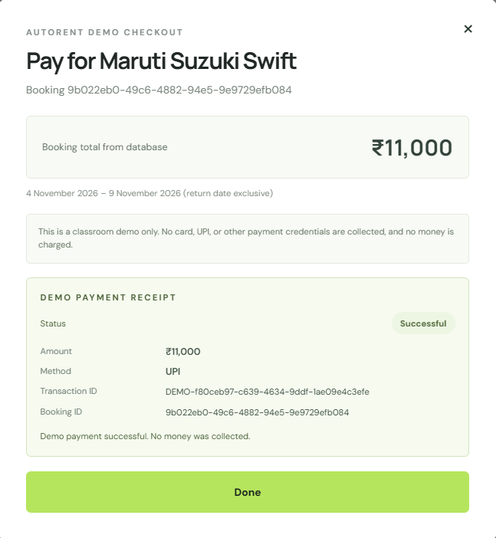
Figure 7. Simulated payment receipt showing method, status, amount, transaction ID, and demo notice.
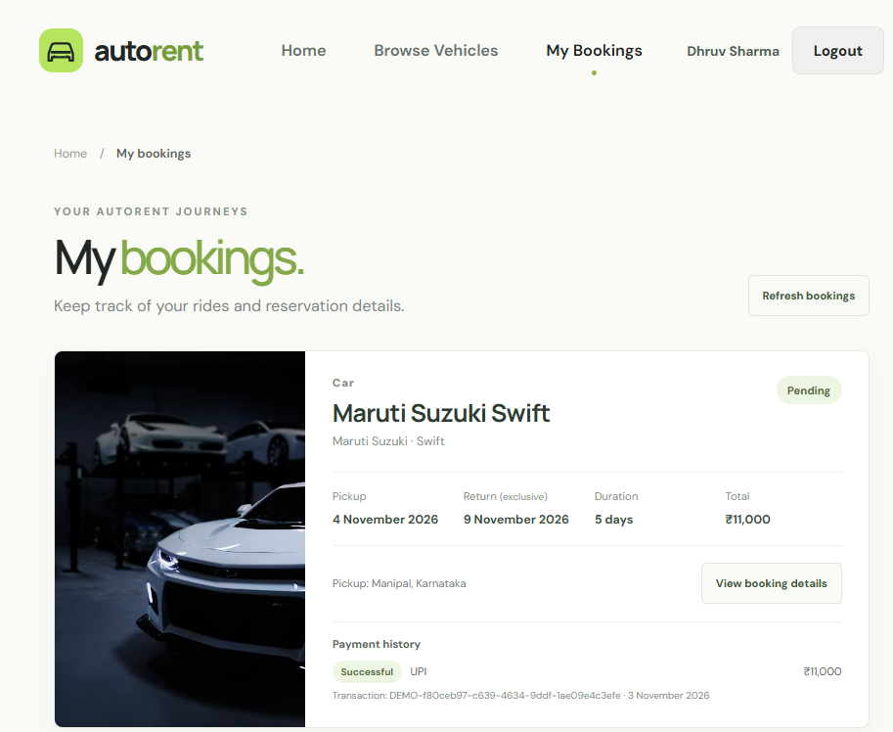
Figure 8. My Bookings view with booking summary and payment history.

4. Conclusion and Future Scope
AutoRent combines a React customer interface, an Express demo-payment endpoint, Supabase Auth, and PostgreSQL data controls. The implemented workflow covers customer accounts, vehicle discovery, date availability, pending reservations, database-calculated daily pricing, booking management, and simulated checkout. The project demonstrates how client validation, server-side ownership checks, database triggers, RLS policies, and constraints contribute different protections. The payment flow is illustrative and does not charge money. Future work could include an administrator interface, vehicle inventory management screens, notifications, and a real payment integration after appropriate security and compliance design. These items are future scope and are not represented as implemented features.

Testing performed
The backend payment API test suite uses Node’s built-in test runner with mocked Supabase HTTP responses. Seven tests passed during preparation: secret-key header placement, database-derived amount and server transaction ID, rejection of browser-supplied amount/status, bearer-token and ownership checks, duplicate successful payment prevention, simulated failure behavior, and rejection of non-customer or non-pending bookings. This is not a live end-to-end test against Supabase. No frontend automated test script is defined in its package.json. No Lighthouse, WAVE, or formal WCAG audit is claimed.

5. References
[1] React Documentation. https://react.dev/
[2] Vite Documentation. https://vite.dev/
[3] Express Documentation. https://expressjs.com/
[4] Supabase Documentation. https://supabase.com/docs
[5] MDN Web Docs. https://developer.mozilla.org/
[6] W3C Web Accessibility Initiative, WCAG Standards and Guidelines. https://www.w3.org/WAI/standards-guidelines/wcag/
References [1–4] support the framework, API, authentication, and database concepts described above. References [5–6] inform the web platform and accessibility context; they do not indicate that a formal accessibility audit was conducted.

