Assignment 1
Introduction to Web Development

1. Difference between frontend, backend, and full-stack development
Frontend development covers everything the user sees and interacts with directly in the browser — layout, colors, buttons, forms, and animations. It is built with HTML, CSS, and JavaScript, often using frameworks like React. Example: the menu, product photos, and “Add to Cart” button on an e-commerce website.
Backend development covers the behind-the-scenes logic — handling requests, talking to the database, managing user accounts, and processing payments. It is built with languages such as Node.js, Python, or Java. Example: when a user clicks “Add to Cart,” the backend checks stock, updates the cart in the database, and sends back a confirmation.
Full-stack development means working on both sides — building the visible interface as well as the server logic behind it. Example: a solo developer building an entire food-delivery app from scratch, covering both the app screens and the order-processing system.

2. Diagram: How the client-server model works
The diagram below illustrates the client-server request-response cycle in web architecture:
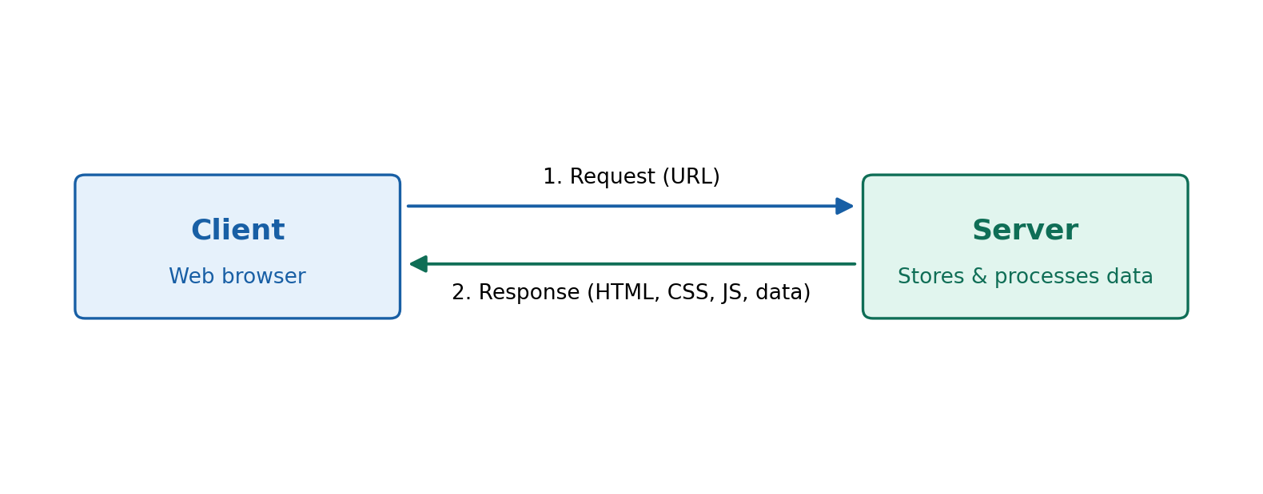
Figure 1: Client-server model
1. The client (browser) sends a request — usually a URL typed or a link clicked.
2. The server receives the request, processes it, and sends back a response — the HTML, CSS, JavaScript, and any data needed to display the page. This cycle repeats every time a new page is requested.

3. How a browser requests and displays a web page
- Step 1 — Enter a URL: The user types a web address or clicks a link in the browser.
- Step 2 — DNS lookup: The browser asks a DNS server to translate the domain name into the numeric IP address of the hosting server.
- Step 3 — Send HTTP request: The browser opens a connection to that IP address and sends an HTTP/HTTPS request for the page.
- Step 4 — Server processes the request: The server may query a database or run backend code, then prepares a response.
- Step 5 — Server sends the response: The server returns the HTML document along with linked CSS, JavaScript, and image files.
- Step 6 — Browser renders the page: The rendering engine builds the page structure from HTML, applies CSS styling, runs JavaScript for interactivity, and paints the final page on screen.

4. Tools required to set up a web development environment
Tool | Purpose
Code editor (VS Code) | Write and edit HTML, CSS, JS, and other code with syntax highlighting and extensions.
Web browser (Chrome, Firefox) | Run and preview the webpage; test appearance and behaviour.
Browser DevTools | Inspect elements, debug JavaScript, check network requests, test responsiveness.
Version control (Git) | Track changes to code over time and collaborate with others.
Git hosting platform (GitHub) | Store code online, share it, and back it up.
Package manager (npm) | Install and manage JavaScript libraries and project dependencies.
Local/live server | Run the project as it would run on a real server, with live reload.
Terminal / command line | Run commands for installing packages, starting servers, using Git.

5. What is a web server?
A web server is software (often running on dedicated hardware) that stores website files and delivers them to browsers on request. It listens for HTTP requests and responds with the appropriate web page, file, or data.

- Apache HTTP Server — one of the oldest and most widely used, especially with PHP-based sites.
- Nginx — known for speed and handling many simultaneous connections; also used as a reverse proxy/load balancer.
- Microsoft IIS — used for hosting ASP.NET applications on Windows servers.
- Node.js (with Express) — a JavaScript-based server, popular in the MERN stack.
- LiteSpeed — a high-performance alternative often used with WordPress hosting.

6. Roles: frontend developer, backend developer, database administrator
- Frontend developer — builds the visual interface: page layout, styling, and interactivity using HTML, CSS, JavaScript, and frameworks like React. Focuses on user experience and responsiveness.
- Backend developer — builds server-side logic: APIs, authentication, business rules, and communication with the database. Focuses on performance, security, and reliability.
- Database administrator (DBA) — designs, manages, and maintains the database: creating schemas, optimizing queries, handling backups, and ensuring data integrity and security.

7. Installing and configuring VS Code for HTML, CSS, and JavaScript
- Download VS Code from code.visualstudio.com for the relevant operating system.
- Run the installer, checking “Add to PATH” on Windows so VS Code can be opened from the terminal using the 'code' command.
- Install the “Live Server” extension (by Ritwick Dey) to preview HTML files with auto-refresh in the browser.
- Install helpful extensions: Prettier (auto-formatting), HTML CSS Support, ESLint (JavaScript error checking), and Auto Rename Tag.
- Create a project folder, open it in VS Code, and create an index.html file. Typing '!' and pressing Tab uses Emmet to generate a full HTML boilerplate.
- Right-click index.html and select “Open with Live Server” to preview the page; it auto-refreshes on save, confirming the setup works.
[Insert screenshot of VS Code with index.html open and the Live Server preview running here.]

8. Static vs. dynamic websites
- Static website — content is fixed; the same HTML is sent to every visitor and does not change unless a developer edits the files. No database or backend logic is involved. Example: a simple personal portfolio page listing projects and contact info.
- Dynamic website — content changes based on user input, database data, or other conditions, generated by backend code. Example: an account page on an e-commerce site showing different order history for every logged-in user.

9. Five web browsers and their rendering engines
Browser | Rendering engine
Google Chrome | Blink
Mozilla Firefox | Gecko
Apple Safari | WebKit
Microsoft Edge | Blink (switched from EdgeHTML in 2020)
Opera | Blink

A rendering engine converts HTML, CSS, and JavaScript into the visual page shown to the user. Different engines can interpret CSS features, animations, and newer web standards slightly differently, which is why the same page can look or behave a little differently across browsers.
- Blink (Chrome, Edge, Opera) — fast and widely adopted; drives much of new web-standards adoption, so most sites are tested primarily on Chrome.
- Gecko (Firefox) — developed independently by Mozilla; historically strong on standards compliance and privacy.
- WebKit (Safari) — Apple's engine, optimized for macOS/iOS performance and battery efficiency; also required for all browsers on iOS.
Because engines differ, developers test important sites across multiple browsers to catch inconsistencies — a practice known as cross-browser testing.

10. Diagram: Basic web architecture flow
The diagram below shows the flow between the client, server, database, and external APIs:
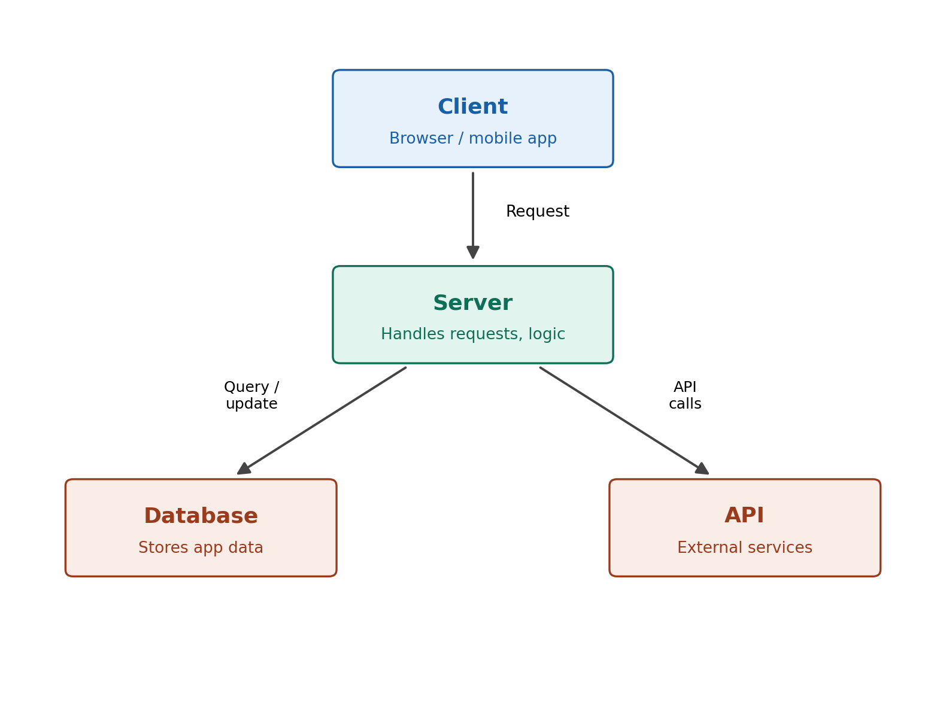
Figure 2: Basic web architecture flow
The client sends a request to the server. The server processes it — reading or saving data via the database, and calling external APIs (such as a payment gateway or maps service) when needed — then sends the final response back to the client.

