Game Design Document

Fill up the following document

1. Write the title of your project.

* Ranger Rocko

1. What is the goal of the game?

The rocket has to kill the monsters before reaching the rocket.

1. Write a brief story of your game.

There was a kingdom of angels . Then a day some devils came to attack to the angels kingdom. The angels were weak in front of devils so their most powerful angel came and he took a rocket with him for his protection. The devils were also not weak thy also took rockets and they again and again came to kill the angel. By being a trustworthy the angel king took a promise that he will be a defender and willable to defeat the monsters.

1. Rules of the game

player has four types of health the player will lose if it his health becomes black. And if monsters touch the rocket.

The monster can move down but player can only move left and right.

Monsters keeps coming till the rocket doesn’t die.

Monsters keep coming randomly from out of the screen between the screen

Monsters can fire back to the player and can dissolve his bullets.

Player has total 3 lives.

Player reaches end he will win.

Player speed will be low than the monsters

At one time more than 1 monster can come

If Player reaches the end message will be displayed ”you saved your kingdom”

1. Which are the playing characters of this game?
2. Playing characters are the ones who respond to the user based on the input from the user.
3. Cars, monkeys, dinos, wizards, etc., are the playing characters in the game.

|  |  |  |
| --- | --- | --- |
| Number | Character Name | What can this character do? |
| 1 | rocket | Fire and move left and right |
| 2 |  |  |
| 3 |  |  |
| 4 |  |  |
| 5 |  |  |
| 6 |  |  |
| 7 |  |  |
| 8 |  |  |

2. Which are the Non-Playing Characters of this game?
3. Non-Playing characters are the ones that don't have an action or behavior when the user interacts with the game.
4. Hurdles, stones, bananas, coins, etc., are non-playing characters in the game.

|  |  |  |
| --- | --- | --- |
| Number | Character Name | What can this character do? |
| 1 | monsters | They can fire back with dangerous weapons at the rocket |
| 2 |  |  |
| 3 |  |  |
| 4 |  |  |
| 5 |  |  |
| 6 |  |  |
| 7 |  |  |
| 8 |  |  |

Draw your imagination of this game. What does this game look like?

1. Draw the game either on your computer or on paper.
2. Add images of the game scenes to show each of the playing and non-playing characters at least once.   
   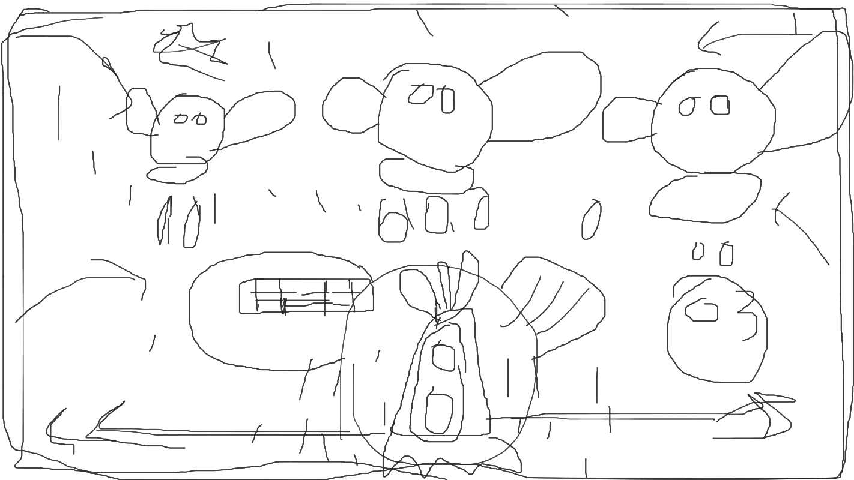

How do you plan to make your game engaging

Continously dangerous monsters coming and firing at the rocket ...

And rocket has to hit the monsters