

Features Extracted from the algorithm are feed to the machine learning model in the training process



Features Extractor Algorithm

Reviews

TAGS (Positive, Neutral, Negative)

Training

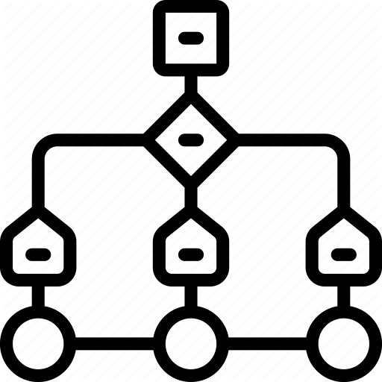

Machine Learning Algorithm

Prediction

Prediction

Viewing of result according to different categories in **graphical chart based form**



Rating NLP Model



Classifier Model

Result

Results

Viewing of result according to different categories in **text based form**

**Overall Rating** for the provided review according to the **NLP model prediction**