**Prof.V.B.Shah Institute of Management & R.V.Patel College of Commerce (Eng.Med.) & V.L.Shah College of Commerce (Guj.Med.) &**

**Sutex Bank College of Computer Applications & Science, Amroli**

**(Accredited ‘B’ (CGPA 2.55) by NAAC Dec.-2009)**

**VEER NARMAD SOUTH GUJARAT UNIVERSITY, SURAT**



**PROJECT REPORT**

**ON**

**Wedding Planner Management System**

**SUBMITTED BY:**

**GUIDED BY:**

**Dhruv Bhikadiya**

**Sanskruti Ramani**

**Roll No: 258**

**Exam No: 5444**



Wedding Planner Management System Page 1

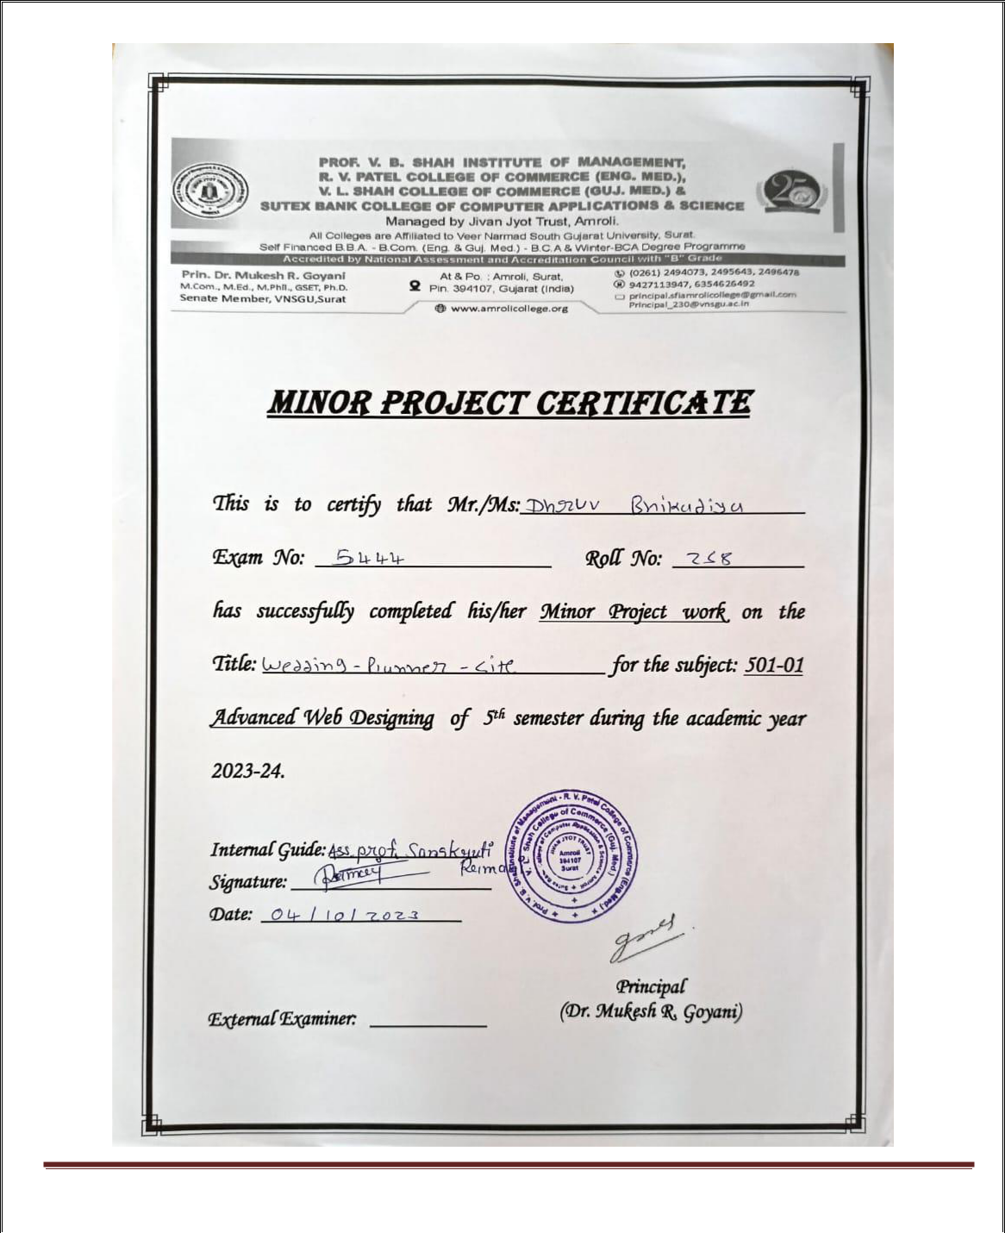

Wedding Planner Management System Page 2

**INDEX**

**Chapter**

1. **Introduction**

1.1 Project description

1.2 Project Profile

1. **Objectives**
2. **System Flow Diagram**
3. **DFD / UML Diagram**
4. **ER Diagram**
5. **Database Design**
6. **System Design**
7. **References**



Wedding Planner Management System

**Page No.**

**3 - 5**

**7**

**8 – 9**

**10–11**

**12**

**13–14**

**14-21**

**22**

Page 3

1. **Introduction**

**Project Description**

* Create unforgettable memories for couples by meticulously planning and executing their dream weddings.
* As a wedding planner, you'll coordinate every detail, from venue selection and decor to

catering and entertainment, ensuring a seamless and magical celebration.

* Wedding Planner management system have contained two panels: 
  + Admin panel
  + User panel
* **Admin Panel: **
  + It is mandatory to login with an Admin account.
  + Admin can update his / her profile.
  + Admin can add, update or delete Venue , Place and Book.
  + Add new admin also.
  + The login admin can see all users of the system including admins, Users.
  + Admin can add Venue for all users only.
  + Admin can add Event Places for all users only.
  + Admin can update Event Places for all users only.
  + Admin Can Delete Event Places for all users only.
  + Admin Can Delete Booking Orders for all users only.



Wedding Planner Management System Page 4

* **Users Panel: **
  + It is mandatory to login with a Users account.
  + Users can book Venue.
  + Users can Add Enquiry.
  + Users can see Blog.
  + For new Users registration must be contact admin

|  |  |  |
| --- | --- | --- |
|  | **Project Profile** | |
|  |  |  |
|  | **Wedding Planner Management System** | |
|  |  |  |
| Project title: |  | Wedding Planner Management System |
|  |  |  |
| Frontend: |  | HTML5, CSS3, JavaScript (ECMA 6) |
|  |  |  |
| Backend: |  | PHP and MySQL |
|  |  |  |
| Browser: |  | Chrome |
|  |  |  |
| Platform: |  | vs code, xampp |
|  |  |  |
| Documentation tool: |  | MS Word |
|  |  |  |
| Internal Guide: |  | Sanskruti Ramani |
|  |  |  |
| Submitted to: |  | Sanskruti Ramani |
|  |  |  |



Wedding Planner Management System Page 5



1. **Objectives**

 **Start to End Process:**

1. Collecting information for system (Requirement Gathering and Analysis).
2. Preparing the design of the system through information.
3. Creating table definition and implementation.
4. Integration of Front-end and Back-end.
5. Custom Functions & Validations.
6. Testing.
7. Debugging and code optimization.



1. **System Flow Diagram**



Wedding Planner Management System Page 6

* **Admin Process Flow Diagram:**

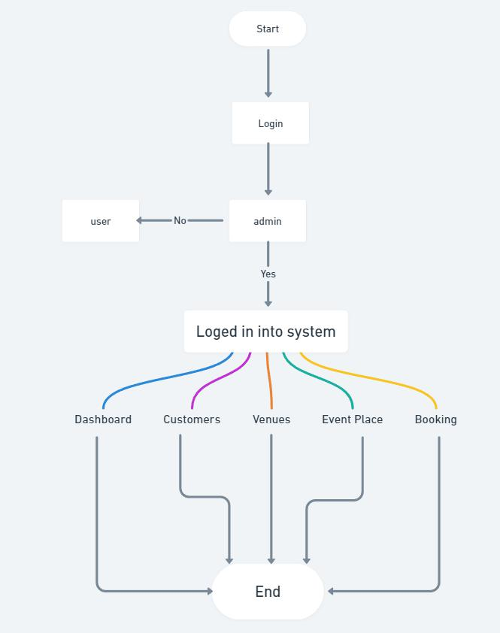

* **User Process Flow Diagram:**



Wedding Planner Management System Page 7

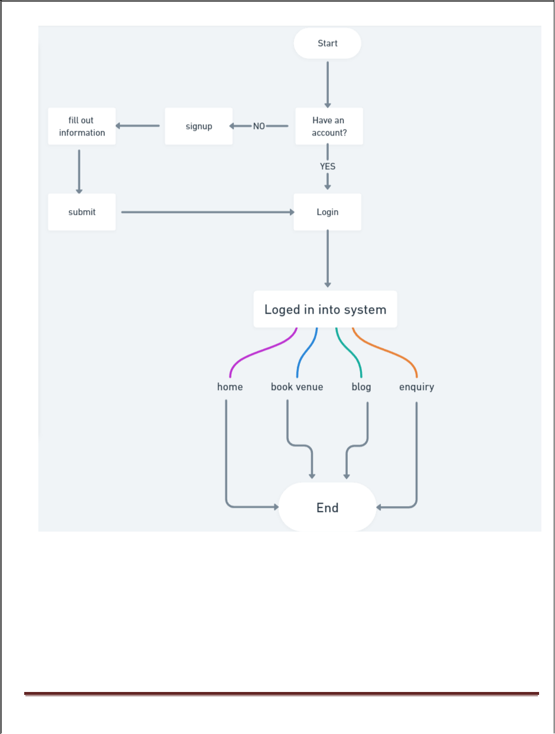

Wedding Planner Management System Page 8

* 1. **DFD / UML Diagram**
* **0 Level Diagram (Context Diagram):**

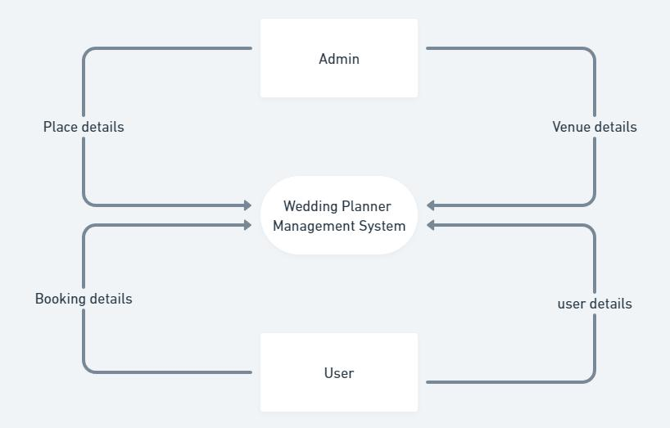

Wedding Planner Management System Page 9

* **1st Level Admin Diagram:**

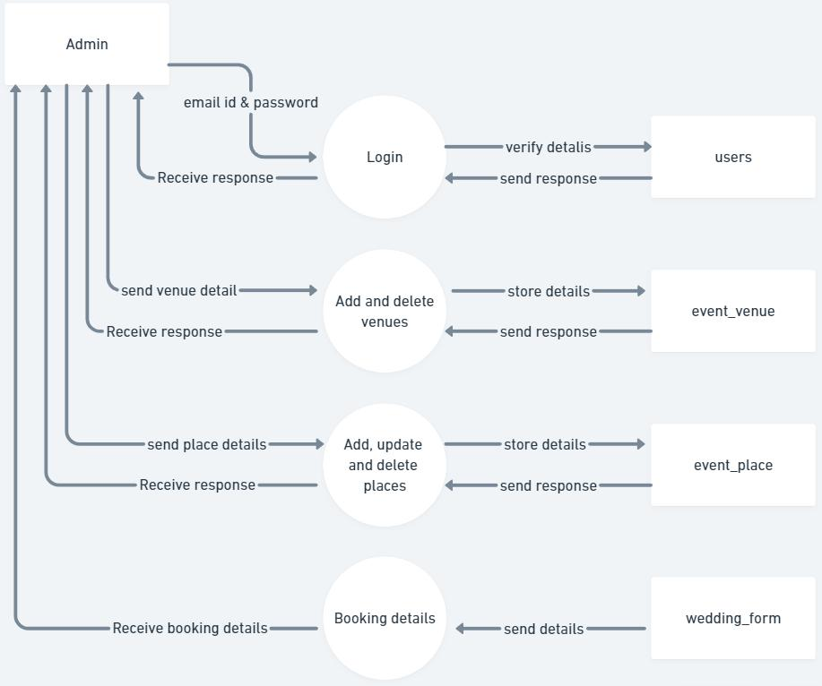

Wedding Planner Management System Page 10

* **1st Level User Diagram:**

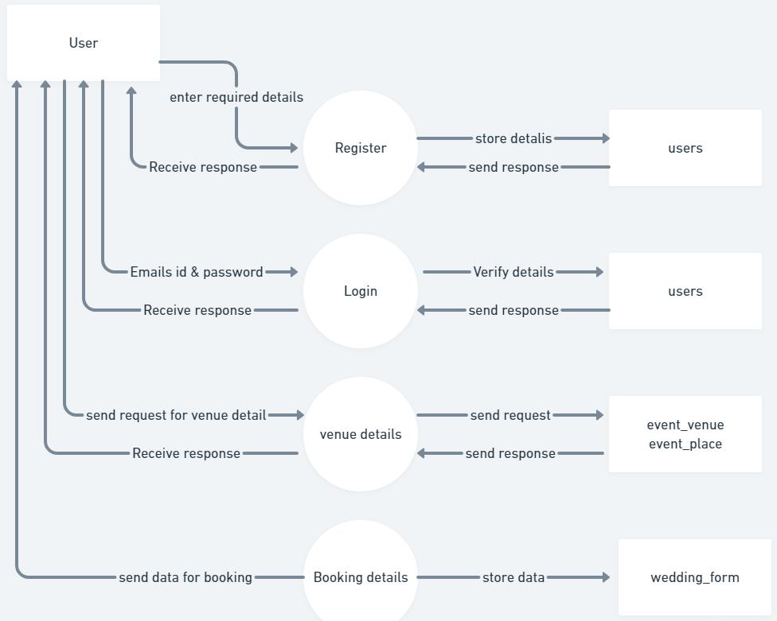

Wedding Planner Management System Page 11

* **ER Diagram:**

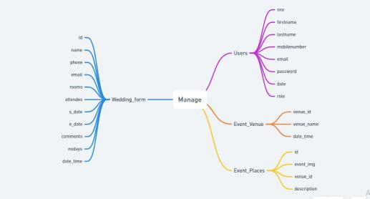

Wedding Planner Management System Page 12

* **Users Table:**

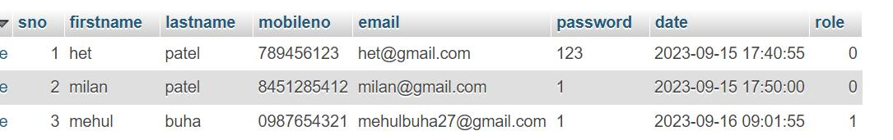

* **Event_Place Table:**

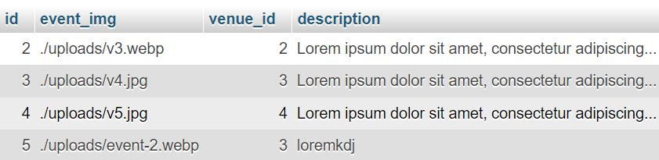

* **Event_Venue Table:**

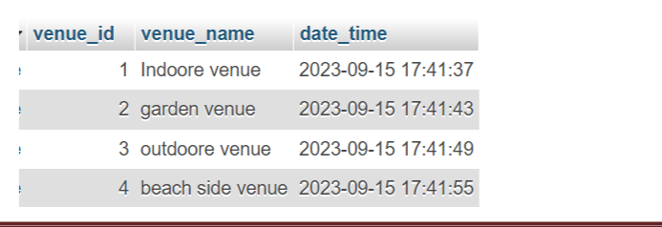

Wedding Planner Management System Page 13

* **Wedding_Form Table:**

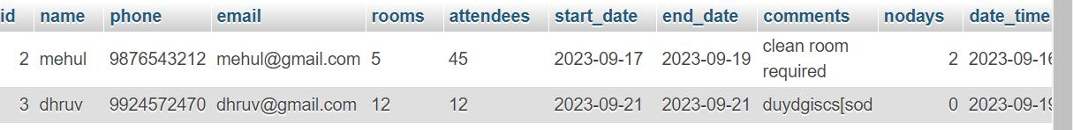

1. **System Design**

* **Admin side:**

**Login Flow**

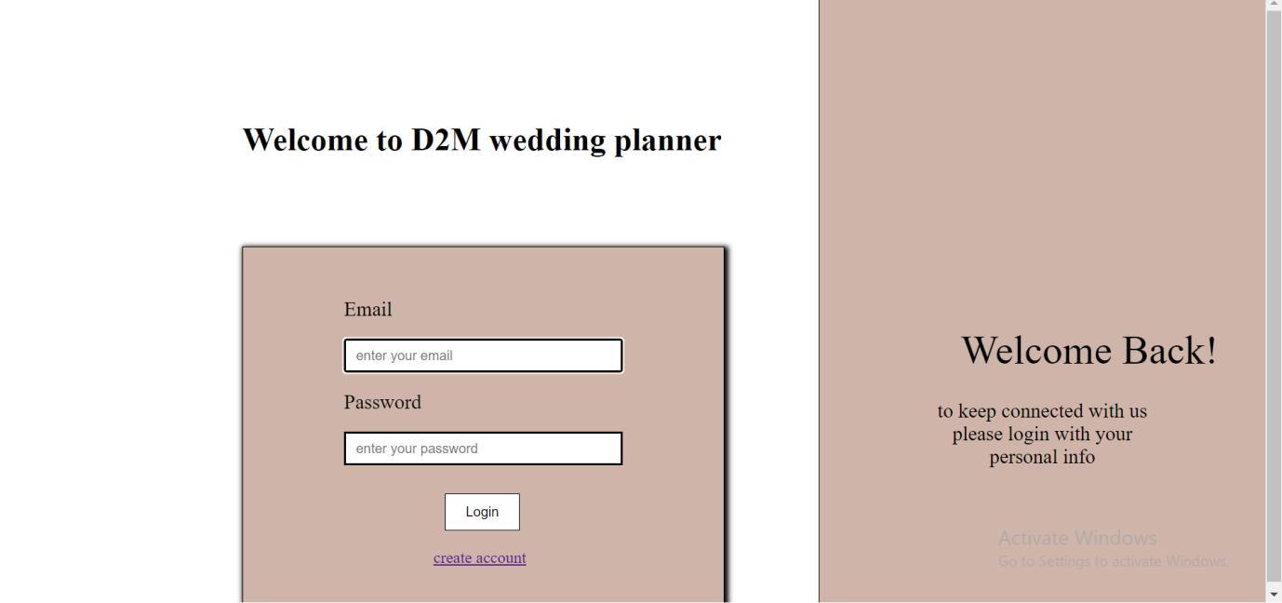

Wedding Planner Management System Page 14

**Dashboard**

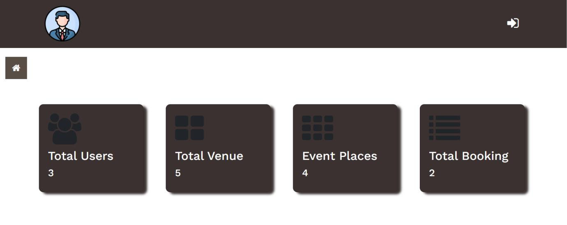

**Customers**

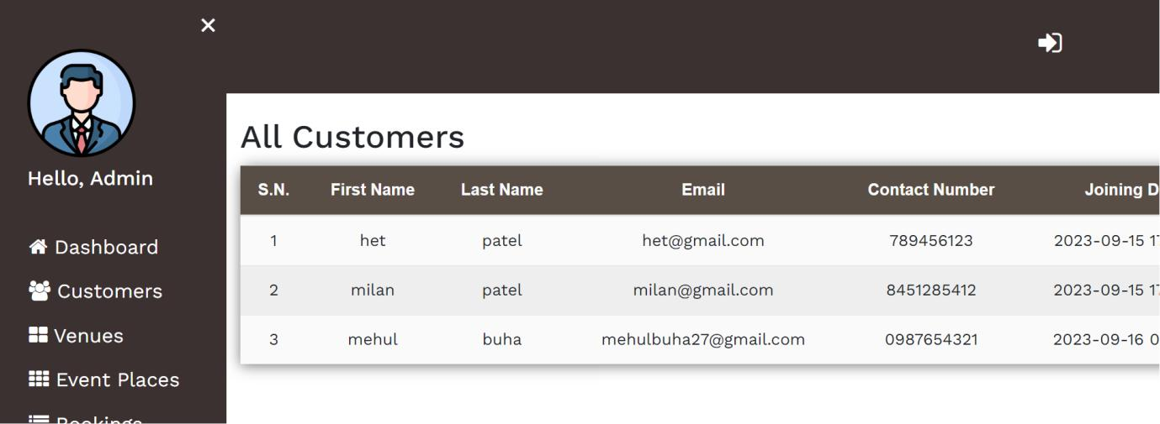

Wedding Planner Management System Page 15

**Venues**

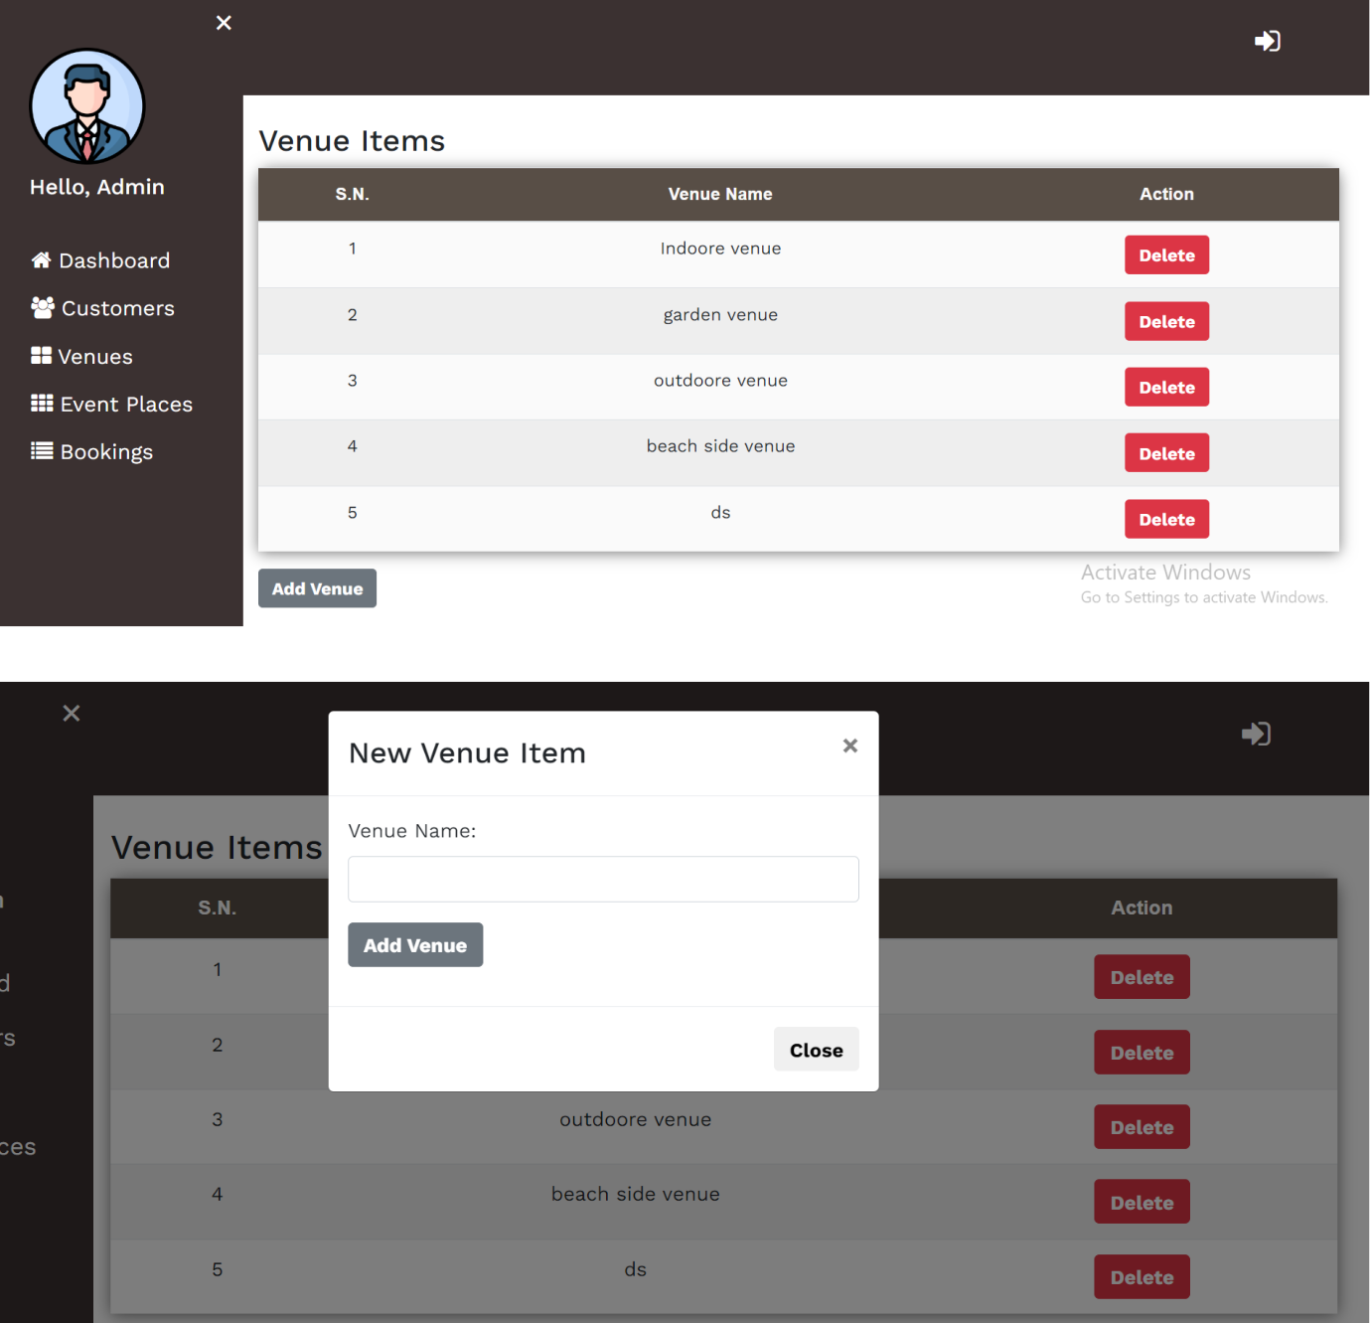

**Event Places**



Wedding Planner Management System Page 16

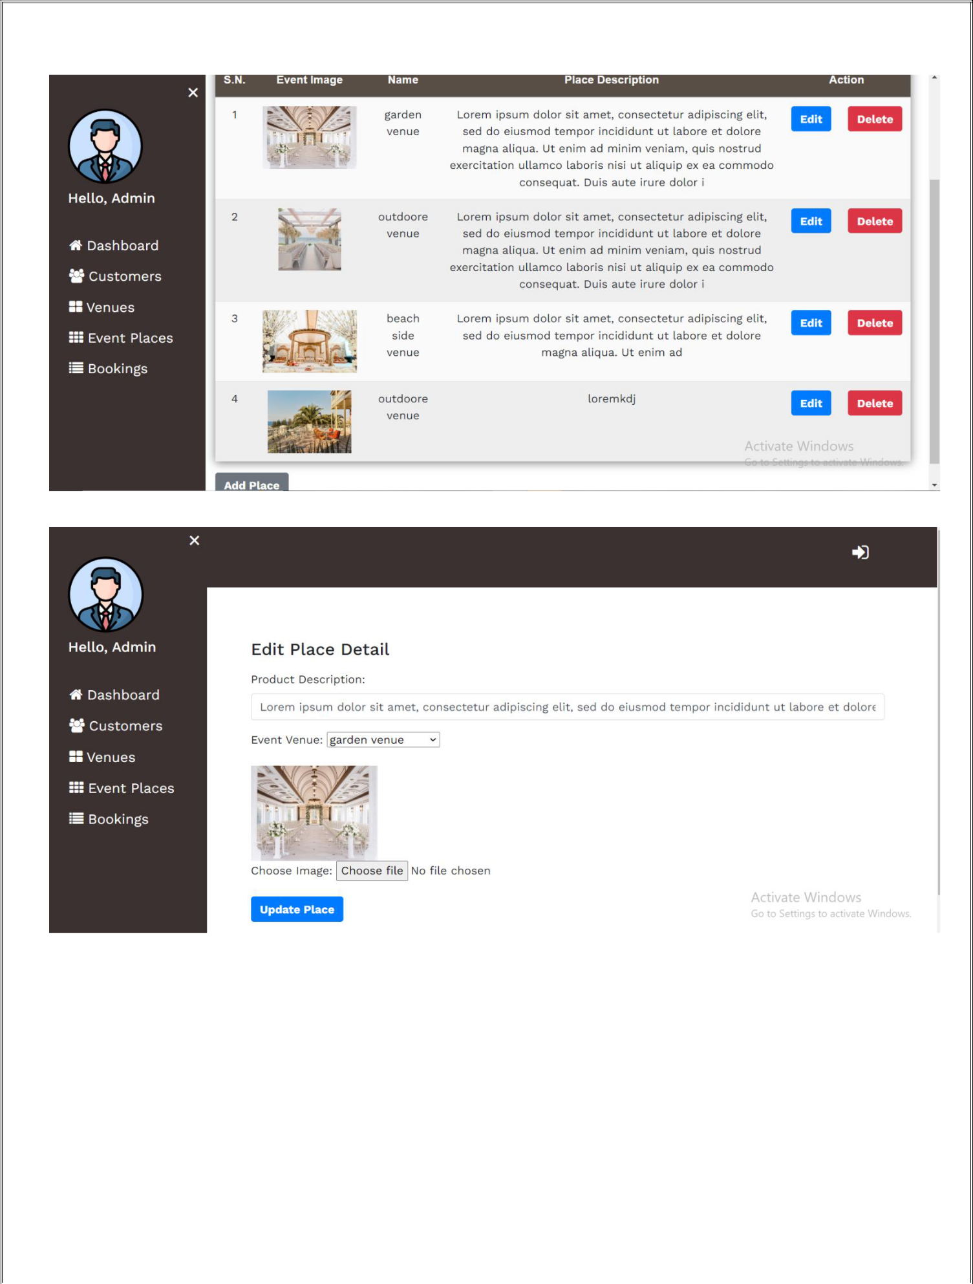

**Booking**



Wedding Planner Management System Page 17

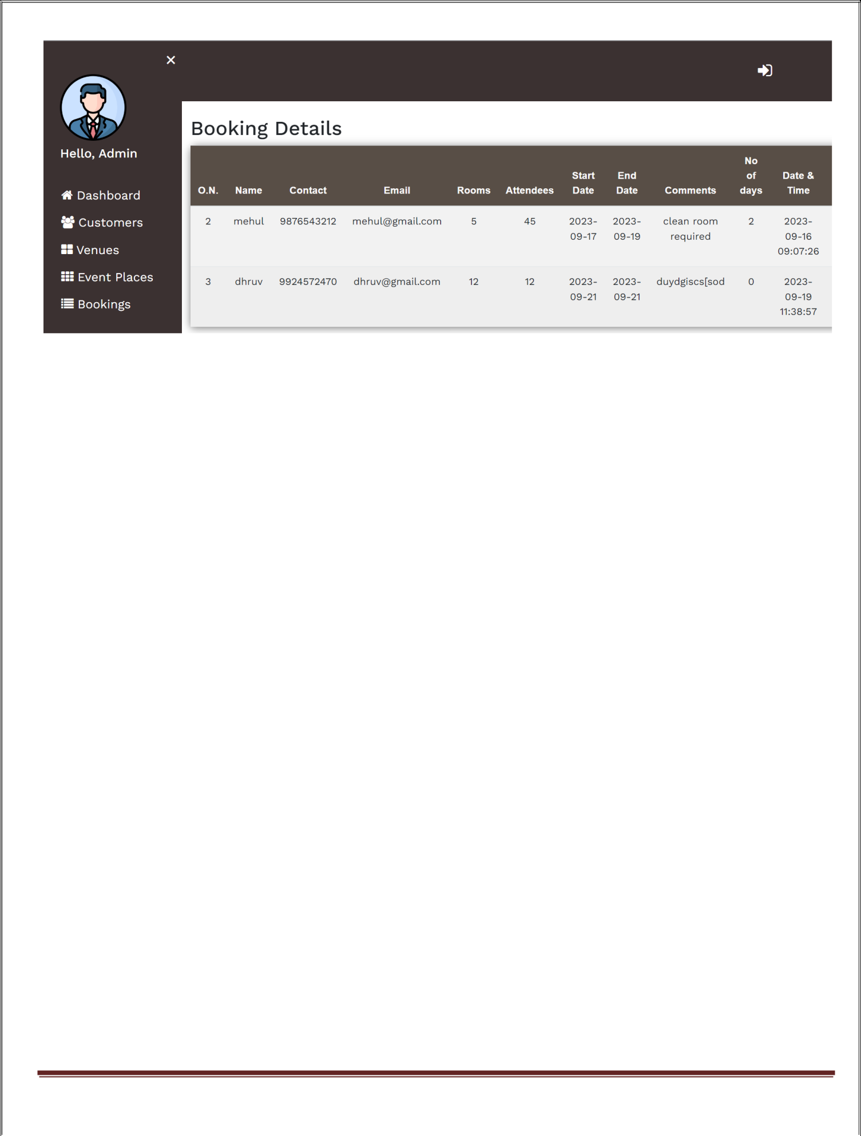

Wedding Planner Management System Page 18

* **User Side:**

**Login Flow**

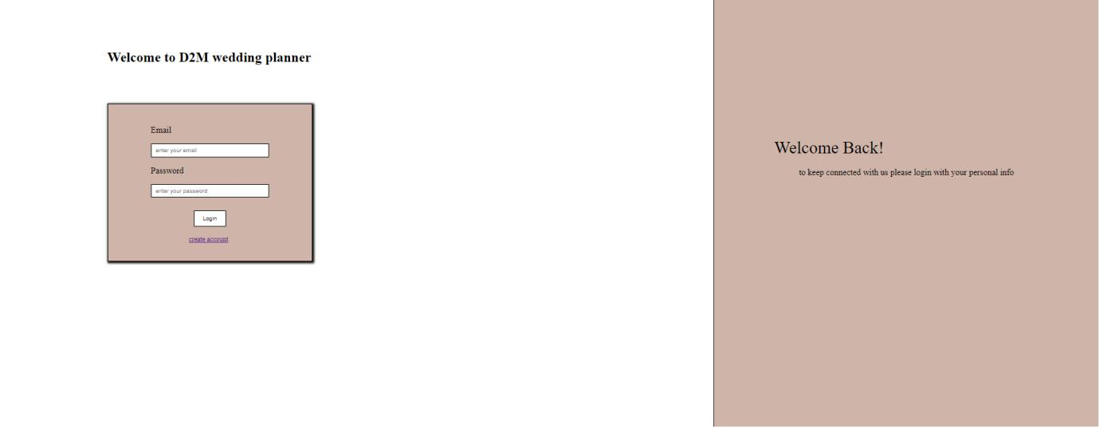

**Registration Account**

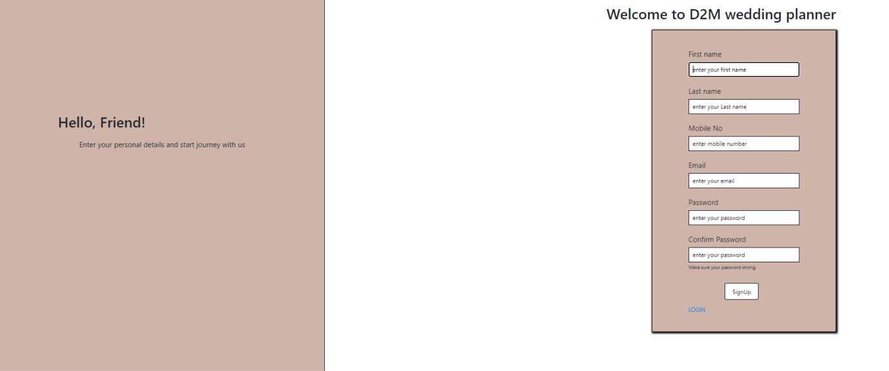

Wedding Planner Management System Page 19

**Dashboard**

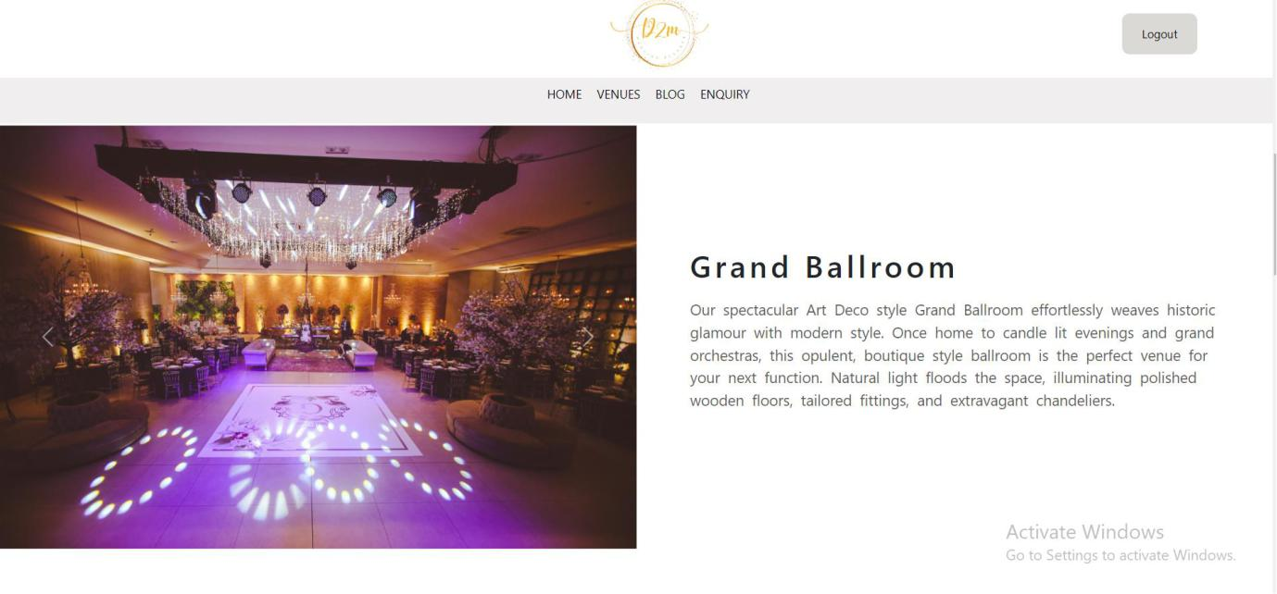

**Venues**

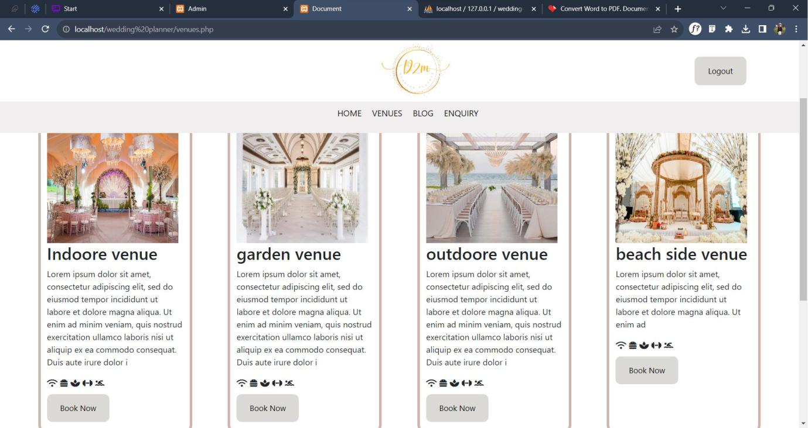

**Booking Form**



Wedding Planner Management System Page 20

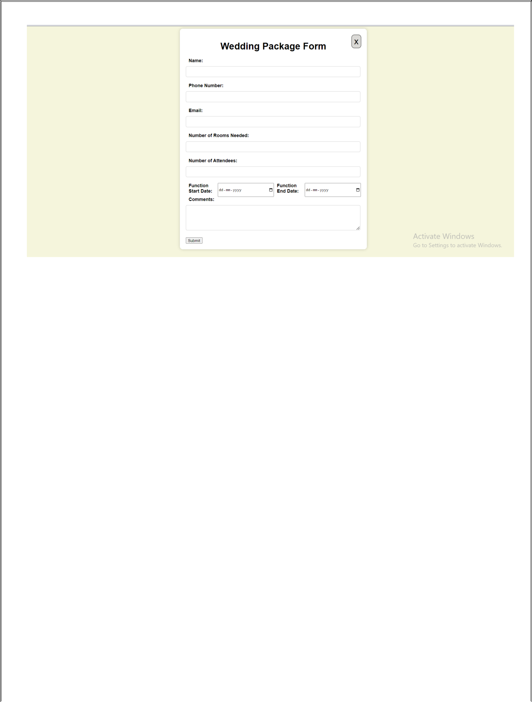

**Enquiry Page**

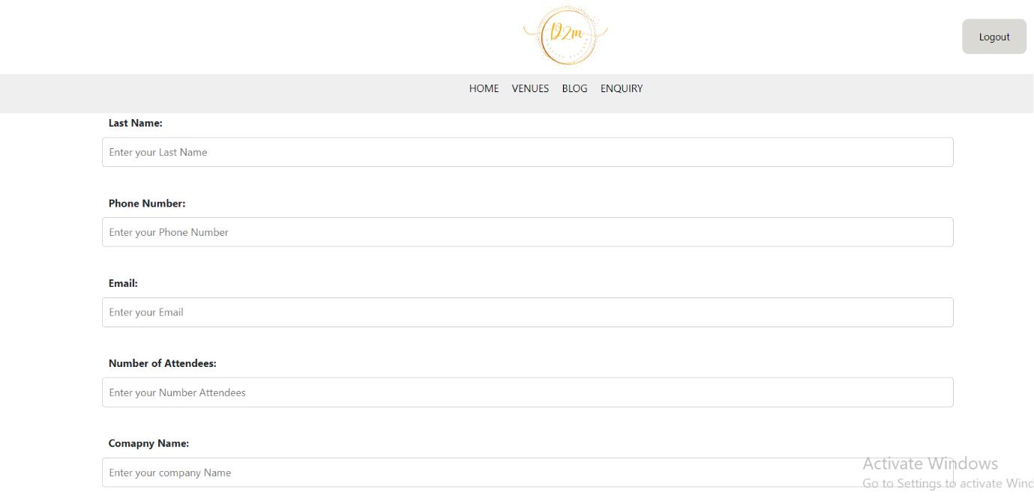

Wedding Planner Management System Page 21

* **References :-**
  + [https://sorrento.intercontinental.com/events-and-wedding?gclid=CjwKCAjwtuOlBhBREiwA7agf1m3NM9ewl0XQPMuFw6mgKO_](https://sorrento.intercontinental.com/events-and-wedding?gclid=CjwKCAjwtuOlBhBREiwA7agf1m3NM9ewl0XQPMuFw6mgKO_kFvTirAoXX37YktUtjihG-Z6hUibCLRoCfLAQAvD_BwE) [kFvTirAoXX37YktUtjihG-Z6hUibCLRoCfLAQAvD_BwE](https://sorrento.intercontinental.com/events-and-wedding?gclid=CjwKCAjwtuOlBhBREiwA7agf1m3NM9ewl0XQPMuFw6mgKO_kFvTirAoXX37YktUtjihG-Z6hUibCLRoCfLAQAvD_BwE)
  + <https://www.w3schools.com/php/default.asp>
  + <https://www.yahoobaba.net/courses/php>
  + <https://getbootstrap.com/docs/5.3/getting-started/introduction>



Wedding Planner Management System Page 22