Week 1 – 2 · Fraud Loss Analytics Platform
Data Pipeline & Medallion Architecture
Bronze landing with audit controls · Silver/Gold transformation in PySpark · Delta Lake

Overview

The project begins with a non-negotiable design principle borrowed from real banks: no analysis or model ever touches data until it has been independently reconciled back to the source file and checked against a set of data-quality rules. This two-week sprint builds the entire data foundation — from raw CSV to a typed, masked, queryable Delta Lake table — on top of which every subsequent week operates.
Week 1 — Bronze Layer & Audit Controls

Why Bronze Stores Everything as TEXT
The bronze layer's sole job is to land the source file exactly as received, with zero transformation. Every column is stored as TEXT (VARCHAR in PostgreSQL), no matter the logical type. This is a deliberate design choice: if a source system sends a malformed amount or a corrupted timestamp, the bronze layer must capture it faithfully so the DQ rules can detect and log it. Coercing types at load time would silently discard evidence.
- Storage: All 22 source columns stored as TEXT in bronze.transactions_raw
- Lineage columns: _run_id, _source_file, _source_row, _loaded_at — every row knows its provenance
- Load method: PostgreSQL COPY (streaming in 100k-row chunks) — no full-file load into memory
Reconciliation — 4 Independent Checks
After every load the reconciler re-reads the source CSV independently (it does not query bronze — it re-reads the file) and compares four counts against what landed in the table. Any mismatch is CRITICAL and stops the pipeline.
- Row count: source rows == bronze rows for this run_id
- Total amount: SUM(amt) within ±$0.01 tolerance (floating-point safe)
- Fraud count: SUM(is_fraud) exact match
- Distinct transaction IDs: COUNT(DISTINCT trans_num) exact match
Why this matters in interviews: Banks call this "source-to-target reconciliation." It proves nothing was lost, duplicated, or altered in the load. Interviewers at RBC and TD specifically look for this.
Data-Quality Rules — 5 Critical, 2 Warning
DQ rules are SQL predicates that run against bronze filtered by run_id. Bad records are written to audit.dq_exceptions with a failure reason. A CRITICAL failure sets the pipeline exit code to 1, blocking CI/CD.
- Missing / duplicate transaction ID: CRITICAL — Every transaction must be uniquely identifiable
- Amount not numeric or ≤ 0: CRITICAL — Loss calculations depend on valid amounts
- Invalid timestamp: CRITICAL — Time-series analysis needs clean dates
- Invalid fraud flag (not 0 or 1): CRITICAL — Label integrity for model training
- Missing card number: CRITICAL — Cardholder linkage requires this field
- Coordinates out of range: WARNING — Flagged for investigation, does not block
- Missing merchant category: WARNING — Clustering and segmentation degrade without it
CI/CD Gate — GitHub Actions
A GitHub Actions workflow runs the full pipeline on every push using sample data (tests/make_sample.py generates clean and dirty files with planted defects). The workflow fails if the pipeline exits with code 1, which happens on any CRITICAL control failure. This means bad data can never silently pass into the gold layer.
python run_week1.py --files data/sample_clean.csv data/sample_dirty.csv
# Exit code 1 → GitHub Actions marks the push as FAILED
SCREENSHOT · pgAdmin4 — bronze.transactions_raw Table
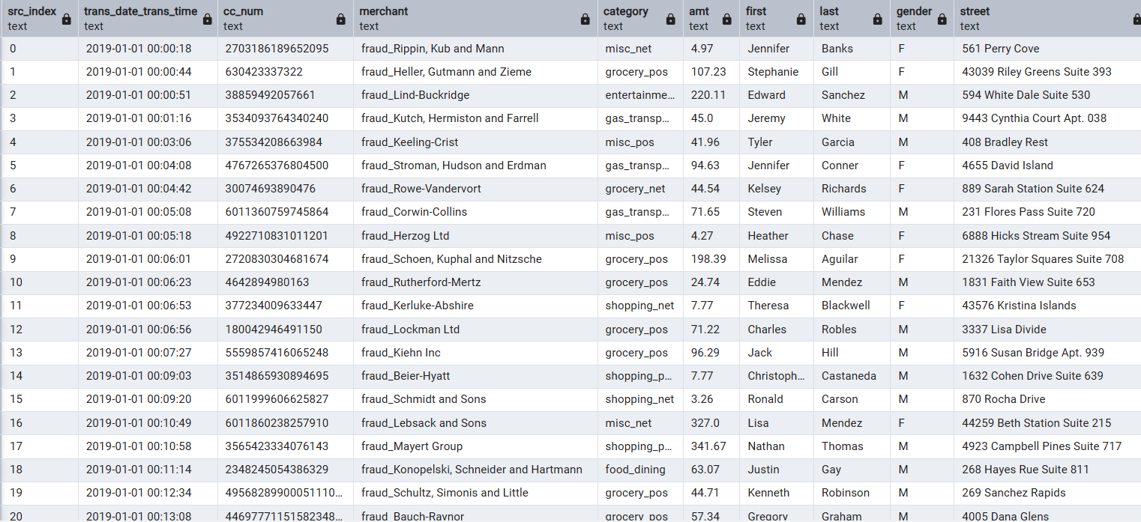
What this shows: The raw PostgreSQL bronze table with all 22 source columns stored as TEXT plus 4 lineage columns (_run_id, _source_file, _source_row, _loaded_at). No type casting is applied at this stage — every value lands exactly as received from the source CSV. This design ensures data issues are never silently discarded; they are captured in the audit layer and corrected downstream in silver. The lineage columns allow any row to be traced back to the exact source file and row number that produced it. Banks call this the raw vault or landing zone.
SCREENSHOT · pgAdmin4 — audit.control_results (All Controls Passing)
What this shows: The audit trail for every data quality control executed in this pipeline run. Each row records one control: RECONCILIATION checks (row count, total amount, fraud count, distinct transaction IDs) and DATA_QUALITY rules (null checks, type validity, duplicate detection). Status PASS means all records passed the predicate. A CRITICAL failure would set the run to FAILED and return exit code 1, blocking CI. All controls passing here confirms the 1,852,394 transactions loaded cleanly with zero data integrity issues.
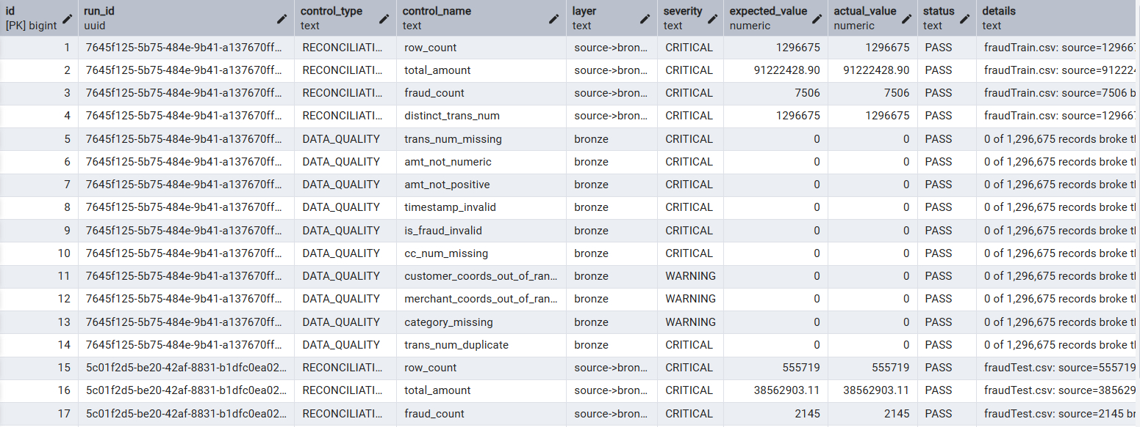

SCREENSHOT · GitHub Actions — CI/CD Pipeline Passing

What this shows: The automated CI/CD pipeline that runs on every GitHub push. It loads both a clean sample and a dirty sample with planted defects covering all CRITICAL rules, runs the full pipeline, and verifies that CRITICAL failures exit with code 1. A green checkmark confirms the pipeline correctly rejects bad data. This is the same pattern used by bank data engineering teams to gate production deployments — no bad data can reach the analytical layers without first being caught and logged.

Week 2 — Silver & Gold Layers in PySpark
Silver Layer — Type Casting, Cleaning, PII Masking
The silver layer reads from the bronze Delta table (or directly from ADLS bronze zone), casts every column to its correct type, applies cleaning rules, and masks PII. The result is written as a managed Delta table: silver.transactions.
- Type casting: txn_time: STRING → TIMESTAMP (using to_timestamp with the source format)
- Type casting: amt: STRING → DECIMAL(12,2)
- Type casting: is_fraud: STRING → INTEGER
- PII masking: cc_num_masked: last 4 digits only — cc_num is dropped (PII)
- Feature addition: geo_dist: computed as Euclidean distance between cardholder lat/long and merchant lat/long
df = df.withColumn('cc_num_masked', F.right(F.col('cc_num').cast('string'), 4))
.drop('cc_num', 'first', 'last', 'street', 'dob') # drop PII
Interview note: Always refer to the column as txn_time (not trans_date — that is the bronze raw name). Silver uses cc_num_masked (4 digits). These distinctions trip up interviewers testing whether you actually ran the code.
Gold Layer — Star Schema
The gold layer reshapes silver into a star schema optimised for analytical queries. A central fact table holds one row per transaction with foreign keys to dimension tables.
- Fact table: fact_transactions: txn_id, txn_time, amt, is_fraud, category_key, merchant_key, cardholder_key
- Dimension: dim_merchant: merchant_id, merchant_name, category, lat, long
- Dimension: dim_cardholder: cardholder_id, city, state, city_pop, cc_num_masked
- Dimension: dim_date: date_key, year, month, day, hour, day_of_week, is_weekend
Delta Lake — Why Not Parquet
Delta Lake wraps Parquet files with a transaction log (_delta_log) that provides ACID guarantees, time travel (query any historical version), and automatic file compaction. For a fraud analytics platform this means: re-runs are idempotent, you can roll back to yesterday's table with one command, and concurrent reads never see partial writes.
# Time travel example
spark.read.format('delta').option('versionAsOf',

3).load('silver/transactions')
SCREENSHOT · Databricks — silver.transactions Delta Table Schema
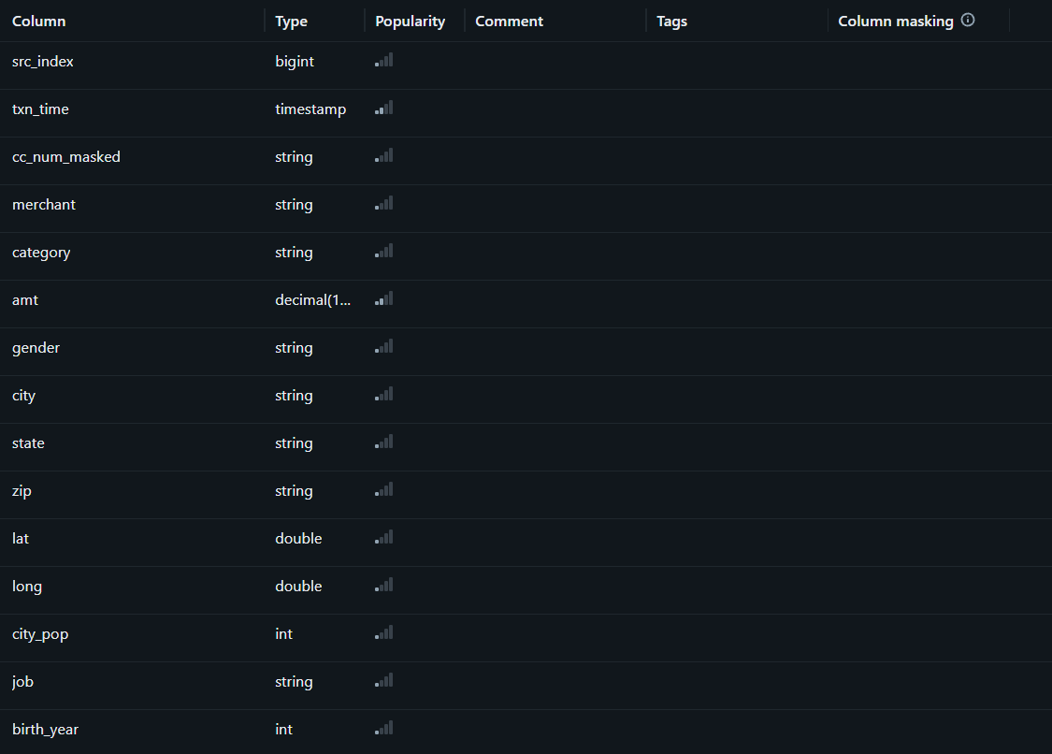
What this shows: The typed schema of the silver Delta table after transformation from bronze. Key changes: txn_time is now TIMESTAMP, amt is DECIMAL(12,2), is_fraud is INT, and cc_num_masked contains only the last 4 digits (PII stripped). A new column geo_dist was computed as Euclidean distance between cardholder and merchant locations. Delta Lake stores this as Parquet with a transaction log, enabling ACID guarantees, time travel (query any historical version), and schema enforcement — features not available in raw Parquet.

SCREENSHOT · Databricks — Notebook 02 Silver Transformation Output
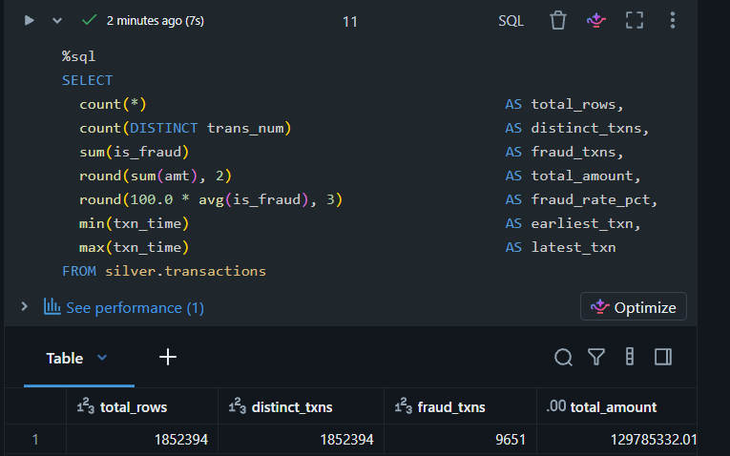
What this shows: The PySpark job output from the silver transformation notebook. Rows read from bronze, transformations applied (type casting, PII masking, geo_dist computation), and the final row count written to silver.transactions. The count should match the 1,852,394 rows reconciled in Week 1, confirming no rows were lost or duplicated during the bronze-to-silver transition.

