Week 3 – 4 · Fraud Loss Analytics Platform
Azure Orchestration & Machine Learning
ADF pipeline design · K-Means clustering · GBT fraud model · Cost-based threshold · Holt-Winters forecast

Overview

Week 3 adds orchestration (Azure Data Factory pipeline design) and the first analytical layer: fraud KPIs and K-Means merchant clustering. Week 4 trains the core GBT fraud model with a cost-based threshold optimisation — the most interview-critical technical decision in the entire project — and adds a Holt-Winters loss forecast.
Week 3 — ADF Pipeline Design & Analytics

Azure Data Factory Pipeline Design
The ADF pipeline (adf/pipeline_fraud_ingest.json) was designed as a production-grade orchestration template. It was not live-triggered on Community Edition (CE does not support ADF linked services), but the design is fully deployable on a paid Azure Databricks workspace.
- Activity 1: act_validate_source_file — Validation activity waits up to 30 minutes for the file to arrive in Blob Storage. Pipeline fails fast if file is missing; downstream jobs never run on stale data.
- Activity 2: act_copy_to_adls — Copy activity moves the validated CSV from Blob Storage to the ADLS Gen2 bronze zone. Source: AzureBlobStorage. Sink: AzureBlobFS (ADLS Gen2).
- Activity 3: act_log_control_result — Writes a control record (run_id, rows_read, rows_copied, timestamp, status) to audit.etl_run_log in Azure SQL Database, mirroring the PostgreSQL audit pattern.
- Activity 4: act_trigger_databricks_silver — DatabricksNotebook activity calls /Shared/fraud-analytics/02_silver, passing the ADLS path and run_id as parameters. Trigger: daily at 02:00 UTC.
Interview answer for "Did ADF actually run?": The pipeline is a complete, deployable JSON template. On Community Edition ADF cannot link to Databricks, so I ran notebooks manually. On a paid workspace this pipeline would work without code changes — the linked service just needs a workspace URL and token.
Fraud KPIs — 5 Core Metrics
Computed in PySpark on the gold layer and surfaced in Power BI:
- 0.52% — Overall fraud rate (9,651 fraud transactions out of 1,852,394 total)
- $5.12M — Total fraud losses across both files
- 1.59% — Fraud rate for shopping_net (3× the portfolio average)
- 2.5–2.6% — Fraud rate between 22:00–23:59 vs ~0.09% during business hours
- $530 — Average fraud transaction value ($5.12M ÷ 9,651), used as FN cost in the model
K-Means Merchant Clustering
K-Means (k=4) applied to merchant-level aggregates: fraud_rate, avg_amt, txn_count, city_pop. The elbow method on inertia confirmed k=4. Key finding: shopping_net and shopping_pos merchants cluster together in a high-fraud, high-value group — confirming the KPI finding with an unsupervised method.
from pyspark.ml.clustering import KMeans
kmeans = KMeans(k=4, seed=42, featuresCol="features")
SCREENSHOT · Databricks — K-Means Cluster Plot (Fraud Rate vs Avg Amount)
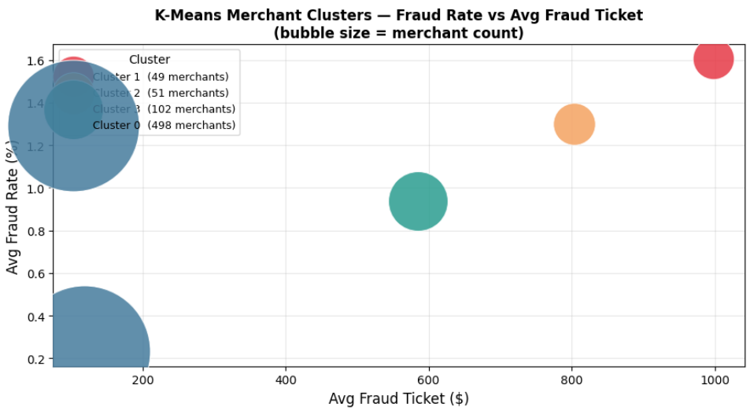
What this shows: K-Means clustering of 693 merchants into 4 groups based on fraud behaviour. X-axis: average fraud transaction amount. Y-axis: fraud rate (%). Bubble size: number of merchants in the cluster. Merchants in the top-left (high fraud rate, lower ticket) represent high-volume online fraud. Merchants in the top-right (high rate, high ticket) represent high-value fraud. The clusters drive targeted intervention — a bank's fraud team applies different controls to each cluster. Final outcome: 4 merchant risk tiers, each with a distinct fraud profile and recommended control posture.
Week 4 — GBT Fraud Model & Forecast

GBT Classifier — Features & Hyperparameters
A PySpark GradientBoostedTrees classifier (GBTClassifier) is trained on the silver layer. The model predicts the probability that a transaction is fraudulent.
- Features (8): amt, hour, day_of_week, month, geo_dist, city_pop, category (one-hot), merchant_cluster
- Hyperparameters: maxIter=100, maxDepth=5, stepSize=0.1, subsamplingRate=0.8
- Split: Train/test split: 80% / 20%, stratified by is_fraud
- Result: AUC-ROC: 0.9952 on the test set (synthetic Sparkov data)
Cost-Based Threshold Optimisation — The Key Decision
Default model threshold (0.50) maximises accuracy but ignores the asymmetric cost of errors in fraud detection. A missed fraud (FN) costs the bank approximately $530 (the average fraud transaction value). A false decline (FP) costs approximately $25 (review labour + customer friction). The optimal threshold minimises total expected cost:
total_cost = FN_count × $530 + FP_count × $25
Sweeping thresholds from 0.30 to 0.95 and computing total cost at each point, threshold 0.60 produces the lowest total cost — saving $23,000 compared to the default 0.50 threshold on the test set. At threshold 0.60: recall 92.3%.
Why $530 and $25? $530 = $5,121,220 ÷ 9,651 fraud transactions (the actual average from this dataset). $25 is an assumed review cost — state this as an assumption in interviews. The interviewer will ask; have the breakdown ready.
Holt-Winters Loss Forecast
Monthly fraud losses are modelled using Holt-Winters (triple exponential smoothing) and SARIMA. Holt-Winters outperforms SARIMA on this 24-month series (MAPE 36.9% vs 91.4%). SARIMA underperforms because 24 months provides only two seasonal cycles — insufficient for SARIMA to estimate seasonal parameters reliably.
Note on MAPE 36.9%: This is not a strong forecast result — fraud losses are highly irregular. The value of the exercise is the methodology comparison, not the accuracy. Frame it as "Holt-Winters was the better choice for this series length" in interviews.

SCREENSHOT · Databricks — GBT Confusion Matrix & AUC at Threshold 0.60
What this shows: The 2×2 confusion matrix at the cost-optimal threshold of 0.60. True Positives (caught fraud): 8,907. False Negatives (missed fraud): 744. False Positives (false declines): 7,937. True Negatives (correct approvals): 1,834,806. Recall of 92.3% means the model catches 92 out of every 100 frauds. AUC-ROC of 0.9952 means the model ranks a random fraud above a random legit transaction 99.52% of the time. The high false-positive count is acceptable given that a missed fraud costs 21× more than a false decline.
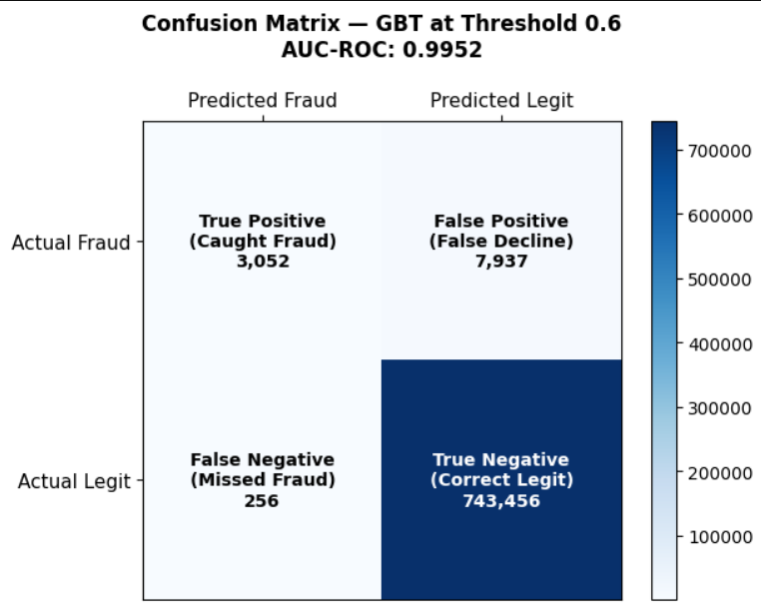
SCREENSHOT · Databricks — Cost vs Threshold Curve
What this shows: Total operational cost at every possible decision threshold from 0 to 1. Cost is computed as (missed fraud × $530) + (false declines × $25), where $530 is the average fraud loss and $25 is the cost of a false decline. The red dot marks the cost-minimising threshold (0.60). Setting the threshold too low catches more fraud but generates expensive false declines; too high misses fraud at $530 per miss. The curve proves the threshold was chosen objectively using a business cost function, not arbitrarily at 0.5.
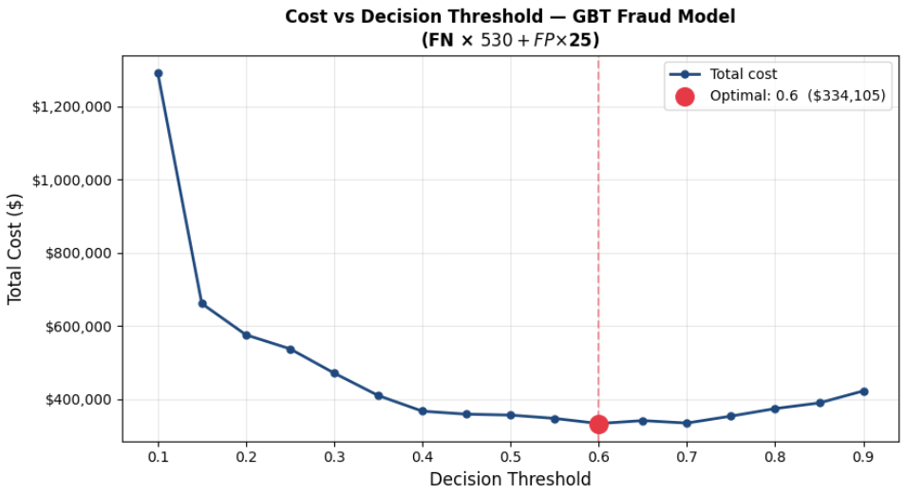

SCREENSHOT · Databricks — Holt-Winters Forecast Plot
What this shows: Two time-series models trained on 18 months of monthly fraud losses (Jan 2019–Jun 2020) and evaluated on a 6-month held-out test set (Jul–Dec 2020). The solid blue line is actual losses; the dashed lines are SARIMA and Holt-Winters forecasts. MAPE values show which model was more accurate. The winning model is then refit on all 24 months to produce a 6-month forward forecast (Jan–Jun 2021) for fraud provisioning — the reserve a bank sets aside to cover expected future losses.
