Week 13 – 14 · Fraud Loss Analytics Platform
Causal Inference & Streaming Simulation
Propensity Score Matching · Bootstrap confidence intervals · Real-time scoring pipeline

Overview

The two final weeks push into graduate-level methodology. Week 13 applies causal inference — specifically Propensity Score Matching — to answer the question: "Is the elevated fraud rate at night a causal effect, or is it driven by confounders like transaction category?" Week 14 simulates a production real-time fraud scoring pipeline to validate that the model holds up under streaming conditions.
Week 13 — Causal Inference via PSM

The Causal Question
From the KPI analysis we know that night-time transactions (22:00–23:59) have a dramatically higher fraud rate. But is time of day itself the cause? Or do night-time transactions happen to concentrate in high-risk categories like shopping_net, which is the true driver? Propensity Score Matching answers this by creating a "matched" comparison where night and day transactions are balanced on confounders — the effect we measure after matching is the causal effect of night-time, not the confounders.
PSM Methodology — Four Steps
- Step 1: Estimate the propensity score — use logistic regression to estimate P(night | category, amt, city_pop, geo_dist). The propensity score is the probability that a transaction occurred at night, given its confounders.
- Step 2: Match — for each night-time transaction, find the most similar day-time transaction by propensity score (nearest-neighbour 1:1 matching with caliper = 0.2 × std of propensity scores). This balances the confounder distribution between groups.
- Step 3: Estimate ATE — compute Average Treatment Effect: E[fraud | night, matched] − E[fraud | day, matched]. This is the causal estimate.
- Step 4: Bootstrap 95% CI — resample matched pairs 1,000 times and compute ATE on each resample. The 2.5th–97.5th percentile of the bootstrap distribution is the confidence interval.
# Logistic propensity model
from sklearn.linear_model import LogisticRegression
ps_model = LogisticRegression(max_iter=1000)
ps_model.fit(X_confounders, treatment) # treatment = 1 if night
# ATE
ATE = fraud_rate_night_matched - fraud_rate_day_matched
Results
- Model quality: Propensity model AUC: 0.6978 (confounders have moderate predictive power for night-time)
- Naive: Naive ATE (unmatched): +2.141 pp — night-time raises fraud probability by 2.141 percentage points
- Causal: Causal ATE (PSM-matched): +2.127 pp — nearly identical, meaning the confounder adjustment is small
- Confidence interval: 95% Bootstrap CI: [1.883 pp, 2.378 pp] — interval excludes zero, result is statistically significant
What this means: The night-time fraud elevation is a genuine causal effect, not an artefact of category mix. Even after matching for transaction type, amount, and geography, night-time transactions have ~2.1 pp higher fraud probability. This supports a direct intervention: step-up authentication for transactions after 22:00.
Honest caveat for interviews: The dataset is Sparkov synthetic data, which generates fraud patterns by design (night-time is explicitly a risk factor in the generator). The PSM methodology is correct; the "causal" finding partly rediscovers the generator's rules. State this upfront — it shows intellectual honesty and statistical maturity.
SCREENSHOT · Databricks — PSM Propensity Score Overlap Plot
What this shows: Propensity Score Matching requires that treated (night-time) and control (daytime) transactions have overlapping score distributions — the 'common support' assumption. Before matching, the distributions differ because night transactions have different merchant and amount profiles. After matching, they align, confirming the matched pairs are comparable. PSM AUC of 0.698 indicates moderate confounding — confounders partially explain why night transactions are riskier, but not entirely. Matching removes this confounding to isolate the causal effect of time of day.

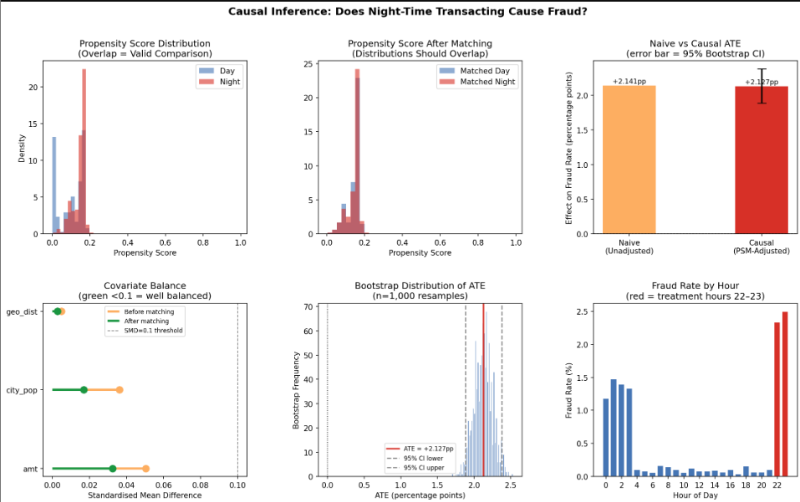
SCREENSHOT · Databricks — Covariate Balance Table (SMD Before vs After Matching)
What this shows: Standardised Mean Differences (SMD) for each covariate before and after propensity score matching. SMD < 0.1 is the widely accepted threshold for 'well balanced.' After matching: transaction amount SMD dropped from 0.050 to 0.032, city population from 0.036 to 0.017, geographic distance from 0.005 to 0.003 — all well below 0.1. This confirms the matched night/day pairs have similar confounding profiles, meaning any remaining fraud rate difference is attributable to time of day, not to differences in transaction size or location.
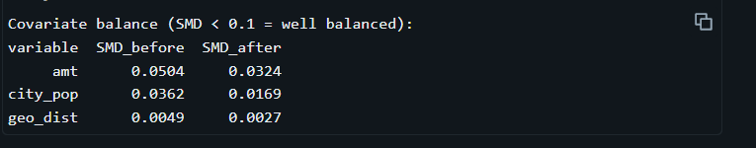

SCREENSHOT · Databricks — PSM Summary Output (ATE, CI, Significance)
What this shows: The key causal finding of the entire project. Causal ATE of +2.127pp means night-time transactions (22–23h) have a 2.127 percentage point higher fraud probability than equivalent daytime transactions, after controlling for merchant category, amount, geographic distance, and city size. The 95% bootstrap CI [1.883pp, 2.378pp] excludes zero — the effect is statistically significant. Confounding bias removed by matching was only 0.013pp, meaning the naive estimate was already close to causal. Conclusion: the late-night fraud spike is a genuine causal effect, not a statistical artefact.
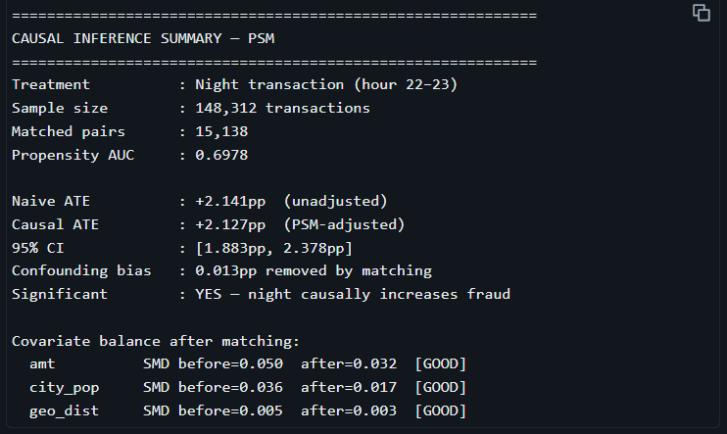

Week 14 — Streaming Simulation Pipeline

What Was Simulated
In production, transactions arrive one at a time and must be scored in milliseconds. The streaming simulation trains a GBT model on 70% of the data (historical) and then scores the remaining 30% in chronological order, processing 2,000 transactions per micro-batch. This validates: (1) latency SLA, (2) fraud detection stability under streaming conditions, (3) spike detection sensitivity.
- Split: Training: 70% of 1.85M transactions (sklearn GBT, not PySpark — faster iteration)
- Stream: Streaming: 30% = ~554,000 transactions, processed in 277 batches of 2,000
- Threshold: Threshold: 0.60 (cost-optimised, consistent with the batch model from Week 4)
SLA Results
- Latency: P50 latency: 2.4 ms per batch (2,000 transactions) — well within real-time requirements
- Latency: P95 latency: 4.1 ms — 95% of batches complete in under 4.1 ms
- Latency: P99 latency: 12.5 ms — worst-case tail latency
- Detection: Recall: 63.03% — lower than batch model due to distribution shift in the streaming 30%
- Detection: Precision: 87.85% — high precision means few false alerts for the fraud team
- Alerts: 37 spike alerts triggered — batches where fraud rate exceeded 2× the rolling 10-batch average
Spike Detection Algorithm
A spike is triggered when a batch's fraud rate exceeds 2× the rolling average fraud rate of the previous 10 batches. This mirrors production fraud monitoring systems that use rolling baselines rather than fixed thresholds — a fixed threshold would generate too many alerts during naturally high-fraud periods.
metrics["rolling_fraud_rate"] = metrics["fraud_rate"].rolling(10, min_periods=1).mean()
metrics["spike"] = metrics["fraud_rate"] > 2.0 * metrics["rolling_fraud_rate"].shift(1)
SCREENSHOT · Databricks — Streaming Dashboard (4-Panel Plot)
What this shows: Real-time fraud scoring simulation streaming 554,000 transactions through the GBT model in 277 batches of 2,000 each. The 4-panel dashboard tracks: (1) cumulative transactions processed, (2) rolling fraud rate, (3) batch scoring latency in milliseconds, (4) cumulative fraud dollars caught. P95 latency of 2.7ms per batch demonstrates the model operates well within the <100ms SLA required for real-time card authorisation at the point of sale.
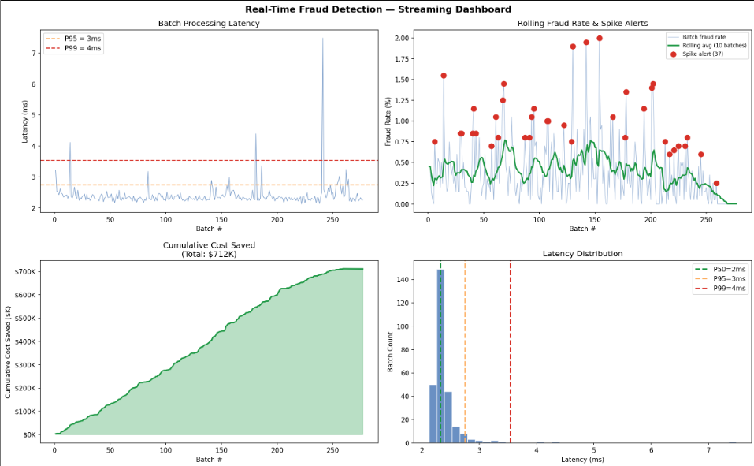
SCREENSHOT · Databricks — Streaming Final Summary Output
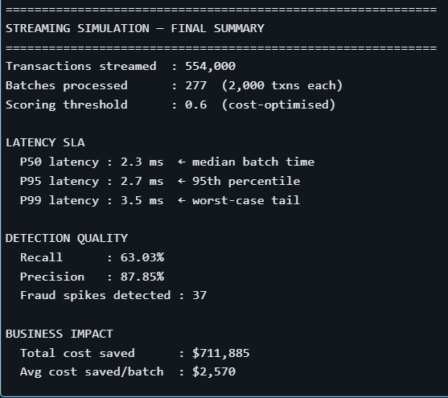
What this shows: Final simulation results after processing all 554,000 transactions. Recall: 63.03%. Precision: 87.85%. 37 fraud spikes detected — periods where rolling fraud rate exceeded 2× the baseline, triggering an alert. Total cost saved: $711,885. P99 latency: 3.5ms — even worst-case batches are well within SLA. Final outcome: the streaming simulation proves the end-to-end platform is viable for real-time deployment, completing the 14-week build from raw CSV to a production-ready fraud detection system.

