Memory-Pressure Forecasting and Growth-Based Warnings: An Empirical Study
Abstract. Forecasting rising memory pressure can support monitoring, but accurate forecasts do not by themselves identify memory leaks. We compare persistence, linear trend, restricted ARIMA and a small LSTM on one Antarex fault-injection recording and three Westermo industrial recordings, using chronological splits and 60- or 300-second horizons. Forecast error and growth-warning performance are evaluated separately. In the original Antarex run, LSTM reduces RMSE from ARIMA’s 1.516 to 1.216 percentage points of RAM. Its warning rule, however, recognizes 34 of 35 injected events against trend-only’s 35, with timestamp recall 0.466 versus 0.859. A matched study of five random seeds and two LSTM input configurations adds 40 runs. Extra features improve mean RMSE on only two of four recordings. Multivariate Antarex warning F1 is $0.571±0.031$, below trend-only’s 0.830, and false alarm starts range from 43 to 137 against 86. Analyzing the saved scores shows that the original missed event occurred simply because the forecast-growth threshold was not reached. Because the Westermo dataset lacks verified leak ground truth, it can only support forecasting evaluations. Furthermore, while local replay and inference benchmarks confirm prototype viability, we have not yet validated live runtime performance or lead-time warnings prior to memory exhaustion.
Keywords: Memory pressure $⋅$ Time-series forecasting $⋅$ LSTM $⋅$ Warning evaluation $⋅$ Operating-system telemetry

1 Introduction
An operating system can report growing memory use without identifying its cause. A larger workload, a cache, or an application retaining allocations can produce similar aggregate measurements. A forecast of memory availability is therefore a resource estimate, not proof of a memory leak. This distinction matters when a forecasting model is used to trigger operational warnings.
We study whether a more accurate short-horizon forecast gives more useful warnings on recorded telemetry. The target is the memory-pressure proxy
$$y_{t}=1−\frac{{available memory}_{t}}{{total physical memory}_{t}}. \text{(1)}$$
It measures the fraction of RAM unavailable for immediate use. Models predict $y_{t+h}$ using observations through time $t$. Warning rules then assess recent growth, optionally requiring the forecast to indicate continued growth. These two tasks are evaluated separately.
The study uses controlled Antarex fault injections and three unlabeled Westermo industrial test-system recordings. Its contribution is empirical: (1) a reproducible comparison of forecast error and warning coverage under the same temporal evaluation protocol; (2) a matched five-seed comparison of memory-only and multivariate LSTMs; and (3) an explanation of a missed injected event using the saved decision scores. We also measure the local replay and inference prototype. Our focus is not on introducing a novel neural network architecture or pinpointing allocation-level root causes. Likewise, evaluating early warning alerts prior to memory exhaustion falls outside the scope of this work.

2 Related Work and Research Gap
They connect the phenomena of resource degradation and workload variability to system failures, including estimates of exhaustion by measurements [32] and stress tests for web servers [8] as well as holistic studies on rejuvenation and prediction of online failure [6,26]. But they do not declare any upward-facing RAM curve as a leak conclusively, unlike the foundational papers: e.g., we need the failure ground truth to understand the exhaustion as in fault-injection experiments by Zhao et al. [36].
Furthermore, the granularity of observation determines the limit of analytical insight. For example, we need dynamic instruments like Valgrind [21] or profiling for adaptive, garbage collector [10,15] to get heap-level insights; otherwise, other frameworks look at runtime metrics for embedded Linux [3], analyze versions of software differentially [20], or put in full diagnosis/mitigation as part of production systems like RESIN [18]. We do not claim any root cause diagnostics for lack of aggregate telemetry on heap allocation and paired software-builds.
For macro-time series, there are approaches to detect the leak patterns from utilization logs (LBR/Precog variants [14]) and compare different models of ARIMA style Box-Jenkins vs. LSTM for Windows telemetry [1]. The power of statistics and simple baseline approaches are still vital yardsticks for the domain [4,12]. Despite the expressive power of LSTMs for sequential modeling[11], we still find the comparisons of different architectures and competitive linear baselines show that complex neural is not necessarily superior to simpler alternatives [7,34].
Different combinations of models for hybrid ARIMA-neural forecasting [35], software fault ARIMA-LSTM forecasting [27], hLSTM-aging [2]. We compare different predictors, and we do not replicate the architectures nor compare different tasks’ scores.
The closest contrasts of the methods are summarized in Table 1. The last column states the boundary pertinent to this study rather than the previous method is generally not good enough.
Anomaly detection has dependencies on assumptions and benchmark quality [5,33,28]. There are differences in the evaluation of forecast errors vs. the warning score [13,25,31]. The availability of information per prediction is explicit using chronological holdout and train-only scale up [30,16].
Table 1. Selected earlier studies and the evidence they provide.
Study | Observation and purpose | Boundary for the present comparison
Jindal et al. [14] | Utilization histories; LBR/Precog leak-pattern methods | Their labels and algorithms differ from our injected-event and forecast-warning protocol.
Assi et al. [1] | Windows counters; ARIMA/LSTM forecast errors | Forecast-error ranking alone does not answer our timestamp/event warning question.
Zhao et al. [36] | Injected leaks; accelerated failure study | Failure outcomes are available there; our audited block has no exhaustion outcome.
Lou et al. [18] | Production service with detection, diagnosis and mitigation | Requires evidence beyond our aggregate replay and growth warnings.
Battisti et al. [2] | Hybrid neural model for software-aging forecasts | Different architecture and target setting; its scores cannot rank our warning rules.
Kim et al. [17] | Evaluation of time-series anomaly detection | Warns about point adjustment; we retain timestamp scores and separate event counts.
Research gap. When analyzing these traces under a single temporal protocol, does a lower forecasting error genuinely improve growth-warning coverage, cut down on false alarms, or speed up recognition? Answering this requires a controlled evaluation. We tackle this problem by pairing matched forecast origins with injected-event labels, running trials across repeated random seeds, and conducting a memory-only ablation. As for the unlabeled workload data, its role is strictly limited to comparing forecast performance rather than supporting leak-detection claims.

3 Data and Experimental Protocol
Figure 1 summarizes the archived workflow. The forecast and warning branches are evaluated separately. The labels calibrate and score the warning rules, but they never enter the predictors. The live sampler is a separate trend-only path, discussed in the algorithm 1.

3.1 Dataset Choice and Forecast Horizons
We picked the Antarex dataset because it combines authentic machine telemetry with logged controlled fault injections [22,24,23]. Specifically, our experiments draw on the fully recovered CPU-MEM_mono block, which spans close to 12 days and captures 228 injected leak episodes, cutting it down to only the metric streams required by our pipeline. While we verified the integrity of this nested archive against its recorded byte size and CRC checksum, we did not download the entire outer archive or check its published MD5 hash. As a result, the traces analyzed here must be viewed as a targeted subset rather than a full validation of the complete Antarex release.
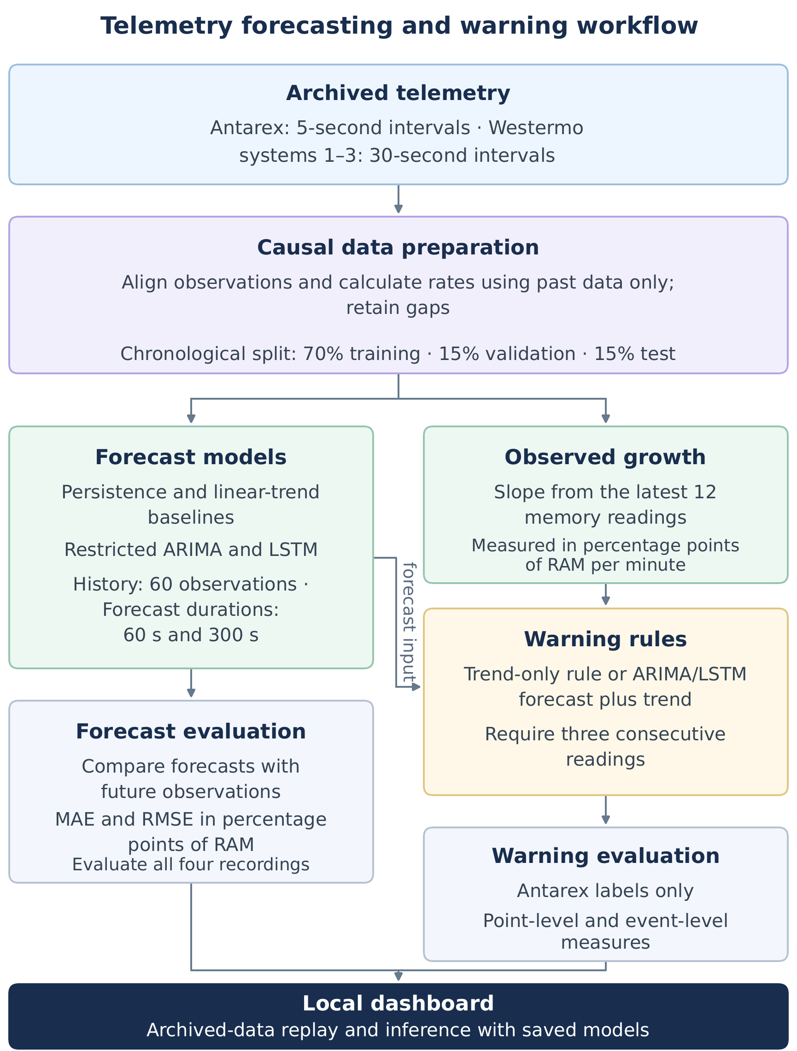
Fig. 1. Architecture of the archived experiment. Horizons are 60 s for Antarex and 300 s for Westermo. Only ARIMA and LSTM forecasts asist the growth rules; persistence and linear trend are forecast baselines, Warning evaluation separates timestamp precision, recall and F1 from event misses, false alarm starts and recognition delay. Westermo supports forecast scores and descriptive alarm counts, not labeled warning scores. The original ARIMA warning rule was removed after validation. pp : percentage points of RAM.
To pair this with an industrial workload, we also incorporated the Westermo dataset, which tracks 19 test systems sampled twice a minute over a one-month period [29]. After downloading all 19 CSV files and verifying them against the repository metadata, we selected the first three systems (Systems 1–3) in numerical order for this pilot study, and each system was modelled independently. Because the Westermo dataset lacks verified memory-leak annotations, we restrict its use to evaluating the forecast accuracy and tallying descriptive alarm counts. Both datasets are distributed under the CC BY 4.0 license, and we maintain full attribution to the original authors.
We resample the Antarex data at 5-second grid while retaining Westermo’s original 30-second sampling interval, setting default forecast horizons to 12 steps (60 s) and 10 steps (300 s), respectively. The selected horizons correspond to roughly ten observations ahead, accounting for each source’s sampling rate. They are practical pilot settings, not validated optimal warning lead times. Likewise, because a 60-step lookback window spans 295 s in Antarex versus 1,770 s in Westermo, error magnitudes across the two datasets should not be interpreted as a controlled comparison over equal wall-clock time.
Table 2. Recording scope and eligible samples. A: Antarex; W1–W3: Westermo systems. Train is the eligible count before LSTM training stride.
Recording | Grid rows | Train | Validation | Test | Inputs
A | 207361 | 145081 | 31032 | 31032 | 7
W1 | 86401 | 59691 | 12891 | 12891 | 8
W2 | 86401 | 60412 | 12891 | 12745 | 7
W3 | 86401 | 60412 | 12891 | 12891 | 8

3.2 Causal Preparation and Feature Availability
For Antarex, the latest source observation before each grid time is used, with a maximum age of 2.1 s. Differences between counter readings are used to compute page-fault, swap, and disk rates based on the actual elapsed time. A rate is considered invalid if a counter resets, the time interval is nonpositive, or the interval exceeds 7.2 s. CPU features are calculated using non-overlapping tick categories. For Westermo, the published CPU and disk rates are used directly without further differentiation. Missing values and gaps are not interpolated.
The selected Antarex inputs include memory pressure, anonymous and committed memory, busy and I/O-wait CPU fractions, and total and major page-fault rates. Swap and monitored disk streams remain constant in the training partition and are therefore excluded. Westermo uses memory pressure, user/system/I/O-wait CPU rates, disk read/write rates, one-minute load, and swap use. For system 2, the constant swap input is removed. Westermo does not contain page-fault fields. Inputs with a training standard deviation of at most ${10}^{−12}$ are treated as constant. Their removal prevents undefined standardization and avoids adding uninformative inputs. However, this does not mean that disk or swap is unimportant for other workloads. The feature ablation described below evaluates the retained feature set as a whole rather than examining the causal effect of each individual feature.
Each recording is divided according to time into 70% training, 15% validation, and 15% test sets. These boundaries are established before the windows are constructed. The training means and population standard deviations are then used to scale the subsequent data. A window is retained only if both its history and target fall within the same valid, contiguous segment and partition. The first Antarex row in each partition is excluded to prevent rate calculations from depending on observations from the preceding partition. Westermo systems 1 and 2 contain 652 and 8 missing grid rows, respectively. The memory-only ablation uses exactly the same coverage mask as the multivariate model, ensuring that differences in sample availability cannot explain the results.
For Antarex, the injection start and end times define half-open labeled intervals $[s,e)$. These intervals are checked against the supplied fault labels. IDs, timestamps, commands, and fault labels are not used as predictor inputs. The labels establish the controlled injection task, but no process-allocation measurements are available to confirm naturally occurring memory leaks. Additionally, a non-leak label may coincide with another injected fault, so it does not necessarily indicate that the system is healthy.

3.3 Predictors and Repeated Runs
Persistence repeats the latest memory pressure. Linear trend extends a least-squares line fitted to 12, 30 or 60 recent values; validation RMSE selects the window. Restricted ARIMA uses orders $(1,1,0)$, $(3,1,0)$ and $(5,1,0)$ without drift. Parameters are estimated by Yule–Walker on the longest contiguous training segment, and validation RMSE selects the order. This limited comparison does not implement a full Box–Jenkins search. Forecasts are clipped to $[0,1]$ for scoring.
Both LSTM variants use one unidirectional layer with 32 hidden units and a linear output from its final hidden state. The recurrent state resets for each window. Training uses standardized-target mean squared error, Adam at 0.001, batch size 64 and gradient clipping at 1.0. Training retains every twelfth eligible Antarex origin and every fourth Westermo origin; validation/test use all eligible origins. The best validation-RMSE checkpoint is selected from at most 20 epochs, with patience four. There is no dropout, bidirectional layer or hybrid ARIMA stage.
The original September Colab experiment used seed 42. The revision trains both feature variants from scratch with seeds 7, 21, 42, 84 and 123 on the same local CPU runtime: 40 runs in total. All checkpoints are frozen before the new test scores are computed. Every seed is reported, with mean and sample standard deviation (SD). This is variation from training randomness on fixed data, not uncertainty across new machines. Memory-only LSTM matches the baselines’ input variable; model fitting and training sample use still differ. With the hidden width fixed, the memory-only model has 4,513 parameters. The seven-input and eight-input models have 5,281 and 5,409, respectively. We add no newly labeled recordings

4 Warning Procedure and Evaluation

4.1 Growth Rules and Threshold Calibration
Let $g_{t}$ be the least-squares slope over the last 12 memory pressure observations, expressed as percentage points (pp) of RAM per min. For forecast $f_{m}(t)$ with horizon $h$ in seconds, define
$$q_{m}(t)=\frac{100[f_{m}(t)−y_{t}]}{h/60}, s_{m}(t)=min\{g_{t},q_{m}(t)\}. \text{(2)}$$
Trend - only uses $s(t)=g_{t}$. Forecast - assisted warnings require both observed and forecast growth. A warning become active on the 3rd consecutive eligible score at or above its threshold; one failure clears it. Gaps and split boundaries reset the count. Three readings suppress isolated excursions but add 10 s of confirmation at Antarex cadence and 60 s at Westermo cadence. This was a fixed engineering choice, not an optimized duration or a statistical - significance test. Mann–Kendall testing and autocorrelation corrections are alternatively future comparisons [19,9].
To adjustt the warning rules, each variant independently evaluates thresholds from the set $\{0.01,0.025,0.05,0.1,0.2,0.4,0.8,1.6,3.2\}$ pp/min, plus a disabled state. We optimize for point-wise validation F1 on Antarex. If multiple thresholds tie, we choose the one that generates leser false - positive timestamps, if a tie still persists, we pick the higher threshold, treating the disabled option as the greatest rank of all. In our initial run, this procedure selected $0.8$ pp/min for the trend -only baseline and $0.4$ pp/min for the LSTM- assisted variant. For ARIMA, however, every candidate threshold yielded zero post - confirmation warnings on the validation split, making the tie-breaking reasoning to select the disabled option. This corner case is specific to our chosen no-drift ARIMA specification and rule pairing — it does not imply that ARIMA is fundamentally incapable of driving warning systems. Across mulitple executions. each newly trained LSTM recalculates its threshold exclusively on the validation split, while we keep the original run’s outputs stored separately.
Algorithm 1 illustrates how we isolate offline model evaluation from the live monitoring loop. When running live, the system samples OS metrics every five seconds through psutil, derives the same memory proxy and an exploratory observed-growth rule, and exports the telemetry—deliberately avoiding running the archived LSTM on mismatched Windows feature streams.
Algorithm 1 Telemetry forecasting and causal warning generation
Input: archived telemetry or a live OS sampler; history window of 60 samples; trend window of 12 samples
1: if the data come from an archived experiment then
2: Align the recorded observations in time and compute rates; keep gaps and note each value’s source
3: Split the data chronologically, fit the scalers on training rows only, and build the valid input windows
4: Train the predictors on the training set and keep the checkpoints with the lowest validation RMSE
5: Choose the warning thresholds from the validation labels, then fix them
6: else
7: Start the five-second sampler and set an exploratory trend threshold
8: end if
9: for each new observation at time $t$ do
10: Read the available telemetry and compute $y_{t}$ using Eq. 1
11: After a gap, clear the history and the count, then wait until enough history has built up
12: Compute the observed slope $g_{t}$ over the last 12 readings
13: if the inputs are compatible with an archived model then
14: Scale the history using the saved training statistics and predict $f_{m}(t)$
15: Set $s_{t}=g_{t}$ for trend-only rules, or compute $s_{t}$ from Eq. 2 for model-assisted rules
16: else
17: Set $s_{t}=g_{t}$; no substitute model inputs are made up
18: end if
19: Update the count of consecutive qualifying steps and raise a warning once the count reaches 3
20: Store the forecast, the score, the warning, and any change in alarm state
21: end for
22: Evaluate the stored forecasts and decisions only where suitable outcomes are available

4.2 What Each Measure Means
MAE is the average absolute difference between predicted and observed future pressure. RMSE squares the errors before averaging and taking the square root, giving large mistakes greater weight [13]. Both are reported in pp of total RAM. An RMSE of 1.5 pp describes forecast deviation on this scale; it is neither 98.5% detection accuracy nor a bound on every error.
At each eligible origin, TP means a warning during a recorded leak, FP a warning outside one, and FN an active leak without a warning. Precision $=TP/(TP+FP)$ asks how many warned timestamps are leak-active. Recall $=TP/(TP+FN)$ asks how much labeled leak time is covered. F1 $=2TP/(2TP+FP+FN)$ balances these two aspects. Zero-denominator ratios remain undefined. Imbalance makes these measures more informative than overall accuracy alone [25].
An alarm start is an inactive-to-active transition, including activation after a gap. False alarm starts per non-leak hour (FA/h) divide starts outside injected-leak intervals by observed non-leak exposure: eligible non-leak origins times cadence. Persistent false warnings are also reported as false-positive minutes. These are distinct costs.
Event recognition requires a new alarm start inside a fully covered injected interval, with a covered sample immediately before it. A prior alarm does not count again. Event recall is recognized events divided by eligible events; detection delay is first alarm time minus injection start. Medians and 90th percentiles describe detected events only, so missed-event counts accompany them. Detecting one timestamp does not make every timestamp in that interval correct [31,17]. These delays measure recognition after injection begins, not warning lead time before exhaustion.

5 Results and Interpretation

5.1 Forecast Accuracy and the Baseline Comparison
Table 3 preserves the original run. On Antarex, LSTM RMSE was 1.216 pp against ARIMA’s 1.516 pp, a 19.8% reduction, while MAE changed only from 0.363 to 0.358 pp. The larger RMSE improvement indicates a stronger effect on large errors than on average absolute error. Across Westermo, the original LSTM reduced RMSE but ARIMA had lower MAE: no method wins under every loss.
The selected Antarex ARIMA$(3,1,0)$ coefficients are approximately $−0.011$, $−0.010$ and $−0.011$. With no drift, forecast increments quickly become small, making its predictions close to persistence; their RMSEs differ by only 0.000196 pp. Linear extrapolation performs worse in all four recordings, consistent with transient slopes not continuing through the forecast horizon. Figure 2 shows the fixed original example interval; full-test scores, rather than that interval, support the comparisons.
Table 3. Original test forecast errors: MAE / RMSE, in percentage points (pp) of total RAM. A uses 60 s; W1–W3 use 300 s. LSTM is the single Colab seed-42 run.
Model | A | W1 | W2 | W3
Persistence | 0.361 / 1.517 | 0.094 / 0.363 | 0.109 / 0.317 | 0.240 / 0.715
Linear trend | 0.377 / 1.744 | 0.145 / 0.376 | 0.144 / 0.348 | 0.329 / 0.818
ARIMA | 0.363 / 1.516 | 0.093 / 0.318 | 0.105 / 0.291 | 0.230 / 0.658
Original LSTM | 0.358 / 1.216 | 0.099 / 0.296 | 0.117 / 0.258 | 0.251 / 0.608
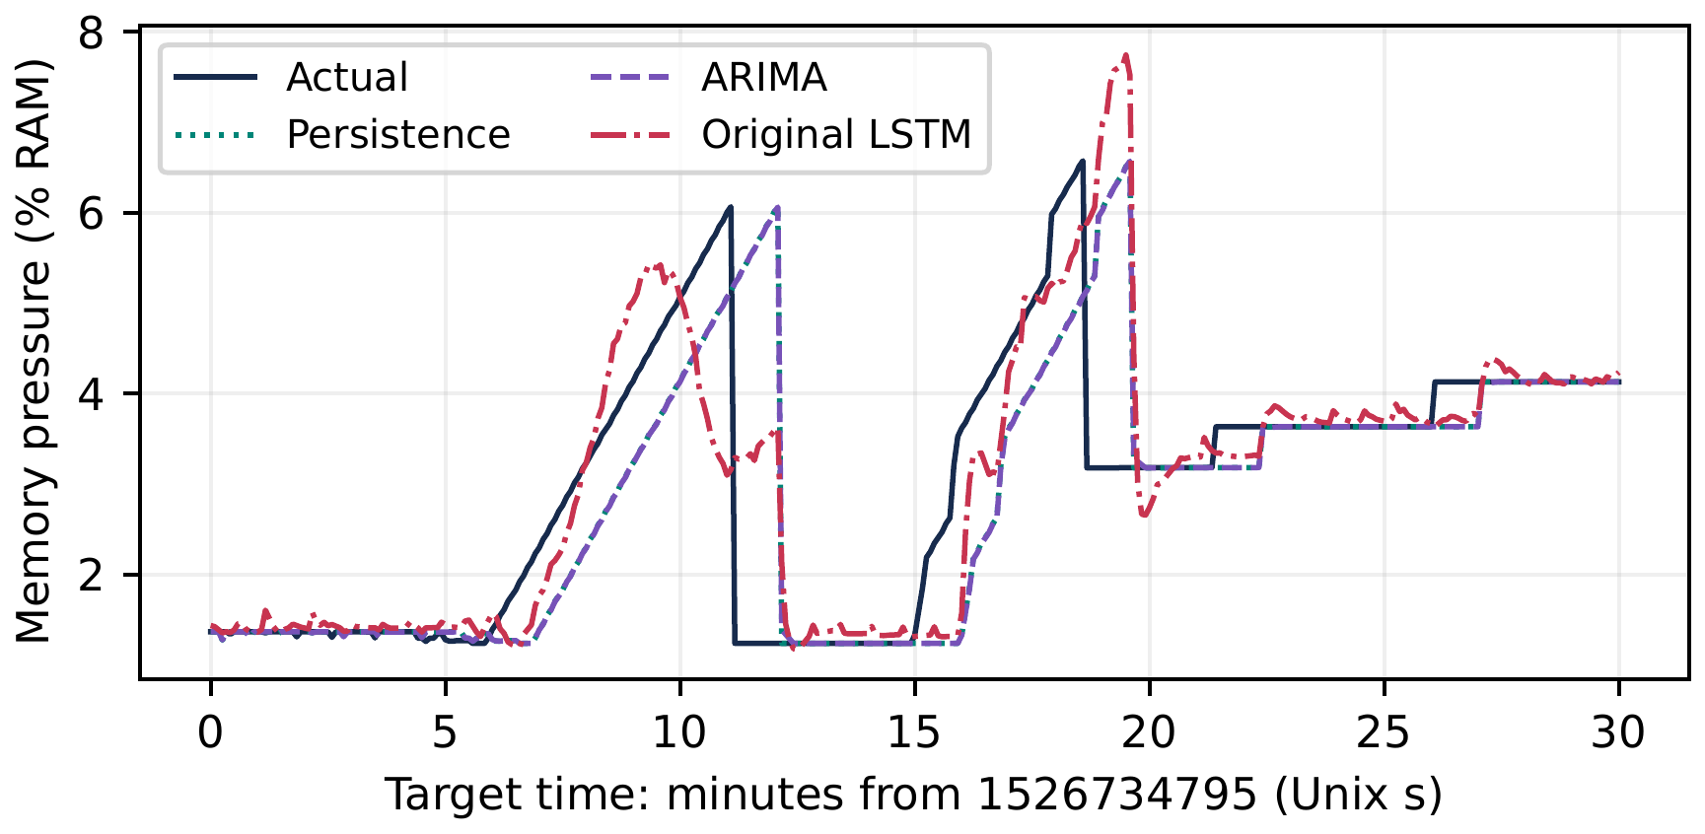
Fig. 2. Original Antarex 60-second-ahead rolling forecasts, aligned by target time. Predictions shown at a time were issued 60 s earlier. Persistence and ARIMA nearly overlap. This is the first fixed 30-minute test interval, not a best-case selection.

5.2 Random Seeds and the Memory-Only Ablation
The new CPU runs use Python 3.12.14, PyTorch 2.8.0+cpu and two Torch threads. Table 4 keeps them separate from Colab. On Antarex, multivariate mean RMSE is 1.204 pp versus memory-only 1.221 pp. Paired multivariate RMSE is lower in four of five Antarex seeds and all five W1 seeds, but only one W2 seed and no W3 seed. On W2 and W3, extra inputs also increase MAE in every paired seed. Additional telemetry therefore does not consistently improve this fixed model and training budget. The experiment does not isolate which feature helps or harms.
Both LSTM variants have lower mean RMSE than restricted ARIMA on each recording, but all their mean MAEs exceed ARIMA’s. Training minimizes squared error, which weights large deviations strongly; lower RMSE with worse MAE is therefore possible. Seed SD describes optimization variability on these recordings, not a confidence interval for other systems. No additional labeled dataset or independent holdout was introduced.
Table 4. Five-seed LSTM test errors: mean $±$ sample SD, in pp. Mem: memory-only; Multi: retained multivariate inputs. All five seeds are included.
Recording | MAE (Mem) | MAE (Multi) | RMSE (Mem) | RMSE (Multi)
A | $0.378±0.018$ | $0.365±0.024$ | $1.221±0.015$ | $1.204±0.020$
W1 | $0.099±0.008$ | $0.103±0.008$ | $0.300±0.001$ | $0.297±0.002$
W2 | $0.110±0.005$ | $0.121±0.004$ | $0.260±0.003$ | $0.263±0.003$
W3 | $0.242±0.011$ | $0.278±0.026$ | $0.606±0.005$ | $0.618±0.009$

5.3 Warnings, Missed Events and Recognition Delay
There are 1933 leak-active origins among 31,032 Antarex test origins and 35 fully covered injected events. Table 5 shows that the original LSTM warning improves precision and reduces false alarm starts from 86 to 42, but covers less leak-active time and misses one event. False alarm rates are 2.128/h for trend-only and 1.039/h for LSTM; false-positive exposure is 34.17 and 13.50 min respectively. Their detected-event 90th-percentile delays are 56.0 and 45.7 s. The disabled ARIMA rule is equivalent to always-off and misses all events.
The difference follows from the warning objective. Regression rewards accurate future levels over all origins, whereas the assisted rule demands both observed and forecast growth above a threshold for three readings. A model can predict the level closely while predicting insufficient continued growth. The additional condition suppresses some false alarms and some true warnings; minimizing forecast RMSE does not optimize event recall or warning F1.
Table 5. Original Antarex test warnings. P/R: timestamp precision/recall; FA: false alarm starts; missed: events missed out of 35; delay: median seconds after injection among detected events only. A dash means undefined.
Rule | P | R | F1 | FA | Missed | Delay (s)
Trend only | 0.802 | 0.859 | 0.830 | 86 | 0 | 30
LSTM + trend | 0.848 | 0.466 | 0.601 | 42 | 1 | 31
ARIMA (off) | – | 0.000 | 0.000 | 0 | 35 | –
Event 1534, a low-intensity injection starting at 22:00:14 UTC on 19 May 2018, demonstrates this mechanism (Fig. 3). During its 236 s and 47 eligible origins, forecast growth peaks at 0.216 pp/min, below the 0.4 threshold. Thus no reading can satisfy the forecast gate, irrespective of the three-reading requirement. Observed growth reaches 0.938 pp/min; trend-only warns after 56 s. Memory pressure spans approximately 3.20–7.17%. The recorded scores explain the decision failure, not its allocation-level cause.
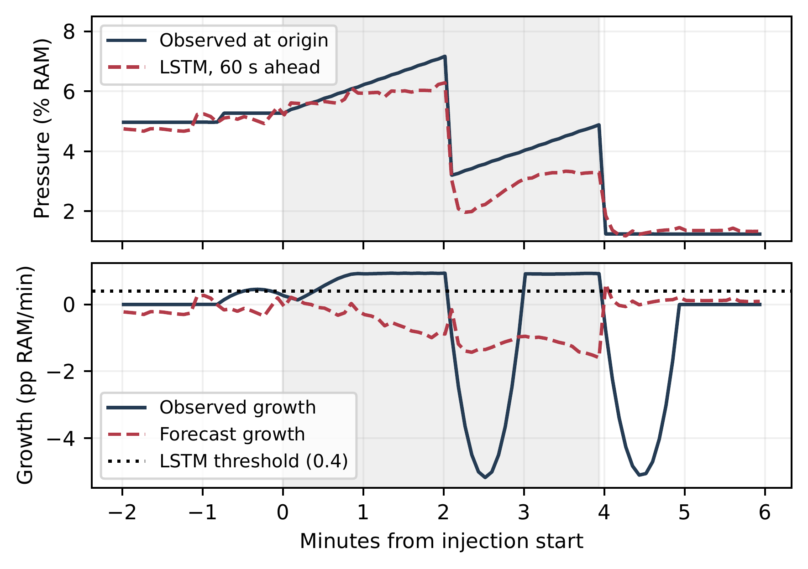
Fig. 3. Original missed injected event 1534. Shading marks the recorded injection. Top: current pressure and the forecast issued at the same origin (its target is 60 s later). Bottom: observed and forecast growth; predicted growth remains below the LSTM gate throughout the injection. pp: percentage points of RAM.
The seed study weakens a general claim of fewer false alarms (Table 6). Multivariate precision is $0.758±0.112$ and recall $0.461±0.010$; memory-only gives $0.648±0.071$ and $0.482±0.021$. Multivariate false starts range from 43 to 137, compared with the unchanged trend count of 86; memory-only ranges from 126 to 168. Each variant misses zero to two events depending on seed. Trend-only F1 remains 0.830, above every new LSTM-assisted run. The original precision/false-alarm advantage is therefore not stable across all repetitions. Validation selects thresholds separately for each run; forecast training variability and threshold decisions both influence these results.
Table 6. Repeated LSTM-assisted Antarex warnings. F1 and FA/h are mean $±$ SD; missed is the range out of 35 events. Delay summarizes the five detected-event medians, not pooled events.
Inputs | F1 | FA/h | Missed | Delay (s)
Multivariate | $0.571±0.031$ | $2.014±1.052$ | 0–2 | $26.6±3.4$
Memory-only | $0.551±0.028$ | $3.405±0.449$ | 0–2 | $30.4±2.7$

5.4 Prototype Checks and Measurement Limits
All 40 implementation tests passed, including loopback HTTP endpoints. Startup verified 76 source files covering 69,559 test origins. In a separate in-process benchmark on Windows with 8 logical CPUs and 7.8 GiB RAM, each recording received 100 replay/JSON requests and 100 warm model requests. Median replay times ranged from 7.05 to 21.84 ms; median warm inference ranged from 0.45 to 0.56 ms (95th percentiles 0.69–0.96 ms). All 404 first/warm inferences matched archived predictions within ${10}^{−6}$ pressure fraction. The first request, including library/model loading, took 5.34 s. Process resident memory increased from 25.4 to 402.3 MiB; this includes replay data, libraries and four models, not isolated monitoring overhead.
These measurements exclude HTTP transport and browser rendering. The live collector returned a Windows performance-counter error before any samples were recorded. No live timing, CPU-overhead or labeled live-detection result is reported. Longer live trials, missing-counter resilience and controlled overhead measurements remain unvalidated. The optional live mode uses exploratory trend warnings, not the archived Linux LSTM.

6 Limitations, Reproducibility and Conclusion
The extended study uses still just one labelled Antarex recording with controlled injections, overlapping time window, holdouts reused. Some former test forecasts had a check during development. Before finalize original warning protocol. The 5 different seeds for repetition of the experiments help to measure variations in optimization. But not the impact of development choices. The multivar, just memory has factored history, origins and training settings. But varies input dimensions and no. of parameters. The improvement is not attributable to just one feature. Independent validation is needed for selected horizons, thresholds and length for confirmation.
Antarex does not achieve the illustrative 80% pressure in the audited block. The observed highest pressure is ~ 42.24%. The study does not claim to have warning before exhaustion / crash (as there was no observation of it). But need of labelled trials with defined resource limits, measured depletion times, warning lead times and without warning. Westermo can not be used to establish real leak detection. They don’t provide the labels for leak. More labelled recordings, process level evidences of allocations, multivariate stat. baselines under matching conditions, independent temporal holdout, longer live trials (in compatible environment) are parts of further work.
Reproducibility. The project keeps the preprocessing steps, baseline, LSTM and warning code. 4 exc. notebooks. Configs for models, weights, origin indices, checksums, scoring scripts. This revision adds the fixed seed & feature protocol. Forecasts & warning results for each run. Missed event analysis. Prototype bench. For reproducing, we apply verif. input package for runing the seed study. Then independently verify saved predictions, warning scores. Private repo. so no presenting materials as publicly. accessible. The author review support using a masked additional code package. There is no clear access to raw and derived data packages. This must be arranged separately. The public dataset sources are referenced above, but public code release or reviewer access needs to be established for "openly reproducible" status.
Conclusion. It should be noted that lower forecasting error and better warning performance are separate results. For example, the LSTM is getting lower RMSE compared to the restricted ARIMA, while the trend-only is covering more labeled time with higher F1 score for warning. The improvement of LSTM precision/false alarms from the original paper is not consistent for all the seeds. The additional features could only improve the mean of RMSEs in just 2 of 4 recordings. The missed event scores showed the threshold of forecast growth which was not met by the missed event. These results help separate the forecasting accuracy and warning performance for operational purposes. It does not yet prove the production level leak diagnosis and that the system can issue warnings before memory exhaustion. Further independent labeled trials, process level measurements and longer life evaluation are required.

References
1. Assi, M.J., Fahad, A.A., Al-Sarray, B.: Time series forecast modeling for the Windows operating system performance using Box-Jenkins and LSTM models. International Journal of Nonlinear Analysis and Applications 13(2), 2121–2131 (2022). https://doi.org/10.22075/ijnaa.2022.26974.3505
2. Battisti, F., Silva, A., Pereira, L., Carvalho, T., Araujo, J., Choi, E., et al.: hLSTM-Aging: A Hybrid LSTM Model for Software Aging Forecast. Applied Sciences 12(13), 6412 (2022). https://doi.org/10.3390/app12136412
3. Beneder, R., Glatz, B., Horauer, M., Rauscher, T.: Memory leak detection runtime-service for embedded Linux devices. In: Proceedings of the 2014 IEEE Emerging Technology and Factory Automation (ETFA). pp. 1–6. IEEE (2014). https://doi.org/10.1109/ETFA.2014.7005223
4. Box, G.E.P., Jenkins, G.M., Reinsel, G.C.: Time Series Analysis: Forecasting and Control. Wiley, 4th edn. (2008). https://doi.org/10.1002/9781118619193
5. Chandola, V., Banerjee, A., Kumar, V.: Anomaly detection: A survey. ACM Computing Surveys 41(3), 1–58 (2009). https://doi.org/10.1145/1541880.1541882
6. Cotroneo, D., Natella, R., Pietrantuono, R., Russo, S.: A survey of software aging and rejuvenation studies. ACM Journal on Emerging Technologies in Computing Systems 10(1), 1–34 (2014). https://doi.org/10.1145/2539117
7. Greff, K., Srivastava, R.K., Koutnik, J., Steunebrink, B.R., Schmidhuber, J.: LSTM: A Search Space Odyssey. IEEE Transactions on Neural Networks and Learning Systems 28(10), 2222–2232 (2017). https://doi.org/10.1109/TNNLS.2016.2582924
8. Grottke, M., Li, L., Vaidyanathan, K., Trivedi, K.S.: Analysis of Software Aging in a Web Server. IEEE Transactions on Reliability 55(3), 411–420 (2006). https://doi.org/10.1109/TR.2006.879609
9. Hamed, K.H., Ramachandra Rao, A.: A modified Mann-Kendall trend test for autocorrelated data. Journal of Hydrology 204(1–4), 182–196 (1998). https://doi.org/10.1016/S0022-1694(97)00125-X
10. Hauswirth, M., Chilimbi, T.M.: Low-overhead memory leak detection using adaptive statistical profiling. In: Proceedings of the 11th International Conference on Architectural Support for Programming Languages and Operating Systems. pp. 156–164. ACM (2004). https://doi.org/10.1145/1024393.1024412
11. Hochreiter, S., Schmidhuber, J.: Long Short-Term Memory. Neural Computation 9(8), 1735–1780 (1997). https://doi.org/10.1162/neco.1997.9.8.1735
12. Hyndman, R.J., Athanasopoulos, G.: Forecasting: Principles and Practice. OTexts, 3rd edn. (2021), https://otexts.com/fpp3/
13. Hyndman, R.J., Koehler, A.B.: Another look at measures of forecast accuracy. International Journal of Forecasting 22(4), 679–688 (2006). https://doi.org/10.1016/j.ijforecast.2006.03.001
14. Jindal, A., Staab, P., Kulkarni, P., Cardoso, J., Gerndt, M., Podolskiy, V.: Memory Leak Detection Algorithms in the Cloud-based Infrastructure. arXiv preprint arXiv:2106.08938 (2021). https://doi.org/10.48550/arXiv.2106.08938
15. Jump, M., McKinley, K.S.: Cork: dynamic memory leak detection for garbage-collected languages. In: Proceedings of the 34th Annual ACM SIGPLAN-SIGACT Symposium on Principles of Programming Languages. pp. 31–38. ACM (2007). https://doi.org/10.1145/1190216.1190224
16. Kapoor, S., Narayanan, A.: Leakage and the reproducibility crisis in machine-learning-based science. Patterns 4(9), 100804 (2023). https://doi.org/10.1016/j.patter.2023.100804
17. Kim, S., Choi, K., Choi, H.S., Lee, B., Yoon, S.: Towards a Rigorous Evaluation of Time-Series Anomaly Detection. Proceedings of the AAAI Conference on Artificial Intelligence 36(7), 7194–7201 (2022). https://doi.org/10.1609/aaai.v36i7.20680
18. Lou, C., Chen, C., Huang, P., Dang, Y., Qin, S., Yang, X., et al.: RESIN: A Holistic Service for Dealing with Memory Leaks in Production Cloud Infrastructure. In: 16th USENIX Symposium on Operating Systems Design and Implementation (OSDI). pp. 109–125. USENIX Association (2022), https://www.usenix.org/conference/osdi22/presentation/lou-resin
19. Mann, H.B.: Nonparametric Tests Against Trend. Econometrica 13(3), 245–259 (1945). https://doi.org/10.2307/1907187
20. Matias, R., Andrzejak, A., Machida, F., Elias, D., Trivedi, K.: A Systematic Differential Analysis for Fast and Robust Detection of Software Aging. In: 2014 IEEE 33rd International Symposium on Reliable Distributed Systems. pp. 311–320. IEEE (2014). https://doi.org/10.1109/SRDS.2014.38
21. Nethercote, N., Seward, J.: Valgrind: a framework for heavyweight dynamic binary instrumentation. In: Proceedings of the 28th ACM SIGPLAN Conference on Programming Language Design and Implementation. pp. 89–100. ACM (2007). https://doi.org/10.1145/1250734.1250746
22. Netti, A., Kiziltan, Z., Babaoglu, O., Sirbu, A., Bartolini, A., Borghesi, A.: Antarex HPC Fault Dataset. Zenodo, version 1.0 (2018). https://doi.org/10.5281/zenodo.2553224
23. Netti, A., Kiziltan, Z., Babaoglu, O., Sirbu, A., Bartolini, A., Borghesi, A.: Online Fault Classification in HPC Systems through Machine Learning. arXiv preprint arXiv:1810.11208 (2018). https://doi.org/10.48550/arXiv.1810.11208, revised 2019
24. Netti, A., Kiziltan, Z., Babaoglu, O., Sîrbu, A., Bartolini, A., Borghesi, A.: FINJ: A Fault Injection Tool for HPC Systems. In: Euro-Par 2018: Parallel Processing Workshops. Lecture Notes in Computer Science, vol. 11339, pp. 800–812. Springer International Publishing (2019). https://doi.org/10.1007/978-3-030-10549-5_62
25. Saito, T., Rehmsmeier, M.: The Precision-Recall Plot Is More Informative than the ROC Plot When Evaluating Binary Classifiers on Imbalanced Datasets. PLOS ONE 10(3), e0118432 (2015). https://doi.org/10.1371/journal.pone.0118432
26. Salfner, F., Lenk, M., Malek, M.: A survey of online failure prediction methods. ACM Computing Surveys 42(3), 1–42 (2010). https://doi.org/10.1145/1670679.1670680
27. Samal, U., Kumar, A.: Improving software reliability: a hybrid ARIMA-LSTM approach for fault prediction. International Journal of System Assurance Engineering and Management 16(5), 1757–1769 (2025). https://doi.org/10.1007/s13198-025-02743-2
28. Schmidl, S., Wenig, P., Papenbrock, T.: Anomaly detection in time series: a comprehensive evaluation. Proceedings of the VLDB Endowment 15(9), 1779–1797 (2022). https://doi.org/10.14778/3538598.3538602
29. Strandberg, P.E., Marklund, Y.: The Westermo test system performance data set. arXiv preprint arXiv:2311.14510 (2023). https://doi.org/10.48550/arXiv.2311.14510
30. Tashman, L.J.: Out-of-sample tests of forecasting accuracy: an analysis and review. International Journal of Forecasting 16(4), 437–450 (2000). https://doi.org/10.1016/S0169-2070(00)00065-0
31. Tatbul, N., Lee, T.J., Zdonik, S., Alam, M., Gottschlich, J.: Precision and Recall for Time Series. In: Advances in Neural Information Processing Systems. vol. 31 (2018), https://proceedings.neurips.cc/paper/2018/hash/8f468c873a32bb0619eaeb2050ba45d1-Abstract.html
32. Vaidyanathan, K., Trivedi, K.S.: A measurement-based model for estimation of resource exhaustion in operational software systems. In: International Symposium on Software Reliability Engineering. pp. 84–93. IEEE (1999), https://scholars.duke.edu/publication/755326
33. Wu, R., Keogh, E.: Current Time Series Anomaly Detection Benchmarks are Flawed and are Creating the Illusion of Progress. IEEE Transactions on Knowledge and Data Engineering 35(3), 2421–2429 (2023). https://doi.org/10.1109/TKDE.2021.3112126
34. Zeng, A., Chen, M., Zhang, L., Xu, Q.: Are Transformers Effective for Time Series Forecasting? Proceedings of the AAAI Conference on Artificial Intelligence 37(9), 11121–11128 (2023). https://doi.org/10.1609/aaai.v37i9.26317
35. Zhang, G.P.: Time series forecasting using a hybrid ARIMA and neural network model. Neurocomputing 50, 159–175 (2003). https://doi.org/10.1016/S0925-2312(01)00702-0
36. Zhao, J., Jin, Y., Trivedi, K.S., Matias Jr., R.: Injecting Memory Leaks to Accelerate Software Failures. In: 2011 IEEE 22nd International Symposium on Software Reliability Engineering. pp. 260–269. IEEE (2011). https://doi.org/10.1109/ISSRE.2011.24

