ACROPOLIS INSTITUTE OF TECHNOLOGY AND RESEARCH
Department of IT, CSE(DS)
Synopsis
AI-Powered Personal Finance Advisor using Agentic AI

1. Introduction

1.1 Problem Context (Real-world scenario)
In today’s digital economy, young professionals, students, and middle-class families frequently overspend due to easy UPI payments, online shopping, and credit cards. Most people lack proper tracking of their income and expenses, leading to low savings, increasing debt, and financial stress.

1.2 Motivation & Need
Existing expense tracker apps only record transactions and provide basic reports. They lack intelligent analysis, future predictions, and personalized guidance. Professional financial advisors are expensive and not accessible to the majority. Hence, there is a need for an affordable, intelligent, and interactive AI-based personal finance advisor.

2. Literature Survey
Various research papers on AI in FinTech, Machine Learning for expense prediction, and Conversational Agents were studied. Existing applications such as Mint, ET Money, Groww, and PhonePe were analyzed. Most current solutions use rule-based or single-model systems and lack multi-agent collaboration and proactive intelligence.

2.1 Problem Statement
Most individuals are unable to effectively track, analyze, and control their spending habits, resulting in poor savings and financial instability. Existing tools fail to provide intelligent, personalized, and conversational financial guidance.

3. Proposed Solution Overview
The proposed system is an intelligent AI-Powered Personal Finance Advisor built on Agentic AI (multi-agent architecture). It uses specialized AI agents that collaboratively collect data, analyze spending patterns, predict future expenses, and deliver personalized advice through a natural language chatbot.

4. Objectives
- To efficiently track and categorize user income and expenses.
- To analyze spending patterns and detect anomalies.
- To predict future expenses and provide proactive alerts.
- To offer personalized financial recommendations via chatbot.
- To enhance financial awareness and saving habits of users.

5. Contributions
- First implementation of Agentic AI (multi-agent system) for personal finance management.
- Development of a conversational virtual financial advisor.
- Integration of predictive analytics for future expense forecasting.
- Making intelligent financial guidance accessible and free for common users.

6. Theoretical Analysis

6.1 Block Diagram / Architecture Diagram
- System Architecture Diagram
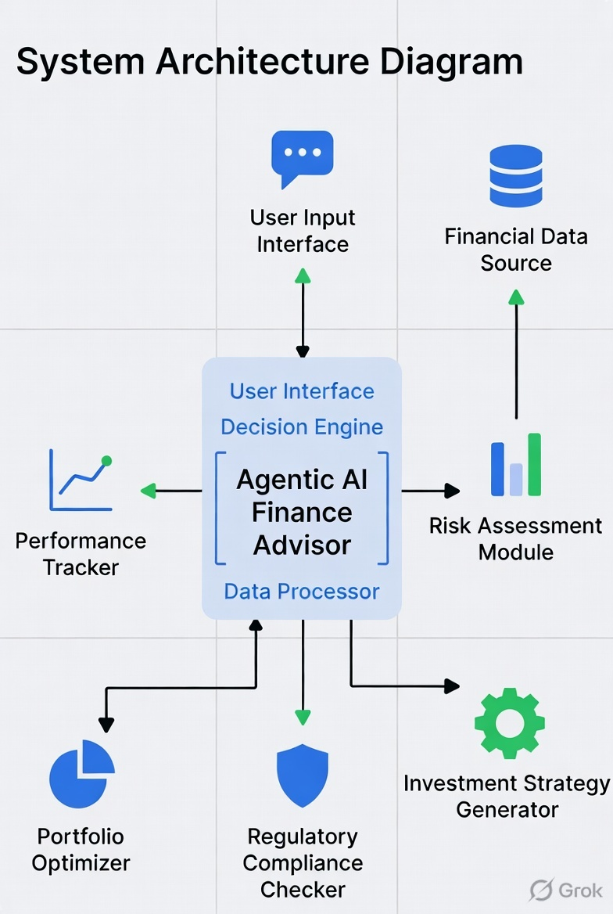

- Workflow Diagram
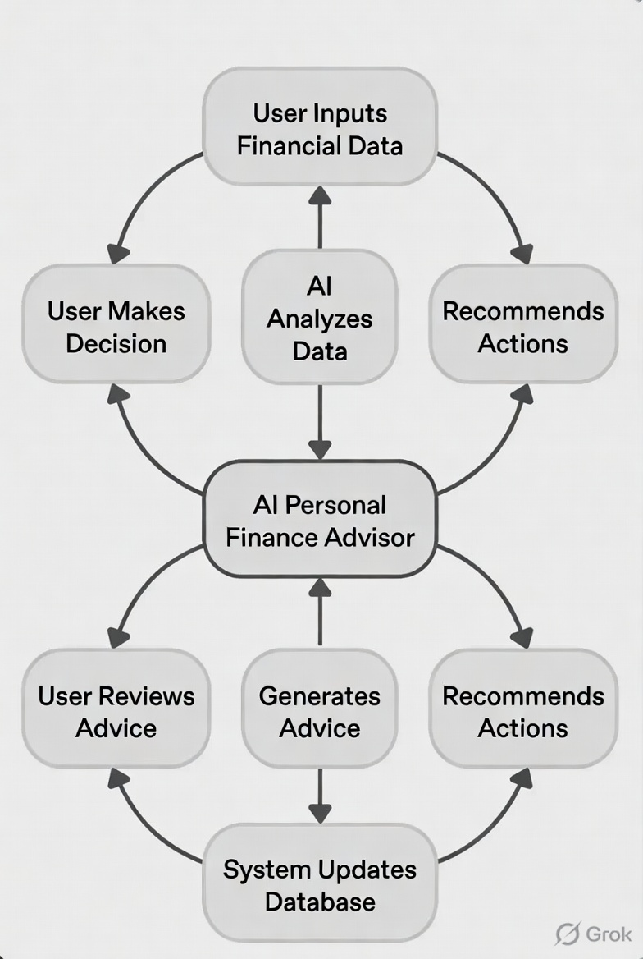

- ER Diagram
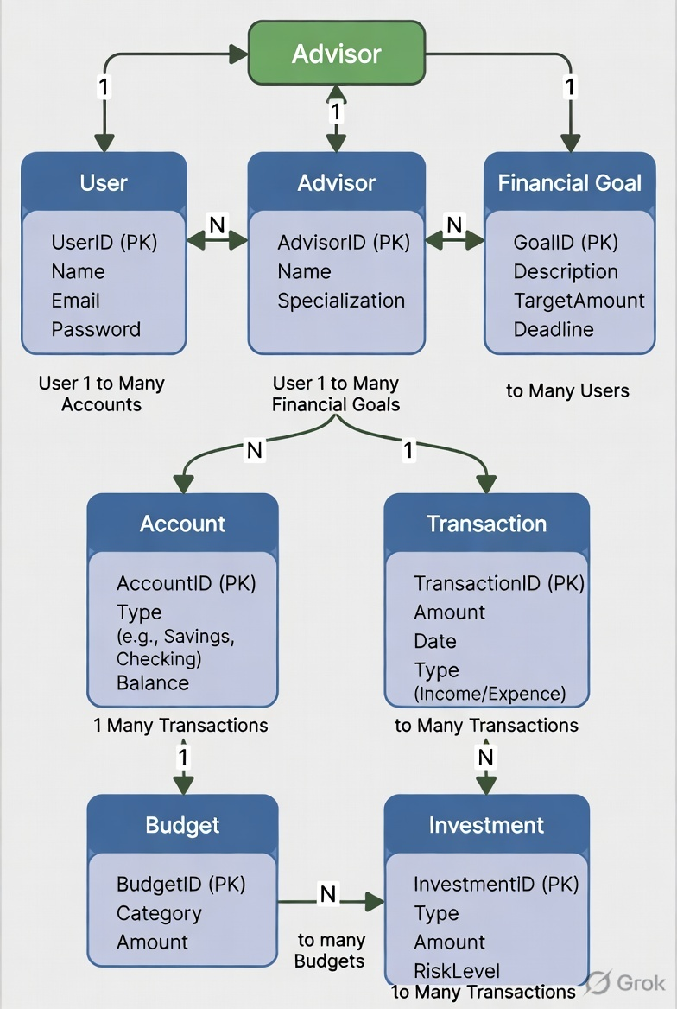

6.2 Hardware/Software Designing
Hardware Requirements:
- Processor: Intel i5 / AMD Ryzen 5 or higher
- RAM: 8 GB or more
- Storage: 256 GB SSD
Software Requirements:
- Operating System: Windows 10/11 or Linux
- Frontend: React.js
- Backend: Python with Flask/FastAPI
- Agent Framework: LangChain or CrewAI
- Database: MongoDB / MySQL
- ML Libraries: Scikit-learn, Pandas, NumPy

7. Applications
- Personal finance management for students and professionals
- Family budget planning and monitoring
- Financial education and awareness tool
- Small business expense tracking
- Future integration with banking and investment platforms

REFERENCES
- “Artificial Intelligence in Personal Finance Management” – IEEE Papers
- “Multi-Agent Systems in Financial Decision Support” – ResearchGate
- LangChain Documentation for Building Agentic Applications
- “Machine Learning Approaches for Expense Prediction” – Various journals
- Official documentation of Scikit-learn, CrewAI, and Flask

Guided By:
Prof. Manish Vyas
Group Members:
- Aditi Rajput (0827CD231004)
- Avani Malviya (0827CD231013)
- Dhruv Dekhane (0827CD231026)
- Mahi Ishwe (0827CD231047)
Project Incharge
Prof. Manish Vyas

