Name : Dhruv Dhabalia

SRN: 202101281

Roll: 27

Subject : OS Lab

Div: E

Assignment- 01

1. Change password:

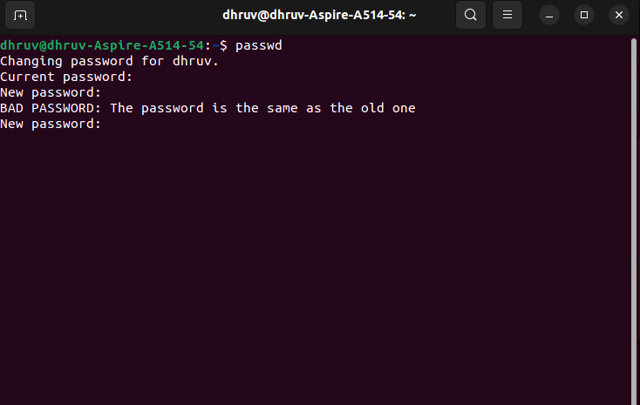

2. **Display system date**

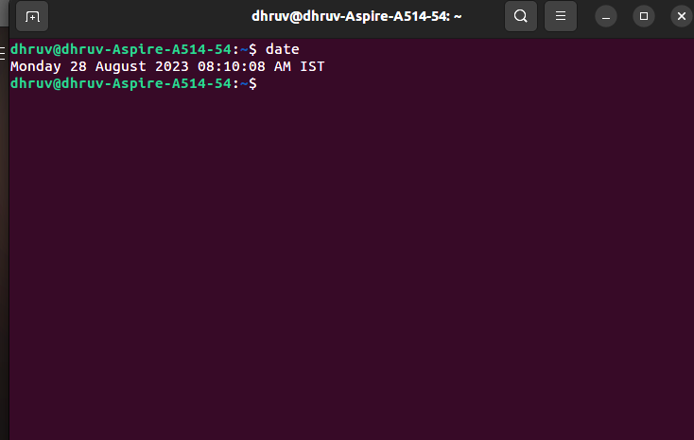

**3] Count number of lines of the file**

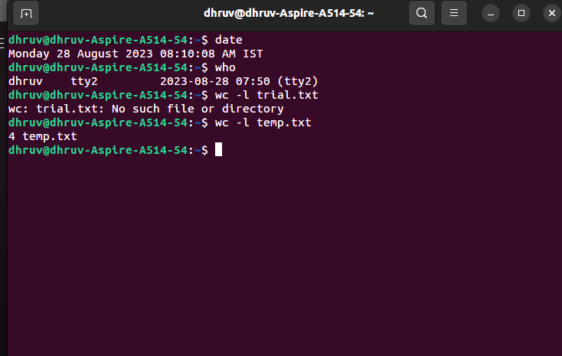

**4] Find out who else is on the system**

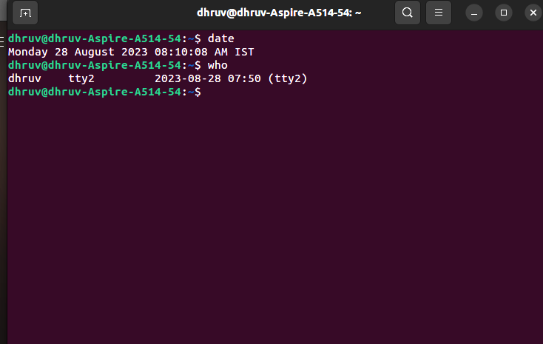

**5] Direct the output of the man page for the date command to a file named as mydate**

**man date > mydate.txt**

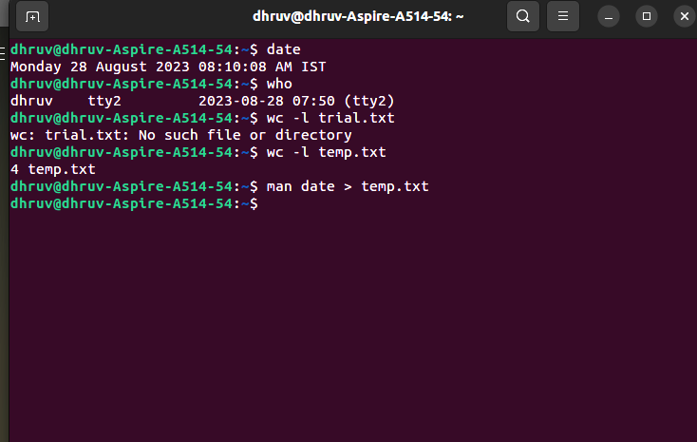

**6] Create a subdirectory**

**mkdir os_lab**

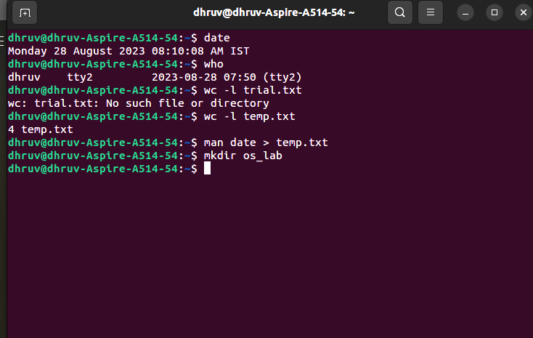

**7] Move mydate into subdirectory into mydir**

**mv mydate.txt mydir**

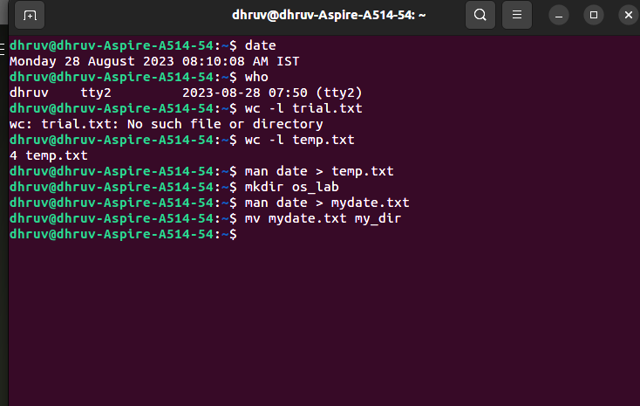

**8] Go to subdirectory mydir and copy file from mydate to new file Ourdate**

Cd mydir

**Cp mydate.txt ourdate.txt**

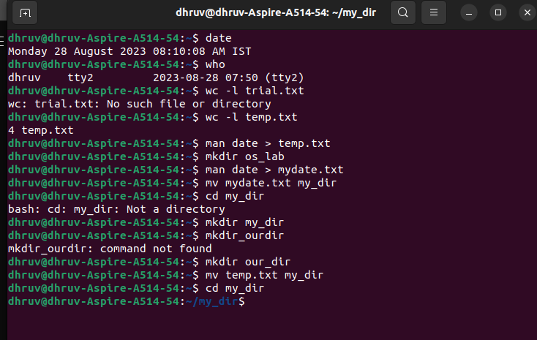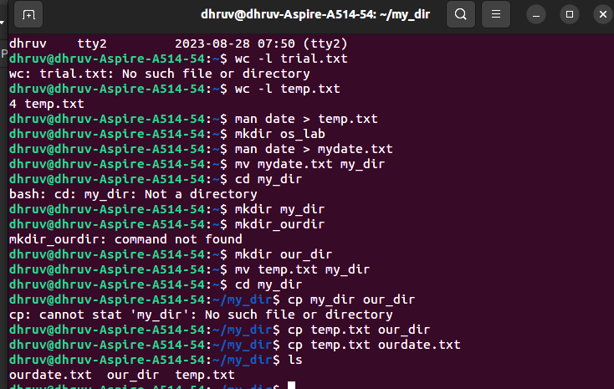

**9] List the content of mydir**

**Ls**



**10] Do a long listing of the file ourdate and note the permission**

**Ls -l ourdate.txt**



**11] Display the name of current directory starting from root**

**Pwd**



**12] List all the files on the home directory**

Cd ..

**Ls**

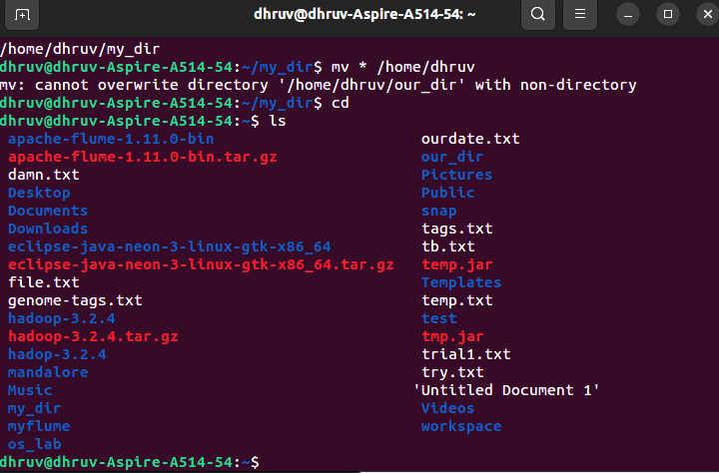

**13] Find first 5 lines of mydate**

**head -n 5 mydate.txt**

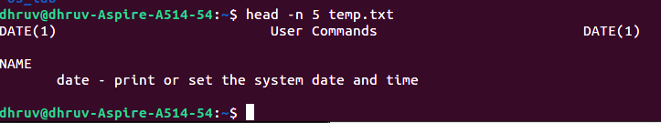

**14] Display last 10 lines**

**tail -n 10 mydate.txt**

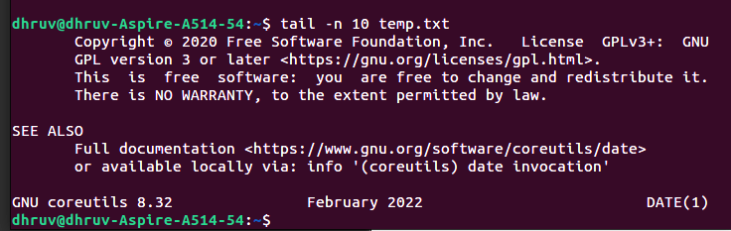

**15] Remove the directory mydir**

**rmdir mydir**



**16] Redefine the output of long listing of a directory to file named list**

**ls -l > list.txt**



**17] Select any 5 capitals of India and enter them into file capital1**

**cat capital1.txt**

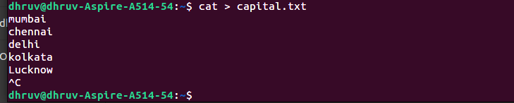

**1 8 ] Create another file capital2 write other 5 capitals . Then create a third file named capital 3**

**cat > capital2.txt**



Cat > capital3.txt

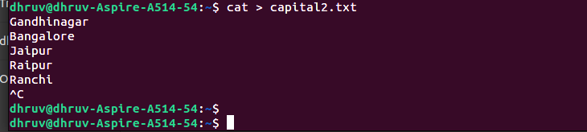

**19] CONCATENATE THE 3 FILES AND REDIRECT OUTPUT IN CAPITAL.TXT**



**20] READ CONTENTS OF FILE CAPITAL AND COUNT NUMBER OF LINES**

cat capital.txt

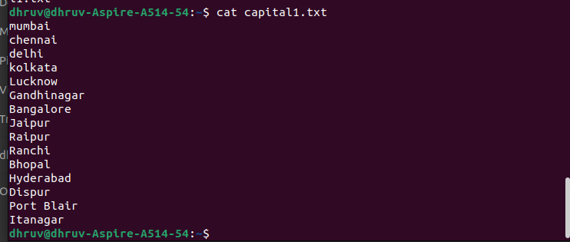

**wc –l capital1.txt**



**21] GIVE READ AND WRITE PERMISSON TO ALL THE USERS FOR THE FILE CAPITAL**

chmod +rw capital.txt

