T. Y. B. Tech (Electrical and Computer)

Name: Dhruv Gadge

Roll No: 1032221588

Exp Title: **SmartDash – Real-Time Accident Detection and Video Logging Using React Native and Expo**

# Aim:

To develop a smart dashcam app using React Native and Expo that detects vehicle impacts, records driving footage, and uploads accident-related video clips to Google Cloud Storage.

# Objective:

- To build a mobile dashcam that continuously records video during a drive.  
- To detect collisions using mobile sensors and extract the relevant video.  
- To automatically store critical video evidence to cloud storage for retrieval.

# Components Required:

- Smartphone with React Native support  
- Expo framework  
- React Native Camera / Expo Camera  
- Google Firebase or Google Cloud Storage  
- Accelerometer (via expo-sensors)  
- JavaScript-compatible development environment (e.g., VS Code)

# Theory:

The SmartDash app is based on the principle of proactive accident documentation. By using mobile sensors to detect impacts, the app triggers video clipping and uploads the relevant segment to the cloud. This prevents data loss and ensures timely backup of critical footage. It represents a smart, low-cost alternative to physical dashcams using the user's own smartphone.

# Procedure:

1. Install Node.js, Expo CLI, and initialize a new React Native project.  
2. Integrate expo-camera and expo-sensors into the app.  
3. Begin continuous video recording on app start.  
4. Use accelerometer to detect sudden deceleration/impact.  
5. When an impact is detected, clip the last 1 minute of video.  
6. Upload the clipped file to Google Cloud Storage.  
7. Test with sudden motion simulation and validate cloud upload.

# Observations:

- Normal driving triggers continuous video recording.  
- Impact detection threshold accurately clips footage.  
- Cloud upload completes successfully within 5–10 seconds.  
- Older videos are discarded or overwritten to conserve space.

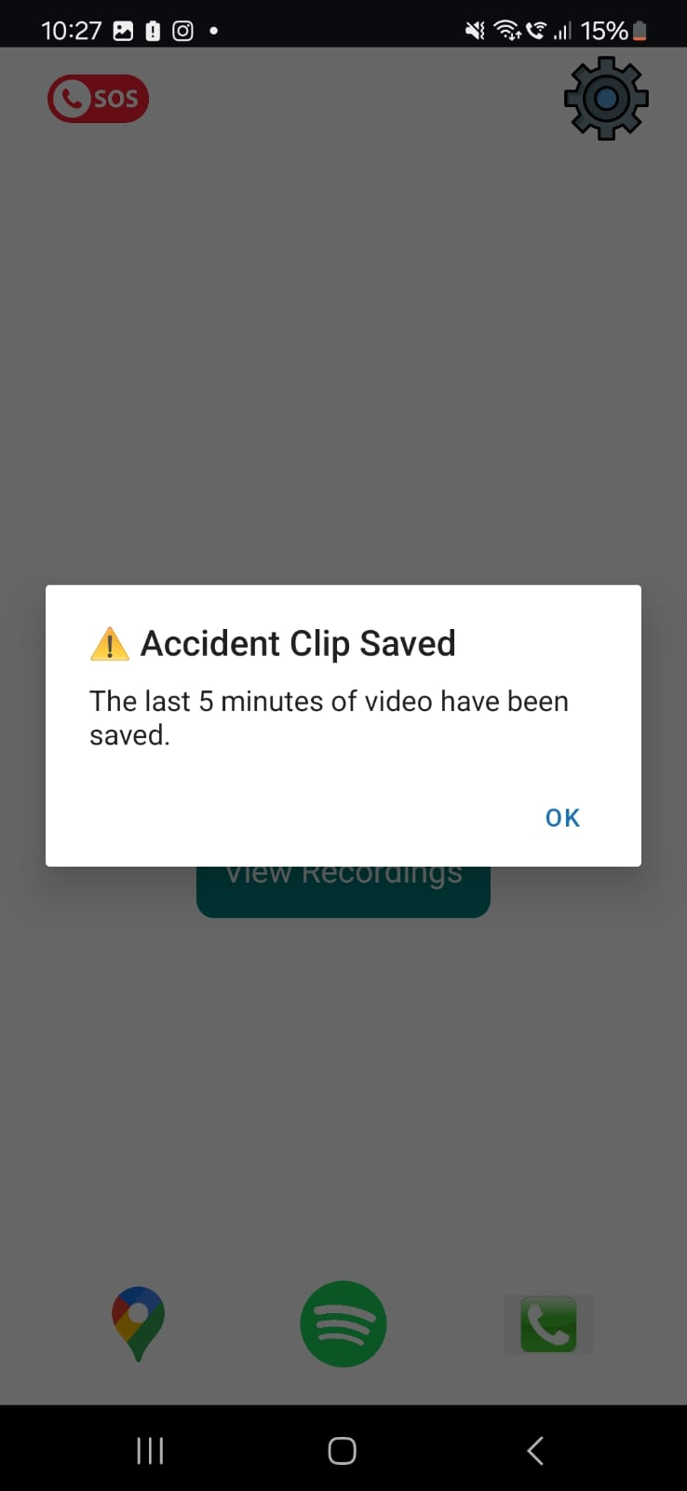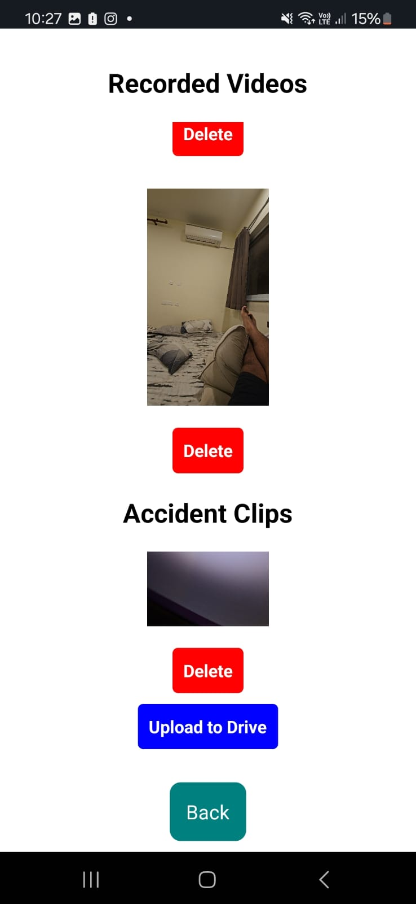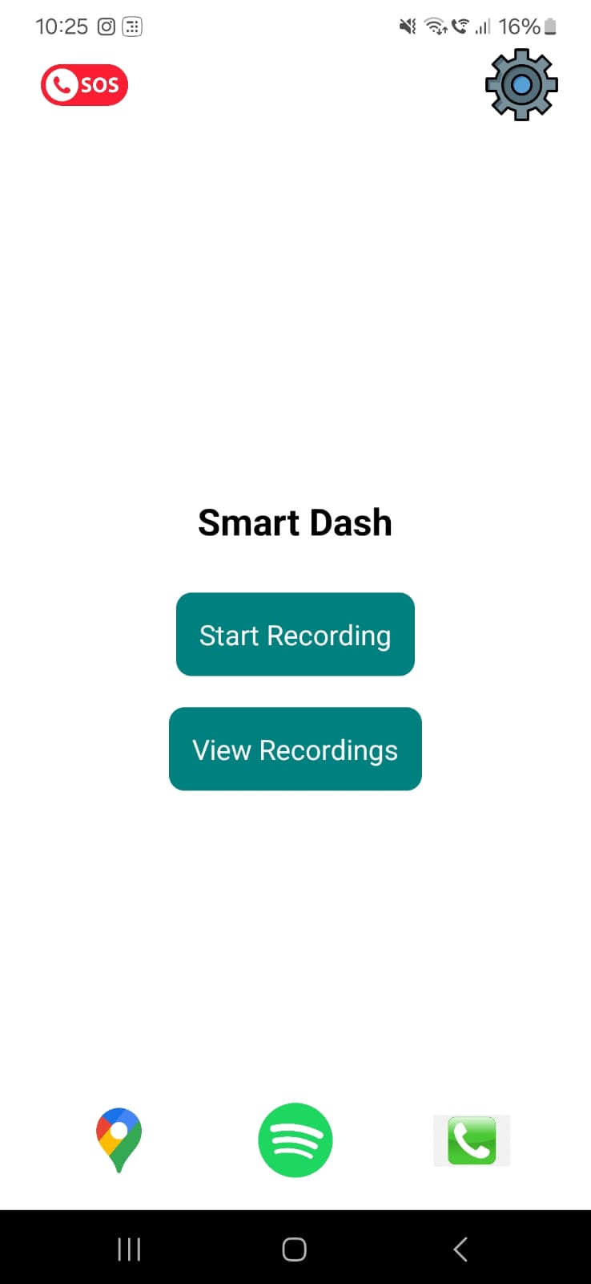

# 

# Conclusion:

The SmartDash app successfully demonstrates real-time video recording, accident detection using mobile sensors, and automatic cloud upload of event data. It shows potential as a safety-focused mobile solution for intelligent transport systems.