**YoloV5 VS YoloR**

* Dataset

1. Source <https://public.roboflow.com/object-detection/bccd/>
2. Class Distribution

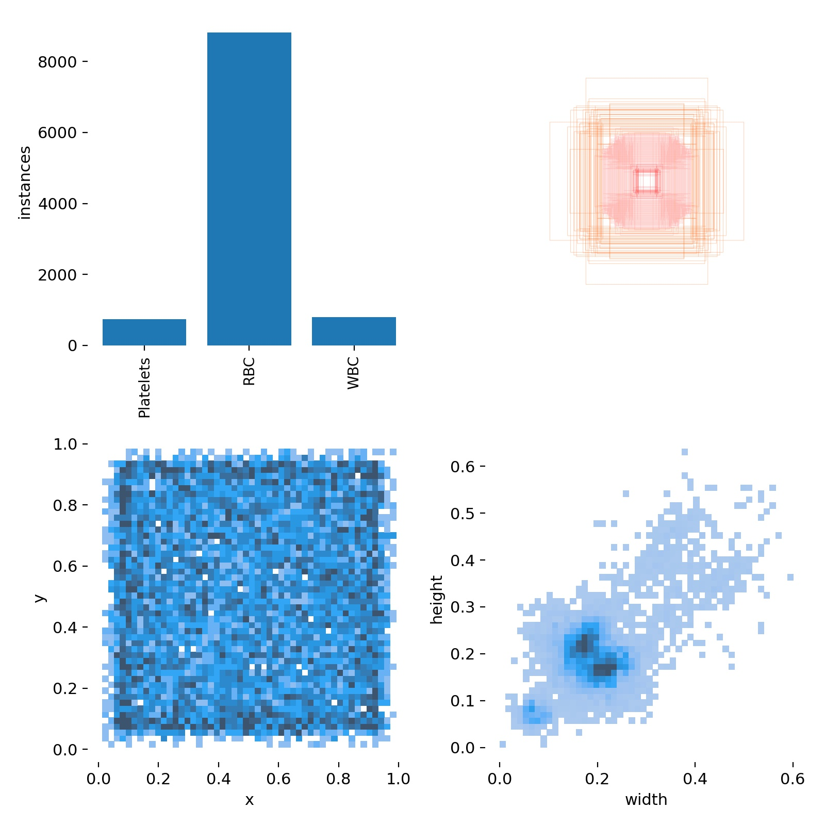

* Basic Hyperparameters:

| Batch Size | 8 |
| --- | --- |
| Learning Rate | 0.01 |
| Epochs | 50 |
| Momentum | 0.937 |
| weight_decay | 0.0005 |

* Performance:

| **Parameters** | **YoloV5 Small** | **YoloR** |
| --- | --- | --- |
| MAP [.5 IOU] | 0.915 | 0.89 |
| MAP [.5:.95 IOU] | 0.62 | 0.6 |
| Time Consumed | 0.8 Hr | 1.2 Hr |
| Analysis | Better performance on test dataset though having almost same MAP as YoloR | Inference has more traits of False Negatives |