YoloV5 VS YoloR

- Dataset
- Source https://public.roboflow.com/object-detection/bccd/

- Class Distribution

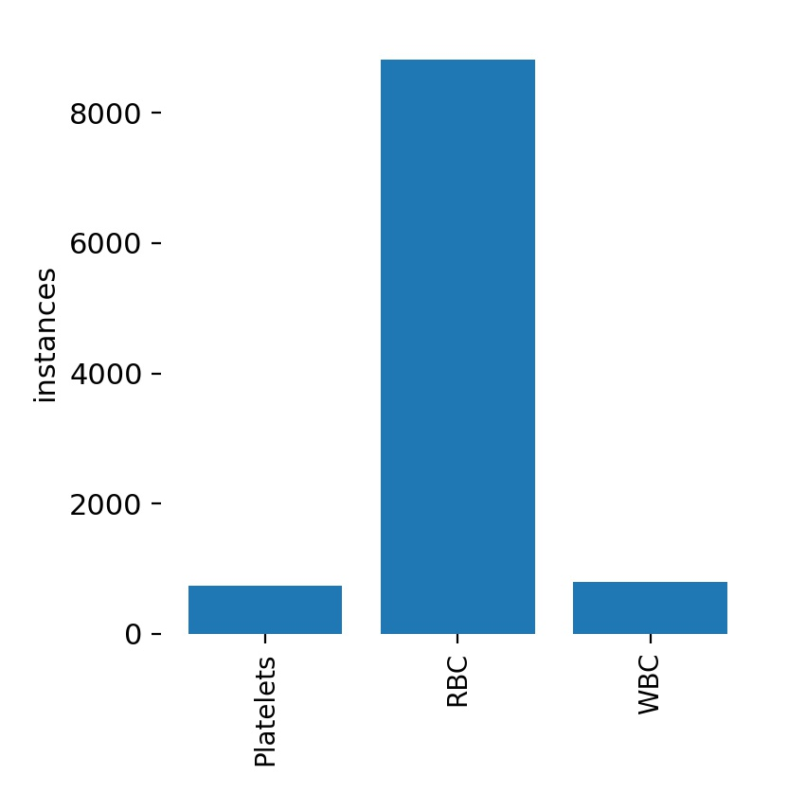

- Basic Hyperparameters:

Batch Size | 8
Learning Rate | 0.01
Epochs | 50
Momentum | 0.937
weight_decay | 0.0005

- Performance:

Parameters | YoloV5 Small | YoloR
MAP [.5 IOU] | 0.915 | 0.89
MAP [.5:.95 IOU] | 0.62 | 0.6
Time Consumed | 0.8 Hr | 1.2 Hr
Analysis | Better performance on test dataset though having almost same MAP as YoloR | Inference has more traits of False Negatives

