Software Requirements Specifications

Version - 1

1 February 2022

Project Name: [chotu.com](http://chotu.com)

Team Name: DASS Team 34

Team Members

Siddik Ayyappa

Poorvaja Banala

Abhijnan Vegi

Dhruv Hirpara

Brief Problem Statement

During the COVID lockdown, many gated communities started to aggregate their essential needs (vegetables, fruits, bakery, dry fruits, snacks, etc.) and invited the respected vendors into the community to deliver the products. Although this is a decent method, it is not highly efficient and meticulous. “Chotu” based on the principle “Together, we gain” aims to be a one-stop application for residents of the same gated community to accumulate their product needs while buying from vendors located in the vicinity of their community. As a result, Chotu promotes buying in bulk, thus leading to potential cashback for the customer, reduced physical interactions for delivery during the COVID era, and the vendors receiving pooled orders from a community rather than inefficiently catering to the needs of a customer individually.

Additional Details

‘Chotu’ take advantage of the following details:

* Different people from the same community should buy together with possible incentives as a ​discount on the total billing amount (or a cashback)​ , reduced instances of entry of delivery personnel (especially during this COVID era), etc on the consumer end. On the seller's end, incentives include knowing about orders well in advance, getting orders in bulk, ​cutting down on the costs of logistics ​, etc.
* The aim is to pool orders from a gated community and place them with a neighborhood shopkeeper, who would then drop off the orders at one point in the community to ​minimize physical interaction​.
* Providing small-time businessmen to participate in the big game.
* The current system followed by most communities (circulating orders via WhatsApp, Google Sheets, etc) has many disadvantages like lack of facility to edit orders, lack of a system to hold customers accountable for the order they  
  make lack of a proper presentation of the orders to the vendor, etc.
* Chotu is meant to serve the needs of people living in a community only. ​People not living in communities won’t be able to avail the benefits of Chotu.
* **Eg:** ​ Let's say Person P living in community C wants to buy products P1, P2, P3 from a vendor V on the Chotu app. Let the original total cost = cost of P1 + cost of P2 + cost of P3 = Rs 1000. Now, if the total billing amount of the community crosses a predetermined amount (let’s say Rs 50,000), then person P will become eligible for a discount of Rs 200 on his purchase.  
  **Case 1: Community target achieved**  
  In this case, person P would have to pay Rs 100 at the time of booking and Rs [(1000-200)-100]= Rs 700 at the time of delivery to the delivery boy.  
  **Case 2: Community target isn’t achieved**  
  In this case, person P would have to pay Rs 100 at the time of booking and Rs [(1000-0)-100] = Rs 900 at the time of delivery to the delivery boy.

System Requirements

1. The application is built for Android and iOS.
2. The base project is based on “**React Native**”
3. Each captain has his/her profile, which can be edited by themselves, and they can also choose the people they would want to do business with.
4. The hosting platform of the application is AWS.

Skills Required

1. React-Native
2. MERN stack
3. HTML, CSS, JS, and React for the frontend part
4. Some basic understanding of WordPress.

Describing the Concept of the application

The application is a companion to the application present right now. It helps the vendor, in this case, referred to as “**captain**”. It helps him take care of his business, by maintaining a track of deliveries,  payments. The Application will also help the captain to change his profile easily.

There are 3 things we have to first know. The localities, Vendors. The Vendors, include the people who sell. The individual sellers, are the people we refer to as **captains**. The localities are the group of people who can do purchases and they are the people to whom the goods are delivered to.

The application is the connection between the Captains and the Localities. The captains are the users of the application.

The deliveries are identified by their PINS (the concept has not yet been explained to the team yet.)

Users Profile

The one and only class of users that would be using the application are called as captain. As decided on (31st January 2022).

Authentication:

The authentication shall be done with the mobile number and a PIN combination. As of the latest discussions the PIN was asked to be set to some default value (1234).

Feature Requirements

| [S.no](http://S.no) | User Case Name | Description | Release |
| --- | --- | --- | --- |
| 1 | Clicking on the Delivery Module Button in the home screen | The homepage shall contain many buttons, and one of them is the delivery module button. Clicking on it would lead to a screen which has a list of Entities, each with a unique combination of Brand_name and Date | R1 |
| 2 | Clicking on the Brand-Date entity | The Delivery page shall contain a list of entities. Upon clicking on them we shall be lead to a new page of list of Locality Entities. | R1 |
| 3 | Clicking on the locality entity | Clicking on the locality entity, we shall be directed to a new page which shall contain users. Meaning we would be lead to a list of users, who have a package delivery in the locality, on the given date, from the given brand. | R1 |
| 4 | Editing the profile of the captain | We shall give the captain an option to edit his profile, supposedly through a form, which the user shall be directed to after clicking a button on the Navigation bar. | R1 |
| 5 | Logging In | This page shall send the authentication data to the backend for verification once the user prompts. | R1 |
| 6 | Clicking the Kathabook button | The use shall be directed to the Khathabook page after clicking clicking on the Khathabook button in the homepage | R1 |
| 7 | Invoice screen | The captain enters the total price on the invoice which is sent to the customer via whatsapp | R1 |
| 8 | URL Shortener | Creates a shortened URL for buying from a brand in a particular locality for the captain to share. | R2 |

Use Case diagram

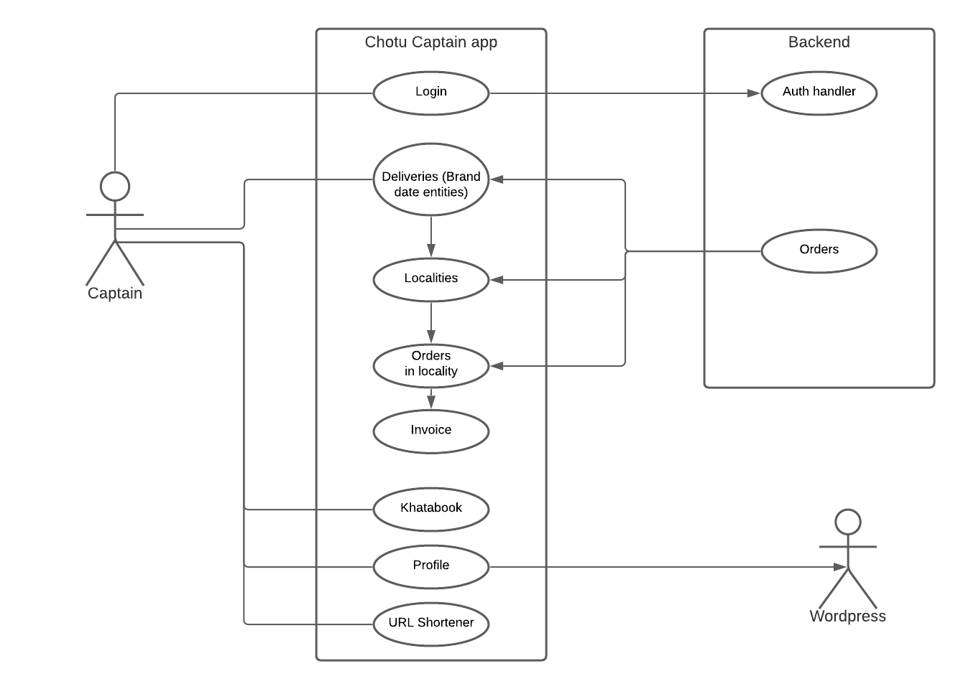

Use case Description(s)

|  |  |
| --- | --- |
| Use Case Number | UC-1 |
| Use Case Name | Clicking on the Delivery Module Button in the Home screen |
| Overview | The homepage shall contain many buttons, and one of them is the delivery module button. Clicking on it would lead to a screen which has a list of Entities, each with a unique combination of Brand_name and Date |
| Actors | Captain |
| Precondition | The user must be in the home page. |
| Flow | 1. The user shall click on the button. (The user must already be logged in.) 2. The user shall be lead to the new-page with the data. 3. There is no input and output to the operation. |
| Alternate Flows | NA |
| Post Condition | The user shall be in the delivery module page level - 1. |

|  |  |
| --- | --- |
| Use Case Number | UC-2 |
| Use Case Name | Clicking on the brand-date entity |
| Overview | The Delivery page shall contain a list of entities. Upon clicking on them we shall be lead to a new page of list of Locality Entities. |
| Actors | Captain |
| Precondition | The user must be in the delivery page’s first level. |
| Flow | 1. The user shall click on the button. (The user must already be delivery page level - 1.) 2. The user shall be lead to the new-page with the data specified in overview. 3. There is no input and output to the operation. |
| Alternate Flows | NA |
| Post Condition | The user shall be in the delivery module page’s level - 2. |

|  |  |
| --- | --- |
| Use Case Number | UC-3 |
| Use Case Name | Clicking on the locality entity |
| Overview | Clicking on the locality entity, we shall be directed to a new page which shall contain users. Meaning we would be lead to a list of users, who have a package delivery in the locality, on the given date, from the given brand. |
| Actors | Captain |
| Precondition | The user must be in the delivery page’s second level. |
| Flow | 1. The user shall click on the button. (The user must already be delivery page level - 2.) 2. The user shall be lead to the new-page with the data specified in overview. 3. There is no input and output to the operation. |
| Alternate Flows | NA |
| Post Condition | The user shall be in the delivery module page’s level - 3. |

|  |  |
| --- | --- |
| Use Case Number | UC-4 |
| Use Case Name | Editing the profile of the captain |
| Overview | We shall give the captain an option to edit his profile, supposedly through a form, which the user shall be directed to after clicking a button on the Navigation bar. |
| Actors | Captain |
| Precondition | The user must be in the home page. |
| Flow | 1. The user shall click on the button. (The user must already be delivery page level - 3.) 2. The user shall be lead to the new-page with the data specified in overview. 3. The input form which contains the user’s new details is the only input to the operation |
| Alternate Flows | Flow - 1  1. The user may decide not to edit the profile, and might hit cancel, or back button. Then would be directed to the page the user was in previously. |
| Post Condition | The user shall be in the page he/she was in previously. |

|  |  |
| --- | --- |
| Use Case Number | UC-5 |
| Use Case Name | Logging In |
| Overview | This page shall send the authentication data to the backend for verification once the user prompts. |
| Actors | Captain |
| Precondition | NA |
| Flow | 1. The user clicks the button for Login 2. The data from the Login form is sent to the backend 3. if(verified) → Sent to Homepage |
| Alternate Flows | There could be issue in the server or maybe the authentication could be unsuccessful. Then the user is directed to the Login page with an error message display. |
| Post Condition | Depending upon the situation, the user may end up in the homepage or the Login page with an error message. |

|  |  |
| --- | --- |
| Use Case Number | UC-6 |
| Use Case Name | Clicking the Khatabook button in the homepage |
| Overview | The use shall be directed to the Khathabook page after clicking clicking on the Khathabook button in the homepage |
| Actors | Captain |
| Precondition | The user must be in the homepage, already logged in. |
| Flow | 1. The user clicks the button for Khathabook in the homepage 2. The user shall be lead to the Khatabook interface. |
| Alternate Flows | NA |
| Post Condition | The user shall be in the Khatabook screen. |

|  |  |
| --- | --- |
| Use Case Number | UC-7 |
| Use Case Name | Invoice screen |
| Overview | The captain enters the total price on the invoice which is sent to the customer via whatsapp |
| Actors | Captain |
| Precondition | The user must be in delivery module’s page level 3. |
| Flow | 1. Thus user clicks on an order entity 2. The user enter the total price on the invoice 3. The users send a message via Whatsapp |
| Alternate Flows | NA |
| Post Condition | The user shall be in delivery module’s page level 3 |

|  |  |
| --- | --- |
| Use Case Number | UC-8 |
| Use Case Name | URL Shortener |
| Overview | Creates a shortened URL for buying from a brand in a particular locality for the captain to share. |
| Actors | Captain |
| Precondition | The user must be in the homepage, already logged in. |
| Flow | 1. The user clicks the button for URL Shortener button on home screen 2. Selects a brand, locality and delivery date. 3. Shares the generated URL |
| Alternate Flows | NA |
| Post Condition | The user shall be in the homepage |