1.PROJECT PROFILE

Project Profile : | Swift chat
Objective: | The objectives of a Real-Time Chat App Web Application are to enable instant, secure, and scalable messaging with a user-friendly interface, supporting features like multi-user chats, notifications, and file sharing while ensuring cross-platform compatibility and future-readiness.
Platform of Application: | Website
Front End Tool: | React.js
Back End Tool: | node.js, Express.js, Socket.io, MongoDB
Project Duration : | 90 Days
Internal Project Guide : | Ms. Kimi Modi
Submitted By : | Jansari Dhruvkumar Jitendrakumar :-22082221016  Patel Khushkumar Shaileshbhai :-22082221059
Submitted To : | Department Of Computer Science [ B.sc ca&it - 6 ]

2. EXISTING SYSTEM

- Limited Communication Methods -Traditional communication relies on letters, emails, and in-person conversations.

- Slow Information Exchange – These methods take time to deliver messages, causing delays.

- Inefficiency in Real-Time Interaction – They are not suitable for instant communication.

- Lack of Accessibility – Physical letters require postage, and emails may not be checked frequently.

3. NEED FOR NEW SYSTEM

- There is a growing need for a modern chat application to improve communication.

- Instant, real-time messaging can revolutionize how people interact.

- Faster and more efficient communication helps in both personal and professional settings.

- A new chat system should be accessible to everyone globally.

4. FUNCTIONAL SPECIFICATION

4.1 USER OF THE SYSTEM

User :-

- Register and log in to the system.
- Send and receive real-time messages.
- Share files like images.
- Customize their profile.
- View message history and search for specific messages.
- Create channels and chat with multiple users.
- Chat with AI to get information and responses.
- Users can share text posts globally across the website.
- They can also manage their posts and use like or dislike features.

4.2 MODULE OF THE SYSTEM

- Registration :-
The user can register on the website.

- Login:-
The user and admin can login on the website.

- Manage Profile:-
User can manage their own profile.

- Manage chats:-
User can manage his own chats with others.

- Manage Channels :-
Users can create channels with multiple users and chat with them at the same time.

- Chat with AI :-
Users can receive AI-generated responses based on their queries.

- Post :- Users can create and manage posts that are shared globally and visible to all users in their contacts.

5. SYSTEM REQUIREMENT

5.1 MINIMUM SOFTWARE REQUIREMENT

Server Side Requirement
Operating System | Window Server 2003 or Any Compatible Server OS
Web Server | Node.js with Express.js
Front-End Tools | React.js (React 18)
Back-End Tool | Node.js, Express.js, Socket.io, MongoDB

Client Side Requirement
Operating System | Window XP or Any Compatible OS
Web Browser | Google Chrome or Any Compatible Browser

5.2 MINIMUM HARDWARE REQUIREMENT

Server Side Requirement
Processor | 3.0 GHz or higher
RAM | 8GB
Hard disk | 50GB SSD

Client Side Requirement
Processor | 2.5 GHz or higher
RAM | 4GB
Hard disk | 20GB free space

6. SYSTEM FLOWCHART

start
Have
an account
Want to join Other Chat
Logout
End
Login
signup
Join chat interface
Join channel
Yes
No
Yes
Join Post
No
Join chat
Join AI bot

7. ER-DIAGRAM

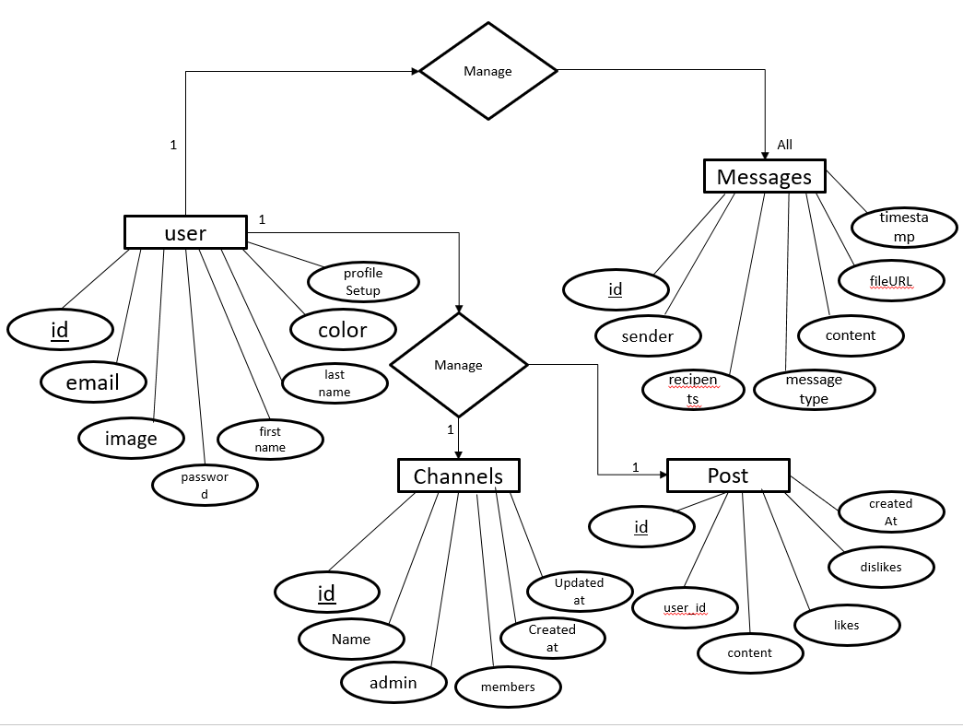

8. DATAFLOW DIAGRAM

8.1 ZERO LEVEL DFD

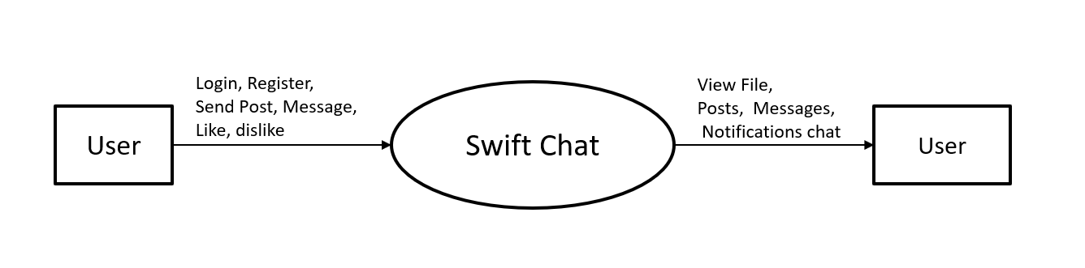

8.2 FIRST LEVEL DFD

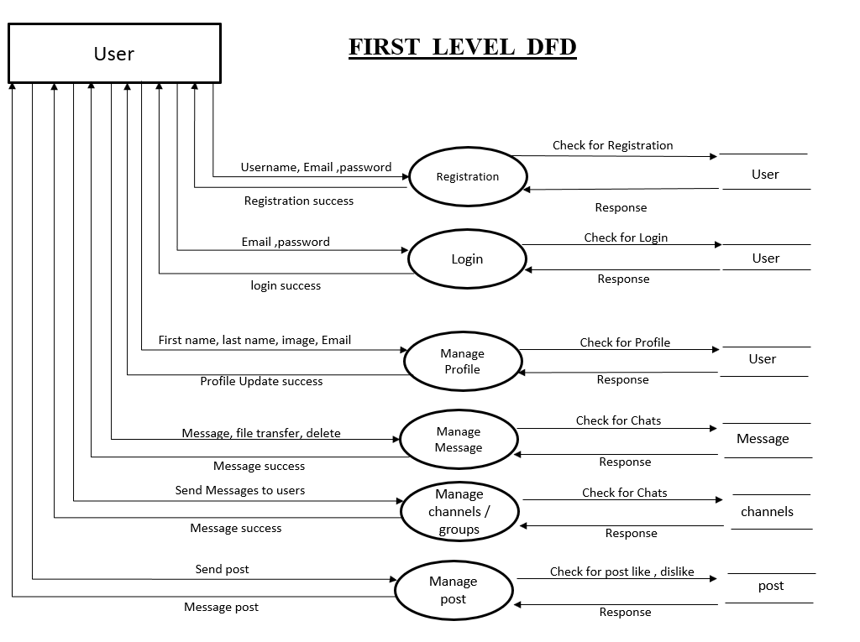

9. DATA DICTIONARY

- User
Table Name : - | Users
Primary Key : - | Id
Foreign Key : - | -
Description : - | To store user information

Sr. No | Field Name | Data Type  (Size) | Constraint | Description | Sample Data
1 | id | object | Primary key | Store Primary key | 5654fgcfc4dx89g4
2 | email | string | Required | Store email | raja@gmail.com
3 | password | string | Required | store password | Raj@956
4 | firstname | string | Required | store First Name | Patel
5 | lastname | string | Required | Store Last Name | Raj
6 | image | string | Required | Store image | user_img.jpg
7 | colour | number | Required | Store Colour | 3
8 | profile setup | Boolean | Required | Store Profile setup | true

2. Messages

Table Name : - | Messages
Primary Key : - | Id
Foreign Key : - | -
Description : - | To store user information

Sr. No | Field Name | Data Type  (Size) | Constraint | Description | Sample Data
1 | id | object | Primary Key | Store id | 56164421497121
2 | sender | object | Required | Store object id of sender | 587468j6848615
3 | recipient | object | Required | Store object id of recipient | 1654685168h546
4 | messageType | string | Required | Store message type | text
5 | content | string | Required | Store message content | Hello!
6 | fileUrl | string | Required | Store fileurl | Upload/files/img.png
7 | timeStamp | date | Required | Store date and time | 2024-07-06T14:50:13

- Channels

Table Name : - | Users
Primary Key : - | Id
Foreign Key : - | -
Description : - | To store user information

Sr. No | Field name | Data Type  (Size) | Constraint | Description | Sample Data
1 | id | object | Primary key | Store Primary key | 5654fgcfc4dx89g4
2 | name | string | Required | Store name | Raja
3 | admin | object | Required | Store channel admin id | 67d91940a172460ea797dcf8
4 | members | object | Required | store members id | a172460ea797dcf867d91940
5 | messages | object | Required | Store messages | Hello
6 | createdAt | Date | - | Store date | 2025-03-18T06:03:48.946
6\7 | updatedAt | Date | - | Store date | 2025-03-18T06:03:48.946

- Post

Table Name : - | Post
Primary Key : - | Id
Foreign Key : - | user_id
Description : - | To store post information

Sr. No | Field Name | Data Type  (Size) | Constraint | Description | Sample Data
1 | Id | Object | Primary key | Store Primary key | 5654fgcfc4dx89g4
2 | user_id | Object | Foreign Key | Store id | 56164421497121
3 | Content | String | Required | Store Content of posts | XYZ…
4 | Likes | object_id | Required | Store Likes count | 1000
5 | disLikes | object_id | Required | Store DisLikes count | 50
6 | createAt | Date | Required | Store post date | 10/04/2025

10. OUTPUT DESIGN

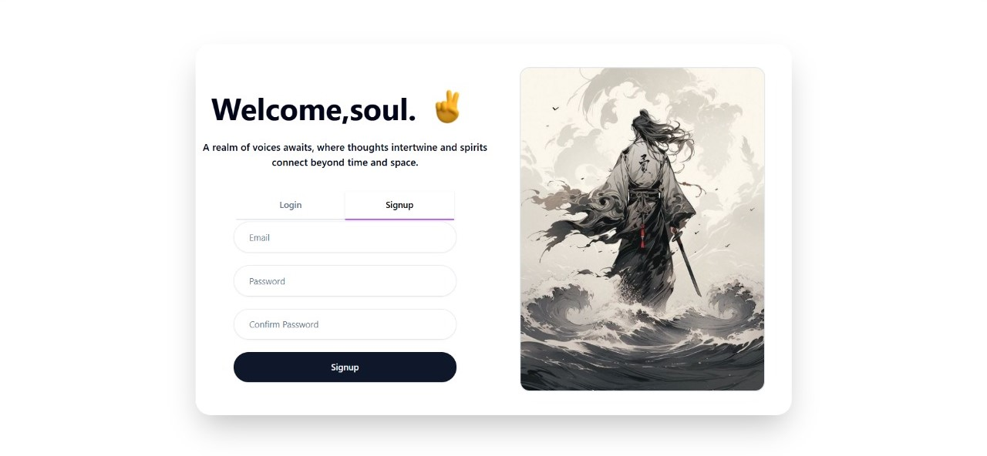

Signup page :- A page where users can create an account to access the website.

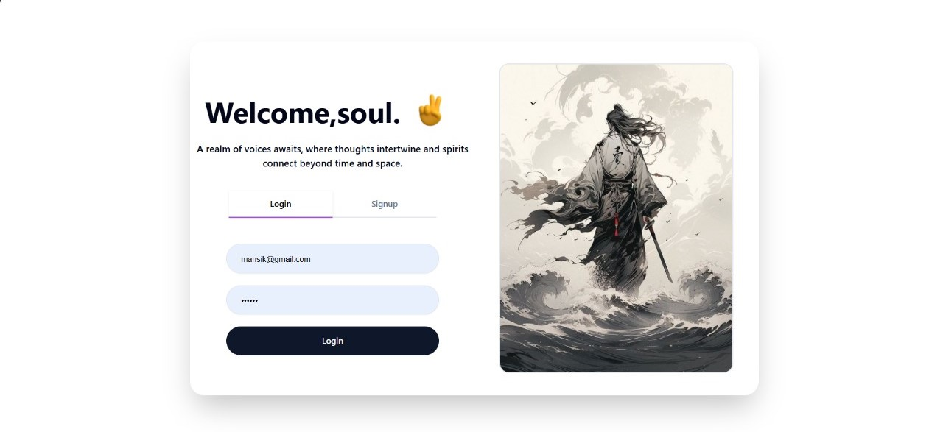

Login page :- A page where users can log in to access the website.

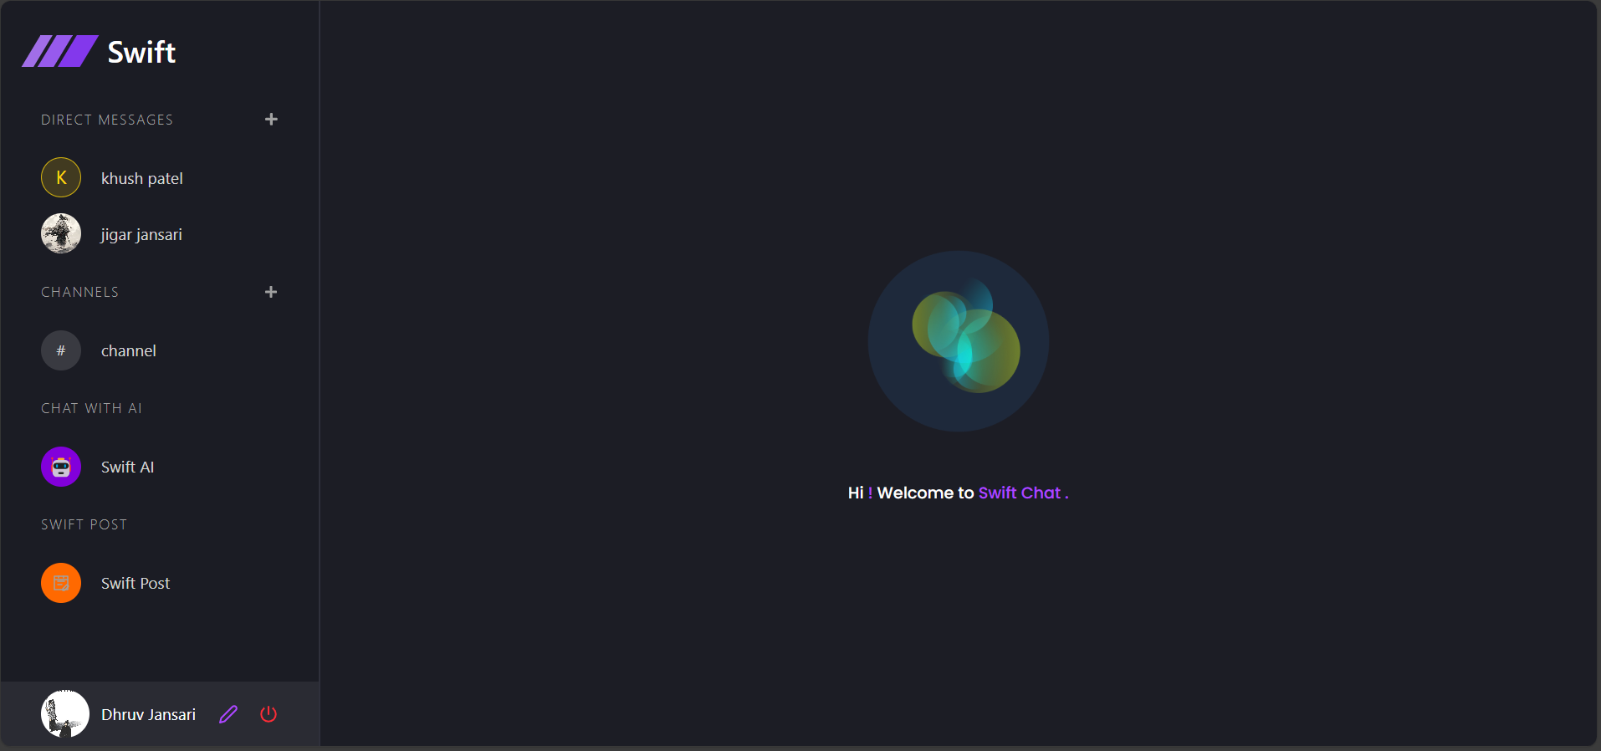

Website Interface

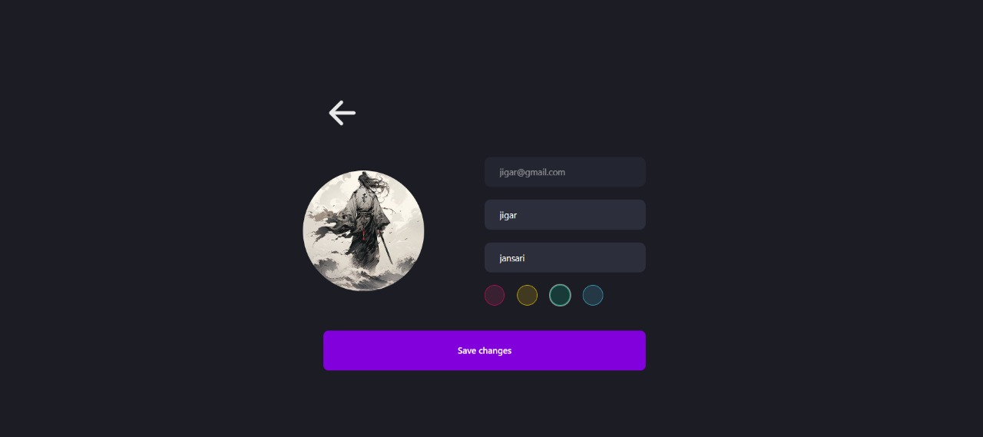

Profile Update Page :- A page where users can update their profile information.

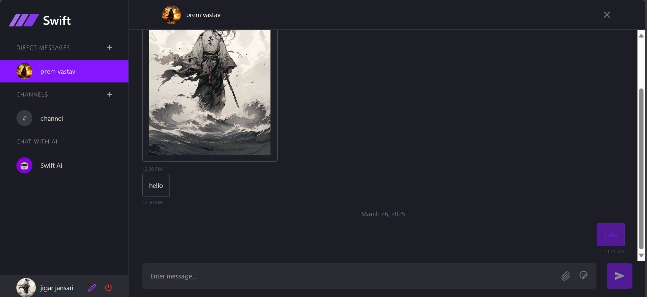

Chat Container :- A section where users can send and receive messages in real-time.

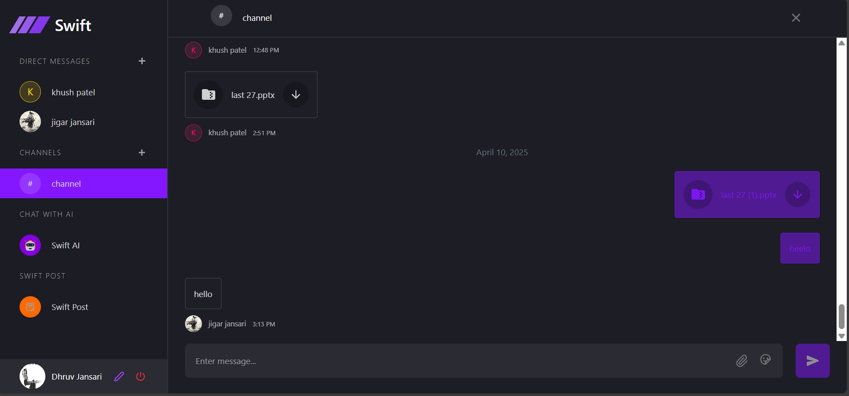

Channel Container :- A section where users can send messages to multiple users and receive messages from them in real-time.

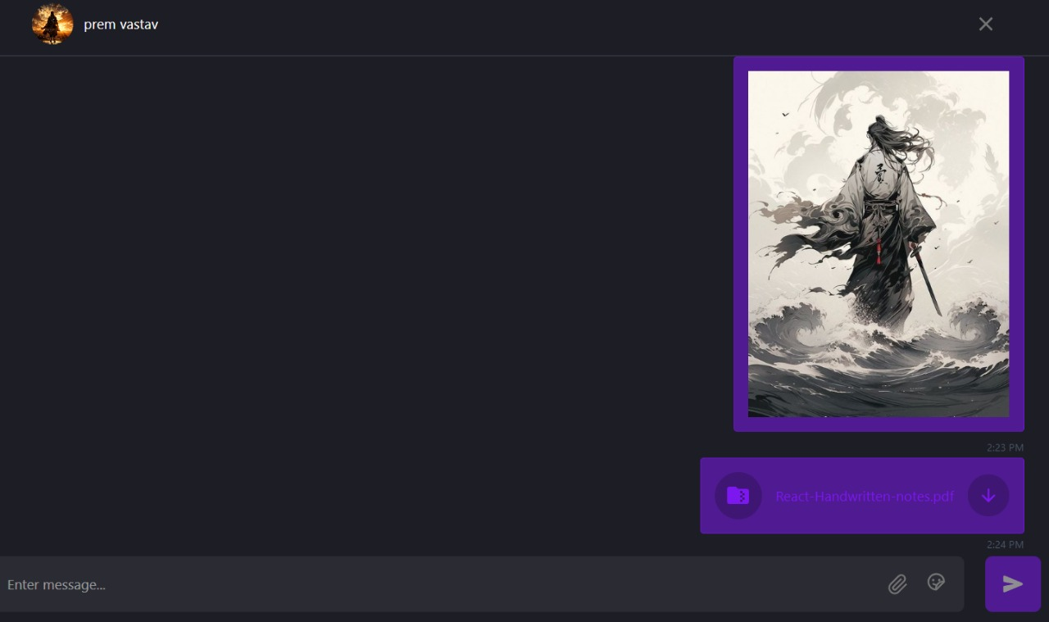

Document Sharing :- Users can send and receive documents in chat.
Users can also download shared documents directly from the chat.

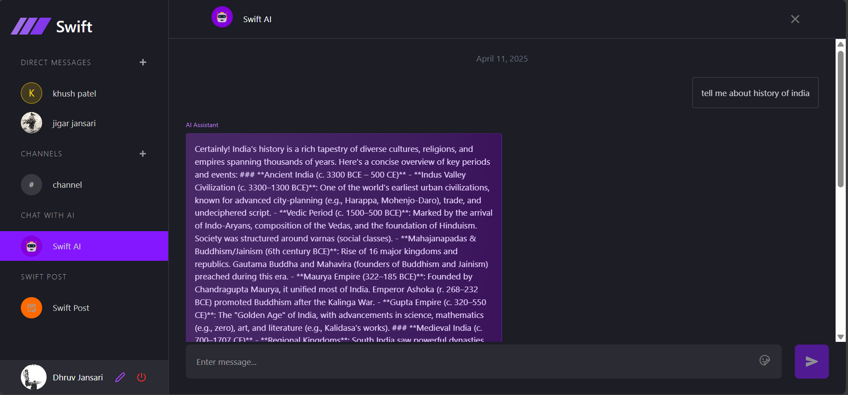

AI Container :- A section where users can send queries and receive AI-generated responses in real-time.

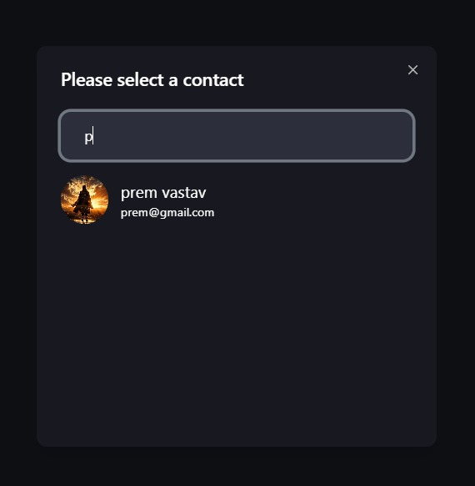

Contact Selector :- Allows users to select a person and start a one-on-one chat.

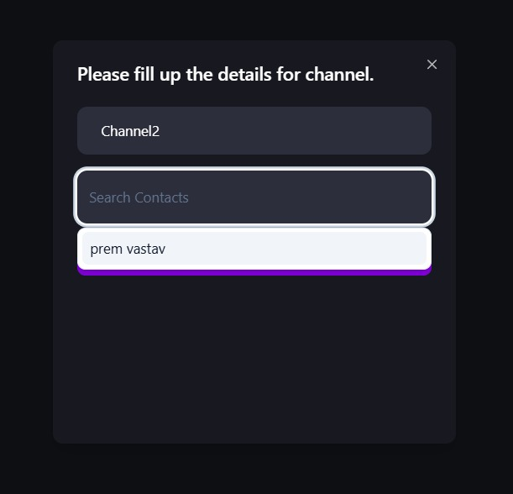

Channel Creator Container :- A section where users can create new channels and add multiple participants for group chats

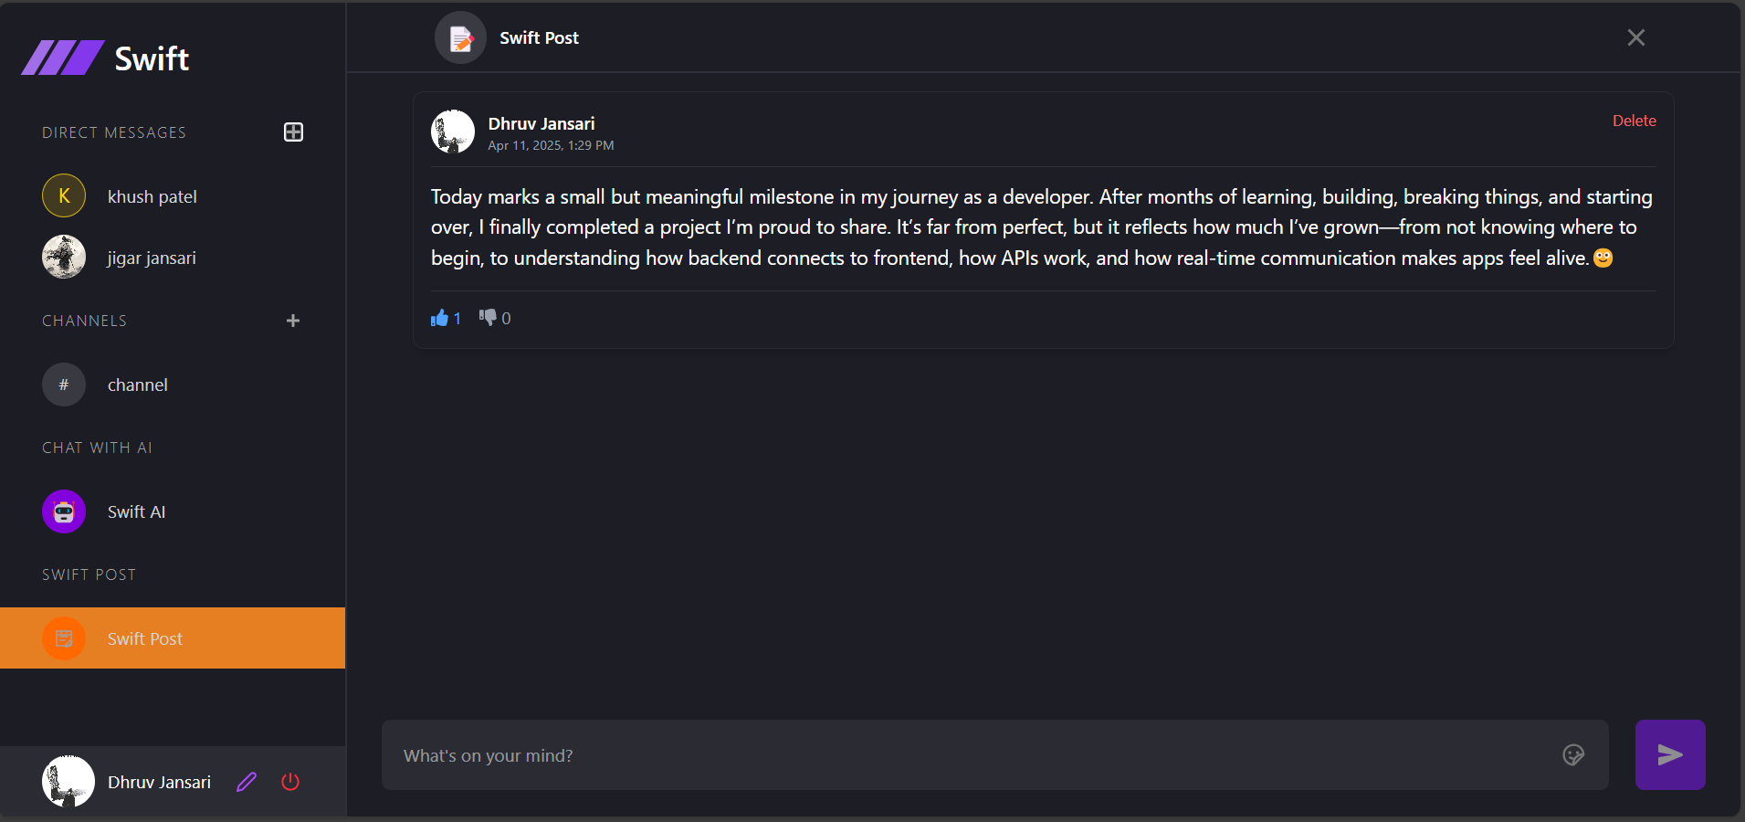

Post:- Users can create, manage, and delete their own posts, as well as like or dislike posts shared by others. This encourages interaction and engagement within the platform.

11. TESTING

No. | Test Condition | Description | Expected Result | Actual Output | Status
1 | Registration | Click on submit button without Email | System will display validation message | System display message like “email are required” | Pass
1 | Registration | Click on submit button without password | System will display validation message | System display message like “Enter password” | Pass
1 | Registration | Click on submit button without  Confirm password | System will display validation message | System display message like “Enter confirm password” | Pass
1 | Registration | Click on signup button  with valid email and password | System will allow to signup | System will display validation message like “signup successful” | Pass

No. | Test Condition | Description | Expected Result | Actual Output | Status
2 | Login | Non-Registered user | System will not allow  Non-Registered user to login | System will display validation message like “Can’t find user” | Pass
2 | Login | Click on login button with invalid email and password | System will not allow user to login | System will display validation message like “Invalid login details” | Pass
2 | Login | Click on login button  with valid email and password | System will allow to login | System will display validation message like “Login successful” | Pass

12. FUTURE ENHANCEMENT

- I will provide google authentication facility, so user can sign up through google account.

- Displays the number of messages received and the count of active users on the website in real time.

- Voice and video calling features will be introduced to enable real-time communication also.

13. BIBLIOGRAPHY

- For developing this “swift chat” I have referred the following website:

    - https://ui.shadcn.com/

    - https://tailwindcss.com/docs/installation/using-vite

    - https://openrouter.ai/

