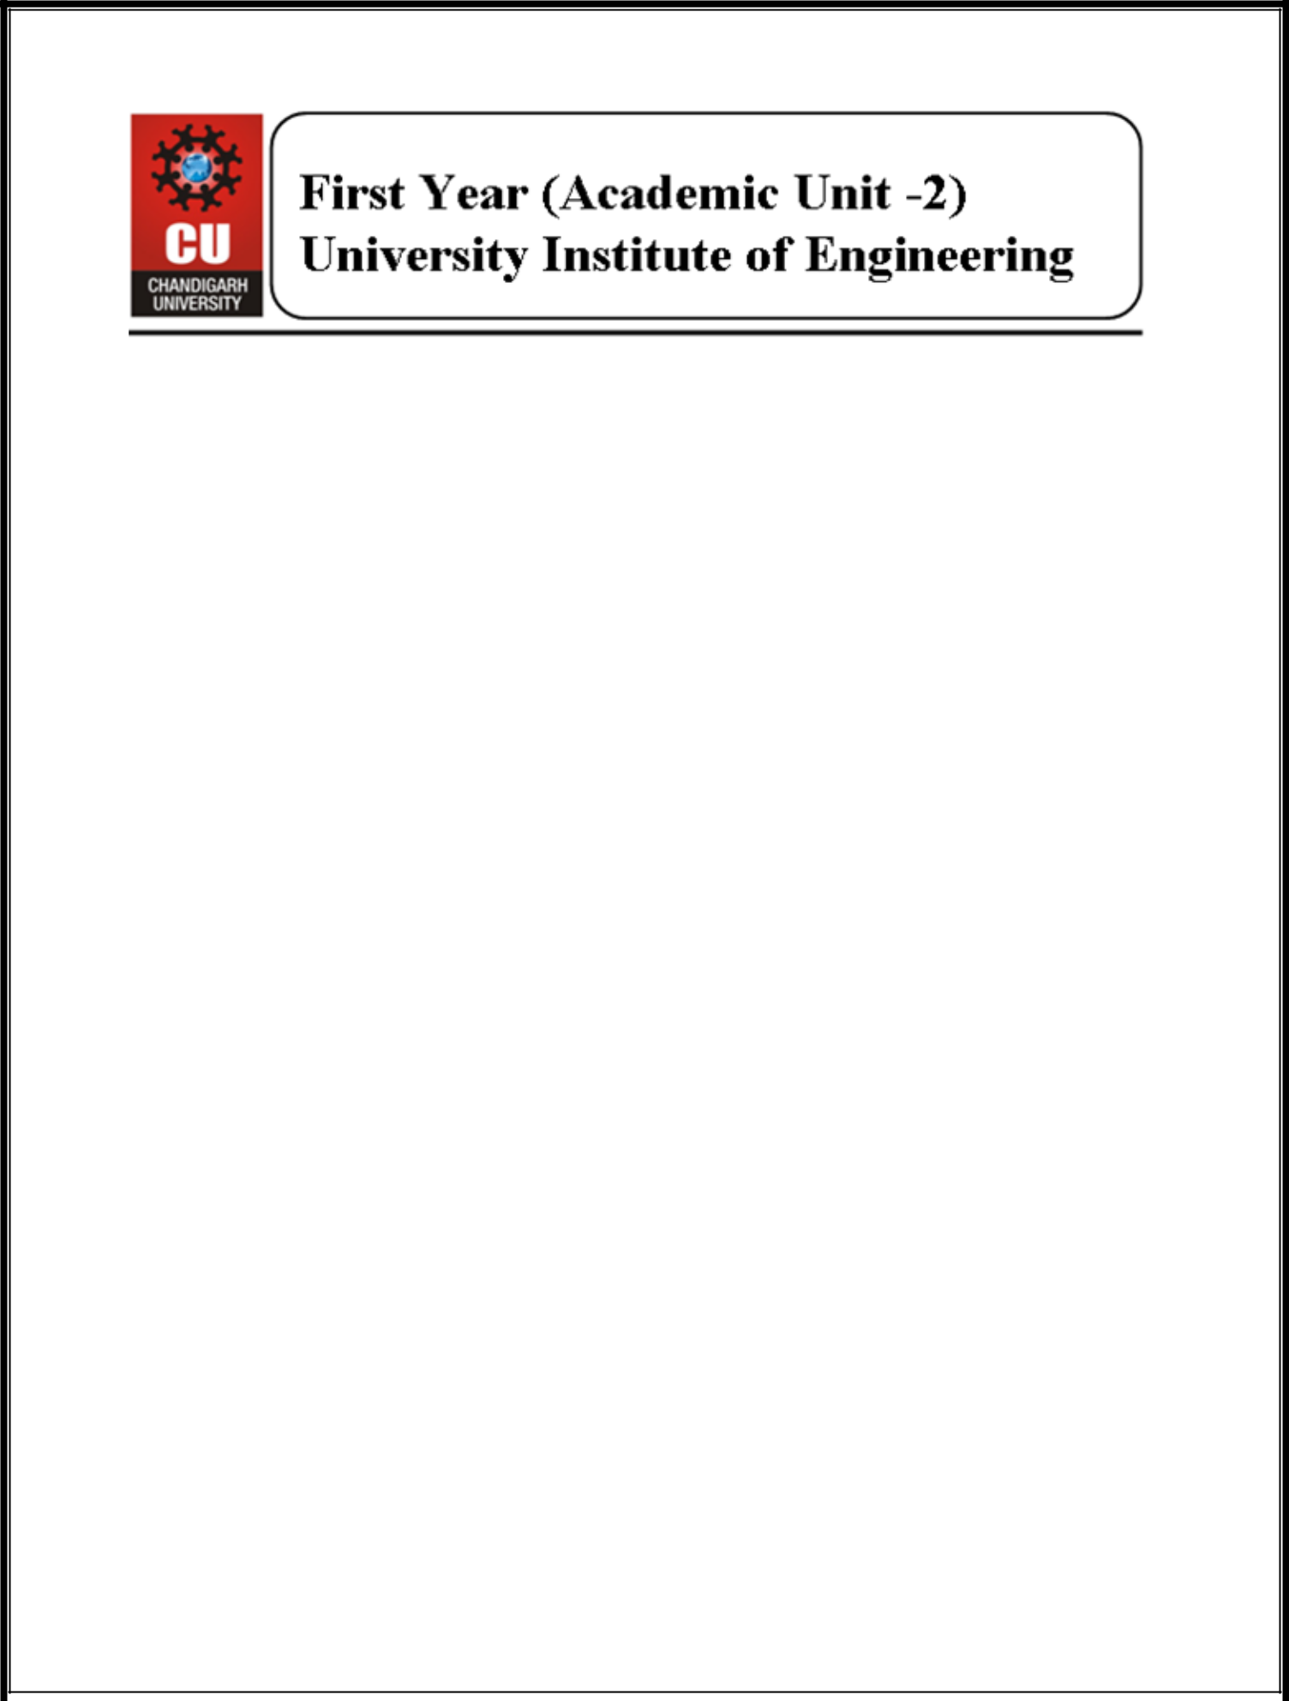

**Department of Computer Science & Engineering**

**Academic Unit-2, Block 4**

**Organized**

**Workshop on**

**“Microsoft Azure Cognitive Services"**

**“Azure Machine Learning Studio”**

**“Git and GitHub Workflow”**

**(7th November 2019)**

The Workshop for IST year students was organized by Academic unit-2 on Topic “Microsoft Azure Cognitive Service, Azure Machine Learning Studio and Git/GitHub Workflow” where all the students were enlightened on conversational Chat bot.

The key elements of the workshop were:

* Microsoft Azure Introduction and Hands-on Session on ML Studio Classic
* Introduction of Git with GitHub Account Creation.
* Hands-on Experience on GitHub and it’s workflow(i.e. push, merge,commit)

**Microsoft Azure Introduction and Hands-on Session on ML Studio Classic:**

First, we had given the introduction about the different API’s like Vision API, Speech API etc. through which the students are able to understand the basic working of how Cloud works.API key generated in Azure Portal used by students to test in the Testing Console provided by Microsoft. Creation of the Microsoft Azure conducted which will be going to help the students for further use. Given the glimpse of the Microsoft Azure and it’s working.In the Azure ML we shown them the sample Model and explained them how the flow works like how to take dataset,split data,train the model and Evaluate It.

**Introduction on Git and GitHub Account Creation:**

Git is a distributed version control system for tracking changes in source code during software development. For any computer science student, knowledge of Git and GitHub is very important. So first we had told the students about the benefits of the GitHub and how to use it. After it, the students had been Hands-On Experience upon how to create a repository into it so that they can learn how to use it. Basic Git Commands are also taught to them such that the

During the Hands-on Session the students are taught about how to working both remotely (through GitHub) and locally (through Git). Important books were also shared with the students so that they can further improve their knowledge and implemented.

The session was held from 2:00 PM to 4:30 PM. It was coordinated by event coordinator Ms Harjeet Kaur under the guidance of Head of the Department **Dr Manisha Malhotra.** The Session ended at 4:30 pm followed by student feedback.

**Glimpses of the workshop:**

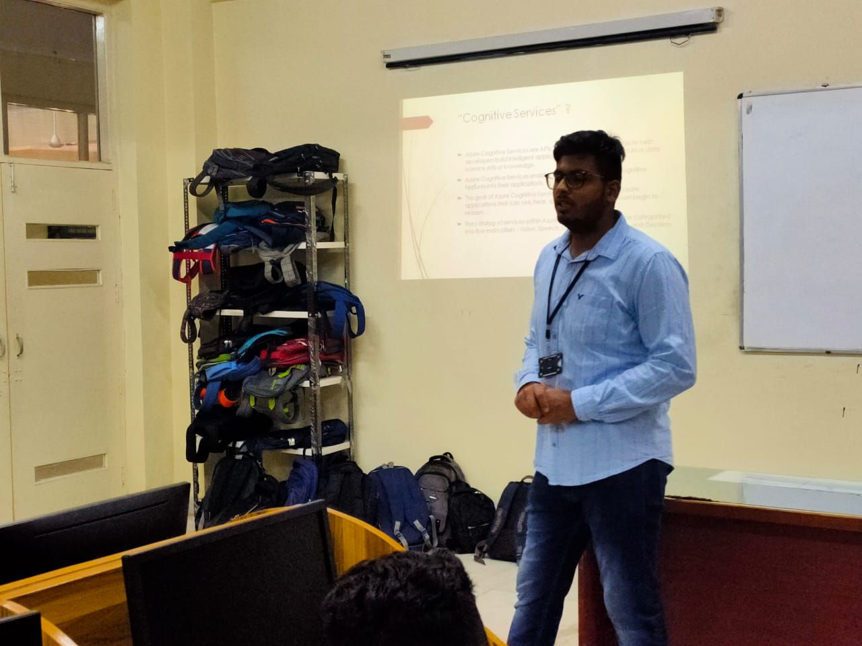

**Fig 1. Microsoft Student Partner Dhruv Kinger session on Microsoft Azure and Cognitive Services.**

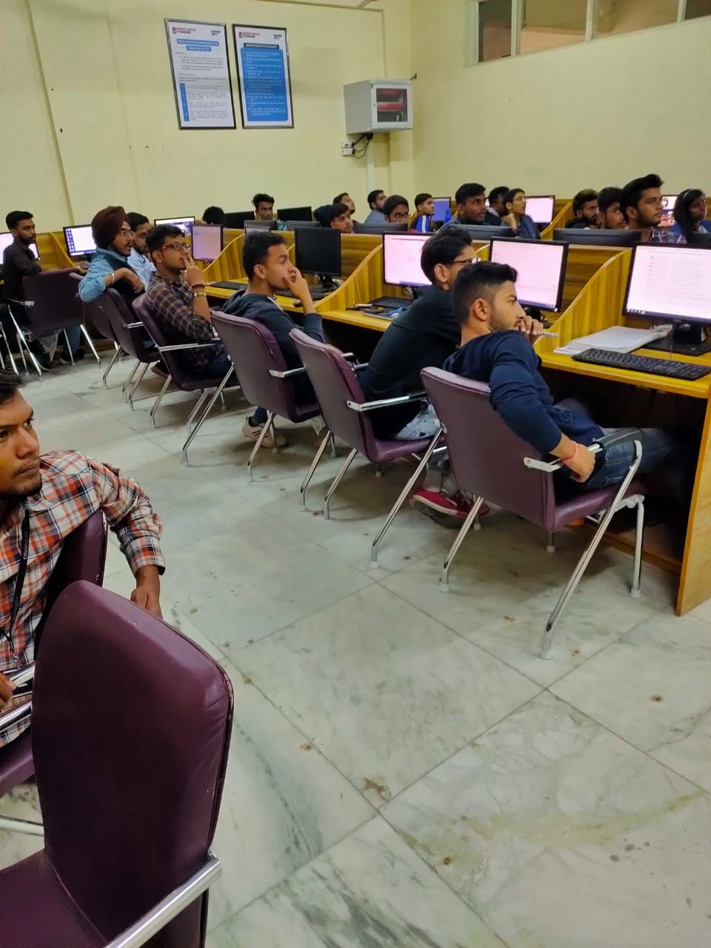**Fig 2. Students getting Hands on Experience on Microsoft Machine Learning Studio** 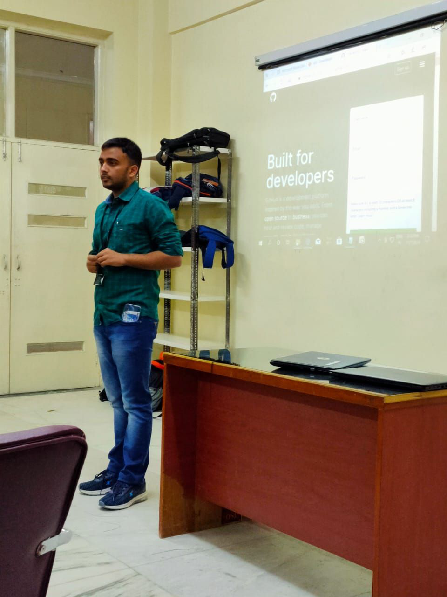

**Fig 3. Rahul Chandra giving Session upon Git Introduction and GitHub Workflow.**