**Social Media Sentiment Analysis Using Azure Logic Apps and Azure Cognitive Services**

Submitted in partial fulfillment of the requirements for the award of degree of

**BACHELOR OF ENGINEERING IN**

**COMPUTER SCIENCE & ENGINEERING**



**Submitted to:**

**Dr. Ruchika Gupta**

**Submitted By:**

**NAME: - Akash Yadav, Dhruv Kinger**

**Roll No: - 17BCS1817,17BCS1785**

#### DEPARTMENT OF COMPUTER SCIENCE & ENGINEERING

**Chandigarh University, Gharuan**

**April 2020**

# ACKNOWLEDGEMENT

First and foremost, I would like to take this opportunity to thank our mentor Gurpreet Sir for his guidance and advice on this project. At the same time I also won’t forget my group participant and also friends to because they were quite good with sharing some of their information to compete this project successfully. Last but not least, I am very grateful to our college, lectures and friends where they gave us enough of time to complete this project and at the same time I would like to thank my friends and classmates who helps me a lot to complete this project.

Thank you

# ABSTRACT

The rapid revolution of Social Network Sites (SNS) around the globe is presenting wide range of data that can be used in studies of sentiment analysis about certain products, brands, services… etc. In addition, cloud computing fields had been one of the most interesting fields in research studies. In this paper, we used the sentiment analysis of top leading cloud service providers namely; Amazon and Microsoft Azure to analyse their customers’ opinions and reviews. To do that, two datasets are extracted which are consisting of tweets that had either organizations’ names or cloud names. We study, and analyze the way customers think about them. In this regard, many organizations tend to find out what do customers think or tweet about their products in order to effectively plan marketing campaigns and try to gain the positive impact of Word-of-Mouth. Results are analyzed and explained in details in term of polarity and emotions classifications to show the impact of sentiment analysis to support organizations decisions.

**Keywords:** Sentiment analysis, Azure, logic apps, Cognitive services

# List of Figures

|  |  |  |
| --- | --- | --- |
| **Figure No.** | **Title** | **Page No.** |
| 1. | **Block Diagram** | 13 |
| 2 . | **Use case Diagram** | 13 |
| 3. | **ER Diagram** | 14 |

**Table of Contents**

|  |  |  |
| --- | --- | --- |
| **Sr. No.** | **Topic** | **Page No.** |
| 1 | CHAPTER 1:- INTRODUCTION | 6 |
| 2 | CHAPTER 2:- SOFTWARE REQUIREMENT SPECIFICATION | 7-12 |
| 3 | CHAPTER 3:- ARCHITECTURE DIAGRAMS | 13-14 |
| 4 | CHAPTER 4:- PROJECT METHODOLGY | 14-16 |
| 5 | CHAPTER 5:- SCREENSHOTS | 17-19 |
| 6 | CHAPTER 6:- CONCLUSION AND FUTURE SCOPE | 20 |
| 7 | REFERENCES | 20 |

## CHAPTER 1:- INTRODUCTION

The rapid revolution of Social Network Sites (SNS) around the globe is presenting wide range of data that can be used in studies of sentiment analysis about certain products, brands, services… etc. In addition, cloud computing fields had been one of the most interesting fields in research studies. In this paper, we used the sentiment analysis of top leading cloud service providers namely; Amazon and Microsoft Azure to analyse their customers’ opinions and reviews. To do that, two datasets are extracted which are consisting of tweets that had either organizations’ names or cloud names. We study, and analyze the way customers think about them. In this regard, many organizations tend to find out what do customers think or tweet about their products in order to effectively plan marketing campaigns and try to gain the positive impact of Word-of-Mouth. Results are analyzed and explained in details in term of polarity and emotions classifications to show the impact of sentiment analysis to support organizations decisions.

The Text Analytics API is a cloud-based service that provides advanced natural language processing over raw text, and includes four main functions: sentiment analysis, key phrase extraction, language detection, and entity recognition.We will need Azure Cognitive services to analyse our Tweet and detect the sentiment of the tweet. The Text Analytics API, which is part of the Cognitive services, is a cloud-based service that provides advanced natural language processing over raw text has 3 main components: sentiment analysis, key phrase extraction, and language detection. There is a 4th component which is in preview now called Entity recognition which identifies and categorize entities in your text as people, places, organizations, date/time, quantities, percentages, currencies, and more. Well-known entities are also recognized and linked to more information on the web.

The Text Analytics API uses a machine learning classification algorithm to generate a sentiment score between 0 and 1. Scores closer to 1 indicate positive sentiment, while scores closer to 0 indicate negative sentiment. Sentiment analysis is performed on the entire document, instead of individual entities in the text. This means sentiment scores are returned at a document or sentence level.

## CHAPTER 2:- SOFTWARE REQUIREMENT SPECIFICATION

##### INTRODUCTION

* 1. PROBLEM DEFINITION

To Check the Sentiment Analysis on Social media platforms like twitter using the Azure

Cognitive Services and Logic Apps

PURPOSE

This document provides a detailed description of Software Requirements Specification (SRS) for Recommendation System. It is prepared according to “IEEE Recommended Statements for Software Requirements Specification - IEEE Standard 830 – 1998”. The Software Requirements Specification (SRS) document is intended to provide the requirements of the Recommender System project and the expectations of the stakeholders. The document includes the project perspective, data model and constraints of the overall system. The intended audiences of the document are project managers, developers, testers and end users. · Project managers review the document and determine whether the planned system fulfills the requirements. They notify the developers to fill up missing parts. · Developers provide consistency by using the documentation. · Testers use the documentation for verification and validation. . End users make use of this document to learn about the scope of the system and its capabilities.

##### SCOPE

The rapid revolution of Social Network Sites (SNS) around the globe is presenting wide range of data that can be used in studies of sentiment analysis about certain products, brands, services… etc. In addition, cloud computing fields had been one of the most interesting fields in research studies. In this paper, we used the sentiment analysis of top leading cloud service providers namely; Amazon and Microsoft Azure to analyse their customers’ opinions and reviews. To do that, two datasets are extracted which are consisting of tweets that had either organizations’ names or cloud names. We study, and analyze the way customers think about them. In this regard, many organizations tend to find out what do customers think or tweet about their products in order to effectively plan marketing campaigns and try to gain the positive impact of Word-of-Mouth. Results are analyzed and explained in details in term of polarity and emotions classifications to show the impact of sentiment analysis to support organizations decisions.

DEFINITIONS, ACRONYMS AND ABBREVIATIONS

|  |  |
| --- | --- |
| **TERM** | **DESCRIPTION** |
| IEEE | Institute of Electrical and Electronics Engineers |
| UML | Unified modified language |

* 1. REFERENCES

[1]<https://towardsdatascience.com/using-azure-cognitive-services-for-sentiment-analysis-of-trumps-tweets-part-1-f42d68c7e40a>

[2] <https://azure.microsoft.com/en-in/updates/sentiment-v3-preview-updates3/>

[3] <https://azure.microsoft.com/en-in/updates/sentiment-v3-preview-updates3/>

[4]<https://docs.microsoft.com/en-us/azure/cognitive-services/text-analytics/how-tos/text-analytics-how-to-sentiment-analysis?tabs=version-3>

##### OVERVIEW

This document includes six chapters:

* Overall description
* Specific requirements
* Data Model and Description
* Behavioral Model and Description
* Planning
* Conclusion

The software requirements begin with the overall description of the project. The product perspective, major functions and constraints are covered briefly. The software and hardware interfaces are stated in the next section as well. The following chapter gives the detailed requirements and functionalities of the software product. The functional and nonfunctional requirements are explained broadly. The design model and design constraints are mentioned extensively. One complete chapter is reserved for the data description and the behavioral model separately. SRS document involves UML diagrams for the project design. The use case, class and state diagrams are depicted in related sections. The documentation is finalized with the estimated schedule and team work for the project.

##### OVERALL DESCRIPTION

The rapid revolution of Social Network Sites (SNS) around the globe is presenting wide range of data that can be used in studies of sentiment analysis about certain products, brands, services… etc. In addition, cloud computing fields had been one of the most interesting fields in research studies. In this paper, we used the sentiment analysis of top leading cloud service providers namely; Amazon and Microsoft Azure to analyse their customers’ opinions and reviews. To do that, two datasets are extracted which are consisting of tweets that had either organizations’ names or cloud names. We study, and analyze the way customers think about them. In this regard, many organizations tend to find out what do customers think or tweet about their products in order to effectively plan marketing campaigns and try to gain the positive impact of Word-of-Mouth. Results are analyzed and explained in details in term of polarity and emotions classifications to show the impact of sentiment analysis to support organizations decisions.

##### SYSTEM INTERFACES

There is just one system requirement which is Internet Access and good system to work

##### HARDWARE INTERFACES

Accessibility to a great extent by storing your collection data on cloud. This brings out the requirement of a network interface on the device. User should have a device with valid internet connection, Wi-Fi or 3G, to be able to keep collection synchronized with cloud.

##### SOFTWARE INTERFACES

The data of the project is organized in a graph because the aim is to handle big data. A graph is a collection of nodes and edges (relationships) that connect node pairs. Key-value pairs are defined on nodes and edges. This is a powerful way of representing relations in the project data. In a graph database, relationships are first-class citizens. They connect two nodes. These two nodes and relationships can hold excessive amount of key-value pairs. Graph database stores data in a graph, the most generic form of data structures, capable of elegantly representing any kind of data in a highly accessible way. Graph database is approximately 1000 times faster for many queries on connected data than a relational database. Moreover, graph database is more intuitive for modeling many domains as a graph.

COMMUNICATION INTERFACES

This system is a application; therefore network connection with TCP/IP protocol is necessary

##### MEMORY

At the beginning of the Recommendation System project, we will be using our local computers.

Therefore minimum 4 GB (64-bit) RAM and 20 GB (64-bit) hard disk space will be needed.

##### 2.1.7 OPERATIONS

This project can tell the user if anyone doing false or bad comments in the site so it will tell the negativity and score of the comment

##### 2.1.8. ADAPTATION REQUIREMENTS

We are going to study with big data on this project. However, our local computers restrict us and we cannot deal with big data. Therefore, we need to deploy our project on a web server.

##### SPECIFIC REQUIREMENTS

There is just one system requirement which is Internet Access and good system to workSign language translation into text and speech offers accessibility to a great extent by storing your collection data on cloud. This brings out the requirement of a network interface on the device. User should have a device with valid internet connection, Wi-Fi or 3G, to be able to keep collection synchronized with cloud.

At the beginning of the Recommendation System project, we will be using our local computers.

Therefore minimum 4 GB (64-bit) RAM and 20 GB (64-bit) hard disk space will be needed.

Various applications are needed like jupyter notebook, python,Spyder etc.

##### FUNCTIONAL REQUIREMENTS

This section encapsulates the major software functions and data flow among the participants of the system. The participants include the user and the interagent. The user, in other words the enduser, is the person that makes use of application. The interagent is the R&D team of ARGEDOR and this actor provides the necessary tools to maintain the connection between the user and our system.

##### NON-FUNCTIONAL REQUIREMENTS

* + 1. PERFORMANCE REQUIREMENTS

Performance is very important issue because we are aiming to make the system real-timed. In other words, the system should have enough speed that users of the system cannot realize the processing of data. In order to make system real-timed,. Besides, it should handle multiple users at the same time.

##### SECURITY

Database has to be reached securely and its data should not be broken. It also should not change except interagent updates.

USABILITY

The scope of the product is widespread. The only requirement is using music streaming and downloading web application. Besides, people from every age shall easily use the system.

##### PORTABILITY

The role of services in enterprise application integration scenarios is to make it easier to tie applications running on heterogeneous platforms together; to help them overcome the communication gaps that arise from decisions to use one development environment over another; and to help abstract such choices so that business developers no longer have to keep track of what operating system or what development environment or what technology decisions have been made , it is portable.

##### CONCLUSION

When applied to social media channels, it can be used to identify spikes in sentiment, thereby allowing you to identify potential product advocates or social media influencers.

It can be used to identify potential negative threads that are emerging online regarding your business, thereby allowing you to be proactive in dealing with it more quickly.

CHAPTER 3:- ARCHITECTURE DIAGRAMS

#### Block diagram

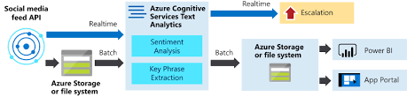

1. **Use case daigram**

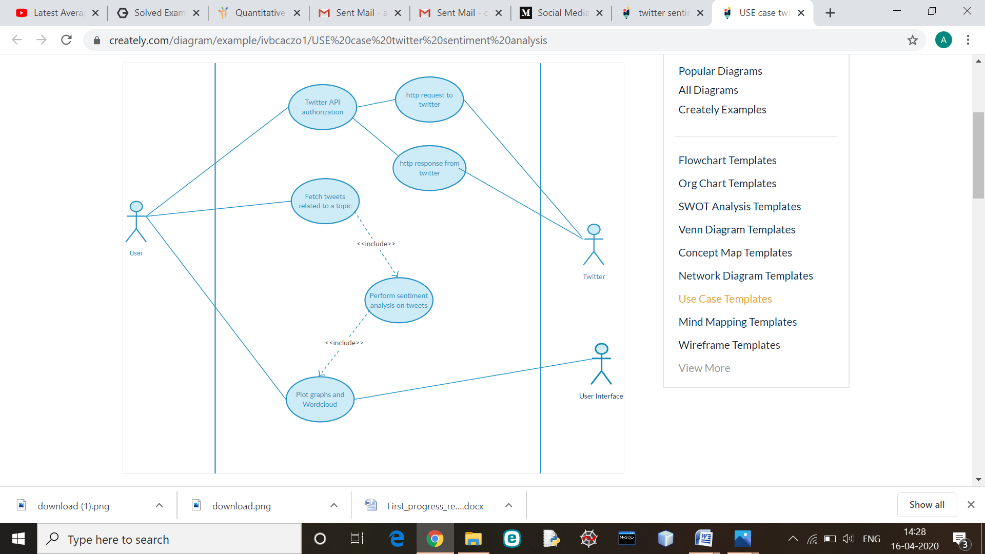

1. ER Diagram

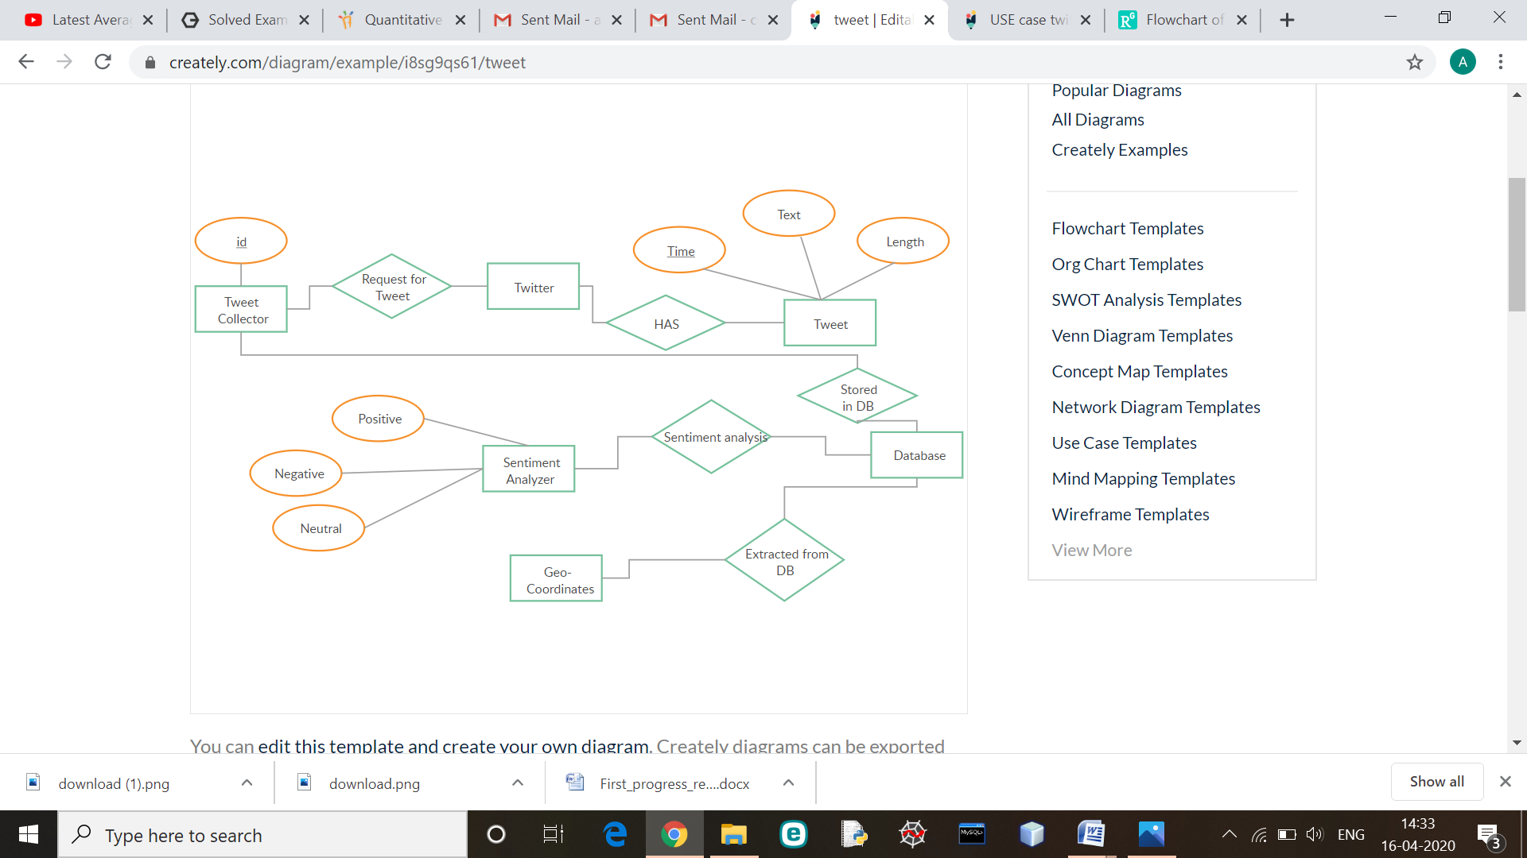

CHAPTER 4:- PROJECT METHODOLGY

**Description:**

**Azure Logic Apps** is a cloud based service that helps to schedule, automate tasks, business processes, and workflows when you need to integrate apps, data, systems, and services across the organizations. It requires a text analytics API Key for the project.

The Text Analytics API is a cloud-based service that provides advanced natural language processing over raw text, and includes four main functions: sentiment analysis, key phrase extraction, language detection, and entity recognition.The API is a part of [Azure Cognitive Services](https://docs.microsoft.com/azure/cognitive-services/), a collection of machine learning and AI algorithms in the cloud for your development projects.

**Modules**

## Sentiment Analysis

Use [sentiment analysis](https://docs.microsoft.com/en-in/azure/cognitive-services/text-analytics/how-tos/text-analytics-how-to-sentiment-analysis) to find out what customers think of your brand or topic by analyzing raw text for clues about positive or negative sentiment. This API returns a sentiment score between 0 and 1 for each document, where 1 is the most positive.  
The analysis models are pretrained using an extensive body of text and natural language technologies from Microsoft. For [selected languages](https://docs.microsoft.com/en-in/azure/cognitive-services/text-analytics/text-analytics-supported-languages), the API can analyze and score any raw text that you provide, directly returning results to the calling application.

## Key Phrase Extraction

Automatically [extract key phrases](https://docs.microsoft.com/en-in/azure/cognitive-services/text-analytics/how-tos/text-analytics-how-to-keyword-extraction) to quickly identify the main points. For example, for the input text "The food was delicious and there were wonderful staff", the API returns the main talking points: "food" and "wonderful staff".

## Language Detection

You can [detect which language the input text is written in](https://docs.microsoft.com/en-in/azure/cognitive-services/text-analytics/how-tos/text-analytics-how-to-language-detection) and report a single language code for every document submitted on the request in a wide range of languages, variants, dialects, and some regional/cultural languages. The language code is paired with a score indicating the strength of the score.

## Named Entity Recognition

[Identify and categorize entities](https://docs.microsoft.com/en-in/azure/cognitive-services/text-analytics/how-tos/text-analytics-how-to-entity-linking) in your text as people, places, organizations, date/time, quantities, percentages, currencies, and more. Well-known entities are also recognized and linked to more information on the web.

**Innovation in model**

* When applied to social media channels, it can be used to identify spikes in sentiment, thereby allowing you to identify potential product advocates or social media influencers.
* It can be used to identify potential negative threads that are emerging online regarding your business, thereby allowing you to be proactive in dealing with it more quickly.
* Sentiment analysis could also be applied to your corporate network, for example, by applying it to your email server, emails could be monitored for their general “tone”.

### CHAPTER 5:- SCREENSHOTS

**Azure Portal**

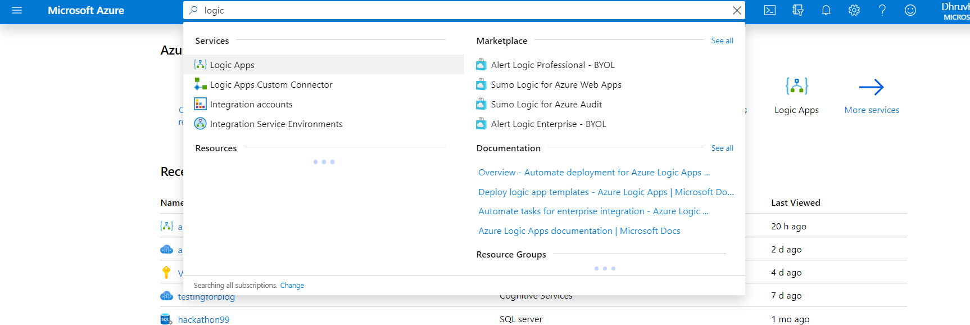

**Logic Apps Designer**

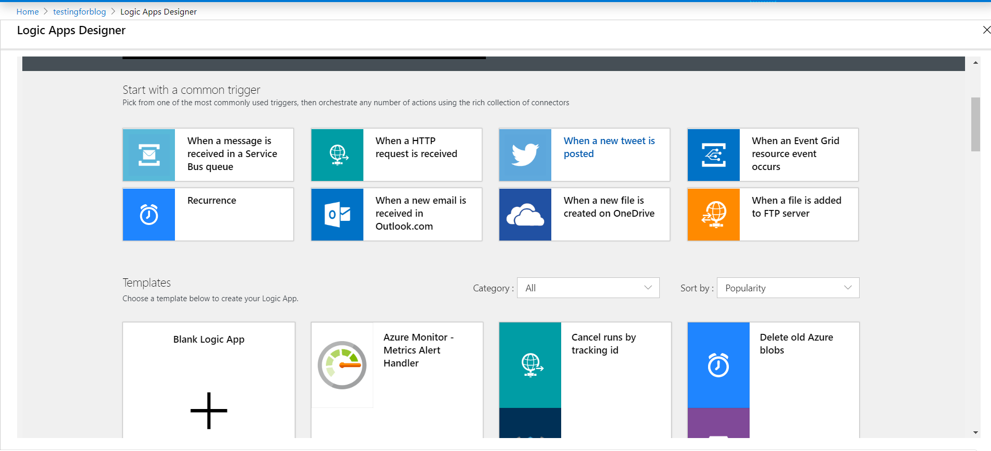

**Logic Creation**

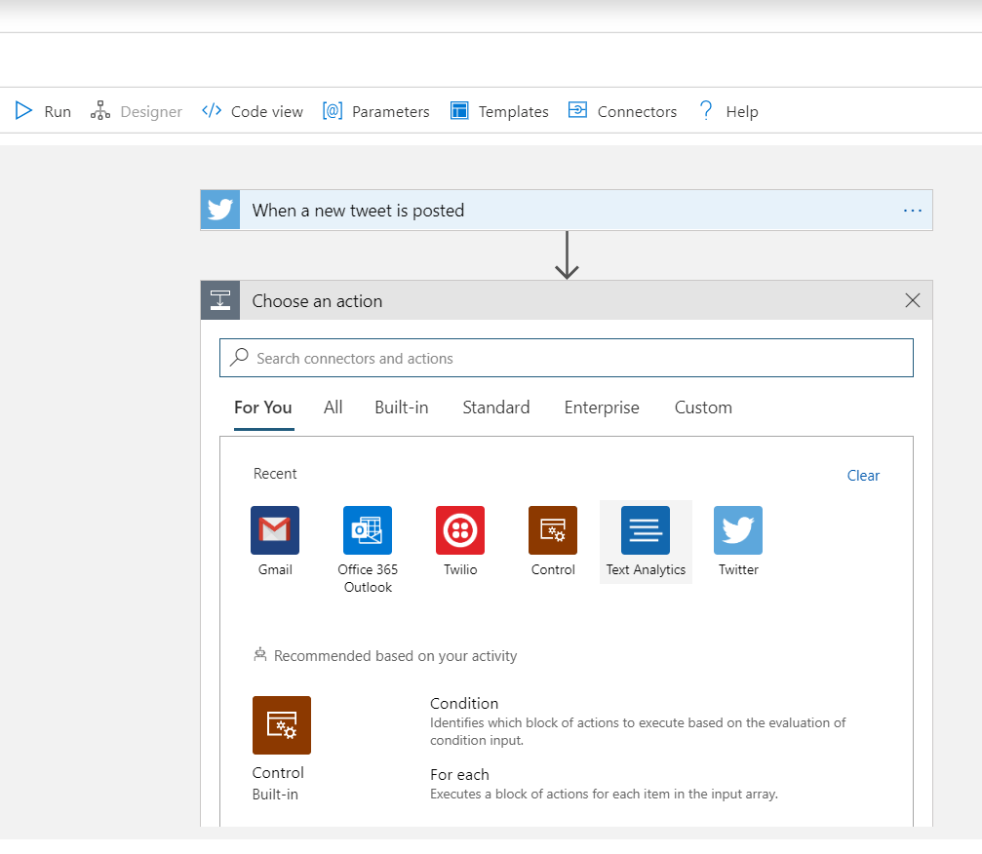

**Last Module**

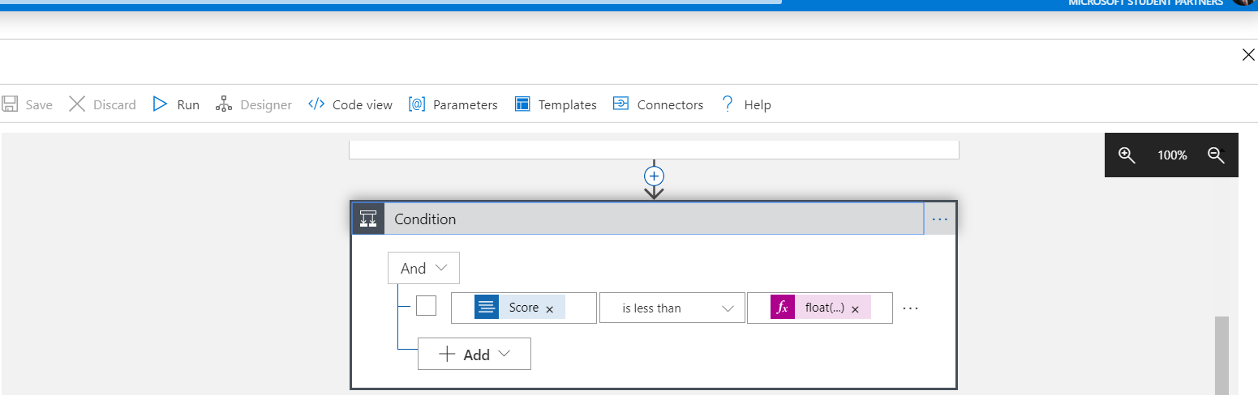

**Email Sending Credentials**

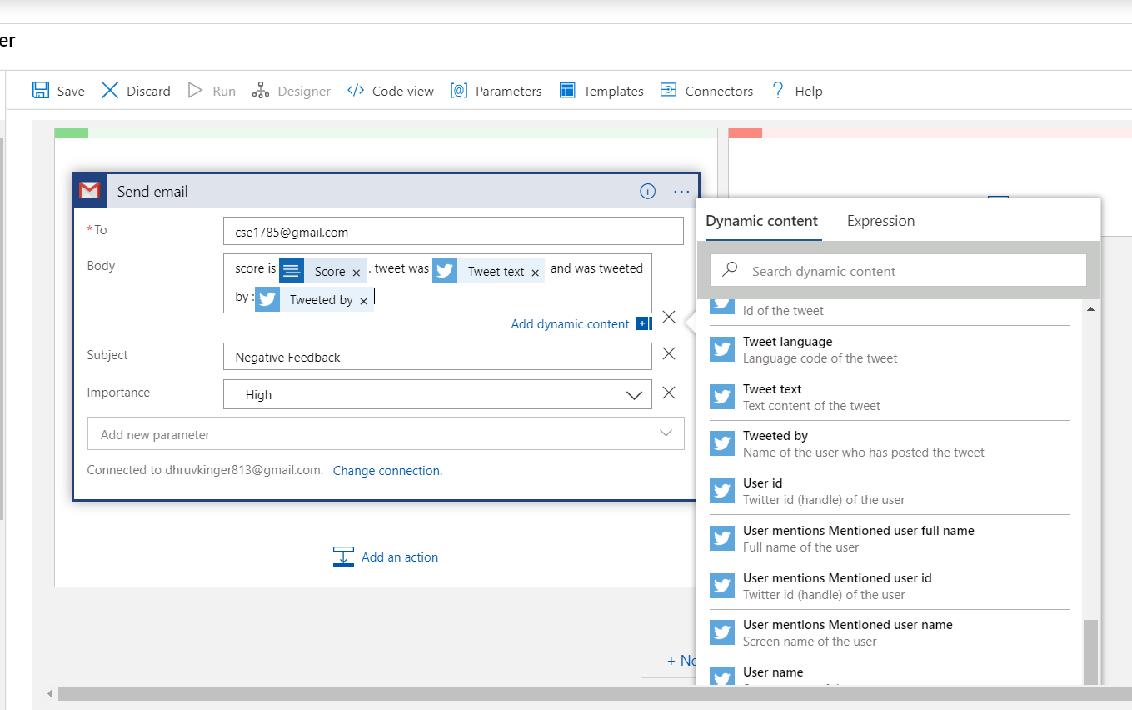

**Sent Email after sentiment analysis**

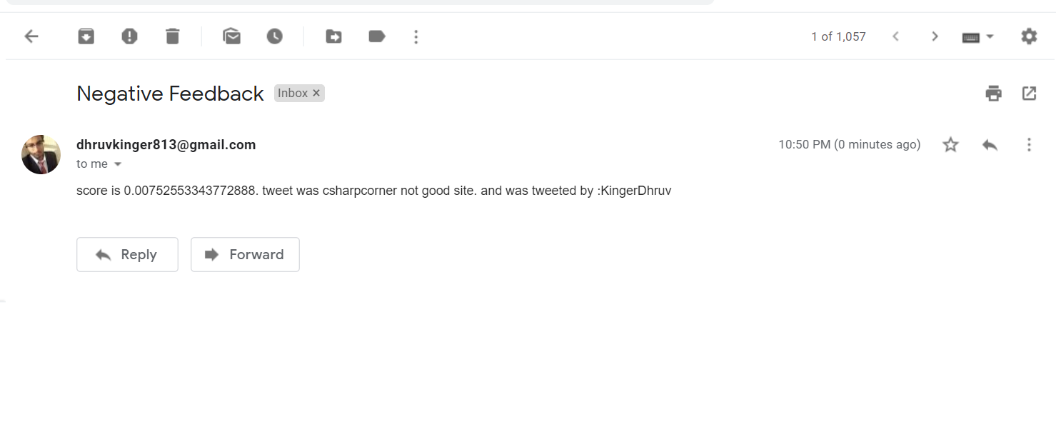

CHAPTER 6:- CONCLUSION AND FUTURE SCOPE

CONCLUSIONS

• When applied to social media channels, it can be used to identify spikes in sentiment, thereby allowing you to identify potential product advocates or social media influencers.

• It can be used to identify potential negative threads that are emerging online regarding your business, thereby allowing you to be proactive in dealing with it more quickly.

• Sentiment analysis could also be applied to your corporate network, for example, by applying it to your email server, emails could be monitored for their general “tone”.

POSSIBLE FUTURE WORK

There are plenty of way to expand on the work done in this project. Firstly, several different languages and moreover different apps full complete sentences and, phrases can be taken into consideration.

REFERENCES

[1] <https://towardsdatascience.com/using-azure-cognitive-services-for-sentiment-analysis-of-trumps-tweets-part-1-f42d68c7e40a>

[2] <https://azure.microsoft.com/en-in/updates/sentiment-v3-preview-updates3/>

[3] <https://azure.microsoft.com/en-in/updates/sentiment-v3-preview-updates3/>

[4]<https://docs.microsoft.com/en-us/azure/cognitive-services/text-analytics/how-tos/text-analytics-how-to-sentiment-analysis?tabs=version-3>