A Term Project
(Microcontroller & IoT Project)
Report of
Intrusion Detection Using Fiber Optics
Submitted by
Chauhan Mayank Durgeshsingh Dhruv Kotadiya
[EC067] [EC075]

B. Tech. Sem. VI
Electronics & Communication
under the supervision
of
Prof. Himanshu U. Prajapati


Dharmsinh Desai University
Department of Electronics and Communication
Faculty of Technology
Nadiad - 387001

Dharmsinh Desai University
Faculty of Technology
College Road, Nadiad – 387001. (Gujarat)

Certificate

This is to certify that the practical / term work carried out in the subject of Microcontroller & IoT and recorded in this journal is the Bonafide work of Mr. / Miss Chauhan Mayank Durgeshsingh, Roll No: EC067 Identity No: 23ECUOS023 of B. Tech. Semester-VI in the branch of Electronics & Communication during the academic year 2025 – 2026.

(Prof. Himanshu U. Prajapati) (Prof. (Dr). Purvang Dalal)
Staff In-Charge Head of the Department
Date: Date:
Dharmsinh Desai University
Faculty of Technology
College Road, Nadiad – 387001. (Gujarat)

Certificate

This is to certify that the practical / term work carried out in the subject of Microcontroller & IoT and recorded in this journal is the Bonafide work of Mr. / Miss Dhruv Kotadiya, Roll No: EC075 Identity No: 23ECUOS036 of B. Tech. Semester-VI in the branch of Electronics & Communication during the academic year 2025 – 2026.

(Prof. Himanshu U. Prajapati) (Prof. (Dr). Purvang Dalal)
Staff In-Charge Head of the Department
Date: Date:

Acknowledgment

We would like to express our sincere gratitude to Prof. Himanshu Prajapati for his valuable guidance, technical support, and continuous encouragement throughout the development of our project, Intrusion Detection Using Fiber Optic. His insightful suggestions and constant motivation helped us successfully complete this project and gain deeper knowledge in the field of IoT and robotics.

We also extend our sincere thanks to Prof. (Dr.) Purvang Dalal, Head of the Department of Electronics and Communication, for providing us with the opportunity and necessary resources to carry out this project. His encouragement and support for innovative learning greatly motivated us to work with dedication and enthusiasm.

We would also like to thank all the faculty members and staff of the Department of Electronics and Communication for their support, guidance, and valuable feedback during the course of this project.

Finally, we would like to express our heartfelt appreciation to our family and friends for their constant encouragement, understanding, and moral support throughout the completion of this project.

Abstract

With the increasing need for intelligent perimeter security systems, fiber optic technology integrated with Internet of Things (IoT) provides an efficient and passive solution for intrusion detection. This project presents the design and development of a Fiber Optic Intrusion Detection System capable of monitoring physical disturbances along a fiber optic cable. The system is built around the ESP32 microcontroller, which enable real-time data transmission.

The system uses a Visible Fault Locator (VFL) laser at 650nm as the light source injected into a fiber optic cable, with a photodiode at the receiving end converting light intensity into an analog ADC signal read by the ESP32. A 1602A LCD displays real-time status and a piezo buzzer provides audio alerts. The system classifies five conditions: Fiber Fault (no light), Low Light (cable bend), Walking (small vibrations), Digging (sudden spike), and Intrusion (sustained vibration). Sensor data and alerts are transmitted through Wi-Fi to a real-time web dashboard using WebSockets.

This system provides a cost-effective and passive solution for applications such as perimeter security, underground cable monitoring, border surveillance, and detection of unauthorized digging or intrusion in restricted areas where deploying active sensors may not be feasible.

Table of Contents
Certificate 2
Certificate 3
Acknowledgment 4
Abstract 6
1. Introduction 9
2. Literature Review 10
3. System Architecture 12
4. Hardware Design 14
a. Microcontroller (ESP32) 14
b. Photodiode 15
c. LCD 1602A Display 16
D. Buzzer 16
e. Potentiometer (LCD Contrast) 17
f. Fiber Optic Cable 18
g. VFL 19
h. Circuit Diagram 19
5. Software Design and Algorithm 21
i. Programming Platform 21
j. Sensor Data Acquisition 22
k. Decision Logic 22
l. Wireless Communication 22
m. Algorithm 23
n. Flow of Operation 24
6. Implementation 24
o. Hardware Assembly 25
p. Threshold Control 26
q. Sensor Integration 26
r. IoT Communication Setup 26
s. System Integration 27
t. Testing and Validation 27
7. Result and Testing 27
u. Dashboard Monitoring 28
v. System Performance 29
8. Applications 30
9. Limitations 30
10. Future Scope 31
11. Conclusion 31
12. References 32

List of Figures

Figure 1 System Architecture………………………………………………………………………………..12
Figure 2 ESP32 Microcontroller Board……………………………………………………………………..14
Figure 3 Photodiode (5mm Black Lens)…………………………………………………………………….15
Figure 4 LCD 1602A Display Module……………………………………………………………………….16
Figure 5 Buzzer………………………………………………………………………………………………..16
Figure 6 Potentiometer………………………………………………………………………………………..17
Figure 7 Fiber Optic Cable……………………………………………………………………………………18
Figure 8 VFL 650nm Laser…………………………………………………………………………………...19
Figure 9 Circuit Diagram……………………………………………………………………………………...20
Figure 10 Hardware Assembly……………………………………………………………………………….25
Figure 11 Dashboard output showing LOW LIGHT………………………………………………………..29
Figure 12 Dashboard showing INTRUSION………………………………………………………………..29

Introduction
Fiber optic sensing refers to the use of optical fiber cables as sensing elements that detect physical disturbances such as vibrations, bends, and pressure along their length. These systems are particularly useful in perimeter security, underground pipeline monitoring, and border surveillance where passive and tamper-resistant detection is required. By integrating photodiode receivers, microcontrollers, and signal analysis, fiber optic systems can classify environmental events and transmit alerts to users in real time.

In recent years, the demand for effective perimeter and intrusion detection systems has increased significantly due to concerns related to physical security, unauthorized access, and infrastructure protection. Traditional monitoring methods such as cameras and PIR sensors are limited by line-of-sight constraints and environmental interference. Fiber optic intrusion detection provides a passive, electromagnetic interference-resistant alternative capable of covering long distances without active electronics along the sensing path.

The integration of the Internet of Things (IoT) has further enhanced the capabilities of intrusion detection systems. IoT enables the ESP32 microcontroller to host a local web server and stream sensor data to connected devices in real time. By transmitting ADC readings and event classifications through Wi-Fi using WebSockets, the system provides instant visibility into the monitored cable environment from any web browser on the local network.

The purpose of this project is to design and develop an IoT-based fiber optic intrusion detection system capable of monitoring physical disturbances along a fiber optic cable. The system uses an ESP32 microcontroller for signal acquisition, event classification, and wireless communication. A 650nm VFL laser injects light into the cable, and a photodiode at the output end converts received light into an analog ADC value. The ESP32 analyzes the ADC signal pattern to classify events as Fiber Fault, Low Light, Walking, Digging, or Intrusion, and displays the status on an LCD while transmitting data to a web dashboard in real time.

Such systems can be applied in various fields including border and perimeter security, underground infrastructure monitoring, industrial zone protection, and detection of unauthorized digging or trespassing. By combining fiber optic sensing with IoT technology, the proposed system offers a passive, cost-effective, and efficient solution for modern intrusion detection and perimeter monitoring applications.

Literature Review
In recent years, several researchers have proposed different types of fiber optic sensing systems that combine optical physics, signal processing, and communication technologies to detect physical intrusions and environmental disturbances. These systems aim to provide passive, long-range detection with minimal maintenance while delivering real-time alerts about potential security threats.

Early intrusion detection systems mainly relied on camera-based and PIR (Passive Infrared) sensor monitoring. These systems were limited by environmental conditions such as fog, darkness, and physical obstructions. They were widely used for perimeter surveillance in residential and commercial buildings. However, such systems are susceptible to false alarms caused by animals, weather changes, and require line-of-sight between the sensor and the detected subject, limiting their effectiveness in outdoor or underground applications.

With the advancement of distributed fiber optic sensing (DFOS) technology, modern intrusion detection systems have integrated phase-sensitive optical time-domain reflectometry (phi-OTDR) and intensity-based detection methods. These systems can detect vibrations, acoustic signals, and temperature changes along the entire length of a fiber optic cable. By analyzing the pattern and magnitude of signal variations, such systems can distinguish between different types of physical events and transmit classifications to a remote monitoring interface.

Several research studies have also explored intensity-based fiber optic sensing using standard single-mode and multimode cables as cost-effective alternatives to distributed sensing systems. These approaches measure the change in received optical power caused by micro-bending, macro-bending, or physical pressure on the cable. Research has shown that such systems can reliably detect footsteps, vehicle movement, and digging activities when combined with appropriate signal processing thresholds.

Despite these advancements, existing fiber optic intrusion detection systems still face certain limitations. Many advanced DFOS systems depend on expensive interrogator hardware and require complex signal processing algorithms. Additionally, environmental factors such as temperature fluctuations, cable installation conditions, and mechanical stress unrelated to intrusion events can affect detection accuracy. Cost, complexity, and the need for specialized optical components remain common challenges for widespread deployment.

Therefore, there is a need for cost-effective intrusion detection systems based on simple intensity measurement of fiber optic cables. By integrating a photodiode receiver, an ESP32 microcontroller, and IoT communication with intelligent ADC threshold-based classification, a practical and reliable detection system can be developed for perimeter monitoring and security applications at low cost.

System Architecture
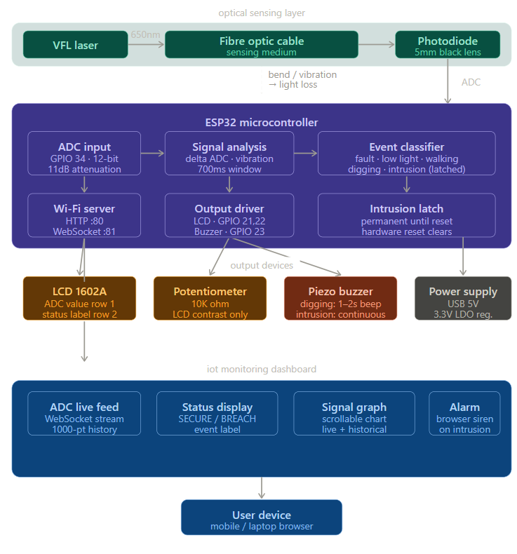
Figure 1 System Architecture

The proposed fibre optic intrusion detection system is designed to monitor physical disturbances along a fibre optic cable and transmit the classified event data to a remote monitoring device. The system integrates a VFL laser, a photodiode, an ESP32 microcontroller, an LCD display, and wireless communication to form a complete intrusion monitoring platform.
At the top level of the system, a mobile phone or laptop acts as the monitoring interface. Through Wi-Fi communication, the user can receive real-time ADC readings and event status updates via WebSockets. The collected information from the ESP32 is transmitted to the web-based dashboard hosted by the ESP32 itself, accessible through the device IP address.

The central component of the system is the ESP32 microcontroller, which functions as the main processing unit. It reads the ADC value from the photodiode connected to GPIO pin 34, processes the signal to detect vibration patterns and light level changes, and classifies the event in real time. The ESP32 also provides built-in Wi-Fi capability, hosting a WebServer and WebSocket server to enable real-time communication with the monitoring dashboard.

The optical sensing chain forms the core of the system. The VFL (Visible Fault Locator) laser at 650nm, 10mW is connected to one end of the fibre optic cable as the light source. At the receiving end, a 5mm black lens photodiode converts the received optical power into an analog voltage signal. This signal is fed to the ADC input of the ESP32, producing a 12-bit digital value ranging from 0 to 4095.

The ADC value represents the optical power received at the photodiode. Any physical disturbance on the fibre cable, such as bending, vibration, pressure, or a cut, causes optical power loss, which reduces the ADC value or introduces fluctuations in the signal. The ESP32 continuously monitors these changes to detect intrusion events.
The output peripherals include the 1602A LCD display connected to GPIO pins 21, 22, 19, 18, 5, and 17, which shows the live ADC value on the first row and the current event classification on the second row. The piezo buzzer connected to GPIO pin 23 provides audio alerts for Digging (1-2 second beep) and Intrusion (continuous alarm until ESP32 reset) events.

All ADC readings are processed by the decision logic unit within the ESP32. The microcontroller evaluates both the absolute ADC value and the pattern of changes over time to determine the event classification. Based on this classification, two main actions occur: the LCD and buzzer are updated to reflect the current state, and the event data is broadcast to all connected WebSocket clients on the monitoring dashboard.

A 10K potentiometer is connected to the VEE pin of the LCD to allow manual adjustment of the display contrast for optimal readability. This is a purely passive component and does not participate in the detection logic. The entire system is powered via the USB port of the ESP32 or an external 3.3V/5V regulated supply. The VFL laser operates at 3.3V and is powered directly from the ESP32 voltage output. The photodiode, LCD, and buzzer are all compatible with the ESP32 operating voltage levels. Thus, the system integrates optical sensing, signal processing, event classification, display output, audio alerting, and wireless communication to form a complete fibre optic intrusion detection platform capable of monitoring physical disturbances and transmitting real-time event data to the user.

Hardware Design
The hardware design of the fiber optic intrusion detection system consists of several electronic components that work together to perform optical signal acquisition, event classification, user feedback, and wireless communication. The system integrates an ESP32 microcontroller, a photodiode, a VFL laser, an LCD display, a piezo buzzer, a potentiometer, and a fiber optic cable as the sensing medium.

Microcontroller (ESP32)
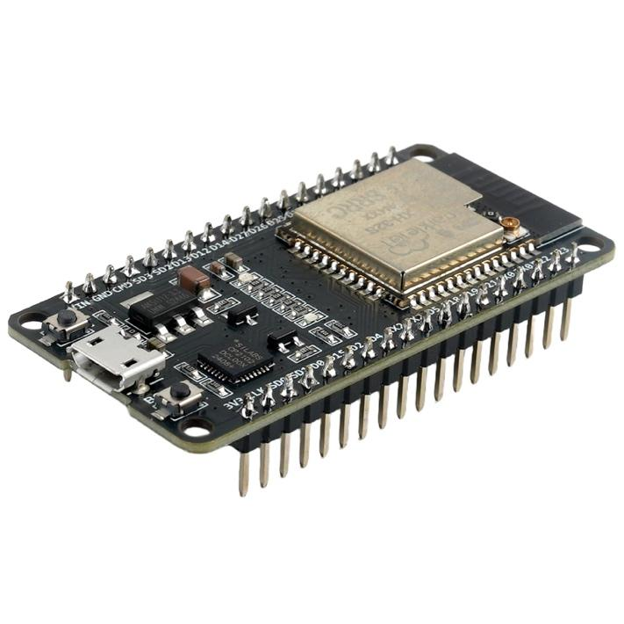
Figure 2 ESP32 Microcontroller Board
The ESP32 microcontroller acts as the central control unit of the system. It reads ADC values from the photodiode, processes the signal to classify intrusion events, drives the LCD and buzzer outputs, and transmits data to the web monitoring dashboard through Wi-Fi.
The ESP32 is selected because it provides built-in Wi-Fi connectivity, a 12-bit ADC with configurable attenuation, high processing speed, and multiple GPIO pins for interfacing with display and output modules. It reads the analog signal from the photodiode on ADC pin 34, applies 11dB attenuation for full-range 0-3.3V measurement, and uses 12-bit resolution for fine-grained signal analysis. Based on the processed data, it updates the LCD, triggers the buzzer, and broadcasts event status to the monitoring dashboard.

Key Specifications:
- Operating Voltage: 3.3V
- Processor: Dual-core Tensilica LX6
- Clock Speed: Up to 240 MHz
- Wireless Communication: Wi-Fi and Bluetooth
- GPIO Pins: Multiple digital and analog pins for sensor interfacing

Photodiode
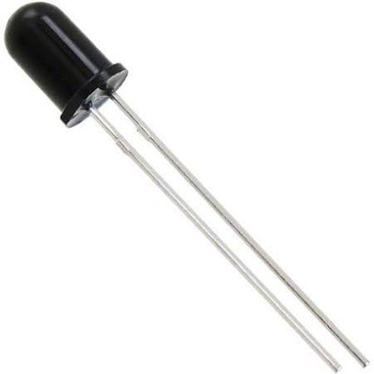
Figure 3 Photodiode (5mm Black Lens)
The photodiode (5mm black lens) is the primary sensor of the system. It is placed at the output end of the fibre optic cable and converts the received optical power from the 650nm VFL laser into an analog voltage signal. The black lens design filters out ambient light interference, ensuring that only light transmitted through the fibre cable is detected.

The VFL (Visible Fault Locator) laser operates at 650nm wavelength with 10mW output power, injecting a continuous red light beam into one end of the fibre optic cable. Any physical disturbance on the cable causes optical attenuation, which the photodiode detects as a reduction or fluctuation in the received signal. The ADC inverts the raw reading (4095 - analogRead) so that higher ADC values represent higher received light levels.

Key Specifications:
- Photodiode Type: 5mm Black Lens
- Spectral Sensitivity: 400nm – 1100nm
- ADC Pin: GPIO 34 (12-bit, 0–4095) light levels.

LCD 1602A Display

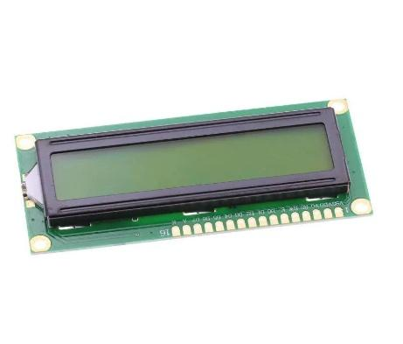
Figure 4 LCD 1602A Display Module
The LCD 1602A is a 16-column, 2-row character display used to show the live ADC value and the current system status. The first row displays the real-time ADC reading from the photodiode. The second row displays the classified event status: NO LIGHT / FAULT, LOW LIGHT, NORMAL (OK), WALKING DETECT, DIGGING DETECT, or INTRUSION ALERT.

The LCD is connected to the ESP32 using 6 GPIO pins in 4-bit parallel mode. A 10K potentiometer connected to the VEE pin of the LCD allows the user to adjust the display contrast for optimal readability. The LCD is updated every loop cycle to reflect the most recent ADC reading and event classification.

Key Specifications:
- Interface: 4-bit parallel (HD44780 compatible)
- Display Size: 16 characters × 2 rows
- Operating Voltage: 5V
- Backlight: LED

Buzzer
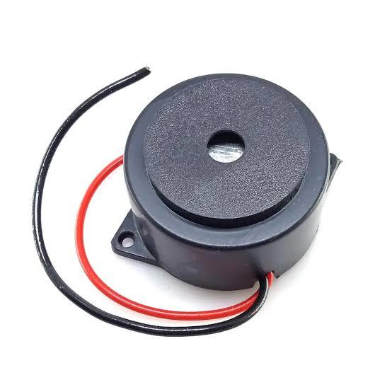
Figure 5 Buzzer
The piezo buzzer is a 3.3V small active buzzer connected to GPIO pin 23 of the ESP32. It provides audio alerts to notify nearby personnel of detected events. The buzzer operates in two distinct modes depending on the severity of the detected event.

For a Digging detection event, the buzzer is activated for approximately 1 to 2 seconds then automatically turns off. For an Intrusion detection event, the buzzer sounds continuously and can only be stopped by pressing the hardware reset button on the ESP32, ensuring that the intrusion alert is not silently dismissed.

Key Specifications:
- Operating Voltage: 3.3V
- Type: Active piezo buzzer
- GPIO Pin: 23
- Trigger: Digital HIGH/LOW

Potentiometer (LCD Contrast)
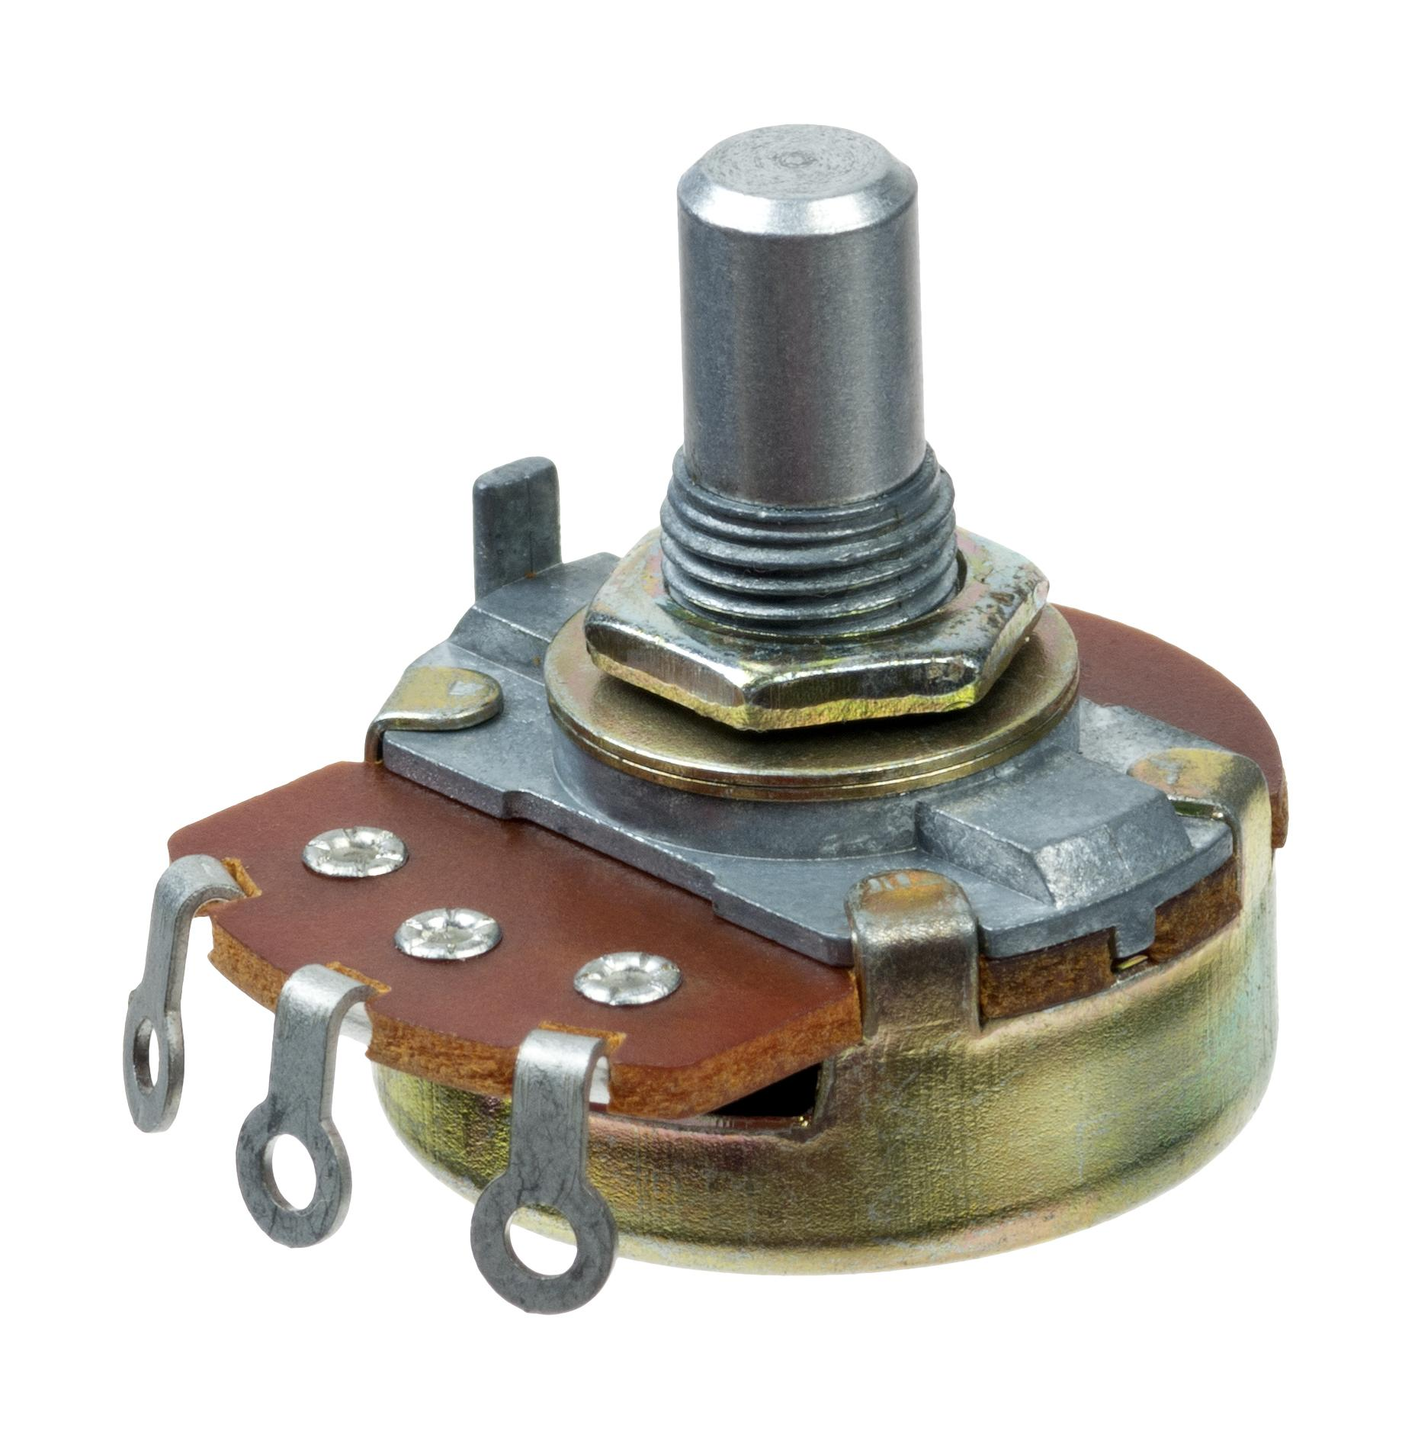
Figure 6 Potentiometer
The potentiometer has no role in the detection logic or ADC signal processing. It is a passive component used solely for display optimization. This allows the operator to set the contrast to a comfortable level regardless of ambient lighting conditions at the installation site.

Key Specifications:
- Operating Voltage: 3.3V – 5V
- Temperature Range: 0°C to 80°C
- Function: LCD contrast adjustment only

Fiber Optic Cable
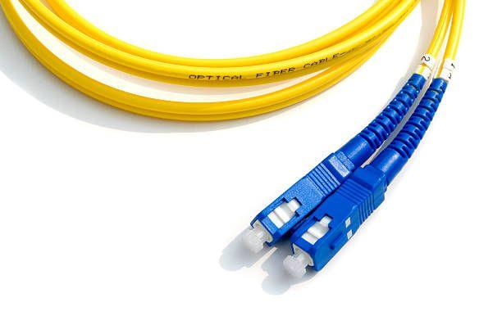
Figure 7 FIber Optic Cable
The fibre optic cable serves as the physical sensing medium of the system. The VFL laser is connected to one end of the cable, and the photodiode is positioned at the other end. Any physical event along the cable such as bending, pressing, vibration, or cutting causes a change in the optical power transmitted through the cable, which is detected as a change in the ADC value.

The fibre optic cable is deployed along the monitoring perimeter or test area. The cable transmits the 650nm red light from the VFL laser with low attenuation under normal conditions. When the cable is physically disturbed, micro-bending and macro-bending effects increase attenuation, reducing the light power received at the photodiode.

Key Specifications:
- Type: Single Mode Fibre Optic Patch Cable
- Connector: SC to SC Simplex
- Core/Cladding: 9/125μm
- Polish Type: UPC (Ultra Physical Contact)
- Application: Sensing medium for intrusion detection

VFL
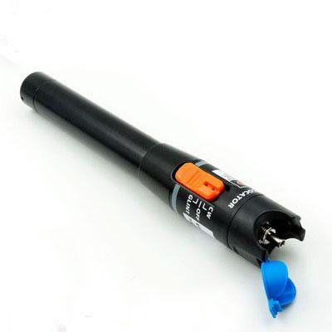
Figure 8 VFL 650nm Laser
The VFL (Visible Fault Locator) is a handheld laser source that injects a continuous 650nm red light beam into the fibre optic cable. It serves as the light source of the intrusion detection system, providing a stable and consistent optical signal that travels through the entire length of the fibre optic cable to the photodiode at the receiving end.

The VFL operates at 10mW output power, which provides sufficient optical power to travel through the fibre cable and produce a detectable analog voltage at the photodiode output. Under normal undisturbed conditions, the received optical power remains stable, producing a consistent ADC value at the ESP32 input. Any physical disturbance on the cable causes optical attenuation, which the photodiode detects as a reduction or fluctuation in the received signal.

Key Specifications:
- Wavelength: 650nm (red visible light)
- Output Power: 10mW
- Connector: SC compatible
- Operating Voltage: 3.3V
- Light Source: Semiconductor laser diode
- Application: Optical signal injection into fibre optic cable

Circuit Diagram
The circuit diagram illustrates the electrical connections between the ESP32 microcontroller, photodiode, LCD 1602A, piezo buzzer, potentiometer, and VFL laser. The ESP32 receives the analog signal from the photodiode on GPIO pin 34. The LCD is connected to GPIO pins 21, 22, 19, 18, 5, and 17 in 4-bit parallel mode.

The ESP32 sends control signals to the L298N motor driver, which drives the DC motors responsible for the robot’s movement. The entire system is powered by a battery through a regulated power supply circuit.

The circuit diagram for the complete hardware system is shown in Figure 7.

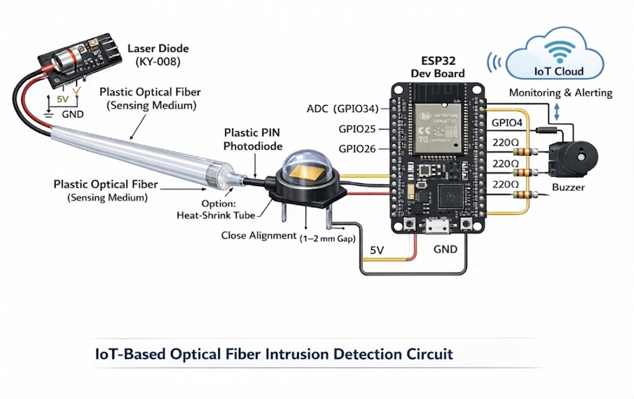

Figure 9 Circuit Diagram

5. Software Design and Algorithm

The software design of the IoT-based surveillance robot defines how the microcontroller processes sensor data, controls the robot’s movement, and transmits information to the monitoring device. The system is programmed using the Arduino IDE, where the ESP32 microcontroller is configured to read sensor inputs, perform decision-making operations, and control the motor driver accordingly.

The software architecture is divided into several functional modules including ADC signal acquisition, vibration analysis, event classification, output control, and wireless communication. These modules work together to ensure that the system can detect and classify physical disturbances on the fiber optic cable and transmit real-time data to the monitoring dashboard.

Programming Platform

The ESP32 microcontroller is programmed using the Arduino Integrated Development Environment (Arduino IDE). The program is written in Embedded C/C++ and uploaded to the ESP32 through a USB interface.

The software uses libraries including WiFi.h for network connectivity, WebServer.h for HTTP server hosting, WebSocketsServer.h for real-time bidirectional data streaming, and LiquidCrystal.h for LCD control. The ADC is configured with 12-bit resolution and 11dB attenuation using analogReadResolution(12) and analogSetAttenuation(ADC_11db) to support the full 0-3.3V input range.

Sensor Data Acquisition

The first stage of the software involves reading the ADC value from the photodiode on GPIO pin 34. The raw ADC reading is such that higher values represent higher received light intensity. The delta ADC (change between consecutive readings) is then calculated to detect instantaneous signal changes caused by vibrations or physical impacts on the cable.

The microcontroller continuously reads the ADC value at approximately 50Hz (20ms loop delay) and maintains a running vibration accumulator over a 700ms time window for walking and intrusion detection analysis.

Decision Logic

After collecting the ADC reading, the ESP32 processes the signal using a multi-level threshold classification algorithm. The algorithm evaluates both the absolute ADC value and the pattern of signal fluctuations to determine the event type.

If the ADC value is below 500, the system reports Fiber Fault (cable cut or disconnected). If the ADC value is between 500 and 1500, it reports Low Light (cable bent). If the delta ADC exceeds 300 in a single reading, it triggers Digging detection. Within the normal ADC range (1500-3000), the vibration sum is accumulated over a 700ms window: a sum exceeding 2000 triggers Intrusion (latched until reset), and a sum exceeding 420 triggers Walking detection.

Wireless Communication

The ESP32 includes a built-in Wi-Fi module that hosts both an HTTP server on port 80 and a WebSocket server on port 81. The HTTP server serves the tactical monitoring dashboard HTML page to any connected browser. The WebSocket server broadcasts JSON messages containing the current ADC value, event status label, and intrusion flag to all connected clients at each loop iteration.

This wireless connectivity enables real-time monitoring of the fiber optic cable from any device on the local Wi-Fi network. The web dashboard displays the live ADC value, event status, a scrollable 1000-point ADC history graph, and a BREACH indicator with visual and audio alarm when intrusion is detected.

Algorithm

The overall operation of the fibre optic intrusion detection system follows a sequential algorithm that continuously monitors the ADC signal and classifies physical events on the cable.
Step 1: Initialize ESP32, configure ADC (12-bit, 11dB attenuation), and set up LCD and buzzer GPIO pins.
Step 2: Connect to Wi-Fi network, start HTTP server and WebSocket server for dashboard communication.
Step 3: Read 12-bit ADC value from photodiode on GPIO 34 and compute value.
Step 4: Evaluate absolute ADC level: classify as Fibre Fault, Low Light, Normal, or High Saturation.
Step 5: Calculate delta ADC from previous reading; check for digging spike (delta >= 300).
Step 6: In Normal range, accumulate vibration sum over 700ms window; classify as Intrusion (sum >= 2000) or Walking (sum >= 420).
Step 7: Update LCD display row 1 with ADC value and row 2 with event status and activate or deactivate buzzer accordingly.
Step 8: Broadcast data (ADC, status, intrusion flag) via WebSocket and repeat loop every 20ms.

Flow of Operation
The software continuously runs in a loop where the ESP32 reads the ADC value, computes the delta, checks thresholds, and updates all outputs accordingly. This 20ms loop cycle ensures that the system responds rapidly to physical disturbances on the fiber optic cable while accumulating vibration data over the 700ms window for walking and intrusion classification.

Thus, the software design enables efficient integration of optical signal monitoring, multi-level event classification, output control, and wireless communication, allowing the intrusion detection system to operate continuously while providing real-time fiber cable status data to the monitoring dashboard.

6. Implementation
The implementation of the fiber optic intrusion detection system involves assembling hardware components, developing firmware for ADC signal acquisition and event classification, and establishing wireless communication for remote dashboard monitoring. The system was developed step by step to ensure proper functioning of each module before integrating them into the complete detection system.

Hardware Assembly
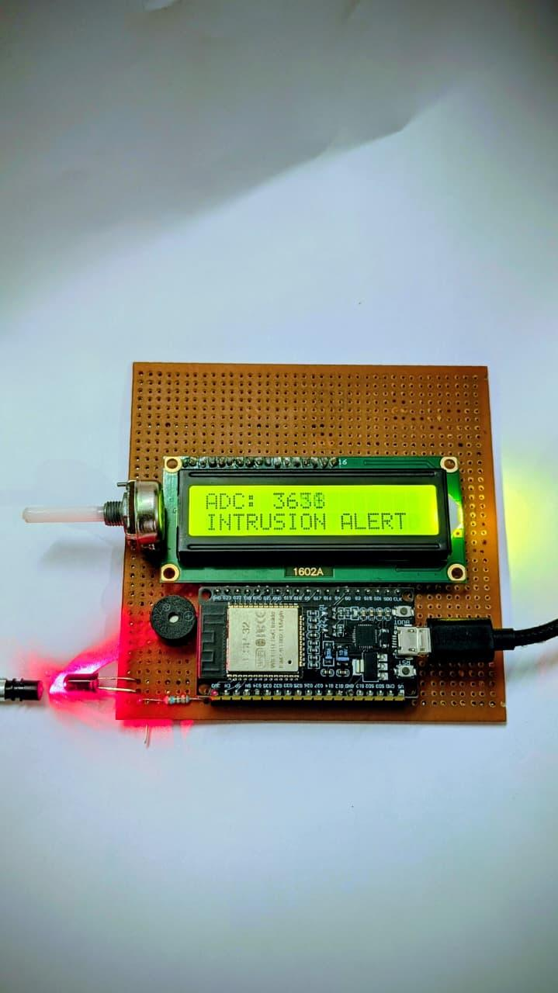
Figure 10 Hardware Assembly
The first step in the implementation process was assembling the hardware components on a breadboard or PCB. The ESP32 microcontroller was placed centrally, with the LCD, buzzer, and potentiometer connected to the appropriate GPIO pins as per the circuit diagram.

The VFL laser was connected to one end of the fibre optic cable, and the photodiode was positioned at the output end. The photodiode analog output was wired to GPIO pin 34 of the ESP32. The fibre optic cable was routed along the perimeter or test area where intrusion detection was required.

The LCD 1602A was connected to GPIO pins 21, 22, 19, 18, 5, and 17 using the LiquidCrystal library in 4-bit parallel mode. The piezo buzzer was connected to GPIO pin 23. The potentiometer wiper was wired to the VO pin of the LCD for contrast adjustment. The ESP32 was powered via USB from a laptop or USB power adapter.

Threshold Control
The ADC inversion formula (adcValue = 4095 - analogRead(ADC_PIN)) was implemented so that increasing light intensity produces increasing ADC values. Threshold constants were defined for Fiber Fault (below 500), Low Light (500 to 1500), Normal (1500 to 3000), and High Saturation (above 3000) conditions. Delta ADC and vibration sum logic were implemented for dynamic event detection.

Sensor Integration
The detection logic was then integrated and tested. The digging detection logic checks if the instantaneous delta ADC exceeds the DIGGING_SPIKE_THRESHOLD of 300, indicating a sudden large change consistent with an impact or digging event. The digging flag is set for 2 seconds then automatically cleared.
The walking and intrusion detection logic accumulates the delta ADC values over a 700ms time window (TIME_WINDOW_MS). At the end of each window, if the vibration sum exceeds 2000 (INTRUSION threshold), the intrusion Latched flag is set permanently. If the sum exceeds 420 (WALKING threshold), the walking Detected flag is set for 2 seconds before auto-clearing.
The intrusion latch mechanism ensures that once an intrusion is detected, the system remains in the alert state and the buzzer continues to sound until the operator physically presses the reset button on the ESP32. This prevents automatic clearing of critical security alerts.

IoT Communication Setup
The ESP32's built-in Wi-Fi module was used to establish wireless communication between the detection system and the monitoring dashboard. The microcontroller was programmed to connect to the configured Wi-Fi network (SSID and password set in firmware) and host a WebServer on port 80 and WebSocketsServer on port 81.

This IoT-based communication allows users to monitor the ADC signal level, event classification status, and intrusion alert state in real time through any web browser connected to the same Wi-Fi network as the ESP32.

System Integration
Once each module was tested individually, all hardware and software components were integrated to form the complete intrusion detection system. The ESP32 continuously reads the ADC value, processes it using the threshold classification logic, updates the LCD and buzzer outputs, and broadcasts the event data via WebSocket.

If an intrusion event is detected, the buzzer activates continuously and the web dashboard displays the BREACH alert with visual flashing and an optional browser-based siren alarm. All ADC readings are logged in the dashboard graph, allowing the operator to scroll back through the signal history to review the event pattern.

Testing and Validation
The final step involved testing the complete system under different simulated intrusion conditions. The fiber optic cable was subjected to walking footsteps, tapping, cable cutting, bending, and digging simulations to verify correct classification by the threshold logic. The wireless communication was also verified to confirm that ADC data and event status were correctly streamed to the dashboard.

The testing process confirmed that the system could correctly classify all five event types and that the intrusion latch mechanism functioned as designed, requiring a hardware reset to clear the alarm state.

7. Result and Testing
The developed fiber optic intrusion detection system was tested to evaluate its performance in terms of event classification accuracy, ADC threshold sensitivity, buzzer response, and wireless data transmission. Several tests were conducted to verify the functionality and reliability of each detection mode. The testing process ensured that the system could successfully classify physical disturbances on the fiber cable and deliver timely alerts.

The dashboard displays important parameters such as the live ADC value, current event classification status, intrusion threat level indicator, and a real-time ADC signal history graph. The results obtained from different test conditions are discussed below.

Dashboard Monitoring
A tactical web-based monitoring dashboard was developed to display real-time fiber optic sensing data. The ESP32 acts as a local HTTP and WebSocket server, serving the dashboard page and streaming live ADC data to any browser that connects to the ESP32's IP address on the local Wi-Fi network.

The dashboard includes control buttons for starting and stopping the monitoring system and displays the sensor readings dynamically.

Displayed Parameters:
- Live ADC value from photodiode
- Current event classification status (NORMAL / WALKING / DIGGING / INTRUSION / LOW LIGHT / FAULT)
- Threat level indicator (SECURE / BREACH)
- Scrollable ADC signal history graph (last 1000 samples)
- System uptime and live clock

The screenshots shown Figure 11, and Figure 12 illustrate different system states during testing.
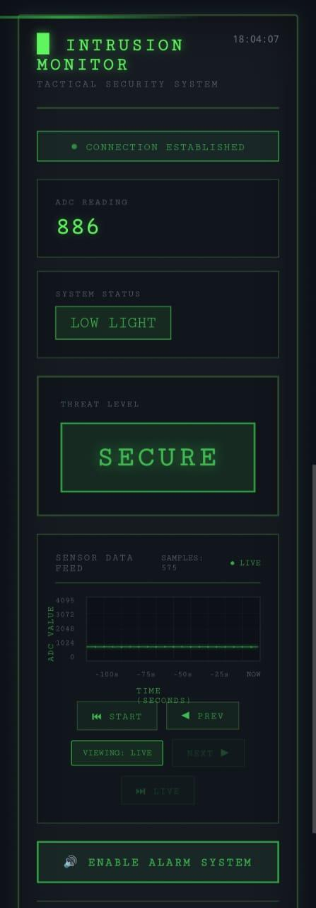  Figure 11 Dashboard output showing LOW LIGHT | 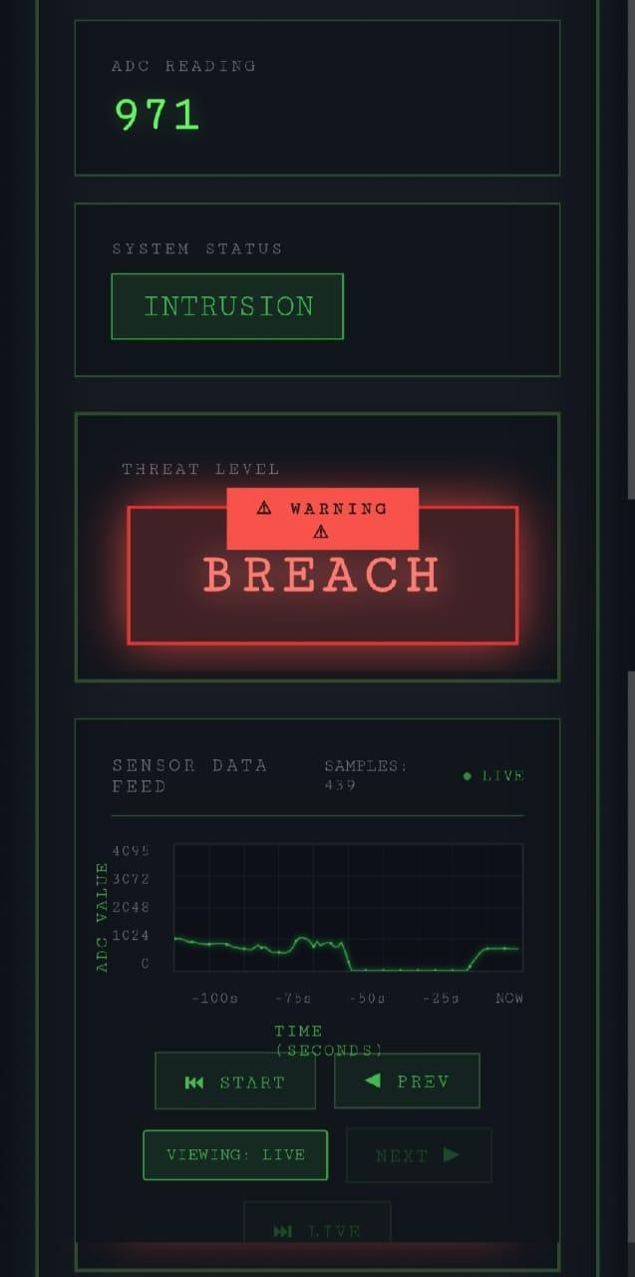  Figure 12 Dashboard output showing INTRUSION

System Performance
The testing results show that the system can effectively classify all five event types with good accuracy under controlled test conditions. The ESP32 processed ADC readings and transmitted event data to the web dashboard with minimal latency over the local Wi-Fi network.

The threshold-based classification correctly identified cable cuts (Fiber Fault), cable bends (Low Light), footstep vibrations (Walking), sharp impacts (Digging), and sustained disturbances (Intrusion) during testing. The intrusion latch functioned correctly, maintaining the alarm state until a manual reset was performed. The web dashboard provided a convenient real-time interface for observing the ADC signal and event classifications.

Overall, the developed system performed reliably and demonstrated its capability as an IoT-enabled fiber optic intrusion detection and perimeter monitoring system.

8. Applications
The fiber optic intrusion detection system can be used in several areas where passive, long-range, and tamper-resistant monitoring is required. Major applications include:

• Border Security Monitoring: Monitoring remote or restricted areas for unusual activities and environmental conditions.

• Industrial Safety Monitoring: Detecting harmful gases and monitoring air quality in factories and industrial plants.

• Home and Building Security: Monitoring indoor environments and detecting human presence and environmental conditions.

• Environmental Monitoring: Observing gas concentration and temperature levels in sensitive environments such as laboratories.

• Disaster Management: Collecting environmental data in hazardous areas such as fire zones or gas leakage locations to assist rescue teams.

9. Limitations
Despite its advantages, the developed system has some limitations:

- ADC Sensitivity Limitations: The 12-bit ADC may not detect very subtle disturbances or long-distance vibrations that cause minimal optical power change.

- Wi-Fi Dependency: The system relies on Wi-Fi connectivity for dashboard monitoring, which may be unavailable in remote outdoor deployments without additional networking infrastructure.

- False Alarm Susceptibility: Environmental vibrations from wind, vehicle traffic, or machinery near the cable may trigger false walking or digging detections if thresholds are not tuned correctly.
- Fixed Threshold Logic: The current threshold values (NO_LIGHT_MAX, DIGGING_SPIKE_THRESHOLD, etc.) are static constants and do not adapt automatically to changing environmental conditions or different cable types.

10. Future Scope
The functionality of the proposed fibre optic intrusion detection system can be further enhanced in the following ways:

- Machine Learning Classification: Integration of machine learning models trained on ADC signal patterns to improve classification accuracy and reduce false alarms.
- Adaptive Threshold Calibration: Implementing automatic threshold adjustment algorithms that adapt to the specific fibre cable type and deployment environment.
- Multi-Zone Monitoring: Expanding the system to monitor multiple fibre optic cable segments simultaneously using multiplexed photodiode inputs or multiple ESP32 nodes.
- Cloud Data Storage and Logging: Storing ADC readings and detection events on cloud platforms for long-term analysis, forensic review, and remote alerting via email or SMS.
- OTDR Integration: Integrating Optical Time Domain Reflectometry for precise location pinpointing of disturbance events along the cable length.
- LoRa or Cellular Connectivity: Adding LoRa or 4G/5G modules to enable remote monitoring of the system in areas without Wi-Fi infrastructure coverage.
areas.

11. Conclusion
In this project, a fiber optic intrusion detection system was successfully designed and developed using the ESP32 microcontroller, a photodiode, and a VFL laser source. The system is capable of detecting five distinct physical event types on the fiber optic cable: Fiber Fault, Low Light, Walking, Digging, and Intrusion, while transmitting real-time ADC data and event classifications to a tactical web-based dashboard through Wi-Fi using WebSockets. The testing results showed that the system can effectively classify physical disturbances and deliver timely alerts including a latched intrusion alarm that requires manual reset. Overall, the project demonstrates how fiber optic sensing combined with IoT technology can provide a cost-effective, passive, and tamper-resistant solution for real-time perimeter intrusion detection and physical security monitoring.

12. References
[1] G. A. Allwood, G. Wild, and S. Hinckley, "Optical Fiber Sensors in Physical Intrusion Detection Systems: A Review," IEEE Sensors Journal, vol. 16, no. 14, pp. 5497–5509, 2016. [Online]. Available: https://ieeexplore.ieee.org/document/7421944
[2] Z. Wang et al., "Distributed Fiber-Optic Sensors for Vibration Detection," Sensors, vol. 16, no. 8, p. 1164, Aug. 2016. [Online]. Available: https://www.mdpi.com/1424-8220/16/8/1164
[3] A. Vikram, S. K. Patel, and O. Alsalman, "Measurement of Optical Fiber Sensors for Intrusion Detection and Warning Systems Fortified with Intelligent False Alarm Suppression," Optical and Quantum Electronics, vol. 56, p. 939, 2024. [Online]. Available: https://doi.org/10.1007/s11082-024-06797-7
[4] H. Wu et al., "Field Test of a Fully Distributed Fiber-Optic Intrusion Detection System for Long-Distance Security Monitoring of National Borderline," Proceedings of SPIE, vol. 9157, 2014. [Online]. Available: https://www.researchgate.net/publication/288295595
[5] V. Dorofeev et al., "Fiber Optic Based Distributed Mechanical Vibration Sensing," Sensors, vol. 21, no. 14, p. 4779, Jul. 2021. [Online]. Available: https://www.mdpi.com/1424-8220/21/14/4779
[6] "Fiber-optic sensor," Wikipedia, Oct. 2025. [Online]. Available: https://en.wikipedia.org/wiki/Fiber-optic_sensor
[7] T. Lojka, M. Misuf, and I. Zolotova, "Smart Home Monitoring System Using ESP32 Microcontrollers," IntechOpen, Nov. 2020. [Online]. Available: https://www.intechopen.com/chapters/74005
[8] "ESP32 WebSocket: Real-Time Communication for IoT," VideoSDK, 2025. [Online]. Available: https://www.videosdk.live/developer-hub/websocket/esp32-websocket
[9] "ESP32 WebSocket Server: Monitor Sensor Data on a Webpage," ArduinoYard, Mar. 2025. [Online]. Available: https://arduinoyard.com/esp32-websocket-server/
[10] "Technical Report: IoT Applications with the ESP32," ESP32 Application Notes, Apr. 2025. [Online]. Available: https://esp32appnotes.com/technical-report-iot-applications-with-the-esp32/
[11] M. Nedoma et al., "Optical Fibre-Based Sensors — An Assessment of Current Innovations," PMC / MDPI Sensors, Sep. 2023. [Online]. Available: https://pmc.ncbi.nlm.nih.gov/articles/PMC10526340/
[12] "Reliable Distributed Fiber-Optic Intrusion Sensor System," FiberStrike, 2023. [Online]. Available: https://fiberstrike.com/fiber-optic-intrus++++++++ion-detection-physical-security-monitoring/

