AHB VIP Verification Plan
1. Introduction
AMBA AHB (Advanced High-performance Bus) is an on-chip communication protocol introduced by ARM as part of the Advanced Micro-controller Bus Architecture (AMBA) specification. It is designed for high-speed, high-bandwidth, and high-clock-frequency system modules in System-on-Chip (SoC) designs. An AHB verification plan defines the features to verify, stimulus to generate, assertions to implement, and functional coverage required to demonstrate that the design complies with the protocol specification.

2. Verification Objective
- Verify correct AHB transfer behavior for all supported transfer types.
- Verify address and data phase timing.
- Verify single and burst transfers.
- Verify HREADY wait-state handling and HRESP response behavior.
- Verify correct handling of HTRANS, HBURST, HSIZE, and HWRITE.
- Verify back-to-back transfers.
- Achieve functional and code coverage closure.
- Check protocol compliance using assertions and a reference model.

3. Verification Testbench
Testbench Methodology: UVM based
Architecture:
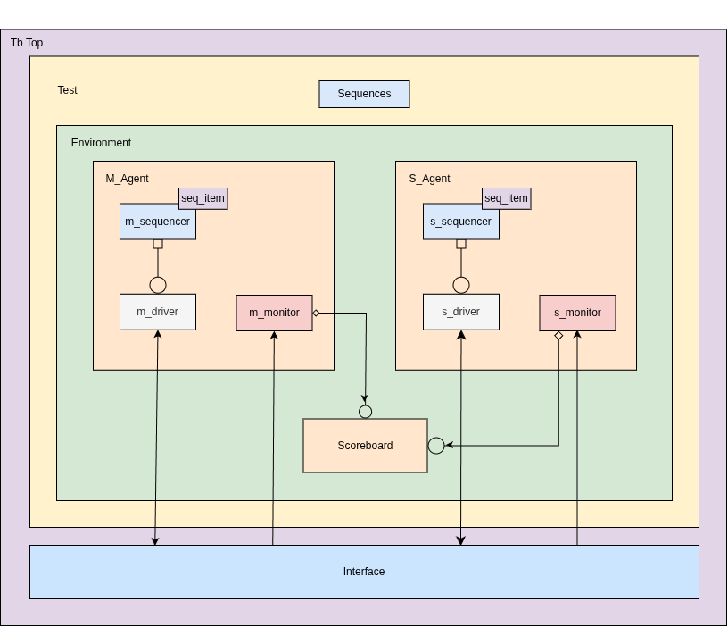

Testbench Top:
- Clock and reset generation - HCLK and HRESETn
- Interface instantiation - ahb_if
- config db registration - uvm_config_db
- starting simulation - run_test

Test: Builds environment, start the sequences and manage simulation objections.
- Sequences: It creates and randomizes (stimulus generation) the data inside sequence item and send to driver via sequencer. Sequences(different scenarios) are inherited from base sequence.

Environment: Encapsulates Master agent, slave agent, scoreboard and coverage.
- AHB Master Agent: It encapsulates sequencer, driver and monitor.
- Driver drives the stimulus to interface like address, control signals and write data.
- Monitor samples the signal from interface and broadcasts completed transaction via uvm_analysis_port.
- Sequencer routes generated sequence item to the driver.
- AHB Slave Agent:
- Driver responds to transactions and drives the read data, ready and response signals and memory is also initialized in this driver.
- Monitor samples the signal from interface and broadcasts completed transaction via uvm_analysis_port.
- Sequencer routes generated sequence item to the driver.

- Scoreboard: Compares expected vs actual results. It also includes the reference memory which act as a expected results.
- Coverage: Coverage sampling, bins, and cross coverage.

Interface: Act as a bridge between Master and Slave.
- Assertions: Cycle-level protocol rule checking.

4. Verification Strategy
The AHB VIP will be verified using a UVM-based testbench consisting of master and slave agents, monitors, a scoreboard, functional coverage in the environment, and protocol assertions in the interface.

- Test Plan:
The test plan defines the test scenarios used to verify AHB VIP functionality and protocol behavior. Test_Plan

Test scenario | Verification objective
Single read test | Verify read transaction generation and monitoring
Single write test | Verify write transaction generation and monitoring
Back-to-back transfers | Verify pipelined transaction handling
Transfer size test | Verify all supported transfer sizes
Burst transfer test | Verify supported burst types and beat sequencing

- Coverage Plan:
The coverage plan defines the functional coverage points and combinations needed to demonstrate that the required AHB features have been exercised. Coverage is implemented in the UVM environment.

Coverage feature | Coverage goal
Transfer type | Cover all applicable transfer types
Transfer direction (HWRITE) | Cover reads and writes
Transfer size (HSIZE) | Cover all supported sizes
Burst type (HBURST) | Cover all supported burst types
Wait states (HREADY) | Cover zero and multiple wait states
Response (HRESP) | Cover applicable successful and error responses
Address regions | Cover configured address ranges and boundaries
Direction × size | Cover required read/write and size combinations
Burst × size | Cover legal burst and size combinations

5. Simulation

Simulation option | Description | Expected result
Compilation | Compile the AHB VIP UVM testbench using Makefile | Compilation completes without errors
Test selection (sequence selection) | Select a sequence using a Makefile variable | Selected UVM sequence executes
Random seed | Pass random seed through Makefile | Simulation runs with the specified seed
Assertion control | Enable/disable assertions through simulation options | Assertions behave according to configuration
Coverage control | Enable functional coverage collection | Coverage data is generated
Waveform generation | Enable waveform dumping through Makefile | Waveform file is generated
Regression | Execute multiple sequences using Makefile | All selected sequences execute and results are reported
Clean | Clean generated simulation files | Temporary and generated files are removed

- Run the code: Make command Makefile
Example: make sim seed=100 child=ahb_burst WAVE=1
sim target will first run the target compile then run the simulation command. Seed will 100 and the sequence (test cases) which we have to run selected by child, for waveform WAVE=1 so that will verify through simulation.
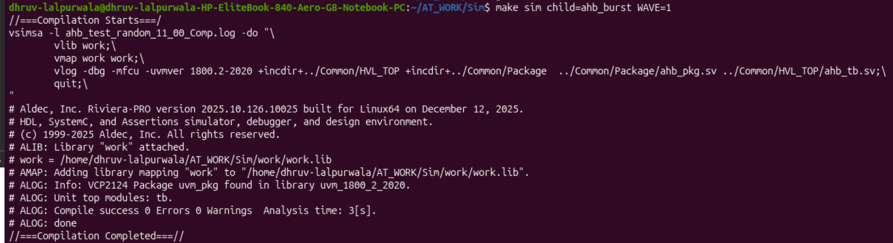Figure 1: Compilation
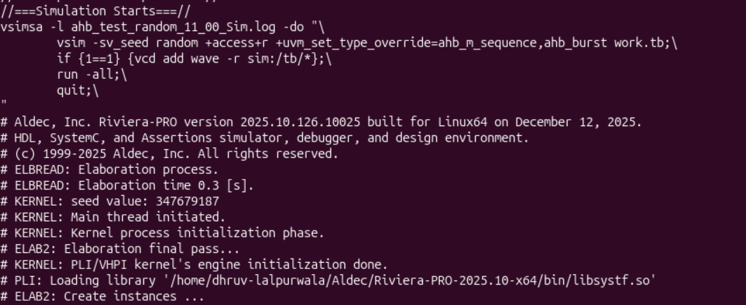Figure 2: Simulation

- Debug Strategy:

Debug method | Description
Simulation log analysis | Analyze simulation logs to identify UVM errors, warnings, and fatal messages
Waveform debugging | Analyze AHB signals to identify protocol timing issues
Transaction debugging | Check transactions generated by the master and slave agents
Scoreboard debugging | Analyze expected and actual transaction mismatches
Assertion debugging | Identify protocol violations reported by interface assertions
Coverage debugging | Identify uncovered bins and missing test scenarios
Random seed debugging | Reproduce failures using the same random seed
Driver debugging | Check driver signal generation and handshake behavior
Monitor debugging | Verify correct sampling and transaction reconstruction
Regression debugging | Analyze failed tests from regression logs

