PHASE 1 – PROJECT PROPOSAL
Research Gap Analyser
A Cross-Paper Synthesis Assistant using LangChain
1. Activity
Activity 1 – RAG-Based Domain Assistant
2. Problem Statement
Literature reviews require researchers to read multiple papers and identify recurring limitations, compare approaches, and determine which problems remain unresolved. A conventional RAG system can answer questions such as “What does Paper A say?”, but it is less useful for questions that require synthesis across several papers. This project proposes a RAG-based assistant that analyzes a small collection of research papers and synthesizes information across them to identify recurring limitations, compared approaches, unresolved problems, and proposed future work.
3. Proposed Solution
The Research Gap Analyser will use LangChain and retrieval-augmented generation (RAG) to retrieve relevant evidence from multiple research papers. Instead of treating each paper independently, the system will organize retrieved evidence on a per-paper basis and then combine it to produce a cross-paper synthesis. The final response will present identified research gaps together with the papers and evidence supporting them.
4. Data Source
- 4–5 open-access research papers in PDF format.
- Papers will be selected around [specific research topic].
- The selected papers should overlap sufficiently in methods, problems, or limitations to support cross-paper comparison.
- The references section will be removed during preprocessing to reduce irrelevant retrieval.
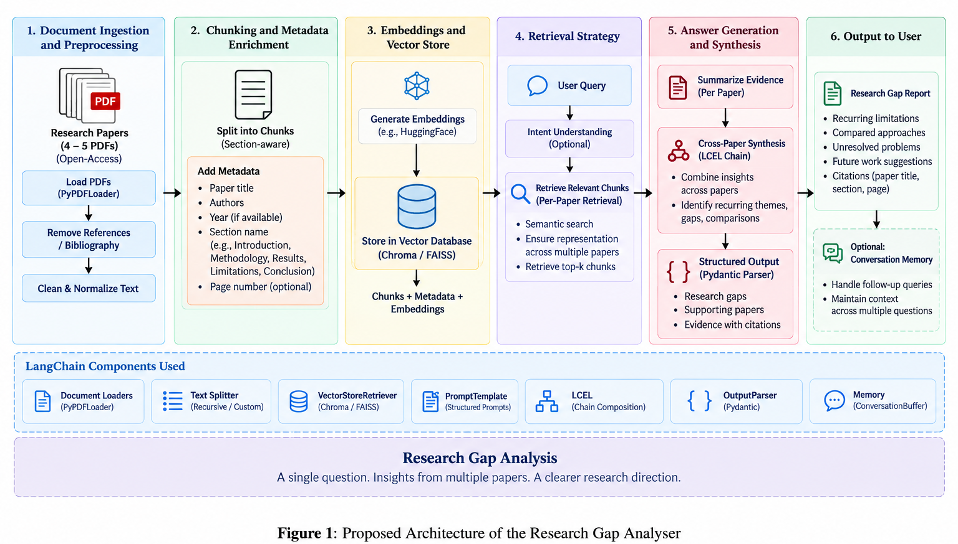
5. Proposed Architecture / Workflow
- PDF ingestion and preprocessing, including removal of the references section.
- Document chunking, with metadata attached to each chunk such as paper title and relevant section (e.g., limitations, conclusion, or future work).
- Embedding generation and storage in a vector store such as FAISS or Chroma.
- Per-paper retrieval for each query so that evidence from one paper does not dominate the final synthesis.
- LCEL-based chain composition: retrieve evidence → summarize relevant evidence for each paper → combine summaries across papers.
- Structured output using a Pydantic-based output parser, containing the identified gap, papers mentioning it, and supporting evidence.
6. LangChain Components
- PromptTemplate – for consistent research-analysis prompts.
- LCEL / Chain Composition – for connecting retrieval, per-paper analysis, and cross-paper synthesis.
- VectorStoreRetriever – for retrieving relevant evidence from the paper corpus.
- OutputParser (Pydantic) – for generating structured and consistent research-gap outputs.
- Conversation Memory – for supporting follow-up questions within a session.
7. Example Queries
- “What limitations are repeatedly mentioned across the papers?”
- “Which approaches or methods are compared?”
- “What problems remain unresolved?”
- “What future work do the authors propose?”
- “Which research gaps appear across multiple papers, and what evidence supports them?”
8. Evaluation Plan
The system will be tested using at least five questions covering both direct retrieval and cross-paper synthesis. One test case will intentionally represent a poor retrieval or generation scenario. Responses will be manually checked against the source papers to determine whether the identified gaps are supported by retrieved evidence and whether the final synthesis is grounded in the documents.
9. Expected Output
- A concise list of research gaps identified across the selected papers.
- The papers in which each gap or limitation is discussed.
- Supporting evidence retrieved from the relevant paper sections.
- A distinction between gaps explicitly stated by authors and patterns inferred from multiple papers, where applicable.
10. Team Roles
- Dhruv Marwal – Document ingestion, preprocessing, and chunking.
- Priyanshu Jha – Embeddings, vector store, retrieval, and LCEL chain.
- Shivang Jain – Structured output, evaluation, testing, report, and demo/video.
The roles are preliminary and may be adjusted during implementation based on workload.

11. Timeline
Phase | Planned Work
Phase 1 – 19 Sep | Finalize topic, paper corpus, problem definition, and architecture.
Phase 2 – 23 Sep | Complete ingestion and retrieval; demonstrate a working per-paper retrieval/answer pipeline.
Phase 3 – 30 Sep | Complete cross-paper synthesis, structured output, evaluation, demo video, and technical report.
12. Expected Learning / Value
The project demonstrates how RAG can be extended beyond simple document question-answering to support multi-document synthesis. It provides practical experience with document preprocessing, metadata-aware retrieval, vector stores, LCEL pipelines, structured LLM outputs, and evaluation of grounded responses.
13. Initial Topic
Research topic: [To be finalized]

