Plot1:Distribution of Events by Hour

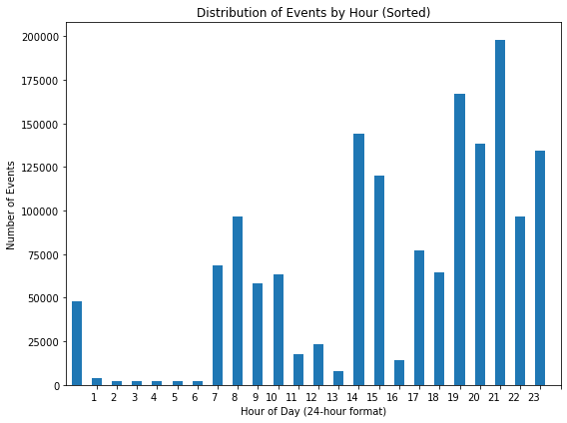

Observation: Clearly number of events is lower in the morning and clearly there is a peak as one approaches night post 19:00. But there is a clear decline observed during early morning hour post midnight.

Plot2:Share of programs in Log Messages

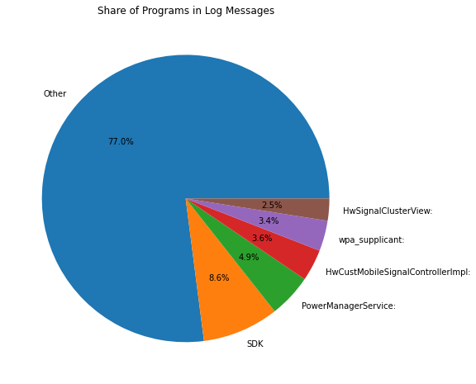

Observation: The top 5 programs account for a very small proportion of the total share.

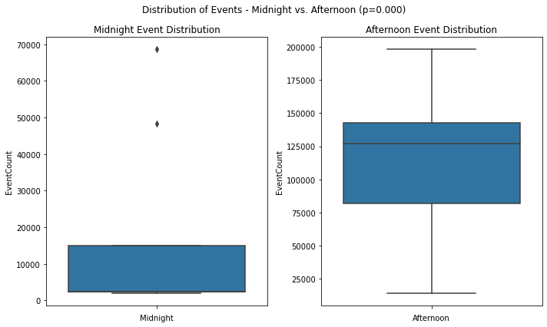

Observation: On an average, number of events higher post-afternoon time window as compared to post-midnight time window and therefore the null-hypothesis is rejected.

Variability is higher in the post-afternoon than the midnight so the assumption of equal variance maybe problematic.

Also there are outlier in the post-midnight time window..

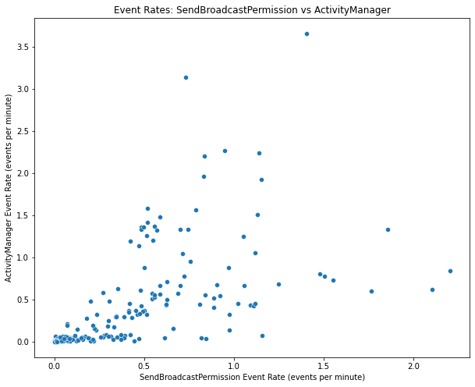

Observation: Event rates very close..

Bugs in the Linear fit model..