|  |  |  |
| --- | --- | --- |
| a6 | House floor type | Nominal |
| cageg | Child's age | Numeric Interval |
| fidg | Family monthly income (USD) | Numeric Boolean |
| b10 | AN Care visit times during pregnancy | Numeric |
| d1 | main source of drinking water | Nominal |
| d6 | Toilet facility type | Ordinal |
| e3 | Main Food | Nominal |
| e4 | Minimum dietary diversity at least 4 out of 8 food groups | Numeric Boolean |
| stunting | Childhood stunting | Numeric Boolean |

Types of Data

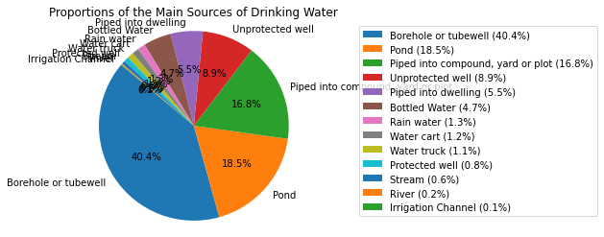

Observations:

Most people use borewells and ponds (basically proximity of sources is very low).

Observations:

Flush to pit Latrine toilets are the most common.

5.

(a)

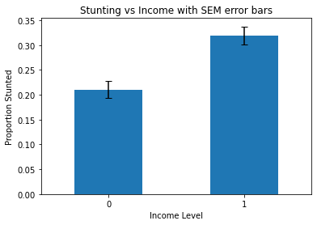

• Null Hypothesis (H0): There is no association between the occurrence of childhood stunting and family income.

• Alternate Hypothesis (H1): There is an association between the occurrence of childhood stunting and family income.

Observation: From the plot it is clearly visible that stunting is associated with income level. Higher Proportion stunted have low income.

(b)I am using logistic regression.

The abstract shows that dietary diversity below a certain threshold is associated with low stunting.

Agrees with what abstract is saying. Have a look at the plot.

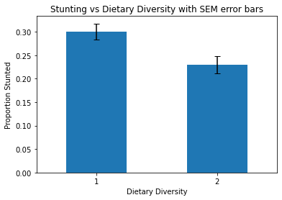

(c)

However, ANOVA assumes that the dependent variable is continuous and normally distributed within each group and that there's homogeneity of variances between the groups. Since the dependent variables binary and these assumptions needn’t be true, a test like Chi Square Test for independence would be much better.