|  |  |  |
| --- | --- | --- |
| Name | Meaning | Type of Data |
| Date | Experimental Day | Numeric |
| Vial | Individual ID | Nominal |
| Treat | Stress Treatment | Ordinal |
| Protein | % of protein in diet | Numeric |
| Rep | replicate number for treatment and diet groups | Numeric |
| Dead | whether fly was dead on experimental day (“Date”) | Nominal |
| Smurf | measure of gut integrity | Ordinal |
| Eggs | number of eggs in vial | Numeric |
| Unhatched | Out of the total eggs how many unhatched? | Numeric |
| Hatched | Out of the total eggs how many hatched? | Numeric |
| NG | Measure of escape ability | Ordinal |

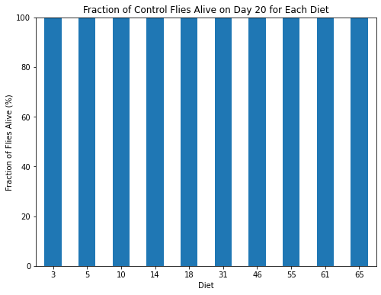

Observations:

All flies in the control group survived until day 20, irrespective of the dietary restriction.

4.

1.

Null Hypothesis (H0): The average lifespan of unharmed (control) flies is the same across all different protein content diets.

Alternative Hypothesis (H1): The average lifespan of unharmed (control) flies differs between at least two different protein content diets.

Observations:

There seems to be a relationship between average life span for control flies different protein content diets…If you look at the control flies bargraph data until 20 days it clearly seems that lifespan has nothing to do with survival rate at all which is also confirmed by looking at this box plot...the variability creeps once we bump up the no. of days to around 100.

2.

Null Hypothesis (H0): There is no difference in the average lifespan of control and injured flies on a low protein (<30%) diet.

Alternative Hypothesis (H1): There is a difference in the average lifespan of control and injured flies on a low protein (<30%) diet.

Observation: From the plot it is clearly visible that there is no significant difference, weakly supporting H0.

3.

Null Hypothesis (H0): There is no difference in the average lifespan of injured and infected flies on a low protein (<30%) diet.

Alternative Hypothesis (H1): There is a difference in the average lifespan of injured and infected flies on a low protein (<30%) diet.

Observation: Average life span of infected flies is lower on an average for low protein(<30%) diet.

4.

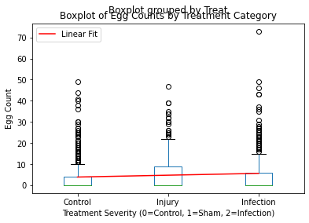

Null Hypothesis (H0): The severity of the treatment (control, injury, infection) has no effect on the fecundity of the subjects on a low protein (<30%) diet.

Alternative Hypothesis (H1): The severity of the treatment affects the fecundity of the subjects on a low protein (<30%) diet, with fecundity decreasing as the severity of treatment increases.

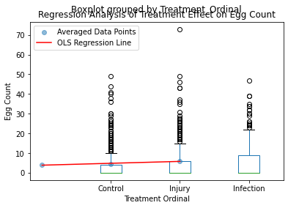

Observation: Too many outliers to conclude anything of significance. Was there a delay in egg production with as no. of days increased? I think so because of the linear decay in control..However the claim is not statistically significant.