SVKM’S NMIMS
MPSTME, Mumbai Campus
Academic Year 2026–2027
DEPARTMENT OF COMPUTER ENGINEERING
SOFTWARE ENGINEERING
FINAL PROJECT REPORT
PERSONAL
BUDGET PLANNER

A Web Application for Personal Budgeting
Expense Tracking and Financial Planning
Submitted By
Dhruv Mehta | C-169 | SAP 70322200180
Moksh Soni | C-183 | SAP 70322200111
Program: BTI CE | Year: V | Semester: IX
Division: D | Batch: D2
Submission Date: 15 October 2026
Guide: Dr. Ravita Mishra

TABLE OF CONTENTS
CHAPTER 1: INTRODUCTION 1
1.1 Background and Motivation 1
1.2 About Personal Budget Planner 1
1.3 Target Audience 1
CHAPTER 2: OBJECTIVES AND SCOPE 2
2.1 Core Project Objectives 2
2.2 Scope of the System 2
CHAPTER 3: LITERATURE SURVEY AND MARKET ANALYSIS 3
3.1 Existing Approaches to Personal Budgeting 3
3.2 Design Implications 3
CHAPTER 4: PROPOSED SYSTEM ARCHITECTURE AND DESIGN 4
4.1 System Architecture 4
4.2 Data Flow Diagram 5
4.3 Use Cases and Actor Interactions 5
CHAPTER 5: SOFTWARE ENGINEERING AND SDLC METHODOLOGY 6
5.1 Iterative and Incremental Model 6
5.2 Modularity and Change Control 6
CHAPTER 6: DATABASE DESIGN AND SCHEMA SPECIFICATIONS 7
6.1 Entity Structure 7
6.2 Relationships and Integrity 8
CHAPTER 7: ALGORITHMIC LOGIC AND CALCULATION ENGINES 9
7.1 Priority Based Budget Allocation 9
7.2 Savings and Goal Calculations 10
7.3 Investment Valuation 10
CHAPTER 8: HARDWARE AND SOFTWARE REQUIREMENTS 11
8.1 Development Environment 11
8.2 Software Stack 11
8.3 Installation and Configuration 11
CHAPTER 9: SYSTEM IMPLEMENTATION AND PROTOTYPE MODULES 12
9.1 Authentication and Dashboard 12
9.2 Income and Expense Management 13
9.3 Budgets and Fixed Commitments 14
9.4 Savings Goals 15
9.5 Bill Calendar 16
9.6 Investment Portfolio 17
9.7 Reports and Settings 18
CHAPTER 10: SOFTWARE TESTING VALIDATION AND RESULTS 19
10.1 Testing Strategy and Evidence 19
10.2 Representative Regression Cases 20
10.3 Validation Demonstration 21
10.4 Valid Input and Testing Limits 22
CHAPTER 11: ADVANTAGES LIMITATIONS AND ETHICAL CONSIDERATIONS 23
11.1 Key Advantages 23
11.2 System Limitations 23
11.3 Data Security and Ethical Considerations 23
CHAPTER 12: CONCLUSION AND FUTURE ROADMAP 24
12.1 Concluding Summary 24
12.2 Future Roadmap 24
REFERENCES AND PROJECT ARTIFACTS 25
Project Artifact Index 25

CHAPTER 1: INTRODUCTION

1.1 Background and Motivation
Personal financial records often spread across bank statements, payment histories and informal notes. A person may know the balance in an account but still lack a clear view of recurring commitments, discretionary spending and progress towards savings goals. Manually combining these records each month makes it difficult to compare spending with a plan and identify overdue obligations.
Personal Budget Planner brings these activities into one web application. Users record their income and expenses, assign priorities to budget categories, maintain savings goals and review financial summaries. The project focuses on transparent calculations and consistent records so that every displayed balance can be traced to saved transactions.

1.2 About Personal Budget Planner
The application uses a React interface, an Express REST API and a MySQL relational database. It includes authentication, a dashboard, income and expense tracking, fixed commitments, budget recommendations, a bill calendar, an investment portfolio, savings goals, reports and profile settings. A validation panel demonstrates the same input rules used by the backend.
Budget recommendations use deterministic priority weights. Linked Indian stocks and mutual funds can use external quotes for valuation, while unsupported assets retain manual valuations. The system records financial activity and planning decisions; it does not initiate bank transfers or execute investment trades.

1.3 Target Audience
The intended users are students managing allowances, salaried individuals planning recurring bills, freelancers recording multiple income sources and individuals saving towards specific purchases or an emergency fund. Each account has its own records and preferences. The application also serves as a software engineering project demonstrating a layered web architecture, relational modelling and regression testing.

CHAPTER 2: OBJECTIVES AND SCOPE

2.1 Core Project Objectives
- Consolidate financial records: provide create, read, update and delete operations for income, expenses, goals, investments and reminders, with monthly filtering.
- Make budgets explainable: allocate available income between fixed requirements and variable categories using explicit priority weights and exact monetary rounding.
- Support savings planning: show goal progress, remaining amounts, required monthly saving and contribution suggestions capped at each goal target.
- Track obligations: show bills by due date, distinguish partial and complete payments, and prevent duplicate calendar payments.
- Provide useful portfolio information: retain historical purchase cost, identify supported instruments and calculate unrealized changes from available market quotes.
- Improve data quality: enforce shared backend validation, account ownership checks and parameterized database access.
- Present financial summaries clearly: display monthly trends, category distribution and in-app alerts through a responsive interface.

2.2 Scope of the System
In scope are individual accounts, manually entered transactions, fixed and variable expense categories, category budgets, recurring and one-time reminders, savings goals, portfolio records and browser-based reports. The backend provides reusable financial calculations through REST endpoints. The interface supports saved light and dark themes.
Out of scope are direct bank synchronization, payment execution, brokerage trading, tax filing, household roles, offline synchronization and automated email or push reminders. Changing a display currency does not provide foreign-exchange conversion. Live investment updates are restricted to the supported INR stock and mutual-fund workflow.

CHAPTER 3: LITERATURE SURVEY AND MARKET ANALYSIS

3.1 Existing Approaches to Personal Budgeting
Paper records and spreadsheets provide flexible ways to record spending. Their effectiveness depends on how regularly a user enters transactions, maintains formulas and reviews totals. A spreadsheet can implement a sophisticated plan, but validation and consistent treatment of dates, rounding and categories must be designed explicitly.
YNAB describes a budgeting method that assigns available money to priorities and encourages planning for future needs [1]. This provides a useful conceptual comparison with category planning. Personal Budget Planner implements its own priority-weighted allocation method; the comparison concerns budgeting approaches rather than a claim of equivalent commercial features.
Aspect | Paper records | Custom spreadsheet | Personal Budget Planner
Monthly totals | Manual addition | Configured formulas | Backend aggregation
Category planning | Written allocation | User-designed formulas | Fixed needs and priority weights
Input validation | Manual review | Depends on workbook rules | Shared server-side rules
Savings goals | Separate notes | Custom goal worksheet | Progress and capped suggestions
Bill tracking | Calendar or diary | Custom due-date columns | Reminders and payment linkage
Account separation | Separate records | File access controls | Authenticated user ownership
Portfolio values | Manual updates | Manual or custom integration | Supported quote lookup and manual assets

3.2 Design Implications
The project combines transaction recording with planning rather than relying on a single balance figure. The main design priorities are an understandable allocation algorithm, consistent validation and clear handling of unavailable market data. React components support reusable interface elements [2], Express organizes API routes and middleware [3], and MySQL provides relational storage and constraints [4].

CHAPTER 4: PROPOSED SYSTEM ARCHITECTURE AND DESIGN

4.1 System Architecture
The system separates presentation, application logic and persistence. The React client uses Axios to request data from the Express API. Authentication middleware checks bearer tokens and loads the current user before protected operations. Controllers coordinate input validation, financial utilities and model methods. Models access MySQL through the mysql2 driver with parameterized SQL.
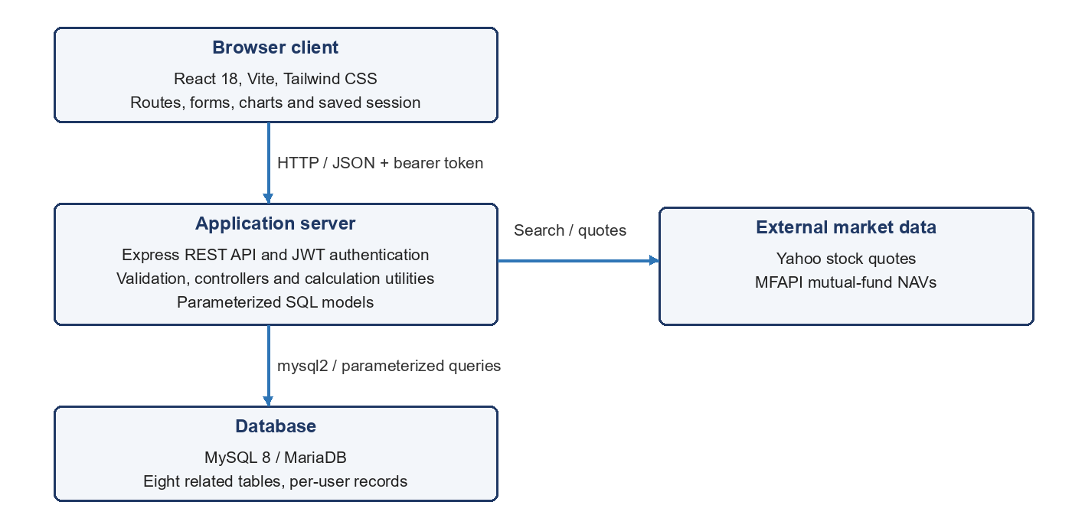
Figure 4.1 Three-tier architecture and external market-data services
The backend is the authority for budget allocation, goal projections and saved portfolio valuations. Keeping this logic separate from React components allows another client to reuse the same rules. External providers supply instrument identification and prices; they do not receive the user's complete transaction ledger through the quotation workflow.

4.2 Data Flow Diagram
At context level, the user supplies credentials, transaction details and planning inputs. The application returns summaries, budget recommendations, reminders and portfolio information. External market-data providers exchange instrument searches and quotes with the server.
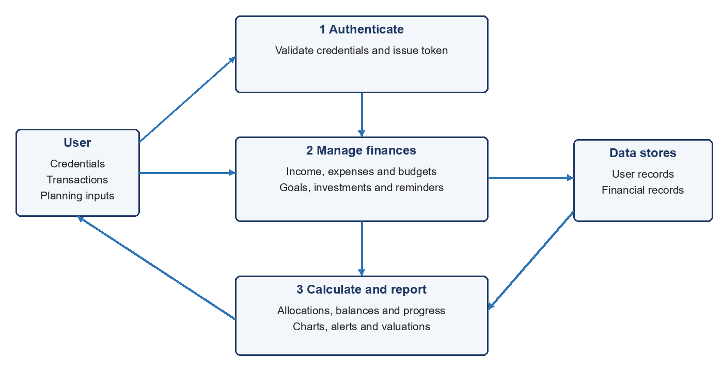
Figure 4.2 Level 1 data flow for authentication, records and reports

4.3 Use Cases and Actor Interactions
Actor | Main interactions | System response
Registered user | Sign in; manage transactions, budgets, goals and reminders | Validate inputs, check ownership and persist records
Registered user | Review dashboard, reports and portfolio | Aggregate records and return calculated summaries
Market-data provider | Respond to instrument searches and price requests | Return supported quote data or a handled failure

For an expense submission, the API validates the amount and date, verifies that the category belongs to the signed-in user, saves the record and exposes the updated total to reports. Failed validation returns field-specific errors without saving the invalid record.

CHAPTER 5: SOFTWARE ENGINEERING AND SDLC METHODOLOGY

5.1 Iterative and Incremental Model
An iterative and incremental model is suitable for this project because the core transaction workflow can operate before all planning and reporting modules are complete. Each increment can extend the schema and API, add its interface and introduce focused tests. The existing QA record documents defects followed by fixes and regression checks, which supports this feedback-driven approach [6].
The following development stages organize the system into verifiable increments. They describe the engineering workflow and deliverables without assigning unrecorded sprint dates or team responsibilities.
Stage | Engineering work | Verification focus
Requirements and design | Define users, financial definitions, scope and relational entities | Agree on data fields and acceptance cases
Core foundation | Implement accounts, protected routes and transaction storage | Registration, login, ownership and CRUD
Planning modules | Implement category budgets, goals and bill reminders | Rounding, contribution caps and partial payments
Portfolio and reporting | Add instrument lookup, valuation, charts and totals | Preserved cost, provider failures and reconciliation
Quality refinement | Improve validation, responsive layouts and failure messages | Regression suite and browser workflows

5.2 Modularity and Change Control
The repository separates frontend pages and reusable components from backend routes, controllers, models, services and utilities. Database migration scripts add investment and calendar fields to existing installations. Git provides version history, and the supplied GitHub repository is the project source artifact [5]. Changes to financial rules should be accompanied by boundary tests and checks that dashboard totals still agree with stored records.

CHAPTER 6: DATABASE DESIGN AND SCHEMA SPECIFICATIONS

6.1 Entity Structure
The schema contains eight tables. Each table uses an auto-increment integer primary key. User-owned records reference Users, and category-dependent records reference ExpenseCategory. Money is stored in DECIMAL columns to retain the declared precision. The following summary reflects database/schema.sql.
Entity | Main relationships | Important attributes
Users | Primary account entity | name, unique email, password hash, currency, salary_date, theme
ExpenseCategory | user_id -> Users | name VARCHAR(100); type fixed or variable
Income | user_id -> Users | source, amount DECIMAL(12,2), month CHAR(7), reminder_id
Expenses | user_id -> Users; category_id -> ExpenseCategory | amount DECIMAL(12,2), date DATE, description, reminder_id
Budgets | user_id -> Users; category_id -> ExpenseCategory | monthly_limit DECIMAL(12,2), priority; unique user/category pair
Goals | user_id -> Users | goal_name, target_amount, saved_amount, deadline, priority
Investments | user_id -> Users | amount, current_value, date, month, provider, instrument_id, units, purchase_price, price_metadata, quantity_metadata
BillReminders | user_id -> Users; optional category_id -> ExpenseCategory | name, amount, due_day, type, is_recurring, notes

6.2 Relationships and Integrity
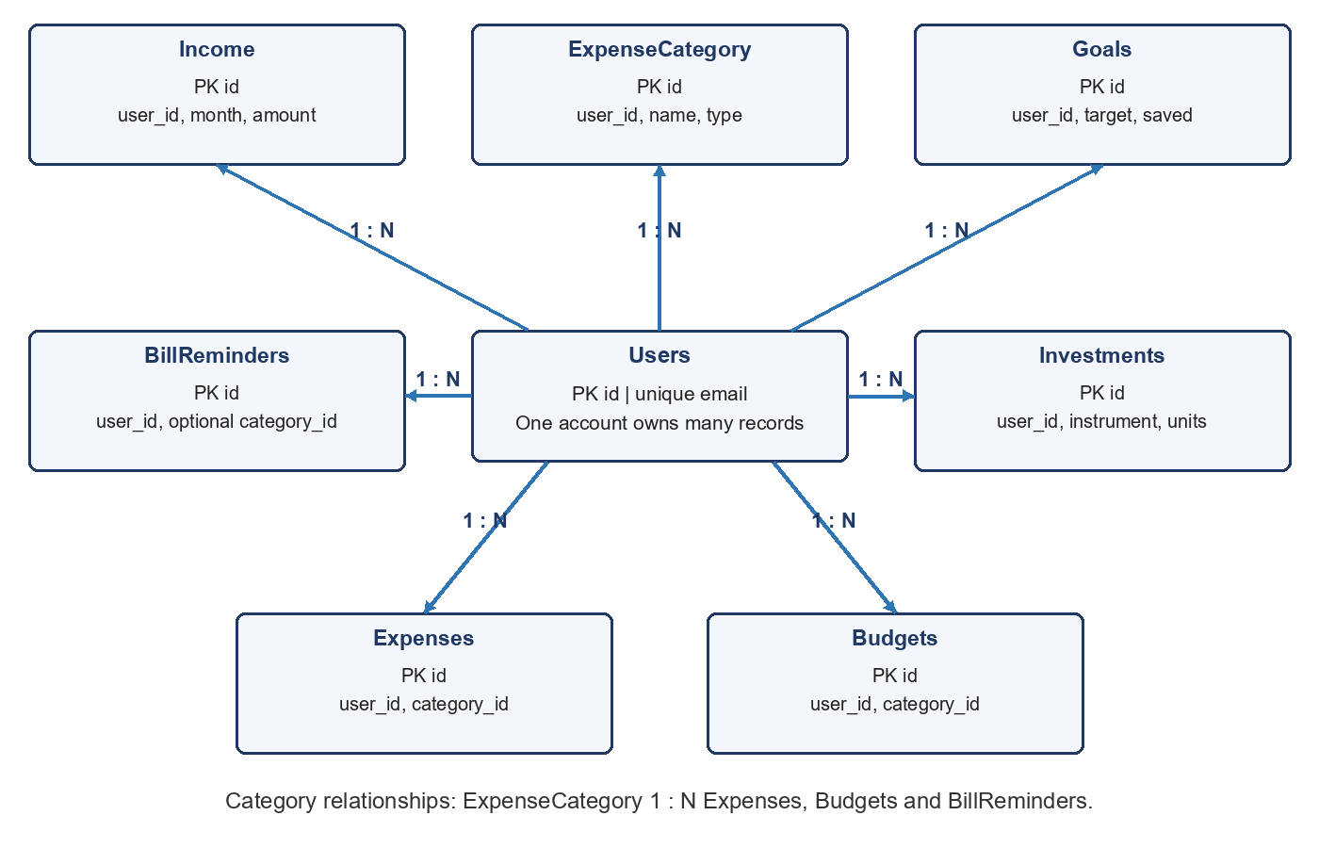
Figure 6.1 Entity ownership relationships with primary and foreign keys
Users has one-to-many relationships with all seven user-owned entity types. ExpenseCategory has one-to-many relationships with Expenses and Budgets, and an optional relationship with BillReminders. The diagram shows the main relationships; user ownership applies to every financial table, including those connected through a category.
The schema enforces unique user email and a unique budget for each user/category pair. Deleting a user cascades to owned records. Deleting a category cascades to related expenses and budgets, while a reminder's category reference becomes null. API checks verify ownership before writing related records.
Income, Expenses and Investments contain nullable reminder_id fields used to associate calendar payments. These fields are logical references managed by the application; the supplied schema does not declare foreign-key constraints for them. Indexes cover common user/month, user/date, user/type and category lookups.
Investments store quantities with DECIMAL(20,8), purchase prices with DECIMAL(24,12), and price and quantity provenance in JSON metadata fields. This separates original purchase cost from a later market valuation and allows the interface to explain a failed or outdated refresh. Profile preferences remain in Users rather than being duplicated in financial records.

CHAPTER 7: ALGORITHMIC LOGIC AND CALCULATION ENGINES

7.1 Priority Based Budget Allocation
The allocation engine first normalizes monthly income to a non-negative value. For each fixed category, an explicitly saved limit takes precedence, including zero. Without a saved limit, the engine uses an internal income-ratio benchmark for recognized names or falls back to an existing positive limit or recorded spending. Current benchmarks are rent 30%, EMI 20%, insurance 5% and internet 2%; these are application heuristics, not personalized financial advice.
If total fixed requirements exceed income, the engine scales them proportionally. It then splits the discretionary remainder across variable categories using priority weights Low = 1, Medium = 2, High = 3 and Very High = 4.
Discretionary remainder = max(0, income - allocated fixed needs)
Variable share = remainder x category weight / total variable weight
The allocateMoney utility works in integer cents, floors proportional shares and distributes residual cents by fractional remainder. It respects row caps and redistributes amounts where a cap is reached. This prevents independently rounded rows from exceeding the available amount.
Category | Priority weight | Illustrative allocation
Rent with saved limit | Fixed requirement | Rs. 15,000
Food | 3 | Rs. 13,125
Fuel | 2 | Rs. 8,750
Shopping | 1 | Rs. 4,375
Entertainment | 1 | Rs. 4,375
Travel | 1 | Rs. 4,375
Total from income of Rs. 50,000 | Variable weight total = 8 | Rs. 50,000

This worked example assumes only the listed categories. A category is exceeded when spending is above its limit, exhausted at 100%, and nearly exhausted from 80% to below 100%. A saved zero limit remains zero and any positive spending exceeds it.

7.2 Savings and Goal Calculations
Monthly savings = total income - total expenses
Net cash added = income - expenses - investments
These measures serve different purposes: savings excludes investment purchases as expenses, while net cash added accounts for the recorded investment outflow. Neither is an automatically reconciled bank balance. Goal contributions track goal progress separately from transaction expenses.
Goal remaining = max(0, target - saved)
Goal progress = min(100, saved / target x 100)
Required monthly saving divides the remaining goal amount by the number of full months to the deadline, with a minimum divisor of one. Expected completion uses the ceiling of remaining amount divided by positive monthly saving capacity. Month-end dates are clamped to a valid day in the target month. Completed goals are distinguished from overdue, unfinished goals.
Contribution suggestions use priority weights but cap each allocation at the remaining target. For example, with Rs. 10 available, a high-priority goal needing Rs. 1 receives Rs. 1 and another unfinished goal can receive the remaining Rs. 9. Zero capacity produces zero suggestions.

7.3 Investment Valuation
Purchase amount = units x purchase calculation price
Current value = saved units x latest available provider price
Unrealized gain = current value - original purchase cost
Return percentage = unrealized gain / purchase cost x 100
All eight asset types convert amount and quantity using the saved purchase price. Decimal arithmetic rounds money to two places and quantities to eight. Quantity or price edits can recalculate cost; unrelated edits preserve quantities. Inconsistent amount/quantity pairs require an authoritative input.
Investment forms and calendar payments reject dates after today in Asia/Kolkata. Date-only display preserves the entered day across browser time zones. Free text accepts Unicode letters, numbers and ordinary spaces; passwords, emails and instrument codes have separate rules.
Estimated quantities retain provenance and require confirmation before live valuation. Owner-accepted quantities need no repeat confirmation, but acceptance is not external verification. Missing legacy quantities remain unknown.
Live pricing requires an exact supported symbol or scheme code. Refresh preserves cost and quantities, skips unsupported assets and retains saved values on provider failure. Returns exclude fees, taxes, dividends and realized sale proceeds.

CHAPTER 8: HARDWARE AND SOFTWARE REQUIREMENTS

8.1 Development Environment
A development machine must run a browser, Node.js processes and a MySQL-compatible database. The following is a practical suggested setup, rather than a benchmarked minimum hardware specification.
Component | Suggested setup
Processor | Modern dual-core processor or better
Memory | 8 GB RAM for browser, editor, API and database
Storage | SSD space for source code, dependencies and database growth
Display | 1366 x 768 or larger for development; responsive mobile views supported
Network | Local connectivity for the API; internet access for market-data requests

8.2 Software Stack
Layer | Project technologies
Frontend | React 18, Vite 5, Tailwind CSS 3, React Router, Axios, Recharts
Backend | Node.js, Express 4, bcryptjs, jsonwebtoken, CORS, dotenv
Database | MySQL 8 or compatible MariaDB; mysql2 driver; no ORM
Testing | Node.js test runner, API integration scripts and browser QA scripts
Runtime configuration | Backend environment file and frontend VITE_API_URL
Browser verification | Recorded QA uses Chromium-based Edge; broader browser coverage remains future work

8.3 Installation and Configuration
For a new installation, create the database using schema.sql, configure the backend database connection and token secret, install project dependencies, then start the API and frontend development server. The documented local ports are 5000 for the API and 5173 for the frontend. Existing installations should use the migration scripts; the full schema script drops and recreates tables. Deployment also requires appropriate HTTPS, secrets management and database backups.

CHAPTER 9: SYSTEM IMPLEMENTATION AND PROTOTYPE MODULES

9.1 Authentication and Dashboard
Registration creates a user account and default expense categories. Passwords are hashed with bcrypt and login returns a signed JWT. Protected routes require a valid session; a temporary server failure is distinguished from an invalid token. The dashboard combines monthly income, expenses, investments, goal progress, recent activity and alerts. Screenshots in this chapter use a temporary demonstration account with example records.
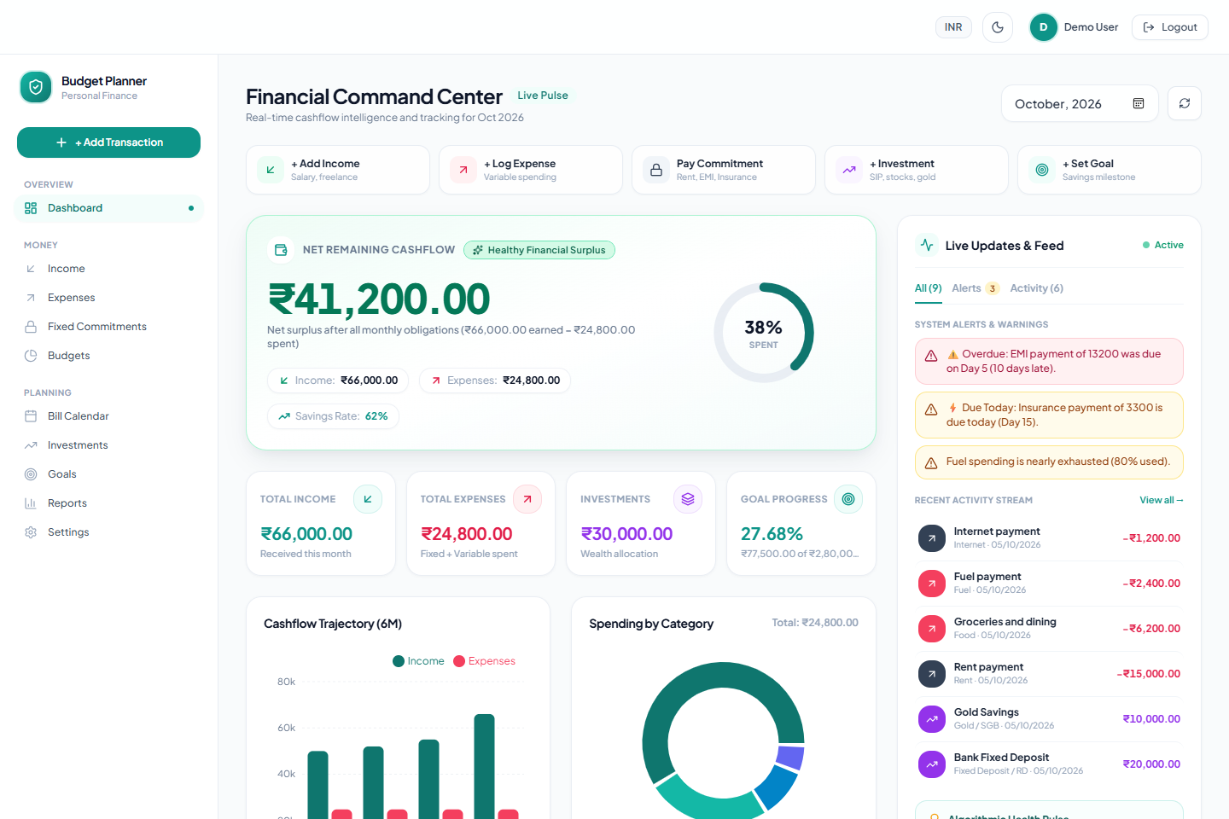
Figure 9.1 Dashboard showing monthly totals, activity and planning alerts
The demonstration month contains Rs. 66,000 of income and Rs. 24,800 of expenses, producing savings of Rs. 41,200. Recorded investment contributions of Rs. 30,000 leave net cash added of Rs. 11,200. The distinction follows the financial definitions in Chapter 7.

9.2 Income and Expense Management
Income entries record a source, amount and month. Expense entries record an owned category, amount, date and description. Search and filters support reviewing transactions, while editing and deletion update the associated totals. Salary entries cannot use future months. Fixed commitments use fixed categories; variable spending uses the expense workflow.
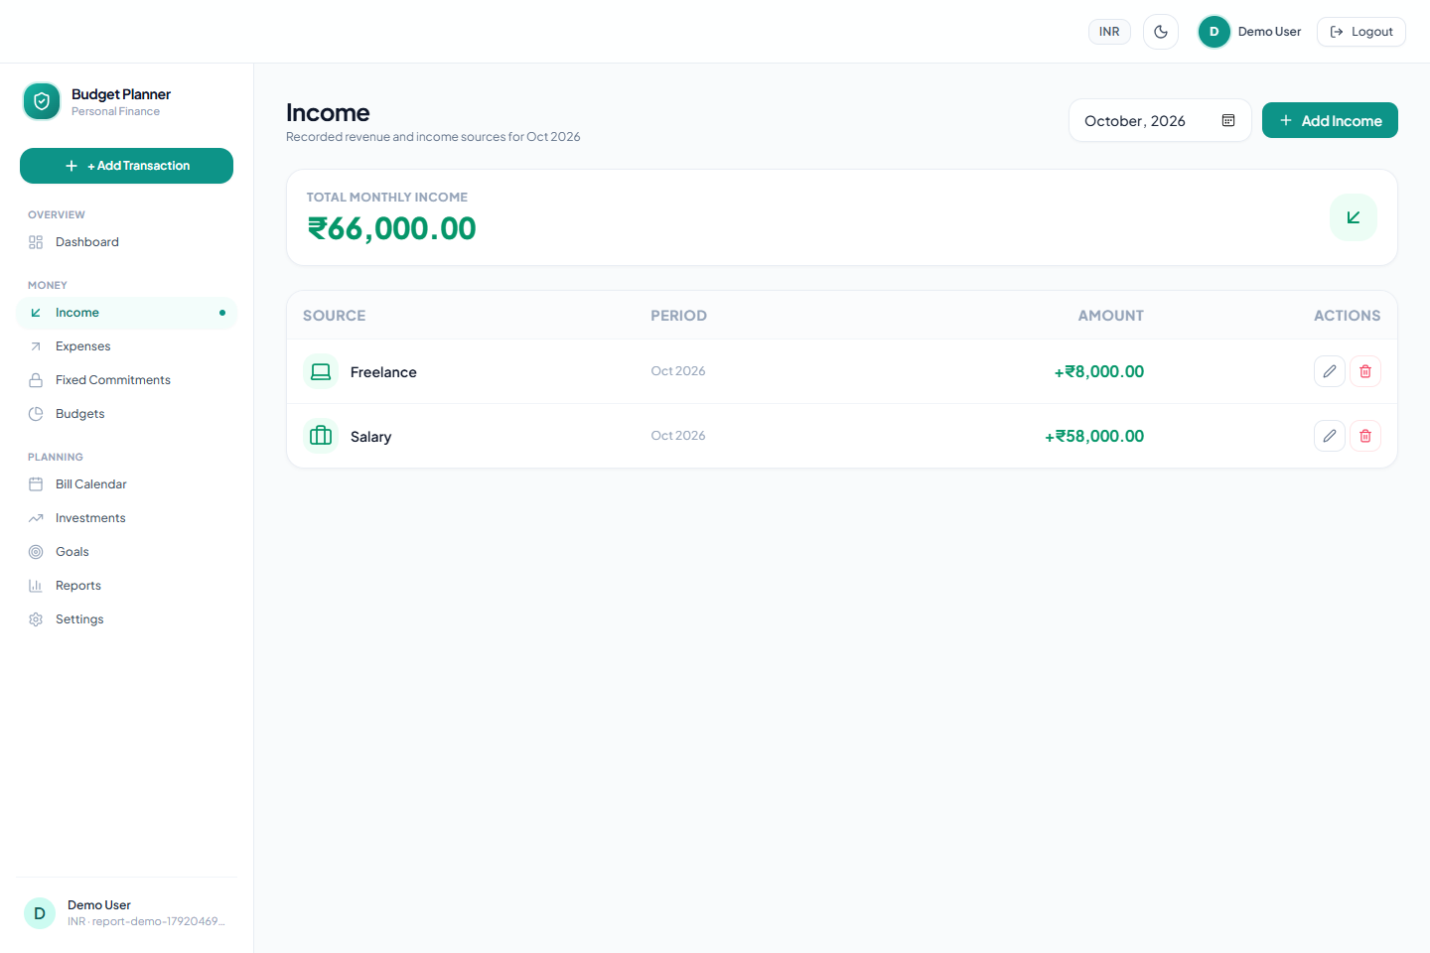
Figure 9.2 Income records with monthly filtering and multiple sources
Client forms give immediate feedback, but the API independently applies input rules and account checks. This prevents a direct request from bypassing constraints enforced by the interface. Category identifiers are checked against the current user before saving an expense.

9.3 Budgets and Fixed Commitments
The Budgets module shows category limits, spending and priority-based recommendations. Users can apply recommendations or retain their own limits. Fixed commitments such as rent and internet are planned separately from discretionary categories. A fully paid fixed commitment is treated as paid, while overdue unpaid commitments produce reminders.
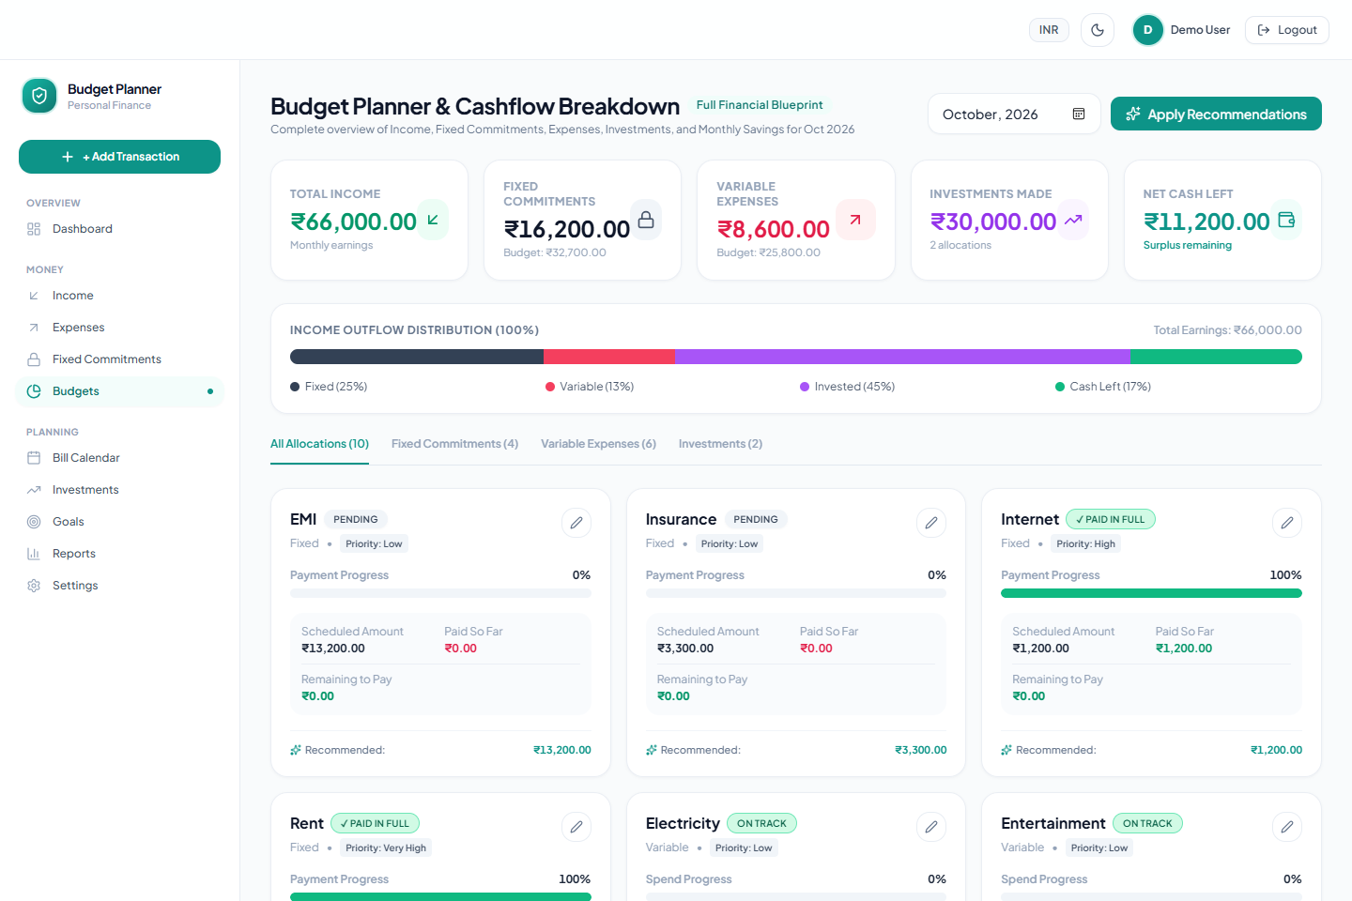
Figure 9.3 Budget planning with income allocation and category controls
The engine preserves a deliberately saved zero limit. It scales recommendations when fixed needs exceed income and distributes remaining funds without creating extra cents. Alerts distinguish approaching a variable limit, reaching it and exceeding it.

9.4 Savings Goals
Users define a goal name, target, saved amount, optional deadline and priority. Goal cards show progress and planning information. Contributions are limited by the remaining target, and suggested contributions share available saving capacity without over-allocating across goals.
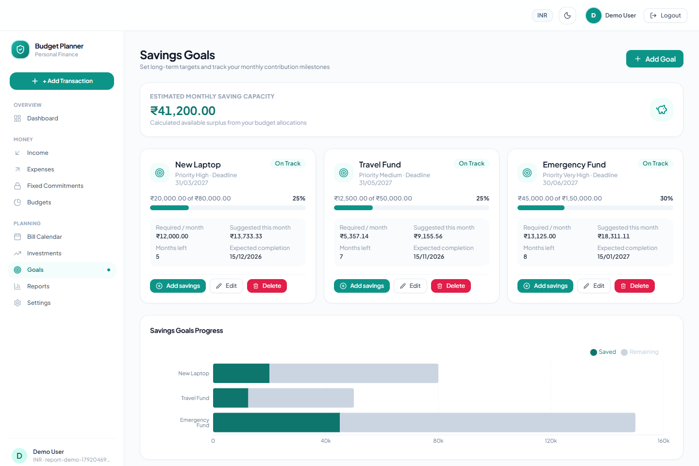
Figure 9.4 Savings goals with target amounts, progress and contribution actions
Expected completion is calculated from current saving capacity and can change when income or expenses change. An overdue goal is not marked on track solely because its remaining balance is small. The projection is a planning estimate based on recorded data.

9.5 Bill Calendar
The Bill Calendar arranges reminders by due day and supports fixed, variable, income and investment types. A quick payment creates the corresponding transaction type and links it to its reminder. Partial payments reduce the outstanding amount, and completed reminders reject another payment for the same month.
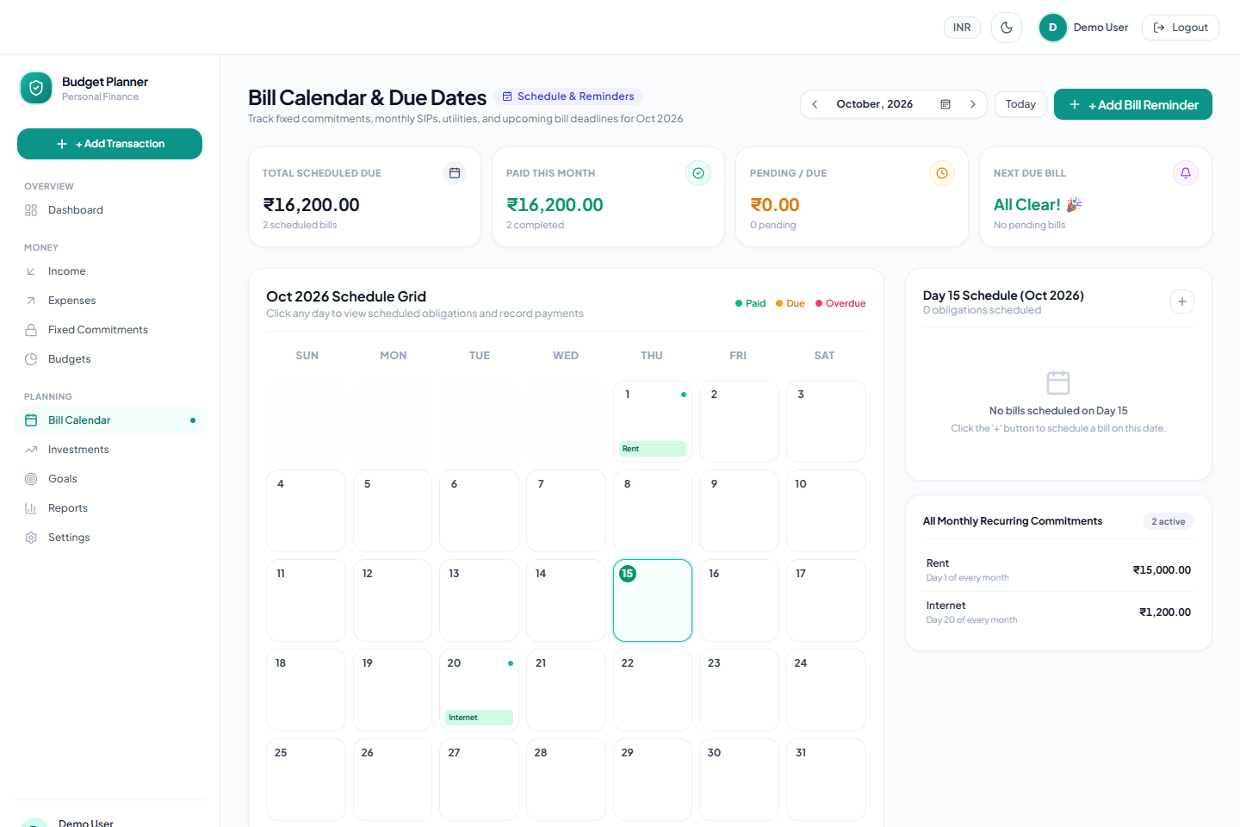
Figure 9.5 Bill calendar with scheduled amounts and payment status
Recurring reminders appear in applicable months. One-time reminders are restricted to their creation month, and due days are clamped for short months. Payment recording uses a database transaction and serialization for the reminder to reduce duplicate-payment races.

9.6 Investment Portfolio
The portfolio supports stocks, mutual funds and manually valued asset classes. All eight asset types support conversion using a saved purchase price and either amount or quantity. For supported INR stocks and funds, users also select an exact instrument for live valuation. The backend checks the calculation again on save. A single portfolio action updates available live values and returns across purchase months.
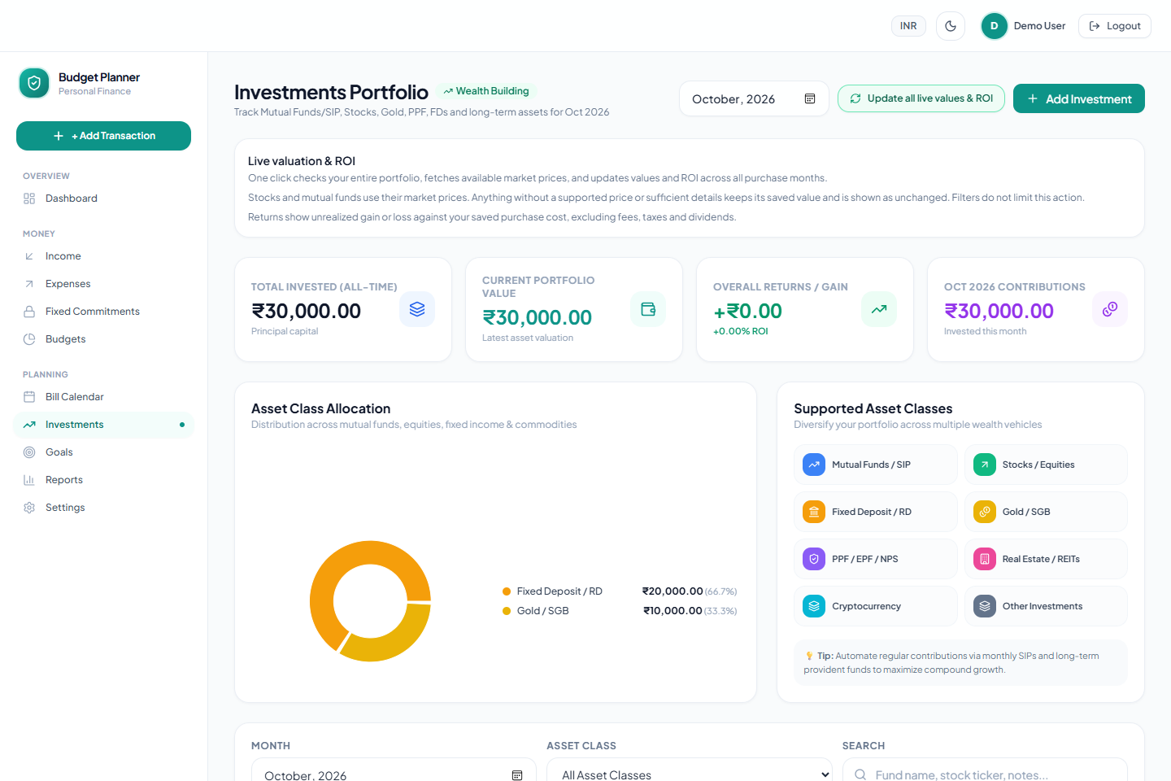
Figure 9.6 Portfolio summary and the action to update live values and ROI
The screenshot contains manual deposit and gold examples at their saved values. Such entries do not receive guessed market returns. Quote failures preserve the previous valuation and show an explanation. Changing visible filters does not limit the whole-portfolio refresh action.

9.7 Reports and Settings
Reports combine monthly income, expense and investment totals with category and trend charts. The selected month controls the summary, and the range selector controls historical trends. Settings manage profile details, currency display, salary day and saved theme. They also provide the validation demonstration panel described in Chapter 10.
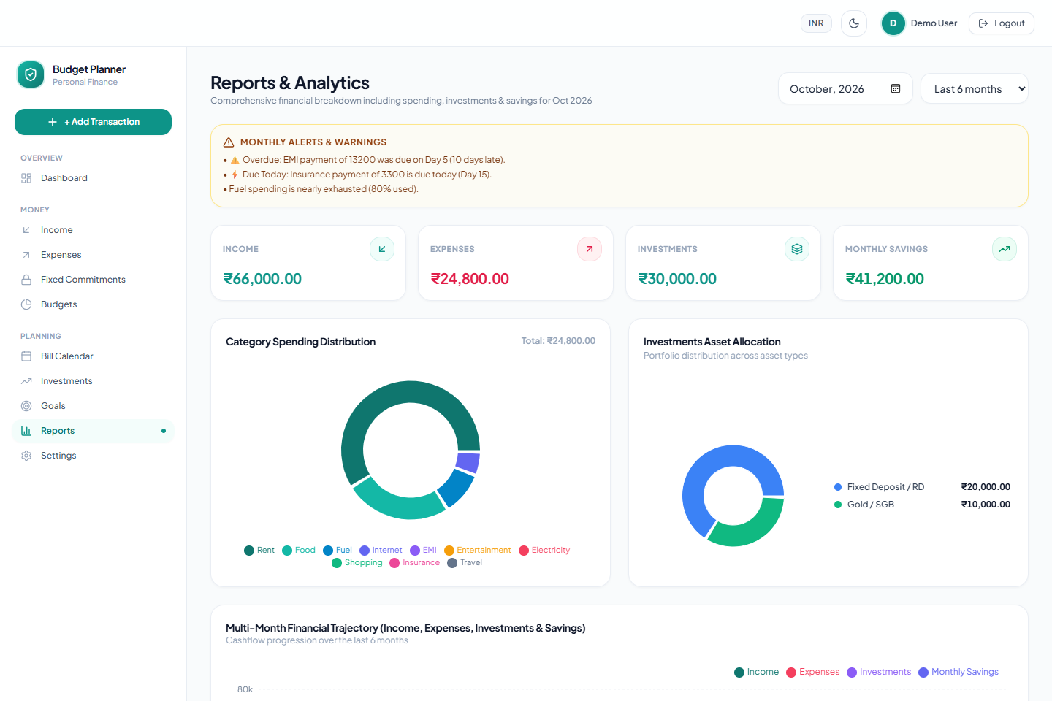
Figure 9.7 Reports and analytics for the demonstration account
Report calculations use backend aggregations. Cumulative savings includes all recorded history rather than only the displayed chart window. Notifications are shown inside the application; this implementation does not send external reminders.

CHAPTER 10: SOFTWARE TESTING VALIDATION AND RESULTS

10.1 Testing Strategy and Evidence
Verification covers utility-level regression tests, real API integration checks, shared validation cases and browser workflows. Boundary cases include zero limits, fractional monetary allocation, goal caps, invalid dates, month-end transitions, missing quantities and provider failures. Account isolation is checked separately from input shape.
The backend regression suite was rerun on 15 October 2026: all 68 tests passed, with zero failures or skipped tests. The API integration suite, production build and focused investment date/layout checks were also rerun on this date. The broader browser and provider checks retain the scope recorded in the project QA report [6].
Verification | Result | Evidence scope
Backend regression suite | 68 passed; 0 failed | Rerun on 15 October 2026
API integration groups | 24 passed; 0 failed | Rerun on 15 October 2026
Shared validation examples | 125 matched expectations | 17 valid and 108 invalid inputs
Invalid API submissions | 108 correctly rejected | Rerun with API integration suite
Browser workflows | 19 groups passed | Earlier character-validation audit
Responsive views | 10 pages at 1440px and 390px | No horizontal overflow recorded
Investment date and layout checks | API and browser passed | Eight types; IST date limit; responsive views
Frontend production build | Succeeded | Rerun; bundle-size advisory remains

Live provider observations are time-dependent. The QA record reports successful stock and fund requests, followed by a later Yahoo quote outage. Controlled fixture tests verify failure handling but do not demonstrate uninterrupted external service availability.

10.2 Representative Regression Cases
Test | Input or condition | Expected result | Outcome
TC01 | Small monetary totals split across seven categories | Row totals equal available cents; no negative allocation | PASS
TC02 | Saved limit = 0; spending = 1 | Preserve zero limit and flag exceeded | PASS
TC03 | Goal needs 1; second goal needs 100; capacity 10 | Suggest 1 and 9 without exceeding targets | PASS
TC04 | Two bills share a category; one payment is linked | Count the payment once for its reminder | PASS
TC05 | Income reminder and unrelated expense | Use income records for income reminder status | PASS
TC06 | Projection starts 31 January and takes one month | Clamp completion to 28 February 2026 | PASS
TC07 | Provider fails during refresh | Retain prior valuation and record failure | PASS
TC08 | Saved quantity and exact supported instrument | Use quantity x quote; preserve purchase cost | PASS
TC09 | All eight asset types and purchase price | Convert amount and units with decimal rounding | PASS
TC10 | Future investment date in form or calendar | Reject after current Asia/Kolkata day | PASS
TC11 | Ambiguous legacy investment name | Do not select an instrument automatically | PASS
TC12 | Future salary month | Reject with a field-specific error | PASS
TC13 | Invalid date, malformed numeric type or blank amount | Reject according to shared input rules | PASS
TC14 | Goal already completed | Return complete status without over-contribution | PASS

PASS in this table means the regression assertion succeeded. A correctly rejected invalid input is a passing regression case. Test identifiers are assigned for this report; the corresponding checks are in backend/test.

10.3 Validation Demonstration
The Settings panel uses the same backend validators as real submissions. Its PASS and FAIL labels describe the supplied input. An invalid amount is expected to show FAIL even when the validation mechanism is working correctly. The examples below were checked through the running application while preparing this report.
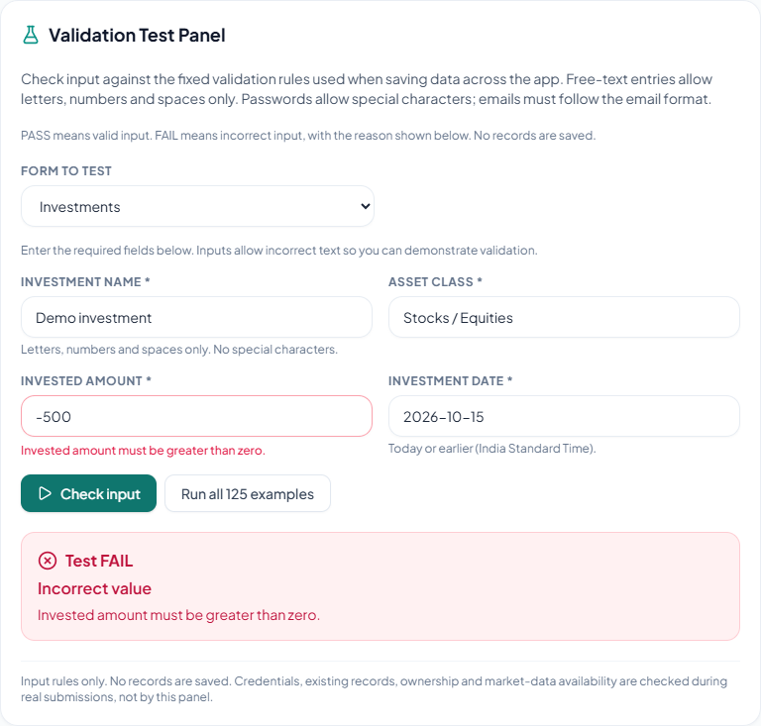
Figure 10.1 Negative investment amount correctly rejected as invalid input
Entering -500 produces the message that the invested amount must be greater than zero. This action inspects input rules only and does not save an investment, check credentials or request a provider quote.

10.4 Valid Input and Testing Limits
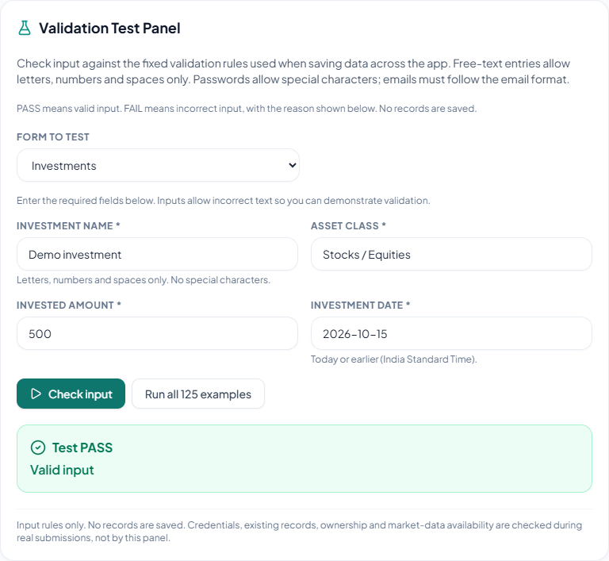
Figure 10.2 Positive investment amount accepted by the validation panel
Changing the amount to 500 with the remaining sample fields valid produces PASS. A real submission must also satisfy ownership, existing-record and market-data checks where applicable. The panel is therefore a demonstration of validation rules rather than a substitute for end-to-end testing.
Sustained load tests, a full security audit and Safari/Firefox verification are outside the recorded QA scope. The tested local workflows and regression cases provide evidence for the implemented behavior without establishing that every possible input or concurrent operation is error-free.

CHAPTER 11: ADVANTAGES LIMITATIONS AND ETHICAL CONSIDERATIONS

11.1 Key Advantages
- Unified planning: income, spending, commitments, goals and investments share one account and a consistent monthly context.
- Explainable calculations: priority weights and explicit formulas make recommendations traceable.
- Data consistency: shared validation and backend calculations reduce discrepancies between forms, reports and direct API requests.
- Useful failure handling: unavailable quotes do not overwrite saved values, and temporary server failures are distinguished from expired sessions.

11.2 System Limitations
Accuracy depends on complete and correct manual entries. The application does not reconcile records with a bank or broker. Goal planning uses recorded saving capacity and does not reserve money in an actual account. Default fixed-category ratios and name matching are simple application heuristics and may not fit every user.
Budget records are unique per user and category, rather than storing a separate budget version for each month. Market quotes may be delayed, stale or unavailable, and manual assets are not automatically repriced. Display currency settings do not perform exchange conversion. The current implementation does not provide offline operation, shared household roles or external reminder delivery.

11.3 Data Security and Ethical Considerations
Passwords are hashed with bcrypt, protected API routes verify JWTs, and model operations use parameterized queries and user ownership checks. These controls reduce common risks but do not replace a deployment security review. The frontend stores its session token in browser local storage, so preventing script injection and protecting the browser session remain important.
Financial records are sensitive. Production use should include HTTPS, limited database access, secure secret storage, backups and a clear retention policy. Report screenshots use a temporary demo account with example values. Budget suggestions and portfolio returns should be interpreted as calculations from recorded information, not as guaranteed outcomes or trading recommendations.

CHAPTER 12: CONCLUSION AND FUTURE ROADMAP

12.1 Concluding Summary
Personal Budget Planner demonstrates a complete web workflow for recording personal finances and translating those records into useful planning information. Its React interface, Express API and relational database support separate modules while sharing common account ownership and calculation rules. Priority-based budget allocation, capped goal suggestions and reminder-linked payments address practical consistency problems beyond basic transaction entry.
The 68 passing regression tests support the tested financial and validation rules. Recorded integration and browser checks provide additional evidence for the local workflows. The main remaining constraints are manual data entry, dependence on external market services and the absence of a full production security and performance assessment.

12.2 Future Roadmap
- Budget history: store monthly budget versions so that editing a current limit does not change the basis for historical comparisons.
- Data portability: add structured import and export with duplicate detection and reconciliation controls.
- Reminder delivery: add opt-in email or push notifications with clear user preferences.
- Account collaboration: introduce household roles and permissions with explicit sharing boundaries.
- Deployment readiness: strengthen session protection, rate limiting, monitoring, backups and security testing.
- Broader verification: extend browser compatibility, accessibility, concurrency and load-test coverage.
These extensions should preserve the existing distinction between user-entered records, calculated summaries and externally sourced market values. New automation should make its assumptions visible and keep correction of source records straightforward.

REFERENCES AND PROJECT ARTIFACTS
1. YNAB. The YNAB Method. Accessed 15 October 2026. https://www.ynab.com/ynab-method
2. React. Quick Start documentation. Accessed 15 October 2026. https://react.dev/learn
3. Express. Official web framework documentation. Accessed 15 October 2026. https://expressjs.com/
4. Oracle. MySQL 8.0 Reference Manual. Accessed 15 October 2026. https://dev.mysql.com/doc/refman/8.0/en/
5. Personal Budget Planner. Project source repository. https://github.com/DhruvMht/personal-budget-planner
6. Personal Budget Planner. QA report dated 15 October 2026. Repository path: docs/qa-report.md.
7. Personal Budget Planner. Schema and backend implementation. Repository paths: database/schema.sql; backend/utils; backend/services; backend/validation.
8. Personal Budget Planner. Automated regression cases. Repository path: backend/test. Verification run: 15 October 2026; 68 passed, 0 failed.
9. Personal Budget Planner. API documentation and setup guide. Repository paths: docs/api-documentation.md and README.md.

Project Artifact Index
Frontend implementation: frontend/src. Backend routes and controllers: backend/routes and backend/controllers. Database migrations: backend/scripts. The implementation screenshots show the local application with temporary example data. Architecture and database diagrams summarize the project source structure.

