17th March 2019****

1. Create a Ubuntu system
2. Create S3 Bucket

Storage -> S3

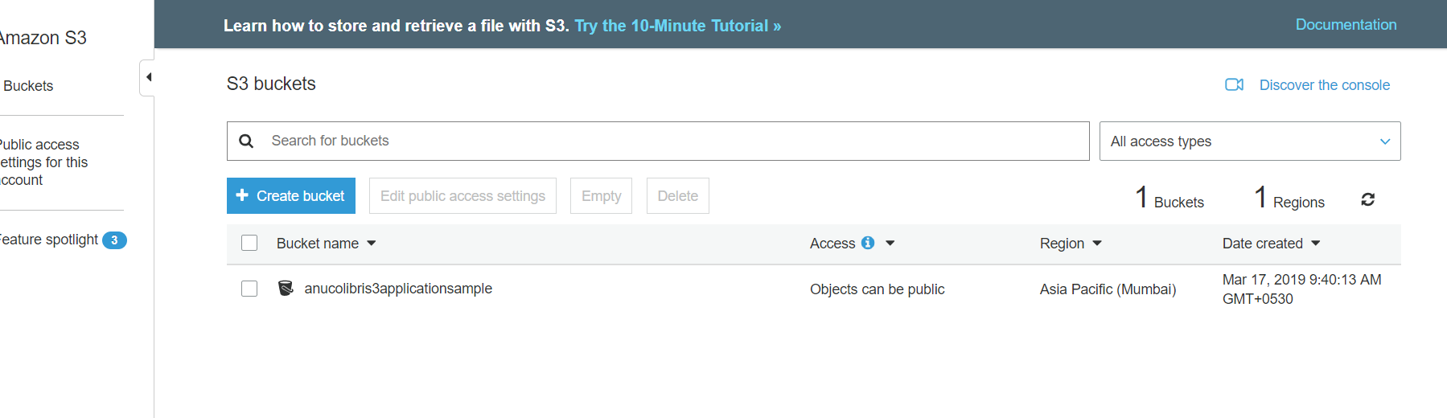

1. Create Iam Role

Services -> Type Iam

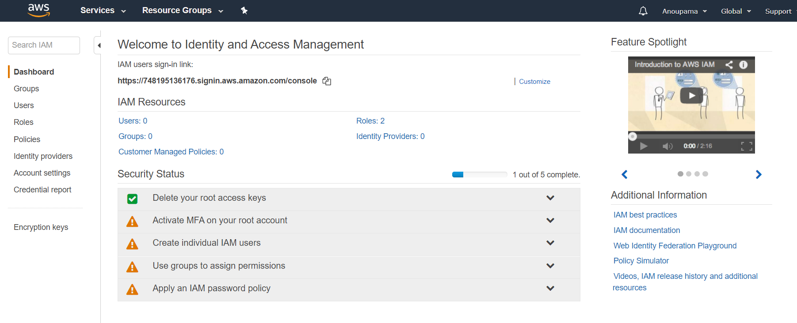

Click on Roles -> Create Role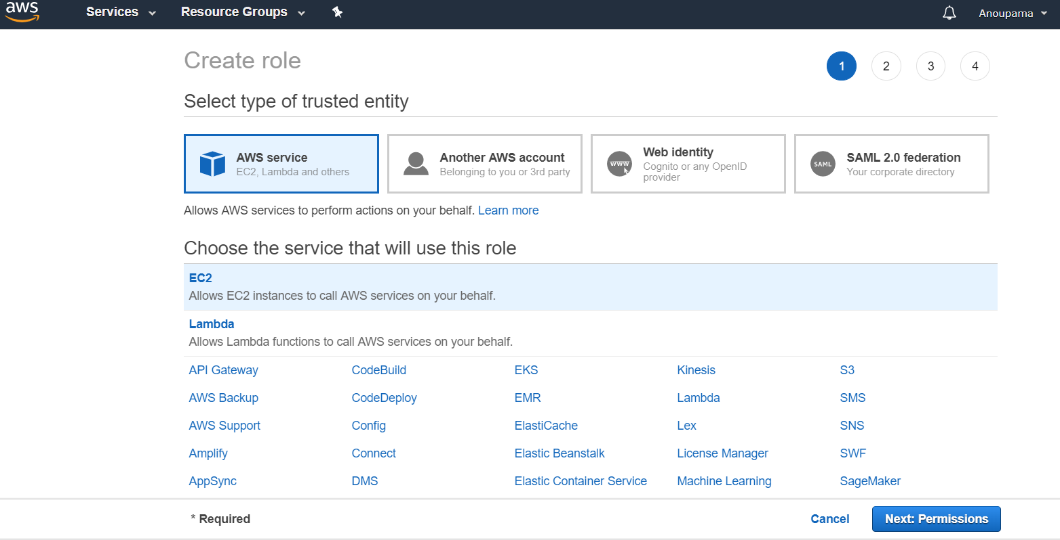

Click on Next Permission ->Type S3

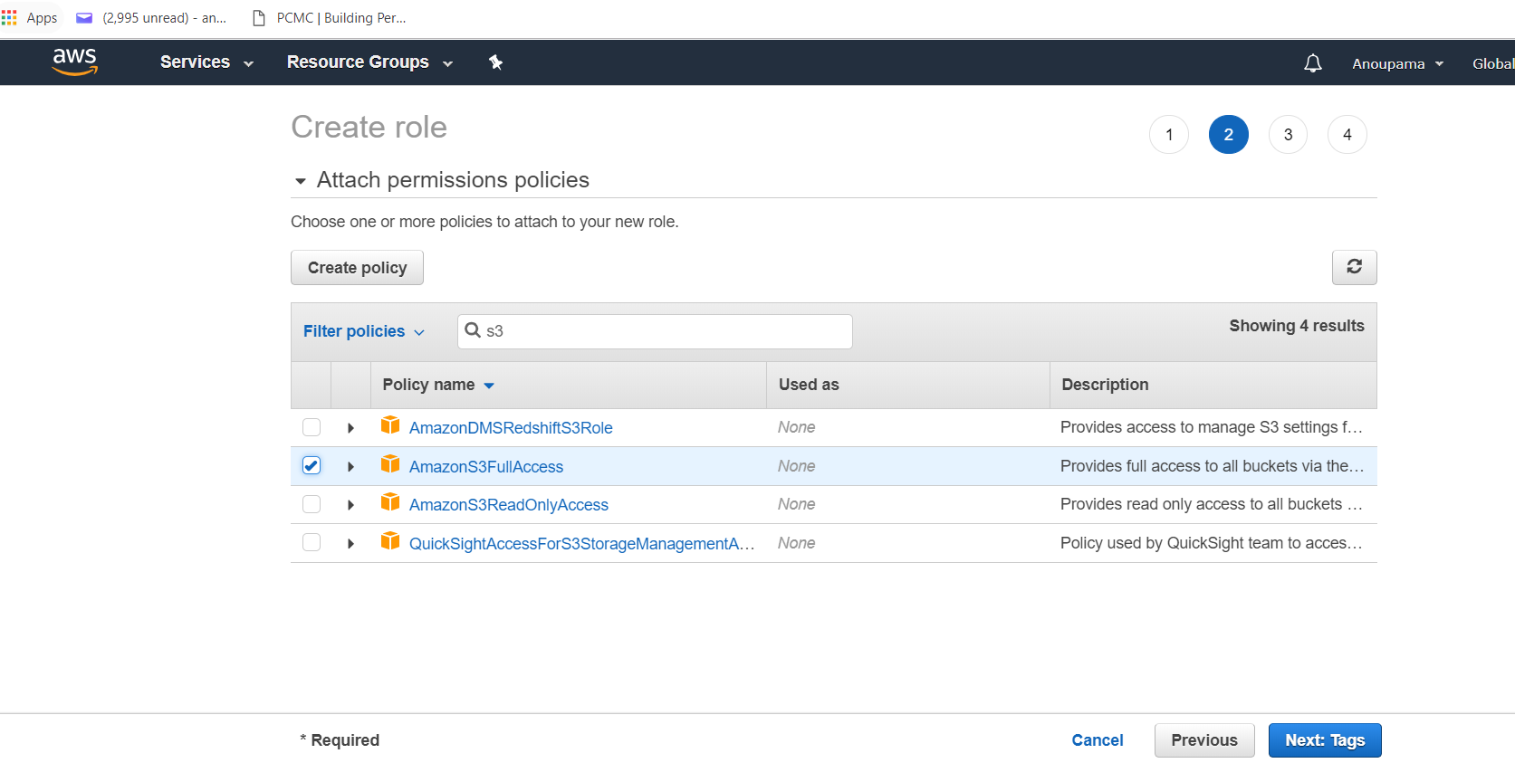

Click on Next:Tags -> enter role name - s3sampleapplicationec2

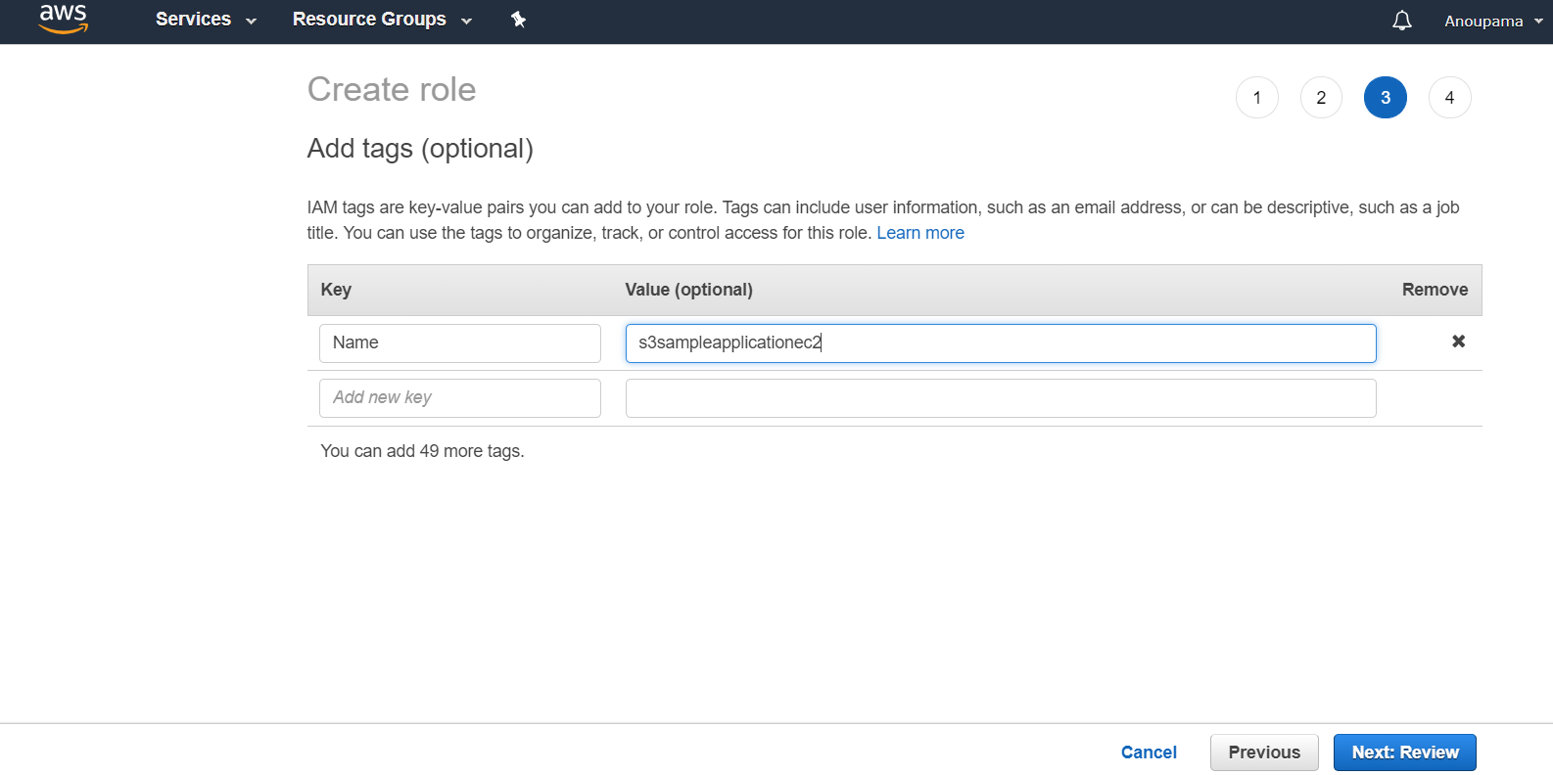

Click on Next:Review -> Role name : s3sampleapplicationec2

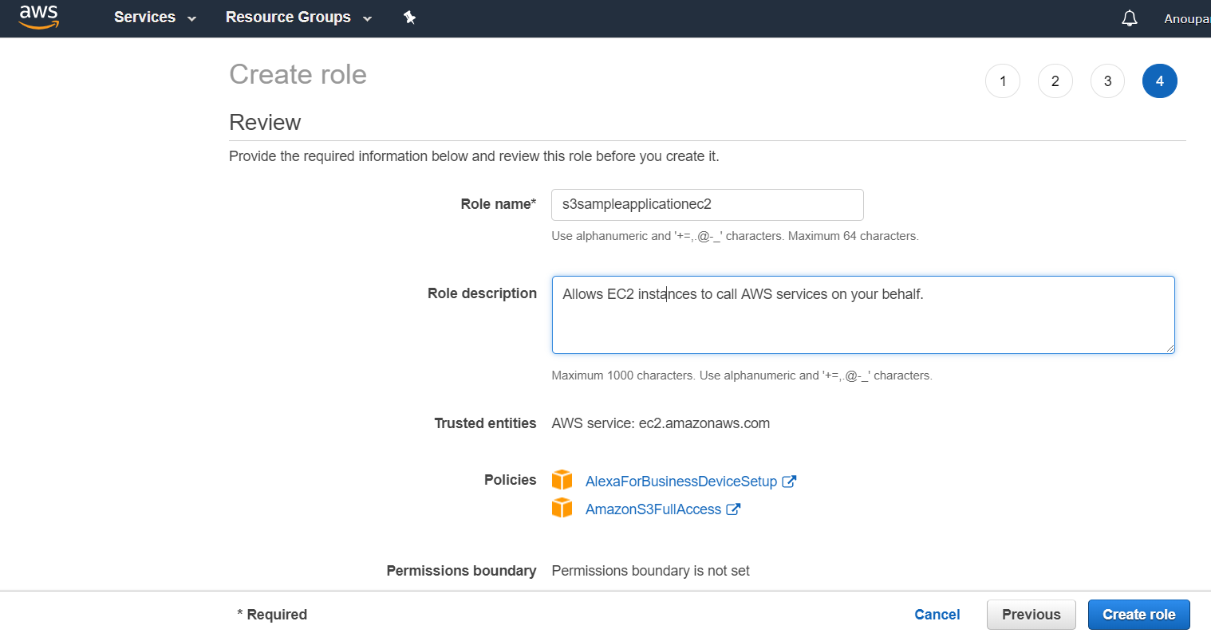

Click On Create Role->

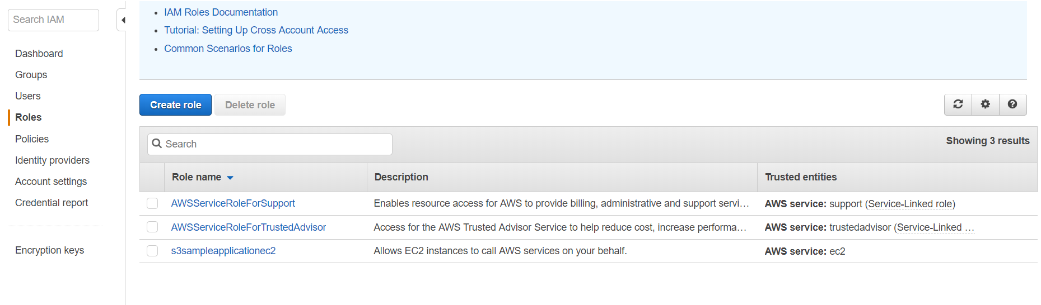

1. Attach the Created IAM role to Ubuntu machine.

Select Ubuntu machine -> Right Click ->Instance Settings-> select Attach/Replace IAM role(3rd option)

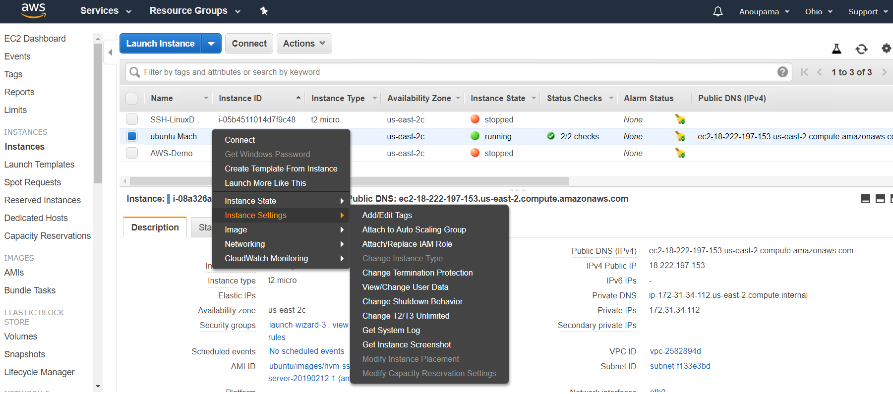

Select Role created in last step-> Click on Apply

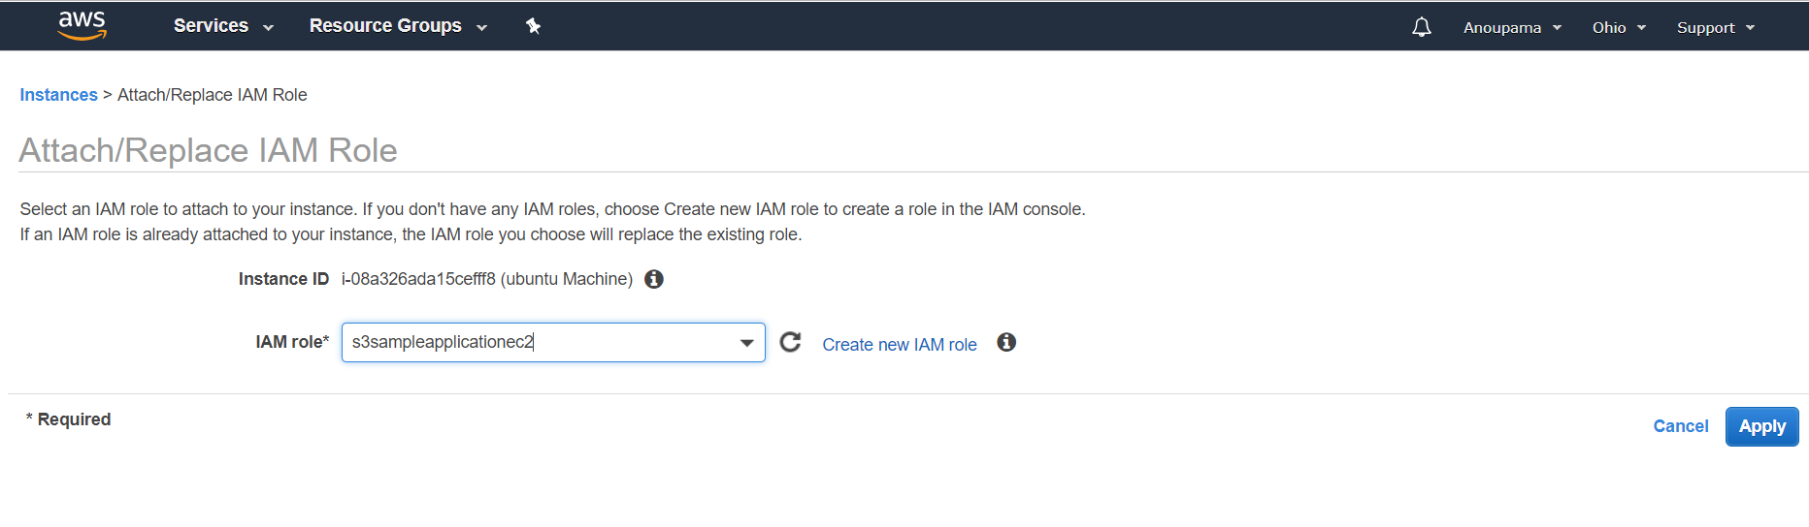

1. Connect/SSH Ubuntu machine and run below command

sudo apt-get update -y

sudo apt-get upgrade -y

sudo apt-get install -y python-pip python-dev build-essential – installed python

sudo pip install django==1.11 requests boto3 django-bootstrap3 pillow -

1. cd /home/ubuntu/
2. run command - git clone <https://github.com/maheshkharwadkar/Django-Application.git>

ubuntu@ip-172-31-34-112:~$ **ls -ltr**

total 4

drwxrwxr-x 5 ubuntu ubuntu 4096 Mar 17 04:44 Django-Application

ubuntu@ip-172-31-34-112:~$ **cd Django-Application/**

ubuntu@ip-172-31-34-112:~/Django-Application$ **ls -ltr**

total 16

drwxrwxr-x 4 ubuntu ubuntu 4096 Mar 17 04:44 s3pythonapp

-rw-rw-r-- 1 ubuntu ubuntu 253 Mar 17 04:44 django.service

-rw-rw-r-- 1 ubuntu ubuntu 252 Mar 17 04:44 userdata.sh

drwxrwxr-x 2 ubuntu ubuntu 4096 Mar 17 04:44 samplepictures

ubuntu@ip-172-31-34-112:~/Django-Application$ cp s3pythonapp /home/ubuntu/

cp: -r not specified; omitting directory 's3pythonapp'

ubuntu@ip-172-31-34-112:~/Django-Application$ cp -r s3pythonapp /home/ubuntu/

ubuntu@ip-172-31-34-112:~/Django-Application$ cd --

ubuntu@ip-172-31-34-112:~$ ls

Django-Application s3pythonapp

ubuntu@ip-172-31-34-112:~$ ls

Django-Application s3pythonapp

ubuntu@ip-172-31-34-112:~$ cd s3pythonapp/s3pythonapp/

ubuntu@ip-172-31-34-112:~/s3pythonapp/s3pythonapp$ ls -ltr

total 28

-rw-rw-r-- 1 ubuntu ubuntu 400 Mar 17 04:54 wsgi.py

-rw-rw-r-- 1 ubuntu ubuntu 1446 Mar 17 04:54 views.py

-rw-rw-r-- 1 ubuntu ubuntu 977 Mar 17 04:54 urls.py

-rw-rw-r-- 1 ubuntu ubuntu 1568 Mar 17 04:54 upload_to_s3.py

drwxrwxr-x 2 ubuntu ubuntu 4096 Mar 17 04:54 templates

-rw-rw-r-- 1 ubuntu ubuntu 4055 Mar 17 04:54 settings.py

-rw-rw-r-- 1 ubuntu ubuntu 210 Mar 17 04:54 forms.py

-rw-rw-r-- 1 ubuntu ubuntu 0 Mar 17 04:54 __init__.py

ubuntu@ip-172-31-34-112:~/s3pythonapp/s3pythonapp$ vi settings.py

:set number

Go to line number 91

90 #REPLACE WITH YOUR AWS BUCKET NAME

91 AWS_BUCKET_NAME = 'colibris3applicationsample'

To

91 AWS_BUCKET_NAME = 'anucolibris3applicationsample'

30 ALLOWED_HOSTS = []

To

30 ALLOWED_HOSTS = ["*"]

ubuntu@ip-172-31-34-112:~/s3pythonapp/s3pythonapp$ **cd ..**

ubuntu@ip-172-31-34-112:~/s3pythonapp$ **ls -ltr**

total 188

-rw-rw-r-- 1 ubuntu ubuntu 809 Mar 17 04:54 manage.py – **entry point for Django application**

-rw-rw-r-- 1 ubuntu ubuntu 184320 Mar 17 04:54 db.sqlite3

drwxrwxr-x 3 ubuntu ubuntu 4096 Mar 17 05:02 s3pythonapp

ubuntu@ip-172-31-34-112:~/s3pythonapp$ **python manage.py runserver 0.0.0.0:80**

Performing system checks...

System check identified no issues (0 silenced).

March 17, 2019 - 05:06:09

Django version 1.11, using settings 's3pythonapp.settings'

Starting development server at http://0.0.0.0:80/

Quit the server with CONTROL-C.

**Error: You don't have permission to access that port**. --- run with root command u will not get this error

ubuntu@ip-172-31-34-112:~/s3pythonapp$ **sudo su**

root@ip-172-31-34-112:/home/ubuntu/s3pythonapp# **python manage.py runserver 0.0.0.0:80**

Performing system checks...

System check identified no issues (0 silenced).

March 17, 2019 - 05:06:39

Django version 1.11, using settings 's3pythonapp.settings'

Starting development server at http://0.0.0.0:80/

Quit the server with CONTROL-C.

This is server which is waiting for request -> ctrl+c will terminate session.

<http://18.222.197.153>

1. root@ip-172-31-34-112:/home/ubuntu/s3pythonapp# vi ../Django-Application/django.service -> this is init script

root@ip-172-31-34-112:/home/ubuntu/s3pythonapp# cp ../Django-Application/django.service /etc/systemd/system/

root@ip-172-31-34-112:/home/ubuntu/s3pythonapp# cd /etc/systemd/system

root@ip-172-31-34-112:/etc/systemd/system# ls –ltr

root@ip-172-31-34-112:/etc/systemd/system# sudo vi django.service

root@ip-172-31-34-112:/etc/systemd/system# sudo systemctl start django.service

root@ip-172-31-34-112:/etc/systemd/system# sudo systemctl status django.service

root@ip-172-31-34-112:/etc/systemd/system# sudo systemctl enable django.service Created symlink /etc/systemd/system/multi-user.target.wants/django.service → /etc/systemd/system/django.service.

1. We need to attach this machine to ELB
2. Create Load balancer

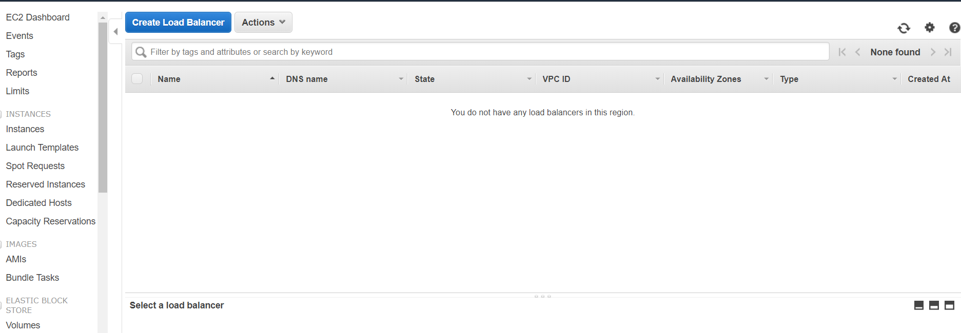

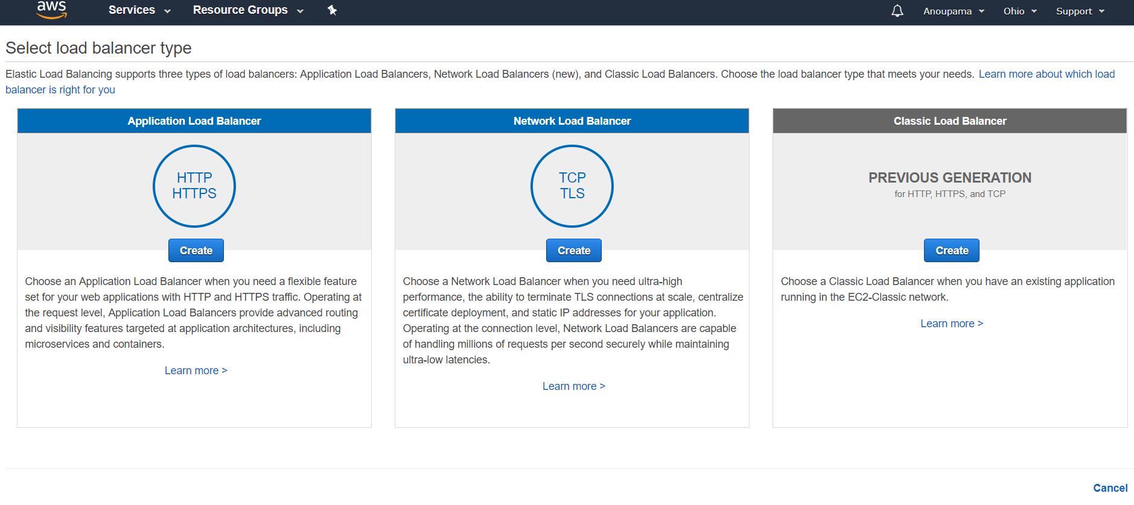

User should directly call from internet

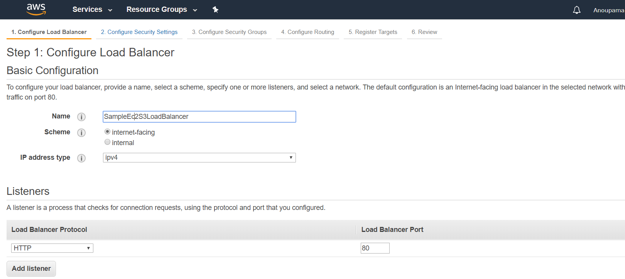

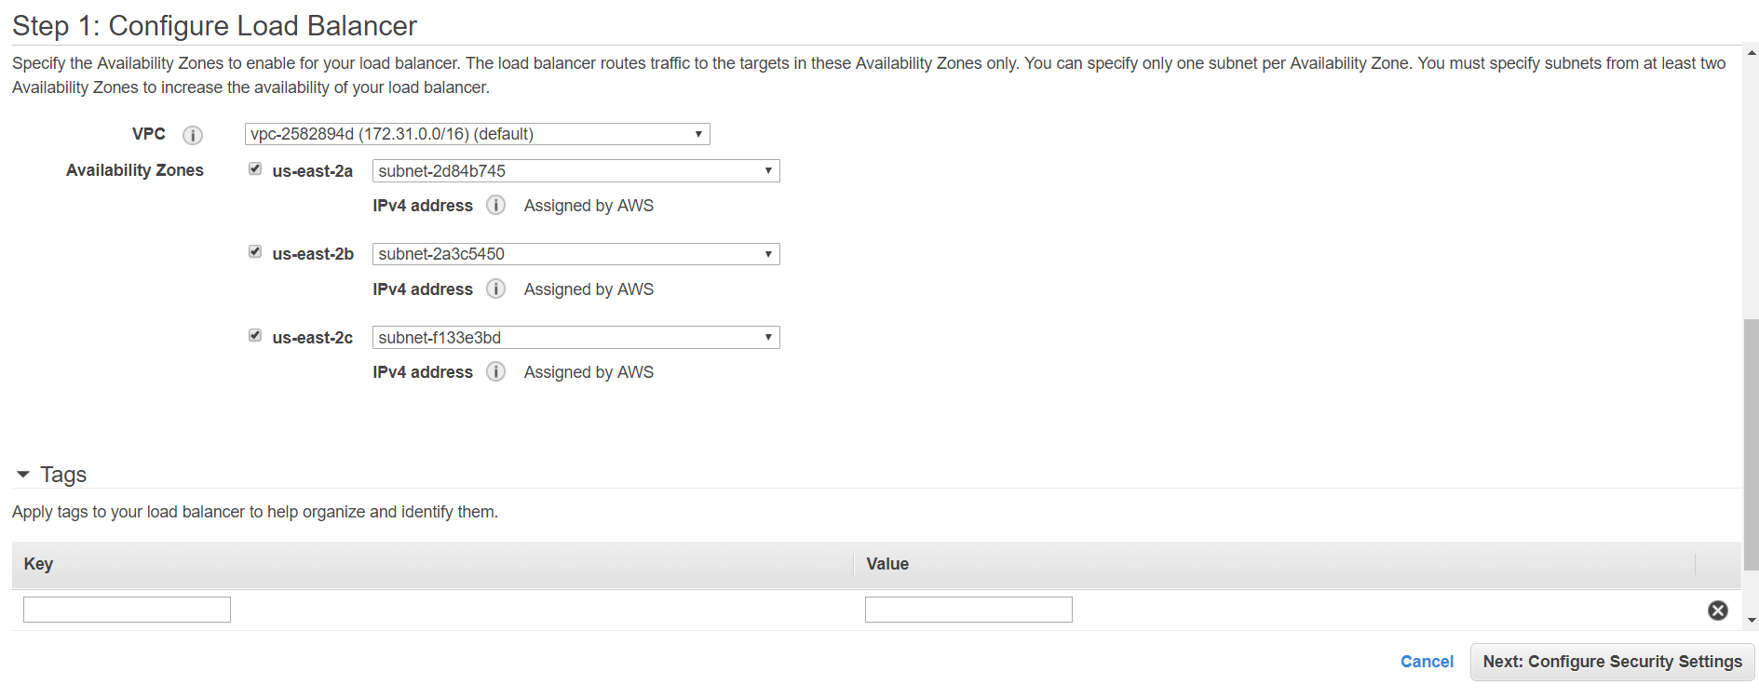

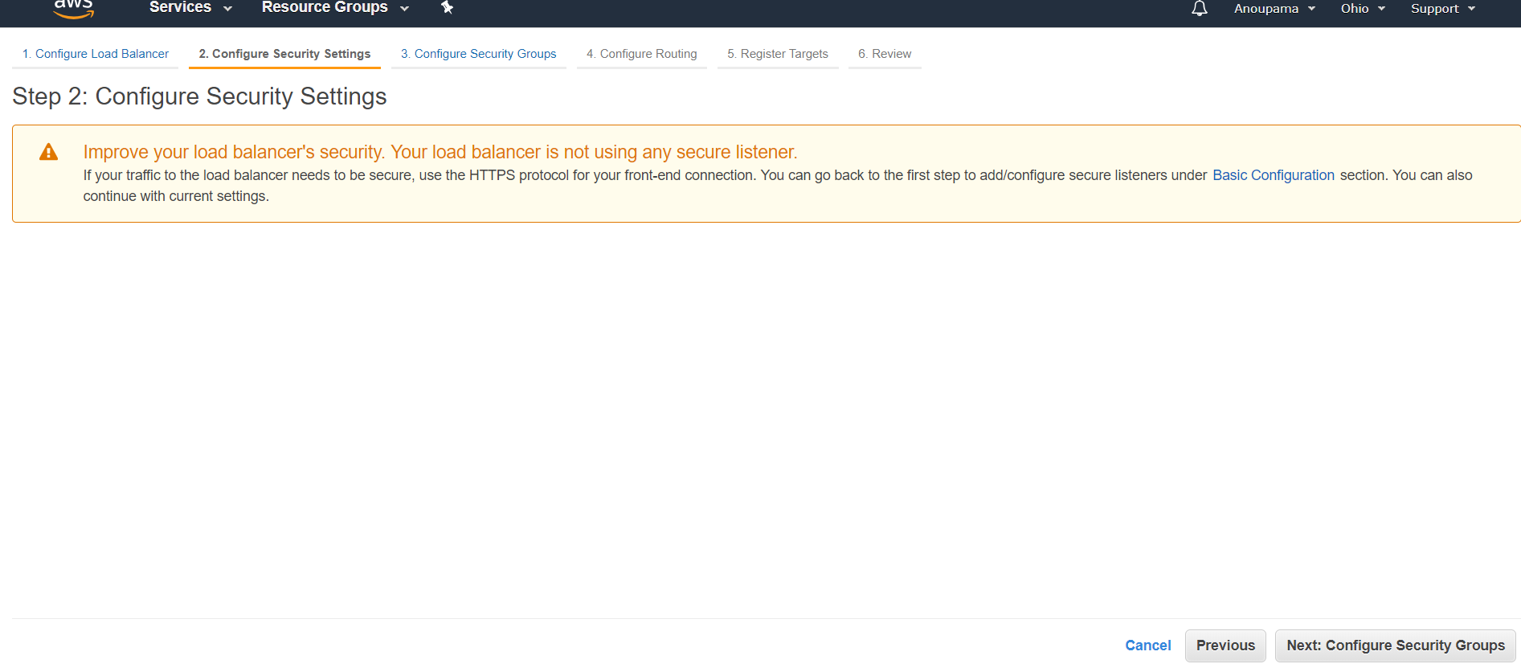

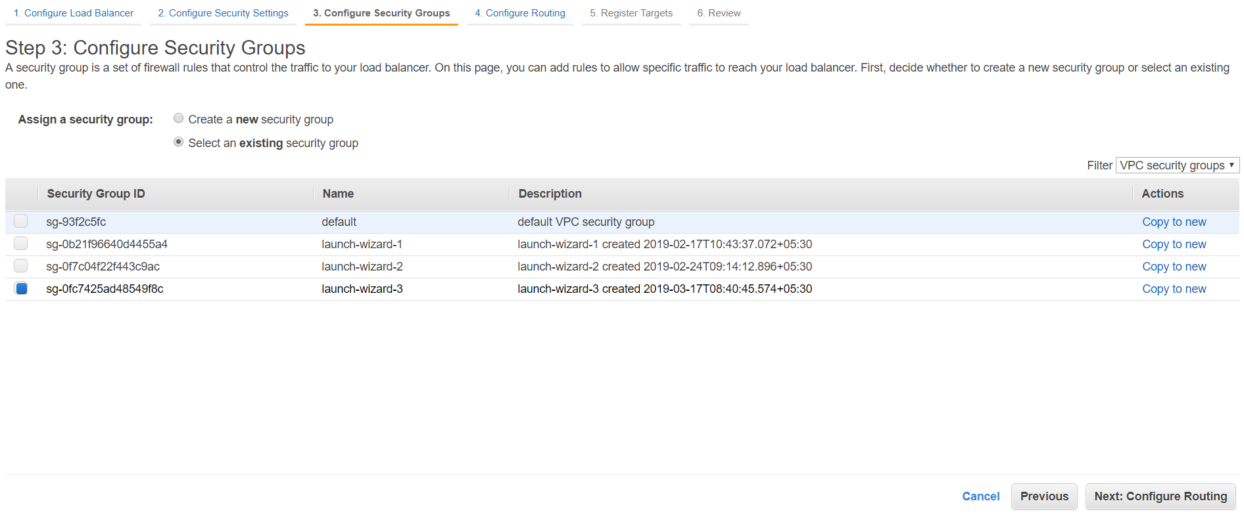

Curl localhost /

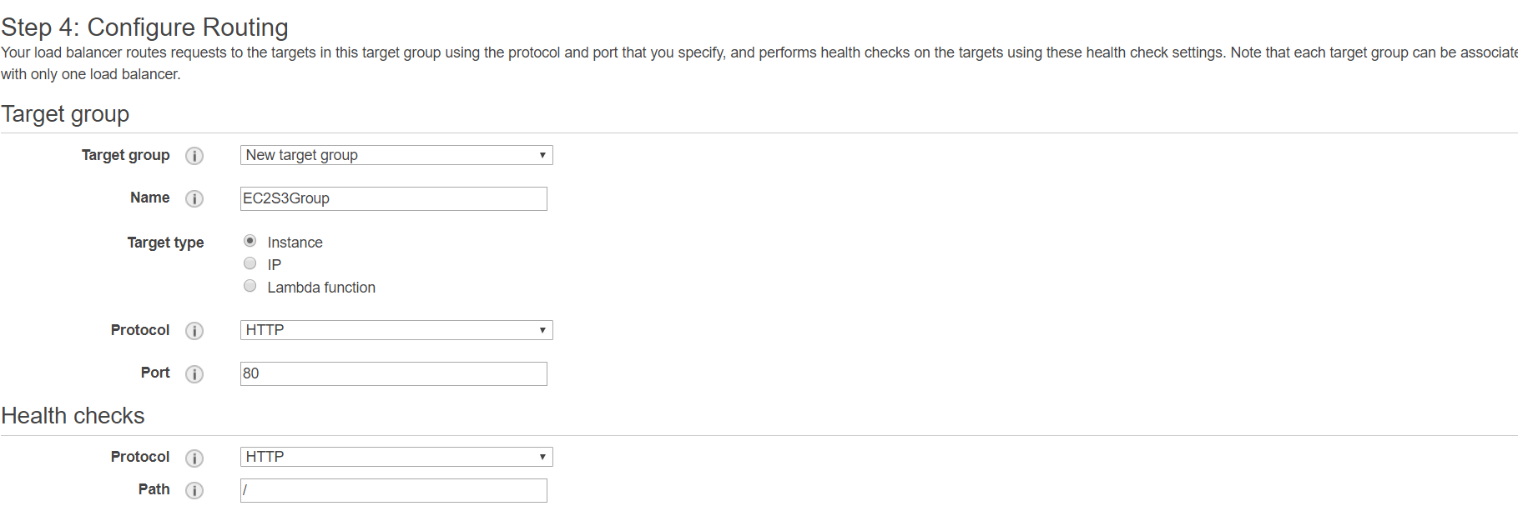

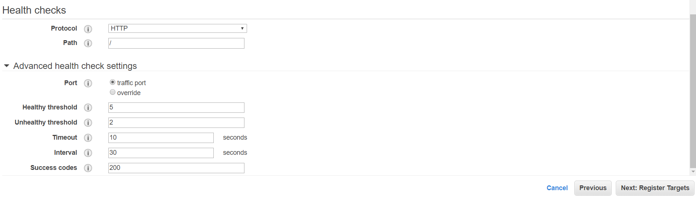

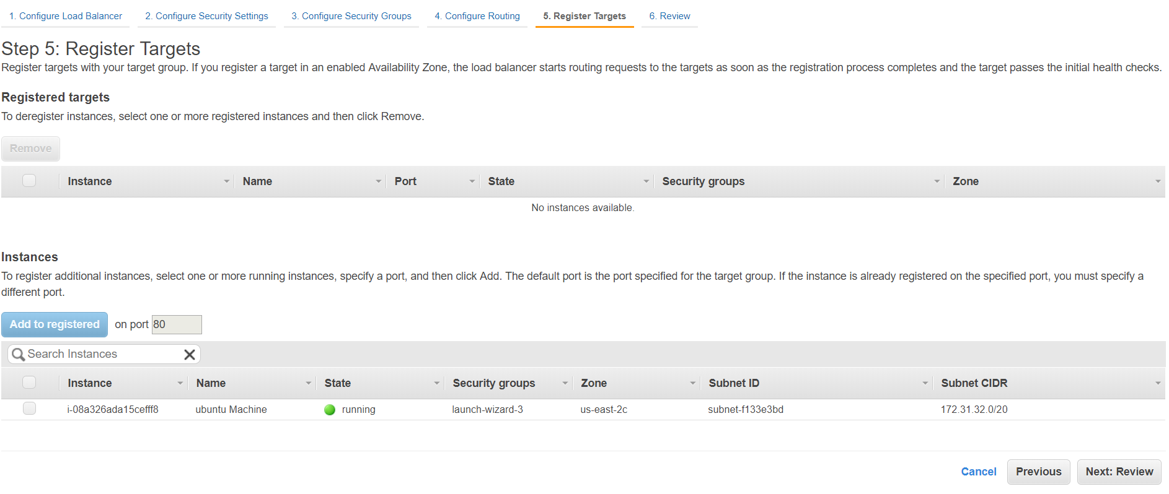

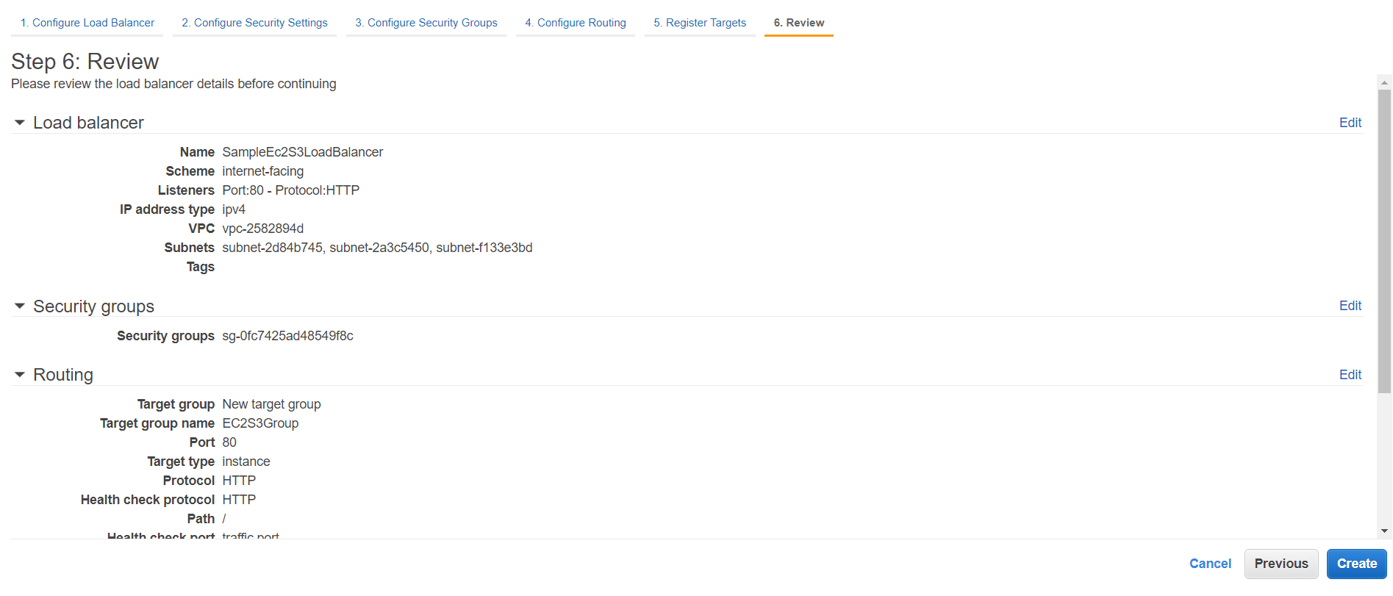

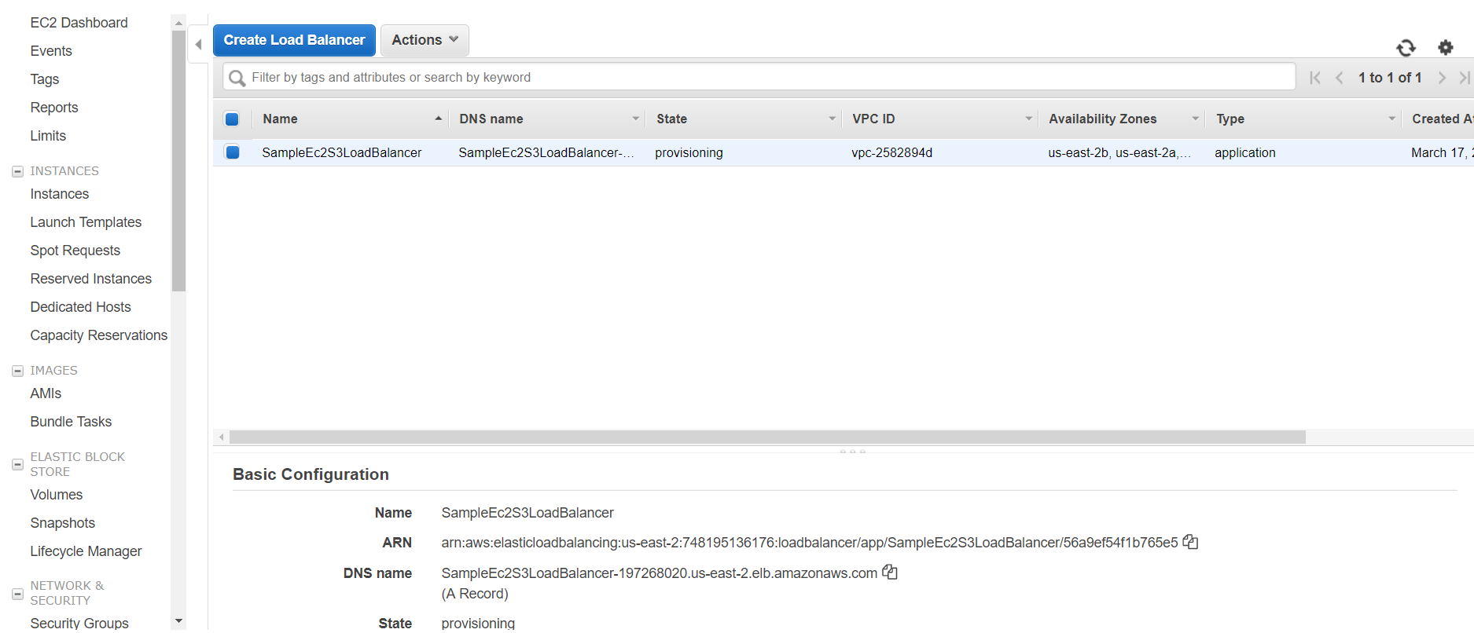

Copy DNS name

ubuntu@ip-172-31-34-112:~$ vi /home/ubuntu/s3pythonapp/s3pythonapp/settings.py

goto line 45

45 ELB_NAME=''

46 ALLOWED_HOSTS.append(ELB_NAME)

To

45 ELB_NAME='SampleEc2S3LoadBalancer-197268020.us-east-2.elb.amazonaws.com'

46 ALLOWED_HOSTS.append(ELB_NAME)

1. Create AMI - s3ApplicationAMI

Stop machine

Create image