Assignment-1(SDLC)

1. What is software? What is software engineering?

* Software is a collection of computer program, procedures, rules, associated documents and concerned data with the operation of the data processing system.
* Software engineering is an engineering discipline that delivers high quality software at agreed cost & in planed schedule.

1. Explain types of software?

* There are Main 5 type of software as given below.

1. Application software

The most common type of the software , application software is a computer software package that perform a specific function for a user , or in some cases , for other application.

1. System software

These software program design to run computer application program and hardware.

1. Driver software

Device drivers control the device and peripherals connected to a computer ,enabling them to perform there specific task .

1. Middleware

The term middleware describe software that mediates between application and system software or between two different kind of application software .

For Example, middleware enables Microsoft Windows To talks to excel and word.

1. Programming software

Computer program use programming software to write code. Programming software and programming tools enable developers to develop , write , test , debug other software programs.

1. What is SDLC? Explain each phase of SDLC?

* The software development life cycle refers to a methodology with clearly defined processes for creating high-quality software.

1. Requirement gathering
2. Analysis
3. Designing
4. Implementation
5. Testing
6. Maintenance
7. What is DFD? Create a DFD diagram on Flipkart.

**DFD** is the abbreviation for **Data Flow Diagram**. The flow of data of a system or a process is represented by DFD. It also gives insight into the inputs and outputs of each entity and the process itself. DFD does not have control flow and no loops or decision rules are present. Specific operations depending on the type of data can be explained by a flowchart.

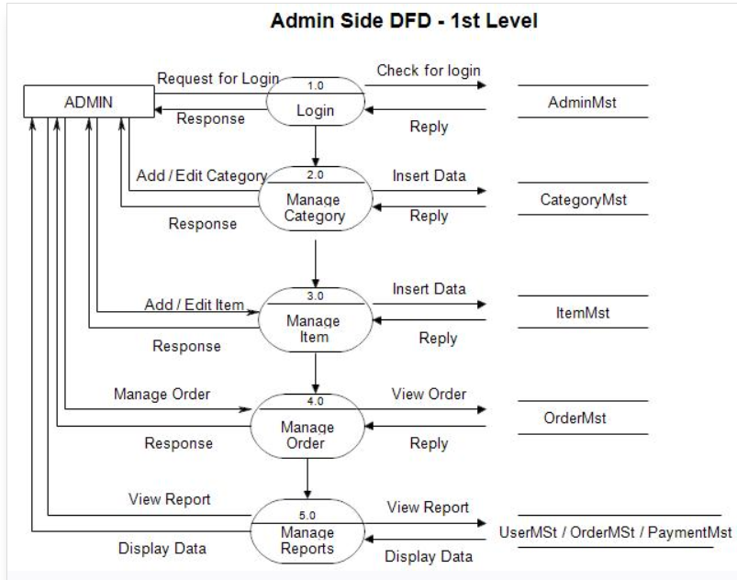

1. What is Flow chart? Create a flowchart to make addition of two numbers.

A flowchart is a type of diagram that represents a [workflow](https://en.wikipedia.org/wiki/Workflow) or process. A flowchart can also be defined as a diagrammatic representation of an algorithm, a step-by-step approach to solving a task.

The flowchart shows the steps as boxes of various kinds, and their order by connecting the boxes with arrows. This diagrammatic representation illustrates a solution model to a given problem. Flowcharts are used in analyzing, designing, documenting or managing a process or program in various fields.

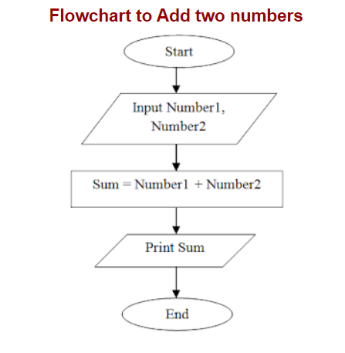

1. What is Use case Diagram? Create a use-case on bill payment on paytm.

A use case diagram is a graphical depiction of a user's possible interactions with a system. A use case diagram shows various use cases and different types of users the system has and will often be accompanied by other types of diagrams as well.

