**Add dependency of the following in your project's POM and make them available in Felix Console.**

**com.google.gson.Gson**

**Version : 2.8**

***POM.xml***

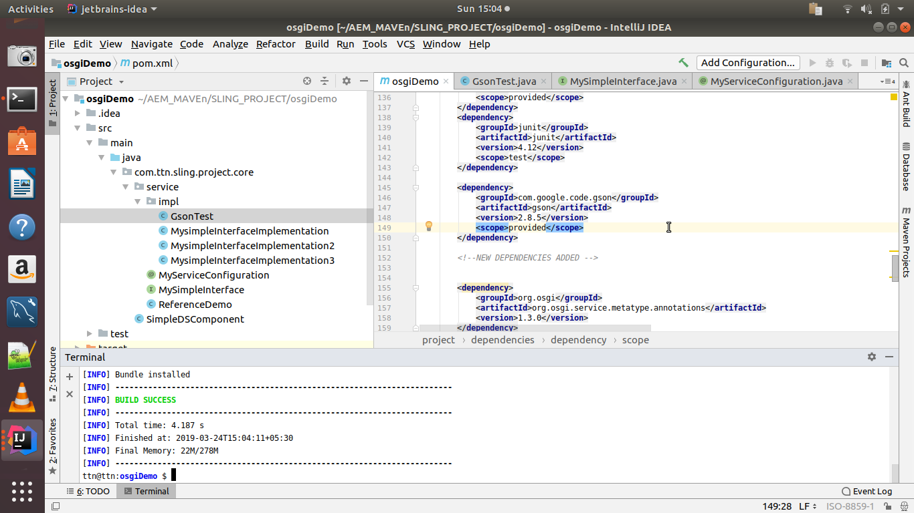

***GSONTEST***

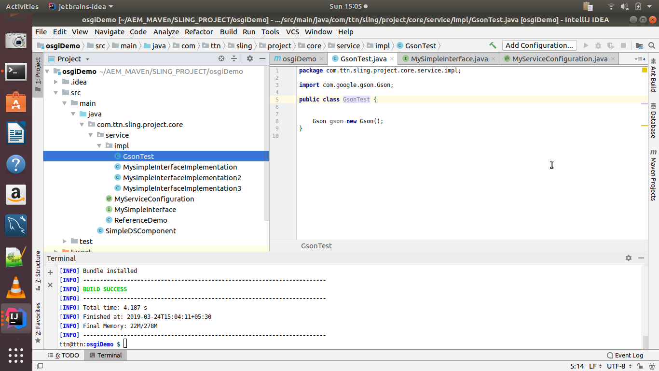

***Output on felix***

